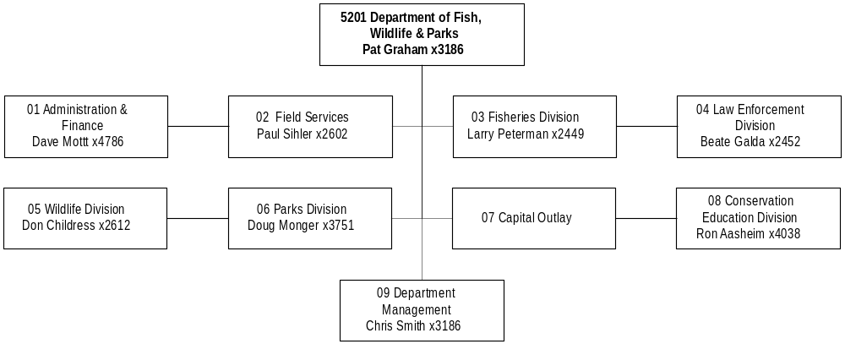
Mission Statement - Through our employees and citizen commission, to provide for the stewardship of the fish, wildlife, parks and recreational resources of Montana while contributing to the quality of life for present and future generations.

Statutory Authority - Title 87 and 23, MCA.

Executive Budget Recommendation –
- Convert the biennial automated licensing system appropriation into an annual appropriation for system operational costs
- Establish 1.00 FTE and federal funding for the administration and management of CARA projects
- Create 3.00 FTE and establish the budget authority to expend funds generated by the variable priced big game hunting licenses
- Enable block management to spend upland game bird license sales revenue as adopted last session
- Strengthen the collection of fisheries information by establishing 3.00 FTE and funding
- Create 3.00 FTE and federal funding to provide specialized enforcement
- Continue funding and include 0.50 FTE for mountain lion research
- Establish federal funding and 1.00 FTE to monitor elk and other ungulates to determine the impact of wolves
- Restore federal funding to administer land and water conservation fund grants
- Reduce recreation trail grants authority in HB 2 and transfer to HB 5 for efficient management
- Maintain federal funding for enhanced aquatic education program
- Establish $2.2 million federal funds for state efforts to conserve and enhance fish, wildlife, historic, and recreational resources.

Language - The following HB 2 language is recommended:
" The appropriations for legislative contract authority are subject to all of the following provisions:
1) legislative contract authority applies only to federal funds.
2) legislative contract authority expenditures must be reported on the state's accounting system and the records must be separate from present law operations. In preparing the 2005 biennium budget for legislative consideration, the office of budget and program planning may not include the expenditures from this item in the present law base.
3) a report must be submitted by the department to the legislative fiscal division following the end of each fiscal year of the biennium. The report must include a list of projects with the related amount of expenditures and FTE for each project.”

“The department is to report to the natural resources and commerce appropriations committee on the projects funded with federal Sikes Act money and state match money. The report is to include an analysis of the viability for continuance to the program and a list of projects funded with the money.”

“Item 8 includes a total of $138,780 for the 2003 biennium for the Montana natural resources information system. Quarterly payments must be made upon receipt of the bills from the state library up to the total amount appropriated."

Agency Proposed Budget  Budget Item | Base  Budget  Fiscal 2000 | PL Base Adjustment  Fiscal 2002 | New  Proposals  Fiscal 2002 | Total  Exec. Budget  Fiscal 2002 | PL Base Adjustment  Fiscal 2003 | New  Proposals  Fiscal 2003 | Total  Exec. Budget  Fiscal 2003
FTE | 568.52 | 4.00 | 19.19 | 591.71 | 4.00 | 19.19 | 591.71
Personal Services | 21,719,523 | 1,982,000 | 674,763 | 24,376,286 | 2,131,405 | 677,885 | 24,528,813
Operating Expenses | 20,005,153 | 510,588 | 2,225,114 | 22,740,855 | 381,173 | 2,220,672 | 22,606,998
Equipment | 701,700 | 15,103 | 55,000 | 771,803 | (247,897) | 40,000 | 493,803
Grants | 1,131,185 | (429,650) | 60,000 | 761,535 | (547,650) | 0 | 583,535
Benefits & Claims | 6,641 | 0 | 0 | 6,641 | 0 | 0 | 6,641
Transfers | 0 | 249,480 | 2,814,817 | 3,064,297 | 249,480 | 2,814,817 | 3,064,297
Total Costs | $43,564,202 | $2,327,521 | $5,829,694 | $51,721,417 | $1,966,511 | $5,753,374 | $51,284,087
General Fund | 419,466 | 14,089 | 0 | 433,555 | 14,089 | 0 | 433,555
State/Other Special | 31,653,448 | 3,092,131 | 637,693 | 35,383,272 | 2,657,864 | 562,855 | 34,874,167
Federal Special | 11,491,288 | (778,699) | 5,192,001 | 15,904,590 | (705,442) | 5,190,519 | 15,976,365
Total Funds | $43,564,202 | $2,327,521 | $5,829,694 | $51,721,417 | $1,966,511 | $5,753,374 | $51,284,087

ADMINISTRATION & FINANCE DIV.

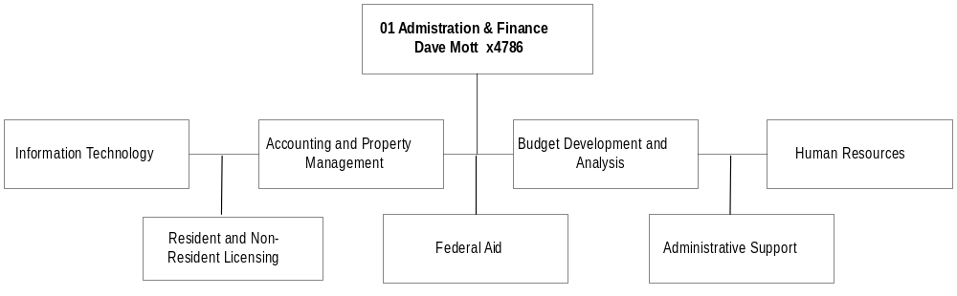
Program Description - The Administration and Finance Division provides department-wide support for accounting, fiscal management, purchasing and property management, personnel, and federal aid administration. In addition, the division provides information technology services to the agency, and administers the sale of hunting, fishing, and other recreational licenses.

Program Indicators –

Indicator | Actual FY1998 | Actual FY1999 | Actual FY2000 | Estimated FY2001 | Requested FY2002 | Requested FY2003
License and Permit Sales | 1,457,000 | 1,489,000 | 1,506,000 | 1,518,000 | 1,577,000 | 1,577,000

Program Proposed Budget  Budget Item | Base  Budget  Fiscal 2000 | PL Base Adjustment  Fiscal 2002 | New  Proposals  Fiscal 2002 | Total  Exec. Budget  Fiscal 2002 | PL Base Adjustment  Fiscal 2003 | New  Proposals  Fiscal 2003 | Total  Exec. Budget  Fiscal 2003
FTE | 54.82 | 0.00 | 2.00 | 56.82 | 0.00 | 2.00 | 56.82
Personal Services | 1,916,860 | 338,747 | 86,534 | 2,342,141 | 353,237 | 86,711 | 2,356,808
Operating Expenses | 5,656,513 | (1,032,581) | 9,500 | 4,633,432 | (1,085,383) | 7,500 | 4,578,630
Equipment | 49,100 | (34,100) | 0 | 15,000 | (34,100) | 0 | 15,000
Transfers | 0 | 249,480 | 75,000 | 324,480 | 249,480 | 75,000 | 324,480
Total Costs | $7,622,473 | ($478,454) | $171,034 | $7,315,053 | ($516,766) | $169,211 | $7,274,918
State/Other Special | 5,598,691 | 427,752 | 12,023 | 6,038,466 | 399,870 | 11,528 | 6,010,089
Federal Special | 2,023,782 | (906,206) | 159,011 | 1,276,587 | (916,636) | 157,683 | 1,264,829
Total Funds | $7,622,473 | ($478,454) | $171,034 | $7,315,053 | ($516,766) | $169,211 | $7,274,918

Significant Present Law Adjustments -
- Continue the appropriation required by state accounting policy for recording account transfers
- Administer the license preference system that was established by the 1999 Legislature
- Create an annual appropriation for the biennial computer budget appropriations and maintain costs at the same level as FY 2000/2001
- Convert the biennial automated licensing system appropriation into an annual appropriation for system operational costs
- Respond to increased Smith River applications and conduct permit drawings
- Adjust for alternative pay plan

New Proposals -
- Create 1.00 FTE and funding to provide maintenance and up-to-date public information on the FWP Internet site
- Establish 1.00 FTE and federal funding for the administration and management of CARA projects
- Restore one-time-only funding for legislative contract authority

Language Recommendations - The following HB 2 language is recommended:
"Item 1b legislative contract authority (LCA) is subject to all LCA provisions stated in the agency's language. LCA is restricted and a one-time-only item in HB 2 and must be requested as a new proposal to be continued into the 2005 biennium. LCA applies only to federal funds."

Proprietary Rates

Program Description -

Duplicating Center
The department duplicating center provides duplicating and bindery services to department employees. This duplicating center has only 1.00 FTE and whenever the demand for services becomes too great, the excess is taken to Publications & Graphics to be completed. This can occur when a particular job is considered too large.

Equipment Enterprise Fund
The department equipment fund provides a fleet of vehicles and aircraft to department employees. The revenue users are department employees, mostly enforcement wardens, fish and wildlife biologists, and park employees. Every month, users are charged for the miles driven (hours flown) during the previous month.

Warehouse Inventory
The department warehouse contains mainly uniform items (both for wardens and non-wardens) and items specifically related to the duties of the department such as gill nets for the fisheries biologists. Overhead costs are recovered by charging a predetermined fixed percentage to all sales.

Revenues and Expenses -

Duplicating Center
Revenues and Expenses. Expenses recovered in the rates are the personal services of the 1.00 FTE, operating expenses and the raw materials needed for duplicating.
Rates have been historically adjusted based on the need to increase or decrease the cash balances in the account. Prior to requesting new rates, a review of the cash balance is done. At FYE 2000, the cash balance was $14,323 or a one-day reserve based on FY 2000 expenses.

Working Capital Discussion. The 60-day working capital requirement provides sufficient cash to fund on-going operations of this program.

Fund Equity Discussion. A portion of the program fund balance has been reserved for the duplicating center equipment and inventory.

Cash Flow Discussion. Field projects are billed monthly for the purchases made during the month. The workload is fairly consistent so there is little fluctuation in cash balances except when additional inventory is purchased.

Equipment
Revenues and Expenses. The objective of the vehicle account is to recover (through rates and annual auction revenues) sufficient funds to cover administrative costs to operate the program (personal services and operations) in addition to being able to replace fleet vehicles at approximately 100,000 miles. A total of 2.06 FTE are funded from this revenue.

Working Capital Discussion. The department attempts to manage this account so that a 60-day working capital amount of cash is available when the cash balance is at its lowest level. During the past biennium, the department has spent down its excess cash balances. The department attempts to ensure that fees are commensurate with costs over time. It does this in two ways. First, proposed rates for the next biennium take into consideration excess income or loss generated from previous periods. Second, prior to assigning new rates at the beginning of a new fiscal year, the rates are recalculated based on actual information.

Fund Equity Discussion. A portion of the program fund balance has been reserved for the book value (original cost less accumulated depreciation) of department vehicles and aircraft.

Cash Flow Discussion. Divisions are billed monthly for the miles driven (hours flown) during the previous month. Cash balances fluctuate during the year for two reasons. The first is that monthly mileage is greater during in the summer and fall than during the winter and spring. The second reason is that new vehicles are purchased in the spring. Thus cash balances are normally highest in December after the hunting season and lowest in the spring after purchasing the new vehicles. Fiscal year end balances tend to be significantly higher than spring balances.

Warehouse Inventory
Revenues and Expenses. The expenses associated with the warehouse include miscellaneous office supplies and expenses for the warehouse worker and inventory purchased needed to replenish existing stock. There are no FTE funded with this program.

Working Capital Discussion. The 60-day working capital requirement provides sufficient cash to fund on-going operations of this program. The department attempts to ensure that fees are commensurate with costs over time by adjusting the proposed rates for excess income or loss from previous periods.

Fund Equity Discussion. A portion of the program fund balance has been reserved for the warehouse inventory.

Cash Flow Discussion. Field projects are billed monthly for the purchases made during the month. Cash balances fluctuate during the year. Cash balances are lowest during the winter when stock is replenished and highest during the summer when temporary and seasonal employees are hired.

Rate Explanation -
Duplicating Center
The rate methodology attempts to determine a rate for various duplicating and bindery services that allows the fund to recover both the cost of the raw materials and all associated personal services and operating costs. Rates have been historically adjusted based on the need to increase or decrease the cash balance. The requested rates have been increased only to recover anticipated inflationary increases in the raw materials and administrative costs.

Duplicating Services Proprietary Account Rates

- Duplicating
Number of copies (includes paper) FY 2002 FY 2003
1-20 $0.045 $0.050
21-100 $0.030 $0.035
210-100 $0.025 $0.030
101-1000 $0.020 $0.025

- Bindery
Collating (per sheet) $0.005 $0.005
Hand Stapling (per set) $0.015 $0.015
Saddle stitch (per set) $0.030 $0.030
Folding (per sheet) $0.005 $0.005
Punching (per sheet) $0.001 $0.001
Cutting (per minute) $0.550 $0.550

Equipment.
The rate methodology attempts to determine a cost/mile rate for various classes of vehicles and a cost/hour rate for each class of aircraft. The methodology is to determine the previous year's expenses, including operating, maintenance, administration and depreciation expenses minus the previous year's revenue generated from the rates and the annual vehicle auction to establish the net income for a particular class. Next the life to date (LTD) net income or loss on a per mile (hour) basis is determined. Future year expenses are estimated based on current year information plus 4 percent. Using the most current year mileage and the projected expenses, a cost/mile (hour) rate is determined for the future year. This rate is adjusted for any LTD net income or loss. In an attempt to minimize large increases or decreases, rates will not change more than 25 percent per year (10 percent for aircraft).

In addition, in order to more fairly charge users, a minimum mileage rate was instigated in FY 2000. This will attempt to recover overhead costs whether a vehicle is driven or not. A minimum monthly overhead charge would be assessed to each vehicle that does not maintain the class average mileage. By using this method, the overhead costs are recovered and low mileage vehicles are not being subsidized by higher mileage vehicles.

Fish, Wildlife & Parks Vehicle and Aircraft Proprietary Rates
- Per Mile Rates
Class Description FY 2002 FY 2003
101 Sedans $0.20 $0.24
303 Suburbans - 4x4 $0.33 $0.35
401 Vans 1/2 Ton $0.18 $0.21
402 Vans 1/2 Ton Window $0.27 $0.32
501 Pickup 1/2 Ton 2x4 $0.33 $0.34
505 Pickup 3/4 Ton 4x4 V8 $0.20 $0.22
507 Grounds Maintenance $0.75 $0.85
518 Bronco 4x4 $0.24 $0.28
519 Pickup 1/2 Ton 4x4 $0.27 $0.34
520 Pickup 3/4 Ton 4x4 HD $0.30 $0.35
521 Pickup 3/4 Ton 4x4 HD XC $0.35 $0.38
532 Pickup 1 Ton 4x4 $0.33 $0.37
533 Pickup 3/4 Ton 4x4 MD $0.24 $0.27
534 Pickup 3/4 Ton 4x4 MD XC $0.29 $0.33
535 Pickup 1/2 Ton 4x4 LD XC $0.29 $0.33

- Per Hour Rates
2001 2 Place Single Engine $ 54.02 $ 56.72
2002 Partnavia $257.24 $270.10
2003 Turbine Helicopters $313.58 $329.26

Vehicles will be assessed a minimum overhead charge if not driven a minimum number of miles in addition to the regular rates.

Warehouse Inventory
The rate requested for the warehouse is an overhead rate that is added to the cost of the inventory items. The overhead rate will generate sufficient revenue to cover the administrative costs of the program.

The agency requests a 7 percent fixed overhead rate for FY 2002 and FY 2003. The rate is calculated by estimating the support costs to run and maintain the warehouse function such as office supplies and other miscellaneous office costs. Based on estimated warehouse sales, a fixed overhead percentage is determined that allows the department to recover the warehouse support costs. This rate is also adjusted for any previous over or under collections. Due to the size of this operation, a simple warehouse overhead rate has been considered the most logical.

Significant Present Law -
Equipment present law explanation
Each year, department employees drive over 4,000,000 miles in department owned vehicles. The department currently has a fleet of over 400 vehicles, which are mainly used by enforcement officers, fish and wildlife biologists and parks employees. The department's request for vehicle replacement is for 41 vehicles in both FY 2002 and FY 2003. This is based on replacing vehicles after a minimum of 100,000 miles. This replacement schedule does not require a present law adjustment.

Routine scheduled maintenance is required for department aircraft to be approved for flight. In the upcoming biennium, the Hughes helicopter needs replacement of the main rotor transmission, tail rotor transmission, main rotor blade, bleed valve and overhaul of turbine and hot end. Costs will be $113,000 in FY 2002 and $60,000 in FY 2003. The supercub is scheduled for an engine overhaul in FY 2003 at a cost of $25,000. These aircraft are used principally for wildlife surveys. This maintenance is necessary in order for these aircraft to continue to operate. These costs have been factored into the aircraft rates for FY 2002 and FY 2003. This present law adjustment is in the field service division's request.

FIELD SERVICES DIVISION

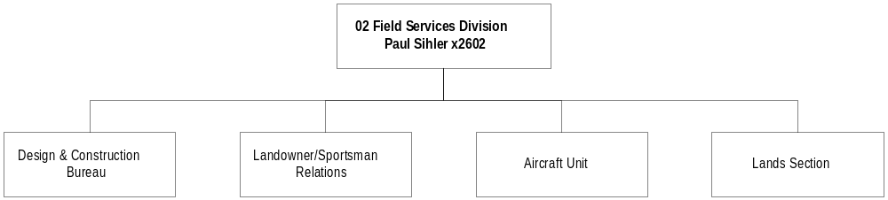
Program Description - The Field Services Division provides services in five areas. The Landowner Sportsman Relations and Block Management program establishes and maintains communications with user and resource-based organizations and individuals; administers the Livestock Loss Reimbursement program; and administers the Block Management program, which provides recreational access on private property. The Game Damage program provides assistance to landowners in minimizing impacts of game animals to property and crops. The Design and Construction Bureau provides architectural and engineering services for construction and maintenance projects at state parks, state fishing access sites, and wildlife management areas. The Aircraft Unit provides aerial mountain lake surveys and fish planting, wildlife surveys, wildlife capture and marking, and transportation for the department. The Land Unit is responsible for the real estate functions of the department, including conservation easements, acquisition and disposal of real estate and real property, and management of all permanent land records.

Program Indicators –

Indicator | Actual FY1998 | Actual FY1999 | Actual FY2000 | Estimated FY2001 | Requested FY2002 | Requested FY2003
Number of acres enrolled in block management | 7,134,585 | 7,273,722 | 7,155,783 | 7,200,000 | 7,200,000 | 7,200,000
Number of hunter days on block management land | 352,000 | 248,314 | 248,129 | 250,000 | 250,000 | 250,000

Program Proposed Budget  Budget Item | Base  Budget  Fiscal 2000 | PL Base Adjustment  Fiscal 2002 | New  Proposals  Fiscal 2002 | Total  Exec. Budget  Fiscal 2002 | PL Base Adjustment  Fiscal 2003 | New  Proposals  Fiscal 2003 | Total  Exec. Budget  Fiscal 2003
FTE | 45.31 | 3.00 | 1.00 | 49.31 | 3.00 | 1.00 | 49.31
Personal Services | 1,520,746 | 285,008 | 43,380 | 1,849,134 | 296,223 | 43,533 | 1,860,502
Operating Expenses | 3,974,216 | 1,569,013 | 10,090 | 5,553,319 | 1,547,619 | 9,937 | 5,531,772
Equipment | 8,500 | 0 | 0 | 8,500 | 0 | 0 | 8,500
Grants | 12,000 | 0 | 0 | 12,000 | 0 | 0 | 12,000
Benefits & Claims | 6,641 | 0 | 0 | 6,641 | 0 | 0 | 6,641
Transfers | 0 | 0 | 60,000 | 60,000 | 0 | 60,000 | 60,000
Total Costs | $5,522,103 | $1,854,021 | $113,470 | $7,489,594 | $1,843,842 | $113,470 | $7,479,415
State/Other Special | 4,843,842 | 1,804,844 | 53,470 | 6,702,156 | 1,789,865 | 53,470 | 6,687,177
Federal Special | 678,261 | 49,177 | 60,000 | 787,438 | 53,977 | 60,000 | 792,238
Total Funds | $5,522,103 | $1,854,021 | $113,470 | $7,489,594 | $1,843,842 | $113,470 | $7,479,415

Significant Present Law Adjustments -
- Establish budget authority to calculate the impacts of net client hunting use
- Pay the increased land lease rates from the Department of Natural Resources on 45,000 acres
- Adjust for alternative pay plan
- Pay increases in taxes and assessments on FWP wildlife management areas, state parks, fishing access sites, and other department owned lands
- Enable block management to spend upland game bird license sales revenue as adopted last session
- Budget technical adjustment for the existing biennial appropriation for public wildlife interface
- Create 3.00 FTE and establish the budget authority to expend funds generated by the variable priced big game hunting licenses

New Proposals -
- Change 1.00 FTE and funding for a public land access coordinator from temporary to permanent
- Establish one-time-only funding for legislative contract authority (LCA)

Language Recommendations - The following HB 2 language is recommended:
"Item 2a legislative contract authority (LCA) is subject to all LCA provisions stated in the agency's language. LCA is restricted and a one-time-only item in HB 2 and must be requested as a new proposal to be continued into the 2005 biennium. LCA applies only to federal funds."

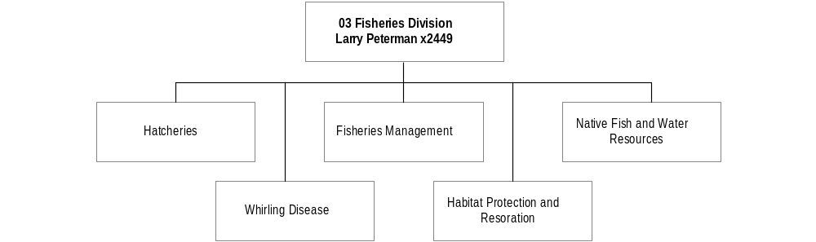
Program Description - The Fisheries Division is responsible for preserving and perpetuating aquatic species and their ecosystems and for meeting public demand for fishing opportunities and aquatic wildlife stewardship. The division formulates and implements policies and programs that emphasize management for wild fish populations and the protection and restoration of habitat necessary to maintain these populations. The program 1) operates a hatchery program to stock lakes and reservoirs where natural reproduction is limited; 2) regulates angler harvests; 3) monitors fish populations; and 4) provides and maintains adequate public access.

Program Indicators –

Indicator | Actual FY1998 | Actual FY1999 | Actual FY2000 | Estimated FY2001 | Requested FY2002 | Requested FY2003
Number of fish stocked  (in millions) | 70.0 | 57.8 | 59.0 | 65.0 | 65.0 | 65.0
Pounds of fish stocked | 300,000 | 265,000 | 275,000 | 300,000 | 300,000 | 300,000
Fish habitat projects | 40 | 46 | 59 | 50 | 50 | 50

Program Proposed Budget  Budget Item | Base  Budget  Fiscal 2000 | PL Base Adjustment  Fiscal 2002 | New  Proposals  Fiscal 2002 | Total  Exec. Budget  Fiscal 2002 | PL Base Adjustment  Fiscal 2003 | New  Proposals  Fiscal 2003 | Total  Exec. Budget  Fiscal 2003
FTE | 108.23 | 0.00 | 4.00 | 112.23 | 0.00 | 4.00 | 112.23
Personal Services | 4,207,215 | 323,129 | 130,767 | 4,661,111 | 352,067 | 131,218 | 4,690,500
Operating Expenses | 2,285,070 | 82,973 | 56,946 | 2,424,989 | 90,528 | 56,495 | 2,432,093
Equipment | 57,225 | 73,867 | 0 | 131,092 | 108,867 | 0 | 166,092
Grants | 21,243 | 0 | 0 | 21,243 | 0 | 0 | 21,243
Transfers | 0 | 0 | 1,851,019 | 1,851,019 | 0 | 1,851,019 | 1,851,019
Total Costs | $6,570,753 | $479,969 | $2,038,732 | $9,089,454 | $551,462 | $2,038,732 | $9,160,947
State/Other Special | 3,152,488 | 155,279 | 55,064 | 3,362,831 | 178,466 | 55,064 | 3,386,018
Federal Special | 3,418,265 | 324,690 | 1,983,668 | 5,726,623 | 372,996 | 1,983,668 | 5,774,929
Total Funds | $6,570,753 | $479,969 | $2,038,732 | $9,089,454 | $551,462 | $2,038,732 | $9,160,947

Significant Present Law Adjustments -
- Continue the funding for the standard replacement of field equipment and the purchase of two hatchery trucks with restrictions to the equipment category
- Adjust for the alternative pay plan

New Proposals -
- Provide assistance at non-FWP sites that provide public fishing access
- Establish one-time-only funding and 1.00 FTE for the coordination and facilitation of recreation management in Montana's most popular and congested waters
- Create 3.00 FTE and funding to increase the fisheries field personnel and operations that are needed for the collection of fisheries information
- Restore one-time-only funding for legislative contract authority

Language Recommendations - The following HB 2 language is recommended:
"Item 3a legislative contract authority (LCA) is subject to all LCA provisions stated in the agency's language. LCA is restricted and a one-time-only item in HB 2 and must be requested as a new proposal to be continued into the 2005 biennium. LCA applies only to federal funds.”

“Item 3b is a restricted appropriation for equipment replacement."

LAW ENFORCEMENT DIVISION

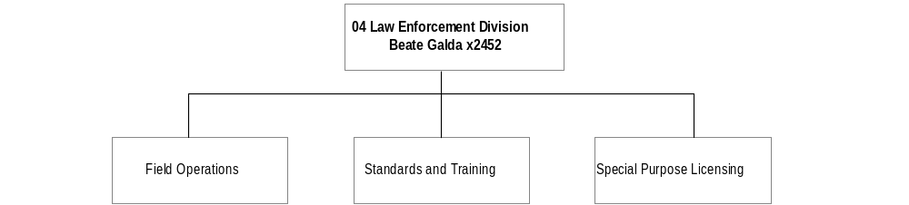

Program Description - The Law Enforcement Division is responsible for ensuring compliance with the department laws and regulations for the protection and preservation of big game animals, fur-bearing animals, fish, game birds, and other wildlife species. It also enforces laws and regulations relative to lands or waters under the jurisdiction and authority of the department such as parks, fishing access sites, and wildlife management areas, as well as those laws and regulations pertaining to boating, snowmobile, and all-terrain vehicle safety and registration. Other duties include administration of special purpose licenses, overseeing the department's licensing agents, and investigating wildlife damage complaints.

Program Indicators –

Indicator | Actual FY1998 | Actual FY1999 | Actual FY2000 | Estimated FY2001 | Requested FY2002 | Requested FY2003
Number of Contacts | 162,053 | 163,658 | 153,580 | 158,000 | 158,000 | 158,000
Number of Violations | 12,311 | 12,494 | 11,215 | 11,800 | 11,800 | 11,800

Program Proposed Budget  Budget Item | Base  Budget  Fiscal 2000 | PL Base Adjustment  Fiscal 2002 | New  Proposals  Fiscal 2002 | Total  Exec. Budget  Fiscal 2002 | PL Base Adjustment  Fiscal 2003 | New  Proposals  Fiscal 2003 | Total  Exec. Budget  Fiscal 2003
FTE | 102.43 | 0.00 | 3.00 | 105.43 | 0.00 | 3.00 | 105.43
Personal Services | 4,443,796 | 278,231 | 112,941 | 4,834,968 | 306,408 | 114,271 | 4,864,475
Operating Expenses | 1,497,522 | 226,496 | 69,900 | 1,793,918 | 87,471 | 39,900 | 1,624,893
Equipment | 126,964 | (52,000) | 15,000 | 89,964 | (52,000) | 0 | 74,964
Grants | 11,496 | 0 | 0 | 11,496 | 0 | 0 | 11,496
Transfers | 0 | 0 | 10,000 | 10,000 | 0 | 10,000 | 10,000
Total Costs | $6,079,778 | $452,727 | $207,841 | $6,740,346 | $341,879 | $164,171 | $6,585,828
General Fund | 132,693 | 3,976 | 0 | 136,669 | 3,976 | 0 | 136,669
State/Other Special | 5,717,358 | 399,189 | 0 | 6,116,547 | 285,182 | 0 | 6,002,540
Federal Special | 229,727 | 49,562 | 207,841 | 487,130 | 52,721 | 164,171 | 446,619
Total Funds | $6,079,778 | $452,727 | $207,841 | $6,740,346 | $341,879 | $164,171 | $6,585,828

Significant Present Law Adjustments -
- Continue zero-based compensation for warden work performed during official holidays, emergency response, and coverage of peak times and seasons
- Restore the biennial appropriation for contract EAs and EISs required by law
- Maintain previous level of support for major criminal violations investigations
- Adjust for the alternative pay plan

New Proposals -
- Establish one-time-only funding for legislative contract authority (LCA)
- Create 3.00 FTE and federal funding to provide specialized enforcement

Language Recommendations - The following HB 2 language is recommended:
"Item 4a legislative contract authority (LCA) is subject to all LCA provisions stated in the agency's language. LCA is restricted and a one-time-only item in HB 2 and must be requested as a new proposal to be continued into the 2005 biennium. LCA applies only to federal funds.”

“Item 4b contains a biennial appropriation of $208,000 for game farm environmental, assessment/environmental impact statement."

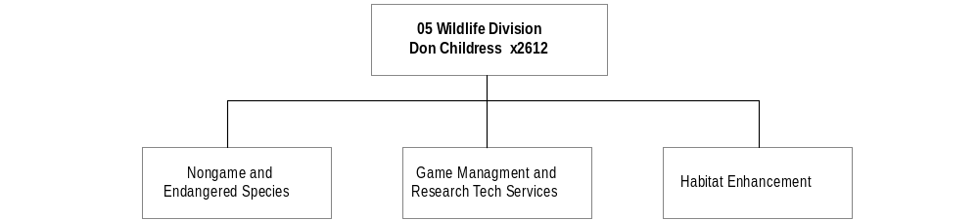

Program Description - The Wildlife Division is responsible for the department statewide wildlife management program, which enhances the use of Montana renewable wildlife resources for public benefit. It protects, regulates, and perpetuates wildlife populations with habitat management and regulated harvest. Through promotion of land management practices, wildlife habitat areas are maintained and enhanced. In addition, the program provides wildlife recreational opportunities to the public, including non-game wildlife, and provides public information regarding conservation of wildlife populations and wildlife habitats. The program manages animals legislatively categorized as big game, small game, furbearers, and threatened and endangered species.

Program Indicators –

Indicator | Actual FY1998 | Actual FY1999 | Actual FY2000 | Estimated FY2001 | Requested FY2002 | Requested FY2003
Acres of habitat acquired or enhanced | 57,054 | 42,285 | 23,771 | 100,000 | 110,000 | 160,000
Regulations printed | 739,100 | 725,400 | 725,400 | 725,400 | 725,400 | 725,400
Recreation day associated with hunting and trapping | **

** Harvest survey data is being revised. Hunter/trapper effort will be calculated using the new information from the revised survey.

Program Proposed Budget  Budget Item | Base  Budget  Fiscal 2000 | PL Base Adjustment  Fiscal 2002 | New  Proposals  Fiscal 2002 | Total  Exec. Budget  Fiscal 2002 | PL Base Adjustment  Fiscal 2003 | New  Proposals  Fiscal 2003 | Total  Exec. Budget  Fiscal 2003
FTE | 98.20 | 0.50 | 2.00 | 100.70 | 0.50 | 2.00 | 100.70
Personal Services | 3,908,397 | 374,290 | 69,402 | 4,352,089 | 402,058 | 69,627 | 4,380,082
Operating Expenses | 2,508,831 | (26,109) | 323,278 | 2,806,000 | 25,312 | 323,053 | 2,857,196
Equipment | 64,926 | 0 | 40,000 | 104,926 | 0 | 40,000 | 104,926
Grants | 110,000 | 25,137 | 0 | 135,137 | 25,137 | 0 | 135,137
Transfers | 0 | 0 | 533,798 | 533,798 | 0 | 533,798 | 533,798
Total Costs | $6,592,154 | $373,318 | $966,478 | $7,931,950 | $452,507 | $966,478 | $8,011,139
State/Other Special | 3,366,666 | 262,076 | 108,169 | 3,736,911 | 312,192 | 108,169 | 3,787,027
Federal Special | 3,225,488 | 111,242 | 858,309 | 4,195,039 | 140,315 | 858,309 | 4,224,112
Total Funds | $6,592,154 | $373,318 | $966,478 | $7,931,950 | $452,507 | $966,478 | $8,011,139

Significant Present Law Adjustments -
- Add 0.50 FTE and funding to manage grizzly and black bear conflicts in northwest Montana
- Increase wildlife population monitoring efforts across the state using 75 percent federal funds
- Reduce and annualize the operating budget for the upland game bird habitat program
- Budget for the increased costs to print hunting regulations
- Adjust for the alternative pay plan
- Reduce budget authority due to savings in data entry efficiencies

New Proposals -
- Continue funding and include 0.50 FTE for mountain lion research
- Establish 0.50 FTE and funding to evaluate black bear management criteria as outlined in the EIS
- Restore one-time-only funding for legislative contract authority (LCA)
- Approve federal funding and 1.00 FTE to monitor elk and other ungulates to determine the impact of wolves
- Inventory game and non-game species associated with the sagebrush/grassland ecosystem

Language Recommendations - The following HB 2 language is recommended:
"Item 5a legislative contract authority (LCA) is subject to all LCA provisions stated in the agency's language. LCA is restricted and a one-time-only item in HB 2 and must be requested as a new proposal to be continued into the 2005 biennium. LCA applies only to federal funds.”

“Item 5b is a restricted appropriation for mountain lion research."

PARKS DIVISION

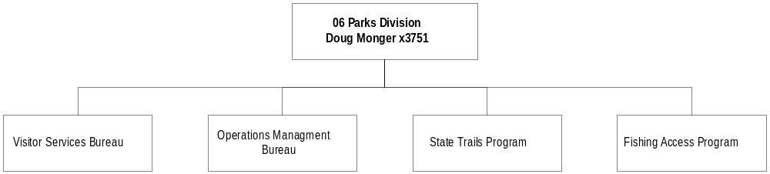

Program Description - The Parks Division is responsible for conserving the scenic, historic, archaeological, scientific, and recreational resources of the state and providing for their use and enjoyment. The program includes 41 parks, 12 affiliated lands such as rifle ranges and recreation sites managed by local and federal agencies, and 312 fishing access sites. Other programs administered by the division include motorized and non-motorized trails, state Capitol Complex grounds maintenance, and the Montana Conservation Corps.

Program Indicators –

Indicator | Actual FY1998 | Actual FY1999 | Actual FY2000 | Estimated FY2001 | Requested FY2002 | Requested FY2003
State Park Visitation* | 1.5 million | 1.5 million | 1.55 million | 1.6 million | 1.7 million | 1.8 million
Satisfaction with state park maintenance | 75% | 75% | 75% | 76% | 77% | 78%
Satisfaction with resources protection | 73% | 73% | 73% | 74% | 75% | 76%
Satisfaction with park information | 68% | 68% | 68% | 69% | 70% | 71%
Satisfaction with park education programs | 45% | 45% | 45% | 47% | 49% | 51%
Satisfaction with feeling safe in parks | 72% | 72% | 72% | 73% | 74% | 75%
* Included to show trends and should not be used as the sole indicator of success

Program Proposed Budget  Budget Item | Base  Budget  Fiscal 2000 | PL Base Adjustment  Fiscal 2002 | New  Proposals  Fiscal 2002 | Total  Exec. Budget  Fiscal 2002 | PL Base Adjustment  Fiscal 2003 | New  Proposals  Fiscal 2003 | Total  Exec. Budget  Fiscal 2003
FTE | 88.52 | 0.00 | 4.79 | 93.31 | 0.00 | 4.79 | 93.31
Personal Services | 2,698,092 | 244,958 | 128,838 | 3,071,888 | 267,173 | 129,268 | 3,094,533
Operating Expenses | 1,770,341 | (186,211) | 268,000 | 1,852,130 | (162,674) | 268,000 | 1,875,667
Equipment | 345,893 | 27,336 | 0 | 373,229 | (270,664) | 0 | 75,229
Grants | 810,082 | (471,423) | 0 | 338,659 | (471,423) | 0 | 338,659
Transfers | 0 | 0 | 50,000 | 50,000 | 0 | 50,000 | 50,000
Total Costs | $5,624,408 | ($385,340) | $446,838 | $5,685,906 | ($637,588) | $447,268 | $5,434,088
General Fund | 284,076 | 10,113 | 0 | 294,189 | 10,113 | 0 | 294,189
State/Other Special | 4,547,243 | 177,636 | 139,838 | 4,864,717 | (74,612) | 140,268 | 4,612,899
Federal Special | 793,089 | (573,089) | 307,000 | 527,000 | (573,089) | 307,000 | 527,000
Proprietary | 0 | 0 | 0 | 0 | 0 | 0 | 0
Total Funds | $5,624,408 | ($385,340) | $446,838 | $5,685,906 | ($637,588) | $447,268 | $5,434,088

Significant Present Law Adjustments -
- Reduce recreation trail grants authority in HB 2 and transfer to HB 5 for efficient management of grants
- Fund off-highway vehicle operations and local grants authority
- Adjust for the alternative pay plan

New Proposals -
- Create 2.79 FTE and state funding for park maintenance and operations improvement
- Reestablish funding for ongoing maintenance at fishing access sites and motorboat parks
- Establish 2.00 FTE and funding for increasing maintenance demands at fishing access sites
- Restore one-time-only funding for legislative contract authority (LCA)
- Maintain federal funding to administer land and water conservation fund grants

Language Recommendations - The following HB 2 language is recommended:
"Item 6a legislative contract authority (LCA) is subject to all LCA provisions stated in the agency's language. LCA is restricted and a one-time-only item in HB 2 and must be requested as a new proposal to be continued into the 2005 biennium. LCA applies only to federal funds”

“Item 6c is a restricted appropriation for motorboat maintenance.”

“Item 6d includes a biennial appropriation of $298,000 for snowmobile equipment."
Proprietary Rates

Program Description -
The Parks Division of Montana Fish, Wildlife and Parks is responsible for the state Capitol Complex Grounds Maintenance program.

The department funds the program through the capitol grounds proprietary account (A/E 06541). Direct costs of the program are accounted for in SABHRS organizations 6391, 6392 and 6393. Indirect costs are charged to the grounds maintenance program and accounted for in SABHRS organization 6399. Indirect costs are recovered through assessment of an indirect cost rate on actual program expenditures of the previous period.

The total annual cost of the capitol grounds maintenance program is allocated to state agencies based on each agency's share of the total square footage of office space on the capitol complex, which is rented from Department of Administration, General Services Division.

Revenues and Expenses -
There are no changes proposed in the provision of services. An increase of $0.025 cents per square foot is proposed for the 2003 biennium.

On an annual basis, revenues and expenses are reviewed to ensure costs are commensurate with the fees charged agencies. Surplus cash may occur during years when the weather is favorable for maintenance and snow removal. Accumulated cash balances from previous periods are used to calculate rates for future periods. A total of 5.66 FTE are funded in this program.

Working Capital Discussion. The 60-day working capital requirement provides sufficient cash to fund on-going operations of the program. On a biennial basis, program costs are reviewed to ensure fees charged to agencies are commensurate with program costs. Each biennium, the account is analyzed to determine if ending cash balances are long or short relative to program working capital requirements. Calculation of rates for future periods can be affected by ending cash balances.

Fund Equity Discussion. Fund balance is reserved for reverted appropriations from the previous period.

Cash Flow Discussion. Agencies are billed quarterly for grounds maintenance and snow removal. Cash balances fluctuate during the year relative to the season and weather conditions. Generally, cash balances are lowest in the first and last quarter of each fiscal year. This is during the busy summer months of lawn and landscape maintenance and during the start up season in the spring. During years of heavy and or frequent snowfall, cash balances can become low in the second and third quarters.

Rate Explanation -
Capitol grounds unit of service is the grounds maintenance and snow removal on the Capitol Complex. The unit price is the total annual revenue of the program divided by the total square footage of rented office space on the Capitol Complex. Square footage of rented office space on the Capitol Complex for the 2003 biennium is provided by General Services Division and used in these calculations. The summary of costs billed to agencies and per unit costs for FY 1996 - FY 2003 are as follows:

FY96 FY97 FY98 FY99 FY00 FY01 FY02 FY03
Revenue $265,338 $263,768 $297,349 $298,562 $296,112 $296,000 $319,189 $319,189
Per Sq. Ft. $.3129 $.3111 $.3446 $.3446 $.3446 $.3446 $.3696 $.3696

An increase in the rate of $.025 cents for the 2003 biennium is proposed.

Significant Present Law -
Requested within decision package #616 are 3.34 FTE to bring the total back to the 5.66 FTE authorized for fiscal years 2000/2001. These positions did not roll forward in the base because they were inadvertently set up at a modified level. Additionally, an increase of 0.40 FTE is being requested. The additional FTE will not create any additional permanent positions but will be used to add to existing positions to improve employee retention and reduce training and recruitment costs. The proposed $0.025 cent increase in the square footage rates is the first increase in four years. It will fund the decision package and provide an adequate fund balance.
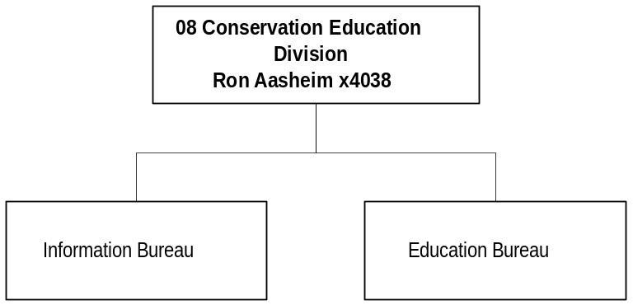

Program Description - The Conservation Education Division, through its Helena office and six regional information officers, provides the department's primary information and education program. Its responsibilities include: 1) distributing public information through news releases, audio-visual materials, brochures and public service announcements; 2) coordinating youth education programs; 3) coordinating the production of hunting, fishing and trapping regulations; 4) coordinating the hunter, bow hunter, snowmobile, boat and off-highway vehicle education and safety programs; and 5) providing reception services for the department's Helena Headquarters. The program publishes the Montana Outdoors magazine; produces video documentaries and television public service announcements, a weekly television report; and maintains a film/video lending library and operates the department's wild animal rehabilitation center.

Program Indicator –

Indicator | Actual FY1998 | Actual FY1999 | Actual FY2000 | Estimated FY2001 | Requested FY2002 | Requested FY2003
Hunter Ed students instructed | 6,100 | 6,500 | 6,300 | 6,500 | 6,800 | 6,800
Bow-hunter Ed students instructed | 2,000 | 1,700 | 1,600 | 2,000 | 2,000 | 2,000
Montana Outdoors subscriptions* | 42,000 | 40,300 | 40,000 | 40,000 | 40,000 | 40,000
* Subscription sales only (does not include Newsstand and miscellaneous sales)

Program Proposed Budget  Budget Item | Base  Budget  Fiscal 2000 | PL Base Adjustment  Fiscal 2002 | New  Proposals  Fiscal 2002 | Total  Exec. Budget  Fiscal 2002 | PL Base Adjustment  Fiscal 2003 | New  Proposals  Fiscal 2003 | Total  Exec. Budget  Fiscal 2003
FTE | 22.25 | 0.00 | 0.90 | 23.15 | 0.00 | 0.90 | 23.15
Personal Services | 914,519 | 77,074 | 37,665 | 1,029,258 | 82,764 | 37,794 | 1,035,077
Operating Expenses | 1,062,429 | (52,847) | 369,228 | 1,378,810 | (48,014) | 369,099 | 1,383,514
Equipment | 8,152 | 0 | 0 | 8,152 | 0 | 0 | 8,152
Grants | 101,364 | 16,636 | 60,000 | 178,000 | (101,364) | 0 | 0
Transfers | 0 | 0 | 35,000 | 35,000 | 0 | 35,000 | 35,000
Total Costs | $2,086,464 | $40,863 | $501,893 | $2,629,220 | ($66,614) | $441,893 | $2,461,743
General Fund | 2,697 | 0 | 0 | 2,697 | 0 | 0 | 2,697
State/Other Special | 1,690,907 | 34,075 | 164,893 | 1,889,875 | (73,402) | 104,893 | 1,722,398
Federal Special | 392,860 | 6,788 | 337,000 | 736,648 | 6,788 | 337,000 | 736,648
Total Funds | $2,086,464 | $40,863 | $501,893 | $2,629,220 | ($66,614) | $441,893 | $2,461,743

Significant Present Law Adjustments –
- Adjust for alternative pay plan

New Proposals -
- Fund 0.40 FTE and operations of the Spring Meadow wild animal rehabilitation center
- Reauthorize federal funding for enhanced aquatic education program
- Continue 0.50 FTE and operations funding for the remedial and continuing hunter education courses
- Create additional funding as a biennial appropriation for the shooting range grants program
- Establish one-time-only funding for legislative contract authority (LCA)
- Use federal funds to add another grade level to the conservation education magazine

Language Recommendations - The following HB 2 language is recommended:
"Item 7a legislative contract authority (LCA) is subject to all LCA provisions stated in the agency's language. LCA is restricted and a one-time-only item in HB 2 and must be requested as a new proposal to be continued into the 2005 biennium. LCA applies only to federal funds.”

“Item 7b is a restricted appropriation for aquatic education program/family fishing.”

“Item 7c is a biennial appropriation of $120,000 for shooting range grants.”

“Item 7d is a biennial appropriation of $60,000 for shooting range grants enhancement."

DEPARTMENT MANAGEMENT

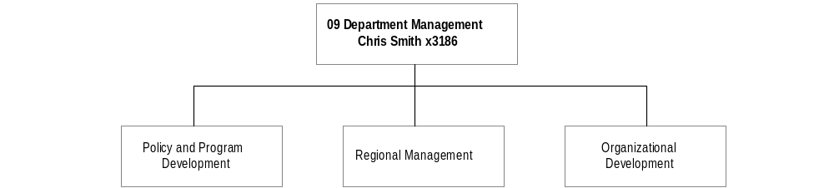
Program Description - The Department Management Division is responsible for: 1) overall department direction regarding policy, planning, program development, guidelines, and budgets; 2) liaison with the Governor's Office and the Legislature; 3) interaction with the Fish, Wildlife and Parks Commission; 4) decision-making for key resource activities affecting the department; 5) supervision of seven divisions that provide program development and staff support; 6) supervision of seven regional offices that are responsible for program implementation; 7) legal services for the department; and 8) liaison with Montana's Indian tribes and with other state and federal agencies.

Program Indicators –

Indicator | Actual FY1998 | Actual FY1999 | Actual FY2000 | Estimated FY2001 | Requested FY2002 | Requested FY2003
Personnel appraisals conducted  (Performance Agreements) | 57% | 67% | 77% | 87% | 93% | 95%
% of employee participants in Leadership & Career Development Initiatives | 19% | 27% | 56% | 65% | 80% | 90%

Program Proposed Budget  Budget Item | Base  Budget  Fiscal 2000 | PL Base Adjustment  Fiscal 2002 | New  Proposals  Fiscal 2002 | Total  Exec. Budget  Fiscal 2002 | PL Base Adjustment  Fiscal 2003 | New  Proposals  Fiscal 2003 | Total  Exec. Budget  Fiscal 2003
FTE | 48.76 | 0.50 | 1.50 | 50.76 | 0.50 | 1.50 | 50.76
Personal Services | 2,109,898 | 60,563 | 65,236 | 2,235,697 | 71,475 | 65,463 | 2,246,836
Operating Expenses | 1,250,231 | (70,146) | 1,118,172 | 2,298,257 | (73,686) | 1,146,688 | 2,323,233
Equipment | 40,940 | 0 | 0 | 40,940 | 0 | 0 | 40,940
Grants | 65,000 | 0 | 0 | 65,000 | 0 | 0 | 65,000
Transfers | 0 | 0 | 200,000 | 200,000 | 0 | 200,000 | 200,000
Total Costs | $3,466,069 | ($9,583) | $1,383,408 | $4,839,894 | ($2,211) | $1,412,151 | $4,876,009
State/Other Special | 2,736,253 | (168,720) | 104,236 | 2,671,769 | (159,697) | 89,463 | 2,666,019
Federal Special | 729,816 | 159,137 | 1,279,172 | 2,168,125 | 157,486 | 1,322,688 | 2,209,990
Total Funds | $3,466,069 | ($9,583) | $1,383,408 | $4,839,894 | ($2,211) | $1,412,151 | $4,876,009

Significant Present Law Adjustments -
- Add 0.50 FTE and state funds to enhance public service in the Billings regional office
- Increase funding for FWP's use of the Natural Resource Information System
- Adjust for the alternative pay plan
- Restore zero-based budget to cover the commissioners' expenses and per diem

New Proposals -
- Authorize one-time-only funding to conduct market research to develop a fair, acceptable fee structure
- Create one-time-only funding for the cadastral database
- Establish one-time-only funding for legislative contract authority (LCA)
- Provide 1.50 FTE and funding for support of geographic information systems
- Establish $2.2 million federal funds for state efforts to conserve and enhance fish, wildlife, historic, and recreational resources

Language Recommendations - The following HB 2 language is recommended:
"Item 8a legislative contract authority (LCA) is subject to all LCA provisions stated in the agency's language. LCA is restricted and a one-time-only item in HB 2 and must be requested as a new proposal to be continued into the 2005 biennium. LCA applies only to federal funds.”

“Item 8b is a restricted appropriation for cadastral database."

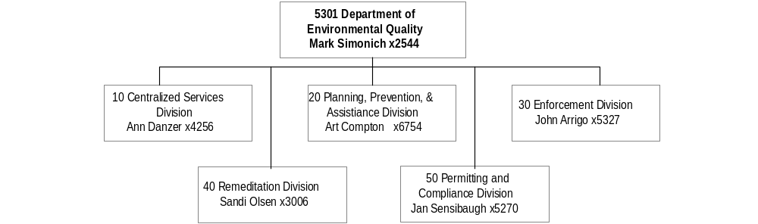

Mission Statement - To protect, promote and enhance public health and environmental quality for the benefit of all Montana citizens.

Statutory Authority - Titles 2, 7, 37, 50, 69, 75, 76, 80, 82 and 90, MCA; USC 24, 30, 33 and 42; P.L. No. 92-500, 95-87, 91, 95-224 and 99-519.

Executive Budget Recommendation –
- Support an additional 1.00 FTE and funding for legal staff due to increased workloads
- Establish a biennial/restricted appropriation of general fund for legal challenges
- Add 1.00 FTE and federal funding for the supplemental federal nonpoint source grant funds which provide financial and technical assistance to conservation districts and watershed groups
- Allow additional funding and 6.00 FTE to accelerate the development of total maximum daily loads to meet the statutory deadline of 2007
- Create 2.00 FTE and federal funding for data quality assurance support and quality control for water quality monitoring activities

Language - The following HB 2 language is recommended:
"Items 2, 4 and 5 include a total of $177,860 for the 2003 biennium for the Montana natural resources information system. Quarterly payments must be made upon receipt of the bills from the state library up to the total amount appropriated."

Agency Proposed Budget  Budget Item | Base  Budget  Fiscal 2000 | PL Base Adjustment  Fiscal 2002 | New  Proposals  Fiscal 2002 | Total  Exec. Budget  Fiscal 2002 | PL Base Adjustment  Fiscal 2003 | New  Proposals  Fiscal 2003 | Total  Exec. Budget  Fiscal 2003
FTE | 349.24 | 11.50 | 13.00 | 373.74 | 11.50 | 13.00 | 373.74
Personal Services | 12,666,881 | 2,105,630 | 433,287 | 15,205,798 | 2,192,598 | 426,039 | 15,285,518
Operating Expenses | 23,946,366 | 28,626,214 | 3,293,283 | 55,865,863 | (4,730,598) | 3,209,551 | 22,425,319
Equipment | 93,060 | 262,500 | 48,990 | 404,550 | 25,516 | 40,000 | 158,576
Grants | 1,085,813 | 196,782 | 0 | 1,282,595 | 243,558 | 0 | 1,329,371
Benefits & Claims | 0 | 3,500,000 | 0 | 3,500,000 | 0 | 0 | 0
Total Costs | $37,792,120 | $34,691,126 | $3,775,560 | $76,258,806 | ($2,268,926) | $3,675,590 | $39,198,784
General Fund | 3,266,376 | 1,512,651 | 182,677 | 4,961,704 | 1,105,604 | 182,375 | 4,554,355
State/Other Special | 19,857,864 | 29,201,244 | 243,143 | 49,302,251 | (6,746,287) | 157,153 | 13,268,730
Federal Special | 14,667,880 | 3,977,231 | 3,349,740 | 21,994,851 | 3,371,757 | 3,336,062 | 21,375,699
Total Funds | $37,792,120 | $34,691,126 | $3,775,560 | $76,258,806 | ($2,268,926) | $3,675,590 | $39,198,784

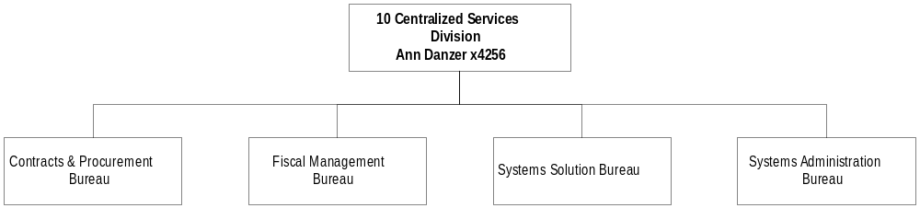

Program Description - The Central Management Division consists of the Director's Office and a Centralized Services office. The Director's Office includes the director's staff, a centralized Legal Services Unit, and a centralized Personnel Office. It is the organizational component of the agency that is responsible and accountable for the administration, management, planning, and evaluation of agency performance in carrying out department mission and statutory responsibilities. The Centralized Services office provides budgeting, accounting, payroll, procurement, contract management, and information technology services support to other divisions.

Program Proposed Budget  Budget Item | Base  Budget  Fiscal 2000 | PL Base Adjustment  Fiscal 2002 | New  Proposals  Fiscal 2002 | Total  Exec. Budget  Fiscal 2002 | PL Base Adjustment  Fiscal 2003 | New  Proposals  Fiscal 2003 | Total  Exec. Budget  Fiscal 2003
FTE | 0.00 | 1.00 | 0.00 | 1.00 | 1.00 | 0.00 | 1.00
Personal Services | 1,350 | 43,454 | 0 | 44,804 | 43,607 | 0 | 44,957
Operating Expenses | 16,072 | 370,711 | 0 | 386,783 | 116,632 | 0 | 132,704
Total Costs | $17,422 | $414,165 | $0 | $431,587 | $160,239 | $0 | $177,661
General Fund | 14,041 | 414,165 | 0 | 428,206 | 160,239 | 0 | 174,280
Federal Special | 3,381 | 0 | 0 | 3,381 | 0 | 0 | 3,381
Total Funds | $17,422 | $414,165 | $0 | $431,587 | $160,239 | $0 | $177,661

Significant Present Law Adjustments -
- Support an additional 1.00 FTE and funding for legal staff due to increased workloads
- Restore funding for database development that is biennial and restricted
- Establish a biennial/restricted appropriation of general fund for legal challenges

Language Recommendations - The following HB 2 language is recommended:
"Item 1a includes a biennial/restricted appropriation of $250,000 general fund for database development.”

“Item 1b is a biennial appropriation for legal challenges."

Proprietary Rates

Program Description- The department has one proprietary fund, which is an internal service fund used to account for the department's indirect cost activity. The indirect pool consists of expenditures from the Director's Office, Personnel and Legal Units, Central Services Administration, and the Fiscal Management, Contracts and Procurement, Systems Solutions, and Systems Administration Bureaus.

Revenues and Expenses - The department anticipates negotiating an indirect rate with the U.S. Environmental Protection Agency (EPA) of approximately 24 percent in FY 2002 and FY 2003. Revenues generated by the current indirect cost rate fund 42.00 FTE. The department's requested rate contains funding for 2.00 FTE that were authorized by the 1999 Legislature but are currently unfunded. In addition, the department has submitted a present law proposal to increase the FTE in the Central Management Program and reduce staff in the other divisions by 6.50 FTE information technology (IT) positions. These positions will be transferred from other department programs to the Systems Solutions and Systems Administration Bureaus. The costs associated with the 6.50 FTE represent approximately 2% of the total proposed indirect cost rate of 24 percent.

Working Capital Discussion. The table in the reference section shows that the department must maintain an average working capital balance of approximately $485,000 to meet its current obligations. Working capital is not directly factored into the indirect cost rate. The indirect cost rate is determined based on guidelines prescribed by the federal government. Refer to the section on Rate Explanation for further details. The department must maintain enough working capital to meet its immediate cash needs to cover payroll and various operating costs. Refer to the Cash Flow discussion below for specific cash needs.

Fund Equity Discussion. The department does not reserve a fund balance on the accounting records nor does it try to maintain a fund balance. The revenues generated should be enough to cover the current year's operations. However, due to timing factors, the fund balance does not always equal zero.

As shown in the table, the ending retained earnings for FY 2000 was $151,529. The retained earnings balance increased between FY 1999 and FY 2000 due to a change in how the indirect rate was calculated from previous years. The rates negotiated with EPA for FY 2000 and FY 2001 were based on the budget for those years. The rates prior to FY 2000 were based on actual expenditure data from the most recent complete fiscal year at the time the indirect proposal was submitted to EPA. Because the rate in FY 2000 was based on budgeted amounts, it was difficult to predict how much of the budget would be spent during the fiscal year. As a result, the department had a slight over-recovery. This over-recovery will be taken into account when the department negotiates its rate with EPA.

As noted in other sections of this narrative, it is necessary for the department to have adequate working capital and cash on hand to meet its immediate cash needs. This working capital is reflected in the ending retained earnings balance. In addition, the department does have contributed capital in its proprietary account of $270,000, which is a result of the agency reorganization mandated by the 1995 Legislature.

Cash Flow Discussion. Cash into this account fluctuates based on the department's vacancy rate. Since the indirect rate is applied against the department's personal services base, as employees are hired or terminate, this causes the monthly revenues flowing into this account to fluctuate either up or down. As noted in the Working Capital section above, the department must maintain enough working capital to pay its immediate cash needs, such as payrolls and operating expenses. An average payroll for the Central Management Program is $65,000 for a two-week period. In addition, like all state agencies, the department must pay insurance premiums to Tort Claims. Therefore, this account must maintain a significant cash balance at the beginning of the fiscal year to cover this obligation. The department paid $164,000 in insurance premiums and bonds in FY 2000 and is budgeted $215,500 and $232,000 in FY 2002 and FY 2003, respectively. Finally, since the proprietary funds operate under a full accrual method in accordance with Generally Accepted Accounting Principles, the department must record a liability on the accounting records for compensated absences. The department's compensated absence liability was approximately $283,000. There must be enough cash available for the department to pay this liability at any given point in time.

Rate Explanation - The department negotiates an annual indirect cost rate with EPA. The approved rate is a fixed rate. This rate is applied against the personal services charged within each division of the department, other than the Central Management Program. This type of rate is the most logical type because it provides the department with an adequate and consistent source of revenue to fund central operations that are utilized by all programs within the department.

The department is requesting an increase in its indirect cost rate from the 23 percent approved in the last legislative session to 24 percent. The proposed increase includes the transfer of 6.50 FTE from other department programs to the Central Management Program in an effort to centralize the information technology function of the department. The remaining increase is to fund 2.00 FTE that were authorized by the 1999 Legislature, but are currently unfunded and remain vacant. In addition, the department has included a request for base adjustments, equipment, and software upgrades.

In FY 2000, the department changed the methodology used to calculate its indirect cost rate in order to more closely reflect future indirect cost activities. The FY 2000 and FY 2001 rates negotiated with EPA were based on the budget approved by the 1999 Legislature for the Central Management Program via their approval of a 23 percent indirect cost rate. The rates negotiated with EPA prior to FY 2000 were based on actual expenditure data for the most recent complete fiscal year at the time the indirect proposal was submitted to EPA. Either method used still requires a carry forward amount be built into the rate. This carry forward amount represents the amount the department either under-recovered or over-recovered in a given year. This computation compares what was initially negotiated versus what actually occurred. This difference is then carried forward into the following year's rate.

The department's indirect cost rate is determined based on guidelines prescribed by the federal government. In addition, the department complies with 17-3-111, MCA, which requires agencies to negotiate a rate that would recover indirect costs to the fullest extent possible. In order to comply with this law, the department has requested a rate that may vary slightly from the rate the department actually negotiates with EPA. The rate approved by the Legislature is considered a cap and therefore, the department cannot negotiate for a rate higher than what has been approved by the legislature. However, the rate negotiated with EPA may be slightly lower.

Significant Present Law -
The department submitted a present law proposal to transfer 6.50 FTE each year from programs 20, 30, 40, and 50 to program 10. To increase efficiencies and provide centralized management of information technology (IT) activities, the department is moving these activities into the Systems Solution Bureau and Systems Administration Bureau in the Centralized Services Division. The request is not for increased funding, it is just to move positions between programs. This request will, however, increase the department's indirect rate.

The amount being transferred by this proposal is $301,066 and $285,916 for FY 2002 and FY 2003, respectively. This includes personal service costs, as well as necessary operating costs associated with these positions. These costs represent 2 percent of the total indirect cost rate of 24 percent. There is no effect on the unreserved fund balance.

PLANNING, PREVENTION & ASSISTANCE DIVISION

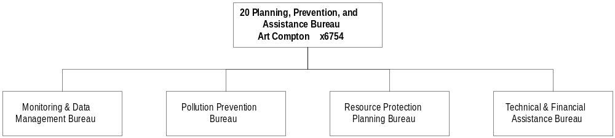

Program Description - The division 1) monitors air and water quality conditions and trends, and assesses sources and severity of pollution problems; 2) works in the areas of air quality, water quality, land conservation, and energy efficiency to find ways to prevent pollution before it occurs; 3) provides planning for energy, watershed, airshed, and solid and hazardous waste management; 4) helps develop water Total Maximum Daily Loads; 5) coordinates department positions on environmental legislation, proposes rules and policy, and develops environmental protection criteria; 6) provides economic modeling and analysis; 7) finances energy retrofits of public buildings, as well as construction and improvement of community drinking water and wastewater systems; and 8) provides technical assistance, education and outreach regarding energy efficiency, occupational health, indoor air quality and radon. The division consists of four bureaus: Monitoring and Data Management, Pollution Prevention, Resource Protection Planning, and Technical and Financial Assistance.

Program Indicators -

Indicator | Actual  FY 1998 | Actual  FY 1999 | Actual  FY 2000 | Estimated  FY 2001 | Estimated  FY 2002 | Estimated  FY 2003
Wastewater/Drinking Water technical assistance efforts  completed | 8 | 36 | 69 | 75 | 75 | 75
Source Water Protection projects completed | 6 | 25 | 25 | 531 | 650 | 642
Small Business Assistance efforts completed | 1067 | 1150 | 734 | 1100 | 1400 | 1400
Air Quality State Implementation  Plans and major projects  completed | 9 | 12 | 12 | 11 | 10 | 8
Airsheds and watersheds  monitored and assessed  for compliance | 500 | 700 | 700 | 500 | 600 | 700

Program Proposed Budget  Budget Item | Base  Budget  Fiscal 2000 | PL Base Adjustment  Fiscal 2002 | New  Proposals  Fiscal 2002 | Total  Exec. Budget  Fiscal 2002 | PL Base Adjustment  Fiscal 2003 | New  Proposals  Fiscal 2003 | Total  Exec. Budget  Fiscal 2003
FTE | 90.54 | 4.00 | 11.00 | 105.54 | 4.00 | 11.00 | 105.54
Personal Services | 3,418,419 | 569,569 | 363,560 | 4,351,548 | 591,211 | 355,162 | 4,364,792
Operating Expenses | 3,670,135 | 2,215,955 | 2,405,149 | 8,291,239 | 1,784,661 | 2,387,936 | 7,842,732
Equipment | 65,085 | 100,000 | 40,000 | 205,085 | 0 | 40,000 | 105,085
Grants | 39,507 | (39,507) | 0 | 0 | (39,507) | 0 | 0
Total Costs | $7,193,146 | $2,846,017 | $2,808,709 | $12,847,872 | $2,336,365 | $2,783,098 | $12,312,609
General Fund | 1,747,869 | 590,169 | 171,502 | 2,509,540 | 581,926 | 171,200 | 2,500,995
State/Other Special | 911,584 | 162,241 | 0 | 1,073,825 | 157,264 | 0 | 1,068,848
Federal Special | 4,533,693 | 2,093,607 | 2,637,207 | 9,264,507 | 1,597,175 | 2,611,898 | 8,742,766
Total Funds | $7,193,146 | $2,846,017 | $2,808,709 | $12,847,872 | $2,336,365 | $2,783,098 | $12,312,609

Significant Present Law Adjustments -
- Budget $1 million and 6.00 FTE to accelerate development of TMDLs to meet the statutory deadline of 2007
- Establish funding for the increased operating costs in the Resource Protection Planning Bureau
- Adjust funding for the Pollution Prevention Bureau operating costs and contracted services
- Restore funding for the Technical and Financial Assistance Bureau operating costs
- Restore funding for the Monitoring and Data Management Bureau increased operating costs
- Transfer 2.00 FTE and funding to Central Management Program due to centralizing IT activities
- Establish a one-time-only/biennial EPA grant appropriation to integrate environmental information through IT activities
- Provide federal funding for technical assistance and administration of the source water program from the drinking water state revolving fund

New Proposals -
- Add 2.00 FTE and federal funds for TMDL data quality assurance support and quality control for water quality monitoring activities
- Establish 1.00 FTE and federal funding to identify projects in the state transportation improvement program that may cause significant adverse impacts on water quality or projects that may correct historical damage caused by transportation projects
- Add 1.00 FTE and $3.9 million federal funds for the supplemental federal nonpoint source grant which provides financial and technical assistance to conservation districts and watershed groups
- Include federal funding for competitive grant applications to the U.S. Department of Energy for specific activities, technologies, or audiences
- Establish 1.00 FTE and federal funding for Montana's portion of the national water quality monitoring federal grants program
- Establish 2.00 FTE and federal funds for technical assistance to air quality monitoring programs of certain tribes
- Increase funding for the Montana State Library Natural Resource Information System
- Shift from federal funds to general fund for waste water technical assistance
- Provide a funding shift from federal funds to general fund for waste water technical assistance
- Create federal funding and 3.00 FTE for air pollution monitoring of fine particulates
- Create 1.00 FTE and establish federal funding for wetland grants manager requested by EPA

Language Recommendations - The following HB 2 language is recommended:
"Item 2a includes a restricted federal special revenue appropriation of $250,784 in fiscal year 2002 and $249,099 in fiscal year 2003 for the fine particulate monitoring program.”

“Item 2b contains a biennial/one-time-only federal special revenue appropriation of $450,000 for the one stop grant.”

“The department is authorized to spend up to $100,000 from the SRF special administration account in the pollution control and/or the drinking water revolving fund loan program. The department is to use funds from the special administration account for the second round (repaid) loans, if the funds become available."

ENFORCEMENT DIVISION
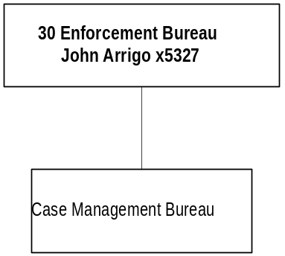

Program Description - The Enforcement Division is the central control for the enforcement of the statutes and regulations administered by the department. The division develops department enforcement policies and procedures for approval by the director and ensures they are implemented in a consistent manner across the department. A citizen complaint clearinghouse and information tracking system is maintained by the division. The division coordinates the legal and technical aspects of enforcement cases, both administrative and judicial, and monitors violators to determine compliance with department orders.

Program Indicators -

Indicator | Actual  FY 1998 | Actual  FY 1999 | Actual  FY 2000 | Estimated  FY 2001 | Estimated  FY 2002 | Estimated  FY 2003
Enforcement Cases | 151 | 250 | 262 | 275 | 300 | 325
Complaints | 1,093 | 1,134 | 949 | 1,050 | 1,060 | 1,070

Program Proposed Budget  Budget Item | Base  Budget  Fiscal 2000 | PL Base Adjustment  Fiscal 2002 | New  Proposals  Fiscal 2002 | Total  Exec. Budget  Fiscal 2002 | PL Base Adjustment  Fiscal 2003 | New  Proposals  Fiscal 2003 | Total  Exec. Budget  Fiscal 2003
FTE | 17.25 | (0.50) | 0.00 | 16.75 | (0.50) | 0.00 | 16.75
Personal Services | 697,088 | 15,807 | 0 | 712,895 | 18,939 | 0 | 716,027
Operating Expenses | 331,235 | 59,184 | 0 | 390,419 | 47,283 | 0 | 378,518
Total Costs | $1,028,323 | $74,991 | $0 | $1,103,314 | $66,222 | $0 | $1,094,545
General Fund | 501,560 | 42,509 | 0 | 544,069 | 30,580 | 0 | 532,140
State/Other Special | 170,063 | 11,319 | 0 | 181,382 | 12,352 | 0 | 182,415
Federal Special | 356,700 | 21,163 | 0 | 377,863 | 23,290 | 0 | 379,990
Total Funds | $1,028,323 | $74,991 | $0 | $1,103,314 | $66,222 | $0 | $1,094,545

Significant Present Law Adjustments -
- Transfer 1.00 FTE and funding due to a reorganization of IT positions
- Establish 0.50 FTE and funding for enforcement cases through a transfer

REMEDIATION DIVISION

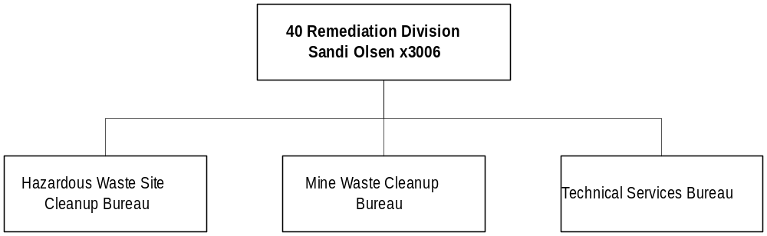

Program Description - The Remediation Division is responsible for: 1) overseeing investigation and cleanup activities at state and federal superfund sites; 2) reclaiming abandoned mine lands; 3) regulating, permitting, and licensing underground storage tanks (UST); 4) implementing corrective actions at sites with leaking UST; 5) providing staff support for processing eligibility applications and claims submitted to the Petroleum Tank Release Compensation Board for cleanup funds; and 6) overseeing groundwater remediation at sites where agricultural and industrial chemical spills have caused groundwater contamination. The purposes of these activities are: 1) to protect human health and the environment; 2) prevent exposure of potential human and ecological receptors to hazardous or deleterious substances that have been released to soil, sediment, surface water, or groundwater; and 3) ensure compliance with applicable state and federal regulations. The division is comprised of three bureaus: Hazardous Waste Site Cleanup Bureau, Mine Waste Cleanup Bureau, Technical Services Bureau, and the Fiscal and Administrative Services Section. The division works closely with the Petroleum Tank Release Compensation Board, which provides financial assistance for cleanup of petroleum contaminated leaking UST sites. The Petroleum Tank Release Compensation Board is attached to the Department of Environmental Quality for administrative purposes.

Program Indicators -
Indicator | Actual  FY 1998 | Actual  FY 1999 | Actual  FY 2000 | Estimated  FY 2001 | Estimated  FY 2002 | Estimated  FY 2003
Permits Issued | 820 | 867 | 422 | 320 | 320 | 320
Active Sites | 4,055 | 4,333 | 4,489 | 4,406 | 4,311 | 4,243
Sited Cleanups Completed Each Year | 252 | 202 | 93 | 174 | 174 | 175
Cost Using State – Managed Funds | 8,557,298 | 9,130,538 | 9,843,280 | 7,995,000 | 7,995,000 | 7,995,000

Program Proposed Budget  Budget Item | Base  Budget  Fiscal 2000 | PL Base Adjustment  Fiscal 2002 | New  Proposals  Fiscal 2002 | Total  Exec. Budget  Fiscal 2002 | PL Base Adjustment  Fiscal 2003 | New  Proposals  Fiscal 2003 | Total  Exec. Budget  Fiscal 2003
FTE | 79.75 | 4.00 | 0.00 | 83.75 | 4.00 | 0.00 | 83.75
Personal Services | 2,589,257 | 677,783 | 0 | 3,267,040 | 697,636 | 0 | 3,286,893
Operating Expenses | 6,789,887 | 1,265,880 | 472,610 | 8,528,377 | 895,451 | 397,610 | 8,082,948
Equipment | 0 | 30,000 | 0 | 30,000 | 0 | 0 | 0
Grants | 5,894 | 0 | 0 | 5,894 | 0 | 0 | 5,894
Benefits & Claims | 0 | 3,500,000 | 0 | 3,500,000 | 0 | 0 | 0
Total Costs | $9,385,038 | $5,473,663 | $472,610 | $15,331,311 | $1,593,087 | $397,610 | $11,375,735
State/Other Special | 2,659,229 | 4,417,143 | 158,978 | 7,235,350 | 621,492 | 83,978 | 3,364,699
Federal Special | 6,725,809 | 1,056,520 | 313,632 | 8,095,961 | 971,595 | 313,632 | 8,011,036
Total Funds | $9,385,038 | $5,473,663 | $472,610 | $15,331,311 | $1,593,087 | $397,610 | $11,375,735

Significant Present Law Adjustments -
- Transfer 2.00 FTE and funding for information technology activities
- Add 1.00 FTE for the LUST program and move funds from operating contract to personal services
- Create a $1 million biennial federal special revenue appropriation for cleanup sites
- Establish 2.00 FTE and RIT funds for Comprehensive Environmental Cleanup Responsibility Act work
- Establish funding for a one-time-only biennial, restricted appropriation for CECRA site contracts
- Provide 1.00 FTE in Kalispell and 1.00 FTE in Billings to manage petro release corrective action
- Create a $3.5 million biennial appropriation for potential orphan share reimbursements

New Proposals -
- Fund proportionate share of the Montana State Library Natural Resource Information System
- Allow petroleum tank funding for a statewide survey of above-ground storage tanks
- Create a one-time-only biennial appropriation to study liabilities of the petro board fund
- Establish a restricted appropriation for database development
- Provide a $600,000 biennial/one-time-only appropriation for LUST trust contracted services

Language Recommendations - The following HB 2 language is recommended:
"Item 4a is a biennial appropriation for abandoned mine reclamation.”

“Item 4b is a biennial/one-time-only restricted appropriation for leaking underground storage tank trust contracted services.”

“Item 4c is a biennial appropriation for leaking underground storage tank trust program.”

“Item 4d contains a biennial/one-time-only appropriation of $75,000 for the petro board fund liabilities study.”

“Item 4e includes a biennial/one-time-only appropriation of $150,000 for contracted services for legal support.”

“Item 4f is a biennial appropriation for cleanup sites/Lockwood solvent.”

“There is appropriated amount up to $3,500,000 state special revenue for orphan share reimbursements during the 2003 biennium."

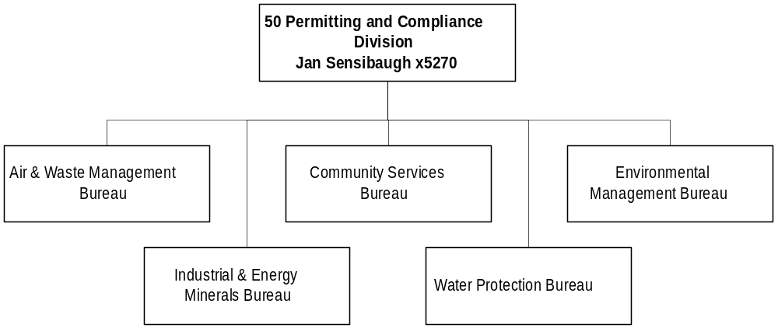

Program Description - The Permitting and Compliance Division administers all DEQ permitting and compliance activities that relate to 25 state regulatory and five related federal authorities. The division: 1) reviews and assesses environmental permit applications (coordinating with other state, local, and federal agencies) to determine control measures needed to ensure compliance with the law and to prevent land, water, and air conditions detrimental to public health welfare, safety and the environment; 2) prepares supporting environmental documents under the Montana Environmental Policy Act and provides training and technical assistance when needed; 3) inspects to determine compliance with permit conditions, laws and rules; and 4) when compliance problems are discovered, provides assistance to resolve the facility's compliance issues, in close coordination with Enforcement Division. Activities are organized in the Air & Waste Management Bureau (air, asbestos, hazardous waste); Community Services Bureau (solid waste, junk vehicles, public water supply, waste water operators); Environmental Management Bureau (hard rock, facility siting); Industrial and Energy Minerals Bureau (coal, uranium, opencut); and Water Protection Bureau (subdivisions, water).

Program Indicators -

Indicator | Actual  FY 1998 | Actual  FY 1999 | Actual  FY 2000 | Estimated  FY 2001 | Estimated  FY 2002 | Estimated  FY 2003
Permits | 4,359 | 4,416 | 4,152 | 4,380 | 4,374 | 4,489
Inspections | 3,075 | 2,875 | 2,599 | 3,658 | 3,353 | 3,363
Environmental Assessments | 1,711 | 1,755 | 1,591 | 1,721 | 1,727 | 1,742
Bond Releases | 272 | 297 | 248 | 314 | 290 | 291
Violations | 3,069 | 3,024 | 2,922 | 2,992 | 2,979 | 2,972

Program Proposed Budget  Budget Item | Base  Budget  Fiscal 2000 | PL Base Adjustment  Fiscal 2002 | New  Proposals  Fiscal 2002 | Total  Exec. Budget  Fiscal 2002 | PL Base Adjustment  Fiscal 2003 | New  Proposals  Fiscal 2003 | Total  Exec. Budget  Fiscal 2003
FTE | 161.70 | 3.00 | 2.00 | 166.70 | 3.00 | 2.00 | 166.70
Personal Services | 5,960,767 | 799,017 | 69,727 | 6,829,511 | 841,205 | 70,877 | 6,872,849
Operating Expenses | 13,139,037 | 24,714,484 | 415,524 | 38,269,045 | (7,574,625) | 424,005 | 5,988,417
Equipment | 27,975 | 132,500 | 8,990 | 169,465 | 25,516 | 0 | 53,491
Grants | 1,040,412 | 236,289 | 0 | 1,276,701 | 283,065 | 0 | 1,323,477
Total Costs | $20,168,191 | $25,882,290 | $494,241 | $46,544,722 | ($6,424,839) | $494,882 | $14,238,234
General Fund | 1,002,906 | 465,808 | 11,175 | 1,479,889 | 332,859 | 11,175 | 1,346,940
State/Other Special | 16,116,988 | 24,610,541 | 84,165 | 40,811,694 | (7,537,395) | 73,175 | 8,652,768
Federal Special | 3,048,297 | 805,941 | 398,901 | 4,253,139 | 779,697 | 410,532 | 4,238,526
Total Funds | $20,168,191 | $25,882,290 | $494,241 | $46,544,722 | ($6,424,839) | $494,882 | $14,238,234

Significant Present Law Adjustments -
- Adjust hardrock operating and respond to increased reclamation and water treatment plans
- Replace equipment and increase water sampling required under the Major Facility Siting Act
- Restore the same level of funding for coal and uranium operating costs
- Include increased operating costs in the subdivision program and grants to counties
- Transfer 1.50 FTE and funding to the Central Management Program for IT activities
- Create 2.00 FTE through an operational plan change within the Public Water Supply Program
- Transfer 0.50 FTE and funding to the Enforcement Program due to legal staff changes
- Provide general fund authority for the solid waste database conversion
- Increase state funding for contracted services for asbestos compliance
- Provide funding and 1.00 FTE for a 401 certification permit writer
- Establish a restricted biennial appropriation for bond forfeitures
- Include a restricted biennial appropriation for MEPA projects
- Continue federal funds for hardrock grant proposals with $500,000 per year
- Increase state funding for grants to counties through the Junk Vehicle Program
- Create 1.00 FTE for administrative support to deal with backlog in the water permits section
- Establish a biennial appropriation for mining fines, fees, and penalties
- Maintain junk vehicle funding for increased abandoned vehicles activities
- Provide federal funds for two public water safety section lease vehicles in Billings

New Proposals -
- Establish 1.00 FTE and funding for a storm water phase II permit writer
- Fully fund the proportionate share of the Natural Resource Information System
- Maintain funding for hardrock equipment
- Establish federal funds and 1.00 FTE for drinking water operator training reimbursement

Language Recommendations - The following HB 2 language is recommended:
"Item 5a includes a biennial/restricted appropriation for bond forfeitures is $32,000,000.”

“Item 5b contains a biennial/restricted appropriation of $300,000 for major facility siting act projects.”

“Item 5c includes a biennial/restricted appropriation of $1,000,000 for Montana environmental policy act projects.”

“Item 5d contains a biennial appropriation of $150,000 for hazardous waste contracted services."

“Item 5e contains a biennial appropriation of $150,000 for fines, fees, and penalties."

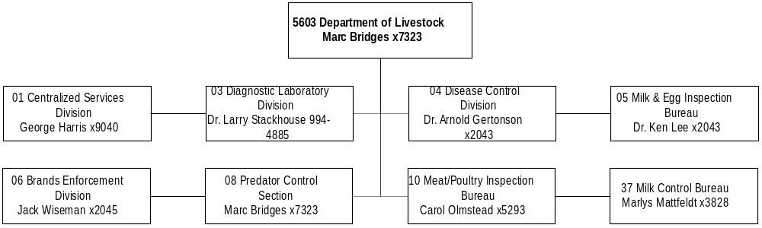
Mission Statement - To control and eradicate animal diseases, prevent the transmission of animal diseases to humans, and protect the livestock industry from theft and predatory animals.

Statutory Authority - Title 81, MCA

Agency Proposed Budget  Budget Item | Base  Budget  Fiscal 2000 | PL Base Adjustment  Fiscal 2002 | New  Proposals  Fiscal 2002 | Total  Exec. Budget  Fiscal 2002 | PL Base Adjustment  Fiscal 2003 | New  Proposals  Fiscal 2003 | Total  Exec. Budget  Fiscal 2003
FTE | 134.71 | 2.32 | 1.75 | 138.78 | 2.32 | 0.00 | 137.03
Personal Services | 4,847,510 | 291,656 | 43,154 | 5,182,320 | 322,203 | 0 | 5,169,713
Operating Expenses | 2,023,279 | 795,470 | 208,255 | 3,027,004 | 711,645 | 221,788 | 2,956,712
Equipment | 345,954 | 91,887 | 10,000 | 447,841 | 66,337 | 10,000 | 422,291
Benefits & Claims | 4,150 | 0 | 0 | 4,150 | 0 | 0 | 4,150
Total Costs | $7,220,893 | $1,179,013 | $261,409 | $8,661,315 | $1,100,185 | $231,788 | $8,552,866
General Fund | 532,277 | 61,925 | 62,380 | 656,582 | 66,908 | 62,380 | 661,565
State/Other Special | 6,241,457 | 276,846 | 223,513 | 6,741,816 | 225,550 | 178,262 | 6,645,269
Federal Special | 447,159 | 840,242 | (24,484) | 1,262,917 | 807,727 | (8,854) | 1,246,032
Total Funds | $7,220,893 | $1,179,013 | $261,409 | $8,661,315 | $1,100,185 | $231,788 | $8,552,866

CENTRALIZED SERVICES PROGRAM

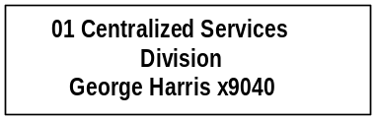

Program Description - The Centralized Services Division is responsible for budgeting, accounting, payroll, personnel, legal services, purchasing, administrative, data processing, and general services functions for the department. The division also provides the overall management of the Milk Control Bureau. The Livestock Crimestoppers' Commission and the Beef Research and Marketing Committee are administratively attached. The staff attorney in this division provides agency legal services to the department.

Program Proposed Budget  Budget Item | Base  Budget  Fiscal 2000 | PL Base Adjustment  Fiscal 2002 | New  Proposals  Fiscal 2002 | Total  Exec. Budget  Fiscal 2002 | PL Base Adjustment  Fiscal 2003 | New  Proposals  Fiscal 2003 | Total  Exec. Budget  Fiscal 2003
FTE | 13.00 | 2.00 | 0.00 | 15.00 | 2.00 | 0.00 | 15.00
Personal Services | 521,497 | 98,001 | 0 | 619,498 | 103,276 | 0 | 624,773
Operating Expenses | 355,838 | 213,663 | (2,138) | 567,363 | 111,087 | (1,735) | 465,190
Equipment | 96,723 | 41,649 | 0 | 138,372 | (1,451) | 0 | 95,272
Total Costs | $974,058 | $353,313 | ($2,138) | $1,325,233 | $212,912 | ($1,735) | $1,185,235
General Fund | 2,217 | 0 | 62,380 | 64,597 | 0 | 62,380 | 64,597
State/Other Special | 923,040 | 206,081 | 36 | 1,129,157 | 109,477 | 439 | 1,032,956
Federal Special | 48,801 | 147,232 | (64,554) | 131,479 | 103,435 | (64,554) | 87,682
Total Funds | $974,058 | $353,313 | ($2,138) | $1,325,233 | $212,912 | ($1,735) | $1,185,235

Significant Present Law Adjustments -
- Upgrade the Diagnostic Laboratory IT management system to meet accreditation levels
- Allow 1.00 FTE and funding though program transfers to accurately record costs for administrative support

New Proposals -
- Increase funding to retain more office space
- Restore general fund authority for federal indirect costs.
- Reduce funding for travel costs associated with the diagnostic lab position

DIAGNOSTIC LABORATORY PROGRAM

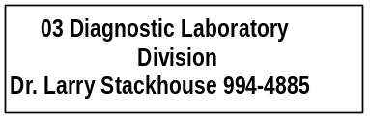

Program Description - The Diagnostic Laboratory Program provides livestock laboratory diagnostic support for the Disease Control Program, Milk and Egg Program, and livestock producers. Testing is done for zoonotic diseases and on dairy products to protect the health of Montana citizens. Laboratory testing services are conducted upon request to assist animal owners, veterinarians, the Department of Fish, Wildlife and Parks and other agencies in protecting the health of animals and wildlife.

Program Proposed Budget  Budget Item | Base  Budget  Fiscal 2000 | PL Base Adjustment  Fiscal 2002 | New  Proposals  Fiscal 2002 | Total  Exec. Budget  Fiscal 2002 | PL Base Adjustment  Fiscal 2003 | New  Proposals  Fiscal 2003 | Total  Exec. Budget  Fiscal 2003
FTE | 21.00 | 0.00 | 0.00 | 21.00 | 0.00 | 0.00 | 21.00
Personal Services | 858,177 | 7,302 | 0 | 865,479 | 11,739 | 0 | 869,916
Operating Expenses | 445,809 | 64,501 | 0 | 510,310 | 66,322 | 0 | 512,131
Equipment | 28,992 | 3,008 | 0 | 32,000 | 21,008 | 0 | 50,000
Total Costs | $1,332,978 | $74,811 | $0 | $1,407,789 | $99,069 | $0 | $1,432,047
General Fund | 192,442 | 0 | 0 | 192,442 | 0 | 0 | 192,442
State/Other Special | 1,140,536 | 63,611 | 0 | 1,204,147 | 81,569 | 0 | 1,222,105
Federal Special | 0 | 11,200 | 0 | 11,200 | 17,500 | 0 | 17,500
Total Funds | $1,332,978 | $74,811 | $0 | $1,407,789 | $99,069 | $0 | $1,432,047

Significant Present Law Adjustments -
- Establish state special and federal funding for replacement equipment at the lab
- Adjust funding for the increase in demand of services in the laboratory
- Maintain funding for MSU recharges and operating costs

ANIMAL HEALTH DIVISION

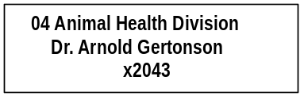

Program Description - The Animal Health Program provides diagnosis, prevention, control, and eradication of animal diseases, including those in bison and game farm animals. The program cooperates with the Departments of Public Health and Human Services, Fish, Wildlife and Parks, and Agriculture to protect human health from animal diseases transmissible to humans. Sanitary standards are supervised for animal concentration points, such as auction markets, and certain animal product processing facilities, such as rendering plants. The Rabies Control Unit protects human health from rabies by controlling the transmission of domestic animal and wildlife rabies, particularly through eradication of skunks.

Program Proposed Budget  Budget Item | Base  Budget  Fiscal 2000 | PL Base Adjustment  Fiscal 2002 | New  Proposals  Fiscal 2002 | Total  Exec. Budget  Fiscal 2002 | PL Base Adjustment  Fiscal 2003 | New  Proposals  Fiscal 2003 | Total  Exec. Budget  Fiscal 2003
FTE | 12.50 | 0.82 | 0.00 | 13.32 | 0.82 | 0.00 | 13.32
Personal Services | 439,116 | 106,481 | 0 | 545,597 | 109,600 | 0 | 548,716
Operating Expenses | 151,785 | 557,670 | 207,893 | 917,348 | 557,723 | 223,523 | 933,031
Equipment | 51,176 | 27,839 | 10,000 | 89,015 | 54,761 | 10,000 | 115,937
Benefits & Claims | 4,150 | 0 | 0 | 4,150 | 0 | 0 | 4,150
Total Costs | $646,227 | $691,990 | $217,893 | $1,556,110 | $722,084 | $233,523 | $1,601,834
State/Other Special | 646,227 | 38,140 | 177,823 | 862,190 | 68,234 | 177,823 | 892,284
Federal Special | 0 | 653,850 | 40,070 | 693,920 | 653,850 | 55,700 | 709,550
Total Funds | $646,227 | $691,990 | $217,893 | $1,556,110 | $722,084 | $233,523 | $1,601,834

0

Significant Present Law Adjustments -
- Provide $653,850 federal funds and 1.32 FTE per year for brucellosis prevention from bison
- Transfer 0.50 FTE and funds to central services for the administrative secretary position

New Proposals -
- Restore state funding for the outbreak of any disease that requires management and control
- Create federal funding for the Greater Yellowstone Interagency Brucellosis Committee

MILK & EGG PROGRAM

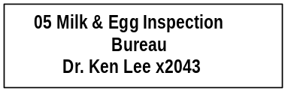

Program Description - The Milk and Egg Program ensures that eggs, milk, and milk products sold or manufactured in Montana are fit for human consumption. Enforcement of state and federal laws is accomplished through licensing, sampling, laboratory testing, and product and site inspections, done in cooperation with other state and federal agencies.

Program Proposed Budget  Budget Item | Base  Budget  Fiscal 2000 | PL Base Adjustment  Fiscal 2002 | New  Proposals  Fiscal 2002 | Total  Exec. Budget  Fiscal 2002 | PL Base Adjustment  Fiscal 2003 | New  Proposals  Fiscal 2003 | Total  Exec. Budget  Fiscal 2003
FTE | 4.50 | 0.00 | 0.00 | 4.50 | 0.00 | 0.00 | 4.50
Personal Services | 203,047 | 6,662 | 0 | 209,709 | 8,061 | 0 | 211,108
Operating Expenses | 29,782 | 3,175 | 0 | 32,957 | 6,427 | 0 | 36,209
Equipment | 29,671 | (2,749) | 0 | 26,922 | (2,749) | 0 | 26,922
Total Costs | $262,500 | $7,088 | $0 | $269,588 | $11,739 | $0 | $274,239
State/Other Special | 241,831 | 2,757 | 0 | 244,588 | 7,408 | 0 | 249,239
Federal Special | 20,669 | 4,331 | 0 | 25,000 | 4,331 | 0 | 25,000
Total Funds | $262,500 | $7,088 | $0 | $269,588 | $11,739 | $0 | $274,239

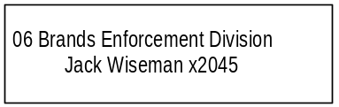

Program Description - The Inspection and Control Program, as part of the Brands Enforcement Division, is responsible for livestock theft investigations, stray livestock investigations, brand inspections, recording of livestock brands, filing of security interests on livestock, livestock auction licensing, livestock dealer licensing, hide inspections, and beef inspections.

Program Proposed Budget  Budget Item | Base  Budget  Fiscal 2000 | PL Base Adjustment  Fiscal 2002 | New  Proposals  Fiscal 2002 | Total  Exec. Budget  Fiscal 2002 | PL Base Adjustment  Fiscal 2003 | New  Proposals  Fiscal 2003 | Total  Exec. Budget  Fiscal 2003
FTE | 62.21 | (0.50) | 1.75 | 63.46 | (0.50) | 0.00 | 61.71
Personal Services | 2,176,166 | (390) | 43,154 | 2,218,930 | 12,440 | 0 | 2,188,606
Operating Expenses | 302,420 | (2,672) | 2,500 | 302,248 | (2,471) | 0 | 299,949
Equipment | 139,392 | 22,140 | 0 | 161,532 | (5,232) | 0 | 134,160
Total Costs | $2,617,978 | $19,078 | $45,654 | $2,682,710 | $4,737 | $0 | $2,622,715
State/Other Special | 2,617,978 | 19,078 | 45,654 | 2,682,710 | 4,737 | 0 | 2,622,715
Total Funds | $2,617,978 | $19,078 | $45,654 | $2,682,710 | $4,737 | $0 | $2,622,715

Significant Present Law Adjustments -
- Transfer out 0.50 FTE and funding to accurately reflect costs of the administrative secretary position
- Restore zero-based funding to the same level for overtime

New Proposals -
- Create 1.75 FTE and funding for the re-recording of brands that occurs every ten years

PREDATOR CONTROL

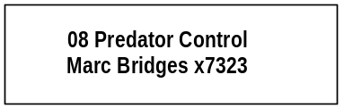

Program Description - The Predator Control Program is administered by the Board of Livestock and the executive officer. The department owns two aircraft and contracts with the U.S. Department of Agriculture Wildlife Services. Through helicopter hunting and contracts, predators that kill or injure domestic livestock, primarily coyotes, are controlled.

Program Proposed Budget  Budget Item | Base  Budget  Fiscal 2000 | PL Base Adjustment  Fiscal 2002 | New  Proposals  Fiscal 2002 | Total  Exec. Budget  Fiscal 2002 | PL Base Adjustment  Fiscal 2003 | New  Proposals  Fiscal 2003 | Total  Exec. Budget  Fiscal 2003
FTE | 1.00 | 0.00 | 0.00 | 1.00 | 0.00 | 0.00 | 1.00
Personal Services | 0 | 0 | 0 | 0 | 0 | 0 | 0
Operating Expenses | 511,471 | (76,236) | 0 | 435,235 | (68,753) | 0 | 442,718
Total Costs | $511,471 | ($76,236) | $0 | $435,235 | ($68,753) | $0 | $442,718
State/Other Special | 511,471 | (76,236) | 0 | 435,235 | (68,753) | 0 | 442,718
Total Funds | $511,471 | ($76,236) | $0 | $435,235 | ($68,753) | $0 | $442,718

Significant Present Law Adjustments -
- Fish, Wildlife & Parks is managing its own predator control, so contract funding is reduced

MEAT/POULTRY INSPECTION

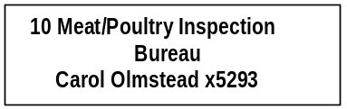

Program Description - The Meat and Poultry Inspection Program within the Meat, Milk and Egg Inspection Division was established in 1987 by the Montana Meat and Poultry Inspection Act. It implements and enforces a meat and poultry inspection system equal to that maintained by the U.S. Department of Agriculture and the Food Safety Inspection Service to assure clean, wholesome, and properly-labeled meat and poultry products for consumers.

Program Proposed Budget  Budget Item | Base  Budget  Fiscal 2000 | PL Base Adjustment  Fiscal 2002 | New  Proposals  Fiscal 2002 | Total  Exec. Budget  Fiscal 2002 | PL Base Adjustment  Fiscal 2003 | New  Proposals  Fiscal 2003 | Total  Exec. Budget  Fiscal 2003
FTE | 16.50 | 0.00 | 0.00 | 16.50 | 0.00 | 0.00 | 16.50
Personal Services | 526,909 | 45,177 | 0 | 572,086 | 48,347 | 0 | 575,256
Operating Expenses | 190,170 | 40,377 | 0 | 230,547 | 47,172 | 0 | 237,342
Equipment | 0 | 0 | 0 | 0 | 0 | 0 | 0
Total Costs | $717,079 | $85,554 | $0 | $802,633 | $95,519 | $0 | $812,598
General Fund | 337,618 | 61,925 | 0 | 399,543 | 66,908 | 0 | 404,526
State/Other Special | 1,772 | 0 | 0 | 1,772 | 0 | 0 | 1,772
Federal Special | 377,689 | 23,629 | 0 | 401,318 | 28,611 | 0 | 406,300
Total Funds | $717,079 | $85,554 | $0 | $802,633 | $95,519 | $0 | $812,598

Significant Present Law Adjustments -
- Adjust for vacancies in the base year
- Charge fixed costs and administrative overhead to this program

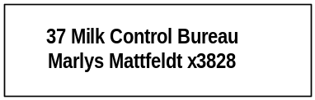

Program Description - The Milk Control Bureau regulates and controls the transfer of milk among producers and plants by enforcing Montana milk control laws and rules. The program ensures compliance with state laws through minimum producer pricing, and by enforcing state law and rules established by the Board of Milk Control which is administratively attached to the Department of Livestock. The staff of the Milk Control Bureau are employees of the Department of Livestock. The Milk Control Bureau also collects the milk tax used to support milk regulatory and testing functions in the department.

Program Proposed Budget  Budget Item | Base  Budget  Fiscal 2000 | PL Base Adjustment  Fiscal 2002 | New  Proposals  Fiscal 2002 | Total  Exec. Budget  Fiscal 2002 | PL Base Adjustment  Fiscal 2003 | New  Proposals  Fiscal 2003 | Total  Exec. Budget  Fiscal 2003
FTE | 4.00 | 0.00 | 0.00 | 4.00 | 0.00 | 0.00 | 4.00
Personal Services | 122,598 | 28,423 | 0 | 151,021 | 28,740 | 0 | 151,338
Operating Expenses | 36,004 | (5,008) | 0 | 30,996 | (5,862) | 0 | 30,142
Total Costs | $158,602 | $23,415 | $0 | $182,017 | $22,878 | $0 | $181,480
State/Other Special | 158,602 | 23,415 | 0 | 182,017 | 22,878 | 0 | 181,480
Total Funds | $158,602 | $23,415 | $0 | $182,017 | $22,878 | $0 | $181,480

Significant Present Law Adjustments -
- Adjust for vacancy in the base year

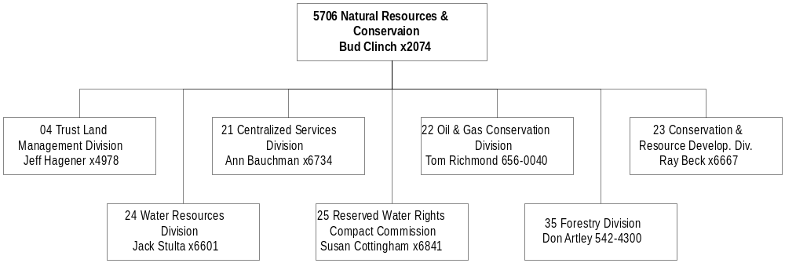

Mission Statement - To ensure Montana's land and water resources provide benefits for present and future generations.

Statutory Authority - 2-15-104 and Title 2, Chapter 15, part 33, MCA.

Executive Budget Recommendation –
- Continue the Agricultural Heritage Program created by SB 342 in the 1999 Legislative Session to develop and purchase agricultural conservation easements
- Pass through funds to the Dry Prairie Rural Water Authority for the Fort Peck Dry Prairie Rural Water System project
- Provide funds to the Eastern Plains RC&D for community projects in sixteen eastern Montana counties
- Fund grants to local organizations for planning new irrigation developments
- Pass through funds for the continued administration of the Rocky Boy North Central Regional Water System project
- Decrease backlog of verifications of permitted water projects
- Expand dam safety improvement program with additional available federal funds
- Maintain forest health monitoring program to control and prevent pathologic outbreaks in Montana's forests.
- Support forest rehabilitation including erosion control, road maintenance, and tree regeneration in the Sula State Forest
- Supply infrastructure and development for several commercial leasing projects

Agency Proposed Budget  Budget Item | Base  Budget  Fiscal 2000 | PL Base Adjustment  Fiscal 2002 | New  Proposals  Fiscal 2002 | Total  Exec. Budget  Fiscal 2002 | PL Base Adjustment  Fiscal 2003 | New  Proposals  Fiscal 2003 | Total  Exec. Budget  Fiscal 2003
FTE | 500.28 | 2.09 | 4.25 | 506.62 | 2.09 | 4.25 | 506.62
Personal Services | 18,454,168 | 1,651,547 | 160,567 | 20,266,282 | 1,776,672 | 161,255 | 20,392,095
Operating Expenses | 8,161,506 | 5,879,740 | 879,567 | 14,920,996 | 2,022,923 | 648,491 | 10,832,920
Equipment | 754,526 | 72,132 | 0 | 826,658 | 67,132 | 0 | 821,658
Capital Outlay | 847 | 0 | 0 | 847 | 0 | 0 | 847
Local Assistance | 221,000 | 0 | 0 | 221,000 | 0 | 0 | 221,000
Grants | 889,760 | 0 | 2,085,000 | 2,974,760 | 0 | 275,000 | 1,164,760
Benefits & Claims | 1,600,977 | (100,977) | 0 | 1,500,000 | (100,977) | 0 | 1,500,000
Transfers | 355,419 | 33,750 | 0 | 389,169 | 33,750 | 0 | 389,169
Debt Service | 389,765 | 194,402 | 0 | 584,167 | 194,602 | 0 | 584,367
Total Costs | $30,827,968 | $7,730,594 | $3,125,317 | $41,683,879 | $3,994,102 | $1084,746 | $35,906,816
General Fund | 16,529,294 | 1,321,810 | 1,572,569 | 19,423,673 | 1,142,736 | 731,960 | 18,403,990
State/Other Special | 12,791,352 | 6,114,687 | 105,000 | 19,011,039 | 2,406,323 | 105,000 | 15,443,175
Federal Special | 1,507,322 | 294,097 | 1,447,748 | 3,249,167 | 304,543 | 247,786 | 2,059,651
Total Funds | $30,827,968 | $7,730,594 | $3,125,317 | $41,683,879 | $3,994,102 | $1,084,746 | $35,906,816

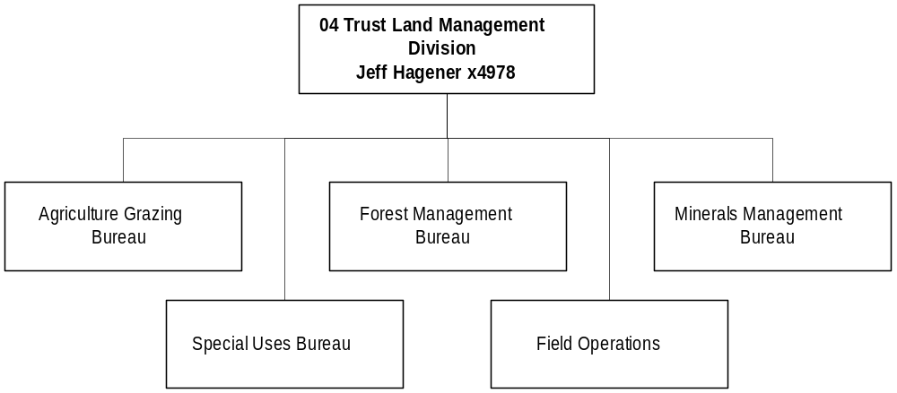
Program Description - The Trust Land Management Division provides for the administration and management of trust lands granted to the State of Montana by the Enabling Act of 1889. These lands currently total 5.2 million surface acres and 6.2 million mineral acres. Additionally, the division is responsible for the administration of approximately 6,000 miles (40,000+ acres) of the beds of navigable waterways. The Trust Land Management Division is divided into four primary programs: forest management; agriculture and grazing management; special use management; and minerals management.

Program Indicators –
Indicator | Actual FY1998 | Actual FY1999 | Actual FY2000 | Estimated FY2001 | Requested FY2002 | Requested FY2003
Total Revenues generated (in millions) | $56.2 | $54.7 | $64.8 | $58.6 | $58.6 | $58.6
State Trust Land Acreage (in millions) | 5.1 | 5.1 | 5.1 | 5.1 | 5.1 | 5.1

Program Proposed Budget  Budget Item | Base  Budget  Fiscal 2000 | PL Base Adjustment  Fiscal 2002 | New  Proposals  Fiscal 2002 | Total  Exec. Budget  Fiscal 2002 | PL Base Adjustment  Fiscal 2003 | New  Proposals  Fiscal 2003 | Total  Exec. Budget  Fiscal 2003
FTE | 123.79 | 0.00 | 1.00 | 124.79 | 0.00 | 1.00 | 124.79
Personal Services | 4,787,492 | 284,686 | 33,290 | 5,105,468 | 315,848 | 33,431 | 5,136,771
Operating Expenses | 2,109,879 | 890,841 | 215,000 | 3,215,720 | 907,542 | 10,000 | 3,027,421
Equipment | 158,516 | 38,632 | 0 | 197,148 | 42,132 | 0 | 200,648
Capital Outlay | 847 | 0 | 0 | 847 | 0 | 0 | 847
Debt Service | 242 | 101,000 | 0 | 101,242 | 101,000 | 0 | 101,242
Total Costs | $7,056,976 | $1,315,159 | $248,290 | $8,620,425 | $1,366,522 | $43,431 | $8,466,929
General Fund | 4,848 | 0 | 48,290 | 53,138 | 0 | 43,431 | 48,279
State/Other Special | 7,039,715 | 1,315,159 | 0 | 8,354,874 | 1,366,522 | 0 | 8,406,237
Federal Special | 12,413 | 0 | 200,000 | 212,413 | 0 | 0 | 12,413
Total Funds | $7,056,976 | $1,315,159 | $248,290 | $8,620,425 | $1,366,522 | $43,431 | $8,466,929

Significant Present Law Adjustments -
- Begin forest rehabilitation including erosion control, road maintenance, and tree regeneration in the Sula State Forest
- Provide infrastructure and development for several commercial leasing projects
- Replace aging computer equipment throughout the Trust Land Management Division

New Proposals -
- Perform an inventory and provide administration for all state owned non-trust lands
- Facilitate cooperation in support of the development of a Habitat Conservation Plan for Montana
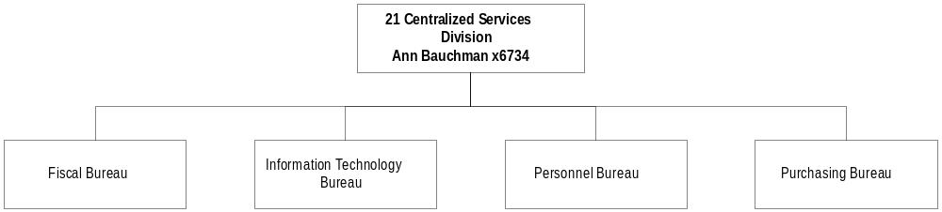

Program Description - The Centralized Services Division provides managerial and administrative support services to the department through: 1) the Director's Office, which includes the director, legal staff, and public information; and 2)support services, which manages all financial activities, coordinates information systems, produces publications and graphic materials, and performs general administrative support services. Support services include fiscal affairs, data processing, personnel, legal, reception, and mail. Responsibilities include trust revenue collection and distribution and maintenance of ownership records for trust and non-trust state-owned land.

Program Proposed Budget  Budget Item | Base  Budget  Fiscal 2000 | PL Base Adjustment  Fiscal 2002 | New  Proposals  Fiscal 2002 | Total  Exec. Budget  Fiscal 2002 | PL Base Adjustment  Fiscal 2003 | New  Proposals  Fiscal 2003 | Total  Exec. Budget  Fiscal 2003
FTE | 41.00 | 0.00 | 0.00 | 41.00 | 0.00 | 0.00 | 41.00
Personal Services | 1,696,668 | 70,039 | 0 | 1,766,707 | 82,417 | 0 | 1,779,085
Operating Expenses | 449,579 | 50,932 | 74,905 | 575,416 | (21,686) | 49,155 | 477,048
Total Costs | $2,146,247 | $120,971 | $74,905 | $2,342,123 | $60,731 | $49,155 | $2,256,133
General Fund | 1,865,298 | 123,520 | 74,905 | 2,063,723 | 63,280 | 49,155 | 1,977,733
State/Other Special | 172,437 | 963 | 0 | 173,400 | 963 | 0 | 173,400
Federal Special | 108,512 | (3,512) | 0 | 105,000 | (3,512) | 0 | 105,000
Total Funds | $2,146,247 | $120,971 | $74,905 | $2,342,123 | $60,731 | $49,155 | $2,256,133

New Proposals -
- Replace old, failing, and inadequate network wiring in the DNRC Missoula Forestry Complex
- Supply proportional share of core service support to the NRIS program in the State Library

Language - The following HB 2 language is recommended:
"Item 2 includes a total of $98,310 for the 2003 biennium for the Montana natural resources information system. Quarterly payments must be made upon receipt of the bills from the state library up to the total amount appropriated."

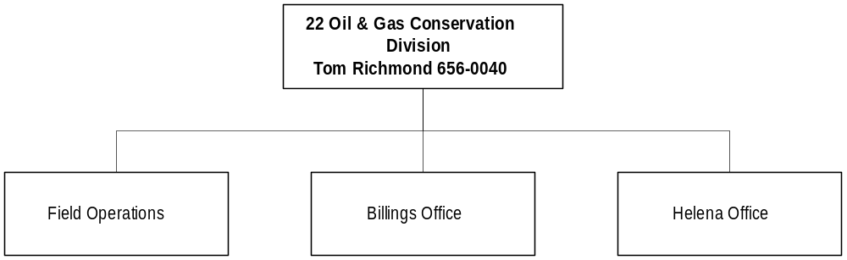

Program Description - The Oil and Gas Conservation Division administers the Montana oil and gas conservation laws to promote conservation and prevent waste in the recovery of these resources through regulation of exploration and production of oil and gas. The division 1) issues drilling permits; 2) classifies wells; 3) establishes well spacing units and pooling orders; 4) inspects drilling, production, and seismic operations; 5) investigates complaints; 6) does engineering studies; 7) determines incremental production for enhanced recovery and horizontal wells to implement the tax incentive program for those projects; 8) operates the underground injection control program; 9) plugs orphan wells; and 10) collects and maintains complete well data and production information.

Indicator | Actual FY1998 | Actual FY1999 | Actual FY2000 | Estimated FY2001 | Requested FY2002 | Requested FY2003
Drilling Permits Issued | 551 | 549 | 480 | 550 | 600 | 600
Wells Completed | 310 | 482 | 417 | 475 | 550 | 550
Oil Production (in million Bbls) | 16.61 | 15.27 | 14.8 | 14.2 | 13.78 | 13.37
Gas Production (in million MCF) | 59.8 | 61.6 | 63.4 | 64.5 | 65.7 | 67

Program Proposed Budget  Budget Item | Base  Budget  Fiscal 2000 | PL Base Adjustment  Fiscal 2002 | New  Proposals  Fiscal 2002 | Total  Exec. Budget  Fiscal 2002 | PL Base Adjustment  Fiscal 2003 | New  Proposals  Fiscal 2003 | Total  Exec. Budget  Fiscal 2003
FTE | 20.50 | 0.00 | 0.00 | 20.50 | 0.00 | 0.00 | 20.50
Personal Services | 662,507 | 148,820 | 0 | 811,327 | 159,836 | 0 | 822,343
Operating Expenses | 297,451 | 90,386 | 0 | 387,837 | 95,942 | 0 | 393,393
Equipment | 27,678 | 0 | 0 | 27,678 | 0 | 0 | 27,678
Total Costs | $987,636 | $239,206 | $0 | $1,226,842 | $255,778 | $0 | $1,243,414
State/Other Special | 868,921 | 357,921 | 0 | 1,226,842 | 374,493 | 0 | 1,243,414
Federal Special | 118,715 | (118,715) | 0 | 0 | (118,715) | 0 | 0
Total Funds | $987,636 | $239,206 | $0 | $1,226,842 | $255,778 | $0 | $1,243,414

Language Recommendations - The following language is recommended for HB 2:
"The department is authorized to decrease state special revenue in the underground injection control program and increase federal special revenue by a like amount when the amount of federal EPA funds available for the program becomes known. Any federal special revenue funds are to be spent before state special revenue funds."

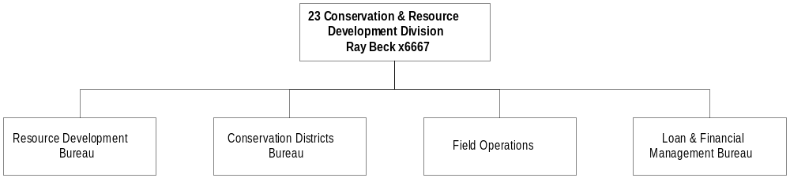

Program Description - The Conservation and Resource Development Division is responsible for the administration of the Conservation District Act, State Grazing District Act, and numerous grant and loan programs. The division provides technical and financial assistance to local governments, state agencies, and private citizens for the conservation, development, protection, and management of natural resources throughout the state.

Program Indicators –

Indicator | Actual FY1998 | Actual FY1999 | Actual FY2000 | Estimated FY2001 | Requested FY2002 | Requested FY2003
Grants provided to communities (in millions) | $1.8 | $2.9 | $3.5 | $3.5 | $3.5 | $3.5
Loans provided to communities (in millions) | $89 | $111 | $135 | $150 | $160 | $170

Program Proposed Budget  Budget Item | Base  Budget  Fiscal 2000 | PL Base Adjustment  Fiscal 2002 | New  Proposals  Fiscal 2002 | Total  Exec. Budget  Fiscal 2002 | PL Base Adjustment  Fiscal 2003 | New  Proposals  Fiscal 2003 | Total  Exec. Budget  Fiscal 2003
FTE | 22.00 | 0.00 | 2.00 | 24.00 | 0.00 | 2.00 | 24.00
Personal Services | 873,768 | 128,310 | 75,358 | 1,077,436 | 133,797 | 75,679 | 1,083,244
Operating Expenses | 614,349 | 245,297 | 316,416 | 1,176,062 | 150,590 | 316,095 | 1,081,034
Equipment | 48,348 | 0 | 0 | 48,348 | 0 | 0 | 48,348
Local Assistance | 221,000 | 0 | 0 | 221,000 | 0 | 0 | 221,000
Grants | 889,760 | 0 | 1,965,000 | 2,854,760 | 0 | 155,000 | 1,044,760
Benefits & Claims | 1,600,977 | (100,977) | 0 | 1,500,000 | (100,977) | 0 | 1,500,000
Total Costs | $4,248,202 | $272,630 | $2,356,774 | $6,877,606 | $183,410 | $546,774 | $4,978,386
General Fund | 2,871,886 | 40,687 | 1,331,774 | 4,244,347 | (84,456) | 521,774 | 3,309,204
State/Other Special | 1,226,064 | 220,544 | 25,000 | 1,471,608 | 256,467 | 25,000 | 1,507,531
Federal Special | 150,252 | 11,399 | 1,000,000 | 1,161,651 | 11,399 | 0 | 161,651
Total Funds | $4,248,202 | $272,630 | $2,356,774 | $6,877,606 | $183,410 | $546,774 | $4,978,386

Significant Present Law Adjustments -
- Remove interest expense for Crow Tribe settlement from base budget as it is no longer needed
- Contract with NRCS for statewide rangeland management support
- Annualize the expenses of the Montana Grass Conservation Commission
New Proposals -
- Continue the Agricultural Heritage Program created by SB 342 in the 1999 Legislative Session to develop and purchase agricultural conservation easements
- Fund grants to local organizations for planning new irrigation developments
- Support regional water system projects with a state coordinator
- Pass through funds to the Dry Prairie Rural Water Authority for the Fort Peck Dry Prairie Rural Water System project
- Pass through funds for the continued progression of the Rocky Boy North Central Montana Regional Water System project
- Continue special revenue funds to the Eastern Plains RC&D for community projects in 16 Eastern Montana counties

Language Recommendations - The following language is recommended for HB2:
"The department is appropriated up to $700,000 for the 2003 biennium from the account established in 76-14-112 for rangeland loans during the 2003 biennium."

"The department is appropriated up to $600,000 for the 2003 biennium from the state special revenue account established in 85-1-604 for the purchase of prior liens on property held as loan security as required by 85-1-618."

"The department is authorized to decrease federal special revenue money in the pollution control and/or the drinking water revolving fund loan programs and increase state special revenue money by a like amount within the special administration account."

WATER RESOURCES DIVISION

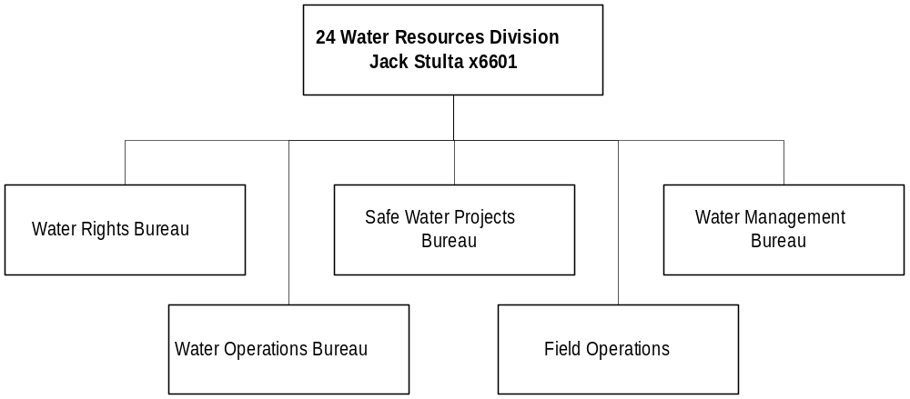

Program Description - The Water Resources Division is responsible for many programs associated with the uses, development, and protection of Montana's water. The division also develops and recommends water policy to the director, Governor, and legislature. The division consists of an administration unit and four bureaus: Water Management Bureau, Water Rights Bureau, State Water Projects Bureau, and the Water Operations Bureau.

Program Indicators -

Indicator | Actual FY1998 | Actual FY1999 | Actual FY2000 | Estimated FY2001 | Requested FY2002 | Requested FY2003
State Water Projects | 46 | 48 | 51 | 46 | 50 | 45
Owned & Managed (Dams inspected) High-hazard dam permits issued | 11 | 17 | 37 | 11 | 11 | 13
Water users group assisted | 13 | 14 | 16 | 16 | 16 | 16

Program Proposed Budget  Budget Item | Base  Budget  Fiscal 2000 | PL Base Adjustment  Fiscal 2002 | New  Proposals  Fiscal 2002 | Total  Exec. Budget  Fiscal 2002 | PL Base Adjustment  Fiscal 2003 | New  Proposals  Fiscal 2003 | Total  Exec. Budget  Fiscal 2003
FTE | 112.50 | 2.75 | 1.25 | 116.50 | 2.75 | 1.25 | 116.50
Personal Services | 4,575,339 | 284,628 | 51,919 | 4,911,886 | 310,795 | 52,145 | 4,938,279
Operating Expenses | 1,823,738 | 3,852,970 | 185,429 | 5,862,137 | 245,624 | 185,241 | 2,254,603
Equipment | 24,793 | (500) | 0 | 24,293 | (500) | 0 | 24,293
Grants | 0 | 0 | 120,000 | 120,000 | 0 | 120,000 | 120,000
Debt Service | 376,341 | 93,402 | 0 | 469,743 | 93,602 | 0 | 469,943
Total Costs | $6,800,211 | $4,230,500 | $357,348 | $11,388,059 | $649,521 | $357,386 | $7,807,118
General Fund | 5,693,470 | 295,025 | 117,600 | 6,106,095 | 364,902 | 117,600 | 6,175,972
State/Other Special | 971,226 | 3,828,626 | 70,000 | 4,879,852 | 176,738 | 70,000 | 1,217,964
Federal Special | 135,515 | 106,849 | 169,748 | 412,112 | 107,881 | 169,786 | 413,182
Total Funds | $6,800,211 | $4,230,500 | $357,348 | $11,398,059 | $649,521 | $357,386 | $7,807,118

Significant Present Law Adjustments -
- Rehabilitate the high-hazard Bair and Nevada Creek Dams using state special revenue
- Convert existing and new water rights documents to electronic digital format
- Expand dam safety improvement program with additional available federal funds
- Prepare a comprehensive dam safety report and a fisheries evaluation and report for the Broadwater hydropower facility

New Proposals -
- Implement a collaborative Clark Fork Basin planning group created in Governor's legislation with 1.00 FTE
- Decrease backlog of verifications of permitted water projects
- Administer the flood damage reduction program

Language Recommendations - The following language is recommended for HB 2:
"During the 2003 biennium, up to $1 million of funds currently in or to be deposited in the Broadwater replacement and renewal account are appropriated to the department for repairing or replacing equipment at the Broadwater hydropower facility."

"During the 2003 biennium up to $70,000 of interest earned on the Broadwater water users account is appropriated to the department for the purpose of repair, improvement, or rehabilitation of the Broadwater-Missouri diversion project."

"During the 2003 biennium, up to $500,000 of funds currently in or to be deposited in the state project hydropower earnings account are appropriated for the purpose of repairing, improving, or rehabilitating department state water projects."

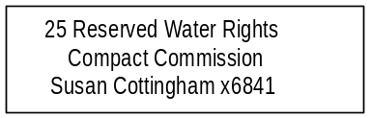

Program Description - The Reserved Water Rights Compact Commission was created by the legislature in 1979 as part of the water rights adjudication effort. It consists of four members appointed by the Governor, two by the President of the Senate, two by the Speaker of the House of Representatives, and one by the Attorney General. Members serve for four years. The commission negotiates water rights with the Indian tribes and federal agencies, which claim federal reserved water rights within the state, to establish a formal agreement (compact) on the amount of water to be allocated to each interest.

Program Indicators -

Indicator | Actual FY1998 | Actual FY1999 | Actual FY2000 | Estimated FY2001 | Requested FY2002 | Requested FY2003
Compacts completed | 0 | 1 | 0 | 1 | 1 | 1
Compacts Under Negotiation | 4 | 5 | 5 | 4 | 3 | 2

Program Proposed Budget  Budget Item | Base  Budget  Fiscal 2000 | PL Base Adjustment  Fiscal 2002 | New  Proposals  Fiscal 2002 | Total  Exec. Budget  Fiscal 2002 | PL Base Adjustment  Fiscal 2003 | New  Proposals  Fiscal 2003 | Total  Exec. Budget  Fiscal 2003
FTE | 12.00 | 0.00 | 0.00 | 12.00 | 0.00 | 0.00 | 12.00
Personal Services | 499,242 | 73,188 | 0 | 572,430 | 76,788 | 0 | 576,030
Operating Expenses | 144,970 | 14,113 | 0 | 159,083 | 12,912 | 0 | 157,882
Equipment | 0 | 6,000 | 0 | 6,000 | 10,500 | 0 | 10,500
Total Costs | $644,212 | $93,301 | $0 | $737,513 | $100,200 | $0 | $744,412
General Fund | 644,212 | 93,301 | 0 | 737,513 | 100,200 | 0 | 744,412
Total Funds | $644,212 | $93,301 | $0 | $737,513 | $100,200 | $0 | $744,412

FORESTRY DIVISION
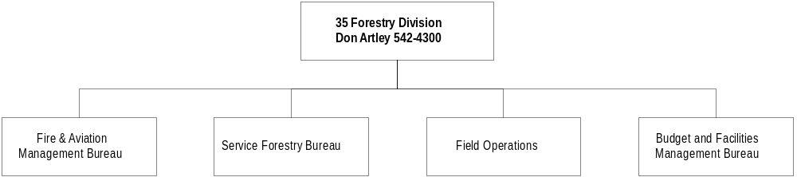

Program Description -
The Forestry Division is responsible for planning and implementing forestry programs statewide. Forestry responsibilities include protecting Montana's natural resources from wildfire, regulating forest practices, and providing a variety of services to private forest landowners.
Specific programs include:

- Fire and Aviation Management - Protecting 50 million acres of state and private forest and watershed lands from wildfire through a combination of direct protection and county support.
- Forest Practice Regulation - Enforcing Montana's streamside management zone regulations and monitoring the voluntary best management practices program on all forests in Montana.
- Administering Montana's Fire Hazard Reduction Law - Ensuring that the fire hazard created by logging and other forest management operations on private forest lands is adequately reduced, or that additional fire protection is provided until the hazard is reduced.
- Providing Forestry Services - Providing technical forestry assistance to private landowners, businesses and communities.
- Tree and Shrub Nursery - Growing and selling seedlings for conservation and reforestation plantings on state and private lands in Montana.

Program Indicators –

Indicator | Actual FY1998 | Actual FY1999 | Actual FY2000 | Estimated FY2001 | Requested FY2002 | Requested FY2003
Total Acres under Fire Protection (in millions) | 50.5 | 50.5 | 52.1 | 52.1 | 52.1 | 52.1
Forest Resources Assistance (in thousands of acres) | 4,117 | 4,100 | 4,100 | 4,100 | 4,125 | 4,125

Program Proposed Budget  Budget Item | Base  Budget  Fiscal 2000 | PL Base Adjustment  Fiscal 2002 | New  Proposals  Fiscal 2002 | Total  Exec. Budget  Fiscal 2002 | PL Base Adjustment  Fiscal 2003 | New  Proposals  Fiscal 2003 | Total  Exec. Budget  Fiscal 2003
FTE | 168.49 | (0.66) | 0.00 | 167.83 | (0.66) | 0.00 | 167.83
Personal Services | 5,359,152 | 661,876 | 0 | 6,021,028 | 697,191 | 0 | 6,056,343
Operating Expenses | 2,72,1540 | 735,201 | 88,000 | 3,544,741 | 631,999 | 88,000 | 3,441,539
Equipment | 495,191 | 28,000 | 0 | 523,191 | 15,000 | 0 | 510,191
Transfers | 355,419 | 33,750 | 0 | 389,169 | 33,750 | 0 | 389,169
Debt Service | 13,182 | 0 | 0 | 13,182 | 0 | 0 | 13,182
Total Costs | $8,944,484 | $1,458,827 | $88,000 | $10,491,311 | $1,377,940 | $88,000 | $10,410,424
General Fund | 5,449,580 | 769,277 | 0 | 6,218,857 | 698,810 | 0 | 6,148,390
State/Other Special | 2,512,989 | 391,474 | 10,000 | 2,914,463 | 371,640 | 10,000 | 2,894,629
Federal Special | 981,915 | 298,076 | 78,000 | 1,357,991 | 307,490 | 78,000 | 1,367,405
Total Funds | $8,944,484 | $1,458,827 | $88,000 | $10,491,311 | $1,377,940 | $88,000 | $10,410,424

Significant Present Law Adjustments -
- Convert the Fire Protection Assessment Computer System from a mainframe to a PC based system
- Maintain 10-year replacement cycle for two-way radio equipment
- Allow reimbursement to DNRC from other states and the federal government for fighting fires or helping with other types of emergencies in other jurisdictions
- Interface field forestry offices with the new master statewide slash accounting database
- Increase federal authority for the Interagency Fire Support Unit

New Proposals -
- Continue forest health monitoring program to control and prevent pathologic outbreaks in Montana forests

Language Recommendations - The following language is recommended for HB 2:
"The department is appropriated up to $20,000 for the 2003 biennium from the account established in 76-13-408, MCA, for hazard reduction bonds during the 2003 biennium."
Proprietary Rates

Program Description -The air operations program in the Forestry Division is funded from the air operations proprietary account for those costs that can be supported by the aircraft rates charged to agencies that use the aircraft and general fund for fixed costs. The program operates three medium helicopters, two light helicopters, and three single engine fixed-wing airplanes. Aircraft are primarily used for fire detection, support and suppression of wildfires, and reclamation work in the Department of Environmental Quality. Fixed costs are paid by the general fund and fire protection tax revenue since they must be paid regardless of number of hours flown. These costs include hangar rent, insurance, and personnel costs. The general fund and fire protection taxes are appropriated by the legislature and transferred to and spent from the proprietary account. Variable costs that are dependent on the hours flown, such as fuel and maintenance, are recovered through an hourly rate charged to all users of the aircraft. Users of the aircraft include DRNC, other state agencies, federal agencies, and the state's wildfire suppression efforts. This revenue is also deposited to the proprietary account.

Rate Explanation -The Aviation Bureau of the Forestry Division at DNRC charges for the usage of its fixed and rotary wing aircraft. Projected expenditures for each year are applied against the number of projected flight hours by each type of aircraft. The aircraft are primarily used for fire detection and suppression. Consequently, aircraft utilization is primarily driven by the severity of each fire season. The goal of the rate methodology is to maintain a fund balance that is less than 60 days, per HB 576 requirements. Rates based on the specific costs and flight usage by type of aircraft are the most fair and equitable for chargeback to the users of the aircraft.

Three rates are determined through this process. The table below illustrates each rate and any future variances in those rates.

Rate Type FY00 Rate FY01 Rate FY02 Rate FY03 Rate
Fixed Wing 90 90 95 95
Bell 206A Helicopter 345 345 355 355
UH-1 Huey Helicopter 850 850 875 875

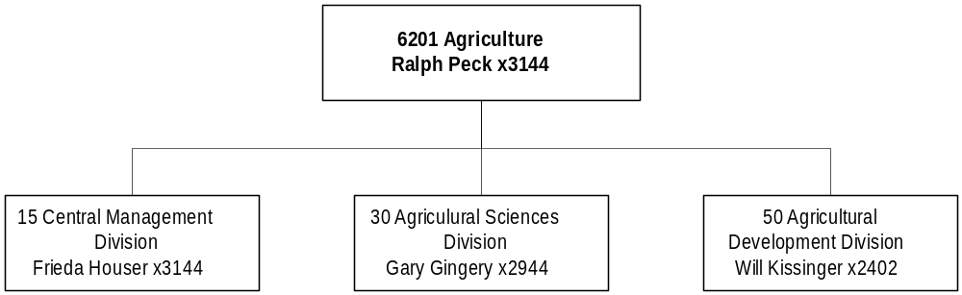

Mission Statement - To protect, enhance, and develop all agriculture in Montana; to encourage and promote production and marketing for agriculture and allied industries; and to provide protection for producers and consumers through administration and enforcement of statutes established by Montana's legislature.

Statutory Authority - Article XII, Section 1, Montana Constitution; Title 80, Chapters 1-15, MCA

Executive Budget Recommendation –
- Implement a comprehensive information technology plan for the department
- Provide alfalfa seed phytosanitary inspections to alfalfa seed growers
- Develop standards for weed seed levels in commercial feed
- Improve genetically modified organisms program
- Continue the implementation of the Organic Certification program

Agency Proposed Budget  Budget Item | Base  Budget  Fiscal 2000 | PL Base Adjustment  Fiscal 2002 | New  Proposals  Fiscal 2002 | Total  Exec. Budget  Fiscal 2002 | PL Base Adjustment  Fiscal 2003 | New  Proposals  Fiscal 2003 | Total  Exec. Budget  Fiscal 2003
FTE | 108.72 | 0.83 | 1.00 | 110.55 | 0.83 | 1.00 | 110.55
Personal Services | 3,512,414 | 641,815 | 56,394 | 4,210,623 | 665,104 | 56,592 | 4,234,110
Operating Expenses | 2,176,271 | 323,591 | 212,918 | 2,712,780 | 236,964 | 112,260 | 2,525,495
Equipment | 214,512 | 60,810 | 25,000 | 300,322 | (2,696) | 42,000 | 253,816
Grants | 2,868,758 | (198,116) | 0 | 2,670,642 | (193,295) | 0 | 2,675,463
Transfers | 80,000 | 0 | 0 | 80,000 | 0 | 0 | 80,000
Debt Service | 1,308 | 0 | 0 | 1,308 | 0 | 0 | 1,308
Total Costs | $8,853,263 | $828,100 | $294,312 | $9,975,675 | $706,077 | $210,852 | $9,770,192
General Fund | 608,714 | 136,143 | 17,864 | 762,721 | 129,878 | 17,864 | 756,456
State/Other Special | 7,451,196 | 640,794 | 120,946 | 8,212,936 | 524,292 | 69,550 | 8,045,038
Federal Special | 518,056 | 13,295 | 108,898 | 640,249 | 14,579 | 108,884 | 641,519
Proprietary | 275,297 | 37,868 | 46,604 | 359,769 | 37,328 | 14,554 | 327,179
Total Funds | $8,853,263 | $828,100 | $294,312 | $9,975,675 | $706,077 | $210,852 | $9,770,192

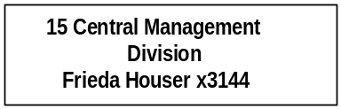

Program Description - Central Management Division performs technical, fiscal, and administrative support functions for the department's internal operations and related programs. Responsibilities include accounting, budgeting, payroll, personnel, purchasing, property control, data processing, systems analysis and computer programming, equal opportunity administration, and legal support to all programs within the department. Included in this division is the director's office, which provides overall policy development for the department.

Program Indicators -

Indicator | Actual FY1998 | Actual FY1999 | Actual FY2000 | Estimated FY2001 | Requested FY2002 | Requested FY2003
Regional/National Projects/Meetings | 112 | 108 | 111 | 115 | 120 | 120
International Projects/Meetings | 25 | 24 | 27 | 28 | 29 | 30

Program Proposed Budget  Budget Item | Base  Budget  Fiscal 2000 | PL Base Adjustment  Fiscal 2002 | New  Proposals  Fiscal 2002 | Total  Exec. Budget  Fiscal 2002 | PL Base Adjustment  Fiscal 2003 | New  Proposals  Fiscal 2003 | Total  Exec. Budget  Fiscal 2003
FTE | 12.00 | 0.00 | 1.00 | 13.00 | 0.00 | 1.00 | 13.00
Personal Services | 486,129 | 49,087 | 39,556 | 574,772 | 52,125 | 39,696 | 577,950
Operating Expenses | 176,207 | 13,228 | 123,799 | 313,234 | (13,870) | 40,213 | 202,550
Equipment | 13,603 | 0 | 0 | 13,603 | 0 | 0 | 13,603
Total Costs | $675,939 | $62,315 | $163,355 | $901,609 | $38,255 | $79,909 | $794,103
General Fund | 230,062 | 16,302 | 17,864 | 264,228 | 5,052 | 17,864 | 252,978
State/Other Special | 319,055 | 40,193 | 120,946 | 480,194 | 28,407 | 69,550 | 417,012
Federal Special | 94,201 | (3,329) | (22,059) | 68,813 | (3,487) | (22,059) | 68,655
Proprietary | 32,621 | 9,149 | 46,604 | 88,374 | 8,283 | 14,554 | 55,458
Total Funds | $675,939 | $62,315 | $163,355 | $901,609 | $38,255 | $79,909 | $794,103

New Proposals -
- Adjust funding for accounting technician position to decrease federal and increase state special funds
- Implement a comprehensive information technology plan for the department

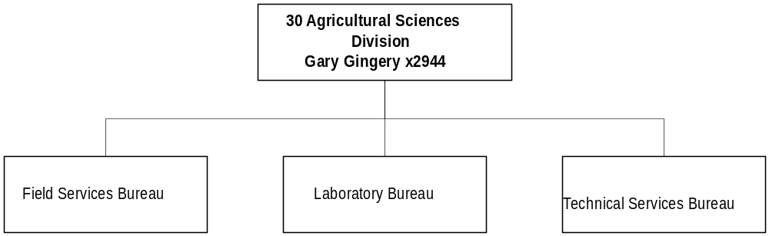

Program Description - The Agricultural Sciences Division (ASD) administers, manages, coordinates, and evaluates the major activities of: 1) pesticide and pest management; 2) analytical laboratory services; 3) noxious weed management; 4) agricultural chemical groundwater management; and 5) vertebrate pest management. This program administers the Montana Pesticides Act, Agricultural Chemical Groundwater Protection Act, Crop Insect Detection Act, Vertebrate Pest Management Act, Noxious Weed Trust Fund Act, elements of the Weed Assistance Act, and the department's Chemical Analytical Laboratory. Duties also include administering agricultural programs related to the production, manufacturing, and marketing of commodities exported from or distributed in the state.

Program Indicators -

Indicator | Actual FY1998 | Actual FY1999 | Actual FY2000 | Estimated FY2001 | Requested FY2002 | Requested FY2003
Commercial Agricultural Products Registered | 14,206 | 15,280 | 12,900 | 13,100 | 13,200 | 13,300
Analysis of Commercial Agricultural Products | 3,711 | 8,382 | 9,784 | 6,928 | 7,700 | 7,700
Commodity Certificates | 5,000 | 4,930 | 4,737 | 4,920 | 4,950 | 4,950
Noxious Weed Trust Fund Grants Awarded | 135 | 138 | 157 | 150 | 150 | 150
Pest Quarantines and Surveys | 18 | 21 | 24 | 26 | 25 | 26
Compliance Assistance, Education, and Inspections | 1,405 | 1,450 | 1,567 | 1,482 | 1,483 | 1,484

Program Proposed Budget  Budget Item | Base  Budget  Fiscal 2000 | PL Base Adjustment  Fiscal 2002 | New  Proposals  Fiscal 2002 | Total  Exec. Budget  Fiscal 2002 | PL Base Adjustment  Fiscal 2003 | New  Proposals  Fiscal 2003 | Total  Exec. Budget  Fiscal 2003
FTE | 56.84 | 0.83 | 0.00 | 57.67 | 0.83 | 0.00 | 57.67
Personal Services | 2,013,766 | 145,428 | 16,838 | 2,176,032 | 157,562 | 16,896 | 2,188,224
Operating Expenses | 878,847 | 105,139 | 89,119 | 1,073,105 | 86,076 | 72,047 | 1,036,970
Equipment | 200,909 | (33,990) | 25,000 | 191,919 | (40,996) | 42,000 | 201,913
Grants | 1,986,260 | (276,878) | 0 | 1,709,382 | (276,878) | 0 | 1,709,382
Total Costs | $5,079,782 | ($60,301) | $130,957 | $5,150,438 | ($74,236) | $130,943 | $5,136,489
General Fund | 51,204 | 87,954 | 0 | 139,158 | 90,035 | 0 | 141,239
State/Other Special | 4,649,966 | (164,412) | 0 | 4,485,554 | (181,870) | 0 | 4,468,096
Federal Special | 378,612 | 16,157 | 130,957 | 525,726 | 17,599 | 130,943 | 527,154
Total Funds | $5,079,782 | ($60,301) | $130,957 | $5,150,438 | ($74,236) | $130,943 | $5,136,489

Significant Present Law Adjustments -
- Expand the seasonal potato inspection program
- Continue implementing organic certification with 1.50 FTE to achieve national accreditation
- Provide alfalfa seed phytosanitary inspections to alfalfa seed growers
- Contract with USDA to perform warehouse compliance inspections
- Develop standards for weed seed levels in commercial feed
- Provide special training on genetically modified organisms

New Proposals -
- Ensure private applicators purchasing and using restricted use pesticides maintain appropriate records
- Reauthorize EPA special grant funds for agriculture projects

Proprietary Rates

Program Description -The department has two proprietary funds (06011 and 06016) being reported together.

The Alfalfa Leaf-cutting Bee Program was established in 1981. The Alfalfa Seed Committee establishes standards for pathogens and parasites, certification of bees, and management of the program in cooperation with the department. Department personnel perform field and laboratory duties for the committee.

Revenues and Expenses -
Revenue amounts to $4715 per year. Laboratory fees (analyses of bee larva for pathogens [$30] and sex ratio [$10] [$3,415 per year], registration fees [$75] STIP [$422], and misc. [$23]. There are no FTE funded; however, overtime paid to the entomologist position for laboratory work was $2,922 per year and per diem for two committee members was $50. Operation costs were $930 for FY 2000. Revenues are dependent upon receipt of laboratory samples each year, which determines level of expenditures.

Rate Explanation -Fees are charged for certification and registration of Alfalfa Leafcutter bees in Montana and for laboratory expenses. The fees charged are set by rule.

AGRICULTURAL DEVELOPMENT

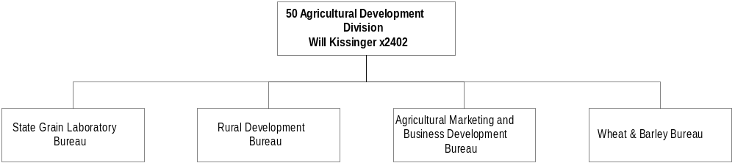

Program Description - The Agricultural Development Division administers programs to promote Montana agriculture through market development and enhancement. Assistance is given toward commercialization of traditional as well as innovative agricultural products and processes. The program provides support to the Alfalfa Seed Committee, the Montana Wheat and Barley Committee, the Montana Agricultural Development Council, and the Board of Hail Insurance. The division is comprised of the following Bureaus: Rural Development, Wheat and Barley, Agriculture Marketing & Business Development and State Grain Laboratory. The State Grain Laboratory provides grades, protein determinations, malting barley germination, and falling number tests for contract settlement prices between buyers and sellers of grain crops in Montana.

Program Indicators -

Indicator | Actual FY1998 | Actual FY1999 | Actual FY2000 | Estimated FY2001 | Requested FY2002 | Requested FY2003
Wheat and Barley:
Market Info Requests | 197 | 229 | 242 | 280 | 300 | 325
Research & Mktg Projects | 78 | 72 | 74 | 79 | 82 | 82
Foreign Trade Delegation  Representatives | 39 | 66 | 61 | 60 | 60 | 60
State Grain Lab:
Official & Submitted  Grades | 21,969 | 22,308 | 22,044 | 25,431 | 26,193 | 26,978
Commodity Grades (Peas,  Beans, Lentils) | 359 | 410 | 314 | 476 | 490 | 504
Related Testing (Proteins,  Germinations, Falling  Numbers) | 23,058 | 22,627 | 25,781 | 26,691 | 27,491 | 28,315
Hail Insurance:
Insurance Policies* | 2,218 | 1,998 | 1,628 | 1,900 | 2,100 | 2,300
Acreage Insured* | 1,401,272 | 1,324,798 | 1,032,353 | 1,204,600 | 1,331,400 | 1,458,200
Ag Finance:
Junior Ag Loans | 179 | 161 | 149 | 160 | 172 | 185
Subordination Loans | 11 | 10 | 8 | 9 | 9 | 10
Rural Assistance Loans | 49 | 61 | 56 | 58 | 60 | 62
Loan Portfolio Amount | $1,665,838 | $2,046,694 | $1,810,602 | $1,955,450 | $2,111,886 | $2,280,836
Marketing & Business Development:
GTA Investment Portfolio | $417,710 | $211,140 | $312,458 | $1,000,000 | $1,000,000 | $1,000,000
Promotions Conducted | 7 | 7 | 7 | 9 | 10 | 12
Trade Shows | 4 | 4 | 4 | 6 | 7 | 9
Trade Missions | 4 | 4 | 5 | 5 | 6 | 6
Companies Assisted w/  Business Start-up | 5 | 8 | 5 | 7 | 10 | 15
Market Assistance (est) | 783 | 914 | 1350 | 1425 | 1500 | 1650
Value-Added Newsletter | 450 | 500 | 650 | 800 | 1000 | 1000
Company marketing plan  assistance | 3 | 4 | 4 | 8 | 10 | 15
Trade Show participants | 6 | 8 | 8 | 15 | 15 | 20

Program Proposed Budget  Budget Item | Base  Budget  Fiscal 2000 | PL Base Adjustment  Fiscal 2002 | New  Proposals  Fiscal 2002 | Total  Exec. Budget  Fiscal 2002 | PL Base Adjustment  Fiscal 2003 | New  Proposals  Fiscal 2003 | Total  Exec. Budget  Fiscal 2003
FTE | 39.88 | 0.00 | 0.00 | 39.88 | 0.00 | 0.00 | 39.88
Personal Services | 1,012,519 | 447,300 | 0 | 1,459,819 | 455,417 | 0 | 1,467,936
Operating Expenses | 1,121,217 | 205,224 | 0 | 1,326,441 | 164,758 | 0 | 1,285,975
Equipment | 0 | 94,800 | 0 | 94,800 | 38,300 | 0 | 38,300
Grants | 882,498 | 78,762 | 0 | 961,260 | 83,583 | 0 | 966,081
Transfers | 80,000 | 0 | 0 | 80,000 | 0 | 0 | 80,000
Debt Service | 1,308 | 0 | 0 | 1,308 | 0 | 0 | 1,308
Total Costs | $3,097,542 | $826,086 | $0 | $3,923,628 | $742,058 | $0 | $3,839,600
General Fund | 327,448 | 31,887 | 0 | 359,335 | 34,791 | 0 | 362,239
State/Other Special | 2,482,175 | 765,013 | 0 | 3,247,188 | 677,755 | 0 | 3,159,930
Federal Special | 45,243 | 467 | 0 | 45,710 | 467 | 0 | 45,710
Proprietary | 242,676 | 28,719 | 0 | 271,395 | 29,045 | 0 | 271,721
Total Funds | $3,097,542 | $826,086 | $0 | $3,923,628 | $742,058 | $0 | $3,839,600

Proprietary Rates

Program Description -The department has two proprietary funds (06011 and 06016) being reported together.

The Montana Agricultural Loan Authority (MALA) was established in 1983 to administer the Beginning Farm Loan Program enacted under 80-12-101 through 80-12-403, MCA. MALA has been inactive since the last loan was issued in 1985. The intent of MALA was to provide for issuance of private purpose tax exempt revenue bonds to facilitate the Beginning Farm Loan Program. However, the Tax Reform Act of 1984 added restrictions to the use of private purpose bonds and prevented bond counsel from issuing clear opinions concerning the tax exempt status of MALA bonds. The Tax Reform Act of 1986 further restricted the use of private purpose tax exempt revenue bonds and again clouded the tax exempt status of the bonds. As a result, lender confidence was lost and very few borrowers could qualify. Eligibility and lender trust continued to deteriorate and the department was unable to provide a self-funded program as required by legislative intent. A proprietary account is maintained on the department books to implement the tax deductions portion of the MALA, which is still in effect under 80-12-211, MCA. The department receives one or two requests each year. The program allows for a Montana income tax and/or capital gains deduction up to $50,000 to the seller of agricultural land sold to a qualifying beginning farmer or rancher. They must meet all qualifications of the program and be approved through the department. A $25 application fee is charged to determine eligibility.

Revenues and Expenses -

No revenue was collected for the Beginning Farm Loan Program.

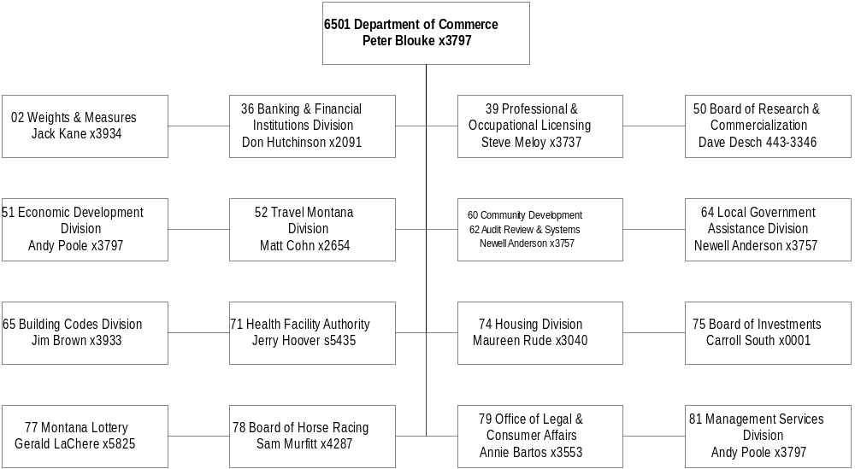

Mission Statement - To enhance the quality of life in Montana by working with our community partners to foster community-led diversification of our economy; to maintain and improve our infrastructure, housing and facilities; and to protect the public by providing a reasonable, customer-oriented regulatory environment.

In support of this mission, the Department of Commerce is committed to:
- Working in partnership with our customers who are economic development organizations, businesses, communities, governmental entities, elected officials, and the public to improve the state's economy through business creation, expansion, retention, and diversification of the state's economic base.
- Enhancing the growth of the Montana economy through the promotion of tourism development and marketing of Montana as a travel and film making destination.
- Promoting access to new markets, both foreign and domestic, for Montana goods and services.
- Developing courses of action and statutory changes which facilitate the growth and health of responsible business enterprises in Montana.
- Providing grants and technical assistance to Montana communities and counties to develop and improve public infrastructure and housing opportunities for the state's citizens.
- Creating a regulatory environment for industries, professionals, and consumers that maintains public confidence, security, service integrity and stability, while fostering a flexible, customer-oriented approach towards the future.
- Pursuing regulatory objectives in a manner that minimizes the costs and complexities of regulation without sacrificing quality.
- Fair and equal treatment of our fellow employees and customers, those who might serve us as volunteers, and those with whom we contract for services.

Statutory Authority - Title 2, Chapter 15, part 3015, MCA, Agriculture Development Council; Title 37, Chapter 1, part 1, MCA, duties and authority of department, director, and boards; and Title 90, Chapter 1, part 1, MCA, planning and economic development.

Executive Budget Recommendation –
- Continue the operations of the Board of Research and Commercialization
- Increase federal grants to Montana communities for economic development projects
- Allow department staff and the general public access to Census data on the Internet
- Increase federal grants to Montana communities for infrastructure, public facility, and housing projects
- Provide building codes education and training for building officials, design professionals and contractors in accordance with HB 245 passed by the 1999 Legislature
- Continue the Section 8 project-based and tenant-based housing assistance programs
- Provide consumer education using proceeds from class action lawsuits filed on behalf of Montana consumers

Agency Proposed Budget  Budget Item | Base  Budget  Fiscal 2000 | PL Base Adjustment  Fiscal 2002 | New  Proposals  Fiscal 2002 | Total  Exec. Budget  Fiscal 2002 | PL Base Adjustment  Fiscal 2003 | New  Proposals  Fiscal 2003 | Total  Exec. Budget  Fiscal 2003
FTE | 241.81 | 4.00 | 0.00 | 245.81 | 4.00 | 1.00 | 246.81
Personal Services | 8,274,062 | 1,305,274 | 0 | 9,579,336 | 1,366,705 | 28,552 | 9,669,319
Operating Expenses | 13,237,039 | 3,116,919 | 459,250 | 16,813,208 | 2,898,807 | 677,100 | 16,812,946
Equipment | 215,069 | 408,684 | 0 | 623,753 | 41,030 | 0 | 256,099
Grants | 26,823,294 | 43,279,420 | 24,983 | 70,127,697 | 46,258,803 | 58,459 | 73,140,556
Debt Service | 239,272 | 916,354 | 0 | 1,155,626 | 916,353 | 0 | 1,155,625
Total Costs | $48,788,736 | $49,026,651 | $484,233 | $98,299,620 | $51,481,698 | $764,111 | $101,034,545
General Fund | 2,095,231 | 553,958 | 78,604 | 2,727,793 | 516,285 | 72,454 | 2,683,970
State/Other Special | 12,273,510 | 2,180,134 | (31,371) | 14,422,273 | 2,036,628 | 30,657 | 14,340,795
Federal Special | 27,677,052 | 44,143,603 | 0 | 71,820,655 | 46,966,323 | 0 | 74,643,375
Proprietary | 6,742,943 | 2,148,956 | 437,000 | 9,328,899 | 1,962,462 | 661,000 | 9,366,405
Total Funds | $48,788,736 | $49,026,651 | $484,233 | $98,299,620 | $51,481,698 | $746,111 | $101,034,545

WEIGHT & MEASURES DIVISION

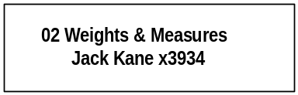

Program Description - The Weights & Measures Bureau is responsible for licensing, inspecting, testing, and certifying all weighing or measuring devices used in commercial transactions in the State of Montana. The bureau also enforces laws and regulations pertaining to quantity control of prepackaged goods and quality control of petroleum products. The bureau is responsible for maintaining the state standards of mass and volume which are used to calibrate other mass or volume standards that are used in testing commercial devices. Program responsibilities are mandated in Title 30, Chapter 12, and Title 82, Chapter 15, MCA

Program Indicators –

Indicator | Actual FY1998 | Actual FY1999 | Actual FY2000 | Estimated FY2001 | Requested FY2002 | Requested FY2003
Scales Licensed | 6,094 | 6,739 | 6,692 | 6,750 | 6,800 | 6,850
Tested, Inspected, Certified | 4,434 | 6,362 | 6,434 | 6,413 | 6,460 | 6,508
Inspection % | 72.76% | 94.50% | 96.14% | 95.00% | 95.00% | 95.00%

Program Proposed Budget  Budget Item | Base  Budget  Fiscal 2000 | PL Base Adjustment  Fiscal 2002 | New  Proposals  Fiscal 2002 | Total  Exec. Budget  Fiscal 2002 | PL Base Adjustment  Fiscal 2003 | New  Proposals  Fiscal 2003 | Total  Exec. Budget  Fiscal 2003
FTE | 11.00 | 0.00 | 0.00 | 11.00 | 0.00 | 0.00 | 11.00
Personal Services | 428,916 | 4,222 | 0 | 433,138 | 6,945 | 0 | 435,861
Operating Expenses | 201,865 | 4,513 | 0 | 206,378 | 3,503 | 0 | 205,368
Equipment | 63,000 | 599 | 0 | 63,599 | 0 | 0 | 63,000
Total Costs | $693,781 | $9,334 | $0 | $703,115 | $10,448 | $0 | $704,229
State/Other Special | 693,781 | 9,334 | 0 | 703,115 | 10,448 | 0 | 704,229
Total Funds | $693,781 | $9,334 | $0 | $703,115 | $10,448 | $0 | $704,229

BANKING & FINANCIAL DIVISION

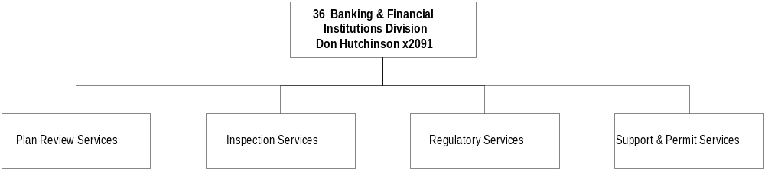
Program Description - The Banking and Financial Institutions Division is responsible for the supervision, regulation, and examination of 1) state-chartered banks, trust companies, savings and loans, and credit unions; 2) consumer loan and sales finance companies; 3) escrow companies; 4) foreign capital depositories in accordance with Title 32, MCA; and 5) deferred deposit loan companies. The purpose of the supervisory function is to investigate the methods of operation and determine if these institutions are operating in a safe and sound manner. Supervision of regulated financial businesses is accomplished through on-site safety and soundness examinations conducted by division examiners. Division responsibilities are mandated primarily in Titles 2, 31, and 32, MCA..

Program Indicators -

Indicator | Actual FY1998 | Actual FY1999 | Actual FY2000 | Estimated FY2001 | Requested FY2002 | Requested FY2003
Examinations performed | 48 | 49 | 55 | 108 | 200 | 220
Licenses issued | 459 | 499 | 548 | 570 | 600 | 600

Program Proposed Budget  Budget Item | Base  Budget  Fiscal 2000 | PL Base Adjustment  Fiscal 2002 | New  Proposals  Fiscal 2002 | Total  Exec. Budget  Fiscal 2002 | PL Base Adjustment  Fiscal 2003 | New  Proposals  Fiscal 2003 | Total  Exec. Budget  Fiscal 2003
FTE | 28.75 | 0.00 | 0.00 | 28.75 | 0.00 | 0.00 | 28.75
Personal Services | 880,902 | 249,400 | 0 | 1,130,302 | 254,859 | 0 | 1,135,761
Operating Expenses | 355,933 | 100,185 | 0 | 456,118 | 102,509 | 0 | 458,442
Equipment | 0 | 1,917 | 0 | 1,917 | 0 | 0 | 0
Total Costs | $1,236,835 | $351,502 | $0 | $1,588,337 | $357,368 | $0 | $1,594,203
State/Other Special | 1,236,835 | 351,502 | 0 | 1,588,337 | 357,368 | 0 | 1,594,203
Total Funds | $1,236,835 | $351,502 | $0 | $1,588,337 | $357,368 | $0 | $1,594,203

Language Recommendations –
The following language is recommended for HB2:
"The department is appropriated in each of the fiscal years 2002 and 2003 up to $500,000 of state special revenue that is deposited in the account established for the purpose of processing charter applications and for the chartering, examination, and regulation of each foreign capital depository that obtains a charter under the provisions of 32-8-205."

POL DIVISION

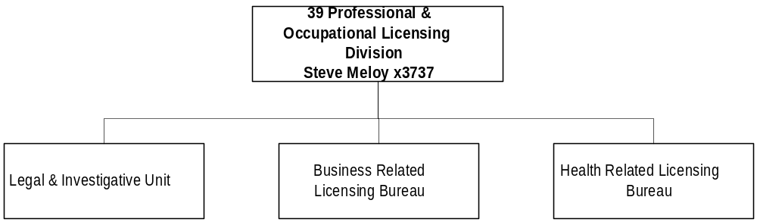

Program Description - The Professional and Occupational Licensing (POL) Division provides the administrative and clerical services required by the 38 professional boards and occupational licensing programs authorized by state statutes. Services provided include correspondence, application processing, issuing and renewing licenses, administering and grading examinations, taking minutes of board meetings, and hearings, and providing legal staff and investigators to investigate legal infractions. The work is mandated in Title 2, Chapter 15, part 18 and Titles 23, 37, and 50, MCA.

Program Proposed Budget  Budget Item | Base  Budget  Fiscal 2000 | PL Base Adjustment  Fiscal 2002 | New  Proposals  Fiscal 2002 | Total  Exec. Budget  Fiscal 2002 | PL Base Adjustment  Fiscal 2003 | New  Proposals  Fiscal 2003 | Total  Exec. Budget  Fiscal 2003
FTE | 32.53 | 2.50 | 0.00 | 35.03 | 2.50 | 0.00 | 35.03
Personal Services | 1,020,151 | 282,131 | 0 | 1,302,282 | 290,530 | 0 | 1,310,681
Operating Expenses | 3,616,538 | 473,080 | 0 | 4,089,618 | 397,262 | 0 | 4,013,800
Debt Service | 7,548 | 2,500 | 0 | 10,048 | 2,500 | 0 | 10,048
Total Costs | $4,644,237 | $757,711 | $0 | $5,401,948 | $690,292 | $0 | $5,334,529
State/Other Special | 4,644,237 | 757,711 | 0 | 5,401,948 | 690,292 | 0 | 5,334,529
Proprietary | 0 | 0 | 0 | 0 | 0 | 0 | 0
Total Funds | $4,644,237 | $757,711 | $0 | $5,401,948 | $690,292 | $0 | $5,334,529

Proprietary Rates

Program Description -The Division of Professional and Occupational Licensing (POL) is charged with licensing and regulating persons and businesses engaged in specific professions and occupations as designated by the legislature. By statute, the 38 professional licensing and regulatory boards/programs are empowered to protect the health, safety, and welfare of the citizens of Montana; adopt rules to conduct business; set procedures; discipline peers; evaluate potential licensees; hold oral interviews; evaluate continuing education programs; hold hearings for disciplinary action; and work in conjunction with associations to maintain high standards of excellence for the regulated professions and occupations within the state. The Division typically issues over 80,000 professional and occupational licenses annually.

The Division provides all the professional, technical, administrative, legal, and clerical services required by the professional licensing regulatory boards/programs authorized by state statutes. Services provided include corresponding with the public and licensees; processing applications for licensees; issuing licenses granted by the boards and programs; renewing licenses; requiring and enforcing continuing education credits for licensees where specified by law; levying fines under the jurisdiction of appropriate boards and programs; inspecting businesses where appropriate; and taking minutes of board meetings and hearings. The Division also arranges for meeting and/or examination facilities for each board and licensing program; administers and grades examinations where required; provides legal staff, investigators and inspectors to investigate legal infractions upon requests from the boards and programs; and initiates disciplinary actions and other legal actions against licensees and unlicensed practitioners. These administrative support functions enable the boards and programs to provide effective and efficient services to the public.

Funding for the POL Pool (HB 576 FUND 06552, an internal service fund) is derived through recharges assessed to the special revenue accounts as authorized by 37-1-101 and 131, MCA, and is based upon a cost-allocation formula.

Revenues and Expenses -
Changes in Services or Fees: There has been no significant change in the services provided by the POL Pool to supported boards and licensing programs from the last biennium. Rates for the Pool have been: (FY98 - 33.68 percent) (FY99 - 33.38 percent) (FY00 - 35.61 percent) (FY01 35.68 percent), and requested 2003 biennium rates are 38.00 percent each year. There are 36.25 FTE funded through recharges to supported boards and occupational licensing programs in 2001 biennium.

Working Capital Discussion: Recharges are allocated to the state special revenue accounts based upon requested appropriations, less any program direct personal services amounts, for each program. Recharges are calculated by totaling all adjusted state special revenue accounts. Based on the total, a percentage is calculated for each state special revenue account to determine a percentage rate. That rate is then multiplied by the total recharge revenue amount to determine the recharge assessment to each program.

The revenue objective of the POL Pool is to assess the common costs of operations to the special revenue accounts on an equitable basis while attempting to maintain a reasonable working capital reserve.

Fund Equity and Reserved Fund Balance: At the proposed 38 percent rate, the Department projects a fiscal 2003 ending fund balance of $320,144, or a 42-day working capital reserve.

Cash Flow Discussion: Recharges are charged to state special revenue accounts on a ongoing basis so a reasonable and prudent working capital reserve must be maintained.

Rate Explanation -The recharge rates proposed for the 2003 biennium are the most appropriate because they most closely match the fees commensurate with cost philosophy, while maintaining a reasonable and prudent working capital reserve.

RESEARCH AND COMMERCIALIZATION PGM

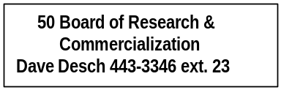

Program Description - The Board of Research and Commercialization Technology was created by the 1999 Montana Legislature to provide a predictable and stable source of funding for research and commercialization projects; expand and strengthen research efforts for the state's basic industries to increase their economic impact on the state economy; and expand research efforts into areas beyond the scope of the basic industries to diversify and strengthen economic security through the creation of technology-based operations and long-tem quality jobs.

The board has the authority to make grants or loans to research and commercialization centers if the projects to be funded 1) have potential to diversify or add value to a traditional basic industry of the state economy, 2) show promise for enhancing technology-based sectors or commercial development of discoveries, 3) employ or take advantage of existing research and commercialization strengths, 4) have a realistic and achievable project design, 5) employ an innovative technology, 6) are located in the state, 7) have a qualified research team, 8) have scientific merit based on peer review, and 9) include research opportunities for students. The board responsibilities are mandated primarily in Title 90, Chapter 10, MCA.

Program Proposed Budget  Budget Item | Base  Budget  Fiscal 2000 | PL Base Adjustment  Fiscal 2002 | New  Proposals  Fiscal 2002 | Total  Exec. Budget  Fiscal 2002 | PL Base Adjustment  Fiscal 2003 | New  Proposals  Fiscal 2003 | Total  Exec. Budget  Fiscal 2003
FTE | 2.00 | 0.00 | 0.00 | 2.00 | 0.00 | 0.00 | 2.00
Personal Services | 0 | 71,245 | 0 | 71,245 | 71,493 | 0 | 71,493
Operating Expenses | 1,204 | 76,832 | 0 | 78,036 | 77,303 | 0 | 78,507
Equipment | 0 | 719 | 0 | 719 | 0 | 0 | 0
Total Costs | $1,204 | $148,796 | $0 | $150,000 | $148,796 | $0 | $150,000
General Fund | 1,204 | 148,796 | 0 | 150,000 | 148,796 | 0 | 150,000
Total Funds | $1,204 | $148,796 | $0 | $150,000 | $148,796 | $0 | $150,000

Significant Present Law Adjustments -
- Continue operations of the Board of Research and Commercialization as approved in the May special session
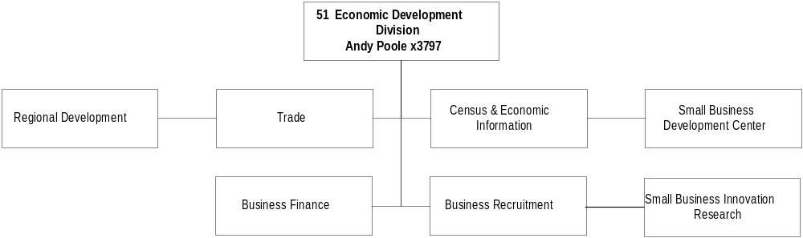

Program Description - The Economic Development Division is comprised of a variety of programs aimed at improving, enhancing, and diversifying Montana's economic and business climate. Working closely with private sector economic and community development partners, other department divisions, state agencies, and federal and private programs, the division strives to enhance the economic base of Montana through business creation, expansion, and retention efforts. Technical and financial assistance and relationships with local development groups, chambers, and similar organizations provide a springboard to help Montana communities develop their full economic potential. Economic development responsibilities are mandated primarily in Title 30, Chapter 16; Title 17, Chapter 6; and Title 90, Chapter 1, MCA.

Program Proposed Budget  Budget Item | Base  Budget  Fiscal 2000 | PL Base Adjustment  Fiscal 2002 | New  Proposals  Fiscal 2002 | Total  Exec. Budget  Fiscal 2002 | PL Base Adjustment  Fiscal 2003 | New  Proposals  Fiscal 2003 | Total  Exec. Budget  Fiscal 2003
FTE | 26.00 | 0.50 | 0.00 | 26.50 | 0.50 | 0.00 | 26.50
Personal Services | 1,025,833 | 101,667 | 0 | 1,127,500 | 107,277 | 0 | 1,133,110
Operating Expenses | 1,278,071 | 61,686 | 22,250 | 1,362,007 | 53,355 | 16,100 | 1,347,526
Equipment | 0 | 8,624 | 0 | 8,624 | 0 | 0 | 0
Grants | 2,214,579 | 875,760 | 0 | 3,090,339 | 875,760 | 0 | 3,090,339
Total Costs | $4,518,483 | $1,047,737 | $22,250 | $5,588,470 | $1,036,392 | $16,100 | $5,570,975
General Fund | 1,090,864 | 153,824 | 22,250 | 1,266,938 | 142,078 | 16,100 | 1,249,042
State/Other Special | 236,521 | 12,139 | 0 | 248,660 | 12,139 | 0 | 248,660
Federal Special | 3,191,098 | 881,774 | 0 | 4,072,872 | 882,175 | 0 | 4,073,273
Total Funds | $4,518,483 | $1,047,737 | $22,250 | $5,588,470 | $1,036,392 | $16,100 | $5,570,975

Significant Present Law Adjustments -
- Catalog and maintain the Census and Economic Information Center library collection
- Increase federal grants to Montana communities for economic development projects

New Proposals -
- Allow department staff and the general public access to Census data on the Internet
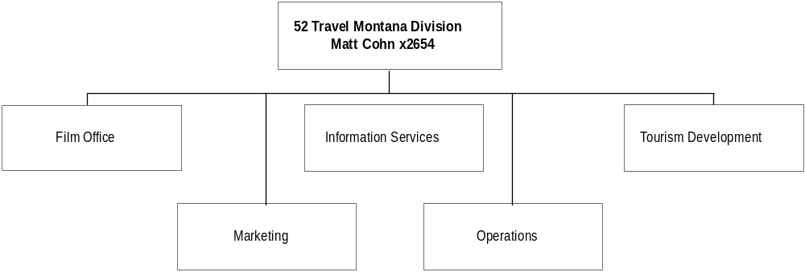

Program Description - The Travel Montana Division strives to strengthen Montana's economy through increased visitor travel, visitor expenditures, and the filming of motion pictures and commercials in the state. The division works to project a positive image of the state through consumer advertising, publicity, international and domestic group travel marketing, printing and distribution of literature, and marketing to motion picture and television production companies. The division is funded primarily by the statutorily-appropriated lodging facility use tax and uses these monies to provide training and assistance to the Montana tourism industry, administer and distribute infrastructure grants, and oversee expenditures of six regional non-profit corporations and the nine specific cities where lodging facility use tax collections exceed $140,000. The division is mandated primarily in Title 15, Chapter 65, and Title 2, Chapter 15, MCA.

Program Proposed Budget  Budget Item | Base  Budget  Fiscal 2000 | PL Base Adjustment  Fiscal 2002 | New  Proposals  Fiscal 2002 | Total  Exec. Budget  Fiscal 2002 | PL Base Adjustment  Fiscal 2003 | New  Proposals  Fiscal 2003 | Total  Exec. Budget  Fiscal 2003
FTE | 0.00 | 0.00 | 0.00 | 0.00 | 0.00 | 0.00 | 0.00
Operating Expenses | 567,913 | 197,236 | 0 | 765,149 | 182,087 | 0 | 750,000
Total Costs | $567,913 | $197,236 | $0 | $765,149 | $182,087 | $0 | $750,000
State/Other Special | 567,913 | 197,236 | 0 | 765,149 | 182,087 | 0 | 750,000
Total Funds | $567,913 | $197,236 | $0 | $765,149 | $182,087 | $0 | $750,000

COMMUNITY DEVELOPMENT DIVISION

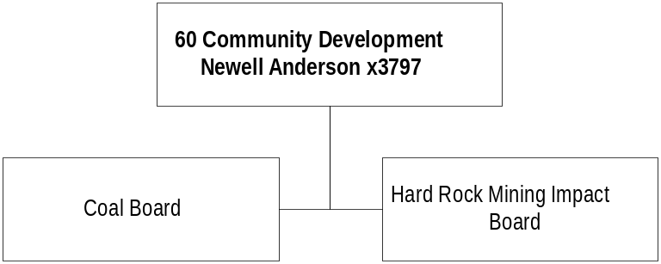

Program Description - The Community Development Bureau works with federal, state, and local governments, and the private sector, in all areas of community development including public facilities planning and financing, community planning and growth management, subdivision regulation and zoning, housing development for low- and moderate-income families, neighborhood revitalization, needs assessment, and coal and hard rock mining mitigation, and project management. The three major programs within the bureau are the Community Technical Assistance Program (CTAP), the Community Development Block (CDBG) Program, and the Treasure State Endowment Program (TSEP). The Montana Coal Board and the Montana Hard Rock Mining Impact Board and their respective programs are attached to the bureau for administrative purposes. These five programs, individually and collectively, provide both financial and technical assistance to Montana communities, local elected officials and staff, nonprofit organizations, private sector developers and consultants, and private citizens. Other assisted entities include local planning boards and zoning commissions, community development corporations, human resource development councils, water and sewer districts, fire departments, and housing authorities. Bureau work is mandated primarily in Title 90, Chapter 1 and Chapter 6, MCA; and federal authorizations 24 CFR 570, subpart 1; and 42 USC 5301.

Program Indicators –

Indicator | Actual FY1998 | Actual FY1999 | Actual FY2000 | Estimated FY2001 | Requested FY2002 | Requested FY2003
Coal Board
Applications | 1 | 40 | 26 | 20 | 20 | 15
Grants | 1 | 1 | 14 | 8 | 12 | 7
Hard Rock Mining
Board Meetings | 2 | 3 | 3 | 4 | 4 | 4
Conference Calls | 3 | 3 | 3 | 3 | 3 | 3
*Contacts:
Public | 35 | 36 | 37 | 40 | 40 | 40
Private | 5 | 6 | 6 | 8 | 8 | 8
CTAP
Customers Assisted | 2,000 | 2,000 | 2,300 | 2,300 | 2,300 | 2,300
Workshops & Meetings | 25 | 25 | 25 | 25 | 25 | 25
Publications | 2,000 | 2,000 | 6,000 | 2,500 | 2,500 | 2,500
Videos | 4 | 7 | 7 | 7 | 7 | 7
Internet Programs | 2 | 2 | 2 | 2 | 2 | 2
County Land Planning
Grants to Counties | 56 | 56 | 56 | 56 | 56 | 56
CDBG Program
Applications Reviewed:
Public Facilities | 15 | 20 | 16 | 16 | 16 | 16
Housing | 6 | 7 | 7 | 7 | 7 | 7
Planning | 25 | 36 | 25 | 25 | 25 | 25
Grants Awarded:
Public Facilities | 7 | 8 | 8 | 8 | 8 | 8
Housing | 6 | 5 | 4 | 4 | 4 | 4
Planning | 18 | 22 | 19 | 19 | 19 | 19
TSEP Program
Applications Reviewed | 0 | 41 | 0 | 39 | 0 | 50
Construction Project Awards | 22 | 0 | 32 | 0 | 30 | 36
Active Projects | 38 | 48 | 42 | 38 | 68 | 68
Preliminary Engineering Grants |  |  |  |  | 29 | 0

Program Proposed Budget  Budget Item | Base  Budget  Fiscal 2000 | PL Base Adjustment  Fiscal 2002 | New  Proposals  Fiscal 2002 | Total  Exec. Budget  Fiscal 2002 | PL Base Adjustment  Fiscal 2003 | New  Proposals  Fiscal 2003 | Total  Exec. Budget  Fiscal 2003
FTE | 13.50 | 0.00 | 1.00 | 14.50 | 0.00 | 1.00 | 14.50
Personal Services | 542,993 | 21,370 | 0 | 564,363 | 24,646 | 28,552 | 596,191
Operating Expenses | 504,652 | 137,610 | 0 | 642,262 | 130,984 | 0 | 635,636
Equipment | 6,309 | 3,114 | 0 | 9,423 | 0 | 0 | 6,309
Grants | 7,415,242 | 1,915,544 | 24,983 | 9,355,769 | 1,915,544 | 58,459 | 9,389,245
Total Costs | $8,469,196 | $2,077,638 | $24,983 | $10,571,817 | $2,071,174 | $87,011 | $10,627,381
General Fund | 359,188 | 89,195 | 0 | 448,383 | 86,772 | 0 | 445,960
State/Other Special | 1,803,777 | 113,950 | 24,983 | 1,942,710 | 109,437 | 87,011 | 2,000,225
Federal Special | 6,306,231 | 1,874,493 | 0 | 8,180,724 | 1,874,965 | 0 | 8,181,196
Total Funds | $8,469,196 | $2,077,638 | $24,983 | $10,571,817 | $2,071,174 | $87,011 | $10,627,381

Significant Present Law Adjustments -
- Increase federal grants to Montana communities for infrastructure, public facility, and housing projects

New Proposals -
- Expand grants to local communities for coal impact mitigation

Language Recommendations – The following language is recommended for HB2:

“The Montana coal board is authorized up to $2,000,000 state special revenue during the 2003 biennium for grants dependent on available revenue in the coal severance tax shared account.”

LOCAL GOV'T. SERVICES DIVISION

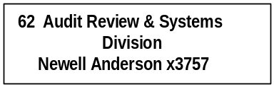

Program Description - The Local Government Services Division consists primarily of two programs - the Local Government Accounting Systems Program and the Local Government Audit Review Program. The Local Government Accounting Systems Program provides technical assistance and training to local government accounting and financial personnel in the areas of local government finance, accounting, budgeting and financial reporting through on-site visits, telephone assistance, and local government training seminars held at various locations throughout the state on a periodic basis. Program staff also serves as liaisons between local governments and various state agencies. The Local Government Audit Review Program is responsible for defining, reviewing, and enforcing auditing requirements for Montana local governments. Program staff review all of the jurisdictions' annual financial reports and certify compliance of local governments with the state Single Audit Act. Systems program work is mandated primarily in Article VIII, Section 12 of the Montana Constitution; Title 2, Chapters 6 and 7; Title 7, Chapters 1, 2, 3, 5, and 6; Title 19, Chapter 18; Title 20, Chapter 1; and, Title 85, Chapter 7, MCA. Audit review program work is mandated primarily in Title 2, Chapter 7, part 5, MCA.

Program Indicators –

Indicator | Actual FY1998 | Actual FY1999 | Actual FY2000 | Estimated FY2001 | Requested FY2002 | Requested FY2003
LGS Systems Program
On Site Assistance (Hours)
LGS Systems Program  On Site Assistance (Hours) | 3,808 | 5443 | 4340 | 5400 | 5700 | 5700
LGS Audit Review Program
Local Government Audits
LGS Audit Review Program  Local Government Audits | 429 | 483 | 455 | 460 | 460 | 460

Program Proposed Budget  Budget Item | Base  Budget  Fiscal 2000 | PL Base Adjustment  Fiscal 2002 | New  Proposals  Fiscal 2002 | Total  Exec. Budget  Fiscal 2002 | PL Base Adjustment  Fiscal 2003 | New  Proposals  Fiscal 2003 | Total  Exec. Budget  Fiscal 2003
FTE | 6.00 | 0.00 | 0.00 | 6.00 | 0.00 | 0.00 | 6.00
Personal Services | 249,113 | 13,603 | 0 | 262,716 | 15,516 | 0 | 264,629
Operating Expenses | 151,616 | 18,075 | 0 | 169,691 | 17,566 | 0 | 169,182
Equipment | 0 | 1,198 | 0 | 1,198 | 0 | 0 | 0
Total Costs | $400,729 | $32,876 | $0 | $433,605 | $33,082 | $0 | $433,811
General Fund | 400,729 | 32,876 | 0 | 433,605 | 33,082 | 0 | 433,811
Total Funds | $400,729 | $32,876 | $0 | $433,605 | $33,082 | $0 | $433,811

Proprietary Rates

Program Description -Audit Review Program (06042) and Local Government Audit & Systems (Defalcation Audit Program) (06043) Descriptions:

Audit Review (06042):
The Audit Review program is responsible for administering the provisions of the Montana Single Audit Act (Title 2, Chapter 7, part 5, MCA), which specifies the audit requirements for all Montana local governments entities. The program performs the following services:

- Mails out and receives annual financial reports from approximately 900 local governments;
- Enters selected financial data from the reports into a database;
- Obtains and enters into the database information regarding school district revenues,
- Determines which local government entities are subject to audit under the act and notifies them of the audit requirements;
- Accepts applications from and maintains a roster of independent auditors authorized to conduct local government audits;
- Prepares and keeps current a legal compliance supplement for use by independent auditors in conducting local government audits;
- Receives and approves audit contracts for local government audits;
- Verifies that all local governments required to have audits do so;
- Receives and reviews local government audit reports to determine whether the audits have been conducted in accordance with required standards;
- Notifies state agencies of audit findings related to financial assistance programs that they administer;
- Receives and reviews each local government's response to the audit report findings and determines whether the entity has developed a satisfactory plan to correct deficiencies noted in the audit report;
- Maintains on file copies of all local government entity audit reports and the local government responses to audit findings, and makes those reports and responses available upon request to state and federal agencies and the public;
- Provides technical advice on accounting, auditing, and legal compliance matters to local governments and certified public accountants conducting local government audits;
- Investigates or refers to auditors for follow-up action complaints or allegations received from the public, either directly or through the Legislative Auditor’s Hotline; and
- Provides information regarding local government audits, audit findings, entity responses to findings, and legal compliance and accounting requirements to the public.

Primary Program Mandates: The work of the Audit Review program is mandated primarily in Title 2, Chapter 7, part 5, MCA.

Funding: Funding for the Audit Review Program (HB 576 fund 06042) is primarily derived from filing fees paid by local governments that are required to be audited by the Montana Single Audit Act (2-7-514, MCA) and from fees paid by certified public accountants who wish to be included on the roster of independent auditors authorized to conduct audits of local governments.

Defalcation Audit (06043):
Title 2-7-503(5) & (6), MCA, state that the department "...may at any time conduct or contract for a special audit or review of the affairs of any local government entity referred to in this part. The special audit or review must, to the extent practicable, build upon audits performed pursuant to this part. (6) The fee for the special audit or review must be a charge based upon the costs incurred by the department in relation to the special audit or review. The audit fee must be paid by the local government entity to the state treasurer and deposited in the enterprise fund to the credit of the department." It is the Defalcation Audit Program’s responsibility to meet the requirements of the aforementioned statute in regards to the need for special audits or reviews.

Based upon an executive recommendation, the 54th Legislative Assembly privatized the Audit Program in the Local Government Assistance Division. Previously, the state provided for the financial and compliance post auditing of the financial statements of local taxing jurisdictions in Montana, as required by law. Private accounting firms now conduct these audits. The auditing is designed to protect the taxpayers' interests by verifying that the financial conditions and operations are responsibly accounted for and reported and that local officials are complying with appropriate statutes and regulations.

With the privatization of the Audit Program came the legislative recognition that the state would no longer have any practicing local government audit staff and the question was asked: "What if a local government experiences a significant defalcation or is called on for some alleged financial or reporting impropriety to have a special audit or review? Who makes the special audit or review decisions if the local government can't or won't?" Under 2-7-503, MCA, the Department of Commerce (Local Government Audit Review and Systems Bureau) has the administrative responsibility, if deemed appropriate, to require that a special audit or review be conducted of a local government entity. Included in this responsibility is the capacity of the state to contract and pay a private CPA firm for the costs of conducting the special audit or review. The special audit or review fee must be paid by the local government entity to the state treasurer and deposited in the enterprise fund to the credit of the department. In many cases, however, the audited local government entity lacks the fiscal resources to pay for the costs of the special audit or review. The department will collect all funds that can be collected.

Primary Program Mandates: The work of the Defalcation Audit program is mandated primarily in Title 2, Chapter 7, part 5, MCA.

Funding: Funding for the Defalcation Audit Program (HB 576 fund 06043) is derived from the reimbursable special audit costs received from local government entities undergoing audits or reviews.

Revenues and Expenses -
(1) Describe any change in provision of service or level of fees:

Audit Review Program:
Based on the most current information available, approximately 470 local government entities will be required to have audits for FY 1999, with approximately another 30 school districts having financial reviews. FY 2000 audit contracts are still being received and processed, and final numbers are not yet available for that fiscal year. Since biennial audits are permitted under Montana law, the department contracts for approximately 450 to audits each year. We anticipate that the number of entities required to be audited each year will remain relatively constant, with a small increase in the number of special purpose districts being required to be audited. As described in more detail above, the program approves contracts for each required audit or financial review, monitors the audit or review progress, and receives copies of the final audit or review report. The program also reviews 100 percent of the audit and review findings and the entity responses to or corrective action plans for those findings, and evaluates the adequacy of the responses or corrective action plans before determining whether or not to accept them. Audit and review findings and entity responses relating to state programs or state administered federal programs are referred to the appropriate state agency for action.

The Audit Review program conducts initial quality control reviews of 100 percent of the audits and financial review reports received. In a typical year, more detailed quality control desk reviews are conducted of approximately 10 to 20 percent of the audit reports received, and detailed quality control reviews of audit working papers are conducted for a limited number of audit reports based on staff time available.

In addition, approximately 900 local governments (excluding school districts and associated cooperatives) are required to file annual financial reports with the department each fiscal year. Information from these reports is utilized to determine whether an entity is required to be audited under state law. The number of annual financial reports received is expected to remain relatively constant, with a small annual increase each year in the number of special purpose districts required to be audited.

To perform the work required at current level, the Audit Review program is currently authorized 4.00 FTE . Staffing is expected to remain at 4.00 FTE for FY 2002 and FY 2003.

The Audit Review program has one major and one minor fee revenue. It is the intent of the department to maintain fees sufficient to pay program operating costs at current level staffing. The Audit Review program does not receive any direct appropriations. Funding is derived entirely from the fees described below. Major Fee: The major fee revenue is the report filing fee required by 2-7-514, MCA. The fee is required by statute to be based upon the costs incurred by the department in the administration of Title 2, Chapter 7, part 5, MCA. 2-7-514, MCA, provides that all local government entities required to be audited under Title 2, Chapter 7, part 5, MCA, shall pay the filing fee. For all local governments except school districts and associated cooperatives, that fee is required to be paid by the local government at the time that it files its annual financial report with the Department of Commerce. In the case of school districts and associated cooperatives, the Office of Public Instruction is required to file a listing of school districts subject to audit by December 31 each year. OPI is also required to pay the filing fee for school districts and associated cooperatives subject to audit. The Department of Commerce bills OPI for the filing fees once a year in January, based on the information provided by OPI in December in the above report. The Department is required to adopt the fee schedule by administrative rule based upon the local government entities’ revenue amounts. That fee schedule has been adopted as ARM 8.94.4102. Fees were reduced effective for annual financial reports for years ended June 30, 1997 and after, which were those received by the department during FY 1998 and after.
Annual Revenues Equal Annual Revenues
To or Greater Than: Less Than: Fee
$0.00 $200,000 $0.00
$200,000 $500,000 $175.00
$500,000 $1,000,000 $375.00
$1,000,000 $1,500,000 $525.00
$1,500,000 $2,500,000 $600.00
$2,500,000 $5,000,000 $675.00
$5,000,000 $10,000,000 $725.00
$10,000,000 $775.00

The above fee schedule provided $244,600 in revenue for FY 2000. No changes to the fee schedule are currently planned. Revenue from this fee schedule for FY 2001, FY 2002, and FY 2003 is estimated to be approximately $236,000.

The Audit Review program was started as a result of legislation passed in 1991. The initial funding for the program was provided by a general fund loan, which was to be repaid over a 5-year period. The last payment of $34,915 on the loan was made in June, 1997. Therefore, the fee schedule for FY 1998 and after does not include revenue for the loan payment. As noted above, the fee schedule in the administrative rules was revised to reduce fees for FY 1998 and after.
Minor Fee: The minor fee revenue is the roster fee provided for by 2-7-506, MCA. That section provides that the Department of Commerce may prepare and maintain a roster of independent auditors authorized to conduct audits of Montana local government entities. The department, in consultation with the Board of Public Accountants, is required to adopt rules governing the:
- Criteria for the selection of the independent auditor;
- Procedures and qualifications for placing applicants on the roster;
- Procedures for reviewing the qualifications of independent auditors on the roster to justify their continuance on the roster; and
- Fees payable to the department for application for placement on the roster.

The department has adopted the above as ARM 8.94.4106. The current fee in the rule is $50 per year. The Department has no present plans to change the fee, which provides approximately $2,900 per year in revenue.

Defalcation Audit Program:
As mentioned above, the department will solicit bids and contract with qualified CPA firms to conduct any special audits or reviews deemed appropriate and necessary by the Local Government Audit Review and Systems programs. No department FTEs are funded with Defalcation Audit program funds. Any related administrative or monitoring work related to the contracted special audits or reviews is performed by Audit Review program staff. The department anticipates that audit rates will be competitive and to some extent negotiable. It should be noted however, that these type of audit engagements typically involve problematic entities and higher costs are a likely result. Since the state is responsible for contracting directly with the CPA firm conducting the special audit or review it is essential that sufficient resources remain available to pay for such an audit engagement should one be deemed necessary. The department’s cost recovery will be entirely dependent on the fiscal capacity of the audited local government entity. All reasonable efforts will be made to recover special audit costs from audited entities.

It is extremely difficult, if not impossible, to project the number of defalcations, or allegations of extraordinary financial impropriety that might require special audits or reviews in the future. The department is, therefore, projecting FY 2002 and FY 2003 expenditure levels at $65,000 annually, which is the same amount as the current and past biennium. State requested special audits and reviews are not those that can be easily planned for, or if they were, they could be more easily prevented. The appropriation authority and financial resources exist only to protect the taxpayers should their fiscal best interests be in jeopardy.

The revenue objective of the Defalcation Audit Program is to recover any special audit or review costs from audited local government entities in order to ensure that sufficient resources remain available for future special audits or review costs should such engagements be deemed necessary. The Defalcation Audit Program does not receive any direct appropriations. Funding is derived entirely from reimbursable special audit costs received from local government entities undergoing audits or reviews.

(2) Working Capital Discussion:

The accompanying report on the Enterprise Funds showing changes in retained earnings and total fund equity combines the Audit Review Program (06042) and the Defalcation Audit Program (06043).

Audit Review Program: The OBPP guidelines provide that projected working capital reserves may not exceed 60 days average daily expenditures for projected personal services, operating expenses, and miscellaneous operating. The working capital reserve level appears to assume that revenue will be received in some uniform manner throughout the fiscal year. That is not the case for the Audit Review program. The filing fees paid by local governments and the Office of Public Instruction is the major revenue source for the program. The fee, except for school districts and associated cooperatives, is required to be paid at the time that the local government files its annual financial report. Those reports are due within six months after the close of the fiscal year. Since almost all Montana local governments operate on a July 1 to June 30 fiscal year, most reports are due by December 31 and the reports and fees are received by the Department during December. Extensions may be granted, and some reports with the required fees are not paid until several months later. In the case of school districts and associated cooperatives, as noted above under the heading Major Fee, the filing fees for those entities are not paid by the Office of Public Instruction until January. Approximately 2 percent of program revenue is received within the first two months (60 days) of the fiscal year, only 5 percent within the first three months, 9 percent within the first four months, 14 percent within the first five months, and 23 percent within the first six months. Approximately 56 percent is received at one time in January from OPI. In excess of 90% of roster fees paid by CPAs are received between April 15 and June 30 each year. Therefore, depending on the exact time during the year that certain major expenditures are incurred, the program needs approximately a four to five month working capital reserve at the beginning of each fiscal year in order to avoid cash deficits.

In addition, the Audit Program currently maintains a database using Informix software for recording information and generating reports regarding local government annual financial reports, audit contracts, audit reports, audit findings, responses to audit findings, and other related information. The Department of Commerce is utilizing Oracle software for all new major databases established and is converting existing Informix databases to Oracle over a period of time. Although an exact time has not been established, the Audit Review program is tentatively planning on converting its database from Informix to Oracle by FY 2004 at the latest. Assuming that the database conversion will be contracted out and thereafter maintained by department staff, we are estimating one-time contracted services costs of approximately $65,000 to $100,000. The Audit Review program has gradually established an additional reserve in order to pay this one-time contracted services expenditure without having to require a substantial fee increase at that time.

As noted above under the heading "Major Fee," the department amended the administrative rule to reduce fees for the FY 1998 and future fiscal years. Because of the time and expense involved in amending administrative rules, changing forms, and changing computer programs, it is the Audit Review program policy to attempt to keep fees relatively level, without fluctuations from year to year. Therefore, fees were reduced beginning in FY 1998 to a level that would gradually reduce the working capital reserve to the four to five month balance (120 - 150 days) over a period of between five and six years, not including the additional working capital reserve for Oracle data base programming. If fees were reduced significantly to immediately reduce the working capital reserve to the four to five month balance by the end of FY 2001, staff would have to turn around and immediately increase fees by a rather significant amount in order to maintain the reserve at that level. Under either approach the local governments and OPI, on behalf of school districts and special education cooperatives, will pay the same amount over the five to six year period.

Defalcation Audit Program:
As noted previously, it is not possible to accurately predict the number of defalcation audits that will occur during any given fiscal year. Therefore, program revenue and expenses have been estimated at $65,000 each for each fiscal year. As a result, the retained capital, total fund equity, and working capital are not anticipated to change through FY 2002 and FY 2003.

Fund Equity and Reserved Fund Balance:

Audit Review Program:
The Audit Review program has no specific requirement to reserve fund balance. As noted in the previous discussions, the program has attempted to gradually increase unreserved fund balance so as to enable the program to pay the costs associated with the conversion of its database from Informix software to Oracle software without major fee increases at that time. It is management’s objective to gradually reduce unreserved fund balance, less the estimated $65,000 to $100,000 database conversion costs, to approximately $45,000 to $70,000 by the end of FY 2003. This objective is in line with the above discussion of working capital requirement. As such, no fee increase in planned for FY 2001, FY 2002, or FY 2003. With estimated fee revenue less than anticipated expenses, unreserved fund balance should gradually decline to the desired level.

Defalcation Audit Program:
The Defalcation Audit Program has no requirement to reserve fund balance. Management's objective is to maintain the current unreserved fund balance. This is due to the uncertainty regarding how many special audits or reviews will be required in any given year, combined with the possible inability to be fully paid for those audit or review costs by the local governments due to limited fiscal resources.

Cash Flow Discussion:
Audit Review Program:
See previous discussion of the Audit Review program revenue flow under "Working Capital Discussion" above. Most program expenses are incurred fairly uniformly throughout the fiscal year, except for periodic capital outlay and contracted services expenditures. The timing of contracted services expenditures associated with audit reviews cannot normally be preplanned. Other than normal operating costs, there are no significant reoccurring cash obligations that must be covered by cash on hand. There could, however, be a significant cash payout for unused vacation and sick leave in the event of the termination or retirement of long-term employees. One employee with over 30 years of service would have a vacation and sick leave payout in excess of $20,000.

Defalcation Audit Program:
As noted previously, it is virtually impossible to predict the number of required special audits or reviews each year. Therefore, the timing of program expenses for contracted services and the timing of payments from local governments cannot be predicted. The program does not have any reoccurring cash obligations that must be covered by cash on hand.

LOCAL GOVT ASSISTANCE ADMIN

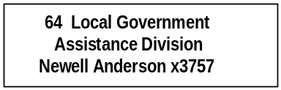

Program Description - The Local Government Assistance Administration program provides the Local Government Services Division with professional administration and legal services. The program supervises both the Community Development Bureau and the Local Government Audit Review and Systems Bureau. Supervised programs include:

Montana Coal Board
Community Development Block Grant Program
Community Technical Assistance Program
Hard Rock Mining Impact Board
Treasure State Endowment Program
Local Government Audit Review Program
Local Government Accounting Systems Program

The Local Government Assistance Administration program functions under multiple federal and state authorities that enable and mandate the individual programs functioning in the Local Government Assistance Division.

Proprietary Rates

Revenues and Expenses -
Changes in Services or Fees: There has been no change in the services provided to supported divisions and programs, or appreciable change in fees from the last biennium. There are 2.50 administrative FTE funded through recharges to supervised divisions and programs.

Working Capital Discussion: The LGA Administration Program rate is calculated by dividing the programs total cost by supported programs requested budgets. The calculated rate is the lowest possible rate as indicated by the negative fund balance, which is a reflection of non-budgeted activities such as compensated absences. This allocation methodology has been used for many, many years and has worked very well. The 60 day Working Capital Calculation was not considered in the determination of rates.

Fund Equity and Reserved Fund Balance: The calculated rate is the lowest possible rate as indicated by the negative fund balance, which is a reflection of non-budgeted activities such as compensated absences.

Cash Flow Discussion: Recharges are charged to supported programs on a biweekly basis according to how much time was worked on each supervised division and program.

Rate Explanation -The revenue objective of the LGA Division Administration program is to maintain the lowest possible fund balance and recharge cost to supervised divisions and programs. The actual operating costs of this administrative unit are charged to each of the supervised divisions and programs based upon the amount of time dedicated to the program. Recharges are billed on the basis of reported time on the pay period time sheets. Generally, administrative costs beyond those directly associated with personal services and a minimal amount of operating costs have not been budgeted for. Rather, these costs, which are primarily incurred by either the administrator or the legal counsel, are billed directly to the program with which that activity was associated.

The only present law adjustments are changes in fixed costs and an increase in indirect costs to the Director’s Office/Management Services Division for a position that was not filled for all of the base year.

There are no new proposals for this program. The rate requested for this administrative program is essentially the same as in previous biennia, updated for inflation and fixed costs.

BUILDING CODES DIVISION

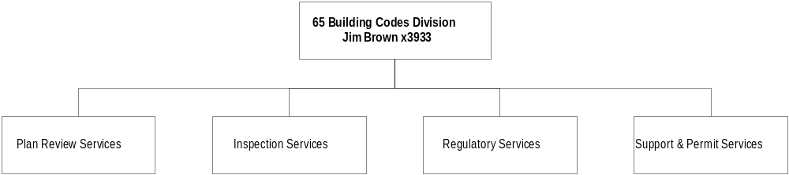

Program Description - The Building Codes Division, in accordance with Title 50, Chapters 60 and 74, MCA, establishes and enforces minimum building (including accessibility), plumbing, mechanical, electrical, energy, elevator, and boiler codes. This enforcement safeguards the public, employees, and property from the hazards inherent in the construction of buildings, including their structural, nonstructural, electrical, plumbing, mechanical, and boiler components, and factory-built buildings manufactured or offered for sale in Montana. When possible, the division approves and certifies local government code enforcement programs to utilize codes adopted by the division. The division also assists the Board of Plumbers and the State Electrical Board with license law enforcement by checking for proper licensing when inspecting projects for code compliance.

Program Indicators –

Indicator | Actual FY1998 | Actual FY1999 | Actual FY2000 | Estimated FY2001 | Requested FY2002 | Requested FY2003
Plumbing:
Permits | 2370 | 2602 | 2841 | 2900 | 2900 | 2900
Inspections | 6966 | 7888 | 10494 | 10500 | 10500 | 10500
Comp. Orders | 58 | 78 | 64 | 65 | 65 | 65
Lic. Checks | 1136 | 1363 | 1194 | 1200 | 1200 | 1200
MECHANICAL:
Permits | 812 | 731 | 798 | 800 | 800 | 800
Inspections | 2215 | 2236 | 2540 | 2600 | 2600 | 2600
Comp. Orders | 22 | 25 | 15 | 15 | 15 | 15
ELECTRICAL:
Permits | 12400 | 12465 | 13087 | 13100 | 13100 | 13100
Inspections | 20615 | 21410 | 23663 | 23700 | 23700 | 23700
Comp. Orders | 76 | 137 | 81 | 80 | 80 | 80
Lic. Checks | 2369 | 1405 | 1735 | 1750 | 1750 | 1750
BOILERS:
Total Inspections | 5319 | 5642 | 5948 | 6000 | 6000 | 6000
State | 2122 | 2277 | 2526 | 2550 | 2550 | 2550
Insurance | 3197 | 3365 | 3422 | 3450 | 3450 | 3450
Total Certs. | 4827 | 5140 | 5594 | 5600 | 5600 | 5600
State | 1846 | 2045 | 2237 | 2250 | 2250 | 2250
Insurance | 2981 | 3095 | 3357 | 3350 | 3350 | 3350
ELEVATORS:
Inspections | 1158 | 1229 | 1315 | 1350 | 1350 | 1350
Certificates | 1328 | 1465 | 1600 | 1600 | 1600 | 1600
BUILDINGS:
Permits | 946 | 977 | 1030 | 1100 | 1100 | 1100
Inspections | 10017 | 10359 | 9996 | 10000 | 10000 | 10000

Program Proposed Budget  Budget Item | Base  Budget  Fiscal 2000 | PL Base Adjustment  Fiscal 2002 | New  Proposals  Fiscal 2002 | Total  Exec. Budget  Fiscal 2002 | PL Base Adjustment  Fiscal 2003 | New  Proposals  Fiscal 2003 | Total  Exec. Budget  Fiscal 2003
FTE | 58.00 | 0.00 | 0.00 | 58.00 | 0.00 | 0.00 | 58.00
Personal Services | 1,979,444 | 225,094 | 0 | 2,204,538 | 237,480 | 0 | 2,216,924
Operating Expenses | 772,984 | 172,658 | 0 | 945,642 | 140,871 | 0 | 913,855
Equipment | 81,882 | 49,909 | 0 | 131,791 | 46,118 | 0 | 128,000
Total Costs | $2,834,310 | $447,661 | $0 | $3,281,971 | $424,469 | $0 | $3,258,779
State/Other Special | 2,834,310 | 447,661 | 0 | 3,281,971 | 424,469 | 0 | 3,258,779
Total Funds | $2,834,310 | $447,661 | $0 | $3,281,971 | $424,469 | $0 | $3,258,779

Significant Present Law Adjustments -
- Provide building codes education and training for building officials, design professionals and contractors in accordance with HB 245 passed by the 1999 Legislature

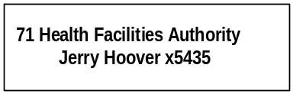

Program Description - The Health Facility Authority was created by the 1983 Legislature and is governed by a seven-member quasi-judicial board. The board members are appointed to four-year terms by the Governor with the advice and consent of the Senate. The purpose of the authority is to assist health care and health care related facilities in containing future health care costs by offering debt financing or refinancing at low-cost, tax-exempt interest rates for buildings and capital equipment. These cost savings are shared with the health care consumer in the form of lower health facility fees. Recently, the legislature extended eligible facilities to include community pre-release centers. The authority program is mandated in Title 90, Chapter 7 and Title 2, Chapter 15.

Proprietary Rates

Revenues and Expenses -
Change in Services or Fees: The authority has gradually reduced its application and annual administrative fee assessments contingent upon its business volume.

Working Capital Discussion: The 60 day Working Capital Calculation is not reasonably applicable to the Health Facilities Authority because the national bond rating agencies, national bond insurers and institutional investors expect the authority to reserve two years operating capital to assure them that it can financially operate between legislative sessions.

Fund Equity and Reserved Fund Balance: The Total Fund Equity requirement for FY 2000 ($4,668,000) is derived from the Authority Program Reserve mandates as follows:
- Biennium Working Capital Reserve=$458,000
- Capital Reserve Account (Loan Loss Reserve)=$3,560,000
- Facility Direct Loan Program Reserve=$650,000

Cash Flow Discussion: The authority has gradually reduced its application and annual administrative fee assessments contingent upon its business volume. However, it continues to carry a two year working capital reserve in order to respond to the forecasted extraordinary expenses and requirements.

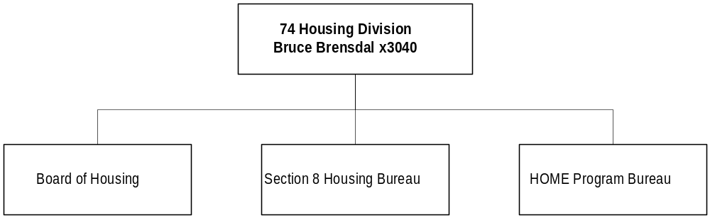

Program Description - The Housing Division, established on July 1, 1995, consolidates all housing programs within the Department of Commerce into one division that includes the Home Investment Partnerships Program (HOME), the Section 8 Housing Program, and the Board of Housing and its programs. Division work is mandated primarily in Title 2, Chapter 15; Title 90, Chapters 1 and 6, MCA; 24 CFR 91, and 92; 24 CFR 5, 792, 813, 887, 982, and 984; and the Governor's Executive Order 27-81.

Program Proposed Budget  Budget Item | Base  Budget  Fiscal 2000 | PL Base Adjustment  Fiscal 2002 | New  Proposals  Fiscal 2002 | Total  Exec. Budget  Fiscal 2002 | PL Base Adjustment  Fiscal 2003 | New  Proposals  Fiscal 2003 | Total  Exec. Budget  Fiscal 2003
FTE | 23.00 | 1.50 | 0.00 | 24.50 | 1.50 | 0.00 | 24.50
Personal Services | 599,574 | 274,738 | 0 | 874,312 | 281,020 | 0 | 880,594
Operating Expenses | 369,468 | 532,185 | 0 | 901,653 | 379,707 | 0 | 749,175
Equipment | 17,201 | 17,979 | 0 | 35,180 | 23,889 | 0 | 41,090
Grants | 17,193,473 | 40,488,116 | 0 | 57,681,589 | 43,467,499 | 0 | 60,660,972
Total Costs | $18,179,716 | $41,313,018 | $0 | $59,492,734 | $44,152,115 | $0 | $62,331,831
Federal Special | 18,179,723 | 41,313,011 | 0 | 59,492,734 | 44,152,108 | 0 | 62,331,831
Proprietary | (7) | 7 | 0 | 0 | 7 | 0 | 0
Total Funds | $18,179,716 | $41,313,018 | $0 | $59,492,734 | $44,152,115 | $0 | $62,331,831

Significant Present Law Adjustments -
- Continue the Section 8 project and tenant housing assistance programs that were removed from the base budget as one-time-only appropriations by the 1999 Legislature
- Increase Section 8 federal funds by $5.5 million and $6.2 million each year, respectively

Proprietary Rates

Program Description –

Board of Housing:
The Montana Board of Housing was created by the Montana Housing Act of 1975. The board is an agency of the State and operates within the Department of Commerce for administrative purposes. Under the Housing Act the board does not receive appropriations from the State's general fund and is completely self-supporting. Substantially all of the funds for the board's operations and programs are provided by the private sector through the sale of tax-exempt bonds. The powers of the board are vested in a seven member board, appointed by the Governor, subject to the confirmation of the State Senate. The board provides policy direction to the agency staff, authorizes bond issues, approves development financing and evaluates board housing programs. These programs include the Single Family Program, Recycled Single Family Program, Multifamily Loan Programs, Low Income Housing Tax Credit Program and the Reverse Annuity Mortgage (RAM) Program.

Revenues and Expenses -
Charge for Services:
Single Family Charges:
According to state statute and, in some cases, the Internal Revenue Code, the board is allowed to earn the amounts that are presented on the "Report on Internal Service and Enterprise Funds". The board earns the bulk of its income from the spread between the interest yield on the Single Family Mortgage loans and the yield on the bonds. The board is allowed to earn 1 ½ percent on Pre 1980 Single Family Programs and 1 1/8 percent on the Post 1980 Single Family Programs.

Financial institutions that originate Single Family loans for the board charge two points, which they keep. According to tax law, origination points must be included in the amount that the board can earn. Operating expenses and servicing fees must be paid from the 1 1/8 percent that Board is allowed to earn. Servicing fees are .375 percent of the mortgage principal balance. The board does not always receive the full 1 1/8 percent or 1 1/2 percent spread. The spreads for the last several bond issues were as follows:

*1995B1-.8799% *1997A2-1.08842% *2000A-1.10302%
*1995B2-.8167% *1998A-1.10078%
*1996A-1.125% *1998B-1.04678%
*1997A1-1.39063% *1999A-1.11985%

*Operating expenses and service fees further reduce the amount of these earnings. The earnings also include 2 points of origination fees that are not received by the board.

The 1 1/8 percent or 1 1/2 percent that the board can earn is based on certain assumptions at the time the bond issue is structured. One of the assumptions is that the loans will prepay at 100 percent of FHA. If the loans actually prepay faster, the board will not earn the initial spread that was calculated. The board only earns this spread if the loans are held for the amount of time that is originally estimated. If the loans prepay early, the money is invested and then is used to redeem bonds. When the mortgages pay off, the board has lost the ability to earn the spread between the mortgage yield and bond yield. Historically, prepayments on the majority of the loans have been over 100 percent, and we expect this trend to continue.

The board also charges a reservation fee of 1/2 of 1 percent of the loan amount reserved. This amount is included in the spread that the board can earn. These fees are capitalized and are amortized as income over the life of the loans, as required by generally accepted accounting principles. Extension fees and late fees are also, occasionally, charged. The majority of these fees are capitalized and amortized over the life of the loans. The extension fees are 1/4 of 1 percent of the loan amount. The amortization of these fees results in an average of approximately $250,000 of income per year. These fees are deposited with the trustees and are used to originate new mortgages.

Multifamily Charges:
Multifamily Programs can earn 1 1/2 percent spread between the mortgage yield and the bond yield. On the last several issues, the board did not receive the full 1 1/2 percent spread. The spreads for the last four bond issues are as follows:

1992A-1.0677%
1996A-.826%
1998A-.28156572%
1999A-1.013963%
Servicing fees and operating expenses further reduce the amount of this spread.

It is possible that six loans may prepay in the Multifamily Program. There are two other loans that may prepay in the year 2005. If these loans prepay, bonds will be redeemed with the prepayments, and the board will no longer earn any spread on these loans. The board, currently, has received one prepayment on a mortgage. The prepayment funds, on that particular loan, were used to call bonds. In the 1992A bond issue, the board is currently using excess revenues to purchase loans at interest rates that are lower than the bond yield. This further reduces the amount of earnings in the Multifamily Program. Under the Multifamily Program, the board can charge a reservation fee, on new loans, of up to 1 percent of the principal balance. Normally, the board charges less than this amount.

Low Income Housing Tax Credit Charges:
The board receives approximately $1.1 million dollars of tax credit allocation, annually. The board charges 4 1/2 percent of the amount of tax credit reserved. In the next biennium, reservation fee income is estimated to be approximately $100,000 per year. The board is also required to monitor the projects that receive tax credits to determine if the projects are in compliance with tax credit regulations. The board charges $20 per unit for compliance fees. The board has approximately 3,400 units. Approximately $68,000 annually will be received during the biennium. Tax credit fees are charged to cover the operating expenses of the program.

Cash Assistance Program Charges (CAP) Charges:
CAP loans are used to assist borrowers with down payment costs. The rates on these loans range from 5 percent to 7 percent. The board does not receive the interest or the principal on these loans until the borrower sells their home. It is difficult to determine how much of the interest and principal will actually be received on these loans or when it will be received. If a loan goes into foreclosure, the principal and interest on these loans will not be received. The board has already experienced some losses on these loans. These loans are not guaranteed or insured.

Reverse Annuity Mortgage Loans (RAM) Charges:
Under the RAM program, elderly homeowners can receive monthly payments, for 10 years, to assist them with their living expenses. The loans accrue interest at 5 percent to 7 percent. The principal and interest is not due until the borrower dies or sells their home. It is difficult to determine how much of the interest and principal will actually be received on these loans or when it will be received. These loans are not guaranteed or insured.

Report on Revenues and Expenses:
Increase in Mortgage Income:
The board's mortgage income during the last five years has continued to increase. Part of the reason is because there are three Single Family bond issues (1992RA, 1995B & 1997A) that were structured to use loan prepayments and excess revenues to originate loans rather than to call bonds or pay debt service. These bond series have 40 year bonds rather than the typical 30 year bonds. These series do not have principal payments on the bonds for ten years, only interest is due. During first ten years of each bond issues, mortgages will be originated with prepayments and the excess revenues.

The board has continued to issue bonds each year to originate new mortgages. During fiscal years 1998, 1999 & 2000, the board issued bonds in the amounts of $51,780,000, $66,625,000 and $157,555,000, respectively. It is anticipated mortgage revenue will continue to increase during the next biennium as the board continues to originate loans with prepayments, excess revenues and bond proceeds.

Investment Income:
The board anticipates that investment income may increase by $500,000. In FY 2000, the board earned approximately $11,000,000 on its investments. During the latter part of FY 2000, the board entered into an repurchase agreement on its Single Family II Indenture. Prior to this investment agreement, the board was earning 5.60 percent on its investments. The repurchase agreement is at 6.43 percent for 30 years. It is anticipated that this will result in an increase of approximately $500,000 per year.

NOTE: For Post 1980 Single Family issues and Post 1986 Multifamily issues, investment earnings cannot exceed the yield on the bonds.

Increase in Fair Market Value:
The increase in fair value is a requirement of GASB 31. It requires that all investments be valued at fair value. During the first year that GASB 31 was implemented, the board recorded a gain of approximately $2.8 million. In the last two years, the board has seen significant drops in the market value. The board does not intend to sell the long-term investments. If they are sold, we will receive the value of the investment on the day of the sale. This amount could be substantially different from the market value at June 30th. No increases or decreases in the fair value are estimated for FY 2001, 2002 or 2003. The market fluctuations are significant and it is impossible to estimate the value of the investments at any given time.

Operations & personal services:
Operations for the next biennium are anticipated to be approximately $4.1 million for FY 2002 and $4.5 for FY 2003. The operating expenses include the following:

Servicer fees:
$2.2 million (FY 2002) $2.4 million(FY 2003)

Operating expenses & personal services:
$1.9 million (FY 2002) $2.1 million (FY (2003)

The operations of the board include purchasing mortgage loans, receiving repayments and prepayments, investing funds, issuing and redeeming bonds. During fiscal year 1999, the board purchased $95,049,674 in mortgages and received $98,343,794 in mortgage repayments, prepayments and interest. The board paid interest and principal on bonds of $95,644,292 and issued new bond proceeds in the amount of $66,625,000. Purchases of investments were $584,241,879 and maturities and sales were $605,955,649. This was done with a staff of 16 FTE.

Miscellaneous Operating:
Miscellaneous operating includes the interest expense on bonds. It also includes the periodic amortization of the cost of issuance expense. The costs associated with issuing the bonds are expensed over the life of the bonds, as required by generally accepted accounting principles.

Over the last three years, the board has issued the following amount of bonds: 1998-$51,780,000; 1999-$66,625,000; 2000-$157,555,000. The issuance of new debt has been greater than the maturities and redemptions of bonds. So, this has resulted in a higher debt service. The board anticipates that this increase in debt service will continue during the next biennium.

Fund Equity and Reserve Fund Balance. As stated in the board's financial statements, Note 1, Fund Accounting: Reserved Retained Earnings (pledged to bondholders) represent bond program funds that are required to be used for program purposes as prescribed by individual bond indentures. The following are restrictions on the Reserved Retained Earnings: Special trust funds and accounts within the indenture are pledged as collateral for the bonds under the individual program indentures; Reserve requirements on cash and investments; Mortgage loans receivable are also pledged as security for holders of the bonds; Certain indentures require asset-liability coverage ratios be met as well as cash flow certificates be furnished for any significant change anticipated in the financial structure of an indenture.

The Trust Indentures entered into by the board requires all mortgages, and all moneys and investments within the indentures are legally restricted to uses provided for in the indentures and fund balance associated with the indentures is legally required to be reserved for those uses.

In addition to the legal requirements mentioned above, the board commits funds to various projects and programs throughout the year. The board has set aside over $150 million of first mortgage funds for special programs, and originates approximately $20 million per year of new loans under this program (targeting income levels of approximately $19,000). As of the end of FY 2000, the board had $24,802,430 in outstanding Recycled Mortgage Program commitments.

In the Multifamily area, the board commits funds to projects around the state, with the intent to pool mortgages and issue bonds to fund mortgages and reimburse the board where it has advanced funds on some of the projects. As of the end of FY 2000, the board has multifamily project commitments of $9,577,323, and has made 17 loans totaling $4,306,990 since the program began in 1994, in addition to the original 8 mortgages totaling $14,045,800.

In order to operate a more efficient Multifamily program, the board was awarded a rating of A2 for its General Obligation on April 8, 1997. In order to obtain the A2 rating, the board pledged that it will use any and all of the moneys, assets or revenues of the board to back bonds issued using the G.O. rating. All of the board's bond issues, with the exception of the Single Family III through X (issued from 1988-1992) hold the board's G.O. pledge.

The fund balance within the Housing Trust Fund is legally required to be reserved for security to the single family programs by Resolution 92-0821-S1, the Fifth Supplemental Trust Indenture for its Single Family II Indenture and by Resolution 93-0624-S2.

The board funds its RAM and CAP programs from the Housing Trust fund, because these are programs for which the board can not issue bonds. As of the end of FY 1999, the board has RAM and CAP loans with an outstanding principal balance and interest of $858,293. Outstanding commitments from the Housing Trust Fund as of FY 1999 were $130,909, for CAP programs, and $1,039,076 for RAM.

The board's budget monies (those projected to be needed for the fiscal year operations) are drawn down from the indentures at the beginning of the fiscal year. These funds are legally pledged to the trust indentures from which they were drawn and any associated fund balance is reserved for the program from which the budgeted funds were withdrawn.

Management Objectives Regarding Fund Balance. The major component of the board fund balance (retained earnings) is its single family program. The board has been recycling repayments and prepayments of mortgages for several years. The board has committed these funds to special programs, at rates which are in many cases below the average coupon on the bonds. The average income on the special programs is less than $19,000, whereas the average income on the board's regular bond programs is about $31,000. The board intends to continue these special programs as they serve Montana citizens the board would not otherwise be able to serve.

Net income over and above bond debt service, operating costs, and servicing fees, is used to write down the rates on special programs or to fund programs such as the RAM Program for elderly, and the CAP which assist the lowest income home buyers. These programs can not be funded from direct bond proceeds as there is no repayment guarantee. In the Multifamily area, the board intends to continue to leverage its multifamily funds into new multifamily loans through the revolving pool so that loans can be completed in a timely and efficient manner.

The board is reviewed at the time of each bond issue by two rating agencies: Standard & Poor's, and Moody's Investor Services. In order to meet the cash flow tests, the board must have sufficient assets, earnings, and liquidity, to meet all bond interest and principal expenses, as well as pay operating expenses. The board just received an Aa2 from Moody's on its largest indenture. Standard & Poor's assigned a AA+ rating noting an increase in excess cash, fully-funded reserves and a blend of investments sufficient to support the rating on the bonds. The board's rating reflects the rates the board gets on its bonds, which is reflected in the mortgage rates passed on to first time home buyers in Montana. In 1990, the board purchased one in ten of the mortgages. In 2000, the board purchased one in four of these mortgages. The board's continuous funding (which was a goal of current management set in 1994) and steady, low interest rates, as well as the board's special programs, have contributed to this increase. In addition the increase in housing costs in Montana has made the need for lower interest rate financing even more profound.

Cash Flow Discussion-
Collection of mortgage payments & purchase of loans:
Each month the board receives funds from the financial institutions that service the board's Single Family and Multifamily loans. The funds include the amount of principal, interest, less servicing fees (.375 percent, .125 percent and .10 percent of the principal balance) that are due on the board loans. The money is collected by the board trustees. Twice monthly, the board purchases loans from new bond proceeds, prepayments or other revenues.

The board receives tax credit reservations fees when the tax credits are approved. These fees are deposited with the state treasurer and are used to cover expenses of the program. Reservations fees on the Single Family and Multifamily Programs are deposited with the trustees when the approved loans are reserved. They are deposited in the program acquisition account and are used to originate new mortgages.

Payment of Bond P & I:
Principal and interest, on the Multifamily and Single Family Bond issues, is due on each February 1, April 1, June 1, August 1, October 1 and December 1. During FY 1999, the board paid $95,644,292 in principal and interest on the bonds.

This number includes scheduled principal and interest payments as well as bond redemptions from prepayments and excess reserves and other revenues. The amount of debt service paid will vary depending on the amount of prepayments received. Under the Single Family I and II Indentures, except for those series that were structured for recycling, each semiannual debt service date, the board determines how many prepayments have been received. The board uses the loan prepayments to redeem bonds in an amount equal to the prepayments received. In eight of the Trust Indentures (Single Family III through X) all repayments, prepayments and investment income must, currently, be used to redeem the bonds each April 1 and October 1. The income cannot be used for any other purpose. Annually, the board reviews any other revenues and excess reserves in the Single Family programs and those amounts are also used to redeem bonds. The Multifamily Program has received prepayments on one loan and bonds were redeemed. In the future, there may be prepayments, and bonds will also be redeemed.

Investment of funds. In the Single Family I and II Indentures, the board invests the majority of prepayments and repayments of loans in repurchase agreements. The interest coming due on the agreements also coincides with a debt service date. In two of the series under the Single Family II Indenture, prepayments and any other revenues are used to originate loans that could not otherwise be originated under the tax laws. These two series do not have principal due on the bonds for the first ten years of the bond issue. These funds are normally invested based on the anticipated loan purchase dates. Under the Single Family I Indenture, a portion of prepayments and repayments are used to originate loans that do not meet the tax laws. These funds are currently invested in a repurchase agreement and withdrawn as the funds are needed for purchases.

The deposit of the initial bond proceeds, used for purchasing loans, is normally invested in a two year, fixed rate, repurchase agreement. As explained above, all funds received on Single Family III through X are used for bond calls and scheduled debt service. These funds are invested in 30 year Guaranteed Investment Contracts. All debt service reserve funds and mortgage reserve funds that must be held as security for the bondholders are invested in long-term securities, repurchase agreements or guaranteed investment contracts. Under the Multifamily Program, the funds are invested to the next debt service date or to a loan purchase date.

Other Mortgage Purchases:
The board also purchases Reverse Annuity Mortgage (RAM) and Cash Assistance loans (CAP). The RAM loans are not repaid until the borrower dies or sells their home. The CAP loans are not repaid until the borrower sells their home. These amounts are assets of the board and the interest is accrued monthly, but the program may not receive the principal and interest repayments for many years.

Operating Expenses:
The board draws funds for its budget annually from the amounts available within the Indentures. The amount of the approved budget, less any cash on hand, is withdrawn from the Indenture and is allocated among the various Indentures. These funds are pledged to the bondholders.

Significant Present Law -
- Automate the monthly loan account reconciliation using Cash Management software

New Proposals -
- Employ additional staff to deal with single-family and multi-family housing projects

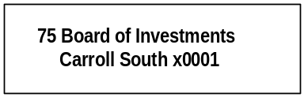

Program Description - Board of Investments staff manage state funds in the Unified Investment program, established under Article VIII, Section 13 of the Montana Constitution. Local governments may invest in the Short-Term Investment Pool. The six investment pools listed below and several individual portfolios are managed.

- Retirement Funds Bond Pool
- Trust Funds Bond Pool
- Short Term Investment Pool
- Montana Stock Pool
- Montana International Equity Pool
- Montana Real Estate Pool

Annual audited financial statements are prepared for each investment pool. Investments not managed in pools are included in an "all other funds" financial statement. The In-State Investment Program consists of Montana residential mortgages and commercial loans. The board also issues bonds and lends the proceeds to eligible government agencies for a variety of purposes.

Program Proposed Budget  Budget Item | Base  Budget  Fiscal 2000 | PL Base Adjustment  Fiscal 2002 | New  Proposals  Fiscal 2002 | Total  Exec. Budget  Fiscal 2002 | PL Base Adjustment  Fiscal 2003 | New  Proposals  Fiscal 2003 | Total  Exec. Budget  Fiscal 2003
FTE | 0.50 | (0.50) | 0.00 | 0.00 | (0.50) | 0.00 | 0.00
Personal Services | 13,078 | (13,078) | 0 | 0 | (13,078) | 0 | 0
Operating Expenses | 19,901 | (19,901) | 0 | 0 | (19,901) | 0 | 0
Total Costs | $32,979 | ($32,979) | $0 | $0 | ($32,979) | $0 | $0
State/Other Special | 32,979 | (32,979) | 0 | 0 | (32,979) | 0 | 0
Total Funds | $32,979 | ($32,979) | $0 | $0 | ($32,979) | $0 | $0

Proprietary Rates

Program Description –
Unified Investment Program:
The Board of Investments currently manages an investment portfolio with a market value of approximately $8.6 billion under the "prudent expert principle." The board also invests local government funds at their discretion. To provide for diversification and reduced risk, the board manages several investment pools in which funds of similar types are invested. The Legislative Auditor audits the board annually. The board consists of nine members appointed by the Governor.

In-State Investments:
Section 17-6-305, MCA authorizes the board to invest up to 25 percent of the permanent coal tax trust fund to assist Montana's economic development. This "In-State Investment” program makes business loans from the trust in participation with financial institutions. The board lends trust fund monies to local governments to fund infrastructure that will serve job-creating businesses locating in the government jurisdiction. The May 2000 Special Legislative Session created a low-interest loan program also funded from the trust. The board purchases Montana mortgages with pension funds as part of the In-State Investment program.

INTERCAP Program:
The board sells bonds and lends the proceeds to eligible governments for a variety of projects. Loan terms range from one to ten years, and short-term loans to finance cash flow deficits or bridge financing are also available. The INTERCAP and In-State Investment programs were created in FY 1984 as part of the "Build Montana" program.

Revenues and Expenses -
Change in Services or Fees: There has been no significant change in the services provided by the Board of Investments from those provided in the last biennium, although the investment portfolio continues to grow in size. The legislature approved 29.00 FTE (26.00 funded from fund 06527, and 3.00 funded from fund 06014) in the last session, and there are proposals to permanently add 4.00 FTE in the 2003 biennium because of growth in the portfolios managed by the board.

Working Capital Discussion: The Board of Investments assesses its costs to the entities that use its services. Typically, this has been done by requesting a maximum level of expenditures similar to what occurs in HB 2. This process has worked very well since the passage of HB 576 and this methodology is continued in the 2003 biennium because it provides an easy comparison with historical financial activity.

Investment Programs (fund 06527): The revenue objective of the investment program is to assess the costs of operations to each portfolio the board invests while maintaining a reasonable and prudent 60-day working capital reserve.

Bond Programs (fund 06014): Nearly all bond program revenues are generated by the difference between interest rates on bonds sold and the interest rate charged on loans made to borrowers. Since these revenues are only received from the trustee on an annual basis, a 270 day fund balance is required to provide adequate funding for the bond program between draws. Remaining revenues are received monthly from the board contract with the Montana Health Facility Authority.

Other revenues, if any, not received by billings to client agencies (e.g. direct appropriations): The Board of Investments does not receive any direct appropriations. Revenue for fund 06527 is generated entirely from charges to each portfolio that the board invests and is used to finance the investment program. Revenue for fund 06014 is generated from the difference between the interest earned from loans to borrowers and interest paid to bond holders and monthly contract revenues received from the Montana Health Facility Authority. Non-budgeted revenues are used to finance statutorily appropriated debt service expenditures.

Fund Equity and Reserved Fund Balance. At the proposed level of expenditures, the board projects a FY 2003 ending unreserved fund balance of $425,960, or approximately a 60 day working capital reserve for fund 06527.

Cash Flow Discussion. Costs to the entities using board services are typically assessed on a monthly basis for fund 06527. Since collections lag by at least one month, the board must maintain a nominal 60-day working capital reserve to meet ongoing operational expenses.

Revenues for fund 06014 are typically received on an annual basis, so a 270-day fund balance is required to provide adequate funding for the bond program between draws.

Rate Explanation –
Investment Programs (fund 06527): The revenue objective of the investment program is to assess the costs of operations to each portfolio the board invests, while maintaining a reasonable and prudent 60-day working capital reserve.

Bond Programs (fund 06014): Nearly all bond program revenues are generated by the difference between interest rates on bonds sold and the interest rate charged on loans made to borrowers. Since these revenues are only received from the trustee on an annual basis, a 270-day fund balance is required to provide adequate funding for the bond program between draws. Remaining revenues are received monthly from the board contract with the Montana Health Facility Authority.
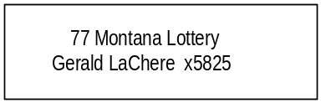

Program Description - The Montana State Lottery designs and markets lottery games that allow players to purchase chances at winning a prize. The lottery presently offers a variety of games, some in cooperation with other lotteries through the Multi-State Lottery Association (MUSL). Montana Cash is exclusively a Montana lottery game. A five-member state lottery commission, appointed by the Governor, sets policy and oversees activities and procedures of the program. The Governor also appoints a lottery director who is responsible for coordinating the lottery's marketing, sales, operations, security and administrative efforts. By law, a minimum of 45 percent of the revenues derived from the sale of lottery tickets is distributed to prizes, but the actual overall prize distribution is over 50 percent of revenue. The remaining net revenue, after sales commissions and operating expenses, is deposited in the general fund on a quarterly basis. The Montana State Lottery is mandated primarily by Title 23, Chapter 7, MCA.

Program Indicators –

Indicator | Actual FY1998 | Actual FY1999 | Actual FY2000 | Estimated FY2001 | Requested FY2002 | Requested FY2003
Transfer to General Fund  (in millions) | $ 6.60 | $ 6.80 | $ 5.80 | $ 6.20 | $ 6.60 | $ 6.90

Program Proposed Budget  Budget Item | Base  Budget  Fiscal 2000 | PL Base Adjustment  Fiscal 2002 | New  Proposals  Fiscal 2002 | Total  Exec. Budget  Fiscal 2002 | PL Base Adjustment  Fiscal 2003 | New  Proposals  Fiscal 2003 | Total  Exec. Budget  Fiscal 2003
FTE | 31.50 | 0.00 | 0.00 | 31.50 | 0.00 | 0.00 | 31.50
Personal Services | 1,263,022 | (2,791) | 0 | 1,260,231 | 9,004 | 0 | 1,272,026
Operating Expenses | 5,201,527 | 916,016 | 437,000 | 6,554,543 | 1,068,575 | 661,000 | 6,931,102
Equipment | 46,677 | 321,870 | 0 | 368,547 | (28,977) | 0 | 17,700
Debt Service | 231,724 | 913,854 | 0 | 1,145,578 | 913,853 | 0 | 1,145,577
Total Costs | $6,742,950 | $2,148,949 | $437,000 | $9,328,899 | $1,962,455 | $661,000 | $9,366,405
Proprietary | 6,742,950 | 2,148,949 | 437,000 | 9,328,899 | 1,962,455 | 661,000 | 9,366,405
Total Funds | $6,742,950 | $2,148,949 | $437,000 | $9,328,899 | $1,962,455 | $661,000 | $9,366,405

Significant Present Law Adjustments -
- Expand the public relations outreach for the Montana Lottery
- Purchase additional on-line gaming system terminals improved with new technology
- Conduct on-going research related to Lottery games, markets, and product appeal
- Provide product support to Montana Lottery retailers

New Proposals -
- Expand the selection of scratch Lottery tickets
- Add new on-line games to the Montana Lottery program

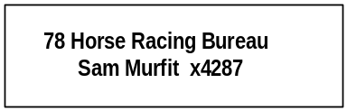

Program Description - The Board of Horse Racing program is responsible for 1) regulating the live and simulcast horse racing industry; 2) ensuring compliance by the approximately 3,500 licensees with state laws and board rules; 3) licensing all racing personnel, establishing race dates for various communities, establishing veterinary practices and standards in connection with horse racing meets; and 4) the auditing, supervision, and investigations related to the pari-mutuel racing system in Montana. The program work is mandated in Title 2, Chapter 15, and Title 23, Chapter 4, MCA.

Program Proposed Budget  Budget Item | Base  Budget  Fiscal 2000 | PL Base Adjustment  Fiscal 2002 | New  Proposals  Fiscal 2002 | Total  Exec. Budget  Fiscal 2002 | PL Base Adjustment  Fiscal 2003 | New  Proposals  Fiscal 2003 | Total  Exec. Budget  Fiscal 2003
FTE | 3.78 | 0.00 | 0.00 | 3.78 | 0.00 | 0.00 | 3.78
Personal Services | 105,333 | 36,197 | 0 | 141,530 | 37,226 | 0 | 142,559
Operating Expenses | 93,117 | 6,712 | 0 | 99,829 | 6,319 | 0 | 99,436
Equipment | 0 | 599 | 0 | 599 | 0 | 0 | 0
Total Costs | $198,450 | $43,508 | $0 | $241,958 | $43,545 | $0 | $241,995
State/Other Special | 198,450 | 43,508 | 0 | 241,958 | 43,545 | 0 | 241,995
Total Funds | $198,450 | $43,508 | $0 | $241,958 | $43,545 | $0 | $241,995

CONSUMER AFFAIRS

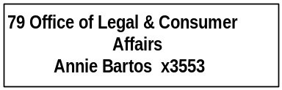

Program Description - The Consumer Affairs Office, in accordance with Title 30, Chapter 14, Title 45, Chapter 8, and Title 61, Chapter 4, MCA, advocates on the behalf of Montana consumers in matters of unfair or deceptive acts in the conduct of any business. The office investigates consumer complaints and provides for an informal mediation process for consumer complaints against businesses. The office enforces Montana consumer protection laws and regulations relating to telemarketing, personal solicitation of sales, New Motor Vehicle Warranty Act, Consumer Protection Act, and the Unfair Trade Practices Act. The office ensures a healthy business environment by preventing groundless consumer complaints against Montana businesses and providing those businesses with the opportunity to resolve legitimate consumer complaints in a manner resulting in stronger business relationships with consumers.

Program Proposed Budget  Budget Item | Base  Budget  Fiscal 2000 | PL Base Adjustment  Fiscal 2002 | New  Proposals  Fiscal 2002 | Total  Exec. Budget  Fiscal 2002 | PL Base Adjustment  Fiscal 2003 | New  Proposals  Fiscal 2003 | Total  Exec. Budget  Fiscal 2003
FTE | 5.25 | 0.00 | 0.00 | 5.25 | 0.00 | 0.00 | 5.25
Personal Services | 165,703 | 41,476 | 0 | 207,179 | 43,787 | 0 | 209,490
Operating Expenses | 102,250 | 93,182 | 0 | 195,432 | 92,317 | 0 | 194,567
Equipment | 0 | 2,156 | 0 | 2,156 | 0 | 0 | 0
Total Costs | $267,953 | $136,814 | $0 | $404,767 | $136,104 | $0 | $404,057
General Fund | 243,246 | 30,167 | 56,354 | 329,767 | 29,457 | 56,354 | 329,057
State/Other Special | 24,707 | 106,647 | (56,354) | 75,000 | 106,647 | (56,354) | 75,000
Total Funds | $267,953 | $136,814 | $0 | $404,767 | $136,104 | $0 | $404,057

Significant Present Law Adjustments -
- Provide consumer education using proceeds from class action lawsuits filed on behalf of Montana consumers

New Proposals -
- Change balance of funding for telemarketing fraud from state special revenue to general fund
- Shift funding of the Lemon Law Program from state special revenue to general fund due to passage of HB 540 referendum

DIRECTOR/MANAGEMENT SERVICES

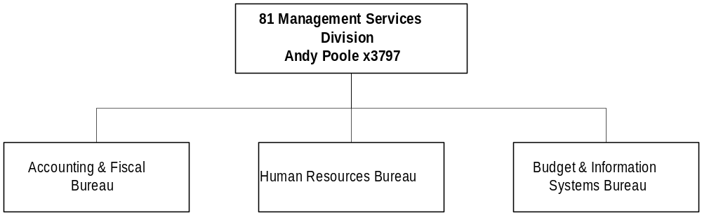

Program Description - The Director's Office/Management Services Division consists of two programs - the Director's Office and the Management Services Division. The Director's Office assists the department with executive, administrative, legal, and policy guidance. This office acts as the liaison among private business, local governments, administratively attached boards, public and private interest groups, the legislature, Indian tribes, individuals, and the Governor's office. The Management Services Division provides internal support to all agency divisions, bureaus, and programs. Services provided by the Management Services Division include accounting and fiscal, budgeting and information systems, contracting and purchasing, human resources, payroll, and training.

Program Proposed Budget  Budget Item | Base  Budget  Fiscal 2000 | PL Base Adjustment  Fiscal 2002 | New  Proposals  Fiscal 2002 | Total  Exec. Budget  Fiscal 2002 | PL Base Adjustment  Fiscal 2003 | New  Proposals  Fiscal 2003 | Total  Exec. Budget  Fiscal 2003
FTE | 0.00 | 0.00 | 0.00 | 0.00 | 0.00 | 0.00 | 0.00
Operating Expenses | 0 | 346,850 | 0 | 346,850 | 266,350 | 0 | 266,350
Total Costs | $0 | $346,850 | $0 | $346,850 | $266,350 | $0 | $266,350
General Fund | 0 | 99,100 | 0 | 99,100 | 76,100 | 0 | 76,100
State/Other Special | 0 | 173,425 | 0 | 173,425 | 133,175 | 0 | 133,175
Federal Special | 0 | 74,325 | 0 | 74,325 | 57,075 | 0 | 57,075
Total Funds | $0 | $346,850 | $0 | $346,850 | $266,350 | $0 | $266,350

Proprietary Rates

Revenues and Expenses -
Change in Services or Fees. There has been no significant change in the services provided to supported programs, or appreciable change in fees from the last biennium. (1999 biennium 9.68 percent, 2001 biennium 9.85 percent, and a 2003 biennium requested rate of 10.25 percent) There were 22.50 FTE permanently funded through indirect charges to supported programs in FY 2000, and there are proposals to add 2.00 FTE in the 2003 biennium.

Working Capital Discussion. The indirect cost rate is calculated by dividing the projected annual expenditures of the Director's Office/Management Services Division, plus a nominal working capital reserve, by the projected actual personal services amounts estimated to be incurred by supported programs. Federally-funded programs are allocated indirect costs via a federally-approved indirect cost rate, while state funded programs are allocated indirect costs via a legislatively-approved indirect cost rate.

Indirect costs are charged to all supported programs on a monthly basis and, since indirect cost collections lag by at least one month, the division must maintain a nominal working capital reserve to meet operating costs.

Fund Equity and Reserved Fund Balance. At the proposed 10.25 percent rate, the department projects a FY 2003 ending unreserved fund balance of $170,567, or approximately a 43-day working capital reserve.

Cash Flow Discussion. Indirect costs are charged to all supported programs on a monthly basis.

Rate Explanation –
The revenue objective of this unit is to maintain the lowest possible indirect cost charge to supported divisions, bureaus, and programs while attempting to maintain a nominal working capital reserve. Indirect costs are charged to divisions, bureaus, and programs on a monthly basis. For example, January's indirect costs would be charged to supported divisions, bureaus, and programs in February. Since indirect cost collections lag by at least one month it is necessary to maintain a reasonable and prudent working capital reserve to meet on going operational expenses. The department has historically used the same methodology in calculating indirect rates because the federal government requires it to be used to charge federally-funded programs indirect costs. The rates proposed for the 2003 biennium are the most reasonable and appropriate available because they most closely match the fees commensurate with costs methodology, while maintaining a minimal working capital reserve, and meeting federal requirements.

New Proposals -
- Hire 2.00 FTE to work on the department website and human resource management

