Purpose - The Long-Range Building Program was initiated in 1965 to provide funding for construction and maintenance of state buildings. The LRBP was developed in order to present a single, comprehensive and prioritized plan for allocating state resources for capital construction and maintenance of state-owned facilities. Primary statutory authority is Title 17, Chapter 7, part 2, MCA.

Executive Recommendation -
- Volume 2 of the Governor's 2003 biennium Executive Budget contains the complete LRBP project applications and recommended project descriptions, which total $163,711,610. All recommended projects are listed on Table F-2.
- HB 5 contains $4,319,660 LRBP, $22,275,325 state special revenue, $14,286,000 federal special revenue, and $33,595,625 other funds for a total of 53 projects and $74,476,610 in the cash bill.
- Highest priorities in the cash recommendations are safety and mechanical projects statewide.
- HB 14 recommends general obligation bonds for 11 projects, of which up to $46.7 million maximum could require general fund debt service payments.
- Total bonded program is for $89,235,000 and includes $46.7 million in LRBP, $11.4 million in state special revenue, $25.7 million in federal special revenue and $5.3 million in other funds.
- General fund debt service is budgeted at $1 million in the Executive Budget balance sheet based on the planned design/construction schedule and the proceeds from the sale of the Montana National Guard Headquarters Armory of $1.2 million.
- If HB 14 is approved, the total LRBP debt service will be approximately $5.9 million by FY 2004, compared with a high of about $20.8 million in FY 1995.

Language Recommendation -
The following language will be included in the introduced version of HB 5:
- “Inmate labor will be utilized for the construction of the new female dormitory wing at the treasure state correctional training center.”
- “The department of fish, wildlife and parks, the department of military affairs, and the department of transportation are authorized to transfer money appropriated in this bill among fund types.”
- “The appropriations of $150,000 in capitol land grant revenue to the department of fish, wildlife, and parks for capitol ground improvements, and $400,000 to the department of administration for capitol complex land acquisition are the last priorities for use of these funds during the 2003 biennium and are dependent upon the availability of revenues. The department of administration architecture and engineering division will set the priorities for revenue available for the two projects.”
- “If HB 5 and the bill to increase the cigarette tax both are passed and approved, the following projects are approved for LRBP funding, in addition to current requested projects: Increase Life Safety Projects, Statewide - $450,000; Increase Hazardous Material Mitigation Fund - $1,000,000; Increase Roofs – Statewide - $150,000; Increase Project Litigation Fund - $25,000; Increase Paving and Improvements at Eastmont, Glendive - $103,300; Code Compliance/Deferred Maintenance, University System - $1,100,000; SWLO Missoula Unit Improvements, DNRC - $150,000.”
- “Funding for the museum study/design is contingent upon passage and approval of HB 16.”

The following language will be included in the introduced version of HB 14:
- All proceeds derived from the sale of the Montana national guard headquarters armory located in Helena, Montana, shall be used to pay the general obligation debt service on the bonds issued for construction of the new DPHHS building. The proceeds of the sale shall be deposited to the general fund for this purpose.”
- “Prior to bonding for the applied technology center, private and/or federal funding must be available to match the bonded amount for completion of the building. The “other” authority in HB 14 may be utilized as federal special revenue authority if required.”

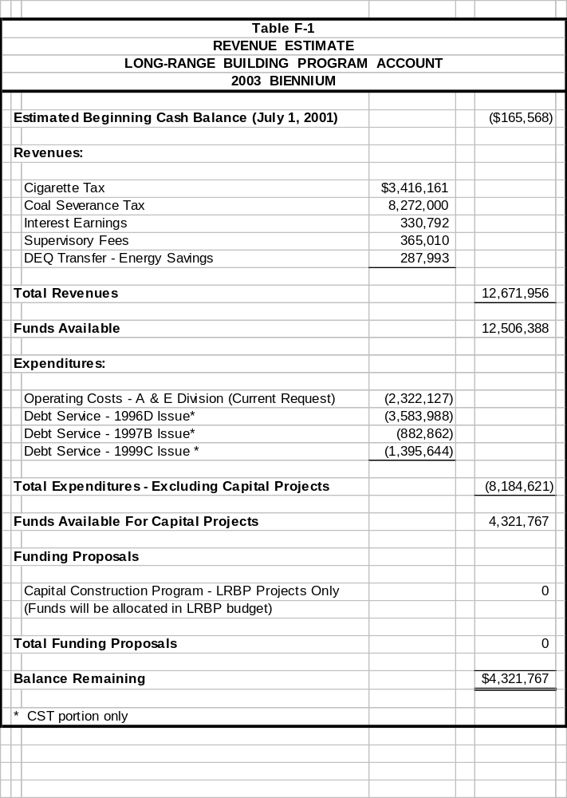

Funding -
- Cigarette tax revenue is projected at $3.416 million
- Coal severance tax revenue is projected at $8.272 million.
- State buildings energy savings transfers by the DEQ are $287,993
- If the cigarette tax increase is adopted as recommended, an additional $3 million would be available for major maintenance.

Table F-2
Long-Range Building Program Recommendations 2003 Biennium Cash & Bonded Projects
Priority | PROJECT | LRBP | STATE SPECIAL | FEDERAL SPECIAL | OTHER FUNDS | TOTAL
 | House Bill 5 - CASH PROGRAM
1 | REPLACE PRIMARY POWER DISTRIBUTION SYSTEM, UM-WMC | 162,750 |  |  | 59,375 | 222,125
2 | LIFE SAFETY PROJECTS, STATEWIDE | 400,000 |  |  |  | 400,000
3 | HAZARDOUS MATERIAL MITIGATION FUND | 350,000 |  |  |  | 350,000
4 | ROOFS – STATEWIDE, A&E | 499,000 |  |  |  | 499,000
5 | ROOFS – STATEWIDE, MUS | 426,000 |  |  |  | 426,000
6 | UPGRADE FOUNDATIONS AND BOILER, MLEA | 200,000 |  |  |  | 200,000
7 | HEATING PLANT STEAM DIST- PHASE II, UM-Tech | 438,750 |  |  | 236,250 | 675,000
8 | FACILITY IMPROVEMENTS, MSD&B | 315,160 |  |  |  | 315,160
9 | LICENSURE COMPLIANCE, MMHNNC | 524,000 |  |  |  | 524,000
10 | MASTER PLAN CAMPUSES, MUS | 150,000 |  |  | 150,000 | 300,000
11 | PROJECT LITIGATION FUND | 475,000 |  |  |  | 475,000
12 | EXPAND UNIT OFFICE, DNRC LIBBY | 94,000 |  |  |  | 94,000
13 | PAVING AND IMPROVEMENTS AT EASTMONT, PHHS GLENDIVE | 200,000 |  |  |  | 200,000
14 | NEW FEMALE DORMITORY WING AT BOOT CAMP, TSCTC | 85,000 |  |  |  | 85,000
15 | ANIMAL & RANGE SCIENCE FACILITY ,MSU |  |  |  | 5,000,000 | 5,000,000
16 | GRANT PROJECTS, ALL CAMPUSES, UM |  |  |  | 1,500,000 | 1,500,000
17 | ADA CODE / DEFERRED MAINTENANCE,UM |  |  |  | 1,000,000 | 1,000,000
18 | FINE ARTS MUSEUM REMODEL/UPGRADE, UM |  |  |  | 5,000,000 | 5,000,000
19 | MULTI MEDIA CENTER, UM YELLOW BAY |  |  |  | 1,350,000 | 1,350,000
20 | INTERNATIONAL CENTER, UM |  |  |  | 1,250,000 | 1,250,000
21 | LAW BUILDING RENOVATION / EXPANSION, UM |  |  |  | 5,000,000 | 5,000,000
22 | SCHOOL OF JOURNALISM BUILDING, UM |  |  |  | 12,000,000 | 12,000,000
23 | FAS MAINTENANCE, FWP |  | 275,000 |  |  | 275,000
24 | FAS SITE PROTECTION, FWP |  | 600,000 | 100,000 |  | 700,000
25 | FAS ACQUISITION, FWP |  | 600,000 |  |  | 600,000
26 | HATCHERY MAINTENANCE, FWP |  | 575,000 |  |  | 575,000
27 | PARK/BEARPAW LAKES DAM REPAIR, FWP |  | 210,000 |  |  | 210,000
28 | FUTURE FISHERIES, FWP |  | 2,010,000 |  |  | 2,010,000
29 | VALIER BOAT RAMP, FWP |  |  | 150,000 |  | 150,000
30 | WILDLIFE HABITAT MAINTENANCE, FWP |  | 750,000 |  |  | 750,000
31 | HABITAT MONTANA, FWP |  | 4,800,000 |  |  | 4,800,000
32 | WATERFOWL STAMP PROGRAM, FWP |  | 230,000 |  |  | 230,000
33 | UPLAND GAME BIRD PROGRAM, FWP |  | 1,200,000 |  |  | 1,200,000
34 | BIG HORN SHEEP PROGRAM, FWP |  | 25,000 |  |  | 25,000
35 | CARA – WILDLIFE, FWP |  |  | 2,120,000 |  | 2,120,000
36 | CULTURAL & HISTORIC PARKS, FWP |  | 1,755,000 | 150,000 |  | 1,905,000
37 | MOTORBOAT RECREATION, FWP |  | 754,650 | 505,000 |  | 1,259,650
38 | FEDERAL WB, FWP |  |  | 745,000 |  | 745,000
39 | LEWIS &CLARK BICENTENNIAL, FWP |  |  |  | 500,000 | 500,000
40 | STATE PARK ROADS, FWP |  | 400,000 |  |  | 400,000
41 | CAPITOL COMPLEX GROUNDS IMPROVEMENTS, FWP |  |  |  | 150,000 | 150,000
42 | LWCF GRANTS, FWP |  |  | 570,000 |  | 570,000
43 | FEDERAL TRAILS GRANTS,FWP |  |  | 1,900,000 |  | 1,900,000
44 | OHV TRAILS GRANTS, FWP |  | 425,000 |  |  | 425,000
45 | CARA – LWCF, FWP |  |  | 6,546,000 |  | 6,546,000
46 | ADMINISTRATIVE FACILITY REPAIR AND MAINTENANCE |  | 764,000 |  |  | 764,000
47 | MAINTENANCE , REPAIR & SMALL PROJECTS, MDT |  | 2,800,000 |  |  | 2,800,000
48 | CONSTRUCT EQUIPMENT STORAGE, BUILDINGS, MDT |  | 2,700,000 |  |  | 2,700,000
49 | MUSEUM STUDY/DESIGN, Admin |  | 1,000,000 |  |  | 1,000,000
50 | CAPITOL COMPLEX LAND ACQUISITION, Admin |  |  |  | 400,000 | 400,000
51 | FEDERAL SPENDING AUTHORITY, DMA |  |  | 1,500,000 |  | 1,500,000
52 | MVH IMPROVEMENTS, PHHS |  | 223,875 |  |  | 223,875
53 | EMVH IMPROVEMENTS, PHHS |  | 177,800 |  |  | 177,800
 | TOTAL HB 5 CASH PROGRAM | $ 4,319,660 | $ 22,275,325 | $ 14,286,000 | $ 33,595,625 | $ 74,476,610
 | House Bill 14 - BONDED PROGRAM
54 | RENOVATE CHEMISTRY BUILDING | 6,350,000 |  |  |  | 6,350,000
55 | RENOVATE LIBERAL ARTS LIFE SAFETY MAINTENANCE, MSU-Billings | 3,220,000 |  |  |  | 3,220,000
56 | REPLACE HVAC- PHASE II - SCIENCE COMPLEX, UM | 3,286,000 |  |  |  | 3,286,000
57 | RENOVATE EXTERIOR LINFIELD HALL AND MONTANA HALL, MSU, DEFERRED MAINTENANCE | 1,450,000 |  |  |  | 1,450,000
58 | CONSTRUCT DPHHS BUILDING, HELENA | 10,162,391 | 11,411,050 | 17,953,559 | 1,200,000 | 40,727,000
59 | EXPAND COT-HELENA, UM | 5,492,000 |  |  |  | 5,492,000
60 | CONSTRUCT NEW DILLON ARMORY,DMA | 1,940,000 |  | 3,800,000 |  | 5,740,000
61 | CONSTRUCT C. RECEPTION UNIT,DOC | 8,547,000 |  |  |  | 8,547,000
62 | UPGRADE HVAC SYSTEMS, COWAN HALL, MSU-Northern | 2,173,000 |  |  |  | 2,173,000
63 | CONSTRUCT MISSOULA JOB SERVICE, Labor |  |  | 4,000,000 |  | 4,000,000
65 | CONSTRUCT APPLIED TECHNOLOGY CENTER, MSU-Northern | 4,125,000 |  |  | 4,125,000 | 8,250,000
 | TOTAL HB 14 BONDED PROGRAM | $ 46,745,391 | $ 11,411,050 | $ 25,753,559 | $ 5,325,000 | $ 89,235,000
 | TOTAL LRB PROGRAM | $ 51,065,051 | $ 33,686,375 | $ 40,039,559 | $ 38,920,625 | $ 163,711,610

CASH PROGRAM EXPANDED WITH CIGARETTE TAX INCREASE
66 | LIFE SAFETY PROJECTS, Admin | 450,000
67 | CODE COMPLIANCE/DEFERRED MAINTENANCE,MUS | 1,100,000
Table F-2

CASH PROGRAM EXPANDED WITH CIGARETTE TAX INCREASE
Priority | PROJECT | LRBP | STATE  SPECIAL | FEDERAL  SPECIAL | OTHER  FUNDS | TOTAL
68 | HAZARDOUS MATERIAL MITIGATION, Admin | 1,000,000
69 | ROOFS STATEWIDE, Admin | 150,000
70 | PAVING AND IMPROVEMENTS AT EASTMONT, GLENDIVE, PHHS | 103,300
71 | SWLO- MISSOULA UNIT IMPROVEMENTS, DNRC | 150,000
72 | PROJECT LITIGATION FUND, Admin | 25,000
 | EXPANDED CASH PROGRAM | 2,978,300 | - | - | - | 2,978,300
 | TOTAL EXPANDED PROGRAM WITH INCREASE CIGARETTE TAX | $ 54,043,351 | $ 33,686,375 | $ 40,039,559 | $ 38,920,625 | $166,689,910

Purpose - The Treasure State Endowment Program (TSEP), administered by the Department of Commerce, is a coal tax-funded program designed to assist communities with infrastructure financing as authorized by Montana voters with passage of Legislative Referendum 110 in 1992. The program is defined in Title 90, Chapter 6, part 7, MCA. Goals for the program include:

- create jobs for Montana residents;
- promote economic growth in Montana by helping to finance the necessary infrastructure;
- encourage local public facility improvements;
- create a partnership between the state and local governments to make necessary public projects affordable;
- support long-term, stable economic growth in Montana;
- protect future generations from undue fiscal burdens caused by financing necessary public works;
- coordinate and improve infrastructure financing by federal, state, local government, and private sources; and
- enhance the quality of life and protect the health, safety, and welfare of Montana citizens.

Executive Recommendation -
- Volume 3 of the Governor's 2003 biennium Executive Budget contains the department’s evaluation of each of the TSEP applications and recommendations.
- About $14 million in net endowment interest will be available for grant awards for the 2003 biennium.
- HB 11 contains recommendations for grants to 31 of the 38 applicants, whose requests totaled $16,771,278 from TSEP funds.
- HB 11 recommends three additional projects for contingent grant funding, if revenue projections are higher or other projects are not able use funds. All recommended projects are listed on Table F-3.

Since the Last Session -
- Improved application ranking process, including pre-defined scoring levels and changes to the engineering review process.
- Prepared a new manual to assist local governments with the process of bidding a project and proceeding with construction.
- Developed new evaluation criteria for each of the seven statutory priorities as a result of the changes to the statutory priorities.

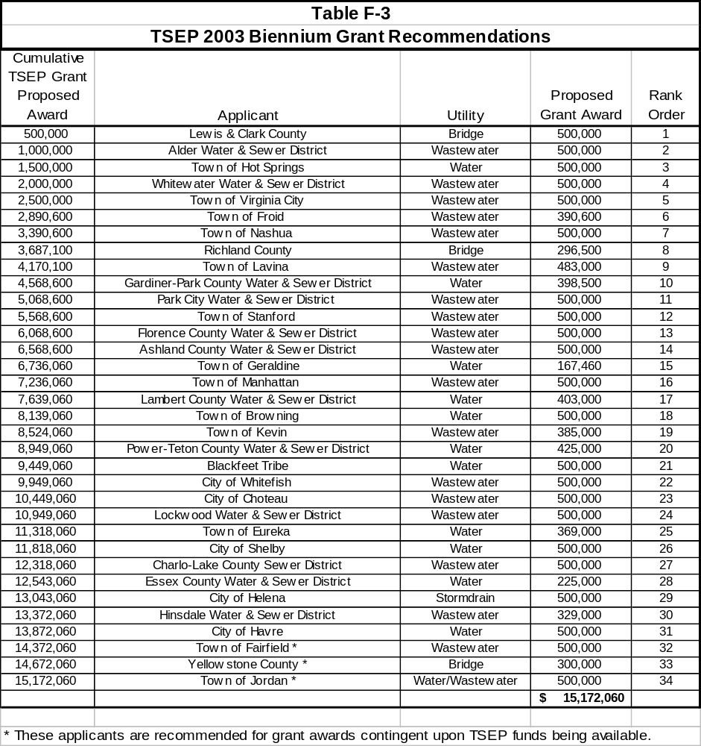

Purpose - The Reclamation and Development Grants Program (RDGP) was established by the Montana Legislature in 1987 to enable funding for projects that indemnify the people of Montana for the effects of mineral development on public resources and that meet other crucial needs serving the public interest and the total environment of the citizens of Montana. Administered by the Department of Natural Resources and Conservation (DNRC), the RDGP fulfills this mission by funding projects that (1) repair, reclaim, and mitigate environmental damage to public resources from nonrenewable resource extraction, and (2) develop and ensure the quality of public resources for the benefit of all Montanans. The RDGP Act is Title 90, Chapter 2, part 11, MCA.

Executive Recommendation -
- Volume 4 of the Governor's 2001 biennium Executive Budget contains the complete project evaluations and funding recommendations for the RDGP. Table F-4 lists the recommended projects.
- HB 7 presents the reclamation and development grant recommendations which total $5,982,297 for 25 projects.
- Requests are matched by about $13 million in non-RDGP funds from a variety of state, federal, private and local sources.
- Representative mineral development-related projects include reclamation and cleanup of the Ruby Gulch mine tailings at the Zortman-Landusky Mine, the Ontario Mine near Elliston, the Broadway/Victoria, Mammoth and Gregory Mines all located in western Montana, four drainages impacted by placer mining located near Canyon Ferry Lake, and numerous oil/gas wells located throughout Montana.
- Non-mineral projects include cleanup and reclamation of three hazardous waste sites contaminated by petroleum and/or pesticides.

Since the Last Session -
- Most project work has been reclamation of abandoned hard rock mines, hazardous waste sites, and plugging and site restoration of orphaned oil and gas wells.
- Progress has been made in reclamation research on heavy metal tolerant plants, technical assistance to local governments, and investigation of cumulative effects on the Yellowstone River caused by channel modifications.
- DNRC received 30 grant applications requesting $7,595,837 in RDGP funding during the interim.

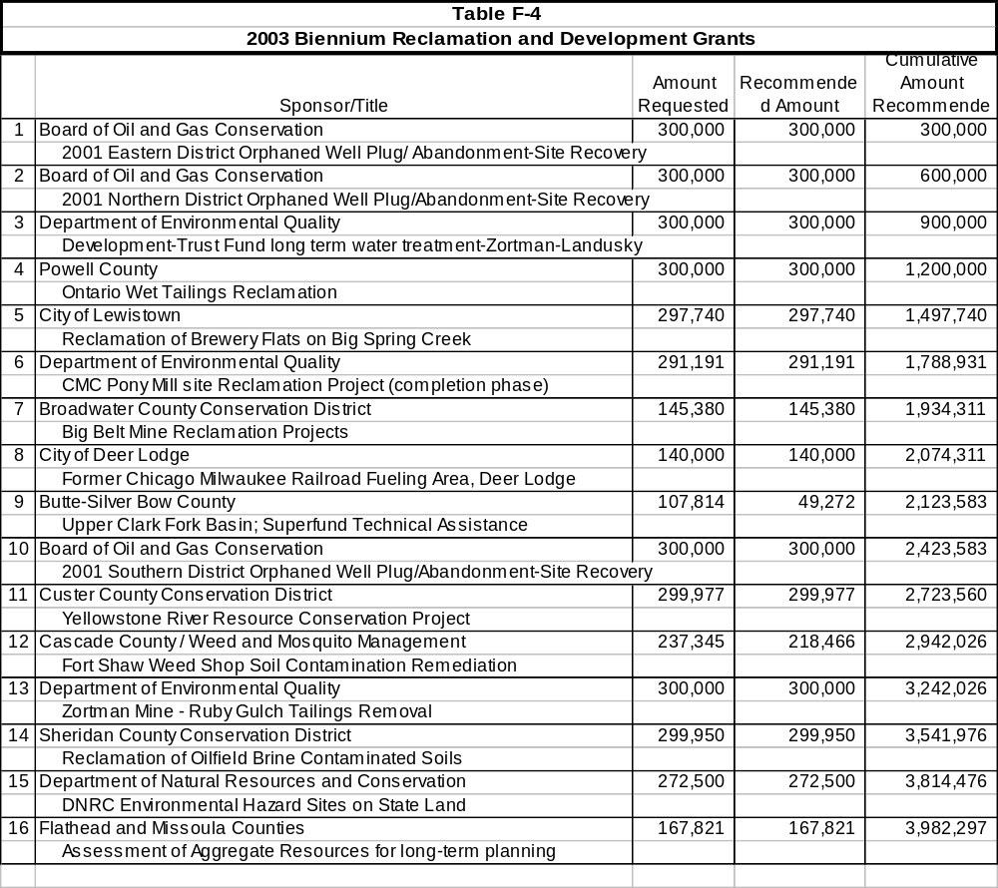

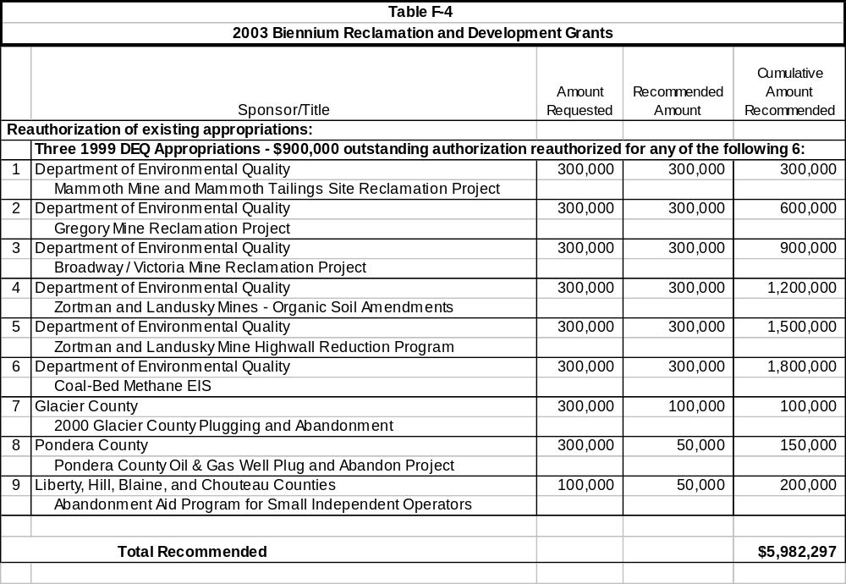

Purpose - The Renewable Resource Grant and Loan Program offers funding for projects that conserve, manage, develop, and preserve renewable resources to provide economic and other benefits of the state's natural heritage. The Department of Natural Resources and Conservation (DNRC) administers the program, which is provided for in Title 85, Chapter 1, part 6, MCA. Governmental entities may apply to the program to obtain funding for community resource-related projects. Project eligibility covers a wide spectrum including irrigation system rehabilitation, stream restoration, watershed management, public water and sewer systems, and resource assessment projects.

Executive Recommendation -
- Volume 5 of the Governor's 2001 biennium Executive Budget contains the complete project evaluations and funding recommendations for all grant and loan applications. Table F-5 shows the recommended projects.
- HB 6 presents the renewable resource grants recommendations for legislative action.
- Grant funding is limited to $3.7million and would provide funding for the first 38 of the 71 applications.
- Funding is recommended in the bill for 61 projects, in order of priority, for a total of $5.9 million, in keeping with the DNRC policy of including all projects that meet minimum technical and financial feasibility requirements.
- The highest priority grant will rehabilitate a state owned, high-hazard dam on the North Fork of the Musselshell River in central Montana.
- Other projects include Nevada Creek and other dam rehabilitation, nutrient reduction on Flathead Lake, Virginia City wastewater, irrigation rehabilitation projects, and numerous proposals for municipal water and sewer systems.
- HB 6 recommends provision of $125,000 in emergency grants to communities for projects that present immediate threats to public health.
- Grant funding for project planning grants is limited to $300,000.
- Grant funding for private grants is limited to $100,000.
- HB 8 presents the renewable resource bonds and loans recommendations from applications that total $3 million in new requests.

Since the Last Session -
- As of August 2000, DNRC entered into grant agreements with 31 of the 39 grantees that received appropriations for a total of $2,708,956.
- Five grants were awarded for emergency repairs to municipal water systems or exploration for water for municipal water systems and for fire related rehabilitation in the Bitterroot Valley.
- Forty-three project planning grants were issued.
- Eleven private grants were issued for a total of $31,708.

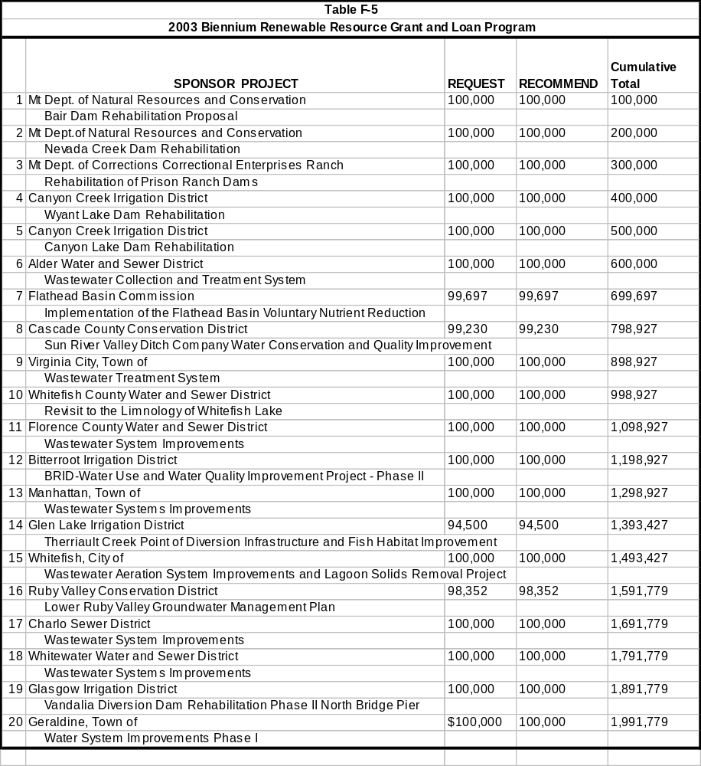

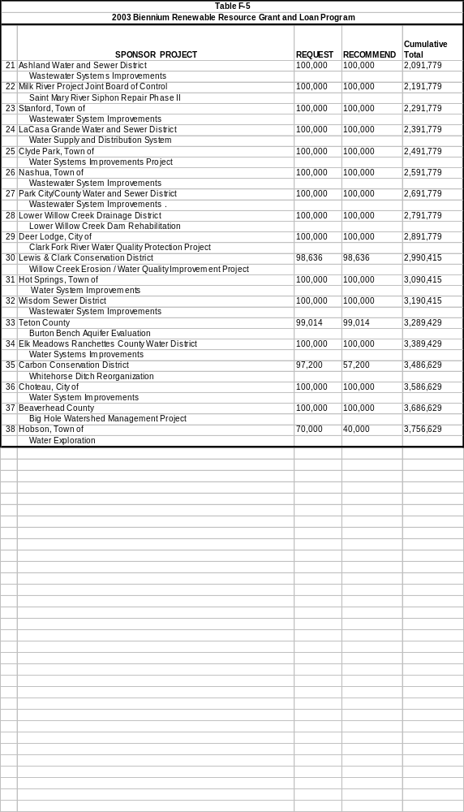

Purpose - The Cultural and Aesthetic Grant Program began in the 1979 biennium for protection of works of art in the state capitol and for other cultural and aesthetic projects as provided in 15-35-108, and Title 22, Chapter 2, part 3, MCA. Initially administered by the Montana Historical Society, the C&A program was transferred to the Montana Arts Council in the 1985 biennium and continued to be funded by the interest from a statutory trust which receives coal severance tax revenues. Project applications are submitted to the MAC for review and ranking by the 16-member Cultural and Aesthetic Projects Advisory Committee, half of whom are appointed by the MAC and half by the MHS.

Coal severance tax revenue of 0.63 percent is statutorily allocated to the capitol art protection trust fund for partial funding of the recommended grants.

Executive Recommendation -
- HB 9 contains all the projects recommended by the advisory committee for funding in the amount of $944,755. Projects are organized into four categories: special projects less than $4,500, special projects, operational support, and capital expenditure grants.
- The revenue estimate for cultural trust interest earnings for the 2003 biennium is $638,000.
- Montana Arts Council administration [appropriated in HB 2] is recommended for $278,245.
- Montana Historical Society is appropriated in HB 9 the first $15,000 for Capitol Complex works of art.
- The remaining balance of $344,755 will be used for C&A projects in HB 9.
- There also is $600,000 of general fund in HB 9 to continue support of the C&A projects. Table F-6 shows all of the requested and recommended grants.
- Language in HB 9 provides a mechanism for spending the funds within the total revenue available.
- Volume 6 of the Governor's 2003 biennium Executive Budget contains the C&A project applications and advisory committee assessment information. Limited copies of this volume are printed for use by members of the Long-Range Planning Appropriations Subcommittee.

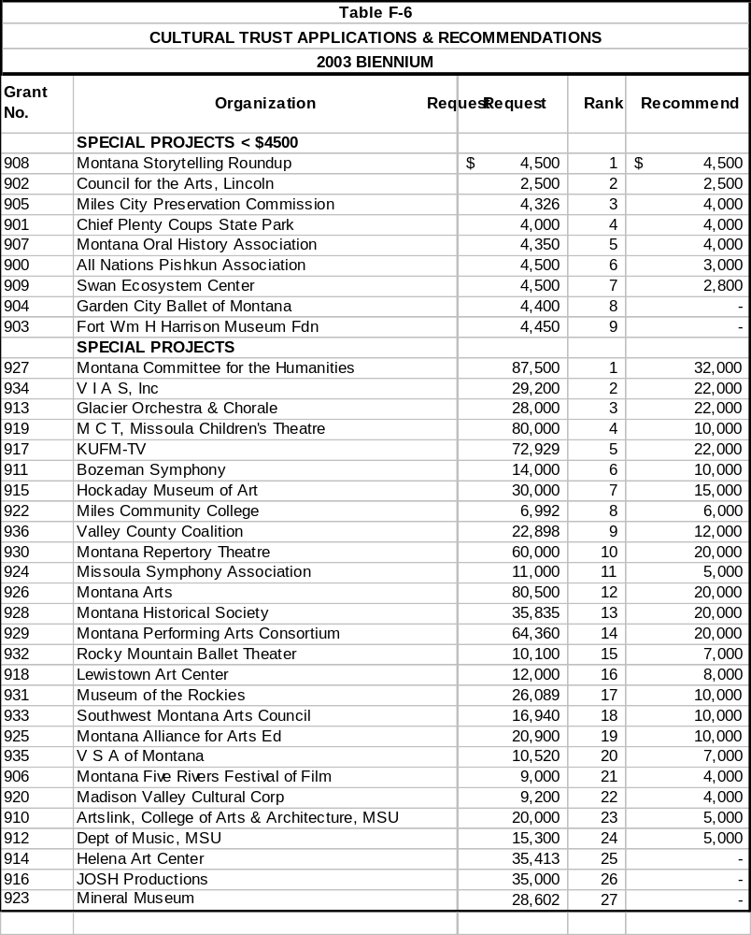
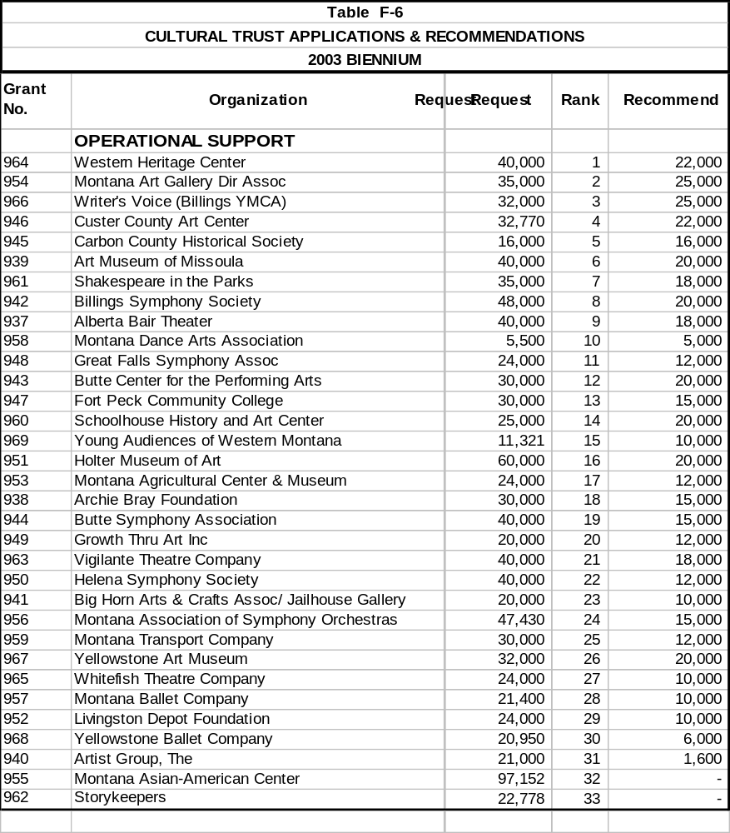

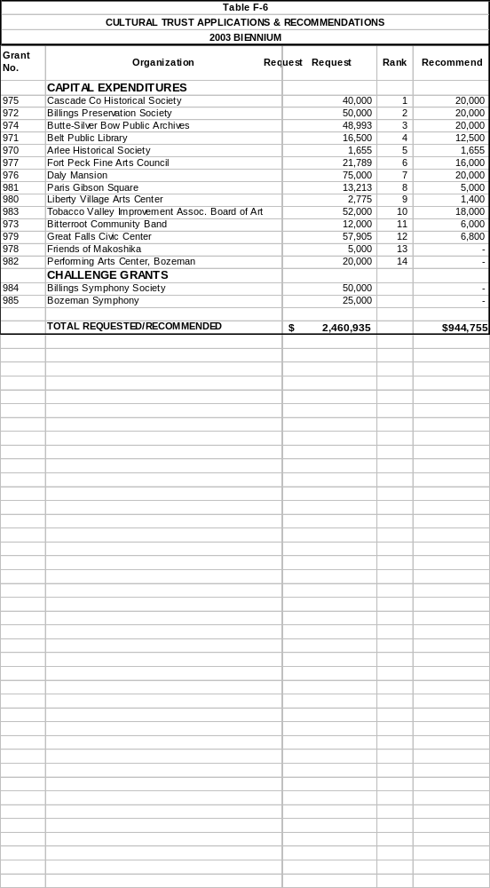
Purpose - Oil overcharge funds are allocated to the states by the U.S. Department of Energy or the courts as a result of litigation against oil companies for overcharging for their products. The funds are awarded as restitution. States must use the funds to assist those who were harmed.

The DOE requires that states present a single plan for all oil overcharge monies. Proposals submitted by agencies and organizations were reviewed and ranked by a five-member task force. Funds available for the 2003 biennium, which are covered by the "Stripper Well settlement guidelines," may not be used to replace state funds and may only be used for the following programs:

1. Low-income home energy assistance,
2. Low-income weatherization,
3. Institutional weatherization,
4. Energy extension service,
5. State energy conservation,
6. Highway and bridge maintenance and repair,
7. Ridesharing,
8. Public transportation,
9. Residential or commercial building energy audits,
10. Grant or loan programs for weatherization or other energy conservation equipment installation,
11. Energy assistance,
12. Airport maintenance or improvement,
13. Reduction in airport user fees.

Executive Recommendation -
- HB 10 contains the recommendations shown in Table F-7 below.
- It is estimated there will be about $563,000 plus carryover funds available for consideration.
- After passage and approval of the oil overcharge projects in HB 10, the Department of Environmental Quality Planning, Prevention & Assistance Division will make formal application to the DOE and serve as the lead state agency.

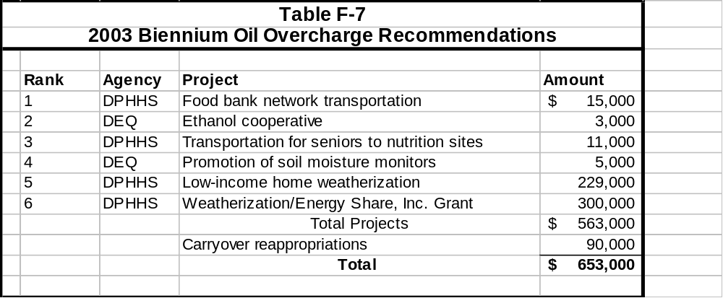

- Calculations for funds available are shown in Table F-8.

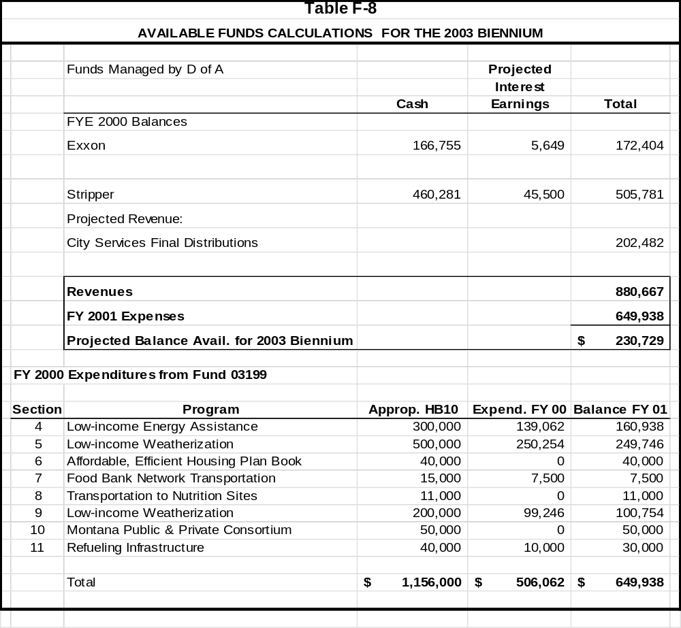

- Oil overcharge funds are managed by the Department of Administration.

Purpose - The State Buildings Energy Conservation Program, operated by the Department of Environmental Quality (DEQ), was established by the 1989 Legislature to reduce operating costs in state facilities by identifying and funding cost-effective energy efficiency improvements. The program operates as a profit center for state government, saving money in agency operating budgets and making money for the Long-Range Building Program through investment in these improvements. Statutory authority is Title 90, Chapter 4, part 6, MCA.

Background -
- The state sells general obligation (G.O.) bonds, uses the bond proceeds to pay for energy efficiency improvements, then uses the resulting energy cost savings to pay the debt service on the bonds.
- Projects are designed so the cost savings exceed the bond debt service.
- There is incremental savings in the short term while the bonds are being repaid, and substantial savings after ten years, when the bonds are retired.
- Energy efficiency improvements include replacing old, inefficient boilers, upgrading inefficient lighting, increasing ventilation system efficiency, insulating buildings, and providing more effective temperature controls.
- DEQ contracts with private engineering firms to perform comprehensive energy analyses on state buildings and building complexes, and to recommend the energy improvements.
- After energy improvements are in place, the DEQ provides on-going training and technical assistance to facility staff to ensure that energy savings are maintained.
- Energy cost savings realized by participating agencies are transferred to a debt service account and used to retire the bonds.
- A portion of the proceeds from each bond issuance is set aside to fund analysis, design, and program administration for the next round of projects so the program is able to continue without additional federal or state funding.

Executive Recommendation -
- HB 12 recommends issuing G.O. bonds not to exceed $3 million for projects during the 2003 biennium.
- The following projects are either in design, construction, or development. Since all projects are coordinated with the architect & engineering division, many of the facilities listed also appear in the LRBP recommendations. The following projects are expected to be among the projects implemented under this program during the 2003 biennium:

Projects in design or construction
University of Montana
Heating Plant, Butte
Science Complex, Missoula
Montana State University
Renne Library, Bozeman
Cowan Hall, Havre
Department of Fish, Wildlife, and Parks
FWP Headquarters, Bozeman

Projects in Development
Department of Military Affairs
Operational Maintenance Shop, Helena
Department of Administration
Justice Building, Helena
Montana State University
College of Technology, Great Falls

Preliminary LRBP Projects
Montana State University
Liberal Arts Building, Billings
Department of Justice
Montana Law Enforcement Academy, Helena
Department of Public Health and Human Services
Montana Mental Health Nursing Care Center, Lewistown

Purpose – The state requires a vehicle to fund large information technology projects, other than through the normal appropriation bill. The 1997 Legislature passed HB 188, defining information technology as infrastructure and as an asset, allowing bonding for large information technology projects. HB 188 authorized $43 million in bonding for information technology projects. The 1999 Legislature authorized $18.8 million for two projects 1) Department of Revenue for $18 million for the META project, 2) the Montana University System for $800,000 for the banner project. All bonds must be issued in accordance with Title 17, Chapter 5, part 8, MCA.

Executive Recommendation –
- HB 15 recommends $800,000 in G.O. bonding for the Department of Justice to purchase 592 automated accounting and reporting system data collection units to continue the 1999 Legislature’s directive for enhanced reporting from gambling establishments. Debt service payments will be made from the gambling state special revenue fund.
- HB 15 recommends $2.5 million of G.O. bonding for PBS digital conversion. The proceeds must be used to meet FCC mandated requirements. Bond proceeds, along with private contributions, may be used to match the national telecommunications information administration grant for digital conversion. The general fund balance sheet in the Governor’s Executive Budget includes $642,814 for debt service on the project for the 2003 biennium.

COAL TAX TRUST FUND LOAN-CULTURAL HERITAGE INITIATIVE

Purpose – Montanans have great pride in their history. To preserve Montana history, and promote economic development through heritage tourism, the Executive Budget proposes a loan from the coal tax trust for funding history preservation and preparing for the upcoming Lewis & Clark Bicentennial. Up to nine million visitors per year could visit the state during the bicentennial period. Grants will be made available to Montana communities to prepare for the bicentennial.

Executive Recommendation –

HB 16 will provide up to $40 million for preservation of Montana history.

Community grants will be funded with $6.75 million and will require one-third hard or soft match for the Lewis & Clark bicentennial.

Heritage Grant Program for preserving local history is funded at $2 million and requires matching funds to the amount of the grant.

Fish, Wildlife and Parks has 21 parks designated as having historical and cultural resources, requiring $6.5 million to preserve, protect, and provide availability for public use.

Virginia City and Nevada City would be funded with $19 million over ten years to enhance restoration and develop an infrastructure to support and improve tourism.

Daly Mansion requires $4 million over several years for structural repair.

Moss Mansion and Original Governor’s Mansion will receive support maintenance.

HB 5 includes $1 million for the study/design of a new Montana Historical Museum that would be funded from HB 16.

Of the $40 million, there is $22.331 million projected to be spent in the 2003 biennium. The general fund balance sheet includes a net general fund interest loss of $583,463 in FY 2002 and $935,829 in FY 2003. for these projects.

