Office of Budget and Program Planning Staff
Mick Robinson, Acting Budget Director Curt Nichols, Assistant Budget Director
Steve Bender, Assistant Budget Director Jane Hamman, Assistant Budget Director
Mike Walsh, Network Administrator Helen Kittel, Administrative Officer
Jeanne Nevins, Administrative Assistant

Code Agency Executive Budget Analyst Back-Up Staff

Section A – General Government & Transportation
1104 Legislative Branch Amy Sassano Mary Beth Linder
1112 Consumer Counsel Amy Sassano Mary Beth Linder
2110 Judiciary Amy Sassano Mary LaFond
2115 Chiropractic Legal Panel Amy Sassano Mary LaFond
3101 Governor’s Office Amy Sassano Mary Beth Linder
3201 Secretary of State Amy Sassano Mary Beth Linder
3202 Comm. of Political Practices Amy Sassano Mary Beth Linder
3401 State Auditor Mary Beth Linder Amy Sassano
5401 Dept. of Transportation Amy Sassano Mary Beth Linder
5801 Dept. of Revenue Mary Beth Linder Amy Sassano
6101 Dept. of Administration Mary Beth Linder Amy Sassano
6102 Appellate Defender Amy Sassano Mary Beth Linder
6103 State Fund Mary Beth Linder Amy Sassano
6104 PERS (non-budgeted) Amy Sassano Mary Beth Linder
6105 TRS (non-budgeted) Amy Sassano Mary Beth Linder

Section B – Public Health and Human Services
6901 Dept. of PHHS Bob Andersen and Connie Welsh

Section C – Natural Resources & Commerce
5201 Dept. of Fish, Wildlife & Parks Beckie Graham Jane Hamman
5301 Dept. of Environmental Quality Doug Schmitz Beckie Graham
5603 Dept. of Livestock Doug Schmitz Beckie Graham
5706 Dept. of Nat. Resources & Cons. Doug Schmitz Amy Sassano
6201 Dept. of Agriculture Doug Schmitz Amy Sassano
6501 Dept. of Commerce Doug Schmitz Amy Sassano

Section D – Public Safety & Justice
4107 Crime Control Division Mary LaFond Doug Booker
4110 Dept. of Justice Mary LaFond Doug Booker
4201 Public Service Regulation Mary LaFond Doug Schmitz
6401 Dept. of Corrections Mary LaFond Doug Booker
6602 Dept. of Labor & Industry Mary Beth Linder Doug Schmitz
6701 Dept. of Military Affairs Doug Booker Doug Schmitz

Section E – Education
3501 OPI Amy Carlson Curt Nichols
3511-5 Colleges of Technology Mark Bruno Curt Nichols
5101 Board of Public Education Beckie Graham Amy Carlson
5102 Commissioner of Higher Education Mark Bruno Curt Nichols
5103-8 MUS Six Units Mark Bruno Curt Nichols
Community Colleges & Research Amy Carlson Curt Nichols
5109 MAES Amy Carlson Curt Nichols
5110 MCES Amy Carlson Curt Nichols
5111 Forestry Experiment Station Amy Carlson Curt Nichols
5112 Bureau of Mines Amy Carlson Curt Nichols
5113 School for the Deaf & Blind Beckie Graham Amy Carlson
5114 Montana Arts Council Beckie Graham Amy Carlson
5115 State Library Beckie Graham Amy Carlson
5117 Montana Historical Society Beckie Graham Amy Carlson
5119 Fire Services Training School Amy Carlson Curt Nichols

Section F – Long Range Building Doug Booker Jane Hamman
State of Montana Vision and Goals

THE VISION:

WE MONTANANS WANT OUR STATE TO BE ECONOMICALLY VIBRANT, ENVIRONMENTALLY CLEAN AND SOCIALLY SECURE, WITH ROOM TO LIVE OUR INDIVIDUAL DREAMS IN THE 21ST CENTURY.

THE GOALS:

1. To protect and enhance the health, well-being and productivity of all Montanans.

2. To preserve the environment and ensure wise, productive use of our natural resources.

3. To build a solid foundation for educational opportunities and social and economic prosperity.

4. To ensure the safety of our communities.

2003 Biennium Executive Budget Bills

HB No. Brief Title of Legislation
1 Feed Bill
2 General Appropriations Act
3 Supplemental Appropriations for current biennium
4 Budget Amendments
5 Long-Range Building Program appropriations
6 Renewable Resource Grants Program
7 Reclamation and Development Grants Program
8 Renewable Resource bonds and loans
- Cultural and Aesthetic Grants Program
10 Oil Overcharge appropriations
11 Treasure State Endowment Program
12 GO bonds for State Building Energy Conservation Program
13 Pay plan bill
14 Long-Range Building Program GO bonds
15 Information Technology GO bonds
16 Coal tax trust fund loan for heritage tourism
17 Emergency supplemental appropriations for fires

Table R-1

AGENCY BUDGET SUMMARY HB 2 ALL FUNDS
 |  |  | Actual FY00 | Budget FY01 | Request FY02 | Request FY03
1104 LEGISLATIVE BRANCH
 | LEGISLATIVE SERVICES
 |  | General Fund | 3,650,692 | 3,855,665 | 4,430,640 | 5,242,420
 |  | State Special Revenue | 997,797 | 448,063 | 917,853 | 439,738
 | LEGIS. COMMITTEES & ACTIVITIES
 |  | General Fund | 316,959 | 259,481 | 933,501 | 0
 |  | State Special Revenue | 0 | 0 | 77,285 | 0
 | FISCAL ANALYSIS & REVIEW
 |  | General Fund | 1,032,018 | 1,079,660 | 1,107,456 | 1,152,486
 | AUDIT & EXAMINATION
 |  | General Fund | 1,730,069 | 1,803,451 | 1,881,243 | 1,894,953
 |  | State Special Revenue | 1,118,180 | 1,275,698 | 1,436,452 | 1,372,966
 |  | Agency Totals | 8,845,715 | 8,722,018 | 10,784,430 | 10,102,563
1112 CONSUMER COUNSEL
 | ADMINISTRATION PROGRAM
 |  | State Special Revenue | 867,516 | 1,098,793 | 1,106,076 | 1,108,133
 |  | Agency Totals | 867,516 | 1,098,793 | 1,106,076 | 1,108,133
2110 JUDICIARY
 | SUPREME COURT OPERATIONS
 |  | General Fund | 2,675,451 | 2,781,800 | 3,509,846 | 3,467,138
 |  | State Special Revenue | 862,894 | 1,004,526 | 1,000,000 | 1,000,000
 |  | Federal Special Revenue | 75,000 | 74,999 | 413,725 | 413,725
 | BOARDS AND COMMISSIONS
 |  | General Fund | 200,676 | 255,832 | 328,253 | 327,305
 | LAW LIBRARY
 |  | General Fund | 693,643 | 662,367 | 796,477 | 791,985
 | DISTRICT COURT OPERATIONS
 |  | General Fund | 4,359,540 | 4,516,993 | 4,862,787 | 4,886,134
 | WATER COURTS SUPERVISION
 |  | State Special Revenue | 625,320 | 649,468 | 669,691 | 678,959
 | CLERK OF COURT
 |  | General Fund | 274,746 | 277,402 | 381,971 | 375,851
 |  | Agency Totals | 9,767,270 | 10,223,387 | 11,962,750 | 11,941,097
2115 CHIROPRATIC LEGAL PANEL
 | LEGAL PANEL OPERATIONS
 |  | State Special Revenue | 10,539 | 17,193 | 15,000 | 15,000
 |  | Agency Totals | 10,539 | 17,193 | 15,000 | 15,000
3101 GOVERNOR'S OFFICE
 | EXECUTIVE OFFICE PROGRAM
 |  | General Fund | 1,124,481 | 1,192,243 | 1,235,160 | 1,213,644
 |  | State Special Revenue | 207,390 | 245,932 | 288,715 | 289,419
 | MANSION MAINTENANCE PROGRAM
 |  | General Fund | 79,921 | 74,683 | 79,548 | 79,703
 | AIR TRANSPORTATION PROGRAM
 |  | General Fund | 170,710 | 147,584 | 176,001 | 177,300
 |  | State Special Revenue | 15,998 | 16,096 | 16,000 | 16,000
 | OFFICE OF BDGET & PGM PLANNING
 |  | General Fund | 1,051,174 | 1,045,755 | 1,133,442 | 1,099,074
 |  | State Special Revenue | 0 | 0 | 0 | 0
 | INDIAN AFFAIRS
 |  | General Fund | 105,116 | 117,760 | 113,367 | 113,750
 |  | State Special Revenue | 0 | 0 | 150,000 | 0
 |  | Federal Special Revenue | 0 | 0 | 2,000,000 | 0
 | LT. GOVERNOR
 |  | General Fund | 208,761 | 207,764 | 226,503 | 228,092
 | CITIZENS ADVOCATE OFFICE
 |  | General Fund | 65,649 | 64,880 | 66,192 | 66,403
 |  | Federal Special Revenue | 14,192 | 15,279 | 15,000 | 15,000
 | MENTAL DIS BD VISITORS
 |  | General Fund | 218,740 | 232,626 | 264,183 | 261,083
 |  | State Special Revenue | 7,358 | 9,724 | 0 | 0
 |  | Federal Special Revenue | 29,464 | 27,796 | 30,000 | 30,500
 |  | Agency Totals | 3,298,954 | 3,398,122 | 5,794,111 | 3,589,968
3202 COMMISSIONER OF POLITICAL PRACTICES
 | ADMINISTRATION
 |  | General Fund | 317,129 | 367,961 | 352,660 | 349,043
 |  | Agency Totals | 317,129 | 367,961 | 352,660 | 349,043
3401 STATE AUDITOR'S OFFICE
 | CENTRAL MANAGEMENT
 |  | General Fund | 152,416 | 0 | 0 | 0
 |  | State Special Revenue | 271,076 | 466,000 | 535,891 | 529,567
 | INSURANCE
 |  | General Fund | 512,384 | 2,000,000 | 0 | 0
 |  | State Special Revenue | 1,799,803 | 2,677,639 | 2,556,001 | 2,496,146
 | SECURITIES
 |  | General Fund | 341,795 | 427,878 | 356,945 | 355,658
 |  | State Special Revenue | 135,497 | 139,587 | 203,106 | 201,333
 |  | Agency Totals | 3,212,971 | 5,711,104 | 3,651,943 | 3,582,704
3501 OFFICE OF PUBLIC INSTRUCTION
 | OPI ADMINISTRATION
 |  | General Fund | 4,330,299 | 4,395,494 | 6,040,862 | 6,084,299
 |  | State Special Revenue | 242,216 | 266,000 | 183,911 | 183,911
 |  | Federal Special Revenue | 5,148,443 | 7,852,974 | 7,604,030 | 7,626,753
 |  | Proprietary Funds | 0 | 0 | 152,083 | 152,114
 | DISTRIBUTION TO PUBLIC SCHOOLS
 |  | General Fund | 476,555,227 | 491,769,841 | 486,835,440 | 496,812,595
 |  | State Special Revenue | 1,000,000 | 1,000,006 | 750,000 | 750,000
 |  | Federal Special Revenue | 73,808,525 | 73,917,376 | 87,765,281 | 90,160,732
 |  | Agency Totals | 561,084,710 | 579,201,691 | 589,331,607 | 601,770,404
4107 CRIME CONTROL DIVISION
 | JUSTICE SYSTEM SUPPORT SERVICE
 |  | General Fund | 2,511,110 | 2,553,913 | 2,600,546 | 2,611,929
 |  | Federal Special Revenue | 8,244,466 | 12,645,156 | 10,349,657 | 10,346,389
 |  | Agency Totals | 10,755,576 | 15,199,069 | 12,950,203 | 12,958,318
4110 DEPARTMENT OF JUSTICE
 | LEGAL SERVICES DIVISION
 |  | General Fund | 2,407,043 | 2,713,883 | 2,855,836 | 2,873,992
 |  | State Special Revenue | 279,238 | 287,284 | 286,403 | 287,757
 |  | Federal Special Revenue | 63,395 | 205,020 | 152,228 | 152,691
 | GAMBLING CONTROL DIVISION
 |  | General Fund | 901,388 | 536,079 | 960,122 | 965,960
 |  | State Special Revenue | 2,005,940 | 2,666,552 | 2,303,835 | 2,326,046
 | MOTOR VEHICLE DIVISION
 |  | General Fund | 7,616,656 | 7,741,979 | 8,515,983 | 8,425,968
 |  | State Special Revenue | 403,056 | 403,054 | 403,056 | 403,056
 |  | Federal Special Revenue | 0 | 0 | 0 | 0
 | HIGHWAY PATROL DIVISION
 |  | General Fund | 1,042,073 | 1,083,606 | 1,079,779 | 1,112,796
 |  | State Special Revenue | 15,552,254 | 16,202,118 | 17,227,644 | 17,528,702
 |  | Federal Special Revenue | 693,174 | 706,301 | 969,038 | 975,779
 | DIVISION OF CRIMINAL INVESTIGATION
 |  | General Fund | 2,214,742 | 2,349,717 | 2,438,757 | 2,453,101
 |  | State Special Revenue | 355,806 | 370,795 | 321,704 | 322,960
 |  | Federal Special Revenue | 1,118,734 | 1,154,606 | 1,338,651 | 1,344,603
 | COUNTY ATTORNEY PAYROLL
 |  | General Fund | 1,556,508 | 1,630,606 | 1,706,886 | 1,752,445
 | LAW ENFORCEMENT ACADEMY DIV
 |  | General Fund | 1,033,438 | 1,080,553 | 1,112,954 | 1,098,227
 |  | State Special Revenue | 0 | 0 | 50,000 | 50,000
 |  | Federal Special Revenue | 0 | 0 | 199,607 | 199,722
 | CENTRAL SERVICES DIVISION
 |  | General Fund | 254,296 | 240,278 | 319,391 | 292,105
 |  | State Special Revenue | 324,913 | 326,512 | 409,166 | 374,267
 |  | Proprietary Funds | 11,760 | 10,991 | 14,879 | 13,609
 | JUSTICE INFORMATION SYSTEMS DIVISION
 |  | General Fund | 2,486,200 | 2,560,384 | 3,028,992 | 3,043,760
 |  | State Special Revenue | 657,371 | 697,240 | 657,371 | 657,371
 |  | Federal Special Revenue | 474,801 | 159,389 | 774,801 | 774,801
 |  | Proprietary Funds | 10,214 | 10,214 | 10,214 | 10,214
 | EXTRADITION & TRANSP PRISONERS
 |  | General Fund | 164,479 | 165,255 | 165,657 | 166,869
 | FORENSIC SCIENCE DIVISION
 |  | General Fund | 1,886,174 | 1,930,595 | 2,158,231 | 2,147,719
 |  | State Special Revenue | 303,202 | 300,912 | 303,205 | 303,205
 |  | Federal Special Revenue | 49,685 | 74,721 | 185,673 | 185,973
 |  | Agency Totals | 43,866,540 | 45,608,644 | 49,950,063 | 50,243,698
4201 PUBLIC SERVICE REGULATION
 | PUBLIC SERVICE REGULATION PROG
 |  | State Special Revenue | 2,300,576 | 2,491,662 | 3,236,594 | 2,417,164
 |  | Federal Special Revenue | 15,616 | 20,099 | 13,763 | 13,763
 |  | Agency Totals | 2,316,192 | 2,511,761 | 3,250,357 | 2,430,927
5101 BOARD OF PUBLIC EDUCATION
 | ADMINISTRATION
 |  | General Fund | 137,503 | 138,362 | 156,828 | 155,507
 |  | State Special Revenue | 11,425 | 11,748 | 12,041 | 12,041
 | ADVISORY COUNCIL
 |  | State Special Revenue | 148,727 | 177,261 | 163,135 | 161,994
 |  | Agency Totals | 297,655 | 327,371 | 332,004 | 329,542
5102 COMMISSIONER OF HIGHER EDUCATION
 | ADMINISTRATION PROGRAM
 |  | General Fund | 1,186,818 | 1,174,288 | 1,326,037 | 1,305,547
 |  | State Special Revenue | 0 | 0 | 0 | 0
 | STUDENT ASSISTANCE PROGRAM
 |  | General Fund | 7,383,508 | 7,717,271 | 8,968,290 | 9,248,008
 |  | Federal Special Revenue | 70,414 | 210,784 | 84,871 | 84,871
 | DDE MATHEMATICS & SCI ED ACT
 |  | Federal Special Revenue | 216,295 | 312,602 | 312,744 | 312,744
 | COMMUNITY COLLEGE ASSISTANCE
 |  | General Fund | 5,204,315 | 5,802,528 | 5,577,726 | 5,600,537
 | TALENT SEARCH
 |  | General Fund | 81,995 | 97,698 | 94,085 | 94,593
 |  | Federal Special Revenue | 426,807 | 614,858 | 2,999,420 | 3,135,332
 | C.D. PERKINS ADMIN
 |  | General Fund | 76,528 | 88,542 | 80,000 | 80,000
 |  | Federal Special Revenue | 8,535,863 | 8,457,140 | 7,767,340 | 6,127,275
 | APPROPRIATION DISTRIBUTION
 |  | General Fund | 110,517,609 | 112,214,724 | 122,231,057 | 124,545,531
 |  | State Special Revenue | 15,567,144 | 16,151,000 | 12,821,144 | 12,989,144
 | TRIBAL COLLEGE ASSISTANCE PROGRAM
 |  | General Fund | 0 | 0 | 417,000 | 417,000
 | GUARANTEED STUDENT LOAN PGM
 |  | Federal Special Revenue | 22,962,076 | 34,582,254 | 34,692,811 | 37,396,398
 | BOARD OF REGENTS-ADMIN
 |  | General Fund | 43,762 | 43,888 | 43,762 | 43,762
 |  | Agency Totals | 172,273,134 | 187,467,577 | 197,416,287 | 201,380,742
5113 MONTANA SCHOOL FOR THE DEAF AND BLIND
 | ADMINISTRATION PROGRAM
 |  | General Fund | 287,964 | 305,507 | 333,093 | 303,298
 | GENERAL SERVICES PROGRAM
 |  | General Fund | 306,719 | 309,498 | 315,673 | 317,099
 | STUDENT SERVICES PROGRAM
 |  | General Fund | 893,270 | 970,281 | 911,838 | 915,326
 |  | Federal Special Revenue | 24,644 | 24,644 | 25,000 | 25,000
 | EDUCATION PROGRAM
 |  | General Fund | 1,706,473 | 1,767,725 | 1,876,807 | 1,877,264
 |  | State Special Revenue | 228,068 | 228,069 | 235,065 | 235,065
 |  | Federal Special Revenue | 56,750 | 56,750 | 63,898 | 63,898
 |  | Agency Totals | 3,503,888 | 3,662,474 | 3,761,374 | 3,736,950
5114 MONTANA ARTS COUNCIL
 | PROMOTION OF THE ARTS
 |  | General Fund | 280,604 | 278,549 | 371,686 | 340,748
 |  | State Special Revenue | 132,440 | 129,399 | 140,829 | 137,416
 |  | Federal Special Revenue | 400,212 | 442,934 | 477,500 | 477,500
 |  | Agency Totals | 813,256 | 850,882 | 990,015 | 955,664
5115 LIBRARY COMMISSION
 | STATE LIBRARY OPERATIONS
 |  | General Fund | 1,540,599 | 1,578,590 | 2,180,740 | 1,905,152
 |  | State Special Revenue | 174,921 | 182,173 | 295,210 | 295,210
 |  | Federal Special Revenue | 662,307 | 1,388,955 | 1,200,694 | 750,694
 | NATURAL RESOURCE INFO SYSTEM
 |  | General Fund | 57,234 | 44,972 | 105,388 | 109,594
 |  | State Special Revenue | 492,560 | 491,443 | 651,871 | 626,929
 |  | Federal Special Revenue | 30,000 | 45,000 | 505,000 | 30,000
 |  | Agency Totals | 2,957,621 | 3,731,133 | 4,938,903 | 3,717,579
5117 MONTANA HISTORICAL SOCIETY
 | ADMINISTRATION PROGRAM
 |  | General Fund | 737,206 | 736,771 | 1,152,701 | 1,125,406
 |  | State Special Revenue | 81,510 | 101,488 | 102,023 | 102,023
 |  | Federal Special Revenue | 57,178 | 58,580 | 57,587 | 58,409
 |  | Proprietary Funds | 0 | 0 | 70,000 | 70,000
 | LIBRARY PROGRAM
 |  | General Fund | 556,884 | 508,152 | 595,683 | 598,687
 |  | State Special Revenue | 2,808 | 4,289 | 2,808 | 2,808
 |  | Federal Special Revenue | 0 | 0 | 0 | 0
 |  | Proprietary Funds | 55,994 | 56,510 | 59,727 | 59,799
 | MUSEUM PROGRAM
 |  | General Fund | 280,204 | 253,396 | 430,602 | 433,938
 |  | State Special Revenue | 108,268 | 134,756 | 128,217 | 128,769
 |  | Proprietary Funds | 7,943 | 9,031 | 7,618 | 7,618
 | PUBLICATIONS
 |  | General Fund | 53,652 | 53,650 | 73,652 | 73,652
 |  | State Special Revenue | 0 | 0 | 0 | 0
 |  | Proprietary Funds | 666,913 | 713,935 | 699,020 | 700,494
 | HISTORICAL SITES PRESERVATION
 |  | General Fund | 22,574 | 23,956 | 47,381 | 44,451
 |  | State Special Revenue | 0 | 0 | 0 | 0
 |  | Federal Special Revenue | 404,510 | 481,746 | 813,196 | 815,607
 | LEWIS & CLARK BICENTENNIAL
 |  | General Fund | 0 | 0 | 100,000 | 100,000
 |  | Agency Totals | 3,035,644 | 3,136,260 | 4,340,215 | 4,321,661
5201 DEPARTMENT OF FISH, WILDLIFE AND PARKS
 | ADMINISTRATION & FINANCE DIV.
 |  | State Special Revenue | 5,598,691 | 4,594,622 | 6,038,466 | 6,010,089
 |  | Federal Special Revenue | 2,023,782 | 623,183 | 1,276,587 | 1,264,829
 |  | Proprietary Funds | 0 | 0 | 0 | 0
 | FIELD SERVICES DIVISION
 |  | State Special Revenue | 4,843,842 | 5,729,950 | 6,702,156 | 6,687,177
 |  | Federal Special Revenue | 678,261 | 677,982 | 787,438 | 792,238
 |  | Proprietary Funds | 0 | 0 | 0 | 0
 | FISHERIES DIVISION
 |  | State Special Revenue | 3,152,488 | 3,180,444 | 3,362,831 | 3,386,018
 |  | Federal Special Revenue | 3,418,265 | 3,454,250 | 5,726,623 | 5,774,929
 | LAW ENFORCEMENT DIVISION
 |  | General Fund | 132,693 | 128,730 | 136,669 | 136,669
 |  | State Special Revenue | 5,717,358 | 6,015,521 | 6,116,547 | 6,002,540
 |  | Federal Special Revenue | 229,727 | 231,129 | 487,130 | 446,619
 | WILDLIFE DIVISION
 |  | State Special Revenue | 3,366,666 | 4,517,997 | 3,736,911 | 3,787,027
 |  | Federal Special Revenue | 3,225,488 | 3,299,816 | 4,195,039 | 4,224,112
 | PARKS DIVISION
 |  | General Fund | 284,076 | 285,620 | 294,189 | 294,189
 |  | State Special Revenue | 4,547,243 | 4,403,843 | 4,864,717 | 4,612,899
 |  | Federal Special Revenue | 793,089 | 874,839 | 527,000 | 527,000
 |  | Proprietary Funds | 0 | 0 | 0 | 0
 | CONSERVATION EDUCATION DIV
 |  | General Fund | 2,697 | 2,698 | 2,697 | 2,697
 |  | State Special Revenue | 1,690,907 | 1,600,236 | 1,889,875 | 1,722,398
 |  | Federal Special Revenue | 392,860 | 435,830 | 736,648 | 736,648
 | DEPARTMENT MANAGEMENT
 |  | State Special Revenue | 2,736,253 | 2,703,132 | 2,671,769 | 2,666,019
 |  | Federal Special Revenue | 729,816 | 693,774 | 2,168,125 | 2,209,990
 |  | Agency Totals | 43,564,202 | 43,453,596 | 51,721,417 | 51,284,087
5301 DEPARTMENT OF ENVIRONMENTAL QUALITY
 | CENTRAL MANAGEMENT PROGRAM
 |  | General Fund | 14,041 | 15,001 | 428,206 | 174,280
 |  | Federal Special Revenue | 3,381 | 0 | 3,381 | 3,381
 | PLAN.PREVENT. & ASSIST.DIV.
 |  | General Fund | 1,747,869 | 1,911,200 | 2,509,540 | 2,500,995
 |  | State Special Revenue | 911,584 | 1,026,813 | 1,073,825 | 1,068,848
 |  | Federal Special Revenue | 4,533,693 | 5,787,873 | 9,264,507 | 8,742,766
 | ENFORCEMENT DIVISION
 |  | General Fund | 501,560 | 517,631 | 544,069 | 532,140
 |  | State Special Revenue | 170,063 | 188,688 | 181,382 | 182,415
 |  | Federal Special Revenue | 356,700 | 413,688 | 377,863 | 379,990
 | REMEDIATION DIVISION
 |  | State Special Revenue | 2,659,229 | 4,492,969 | 7,235,350 | 3,364,699
 |  | Federal Special Revenue | 6,725,809 | 6,647,041 | 8,095,961 | 8,011,036
 | PERMITTING & COMPLIANCE DIV.
 |  | General Fund | 1,002,906 | 1,102,819 | 1,479,889 | 1,346,940
 |  | State Special Revenue | 16,116,988 | 56,536,861 | 40,811,694 | 8,652,768
 |  | Federal Special Revenue | 3,048,297 | 3,093,641 | 4,253,139 | 4,238,526
 |  | Agency Totals | 37,792,120 | 81,734,225 | 76,258,806 | 39,198,784
5401 DEPARTMENT OF TRANSPORTATION
 | GENERAL OPERATIONS PROGRAM
 |  | State Special Revenue | 13,356,684 | 13,837,532 | 17,754,281 | 17,400,260
 |  | Federal Special Revenue | 717,661 | 595,002 | 1,254,386 | 1,188,236
 | CONSTRUCTION PROGRAM
 |  | General Fund | 250,000 | 250,000 | 250,000 | 250,000
 |  | State Special Revenue | 90,693,250 | 46,153,810 | 72,040,676 | 74,647,570
 |  | Federal Special Revenue | 236,847,100 | 285,838,040 | 289,874,050 | 296,628,731
 | MAINTENANCE PROGRAM
 |  | State Special Revenue | 68,159,583 | 79,023,706 | 76,603,219 | 76,933,372
 |  | Federal Special Revenue | 812,538 | 9,246,376 | 5,090,609 | 5,090,609
 | MOTOR CARRIER SERVICES DIV.
 |  | State Special Revenue | 4,798,503 | 4,985,278 | 5,039,123 | 5,056,982
 | AERONAUTICS PROGRAM
 |  | State Special Revenue | 712,150 | 1,234,641 | 1,450,814 | 768,273
 |  | Federal Special Revenue | 65,000 | 74,230 | 85,500 | 85,500
 | TRANSPORTATION PLANNING DIVISI
 |  | State Special Revenue | 1,691,313 | 1,641,187 | 2,597,665 | 2,061,597
 |  | Federal Special Revenue | 4,834,265 | 7,204,308 | 7,121,222 | 6,668,088
 |  | Agency Totals | 422,938,047 | 450,084,110 | 479,161,545 | 486,779,218
5603 DEPARTMENT OF LIVESTOCK
 | CENTRALIZED SERVICES PROGRAM
 |  | General Fund | 2,217 | 100,316 | 64,597 | 64,597
 |  | State Special Revenue | 923,040 | 927,046 | 1,129,157 | 1,032,956
 |  | Federal Special Revenue | 48,801 | 49,580 | 131,479 | 87,682
 | DIAGNOSTIC LABORATORY PROGRAM
 |  | General Fund | 192,442 | 164,210 | 192,442 | 192,442
 |  | State Special Revenue | 1,140,536 | 1,085,622 | 1,204,147 | 1,222,105
 |  | Federal Special Revenue | 0 | 0 | 11,200 | 17,500
 | ANIMAL HEALTH DIVISION
 |  | State Special Revenue | 646,227 | 684,249 | 862,190 | 892,284
 |  | Federal Special Revenue | 0 | 0 | 693,920 | 709,550
 | MILK & EGG PROGRAM
 |  | State Special Revenue | 241,831 | 251,437 | 244,588 | 249,239
 |  | Federal Special Revenue | 20,669 | 20,670 | 25,000 | 25,000
 | INSPECTION & CONTROL PROGRAM
 |  | State Special Revenue | 2,617,978 | 2,635,621 | 2,682,710 | 2,622,715
 | PREDATOR CONTROL
 |  | State Special Revenue | 511,471 | 512,201 | 435,235 | 442,718
 | MEAT/POULTRY INSPECTION
 |  | General Fund | 337,618 | 419,819 | 399,543 | 404,526
 |  | State Special Revenue | 1,772 | 1,762 | 1,772 | 1,772
 |  | Federal Special Revenue | 377,689 | 419,864 | 401,318 | 406,300
 | MILK CONTROL BUREAU
 |  | State Special Revenue | 158,602 | 181,563 | 182,017 | 181,480
 |  | Agency Totals | 7,220,893 | 7,453,960 | 8,661,315 | 8,552,866
5706 DEPARTMENT OF NATURAL RESOURCES AND CONSERVATION
 | CENTRALIZED SERVICES
 |  | General Fund | 1,865,298 | 1,901,967 | 2,063,723 | 1,977,733
 |  | State Special Revenue | 172,437 | 173,667 | 173,400 | 173,400
 |  | Federal Special Revenue | 108,512 | 96,844 | 105,000 | 105,000
 | OIL & GAS CONSERVATION DIV.
 |  | State Special Revenue | 868,921 | 1,103,019 | 1,226,842 | 1,243,414
 |  | Federal Special Revenue | 118,715 | 110,000 | 0 | 0
 | CONSERVATION/RESOURCE DEV DIV
 |  | General Fund | 2,871,886 | 2,835,291 | 4,244,347 | 3,309,204
 |  | State Special Revenue | 1,226,064 | 1,295,507 | 1,471,608 | 1,507,531
 |  | Federal Special Revenue | 150,252 | 182,090 | 1,161,651 | 161,651
 | WATER RESOURCES DIVISION
 |  | General Fund | 5,693,470 | 5,833,127 | 6,106,095 | 6,175,972
 |  | State Special Revenue | 971,226 | 1,065,849 | 4,869,852 | 1,217,964
 |  | Federal Special Revenue | 135,515 | 132,250 | 412,112 | 413,182
 | RESERVED WATER RIGHTS COMP COM
 |  | General Fund | 644,212 | 691,548 | 737,513 | 744,412
 |  | State Special Revenue | 0 | 0 | 0 | 0
 | FORESTRY & TRUST LANDS
 |  | General Fund | 5,454,428 | 5,750,344 | 6,271,995 | 6,196,669
 |  | State Special Revenue | 9,552,704 | 10,407,005 | 11,269,337 | 11,300,866
 |  | Federal Special Revenue | 994,328 | 1,247,069 | 1,570,404 | 1,379,818
 |  | Agency Totals | 30,827,968 | 32,825,577 | 41,683,879 | 35,906,816
5801 DEPARTMENT OF REVENUE
 | DIRECTORS OFFICE
 |  | General Fund | 2,631,010 | 2,611,953 | 2,978,087 | 2,759,765
 |  | State Special Revenue | 574 | 0 | 300 | 0
 |  | Federal Special Revenue | 805 | 0 | 800 | 0
 |  | Proprietary Funds | 139,673 | 142,259 | 225,240 | 229,721
 | INFORMATION TECHNOLOGY
 |  | General Fund | 1,899,468 | 1,687,597 | 1,742,610 | 1,840,849
 |  | Federal Special Revenue | 178,339 | 184,065 | 190,662 | 196,382
 |  | Proprietary Funds | 323,088 | 328,755 | 510,309 | 520,461
 | RESOURCE MANAGEMENT
 |  | General Fund | 1,166,663 | 1,072,521 | 1,542,219 | 1,556,916
 |  | Proprietary Funds | 1,367,727 | 1,399,590 | 1,586,838 | 1,592,780
 | COMPLIANCE VALUATION AND RESOLUTION
 |  | General Fund | 34,284,577 | 77,793,863 | 76,826,838 | 77,142,814
 |  | State Special Revenue | 252,411 | 252,854 | 213,345 | 213,214
 |  | Federal Special Revenue | 1,818,782 | 1,900,984 | 1,940,119 | 1,984,848
 |  | Agency Totals | 44,063,117 | 87,374,441 | 87,757,367 | 88,037,750
6101 DEPARTMENT OF ADMINISTRATION
 | GOVERNOR ELECT PROGRAM
 |  | General Fund | 0 | 0 | 0 | 0
 | ACCOUNTING & MGMT SUPPORT PROG
 |  | General Fund | 1,108,502 | 1,119,043 | 1,417,504 | 1,170,292
 |  | State Special Revenue | 2,557 | 11,376 | 5,057 | 5,057
 |  | Federal Special Revenue | 28,670 | 32,332 | 64,768 | 62,906
 |  | Proprietary Funds | 41,008 | 38,395 | 41,235 | 41,407
 | ARCH & ENGINEERING PGM
 |  | State Special Revenue | 1,034,832 | 1,058,274 | 1,156,831 | 1,165,277
 |  | Capital Projects | 0 | 0 | 0 | 0
 | PROCUREMENT & PRINTING DIV.
 |  | General Fund | 508,524 | 515,002 | 541,198 | 543,141
 | INFORMATION SERVICES DIVISION
 |  | General Fund | 598,112 | 623,218 | 192,275 | 190,687
 |  | Federal Special Revenue | 0 | 0 | 800,000 | 0
 | GENERAL SERVICES PROGRAM
 |  | General Fund | 341,410 | 356,350 | 405,504 | 412,534
 |  | Capital Projects | 0 | 0 | 0 | 0
 | STATE PERSONNEL DIVISION
 |  | General Fund | 1,116,125 | 1,204,080 | 1,168,972 | 1,153,889
 |  | State Special Revenue | 4,596 | 13,000 | 28,600 | 29,400
 | STATE TAX APPEAL BOARD
 |  | General Fund | 283,325 | 399,958 | 376,411 | 378,625
 |  | Agency Totals | 5,067,661 | 5,371,028 | 6,198,355 | 5,153,215
6102 APPELLATE DEFENDER
 | APPELLATE DEFENDER
 |  | State Special Revenue | 170,891 | 192,427 | 181,134 | 182,501
 |  | Agency Totals | 170,891 | 192,427 | 181,134 | 182,501
6201 DEPARTMENT OF AGRICULTURE
 | CENTRAL MANAGEMENT DIVISION
 |  | General Fund | 230,062 | 205,117 | 264,228 | 252,978
 |  | State Special Revenue | 319,055 | 322,424 | 480,194 | 417,012
 |  | Federal Special Revenue | 94,201 | 95,971 | 68,813 | 68,655
 |  | Proprietary Funds | 32,621 | 33,167 | 88,374 | 55,458
 | AGRICULTURAL SCIENCES DIV.
 |  | General Fund | 51,204 | 65,603 | 139,158 | 141,239
 |  | State Special Revenue | 4,649,966 | 5,094,111 | 4,485,554 | 4,468,096
 |  | Federal Special Revenue | 378,612 | 438,072 | 525,726 | 527,154
 | AGRICULTURAL DEVELOPMENT
 |  | General Fund | 327,448 | 1,413,000 | 359,335 | 362,239
 |  | State Special Revenue | 2,482,175 | 6,238,651 | 3,247,188 | 3,159,930
 |  | Federal Special Revenue | 45,243 | 648,053 | 45,710 | 45,710
 |  | Proprietary Funds | 242,676 | 260,734 | 271,395 | 271,721
 |  | Agency Totals | 8,853,263 | 14,814,903 | 9,975,675 | 9,770,192
6401 DEPARTMENT OF CORRECTIONS
 | ADMIN AND SUPPORT SERVICES
 |  | General Fund | 13,283,400 | 14,122,096 | 16,666,237 | 16,396,306
 |  | State Special Revenue | 2,695 | 99,542 | 4,321 | 1,358
 |  | Federal Special Revenue | 0 | 0 | 0 | 0
 |  | Proprietary Funds | 52,838 | 50,308 | 67,057 | 65,181
 | COMMUNITY CORRECTIONS
 |  | General Fund | 31,104,645 | 31,327,488 | 33,884,684 | 36,311,481
 |  | State Special Revenue | 517,239 | 229,705 | 573,890 | 573,890
 |  | Federal Special Revenue | 240,518 | 260,764 | 428,987 | 428,987
 | SECURE FACILITIES
 |  | General Fund | 43,682,312 | 43,993,477 | 51,108,286 | 54,764,935
 |  | State Special Revenue | 1,081,203 | 1,370,366 | 1,152,279 | 1,152,595
 |  | Federal Special Revenue | 217,367 | 321,340 | 533,362 | 556,968
 | MONT CORRECTIONAL ENTERPRISES
 |  | General Fund | 1,033,831 | 1,046,168 | 1,020,245 | 1,022,711
 |  | Federal Special Revenue | 0 | 0 | 0 | 0
 |  | Proprietary Funds | 284,049 | 365,959 | 518,691 | 520,108
 |  | Agency Totals | 91,500,097 | 93,187,213 | 105,958,039 | 111,794,520
6501 DEPARTMENT OF COMMERCE
 | WEIGHT & MEASURES DIVISION
 |  | State Special Revenue | 693,781 | 640,491 | 703,115 | 704,229
 | BANKING & FINANCIAL DIVISION
 |  | State Special Revenue | 1,236,835 | 1,707,180 | 1,588,337 | 1,594,203
 | POL DIVISION
 |  | State Special Revenue | 4,644,237 | 5,072,746 | 5,401,948 | 5,334,529
 |  | Proprietary Funds | 0 | 0 | 0 | 0
 | RESEARCH AND COMMERCIALIZATION PGM
 |  | General Fund | 1,204 | 148,796 | 150,000 | 150,000
 | ECONOMIC DEVELOPMENT DIVISION
 |  | General Fund | 1,090,864 | 1,089,219 | 1,266,938 | 1,249,042
 |  | State Special Revenue | 236,521 | 217,593 | 248,660 | 248,660
 |  | Federal Special Revenue | 3,191,098 | 3,707,425 | 4,072,872 | 4,073,273
 | MONTANA PROMOTION DIVISION
 |  | State Special Revenue | 567,913 | 751,760 | 765,149 | 750,000
 | COMMUNITY DEVELOPMENT DIVISION
 |  | General Fund | 359,188 | 387,331 | 448,383 | 445,960
 |  | State Special Revenue | 1,803,777 | 1,607,414 | 1,942,710 | 2,000,225
 |  | Federal Special Revenue | 6,306,231 | 8,327,370 | 8,180,724 | 8,181,196
 | LOCAL GOV'T. SERVICES DIVISION
 |  | General Fund | 400,729 | 385,730 | 433,605 | 433,811
 | BUILDING CODES DIVISION
 |  | State Special Revenue | 2,834,310 | 3,182,823 | 3,281,971 | 3,258,779
 | HOUSING DIVISION
 |  | Federal Special Revenue | 18,179,723 | 33,435,717 | 59,492,734 | 62,331,831
 |  | Proprietary Funds | -7 | 0 | 0 | 0
 | BOARD OF INVESTMENTS
 |  | State Special Revenue | 32,979 | 30,000 | 0 | 0
 | MONTANA STATE LOTTERY
 |  | Proprietary Funds | 6,742,950 | 8,639,126 | 9,328,899 | 9,366,405
 | BOARD OF HORSE RACING
 |  | State Special Revenue | 198,450 | 244,325 | 241,958 | 241,995
 | CONSUMER AFFAIRS
 |  | General Fund | 243,246 | 259,396 | 329,767 | 329,057
 |  | State Special Revenue | 24,707 | 96,982 | 75,000 | 75,000
 | DIRECTOR/MANAGEMENT SERVICES
 |  | General Fund | 0 | 0 | 99,100 | 76,100
 |  | State Special Revenue | 0 | 0 | 173,425 | 133,175
 |  | Federal Special Revenue | 0 | 0 | 74,325 | 57,075
 |  | Agency Totals | 48,788,736 | 69,931,424 | 98,299,620 | 101,034,545
6602 LABOR AND INDUSTRY
 | JOB SERVICE DIVISION
 |  | General Fund | 595,109 | 600,424 | 956,577 | 958,153
 |  | State Special Revenue | 6,046,489 | 7,521,689 | 6,892,429 | 6,869,308
 |  | Federal Special Revenue | 23,710,321 | 22,983,150 | 24,467,091 | 24,477,570
 |  | Proprietary Funds | 7,682 | 8,083 | 6,832 | 6,832
 | UNEMPLOYMENT INSURANCE DIVISION
 |  | State Special Revenue | 285,705 | 281,648 | 288,653 | 288,653
 |  | Federal Special Revenue | 5,206,120 | 5,458,171 | 6,437,924 | 6,524,606
 | COMMISSIONER'S OFFICE/CSD
 |  | General Fund | 133,561 | 136,217 | 166,287 | 166,729
 |  | State Special Revenue | 552,457 | 611,182 | 543,305 | 545,244
 |  | Federal Special Revenue | 437,167 | 513,180 | 453,082 | 454,863
 |  | Proprietary Funds | 39,971 | 39,735 | 53,174 | 53,456
 | EMPLOYMENT RELATIONS DIVISION
 |  | General Fund | 757,305 | 769,739 | 925,678 | 927,407
 |  | State Special Revenue | 5,715,686 | 6,196,681 | 5,873,126 | 5,892,127
 |  | Federal Special Revenue | 411,580 | 441,705 | 656,432 | 657,132
 |  | Proprietary Funds | 0 | 0 | 0 | 0
 | MT COMMUNITY SERVICES
 |  | General Fund | 24,895 | 24,897 | 99,895 | 99,895
 |  | State Special Revenue | 4,999 | 5,000 | 28,191 | 28,200
 |  | Federal Special Revenue | 1,839,374 | 1,965,758 | 2,968,889 | 2,969,805
 | WORKERS COMPENSATION COURT
 |  | State Special Revenue | 396,373 | 403,883 | 427,811 | 432,759
 |  | Agency Totals | 46,164,794 | 47,961,142 | 51,245,376 | 51,352,739
6701 DEPARTMENT OF MILITARY AFFAIRS
 | OPERATIONS SUPPORT
 |  | General Fund | 324,696 | 398,462 | 382,391 | 385,262
 |  | Federal Special Revenue | 35,558 | 40,677 | 72,316 | 73,179
 | CHALLENGE PROGRAM
 |  | General Fund | 0 | 0 | 1,120,000 | 1,120,000
 |  | Federal Special Revenue | 0 | 0 | 1,680,000 | 1,680,000
 | SCHOLARSHIP PROGRAM
 |  | General Fund | 0 | 0 | 350,000 | 0
 | ARMY NATIONAL GUARD PGM
 |  | General Fund | 1,150,302 | 1,150,340 | 1,314,130 | 1,366,585
 |  | State Special Revenue | 3,138 | 25,000 | 28,500 | 28,500
 |  | Federal Special Revenue | 3,129,388 | 3,432,316 | 3,706,215 | 3,786,960
 | AIR NATIONAL GUARD PGM
 |  | General Fund | 196,218 | 215,639 | 202,401 | 209,691
 |  | Federal Special Revenue | 1,791,247 | 1,888,020 | 2,041,389 | 2,033,102
 | DISASTER COORDINATION RESPONSE
 |  | General Fund | 454,972 | 514,427 | 511,953 | 526,727
 |  | State Special Revenue | 18,541 | 18,790 | 21,597 | 21,597
 |  | Federal Special Revenue | 1,041,721 | 1,015,371 | 1,772,969 | 1,337,715
 | VETERANS AFFAIRS PROGRAM
 |  | General Fund | 666,918 | 676,003 | 715,025 | 705,915
 |  | State Special Revenue | 61,267 | 149,731 | 150,000 | 150,000
 |  | Federal Special Revenue | 0 | 0 | 0 | 0
 |  | Agency Totals | 8,873,966 | 9,524,776 | 14,068,886 | 13,425,233
6901 DEPARTMENT OF PUBLIC HEALTH AND HUMAN SERVICES
 | HUMAN AND COMMUNITY SERVICES DIVISION
 |  | General Fund | 19,601,819 | 19,525,344 | 19,578,162 | 19,411,721
 |  | State Special Revenue | 3,484,798 | 4,070,457 | 3,398,064 | 3,417,852
 |  | Federal Special Revenue | 72,744,541 | 96,140,778 | 164,458,019 | 138,407,027
 | CHILD & FAMILY SERVICES DIV
 |  | General Fund | 18,116,310 | 19,407,565 | 22,973,355 | 24,550,421
 |  | State Special Revenue | 2,877,029 | 3,660,252 | 2,959,290 | 2,981,037
 |  | Federal Special Revenue | 19,235,178 | 22,921,122 | 20,721,567 | 22,134,794
 | DIRECTOR'S OFFICE
 |  | General Fund | 550,778 | 652,772 | 626,669 | 630,527
 |  | State Special Revenue | 966,273 | 1,003,608 | 1,304,236 | 1,367,912
 |  | Federal Special Revenue | 700,454 | 681,197 | 787,776 | 792,721
 | CHILD SUPPORT ENFORCEMENT
 |  | General Fund | 211 | 0 | 0 | 0
 |  | State Special Revenue | 2,327,013 | 2,420,196 | 3,375,760 | 3,371,771
 |  | Federal Special Revenue | 6,041,904 | 6,721,657 | 7,041,908 | 6,937,965
 | HEALTH POLICY & SERVICES DIVISION
 |  | General Fund | 48,619,148 | 51,471,704 | 57,619,612 | 60,777,872
 |  | State Special Revenue | 11,561,315 | 9,927,226 | 14,815,769 | 16,469,541
 |  | Federal Special Revenue | 178,318,813 | 190,794,945 | 225,474,777 | 241,537,418
 | DIVISION OF QUALITY ASSURANCE
 |  | General Fund | 1,658,639 | 1,541,688 | 1,932,613 | 1,943,801
 |  | State Special Revenue | 386,883 | 423,120 | 406,711 | 408,123
 |  | Federal Special Revenue | 4,093,756 | 4,007,734 | 4,996,585 | 5,020,172
 | OPERATIONS & TECHNOLOGY DIV
 |  | General Fund | 10,767,331 | 10,904,307 | 12,320,512 | 12,481,094
 |  | State Special Revenue | 2,062,464 | 2,388,025 | 2,281,272 | 2,297,511
 |  | Federal Special Revenue | 15,202,803 | 14,324,432 | 15,985,147 | 16,300,411
 | DISABILITY SERVICES DIVISION
 |  | General Fund | 41,387,750 | 42,462,294 | 44,882,355 | 46,817,554
 |  | State Special Revenue | 97,368 | 1,165,115 | 97,368 | 97,368
 |  | Federal Special Revenue | 50,576,332 | 60,599,562 | 56,824,335 | 58,762,806
 | SENIOR & LONG-TERM CARE SVCS
 |  | General Fund | 41,427,657 | 44,002,468 | 46,064,991 | 47,632,530
 |  | State Special Revenue | 2,790,322 | 2,834,873 | 3,746,446 | 4,813,981
 |  | Federal Special Revenue | 115,932,802 | 124,645,768 | 132,002,511 | 139,315,335
 | ADDICTIVE & MENTAL DISORDERS
 |  | General Fund | 46,684,220 | 42,567,668 | 55,012,070 | 56,668,056
 |  | State Special Revenue | 5,816,560 | 21,612,833 | 7,043,924 | 7,406,329
 |  | Federal Special Revenue | 42,814,238 | 37,433,475 | 70,171,169 | 75,980,006
 |  | Agency Totals | 766,844,709 | 840,312,185 | 998,902,973 | 1,018,733,656
 |  | All Agencies | 2,389,894,774 | 2,655,456,447 | 2,931,002,385 | 2,933,740,115
STATEWIDE TOTALS
 |  | General Fund | 1,045,458,225 | 1,116,991,601 | 1,176,287,414 | 1,202,327,663
 |  | State Special Revenue | 365,493,799 | 406,017,611 | 415,214,876 | 378,139,432
 |  | Federal Special Revenue | 968,915,650 | 1,120,340,443 | 1,325,788,510 | 1,339,535,642
 |  | Proprietary Funds | 10,027,100 | 12,106,792 | 13,711,585 | 13,737,378
 |  | All Agencies | 2,389,894,774 | 2,655,456,447 | 2,931,002,385 | 2,933,740,115

- There is $38,777,676 general fund and $28,156,087 of state special and federal special revenue recommended for supplemental appropriations in FY 2001.
- FY 2001 is unique in that there is a change in administration for every statewide elected office and a potential change in the exempt staff of those officials. The projections for costs due to changes in administration will likely be amended during the course of deliberations on the regular supplemental appropriations bill.
- HB 3 contains most of the supplemental appropriations.
- HB 17 is an emergency supplemental appropriations bill for consideration early in the session to reimburse state agencies for fire suppression and fire-related costs.

General Government and Transportation – Section A

Governors Office - $144,748 general fund for the change in administration.

State Auditor - $3,582 general fund and $62,517 state special revenue for the change in administration.

Department of Revenue - $35,575 general fund for the change in administration.

Department of Administration - $17,500 state special revenue authority for the day care center.

Public Health and Human Services – Section B

Department of PHHS – $14,028,000 general fund and $28,000,000 federal special revenue comprised of a shortfall in the Medicaid Primary Care program due to increased pharmaceutical costs and a shortfall in projected 9-mil levy funding used to provide state matching funds. This component of the supplemental is approximately $10.4 million total funds ($2.8 million general fund). The remainder of the supplemental request is due to increased costs in the Mental Health program, both the Medicaid and the non-Medicaid components. The department has taken steps to contain costs by enhancing management of the program through better utilization review, tightening the criteria for reimbursing partial hospitalization services, capping membership in the mental health services (non-Medicaid) plan, and refinancing services to eligible children from the Children’s Health Insurance Program (CHIP).

Natural Resources and Commerce – Section C

Department of Natural Resources and Conservation – In HB 17 there is $6,048,986 general fund, which is comprised of the general fund that was transferred from FY 2001 to FY 2000 to pay the costs of fire suppression last year, and $2 million that was transferred from water resources to forestry in FY 2001. This supplemental recommendation is in a separate bill to enable more rapid legislative consideration of a single issue—fire costs. The DNRC will be unable to meet payroll in February without restoration of its FY 2001 budget or a general fund loan. Depending on what FEMA approves for additional reimbursements between now and the session, there may be several other agencies with unreimbursed expenses up to several hundred thousand dollars. The Department of Fish, Wildlife and Parks currently has the highest pending fire expenses and the executive recommends that the license account be made whole if FEMA or the US Forest Service does not pay those costs.

In HB 3 there is for fire suppression costs an additional $7,134,721 general fund not expected to be reimbursed by FEMA or the US Forest Service and an additional $42 million general fund that is expected to be reimbursed in either FY 2001 or FY 2002. The $42 million also is carried on the executive budget balance sheet as revenue, split between both years.

Also in HB3, there is $12,260 general fund for the change in administration.

Department of Agriculture - $23,154 general fund and $23,154 state special revenue for the change in administration.

Public Safety and Justice – Section D

Department of Justice - $134,927 general fund and $60,056 state special revenue for the change in administration.

Department of Labor and Industry - $10,360 federal special revenue for the change in administration.

Department of Military Affairs - $18,251 general fund for the change in administration.

Education – Section E

Office of Public Instruction - $153,249 general fund for the change in administration. In addition, there is $8,905,000 general fund for K-12 BASE aid, and $1,517,800 of general fund that is statutorily set aside, but not yet appropriated, from the timber harvest for technology revenue for distribution to school districts.

Montana Historical Society - $249,923 general fund for moving the Bob Scriver collection from Browning to Helena and paying ongoing rent and utilities for the collection. In addition, there is $350,000 general fund, which is a continuing appropriation for FY 2001 and FY2002, for the archival costs for all of the cumulative changes in administration.

Table R-2
STATUTORY APPROPRIATIONS ALL FUNDS
 |  |  | Actual FY00 | Budget FY01 | Request FY02 | Request FY02
2110 JUDICIARY
 | DISTRICT COURT REIMBURSEMENT
 |  | State Special Revenue | 6,430,188 | 5,469,894 | 6,424,673 | 6,424,856
 |  | Agency Totals | 6,430,188 | 5,469,894 | 6,424,673 | 6,424,856
3401 STATE AUDITOR'S OFFICE
 | LOCAL ASSISTANCE TO COUNTIES
 |  | General Fund | 12,566,889 | 14,338,343 | 13,835,650 | 14,447,100
 | FOREST RES & FPGA TO COUNTIES
 |  | Federal Special Revenue | 6,283,122 | 8,634,448 | 8,250,000 | 8,250,000
 |  | Agency Totals | 18,850,011 | 22,972,791 | 22,085,650 | 22,697,100
4110 DEPARTMENT OF JUSTICE
 | LEGAL SERVICES DIVISION
 |  | State Special Revenue | 46,029 | 75,000 | 75,000 | 75,000
 | GAMBLING CONTROL DIVISION
 |  | State Special Revenue | 29,696,323 | 30,468,500 | 31,869,346 | 31,915,336
 | MOTOR VEHICLE DIVISION
 |  | General Fund | 319,028 | 350,000 | 400,000 | 400,000
 | CENTRAL SERVICES DIVISION
 |  | General Fund | 0 | 0 | 0 | 0
 |  | State Special Revenue | 94,383 | 125,000 | 125,000 | 125,000
 |  | Federal Special Revenue | 66,401 | 125,000 | 125,000 | 125,000
 |  | Agency Totals | 30,222,164 | 31,143,500 | 32,594,346 | 32,640,336
5102 COMMISSIONER OF HIGHER EDUCATION
 | STUDENT ASSISTANCE PROGRAM
 |  | State Special Revenue | 92,841 | 167,000 | 249,842 | 330,226
 | APPROPRIATION DISTRIBUTION
 |  | General Fund | 0 | 65,000 | 65,000 | 65,000
 |  | State Special Revenue | 1,288,629 | 667,705 | 1,139,000 | 1,152,600
 |  | Agency Totals | 1,381,470 | 899,705 | 1,453,842 | 1,547,826
5113 MONTANA SCHOOL FOR THE DEAF AND BLIND
 | EDUCATION PROGRAM
 |  | State Special Revenue | 155,651 | 129,000 | 156,197 | 156,124
 |  | Agency Totals | 155,651 | 129,000 | 156,197 | 156,124
5117 MONTANA HISTORICAL SOCIETY
 | ADMINISTRATION PROGRAM
 |  | State Special Revenue | 94,206 | 185,650 | 119,600 | 125,000
 | HERITAGE COMMISSION
 |  | State Special Revenue | 662,739 | 700,000 | 700,000 | 700,000
 |  | Agency Totals | 756,945 | 885,650 | 819,600 | 825,000
5201 DEPARTMENT OF FISH, WILDLIFE AND PARKS
 | PARKS DIVISION
 |  | State Special Revenue | 426,222 | 541,820 | 819,974 | 714,146
 |  | Agency Totals | 426,222 | 541,820 | 819,974 | 714,146
5301 DEPARTMENT OF ENVIRONMENTAL QUALITY
 | PLAN.PREVENT. & ASSIST.DIV.
 |  | State Special Revenue | 0 | 20,835 | 0 | 0
 | REMEDIATION DIVISION
 |  | State Special Revenue | 5,449,446 | 3,959,168 | 5,449,446 | 5,449,446
 |  | Agency Totals | 5,449,446 | 3,980,003 | 5,449,446 | 5,449,446
5401 DEPARTMENT OF TRANSPORTATION
 | GENERAL OPERATIONS PROGRAM
 |  | State Special Revenue | 16,787,592 | 16,740,036 | 16,737,073 | 16,737,152
 | CONSTRUCTION PROGRAM
 |  | State Special Revenue | 54,000 | 54,000 | 54,000 | 54,000
 | AERONAUTICS PROGRAM
 |  | State Special Revenue | 271,626 | 221,099 | 271,626 | 271,626
 |  | Agency Totals | 17,113,218 | 17,015,135 | 17,062,699 | 17,062,778
5603 DEPARTMENT OF LIVESTOCK
 | INSPECTION & CONTROL PROGRAM
 |  | State Special Revenue | 0 | 500 | 0 | 0
 |  | Agency Totals | 0 | 500 | 0 | 0
5706 DEPARTMENT OF NATURAL RESOURCES AND CONSERVATION
 | CENTRALIZED SERVICES
 |  | General Fund | 547,906 | 551,087 | 547,906 | 547,906
 | OIL & GAS CONSERVATION DIV.
 |  | State Special Revenue | 134,492 | 65,508 | 200,000 | 0
 | CONSERVATION/RESOURCE DEV DIV
 |  | State Special Revenue | 163,313 | 0 | 162,313 | 162,313
 |  | Agency Totals | 845,711 | 616,595 | 910,219 | 710,219
5801 DEPARTMENT OF REVENUE
 | RESOURCE MANAGEMENT
 |  | State Special Revenue | 4,296,929 | 4,076,970 | 4,296,929 | 4,296,929
 | COMPLIANCE VALUATION AND RESOLUTION
 |  | General Fund | 11,559,050 | 10,270,000 | 8,990,384 | 7,706,051
 |  | State Special Revenue | 40,673,724 | 34,753,318 | 40,673,724 | 40,673,724
 |  | Agency Totals | 56,529,703 | 49,100,288 | 53,961,037 | 52,676,704
6101 DEPARTMENT OF ADMINISTRATION
 | ACCOUNTING & MGMT SUPPORT PROG
 |  | General Fund | 12,965,864 | 22,342,184 | 22,480,564 | 23,829,372
 |  | Federal Special Revenue | 224,689 | 237,887 | 224,689 | 224,689
 |  | Capital Projects | 450,703 | 500,201 | 412,530 | 410,089
 | INFORMATION SERVICES DIVISION
 |  | State Special Revenue | 3,869,498 | 4,096,934 | 3,869,498 | 3,869,498
 | RISK MANAGEMENT & TORT DEFENSE
 |  | State Special Revenue | 11,759 | 802,856 | 771,178 | 771,178
 |  | Agency Totals | 17,522,513 | 27,980,062 | 27,758,459 | 29,104,826
6201 DEPARTMENT OF AGRICULTURE
 | AGRICULTURAL SCIENCES DIV.
 |  | State Special Revenue | 0 | 0 | 20,000 | 20,000
 | AGRICULTURAL DEVELOPMENT
 |  | General Fund | 0 | 1,164,140 | 1,250,000 | 1,250,000
 |  | State Special Revenue | 0 | 0 | 65,019 | 0
 |  | Proprietary Funds | 2,366,206 | 3,598,543 | 6,027,818 | 6,027,818
 |  | Agency Totals | 2,366,206 | 4,762,683 | 7,362,837 | 7,297,818
6501 DEPARTMENT OF COMMERCE
 | POL DIVISION
 |  | State Special Revenue | 59,050 | 100,000 | 100,000 | 100,000
 | RESEARCH AND COMMERCIALIZATION PGM
 |  | General Fund | 0 | 4,850,000 | 4,850,000 | 4,850,000
 | ECONOMIC DEVELOPMENT DIVISION
 |  | General Fund | 223,826 | 1,231,173 | 1,450,000 | 1,450,000
 |  | State Special Revenue | 200,005 | 200,000 | 200,000 | 200,000
 | MONTANA PROMOTION DIVISION
 |  | State Special Revenue | 8,782,308 | 9,356,061 | 10,617,761 | 11,134,510
 | COMMUNITY DEVELOPMENT DIVISION
 |  | State Special Revenue | 1,601,798 | 800,899 | 0 | 0
 | BOARD OF INVESTMENTS
 |  | Proprietary Funds | 3,095,257 | 3,500,000 | 3,095,257 | 3,095,257
 | MONTANA STATE LOTTERY
 |  | Proprietary Funds | 17,320,965 | 18,765,389 | 21,011,562 | 22,555,562
 |  | Agency Totals | 31,283,209 | 38,803,522 | 41,324,580 | 43,385,329
6602 LABOR AND INDUSTRY
 | UNEMPLOYMENT INSURANCE DIVISION
 |  | Federal Special Revenue | 370,418 | 431,805 | 370,418 | 370,418
 | EMPLOYMENT RELATIONS DIVISION
 |  | State Special Revenue | 442,742 | 846,665 | 500,811 | 500,811
 |  | Proprietary Funds | 59,101 | 0 | 0 | 0
 |  | Agency Totals | 872,261 | 1,278,470 | 871,229 | 871,229
6901 DEPARTMENT OF PUBLIC HEALTH AND HUMAN SERVICES
 | DISABILITY SERVICES DIVISION
 |  | State Special Revenue | 965,496 | 1,092,561 | 1,040,221 | 1,039,506
 | ADDICTIVE & MENTAL DISORDERS
 |  | State Special Revenue | 1,510,923 | 2,909,150 | 2,911,032 | 2,910,857
 |  | Agency Totals | 2,476,419 | 4,001,711 | 3,951,253 | 3,950,363
 |  | All Agencies | 192,681,337 | 209,581,329 | 223,006,041 | 225,514,100
STATEWIDE TOTALS
 |  |  | Actual FY00 | Budget FY01 | Request FY02 | Request FY02
 |  | General Fund | 38,182,563 | 55,161,927 | 53,869,504 | 54,545,429
 |  | State Special Revenue | 124,261,912 | 118,626,129 | 129,619,263 | 129,909,838
 |  | Federal Special Revenue | 6,944,630 | 9,429,140 | 8,970,107 | 8,970,107
 |  | Capital Projects | 450,703 | 500,201 | 412,530 | 410,089
 |  | Proprietary | 22,841,529 | 25,863,932 | 30,134,637 | 31,678,637
 |  | All Agencies | 192,681,337 | 209,581,329 | 223,006,041 | 225,514,100

Inflation/Deflation

The following expenditure accounts have been inflated/deflated in all agency budgets from the FY 2000 base amounts due to the new recommended amounts/rates:

Acct Name FY2000 FY2001 Primary Reason
2171 Shared Mid-Tier Processing 1.140% 1.080% Market conditions
2172 Computer Processing/DofA 0.800% 0.800% ISD efficiencies create reduction
2175 EUS/LAN Administration 0.850% 0.850% Market conditions
2193 Photocopier Pool 1.110% 1.200% Technical improvements
2385 Daytime Long Distance 0.930% 0.930% Market conditions
2404 In-State Motor Pool 1.180% 1.280% Rate calculation
2601 Electricity 1.070% 1.090% Assumed market conditions
2603 Natural Gas 1.180% 1.100% Assumed market conditions

No other inflation or deflation is included in the adjusted base budgets for FY 2002 and FY 2003. Agency requests for other changes to the adjusted base budget were submitted in decision packages (DPs), which will be listed individually in separate tables for legislative action in the Legislative Fiscal Division analysis of the budget.

Fixed Costs
Agencies will be billed in the 2003 biennium consistent with the amounts budgeted for the following objects of expenditures, although there are exceptions, notably network fees which are based on the number of devices actually on the system.
2104 Insurance and bonds Dept of Administration-Risk Management & Tort Defense Div.
2113 Warrant writing fees Dept of Administration-Accounting & Management Support Div.
2114 Payroll service fees Dept of Administration-State Personnel Division
2122 Audit fees Office of the Legislative Auditor
2148 SABHRS fees Dept of Administration-Information Services Division
2174 DofA data network fees Dept of Administration-Information Services Division
2307 Messenger services Dept of Administration-Central Mail Division
2527 Rent - DofA buildings Dept of Administration-General Services Division
2770 Grounds maintenance Dept of Fish, Wildlife and Parks
2875 MT PRRIME bond costs Dept of Administration-Accounting & Management Support Div.
2895 State funds cost allocation Dept of Administration-Accounting & Management Support Div.
plan (SFCAP)

The manner in which each of these objects was adjusted in the budget is summarized below.

Insurance
- The state self insures for property losses under $150,000 (Prison < $250,000).
- Insurance Unit budget increases 23 percent for FY 2002 over FY 2000 due to general liability and vehicle increases of 28 percent due to expanded exposure. Although there is an 11 percent increase in operating costs, it is an insignificant factor in the overall increase.
- Expansion of government property, replacement values for increased property values, and state assumption of county roads under SB 333 are prominent reasons for the insurance increases.
- FY 2000 Actual: $6,541,488 FY 2002 Budgeted: $8,056,480 FY 2003 Budgeted: $8,657,660

Warrant Writer
- Check writing and auto-deposit capabilities for two million annual transactions are provided to state agencies. The service is charged out on actual experience and projected based on historical demand.
- FY 2000 budget: $677,203 FY 2002 projected: $831,766 FY 2003 projected: $845,138

Payroll Service
- Payroll processing for more than 12,000 state employees has projected operating expenses of $359,168 in FY 2002 and $367,908 in FY 2003.
- State agencies will pay $358,604 in FY 2002 and $367,908 in FY 2003 for this service.
- FY 2000 actual expenses: $350,437.

Audit
- Total statewide financial compliance audit costs for the 2003 biennium are $2,973,450.
- Biennium financial compliance audit costs for the 2001 biennium were $2,654,490.

SABHRS costs (formerly called MT PRRIME)
- Two functional costs to finance the Statewide Accounting, Budgeting, and Human Resource Systems (SABHRS) have been distributed to state agency budgets: the costs to finance the bonds and the costs to maintain the uniform central management system environment.
- In March 1998, there were $16.5 million of bonds sold for MT PRRIME and $3.8 million for the Revenue Processing Center, with first bond payments due in FY 1999. The Revenue Processing Center bonds are not distributed to agency budgets.
- The $16.5 million bond obligation was distributed to agency budgets in object 2875: $2,506,518 in FY 2000 and $2,490,067 in FY 2001; $2,469,370 in FY 2002 and $2,050,913 in FY 2003.
- The SABHRS operations bureau will maintain the uniform central management system with total budgeted operating expenses of $4,153,586 in FY 2002 and $4,197,128 in FY 2003. State agencies will pay this in distributed fixed costs, allocated by FTE, using all funds proportionately.

Data Network Fees
- The amount for network fees is the number of agency network devices that will be in use in FY 2002 and FY 2003 times $73.50 each month.

Messenger Service
- Mail sorting, outgoing pickup and incoming mail delivery to all state agencies within the Helena metropolitan area is a budgeted cost, then distributed as a fixed cost to customer agencies, based upon historical volume, the number of FY 2000 holdouts (similar to a post office box), and the number of FY 2000 deliveries. The distributed fixed costs are $171,655 each year of the biennium, compared with $163,704 approved by the 56th Legislature for each year of the 2001 biennium.

Department of Administration Rent
- Agencies within the Capitol Complex will pay $5.90 and $6.017 per square foot for office space in FY 2002 and FY 2002, respectively, as compared to $5.13 and $5.37 in the 2001 biennium.
- The increase is due to a 12.95 percent increase in personal services, an average increase of 19.25 percent per year for property, boiler, and liability insurance, and a 30 percent increase in contracted services particularly in the janitorial, security, and mechanical contracts.
- Warehouse space is budgeted at $2.12 per square foot (psf) each year of the 2003 biennium, which is the same psf price charged in the 2001 biennium.

Grounds Maintenance
- Capitol grounds maintenance, snow removal, and water charges are paid by Capitol Complex agencies at a rate of $0.3696 psf of rented office space. This rate was $0.3446 psf in the 1999 and 2001 biennia.

SFCAP (State Fund Cost Allocation Plan)
- The costs of certain general government services financed from the general fund are recovered from nongeneral and nonfederal funded programs. Office of Budget and Program Planning, Accounting Principles and Financial Reporting Sections, the Treasury, the Classification Unit, Labor Relations Unit and Administration/Policy Unit of Personnel Division of DofA services are allocated. The allocation is a two-step process: 1) allocation to each state agency for the cost center budget based on indirect measures of workload generated by that agency; and 2) allocation by fund type. General fund and federal funds are excluded from the cost recovery. The cost recovery flows into the general fund.
- Total amount allocated to nongeneral and nonfederal programs under object of expenditure 2895 is $629,574 in FY 2002 and $661,307 in FY 2003.

SWCAP (Statewide Cost Allocation Plan)
- The costs of certain general government services are recovered from federal funds through negotiated cost allocation agreements with agencies of the federal government.

State Building Energy Conservation Program
- The Department of Environmental Quality (DEQ) manages the State Building Energy Conservation Program to reduce operating costs in state facilities by identifying and funding cost-effective energy-efficiency improvements.
- Agencies that have completed or substantially completed projects incorporated savings into their budgets of $1,712,620 in the 2001 biennium. A total of $4,798,868 in utility cost savings has been realized through this program since its inception in FY 1994.
- More information regarding this program is in HB 12 and Section F, Long-Range Planning, of this book.

Vacancy Savings
- Vacancy savings of 3 percent was applied to all agencies except those with fewer than 20.00 FTE, to elected officials per se, to university system faculty, to the legislative branch, and to the judicial branch.
- The vacancy savings from the HB 2 base budgets of the affected agencies generated $13.8 million in FY 2002 and $15.2 million in FY 2003. In addition, the 3 percent vacancy savings applied to personal services in present law and new proposal decision packages for the same affected agencies generated $14.2 million and $14.3 million each year, respectively. The amount realized for application towards funding the recommended HB 13 pay plan for the 2003 biennium is $57.5 million total funds.
- HB 13 pay plan bill also includes a very important biennial contingency account of $1 million general fund and $3 million other funds for agencies that are unable to achieve the 3 percent vacancy savings due to lack of staff turnover and agencies that are unable to absorb the full costs of retirement payouts. A number of agencies are projecting very significant, costly retirements in the 2003 biennium and the executive recommends this contingency, rather than funding individual agencies for unknown projected costs.

Agency Mission, Goals and Objectives
- The mission for each state agency is printed as part of the budget.
- Goals and objectives also are required in accordance with 17-7-111(3)(c), MCA, and are available by agency upon request from the OBPP, Room 277 State Capitol and on the Internet at www2.state.mt.us./budget.

Analysis of Receipts by Fund
- The analysis of receipts by fund required by 17-7-124, MCA, is available on request from the OBPP, Room 277 State Capitol.

The State of Montana’s ability to finance the demands for state and local government services, and the increasing needs for additional services, is dependent on the performance of the state, national and world economies. These conditions affect the revenues available to provide services, the cost of their provision and the demand for services.

The executive branch’s revenue estimation team prepared the general fund revenue estimates used in providing a balanced executive budget. State law also requires the Revenue and Taxation Committee to adopt a set of revenue assumptions for use in funding legislative programs. The committee will act on their estimates November 17, 2000, which is too late to be considered for use in the Executive Budget. The executive estimates will be presented to the committee to provide a reasonable basis for their deliberations.

The following provides an overview of the key economic conditions and assumptions implicit in the executive revenue estimates. Additional detail is provided in the executive branch’s general fund revenue estimating book.

General Overview – The state’s economy and tax base over the course of the next few years is dependent in large part on the US and world economies. Recent forecasts from reputable and respected forecasting firms indicate a slowing, but continually growing US economy, and a growing world economy.

In the US, growth in real gross domestic product (GDP) is forecast to slow from the 4-5 percent growth range of the past several years to around 3.5 percent over the next several years. In addition, job growth is anticipated to be slower, and consumer spending is forecast to decline as prices rise faster than earnings.

Forecasters are also calling for a rise in the general level of interest rates over the next several years. Growth in investment is anticipated to decline from the 12-14 percent range to about 6 percent by 2002. Higher interest rates in coming years are anticipated to slow housing starts, which have been driven in large part by 2nd and 3rd homes in recent years. Forecasters also call for a slowdown in the growth of corporate profits.

Worldwide, Asian, European, and Latin American economies are all anticipated to rebound from sluggishness in recent years. Combined with a forecast of a slightly falling dollar, this may bode well for Montana cattle and wheat producers, as exports, including commodities, and commodity prices are anticipated to rise in response to the improving world economy.

The possibility of a general stock market correction, and uncertainty in oil and electricity prices add an element of risk to the general “soft landing” forecast.

Personal Income – Personal income is the most commonly used measure of state economic performance. It is intended to measure the total income of the state residents from wages and salaries; interest and dividends; rental receipts; farm income; and transfer payments. Key components of personal income provide insights about the level of the personal income tax base and the ability of the state residents to consume taxable services.

Total wage and salary income, the largest component of personal income and the income tax base, grew by just 3.84 percent in 1999, the lowest rate of growth in this component since 1987. It is forecast to rebound to growth of 5.2 percent in calendar year 2000; decline to 4.8 percent in 2001; increase to 5.1 percent in 2002; and then decline again to 4.5 percent in 2003. The compound average annual rate of growth in wage and salary income reported on tax returns over the course of the 1990s was 5.43 percent.

Income Tax Simulation Base – The individual income tax estimates are based on calendar year 1999 returns and projected growth rates. The projected growth rates are derived from a variety of sources including Wharton Econometrics Forecasting Associates (WEFA), and the Bureau of Business and Economic Research at the University of Montana. Other growth rates rely on the Montana-specific history of growth in recent years, and growth in population.

Corporate Profits – Corporate License Tax revenue is a very volatile source of revenue for Montana, with the revenue forecasts derived in large part based on forecasts of US corporate profits before tax. WEFA is forecasting the growth rate of US corporate profits to decline substantially over the next few years. Profits grew 8.5 percent in 1999, and are forecast to grow 14.7 percent in 2000. However, this growth rate is forecast to decline to 3.6 percent by 2003. The estimates of corporation license tax revenue reflect this general decline in the growth rate of corporate profits.

Adding uncertainty to corporate profits revenue over the forecast period is the pending sale of many utility properties by the Montana Power Company, which is expected to conclude sales totaling $1.8 billion in the next year. Extraordinary gains that may accrue from these sales have not been included in revenue estimates at this time.

Property Tax – The property tax base was significantly altered by legislation passed during the 1999 legislative session. Legislation reduced by half the tax rates applied to electric generation property, telecommunications property, and all business equipment (HB 128, HB 174, SB 200); exempted intangible personal property from taxation (SB 111); and implemented 1997 reappraisal values while reducing tax rates applied to residential property (SB 184). Property taxes to the state general fund decreased by 4.23 percent in FY 2000, and are forecast to decline by about 10 percent in FY 2001. Property taxes are expected to remain constant in FY 2002, before growing by about 2.6 percent again in FY 2003.

Interest Rates – The Federal Open Market Committee made no adjustment to interest rates at its October 3 meeting; however, WEFA anticipates the fed will provide for a small increase in rates prior to the end of this year, and that interest rates, in general, will rise over the forecast period.

Short-term interest rates, which primarily affect earnings of short-term investments that include the treasury cash account, are expected to rise in every year until FY 2003. However, treasury cash account interest earnings are expected to decline in FY 2002 and 2003 due to lower account balances available for investing.

Blended long-term rates are forecast to grow over the forecast period. For example, the average rate for 30-year treasury bonds is expected to increase steadily from 5.9 percent in calendar year 1999 to 6.7 percent by calendar year 2003. However, the yield on the state’s trust fund bond pool is forecast to remain stable over the forecast period due to the mix of bonds currently in the pool, the timing of when these bonds will mature, and blended yields on new issues will be relatively close to yields on bonds currently in the pool.

Natural Resource Extraction – Montana has historically enjoyed substantial revenues from the extraction of natural resources. While this revenue has declined significantly from the levels of the 1980s due to production, price, and/or tax rate reductions, natural resources taxes are still an important source of state and local revenue. Recent increases in platinum and palladium prices, and the rise in oil and natural gas prices, will increase revenues from natural resource-based taxes over the forecast period, relative to recent years.

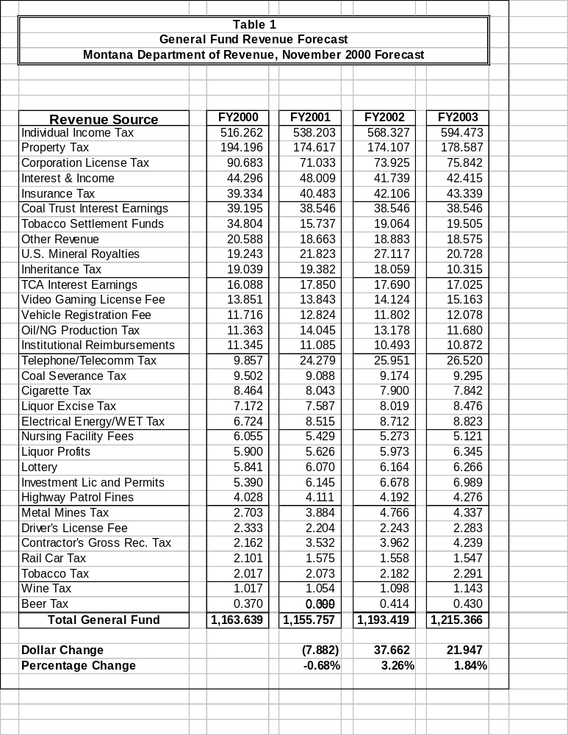

Statute does not require enterprise or internal service funds to conform to the same budget development terms and procedures as other funds appropriated by the legislature. In most cases, planned expenditures by the agencies responsible for these accounts are not reviewed or appropriated by the legislature.

However, the executive is required by section 17-7-123, MCA, to submit as part of the budget to the legislature “a report on: enterprise funds . . .including retained earnings and contributed capitol, projected operations and charges, and projected fund balances; and (b) fees and charges in the internal service fund type, including changes in the level of fees and charges, projected use of the fees and charges, and projected fund balances . . .” Any proprietary funds that are appropriated in HB 2 are not included in this report.

Such reports are uniformly compiled and are presented in this section: Proprietary Funds Tables

The enterprise funds (typically funds “060xx”) account for operations that are financed and operated in a manner similar to private enterprise where the intent is to provide goods or services to the general public. Each agency that manages an enterprise fund is prepared to justify and provide documentation for the charges.

The internal service funds (typically funds “065xx”) account for the financing of goods and services provided by one agency to other agencies of state government. Per 17-7-123(6)(b), MCA, “Fees and charges in the internal service fund type must be approved by the legislature in the general appropriations act. Fees and charges in a biennium may not exceed the level approved by the legislature in the general appropriation act effective for that biennium.” The internal service fund tables have listed the rates upon which the legislature must act. Agencies calculated these rates by considering federal guidelines, OMB Circular A-87, since these must apply to federal programs; considering cash flow, working capitol needs, and current and projected fund equity.

The fund tables follow in agency numerical order.

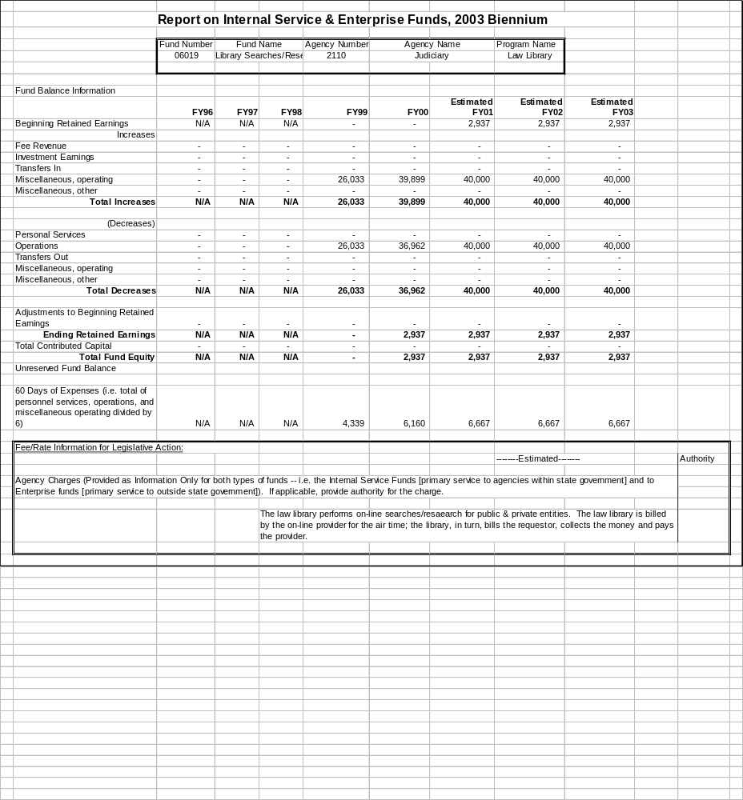

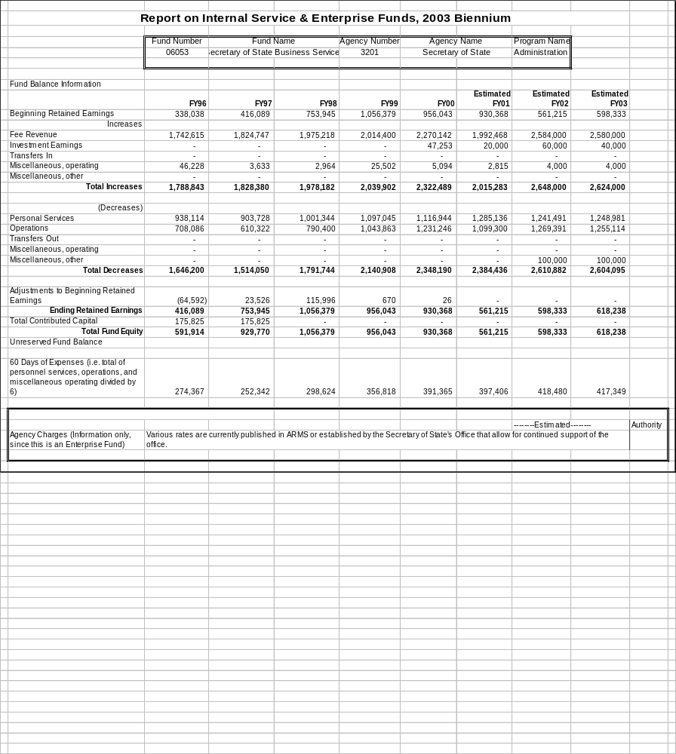
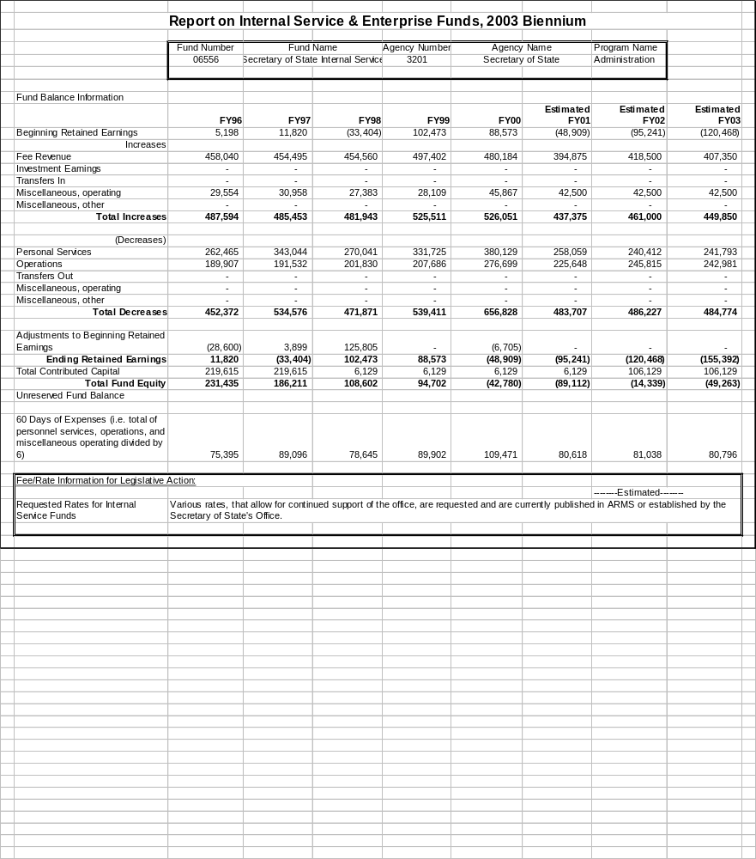

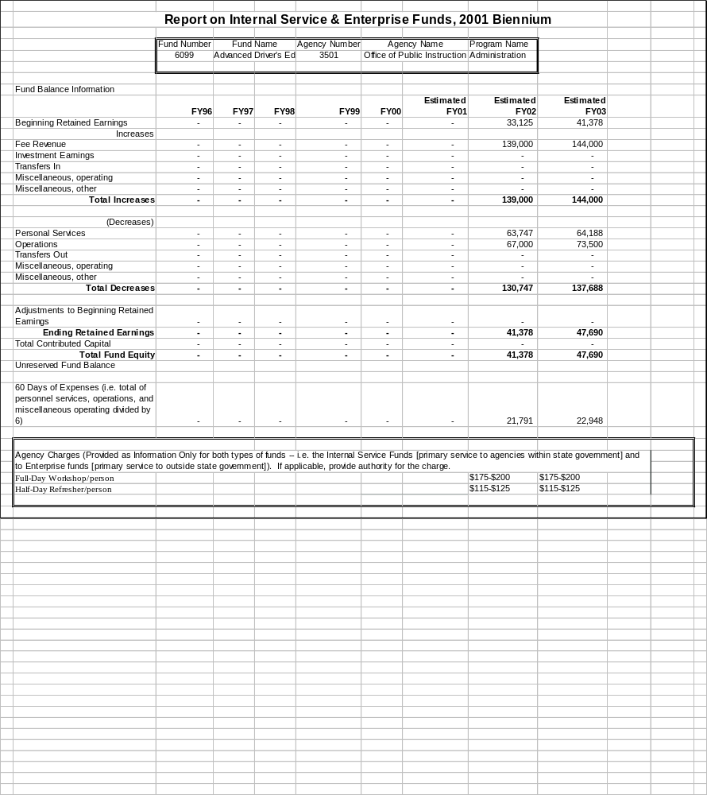
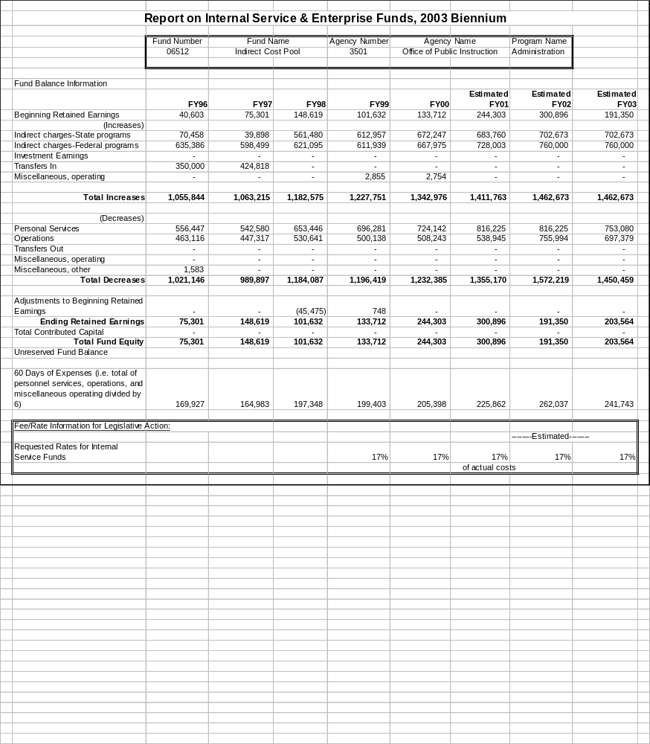
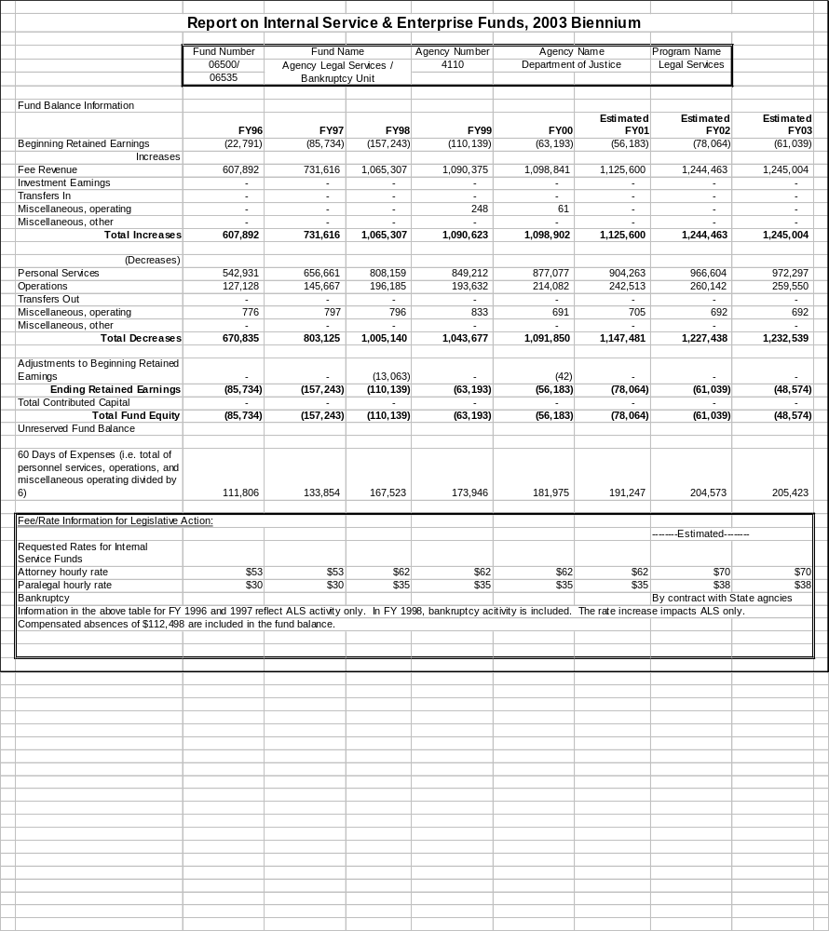
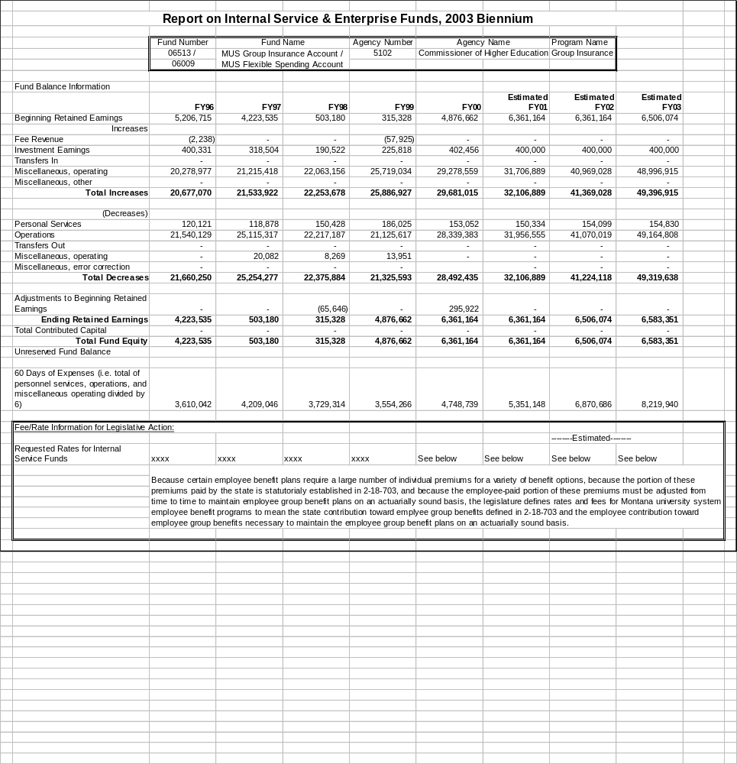

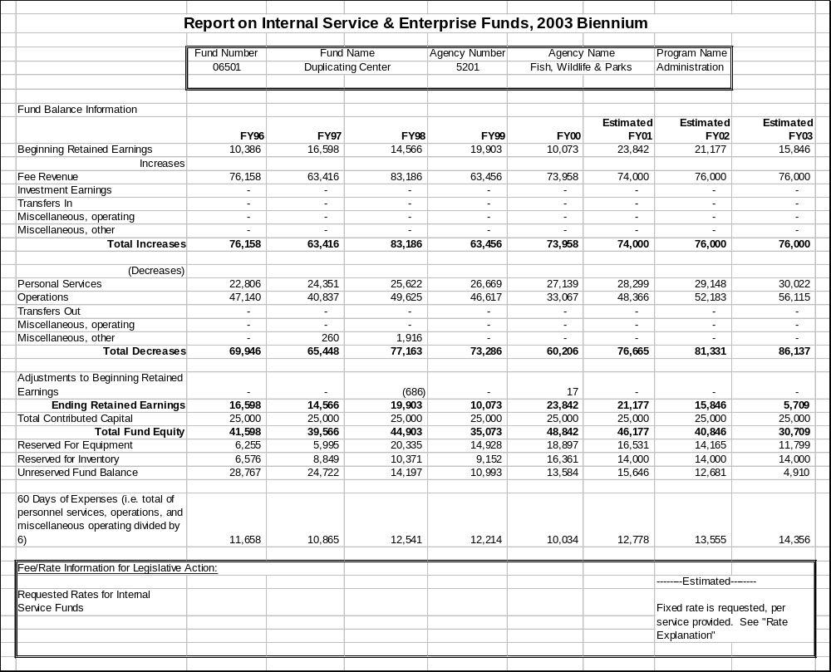

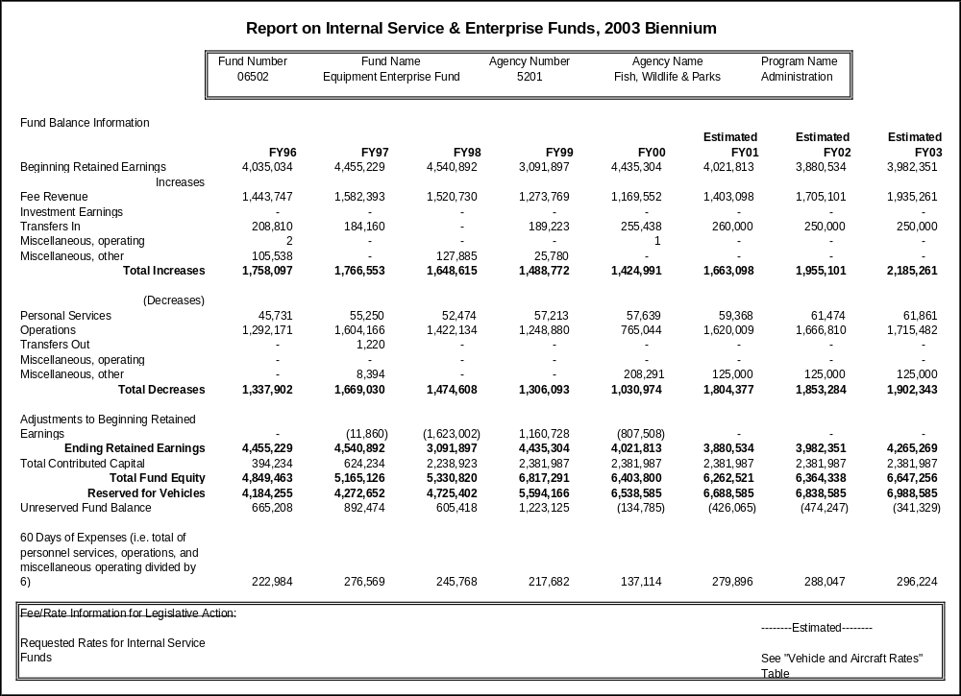
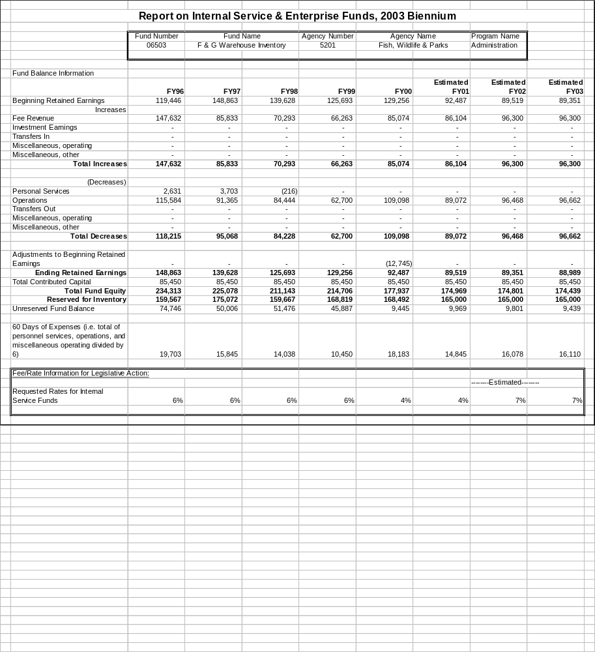

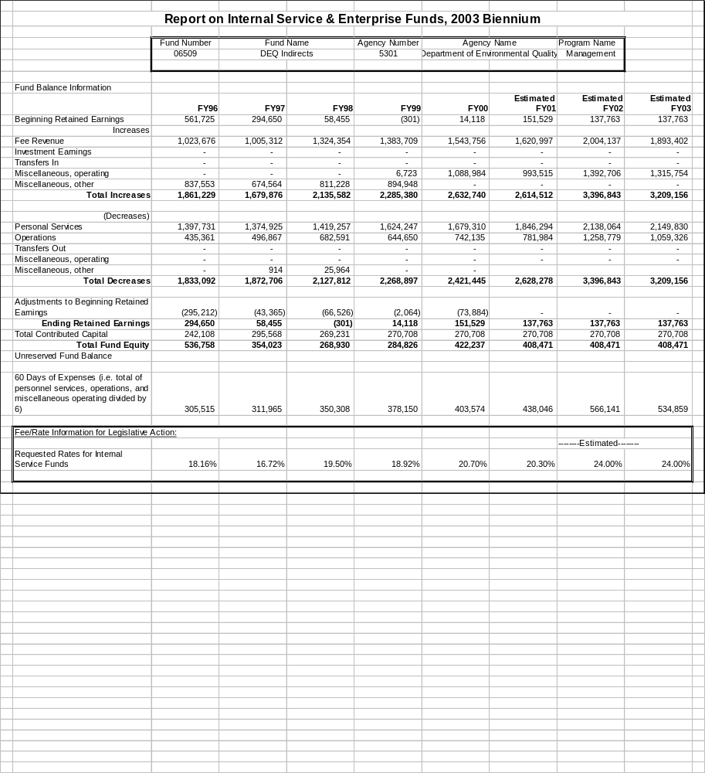
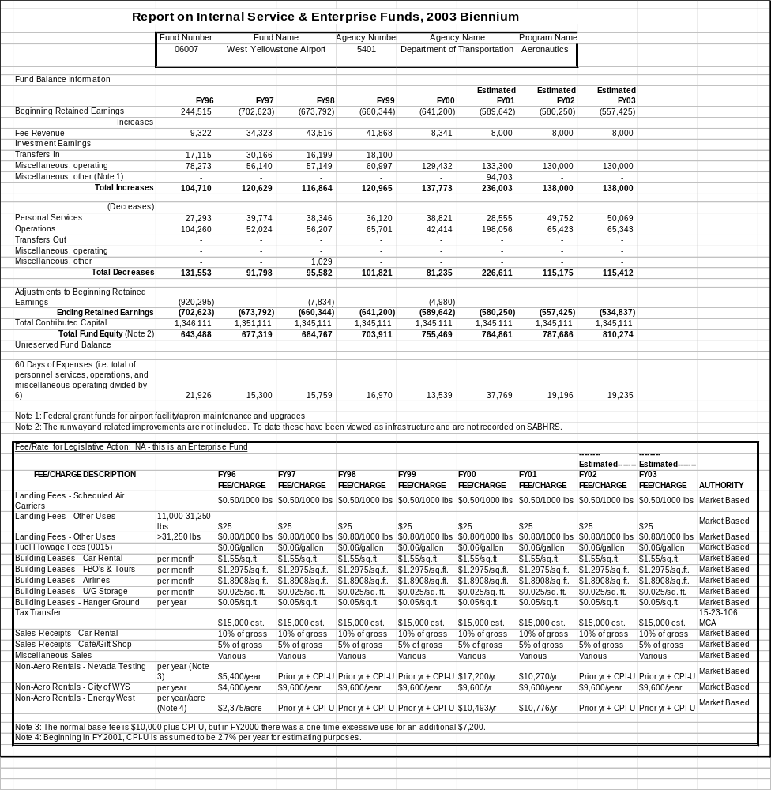
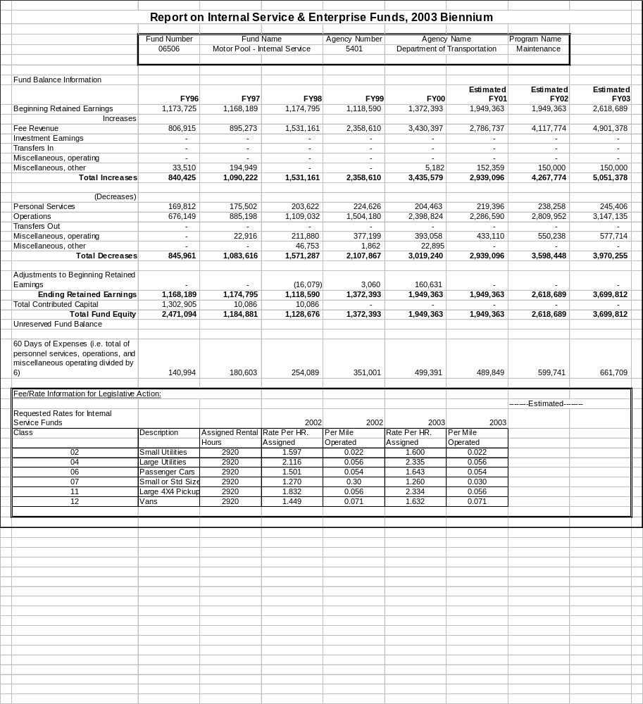
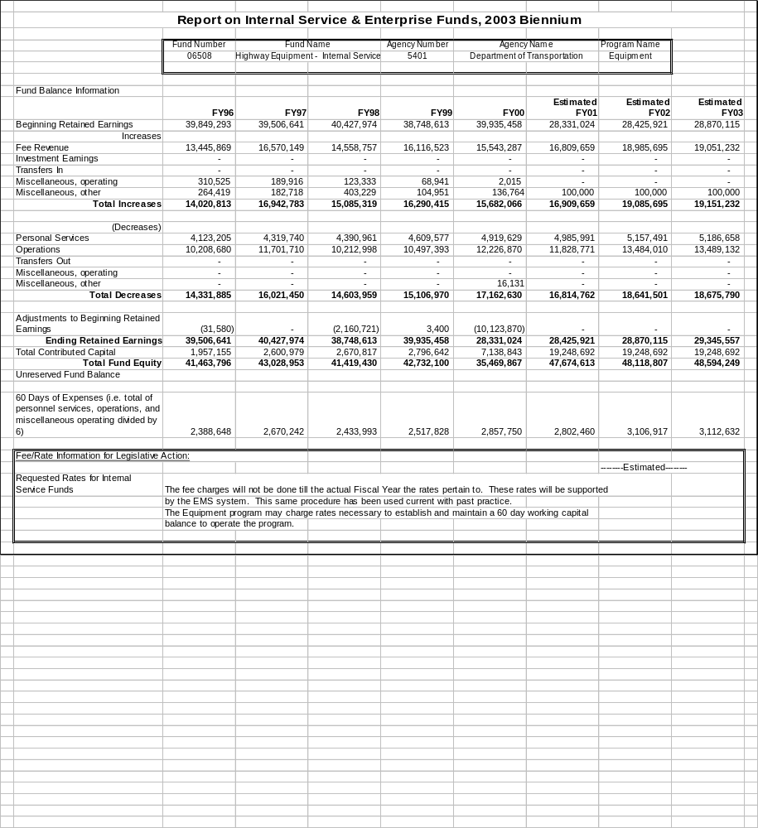
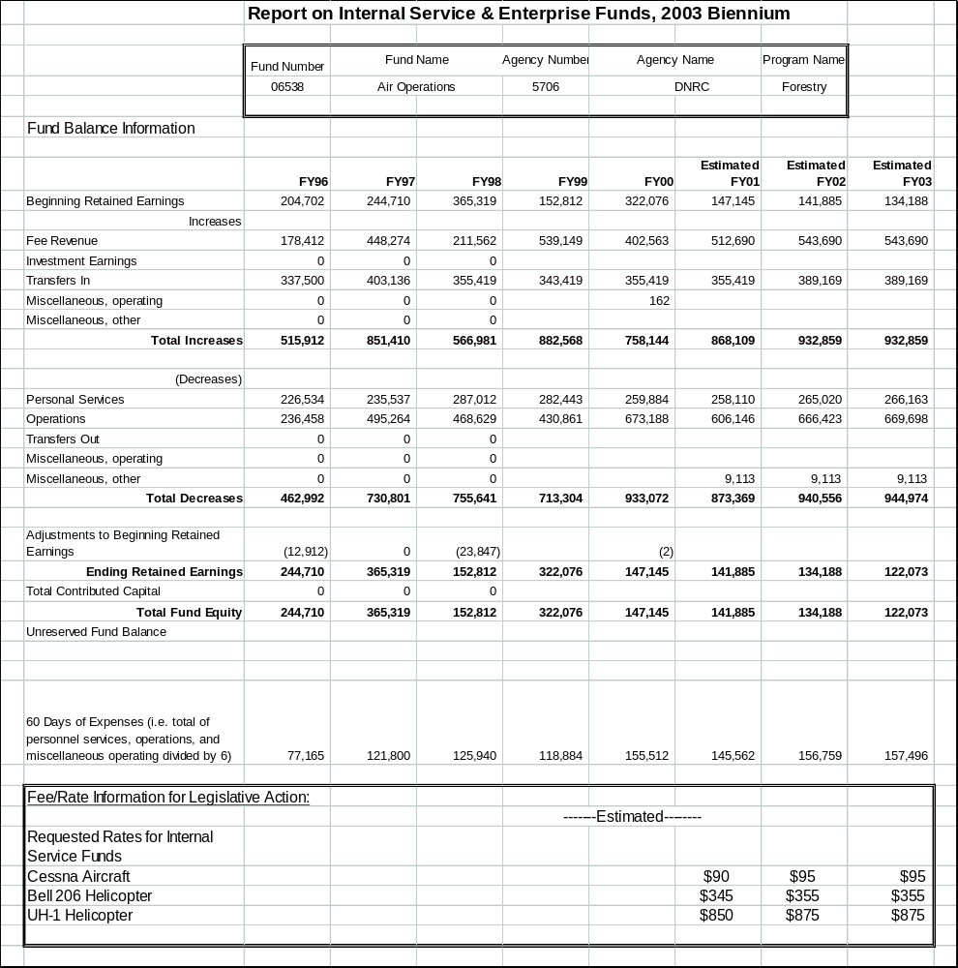
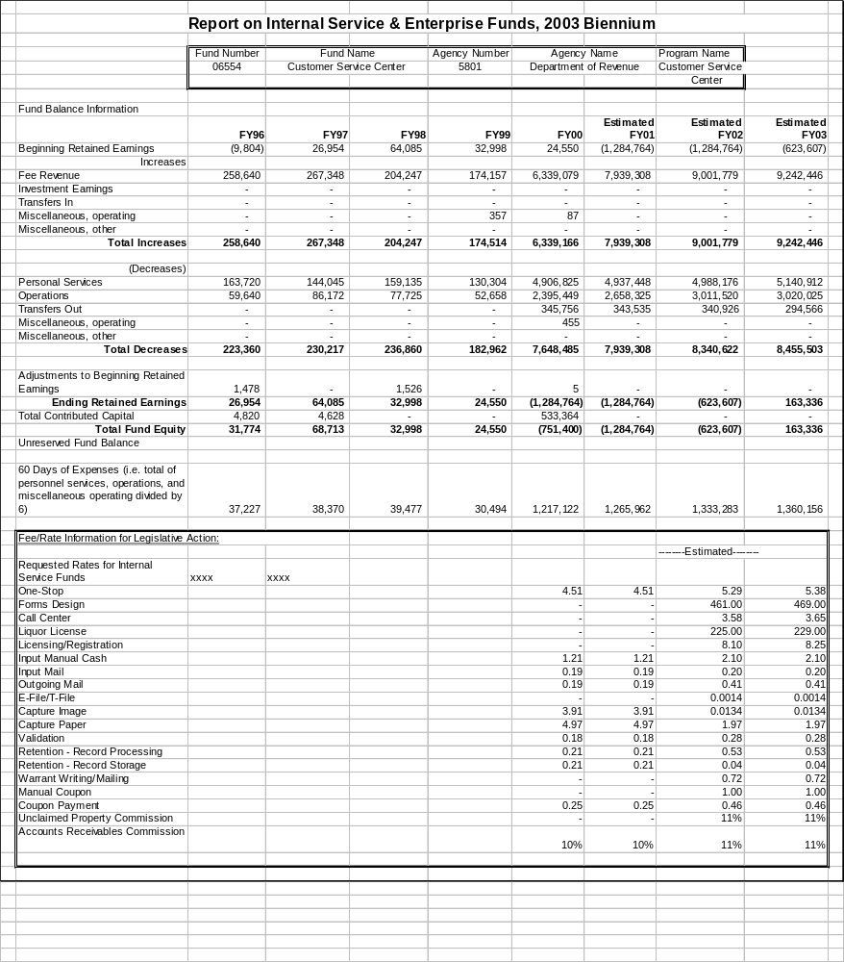
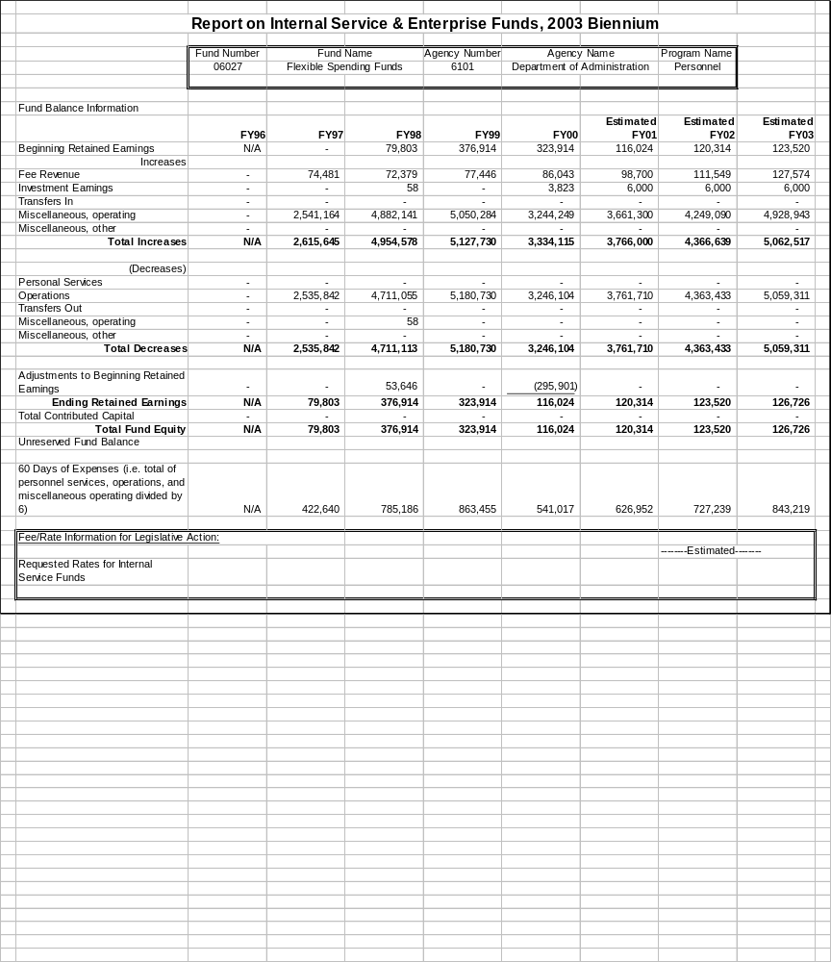
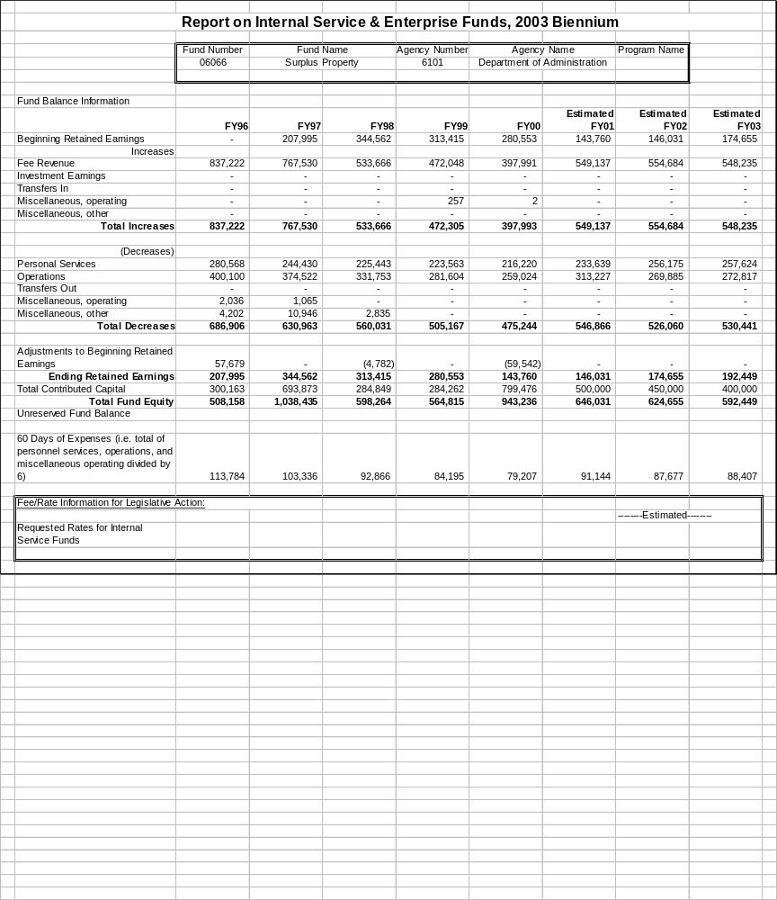
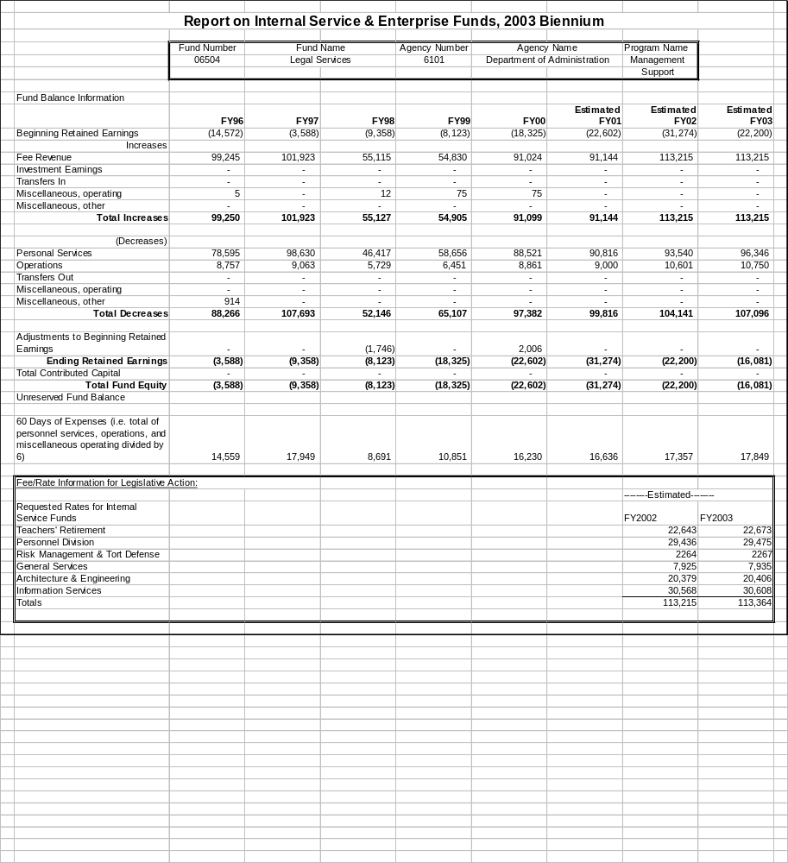
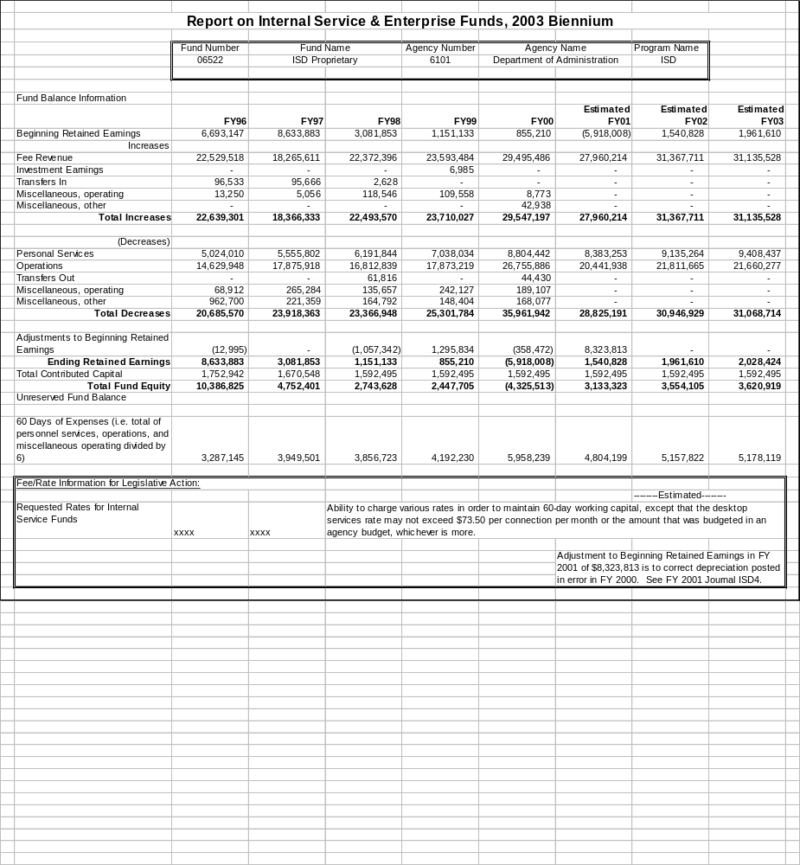
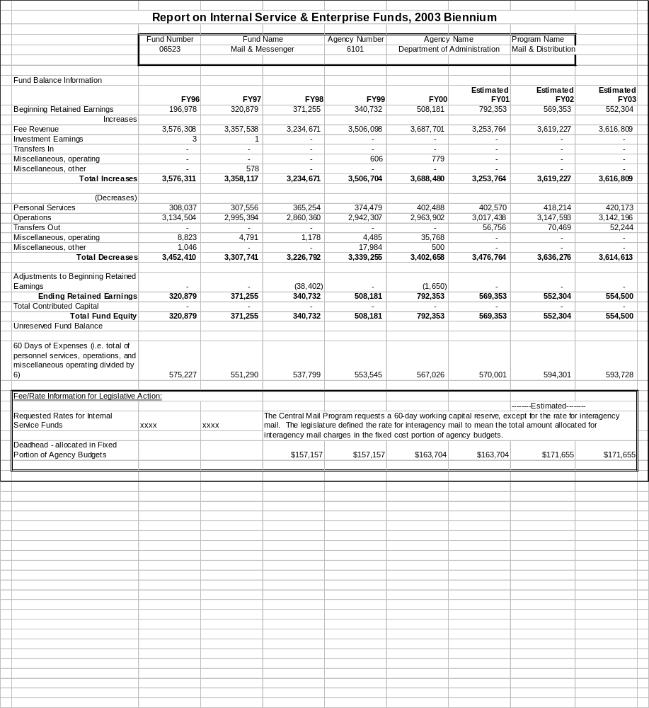
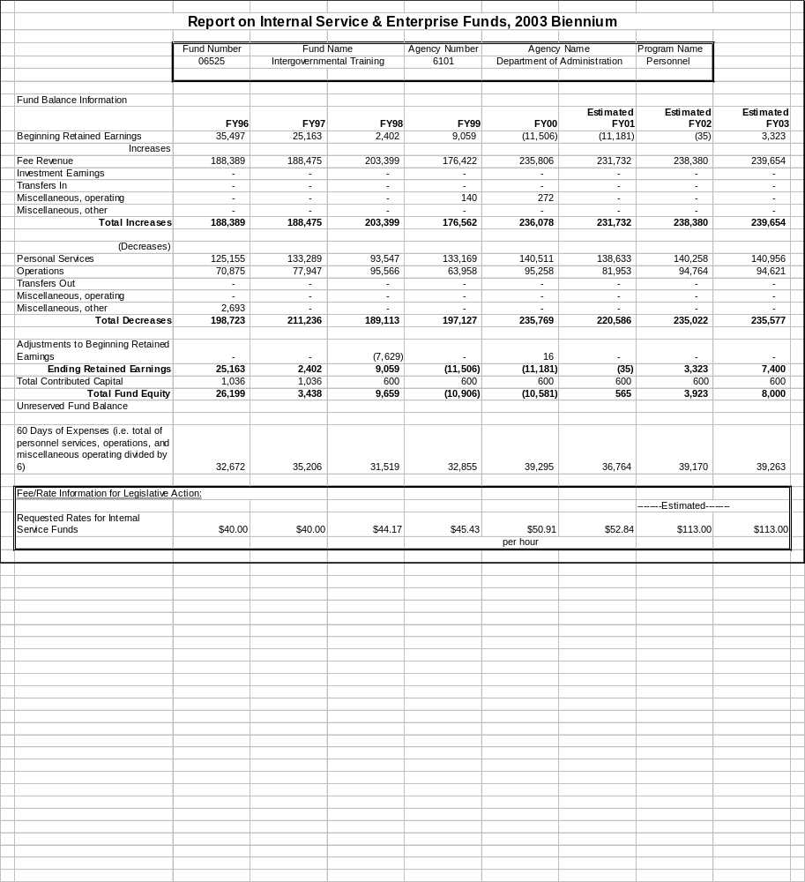
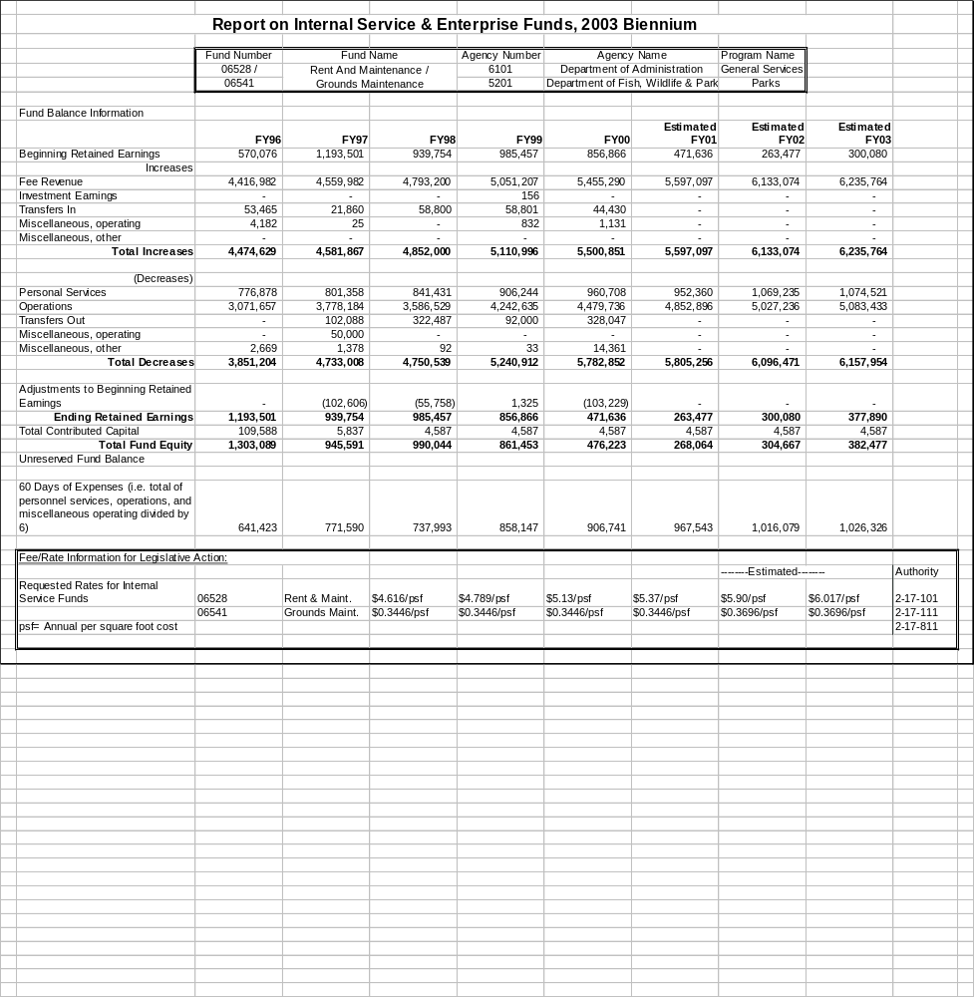
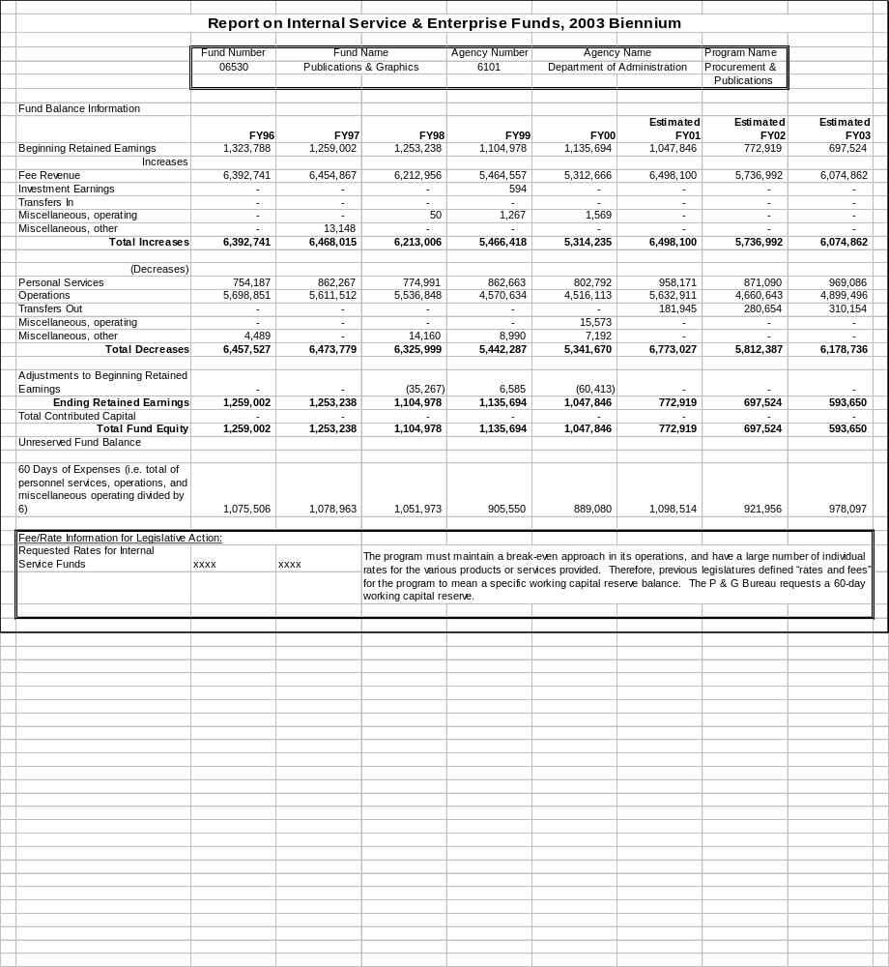
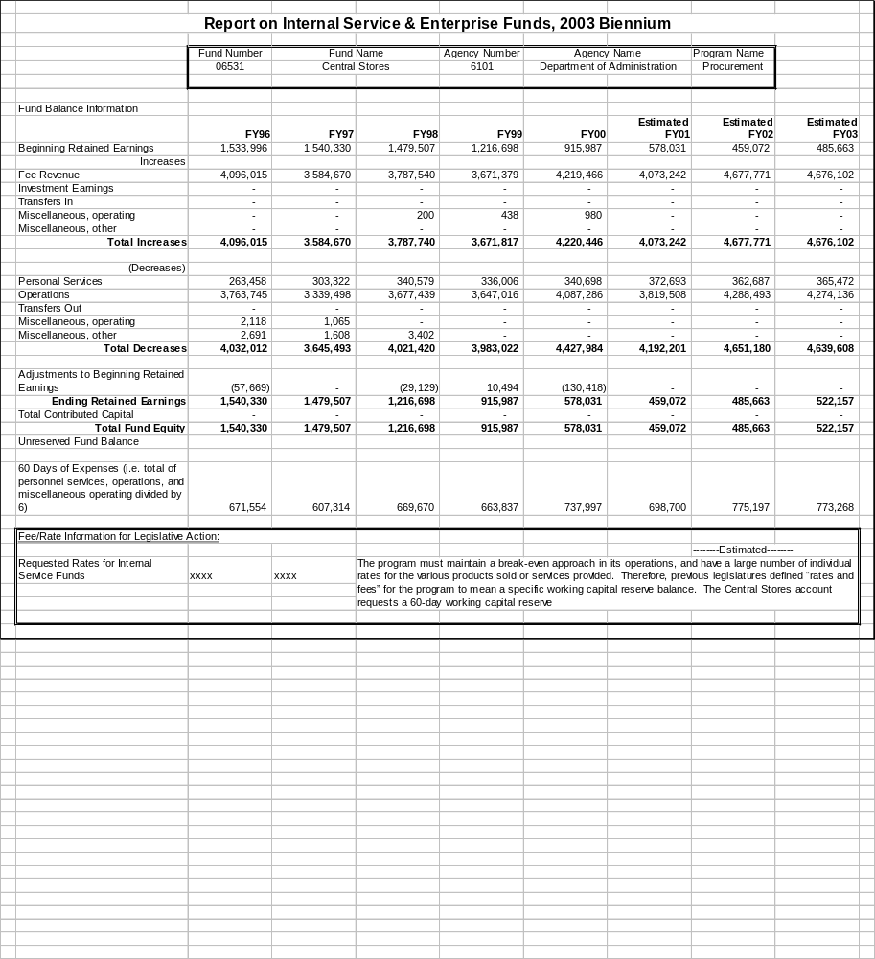
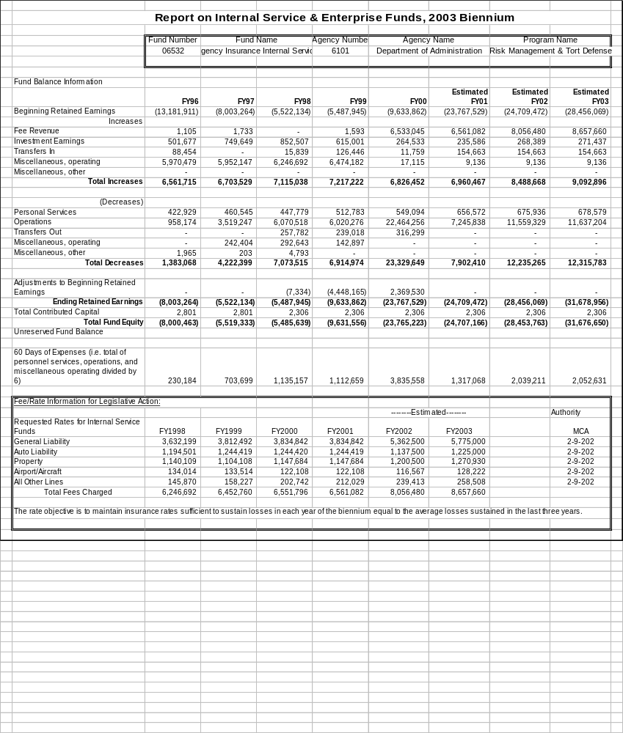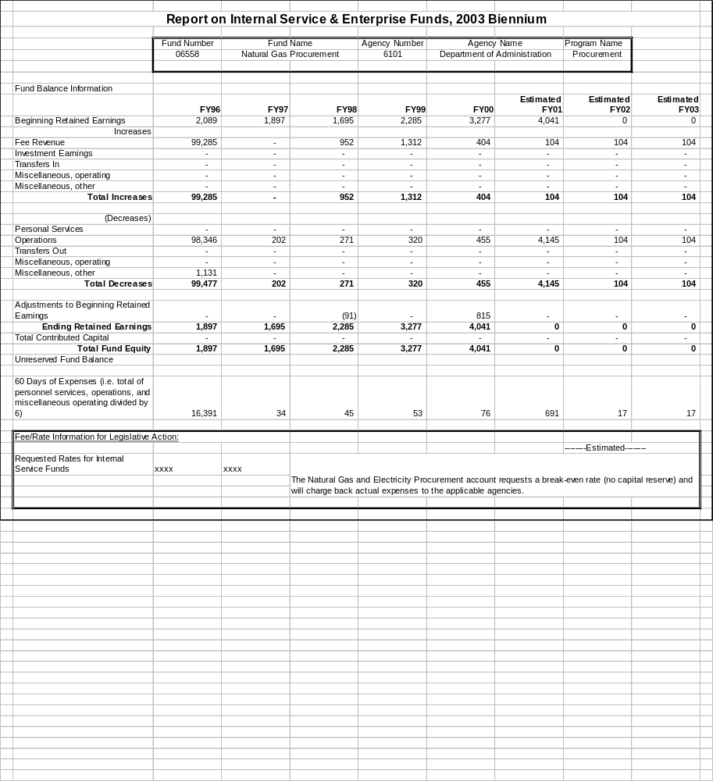
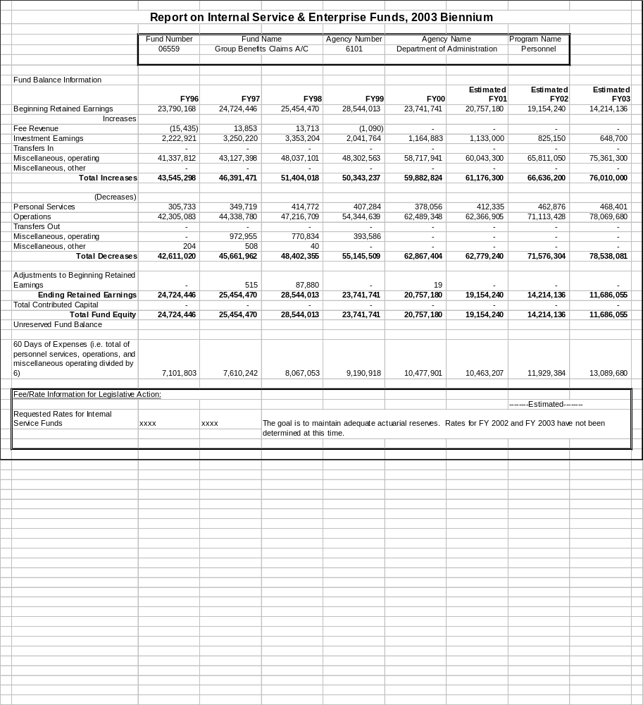
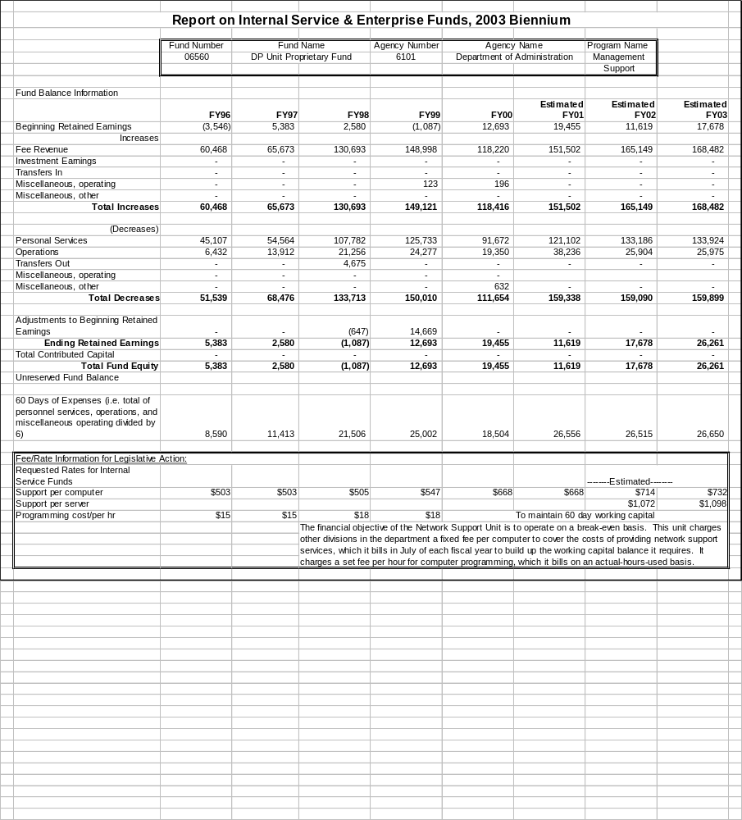
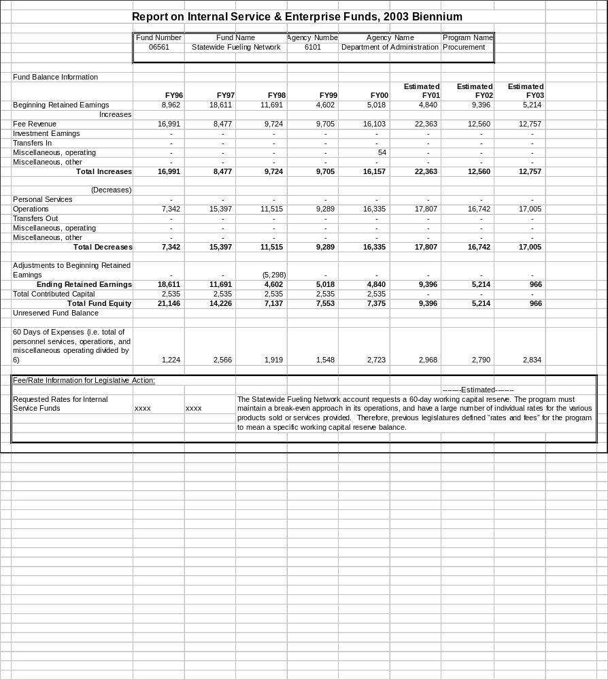
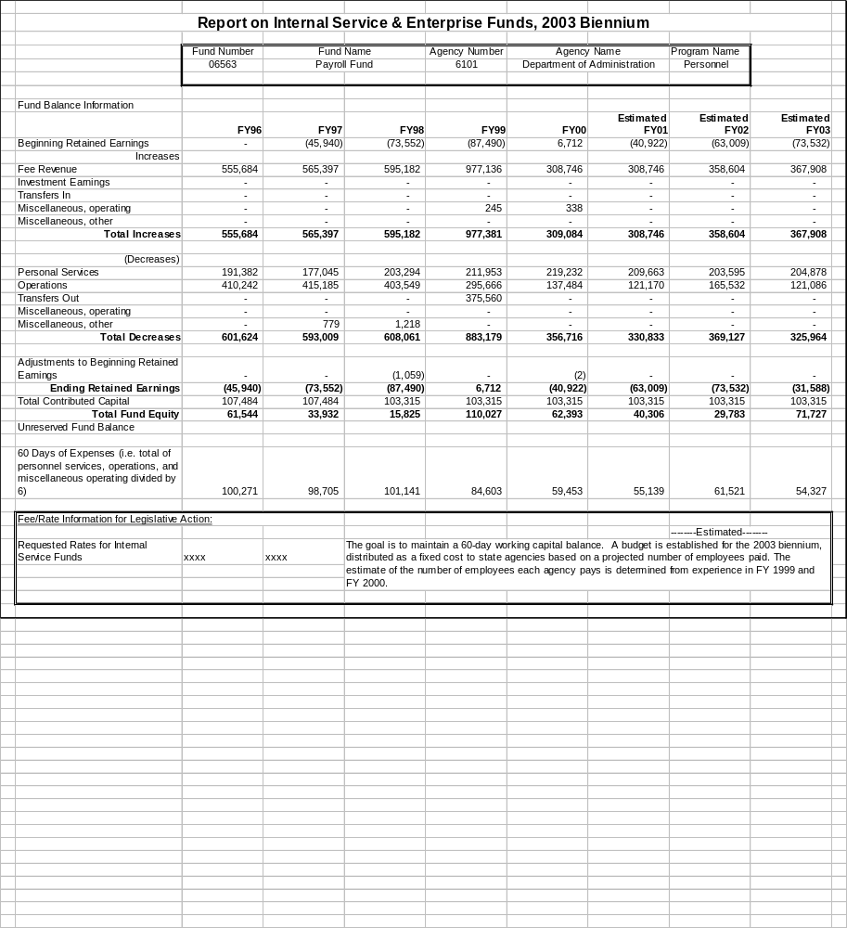
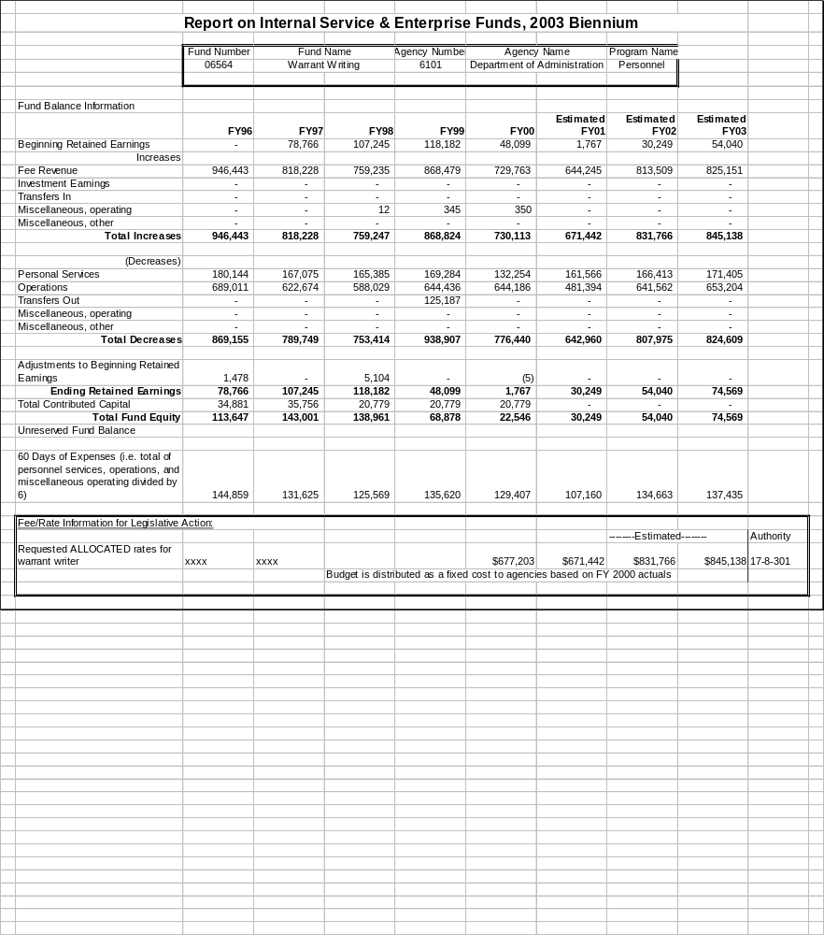
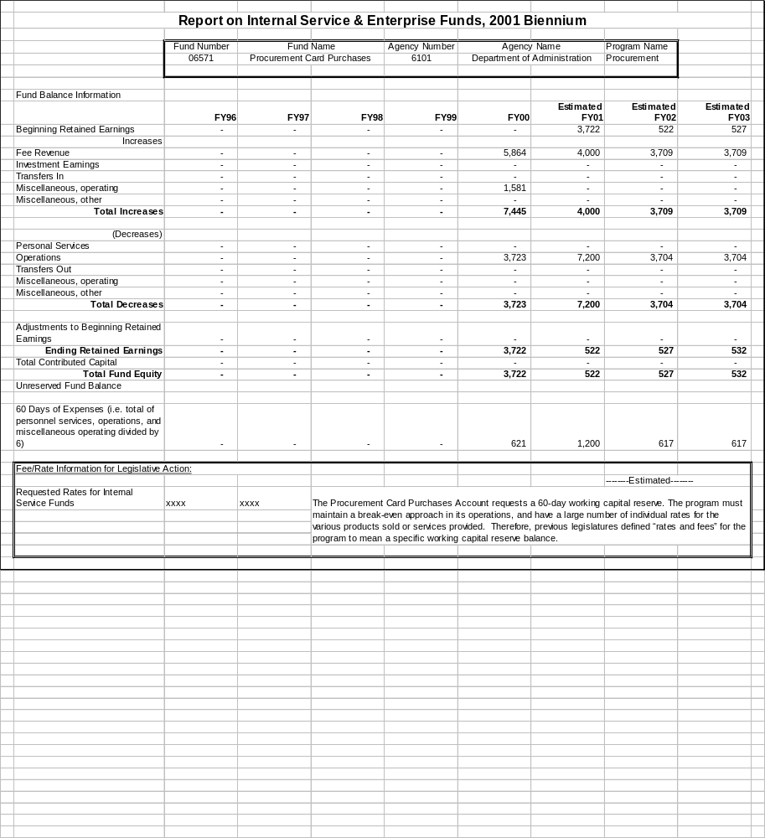
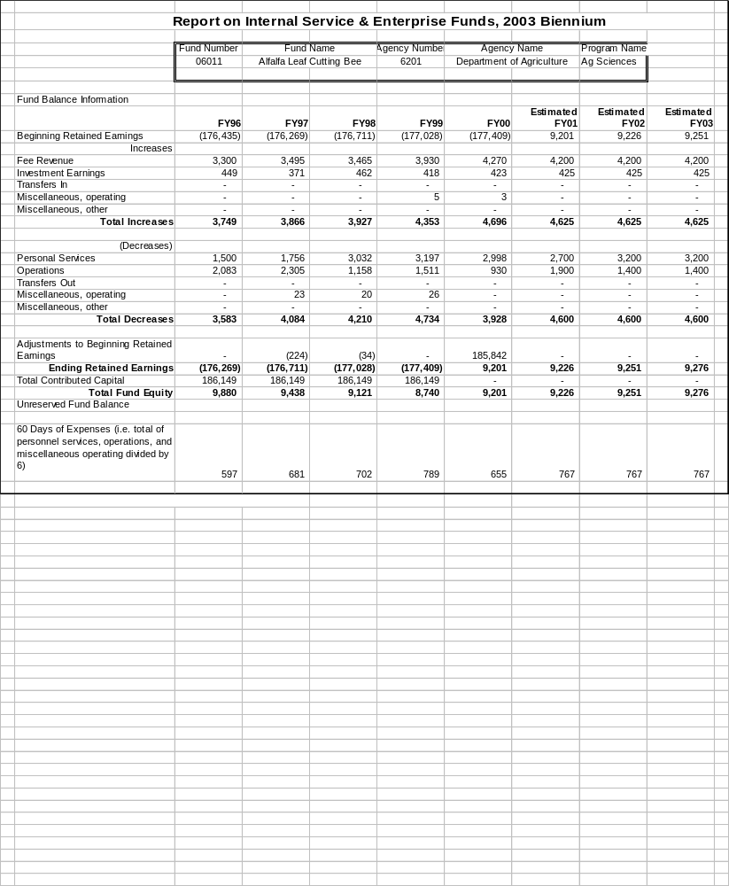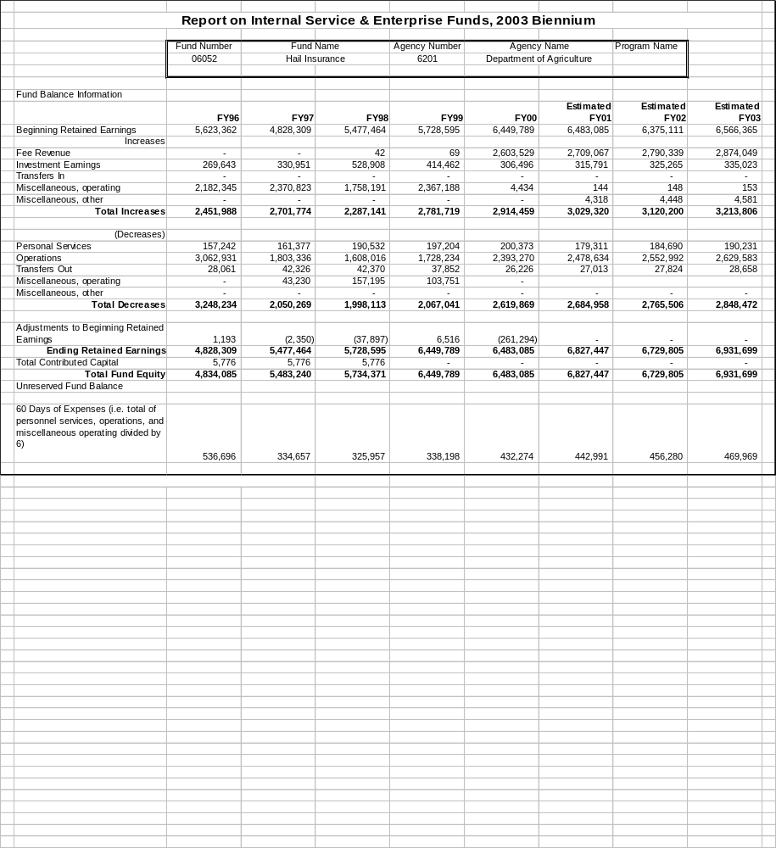

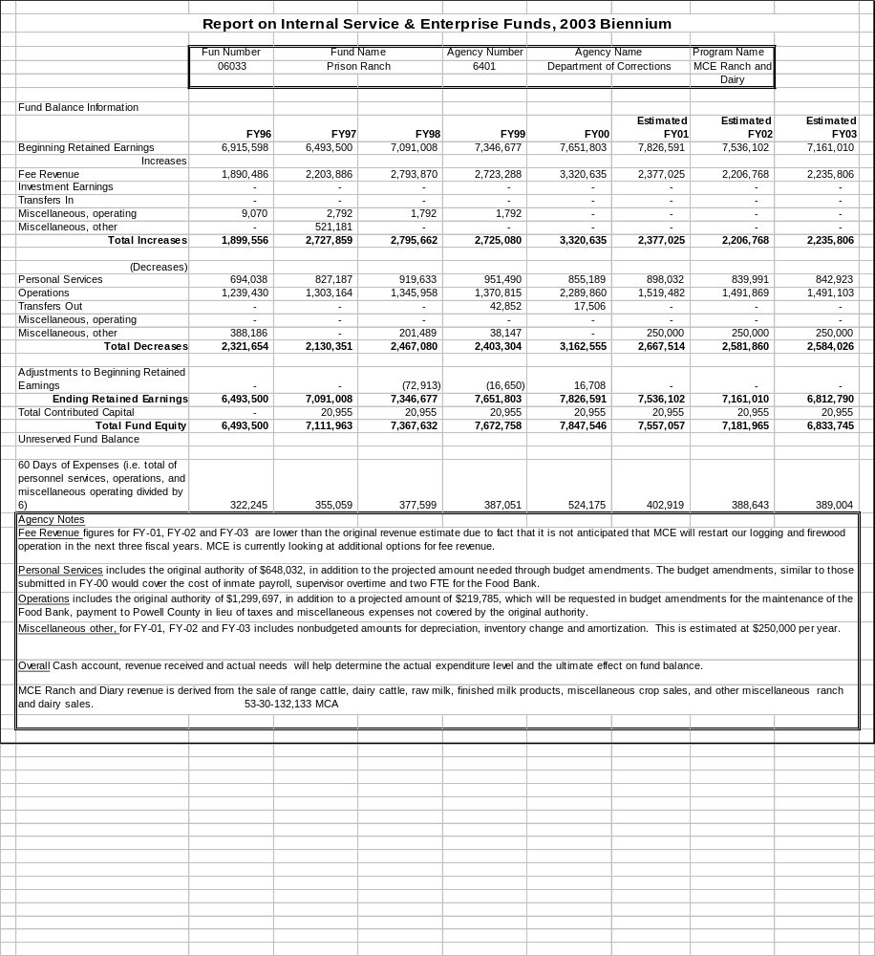
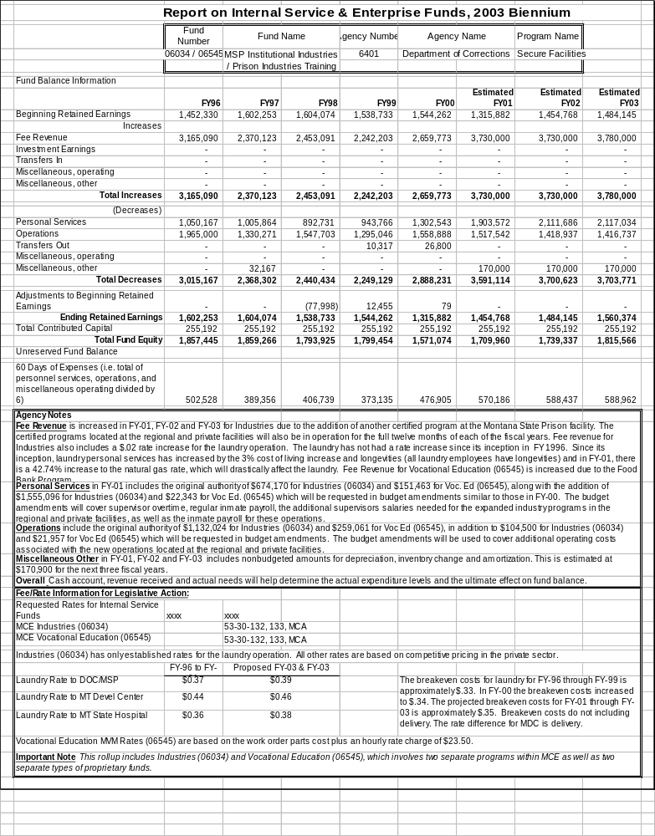
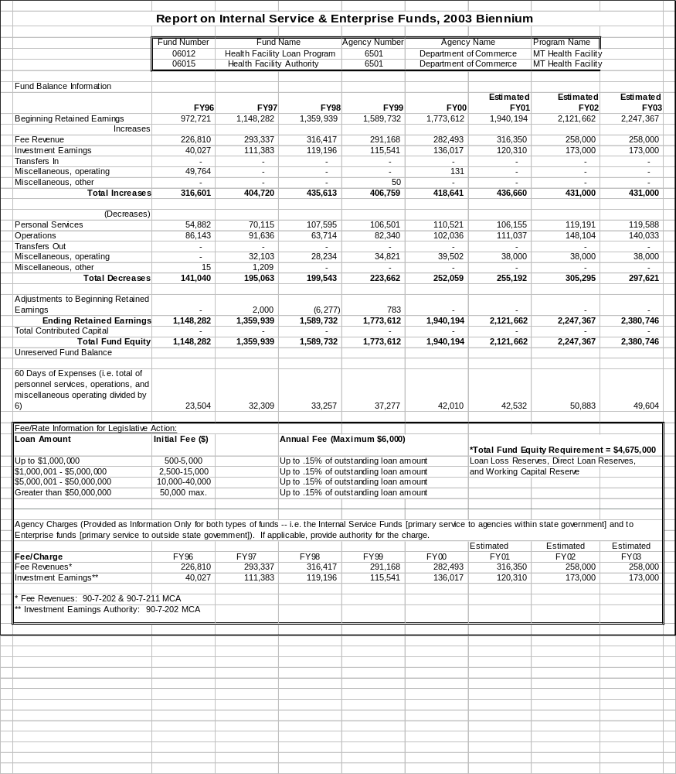
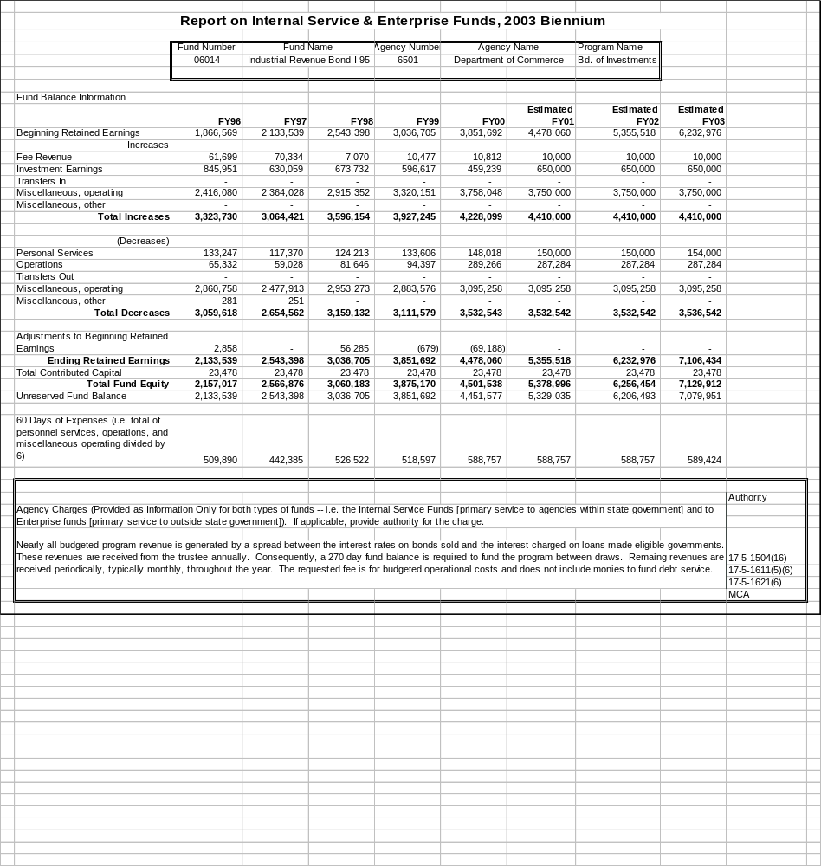
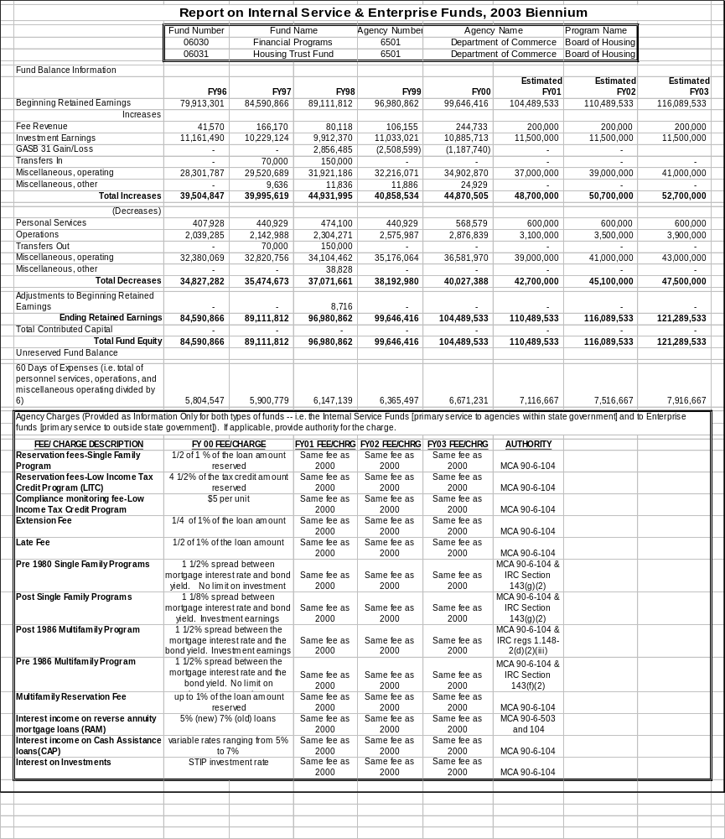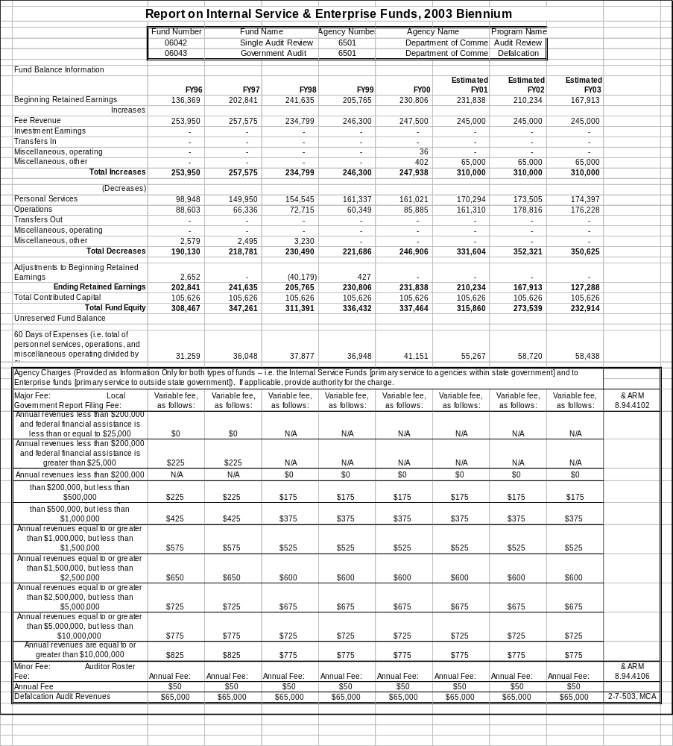
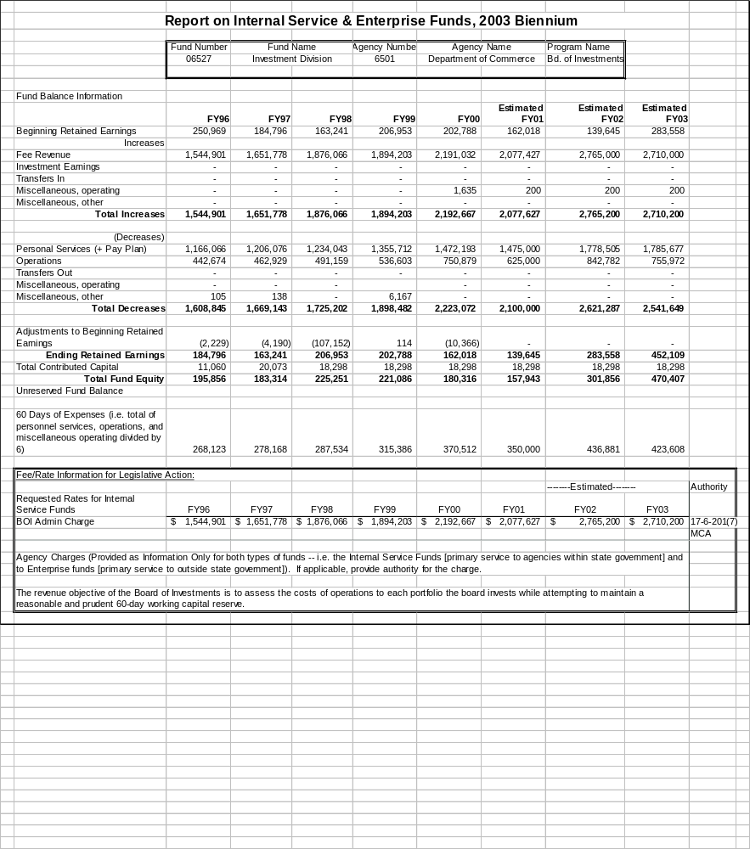
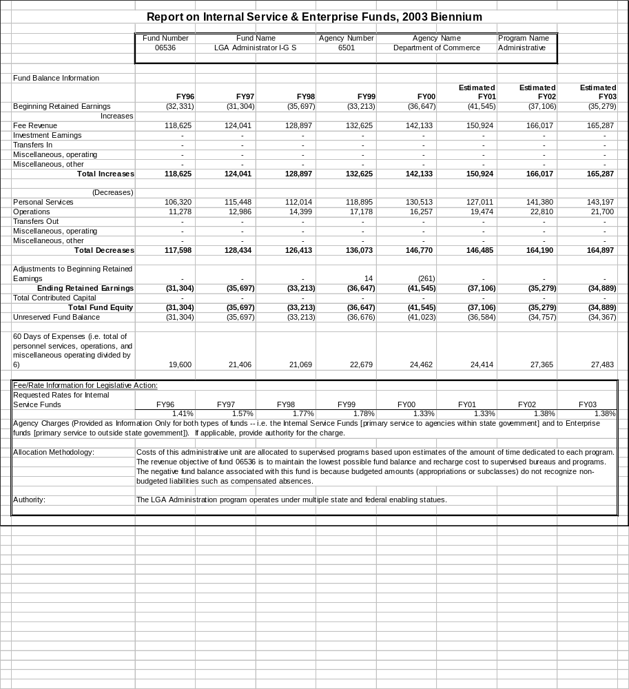
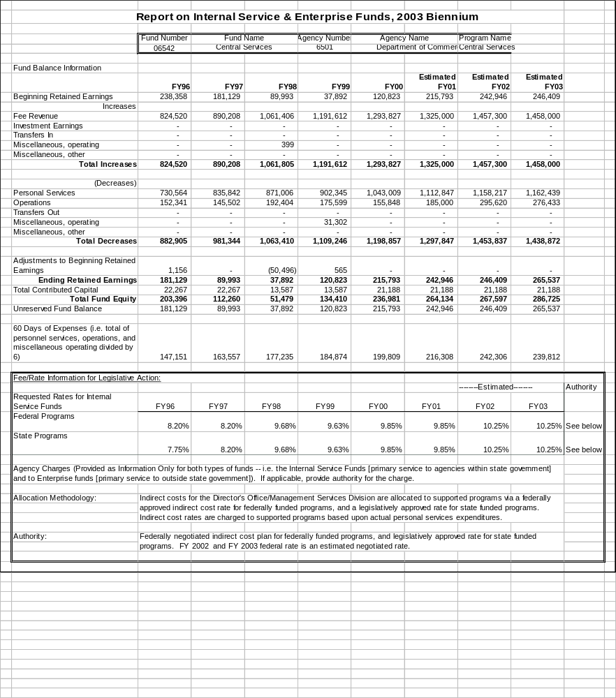
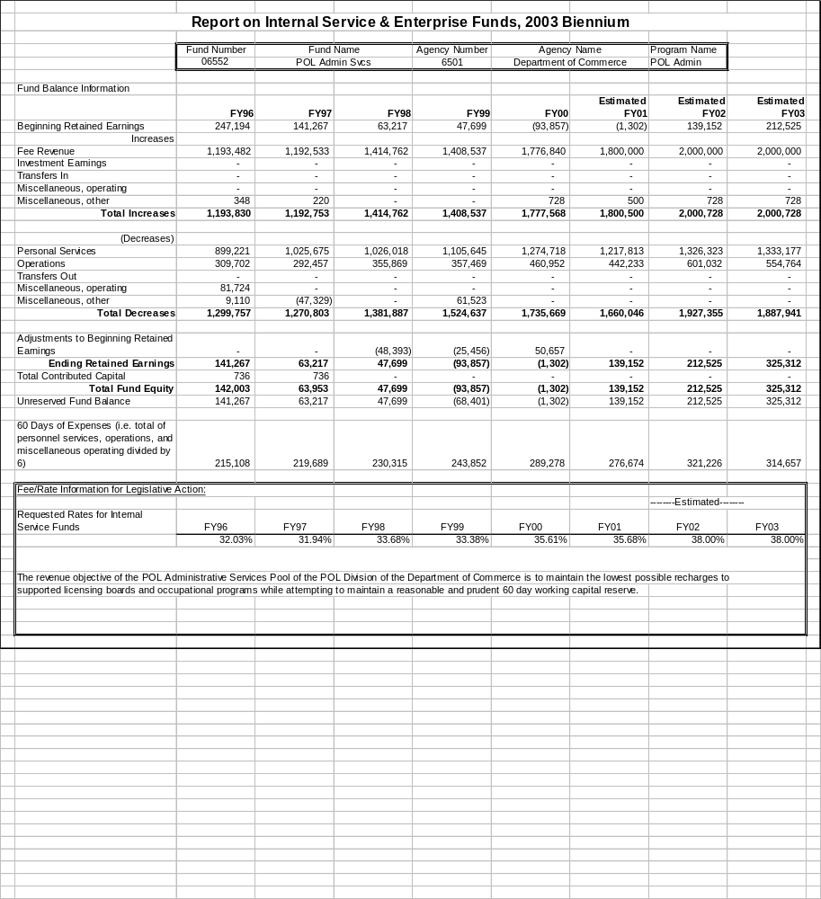

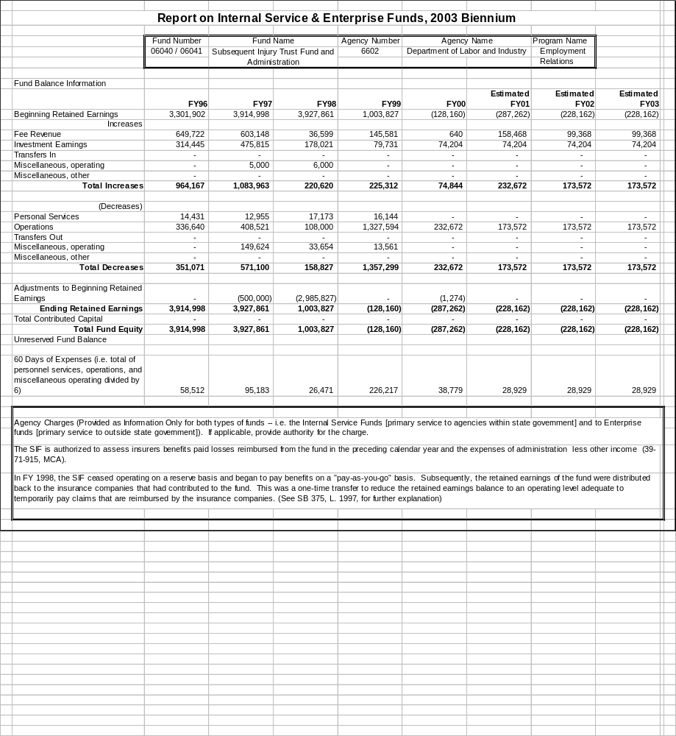
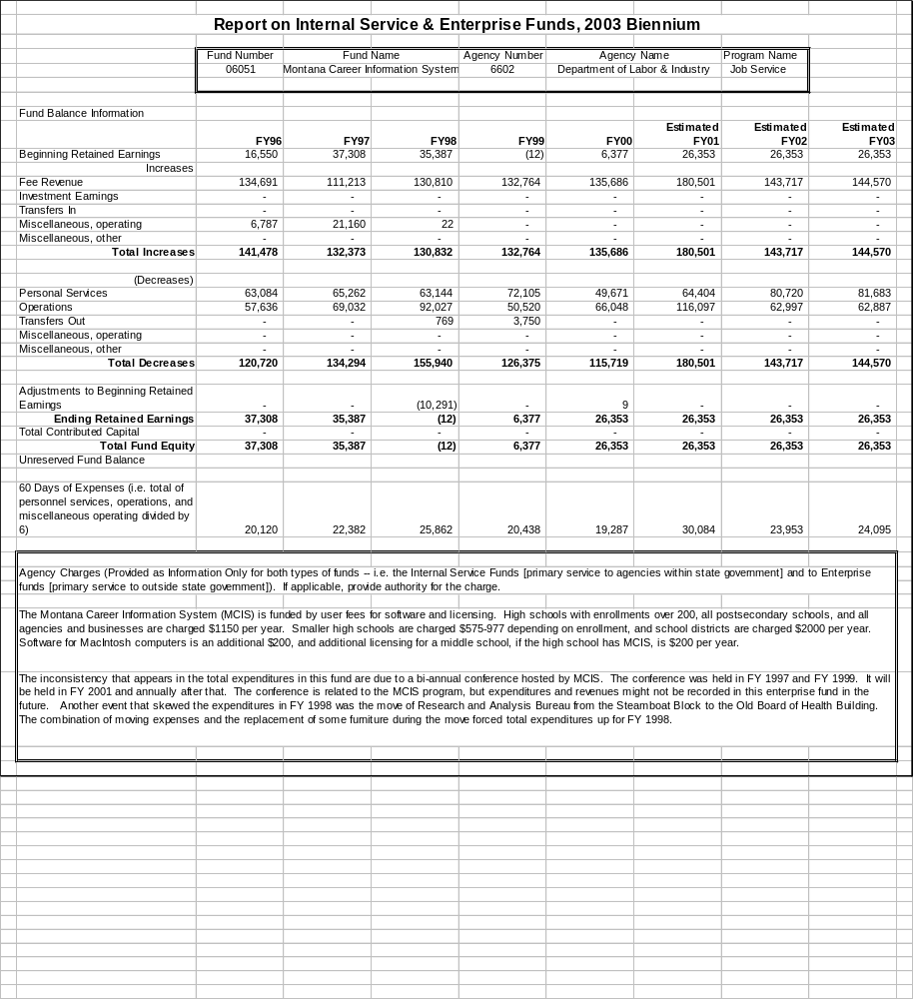
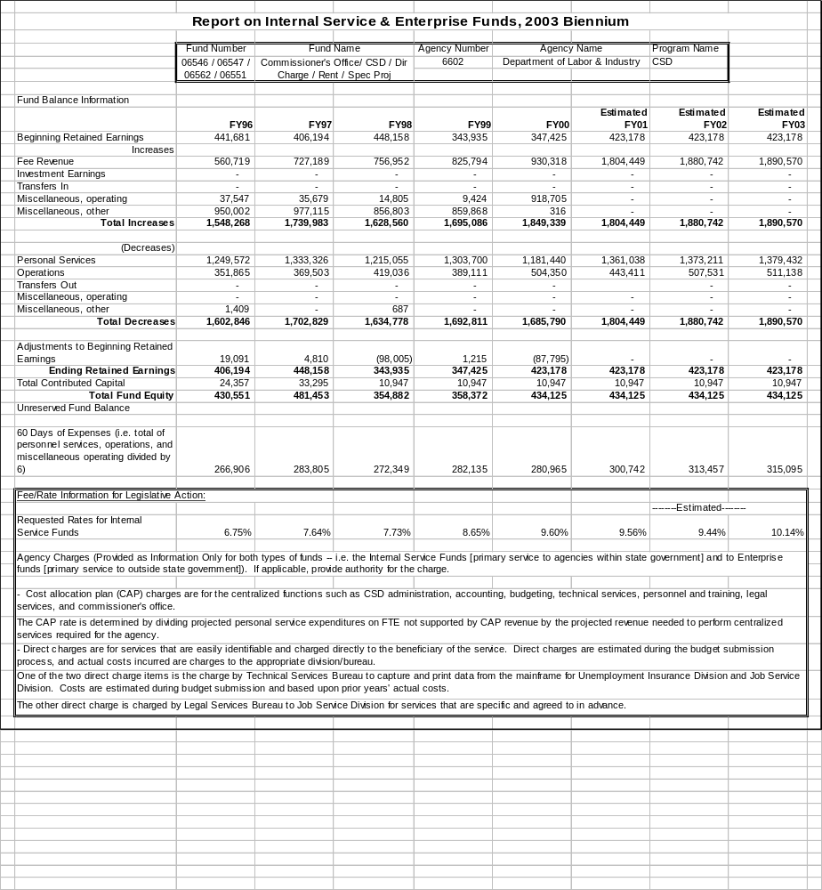

.

GLOSSARY OF TERMS USED IN THE EXECUTIVE BUDGET

Account – A name for one of the different kinds of accounts used in the PeopleSoft general ledger, such as expense, revenue, asset, liability, and equity.

Accrual Basis - A basis of accounting in which transactions are recognized at the time they are incurred, as opposed to when cash is received or spent. (GFOA)

Activity - Departmental efforts which contribute to the achievement of a specific set of program objectives; the smallest unit of the program budget. (GFOA)

Administrative Authorization - An administrative authorization is established to provide authority for funds transferred from another agency.

Ad Valorem Taxes - commonly referred to as property taxes, are levied on both real and personal property according to the property’s valuation and the tax rate. (GFOA)

Agency - Each state office or department of the executive branch, office of the judicial branch, or office of the legislative branch of state government, except for purposes of capital projects administered by the Department of Administration, for which institutions are treated as one department and university units as one system. (MCA)

Agency Mission - Agency mission statements articulate the reason for an agency’s existence. Stated clearly and concisely, preferably in one sentence, most mission statements will remain constant for years. All agencies are required by substantive law to develop agency mission statements for publication in the executive budget. (PBB memo)

Agency Transfer - Direct transfer of appropriation authority from one agency to another agency. (MOM)

Allot - To divide an appropriation into amounts that may be encumbered or expended during an allotment period. (GFOA)

Annualize - Taking changes that occurred mid-year and calculating their cost for a full year, for the purpose of preparing an annual budget. (GFOA)

Appropriation - A legal authorization to incur obligations and to make expenditures for specific purposes. (GFOA)

Appropriation - Authority established by legislative action or executive order for amounts that may be disbursed from an accounting entity, program, and/or expenditure account for a particular purpose during a specific period of time.

In the College and University Business Administration (CUBA) fund structure, the first digit of the assigned five-digit appropriation number is the same as the first digit of the accounting entity code. The second digit of the appropriation number designates the fiscal year. The third digit of these CUBA appropriation numbers is alphabetic. For example, 32E01 is an appropriation number that could be assigned to fund 31xxx for FY 2002. (MOM)

Approved Long-Range Building Program Budget Amendment - Approval by the budget director of a request submitted through the Architecture and Engineering Division of the Department of Administration to transfer excess funds appropriated to a capital project within an agency to increase the appropriation of another capital project within that agency or to obtain financing to expand a project with funds that were not available for consideration by the legislature. (MCA)

Approving Authority - means
(a) the Governor or the designated representative for executive branch agencies;
(b) the Chief Justice of the Supreme Court or the designated representative for judicial branch agencies,
(c) the Speaker for the House of Representatives;
(d) the President for the Senate;
(e) appropriate legislative committees or a designated representative for legislative branch agencies, or
(f) the Board of Regents of Higher Education or its designated representative for the university system. (MCA)

Assessed Value - The value placed on real and other property as a basis for levying taxes. (GFOA)

Assessed Valuation - The valuation set upon real estate and certain personal property by the assessor as a basis for levying property taxes. (GFOA)

Assessment Ratio - The ratio at which the tax rate is applied to the tax base. (GFOA)

Asset - Resources owned or held by a government which have monetary value.

Attrition - A method of achieving a reduction in personnel by not refilling the positions vacated through resignation, reassignment, transfer, retirement, or means other than layoffs. (GFOA)

Authorized Positions - Employee positions which are authorized in the adopted budget and are to be filled during the year. (GFOA)

Available (Undesignated) Fund Balance - This refers to the funds remaining from the prior year which are available for appropriation and expenditure in the current year. (GFOA)

Base Budget - Cost of continuing the existing levels of service in the current budget year. (GFOA); that level of funding authorized by the previous legislature. (MCA) The base budget for 2003 biennium budget development and analysis purposes is the combined level of ongoing expenditures using FY 2000 actual expenditures from authority contained in HB 2 [general appropriations act], HB 13 [pay plan], and other permanent appropriations bills. (EPP memo & MCA)

Bond - A long-term I.O.U. or promise to pay. It is a promise to repay a specified amount of money (the face amount of the bond) on a particular date (the maturity date). Bonds are primarily used to finance capital projects and significant information technology projects in Montana. (GFOA)

Bond Refinancing - The payoff and re-issuance of bonds, to obtain better interest rates and/or bond conditions. (GFOA)

Budget - A plan of financial activity for a specified period of time (fiscal year or biennium) indicating all planned revenues and expenses for the budget period. (GFOA); An annual financial plan showing projected costs and revenue over a specified time period. (GFOA) The 2003 biennium Governor's Executive Budget is at http://www2.state.mt.us/budget/index.htm.

Budget Amendment - Increases in authority are processed in accordance with Title 17, Chapter 7, part 4, MCA. (MOM)

Budgetary Basis - This refers to the basis of accounting used to estimate financing sources and uses in the budget. This generally takes one of three forms: GAAP, cash, or modified accrual. (GFOA)

Budget Calendar - The schedule of key dates that a government follows in the preparation and adoption of the budget. (GFOA) The Montana schedule is at http://www2.state.mt.us/budget/index.htm.

Budgetary Control - The control or management of a government in accordance with the approved budget for the purpose of keeping expenditures within the limitations of available appropriations and resources. (GFOA)

Capital Assets - Assets of significant value and having a useful life of several years.

Capital Budget - The appropriation of bonds or operating revenue for improvements to facilities and other infrastructure. (GFOA)

Capital Improvements - Assets of significant value and having a useful life of several years. Capital assets are also called fixed assets. (GFOA)

Capital Improvements - Projects which are long-term assets such as roads, buildings, and information technology.

Capital Projects Program - A plan for capital outlay to be incurred each year over a fixed number of years to meet capital needs arising from the government’s long-term needs.

Capital Project - Major construction, acquisition, or renovation activities which add value to government  physical assets or significantly increase their useful life. Also called capital improvements. (GFOA)

Capital Project Funds - (Fund 05XXX) - To account for resources used for the acquisition or construction of major capital facilities other than those financed by proprietary, trust, or higher education funds. (MOM)

Capital Reserve - An account used to segregate a portion of the government’s equity to be used for future capital program expenditures. The amount of capital reserve is roughly equal to the government’s annual equipment depreciation and an amount identified as being needed for future capital acquisition. (GFOA)

Carry-Forward (CA) -Appropriation which is established as authorized by 17-7-304, MCA. Montana University System units may establish carry-forward authority for 100 percent of the money appropriated and unexpended and unencumbered; other state agencies may utilize 30 percent for any purpose that is consistent with the goals and objective of the agency. (MOM)

Cash Basis - A basis of accounting in which transactions are recognized only when cash is increased or decreased. (GFOA)

Collective Bargaining Agreement - A legal contract between the employer and a verified representative of a recognized bargaining unit for specific terms and conditions of employment (e.g., hours, working conditions, salary, fringe benefits, and matters affecting health and safety of employees). (GFOA)

Commodities - Expendable items that are consumable or have a short life span. Examples include office supplies, gasoline, minor equipment, and asphalt. (GFOA)

Constant or Real Dollars - The presentation of dollar amounts adjusted for inflation to reflect the real purchasing power of money as compared to a certain point in time in the past. (GFOA)

Consumer Price Index (CPI) - A statistical description of price levels provided by the U.S. Department of Labor. The index is used as a measure of the increase in the cost of living (i.e., economic inflation). (GFOA)

Contingency - A budgetary reserve set aside for emergencies or unforeseen expenditures not otherwise budgeted. (GFOA)

Continuing Appropriation - An appropriation that is valid for more than one fiscal year. (MOM)

Contractual Services - Services rendered to a government by private firms, individuals, or other governmental agencies. Examples include utilities, rent, maintenance agreements, and professional consulting services. (GFOA)

Cost-of-living Adjustment (COLA) - An increase in salaries to offset the adverse effect of inflation on compensation. (GFOA)

Debt Service - The cost of paying principal and interest on borrowed money according to a predetermined payment schedule. (GFOA)

Debt Service Funds - (A/Es 04XXX) To account for resources accumulated for payment of principal and interest on most general long-term obligations (except capital leases and compensated absences). (MOM)

Decision Package - Group of changes to an agency budget, presented either as a present law adjustment or a new proposal, that focus on function rather than expenditure account. (OBPP Budget Instructions)

Dedicated Tax - A tax levied to support a specific government program or purpose. (GFOA)

Deficit - The excess of an entity’s liabilities over its assets or the excess of expenditures or expenses over revenues during a single accounting period. (GFOA)

Department - The basic organizational unit of government which has its own mission and is functionally unique in its delivery of services. (GFOA)

Depreciation - Expiration in the service life of capital assets attributable to wear and tear, deterioration, action of the physical elements, inadequacy, or obsolescence. (GFOA)

Direct Transfers (ATs) - Authority for funds transferred from one state agency to another state agency pursuant to 17-8-101, 18-2-102, 18-2-105, or 90-4-607, MCA. Most ATs are zero-based grants, but the few remaining transactions are reviewed during budget development on a case-by-case basis to determine which, if either, agency should have the expenditure in its base budget. (EPP- memo)

Disbursement - The expenditure of monies from an account. (GFOA)

Efficiency Indicators - A measure of productivity and cost-effectiveness that often is expressed as a ratio of inputs to outcomes, e.g., cost per vaccination given to a child, average expenditure per pupil in elementary schools, number of miles patrolled per highway patrol officer assigned to traffic. (PBB memo)

Effectiveness measure - A criterion for measuring the degree to which the objective sought is attained.

Employee (or fringe) Benefits - Contributions made by a government to meet commitments or obligations for employee fringe benefits. Included are the government’s share of costs for Social Security and the various pension, medical, and life insurance plans. (GFOA)

Encumbrances - Commitments related to unperformed (executory) contracts for goods or services. (GASB)

Entitlement - Payments to which local governmental units are entitled, pursuant to an allocation formula determined by the agency providing the monies, usually the state or the federal government. (GFOA)

Enterprise Funds – Funds which account for operations that are financed and operated in a manner similar to private enterprise where the intent is to provide goods or services to the public. See proprietary funds.

Executive Branch - All administrative offices, boards, bureaus, commissions, units, instrumentalities, and agencies of the state not designated as part of either the judicial or the legislative branch of state government. (MOM)

Expenditure - The payment of cash on the transfer of property or services for the purpose of acquiring an asset, service, or settling a loss. (GFOA)

Expenditure Account - An expenditure classification, referring to the lowest and most detailed level of classification, such as electricity, office supplies, asphalt, and furniture. (GFOA)

Expense - Charges incurred (whether paid immediately or unpaid) for operations, maintenance, interest, or other charges. (GFOA)

Fiduciary Funds - Trust and agency funds (funds 07XXX - 09XXX) - To account for assets held by the state in a trustee capacity or as an agent for individuals, private organizations, other governments or other funds. These include: (a) agency funds (fund 07XXX); (b) expendable trust funds (fund 08XXX); (c) nonexpendable trust funds (funds 090XX); and (d) pension trust funds (funds 095XX). [The Department of Administration has requested a bill to conform these funds with GASB 34 which will change expendable trust funds to private-purpose trust funds and nonexpendable trust funds to permanent funds.] (MOM)

Fiscal Note –Information prepared by the budget director regarding the impact of a bill on the revenues, expenditures, or fiscal liability of the state or a county or municipality, except appropriation measures that carry their own specific dollar amounts. A fiscal note may be requested by a committee considering a bill, the sponsor through the presiding officer, or a majority of the members of the house in which the bill is to be considered at the time of second reading. A fiscal note may be revised whenever additional information is received or the bill is amended to change the impact. (Title 5, Chapter 4, part 2, MCA)

Fiscal Policy - A government’s policies with respect to revenues, spending, and debt management as these relate to government services, programs, and capital investment. Fiscal policy provides an agreed-upon set of principles for the planning and programming of government budgets and their funding. (GFOA)

Fiscal Year - A twelve-month period designated as the operating year for accounting and budgeting purposes in an organization. (GFOA)

Fiscal Year (FY) - The state fiscal year is July 1 through June 30. FY 2001 refers to the fiscal year ending June 30, 2001. The federal fiscal year (FFY) is October 1 through September 30.

Fixed Assets - Assets of a relatively permanent nature with a useful life of more than one year whose identity does not change with use. State agencies are required to capitalize fixed assets if the unit cost is $5,000 or more.

Full Faith and Credit - A pledge of a government’s taxing power to repay debt obligations. (GFOA)

Full-time Equivalent Position (FTE) - A part-time position converted to the decimal equivalent of a full-time position based on 2,080 hours per year. For example, a part-time typist working for 20 hours per week would be the equivalent to 0.50 of a full-time position. (GFOA/MCA)

Function - A group of related activities aimed at accomplishing a major service or regulatory program for which a government is responsible (e.g., public safety). (GFOA/MCA)

Function - A duty, power, or general area of activity assigned to an agency. (MOM)

Fund - An independent financial entity with a self-balancing set of accounts provided to record assets or other resources together with all related liabilities, obligations, reserves, and equities which are segregated for the purpose of maintaining a record of specific governmental activities or as a management tool to ensure that certain objectives are in accordance with specific statutes, regulations, policies, restrictions, or limitations. A fund is designated with a unique five-digit number with the second digit indicating fund type. For example 02345 would be state special revenue, 03345 would be federal special revenue, 05345 would be capital projects, and 06345 would be proprietary. (MOM)

Fund - A fiscal entity with revenues and expenses that are segregated for the purpose of carrying out a specific purpose or activity. (GFOA)

Fund Balance - The difference between governmental fund assets and liabilities, also referred to as fund equity. (GASB)

GAAP - Generally Accepted Accounting Principles. Uniform minimum standards for financial accounting and recording, encompassing the conventions, rules, and procedures that define accepted accounting principles. Montana statutes require conformity to GAAP. (GFOA)

General Fund - (A/E 01100) - To account for all governmental financial resources except those required to be accounted for in another fund. (MOM)

Goal - A general end toward which an agency directs its efforts. Goals represent the highest, yet realistically achievable aspirations for a program of state government. (PBB memo)

Grants - A contribution by a government or other organization to support a particular function. Grants may be classified as either operational or capital, depending upon the grantee. (GFOA)

Hourly - An employee who fills a temporary or short-term position. Such employees provide contingency staffing for government operations during peak workloads or address temporary staffing needs. Hourly employees are paid on a per-hour basis, and receive limited benefits. (GFOA)

HB 576 – A bill enacted by the 1995 Legislature to eliminate the requirement that most proprietary funds be appropriated. Previous to 1995, funding related to certain services was double appropriated in HB 2: once in the program paying the fees and charges, and again in the program providing the service.

Indirect Cost - A cost necessary for the functioning of the organization as a whole, but which cannot be directly assigned to one service. (GFOA)

Infrastructure - The physical assets of a government (e.g., public buildings, utilities, roads, parks). (GFOA)

Interfund Transfers - The movement of monies between funds of the same governmental entity. (GFOA)

Intergovernmental Revenue - Funds received from federal, state, and other local government sources in the form of grants, shared revenues, and payments in lieu of taxes. (GFOA)

Internal Service Charges - The charges to user departments for internal services provided by another government agency, such as data processing. (GFOA)

Internal Service Funds – Funds which account for the financing of goods or services provided by one agency to other agencies of state government. See

Legislative Appropriation - There are three types of legislative appropriations as follows below. (MOM)

Legislative Appropriation (LA) – “Language Appropriation” contained in a bill for a non-specific, but limited dollar amount. For example, authority to accept and expend funds received for a particular purpose up to a maximum amount.

Legislative Appropriation (HB) – “House Bill” appropriation(s) for a specific dollar amount and specific purpose(s) contained in a House appropriation bill.

Legislative Appropriation (SB) – “Senate Bill” appropriation(s) for a specific dollar amount and specific purpose(s) contained in a Senate appropriation bill.

LRBP Budget Amendment (BA) - Approval by the Budget Director of a request submitted through the Architecture and Engineering Division of the Department of Administration to transfer excess funds appropriated for a capital project within an agency to increase the appropriation of another capital project within that agency or to obtain financing to expand a project with funds that were not available for consideration by the legislature. (MOM)

Levy - To impose taxes for the support of government activities. (GFOA)

Line-item - A portion of a program budget that is segregated to focus on what is to be bought. (GFOA)

Long-term Debt - Debt with a maturity of more than one year after the date of issuance. (GFOA)

Materials and Supplies - Expendable materials, operating supplies, and minor equipment including personal computers less than $5,000 necessary to conduct departmental operations. (GFOA)

MBARS - Montana Budget Analysis and Reporting System that provides all state agencies with one computerized system for budget development, maintenance and tracking. (MBARS Instruction Manual)

Mill - The property tax rate that is based on the valuation of property. A tax rate of one mill produces one dollar of taxes on each $1,000 of assessed property valuation. (GFOA)

Modified Accrual Basis - A basis of accounting in which revenues/additions are recognized in the accounting period in which they become susceptible to accrual, when they become both measurable and available. Available means collectible within the current period, or soon enough thereafter to be used to pay liabilities of the current period. Expenditures/deductions are recognized when the related liability is incurred, with certain exceptions. (MOM)

MT PRRIME - Montana project to reengineer the revenue and information management environment was the name of the bond authority used to create the state accounting, budgeting and human resources system (SABHRS) and the Department of Revenue revenue processing center.

Necessary - Essential to the public welfare and of a nature that cannot wait until the next legislative session for legislative consideration. (Schenck memo - MCA)

New Proposals - Requests to provide new nonmandated services, to change program services, to eliminate existing services, or to change sources of funding. All Governor’s budget initiatives are contained in new proposals. (EPP - memo)

Nominal Dollars - The presentation of dollar amounts not adjusted for inflation. Adjusting for inflation would be done to reflect the real purchasing power of money today. (GFOA)

Non-Discretionary - An absolutely essential expenditure request required to maintain services and functions and to meet statutory requirements. (EPP - memo)

Objective - Clear targets for specific action and the quantified results of that action that are achievable, measurable and time limited. (PBB memo)

Objectives - Certain accomplishments a department intends to achieve during the fiscal year. (GFOA)

Obligations - Amounts which a government may be legally required to meet out of its resources. They include not only actual liabilities, but also encumbrances not yet paid. (GFOA)

Operating Expenses - The cost for personnel, materials and equipment required for a department to function. (GFOA)

Operating Revenue - Funds that the government receives as income to pay for ongoing operations. It includes such items as taxes, fees from specific services, interest earnings, and grant revenues. Operating revenues are used to pay for the day-to-day services. (GFOA)

OBPP Approving Authority - The Governor and/or OBPP when designated are the approving authority for all changes in appropriations and operating budget for the following agencies: Governor’s Office, Office of the Secretary of State, Commissioner of Political Practices, Office of the State Auditor, Office of Public Instruction, Department of Justice, Public Service Regulation, Board of Public Education, School for the Deaf and Blind, Montana Arts Council, State Library Commission, Montana Historical Society, Department of Administration, Department of Agriculture, Department of Corrections, Department of Commerce, Department of Labor and Industry, Department of Military Affairs, Department of Public Health and Human Services. (MOM)

One-Time-Only Appropriations - (OTOs) Refers to funding authorized by the previous legislature which was assigned a separate appropriations number by the OBPP due to a statement of legislative intent that a specific amount of the funding/FTE was not to be included in the base budget for the next biennium. (EPP - memo)

Operating Budget Change - Moves authority from one first-level expenditure category to another within the same program without an increase or decrease in the total appropriation level for the program from this source of authority. (MOM)

Operating Expenditures - Generally, all expenditures that do not meet the personal services and capital outlay classification criteria. These expenditures include, but are not limited to, professional services, supplies, insurance, etc. (GFOA)

Oracle - Database and application development software vendor offering a variety of application development tools and a major promoter of the network computer. (The Computer Glossary)

Outcome Indicators - A way to measure results and assess program impact and effectiveness. Outcome indicators are the most important performance measures because they show whether or not expected results are being achieved, e.g., reduction in the incidence of communicable disease, percentage change in toxic air, high school graduation rate and ACT scores. (PBB memo)

Output Indicator - A unit of work accomplished or number of customers served, e.g., number of permits issued, number of miles of roads resurfaced, number of vaccinations given to children. Output indicators focus on the level of activity in providing the service. (PBB memo)

Pay-as-you-go Basis - A term used to describe a financial policy by which capital outlays are financed from current revenues rather than through borrowing. (GFOA)

Performance Budget - A budget wherein expenditures are based primarily upon measurable performance of activities and work programs. (GFOA)

Performance Measures - Specific quantitative and qualitative measures of work performed, with respect to program goals and objectives, for which data formerly was collected and reported semi-annually. (PBB memo)

Performance Targets - Specific level of performance to be attained within the fiscal year or biennium. (PBB memo)

Personal Services - Expenditures for salaries, wages, and fringe benefits of government employees. Fringe benefits include FICA, Public Employees’ Retirement System, hospital and medical insurance, life insurance, workers compensation, and, if applicable, clothing allowance, education assistance, and other personal services. (GFOA)

Present Law Base - That additional level of funding needed under present law to maintain operations and services at the level authorized by the previous legislature, including but not limited to:
(i) changes resulting from legally-mandated workload, caseload, or enrollment increases or decreases;
(ii) changes in funding requirements resulting from constitutional or statutory schedules or formulas;
(iii) inflationary or deflationary adjustments; and
(iv) elimination of nonrecurring appropriations. (EPP memo)

Prior-Year Encumbrances - Obligations from previous fiscal years in the form of purchase orders, contracts or salary commitments which are chargeable to an appropriation, and for which a part of the appropriation is reserved. They cease to be encumbrances when the obligations are paid or otherwise terminated. (GFOA)

Program - A group of related activities performed by one or more organizational units for the purpose of accomplishing a function for which the government is responsible. (GFOA)

Program - A grouping of functions or objectives that provides the basis for legislative review of agency activities for appropriations and accountability purposes. (MOM)

Program - As used in (this act) “program” has the same meaning as defined in 17-7-102, is consistent with the management and accountability structure established on the state accounting, budgeting and human resources system (SABHRS), and is identified as a major subdivision of an agency ordinally numbered with an Arabic numeral. (HB 2, Section 5 and MOM)

Program Budget - A budget which allocates money to the functions or activities of a government rather than to specific items of cost or to specific departments. (GFOA)

Program Goals - The general ends toward which agencies direct their efforts. A goal addresses issues by stating policy intention. Goals may be qualitative and/or quantifiable, but are not expressed in quantified terms. The order in which goals are expressed reflects the agency’s priorities for use of program resources. Goals are not time-limited. Goals represent the highest, yet realistically achievable, aspirations for a program. (PBB memo)

Program Objectives - Clear targets for specific action and the quantified results or impacts of that action. Objectives have shorter time frames than goals and generally state quantity. An objective is achievable, measurable, time-limited and sets the direction for strategies and work plans. There usually are multiple objectives for each program goal. All agencies are required by substantive law to develop program objectives for submission with the executive budget. (PBB memo)

Program Performance Budget - A method of budgeting whereby the services provided are broken down in identifiable units which have measurable objectives and performance targets

Program Revenue (Income) - Revenues earned by a program, including fees for services, license and permit fees, and fines. (GFOA)

Program Size - The magnitude of a program, such as the size of clientele served or the volume of service in relation to the population or area. (Schenck memo - MCA)

Program Size Indicator - A measure to indicate the magnitude of a program. (Schenck memo - MCA)

Program Transfer - Transfer of appropriation authority between programs without an overall appropriation increase, in accordance with 17-7-139, MCA.

Proprietary Funds -

 Enterprise Funds - (Fund 060XX) - To account for operations (a) financed and operated similar to private business enterprises, where the intent of the legislature is that costs are to be financed or recovered primarily through user charges; or (b) where the legislature has decided that periodic determination of revenues earned, expenses incurred, or net income is appropriate.

 Internal Service Funds - (Fund 065XX) - To account for the financing of goods and services provided by one department or agency to other departments, agencies, or other governmental entities on a cost-reimbursement basis.

Purpose - A broad statement of the goals, in terms of meeting public service needs, that a department is organized to meet. (GFOA)

Reorganization - Agency-initiated transfer of function(s) from one program to another program or transfer of 5.00 FTE or more from one program to another; or legislature-initiated transfer of any FTE, appropriations, property or other items pursuant to passage and approval of a bill. The Governor is the final arbiter in executive branch reorganization in accordance with 2-15-132, MCA. (MOM)

Requesting Agency - The agency of state government that has requested a specific budget or a budget amendment. (Schenck - memo MCA)

Reporting Levels - Sixteen-digit numbers used to establish a tree structure grouped into seven different levels. Reporting level 4 (RL4) is the analytical level at which agencies submit budgets and both the OBPP and LFD analyze, adjust and maintain approved data. (EPP memo)

Reserve - An account used either to set aside budgeted revenues that are not required for expenditure in the current budget year or to earmark revenues for a specific future purpose. (GFOA)

Reserve - A portion of a fund that is restricted for a specific purpose and not available for appropriation. (GFOA)

Reserve for Construction - Funds that are set aside for emergency and unanticipated needs. The amount budgeted is appropriated in the applicable fund(s). (GFOA)

Resolution - A special or temporary order of a legislative body; an order of a legislative body requiring less legal formality than an ordinance or statute. (GFOA)

Resources - Total amounts available for appropriation including estimated revenues, fund transfers, and beginning balances. (GFOA)

Revenue - Sources of income financing the operations of government. (GFOA)

SABHRS – The new PeopleSoft state accounting, budgeting, and human resources system that also includes asset management. SABHRS replaces three outdated, major legacy systems: SBAS, PPP and PAMS.

Server - A high-speed computer in a Local Area Network (LAN) that stores the programs and data files shared by users on the network. (The Computer Glossary)

Service Lease - A lease under which the leaser maintains and services the asset. (GFOA)

Short Title - A descriptive term used to describe a particular bill, for example the general appropriations bill may be cited as the “Budget Act”. The short title created by the Legislative Services Division is also used by the Office of Budget and Program Planning on each fiscal note for cross reference to the LAWS 2001.

Site-based Budgeting - A decentralized budget process whereby budget preparation and development are based on program and/or regional sites. (GFOA)

Sixty Days of Expenses - Used at the bottom of the report forms on internal service and enterprise funds to show the total of personal services, operations, and miscellaneous operating divided by 6 because 60 days is the standard allowed. Exceptions require state and/or federal authorization.

Source of Revenue - Revenues are classified according to their source or point of origin. (GFOA)

Special Revenue Funds - (Funds 02XXX - 03XXX) - To account for the proceeds of specific revenue sources restricted to expenditures for specified purposes (other than expendable trusts or major capital projects).

Statutory Appropriation - (SA) An appropriation specified in 17-7-502, MCA. In addition, the statute(s) must specifically state that a statutory appropriation is made. (MOM)

Subclass – An identification system regarding the source of appropriation authority. The subclass is a 5-byte field where the first three bytes indicate the agency program, the fourth byte indicates the source of authority, and the fifth byte is assigned by the agency.

Supplemental Appropriation - An additional appropriation made by the governing body after the budget year or biennium has started. (GFOA)

Supplemental Appropriation (SP) - There are two types of supplemental appropriations to increase spending authority for a fiscal year: A transaction in an even-numbered year which transfers spending authority from the second year of the biennium to the first year; and an appropriation passed and approved in a house bill to provide authority for the odd-numbered fiscal year ending the current biennium. (MOM)

Tax Levy - The resultant product when the tax rate per one hundred dollars is multiplied by the tax base. (GFOA)

Taxes - Compulsory charges levied by a government for the purpose of financing services performed for the common benefit of the people. This term does not include specific charges made against particular persons or property for current or permanent benefit, such as special assessments. (GFOA)

Transfers - All interfund transactions except loans or advances, quasi-external transactions, and reimbursements. (GFOA)

Transfers In/Out - Amounts transferred from one fund to another to assist in financing the services for the recipient fund. (GFOA)

Unencumbered Balance - The amount of an appropriation that is neither expended nor encumbered. It is essentially the amount of money still available for future purposes. (GFOA)

Unreserved Fund Balance - The portion of a fund’s balance that is not restricted for a specific purpose and is available for general appropriation. (GFOA)

University System Unit - The Board of Regents; Office of the Commissioner of Higher Education; University of Montana with campuses at Missoula, Butte, Dillon and Helena; Montana State University with campuses at Bozeman, Billings, Havre and Great Falls; the Agricultural Experiment Station with central offices at Bozeman; the Forest and Conservation Experiment Station with central offices at Missoula; the Bureau of Mines and Geology with central offices at Butte; the Fire Services Training School at Great Falls; and the Community Colleges at Miles City, Glendive, and Kalispell. (MOM, MCA)

User Charges - The payment of a fee for direct receipt of a public service by the party who benefits from the service. (GFOA)

Variable Cost - A cost that increases/decreases with increases/decreases in the amount of service provided, such as the payment of a salary. (GFOA)

Working Capital - The amount of cash remaining if all of the current assets were converted to cash at their book value and all of the current liabilities paid at their book value.

Working Cash - Excess of readily-available assets over current liabilities. Or cash on hand equivalents that may be used to satisfy cash flow needs. (GFOA)

Workload Indicator - A unit of work to be done, e.g., number of permit applications received, the number of households receiving refuse collection service, or the number of burglaries to be investigated. (GFOA)

Work Years - The amount of personnel resources required for a program expressed in terms of the “full-time equivalent” number of employees. One “work year” is equal to one full-time, year round employee. For most categories, this equals 2,080 hours per year (40 hours per week times 52 weeks). The number of hours a part-time employee is budgeted to work during the year is divided by 2,080 to arrive at the equivalent number of “work years” for the position.

Key: GASB = Governmental Accounting Standards Board
GFOA = Governmental Finance Officers Association
MCA = Montana Codes Annotated
MOM = Montana Operations Manual
Schenck Memo = Report from the state Legislative Fiscal Analyst to the
Legislative Finance Committee
INDEX

Administration, Department of (DofA) …………………………………………………………………………………………. A-47
Adult Protective Services ……………………………………………………………………………………………………….. B-17
Aeronautics (DOT) ……………………………………………………………………………………………………………….. A-36
Agency Budget Summary HB 2 All Funds ……………………………………………………………………………...…….. R-4
Agency Supplemental Appropriations Summary ………………………………………………………………….………… R-15
Agriculture, Department of …………………………………………………………………………………………………….. C-45
Agricultural Experiment Station (AES) ……………………………………………………………………………………….. E-32
Americans with Disabilities Act Report ………………………………………………………………………………………. R-83
Appellate Defender . …………………………………………………………………………………………………………….. A-67
Architecture and Engineering (DofA) ….……………………………………………………………………………………… A-50
Board of Crime Control .. ………………………………………………………………………………………………………… D-1
Board of Public Education ……………………………………………………………………………………………………….. E-6
Board of Investments ………………..………………………………………………………………………………………….. C-76
Board of Regents …………………..…………………………………………………………………………………………… E-38
Bonding for Long-Range Building (HB 14) ………………………………………………………………………………………. F-1
Bonding for Information Technology (HB 15) ………..………………………………………………………………………… F-23
Budget Background Information ………………..…………………………………………………………………………….. R-24
Budget Bills Introduced ………………………………………………………………………………………………………….. R-2
Bureau of Mines and Geology ………………..……………………………………………………………………………….. E-35
Children’s Health Insurance Program (CHIP) ………………..………………………………………………… Overview-4, B-9
Chiropractic Legal Panel ………………………………………………………………………………………………………... A-13
Citizens Advocate ………………..…………………………………………………………………………………………….. .A-18
Child Support Enforcement ………………………………………………………………………………………………………. B-8
Clerk of Supreme Court ………………..………………………………………………………………………………………… A-12
Coal Tax Trust Fund Loan – Heritage Tourism (HB 16) ..……………………………………………………………………. F-23
Commerce, Department of ……..………….……………………………………………………………………………………. C-51
Commissioner of Higher Education ………………..…………………………………………………………………………... E-23
Commission of Insurance and Securities (State Auditor) ………………..…………………………………………………... A-21
Commissioner of Political Practices ………………….………………………………………………………………………… A-20
Community Colleges ……………….…………………………………………………………………………………………... E-27
Community Correction (DOC) ………………….……………………….……………………………………………………….. D-20
Consumer Counsel …………………..…………………………………………………………………………………………….. A-6
Cooperative Extension Service (CES) …………………..……………………………………………………………………… E-33
Corrections, Department of (DOC) ………………...………………………………………………………………………….… D-16
Cultural and Aesthetic Grant Program (HB 9) ..………..……………………………………………………………………… F-16
Customer Service Center (DOR) ……………………………………………………………………………………………… A-44
Disability Services ………………………………………………………………………………………………………………. B-14
District Courts Government …………………...…………………………………………………………………………………. A-11
Division of Criminal Investigation (DOJ) ………………….…………………...………………………………………………… D-9
Eastmont Human Services Center ……………………………………………………………………………………………… B-14
Eastern Montana Veterans Home ………………………………………………………………………………………………. B-17
Economic Development ………………...……………………………………………………………………………………… C-57
Economic Overview …………………..………………………………………………………………………………………….. R-27
Environmental Quality, Department of (DEQ) ………………….……………………………………………………………… C-18
Executive Branch Organization Chart ……………………………………………………………………………………………. R-3
Families Achieving Independence In Montana (FAIM) …………………….………………………………………………….. B-3
Fire Services Training School …………………..……………………………………………………………………………….. E-35
Fish, Wildlife and Parks, Department of (FWP) …………………..…………………………………………………………….. C-1
Forensic Science Division (DOJ) ……………………………………..…………………………………………………………. D-13
Forestry and Conservation Experiment Station …………………..…………………………………………………………… E-34
Forestry Division (DNRC) ………………………………………………………………………………………………………… C-42
Foster Care Program …………………………………………………………………………………………………………….. B-5
Gambling Control Division (DOJ) ………………….…………………….……………………………………………………….. D-6
General Fund Balance Sheet …………………..……………………………………………………………………………………. 7
General Fund One-Time-Only Appropriations ……………………………………………………………………………………. 9
General Fund Revenue Forecast …………………….…………………………………………………………………………. R-29
General Fund Summary by Agency …………………..……………………………………………………………………………. 8
General Services Division (DofA) ………………….……………………………………………………………………………. A-58
Glossary of Terms ……………………………………………………………………………………………………………. R-105
Governor’s Office ………………..……………………………………………………………………………………………… A-14
Health Facility Authority ….……………….…………………………………………………………………………………… C-69
Highway Construction ……………….…………………………………………………………………………………………. A-29
Highway Patrol Division (DOJ) …………………….……………………………………………………………………………. D-8
Highway Maintenance ……………………………………………………………………………………………………………. A-30
Highway State Special Revenue Account (DOT) ………………….………………………………………………………….. A-26
Historical Society ………………………………………………………………………………………………………………… E-16
Housing Division …………………..………………………………………………………………………………………………. C-70
Human Rights ………………….………………………………………………………………………………………………… D-32
Indian Affairs, Office of ……………………..……………………………………………………………………………………. A-17
Information Services Division (DofA) …………………..……………………………………………………………………….. A-54
Information Technology Bond Proposal (HB 15) ..……..……………………………………………………………………. F-23
Job Service ……………….……………………………………………………………………………………………………… D-28
Jobs for Montana Graduates …………………………………………………………………………………………………….. D-29
Judiciary …………………….……………………………………………………………………………………………………… A-7
Justice, Department of …………………………………………………………………………………………………………… D-3
K-12 Education Budget …………………..…………………………………………………………………………. Overview-2, E-1
Labor and Industry, Department of …………………..…………………………………………………………………………. D-27
Law Enforcement Academy Division (DOJ) ………………….………………...……………………………………………. D-10
Legal Services Division (DOJ) …………………..…………………...…………………………………………………………… D-4
Legislative Audit & Examination ..………………………………………………………………………………………………… A-5
Legislative Branch ………………………………………………………………………………………………………………… A-1
Legislative Fiscal Analysis & Review …………………..………………………………………………………………………… A-3
Legislative Services ………………………………………………………………………………………………………………. A-2
Lieutenant Governor’s Office …………………..………………………………………………………………………………… A-17
Livestock, Department of …………………..…………………………………………………………………………………….. C-28
Long-Range Building Program (HB 5 cash; HB 14 bonds) ………………………………………………………………….. F-1
Medicaid …………………..…………………………………………………………………………………………………………. B-9
Mental Disabilities Board of Visitors ………………….………………………………………………………………………… A-18
Mental Health Services …………………………………………………………………………………………………………… B-20
Military Affairs, Department of ………………….……………………………………………………………………………….. D-35
Montana Arts Council (MAC) ……………………………………………………………………………………..…….. E-11, F-16
Montana Community Services Program ………………….……………………………………………………………………. D-33
Montana Developmental Center ………………….…………………………………………………………………………….. B-16
Montana Lottery ………………..………………………………………………………………………………………….……. C-78
Montana Mental Health Nursing Care Center …………………………………………………………………………………. B-20
Montana State Hospital ………………….……………………………………………………………………………………….. B-20
Montana University System (MUS) …………………..…………………………………………………………... Overview-3, E-30
Montana Veterans Home ………………….……………………………………………………………………………………… B-18
Motor Carrier Services ……………………………………………………………………………………………………………. A-34
Motor Vehicle Division (DOJ) ………………….…………………..……………………………………………………………… D-7
Natural Resource Information Systems (NRIS) ………………….……………………………………………………………. E-14
Natural Resources and Conservation, Department of (DNRC) …………………………………………………………….. C-35
OBPP Staff List ……………….….…………………………………………………………………………………………………. R-1
Office of Public Instruction (OPI) ………………….……………………………………………………………………………… E-1
Oil Overcharge Program ( HB 10) ……..……………………………………………………………………………………….. F-20
Pay Plan (HB 13) ....…………………………………………………………………………………………………….. Overview-3
Pre-Release Centers …………………………………………………………………………………………………………… D-20
Probation and Parole …………………………………………………………………………………………………………… D-20
Procurement and Printing ………………………………………………………………………………………………………… A-51
Proprietary Funds Description ….……………..………………………………………………………………………………. R-30
Proprietary Rates Tables ………………….……………………………………………………………………………. R-31 – R-78
Public Employees’ Retirement System ………………………………………………………………………………………… A-72
Public Health and Human Services, Department of (DPHHS) …………………..…………………………………………. B-1
Public Service Regulation ………………….……………………………………………………………………………………. D-15
Reclamation and Development Grants Program (RDGP) (HB 7) ………….……………………………………………… F-10
Renewable Resource Grant and Loan Program (HB 6 and HB 8) ..……………………………………………………… F-13
Resource Indemnity Trust (RIT) ……………………………………………………………………………………………… R-103
Revenue, Department of (DOR) ……………….…………………………………………………………………………….. A-39
Risk Management and Tort Defense (DofA) ……………………………………………………………………………….. A-65
SABHRS …………………………………………………………………………………………………… A-54, R-25, IT-43 & 64
School for the Deaf and Blind …………………..………………………………………………………………………………… E-8
School Improvement ………………….……………………………………………………………………………………………. E-2
Secretary of State …………………..…………………………………………………………………………………………….. A-19
Secure Facilities (DOC) ………………………………………..………………………………………………………………. D-23
State Auditor’s Office …………………..………………………………………………………………………………………… A-21
State Buildings Energy Conservation Program (HB 12) .……….……………………………………………………………. F-22
State Compensation Insurance Fund …………………..………………………………………………………………………. A-68
State Motor Pool (DOT) ………………………………………………………………………………………………………… A-32
State Personnel Division (DofA) …………………..……………………………………………………………………………. A-60
State Tax Appeal Board (DofA) …………………..…………………………………………………………………………….. A-66
Statutory Appropriations, All Funds …………………………………………………………………………………………… R-20
Subsidized Adoption Program …………………..………………………………………………………………………………… B-5
Supplemental Appropriations …………………..……………………………………………………………………………….. R-18
Supreme Court …………………..…………………………………………………………………………………………………. A-9
Tax Policy and Research ………………………………………………………………………………………………………… A-41
Teachers’ Retirement System …………………..………………………………………………………………………………. A-73
Teacher Shortage / Teacher Salaries ………………….………………………………………………………………………… E-3
Tourism Tax Discussion ………………………………………………………………………………………………………….. R-90
Transportation, Department of (DOT) …………………..……………………………………………………………………… A-24
Transportation Planning Division ………………..……………………………………………………………………………... A-37
Treasure State Endowment Program (HB 11) .……..………………………………………………………………………... F-8
Travel Montana Division ………………..……………………………………………………………………………………….. C-58
Trust Land Management Division (DNRC) ………………..…………………………………………………………………… C-36
Unified Prevention Budget …………………..…………………………………………………………………………………… R-79
Unemployment Insurance ……………………………………………………………………………………………………… D-29
Vision, State of Montana …………………..………………………………………………………………………………………. R-2
Vocational Rehabilitation ………………..………………………………………………………………………………………. B-14
Warrant Writer …………………….…………………………………………………………………………………………….. A-49
Water Courts …………………………………………………………………………………………………………………….. A-11
Water Resources Division (DNRC) …………………………………………………………………………………………… C-41
Workers Compensation Court …………………………………………………………………………………………………… D-34
Workers Compensation Insurance Regulation ……………….………………………………………………………………... D-32

