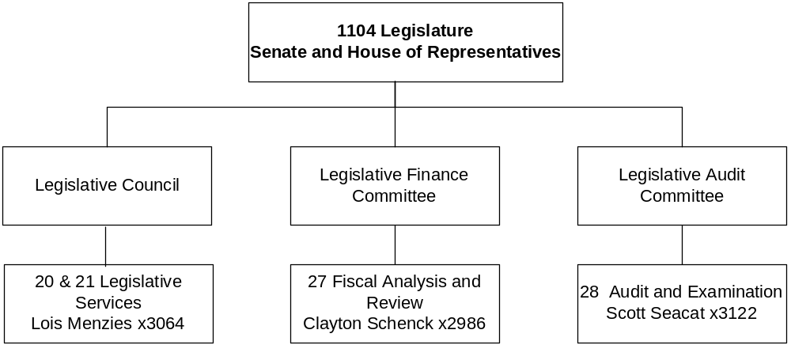

Mission Statement - The mission of the Legislature is to exercise the legislative power of state government vested in the Legislature by The Constitution of the State of Montana. The mission of the Legislative Branch, i.e., the consolidated legislative agency, is to provide the administrative structure to support accomplishment of the mission of the Legislature.

Statutory Authority - Principal statutory authority for the Legislative Services Division is found in Title 1, Chapter 11, and Title 5, Chapters 5 and 11, MCA. Principal statutory authority for the Legislative Fiscal Division is found in The Legislative Finance Act, Title 5, Chapter 12, MCA. The function of the Legislative Audit Division is constitutionally required, with principal statutory authority in The Legislative Audit Act, Title 5, Chapter 13, MCA.

Agency Proposed Budget  Budget Item | Base  Budget  Fiscal 2002 | PL Base Adjustment  Fiscal 2004 | New  Proposals  Fiscal 2004 | Total  Exec. Budget  Fiscal 2004 | PL Base Adjustment  Fiscal 2005 | New  Proposals  Fiscal 2005 | Total  Exec. Budget  Fiscal 2005
FTE | 125.27 | (1.50) | 0.00 | 123.77 | (1.50) | 0.00 | 128.94
Personal Services | 6,639,917 | 1,003,955 | 26,226 | 7,670,098 | 957,977 | 0 | 7,597,894
Operating Expenses | 3,202,051 | 373,380 | 244,619 | 3,820,050 | (607,135) | 66,225 | 2,661,141
Equipment | 6,890 | 13,110 | 0 | 20,000 | 13,110 | 0 | 20,000
Total Costs | $9,848,858 | $1,390,445 | $270,845 | $11,510,148 | $363,952 | $66,225 | $10,279,035
General Fund | 7,670,815 | 1,228,488 | 270,845 | 9,170,148 | 858,516 | 66,225 | 8,595,556
State/Other Special | 2,178,043 | 161,957 | 0 | 2,340,000 | (494,564) | 0 | 1,683,479
Total Funds | $9,848,858 | $1,390,445 | $270,845 | $11,510,148 | $363,952 | $66,225 | $10,279,035

------------------- Agency General Fund Target - $14.18 million ---------------------

The general fund target for the Legislative Branch was calculated in the same manner as all other agency targets. In accordance with 17-7-122, MCA, the Legislative Branch budget request is presented as submitted.

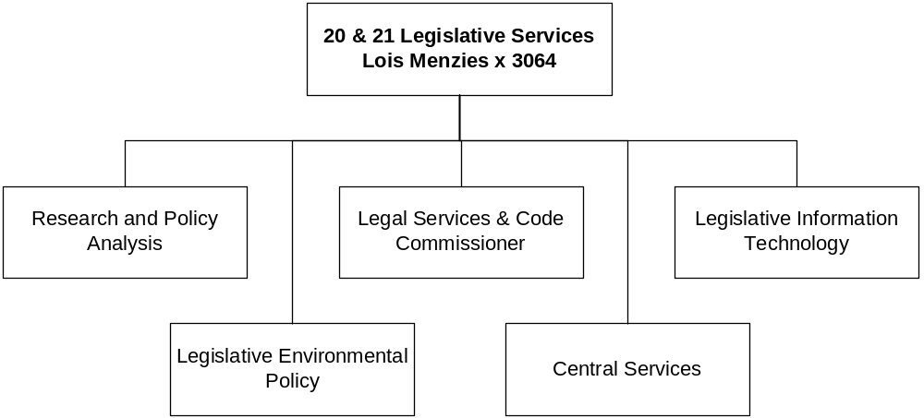

Program Description - The Legislative Services Division provides research, reference, legal, technical, information technology, and administrative support services to the House, Senate, and other divisions of the Legislative Branch. Division services include: 1) bill and amendment drafting, preparation of bills for introduction, and engrossing and enrolling bills; 2) publication of legislative documents of record; 3) provision of legislative research and reference services; legal counseling on legislative matters and agency legal support; 4) agency management and business services; 5) planning, installation and maintenance of the agency computer network and applications; 6) legislative committee staffing and support; 7) preparation, publication and distribution of the Montana Code Annotated text and annotations; 8) review of the text of proposed ballot measures; 9) broadcasting of legislative activities; and 10) provision of legislative information to the public. The Legislative Council provides policy guidance to the Legislative Services Division.

Program Proposed Budget  Budget Item | Base  Budget  Fiscal 2002 | PL Base Adjustment  Fiscal 2004 | New  Proposals  Fiscal 2004 | Total  Exec. Budget  Fiscal 2004 | PL Base Adjustment  Fiscal 2005 | New  Proposals  Fiscal 2005 | Total  Exec. Budget  Fiscal 2005
FTE | 49.50 | 0.00 | 0.00 | 49.50 | 0.00 | 0.00 | 54.67
Personal Services | 2,680,398 | 390,048 | 0 | 3,070,446 | 455,038 | 0 | 3,135,436
Operating Expenses | 2,546,554 | 6,829 | 0 | 2,553,383 | (369,157) | 66,225 | 2,243,622
Equipment | 6,890 | 13,110 | 0 | 20,000 | 13,110 | 0 | 20,000
Total Costs | $5,233,842 | $409,987 | $0 | $5,643,829 | $98,991 | $66,225 | $5,399,058
General Fund | 4,328,746 | 377,942 | 0 | 4,706,688 | 625,068 | 66,225 | 5,020,039
State/Other Special | 905,096 | 32,045 | 0 | 937,141 | (526,077) | 0 | 379,019
Total Funds | $5,233,842 | $409,987 | $0 | $5,643,829 | $98,991 | $66,225 | $5,399,058

--------------------------------- Present Law Adjustments --------------------------------

Total Agency Impact | General Fund Total
FY04 ($29,587) | FY04 ($81,134)
FY05 ($485,750) | FY05 ($152,783)
PL- 1 - LSD Biennial Program Operations -
The Legislative Branch business cycle is biennial, related to the cyclical nature of legislative sessions, production and publication of the Montana Codes Annotated, interim study committees and activities, and biennial audit work. Revenue collections spike and ebb in response to the biennial cycle. The Legislative Services Division budget is presented in annual format for budget review only; the budget will be established as biennial to respond to the need to responsibly manage the branch's cyclical expenditures and revenues.

Included in this package are increases from base in staff overtime and temporary services staffing of the bill status system related to the non-base year 2005 legislative session. Significant operational decreases occur in consulting services, travel, and minor equipment, as well as printing, shipping, and credit card and royalty fees related to non-base year reductions in the publication and distribution of the Montana Codes Annotated. Fixed cost expenses, included in statewide present law adjustments, increase $193,541 over the biennium.

---------------------------------------- New Proposals ----------------------------------------

Total Agency Impact | General Fund Total
FY04 $0 | FY04 $0
FY05 $66,225 | FY05 $66,225
NP- 2 - Connect Legislator Laptop Computers to Network -
The Legislative Branch Computer System Planning Council, established in 5-11-402, MCA, is responsible for developing and maintaining the Legislative Branch computer system plan. Included in the 2005 biennium plan is a proposal requesting funding to connect 75 laptop computers, personally owned by legislators, to the state data network during the 2005 regular legislative session. The proposal totals $66,225, including funding for contracted support services and monthly network connection fees, and would be a biennial appropriation placed in the first year.

Program Description - The Legislative Committees and Activities Program processes and monitors the expenditures of various legislative committees and activities, particularly those conducted during the interim between legislative sessions. Services include: 1) limited support of interim studies activities established under 5-5-202 through 5-5-217, MCA; 2) support of interstate cooperation activities of the legislature; and 3) support of other legislative activities for which appropriations are made.

Program Proposed Budget  Budget Item | Base  Budget  Fiscal 2002 | PL Base Adjustment  Fiscal 2004 | New  Proposals  Fiscal 2004 | Total  Exec. Budget  Fiscal 2004 | PL Base Adjustment  Fiscal 2005 | New  Proposals  Fiscal 2005 | Total  Exec. Budget  Fiscal 2005
FTE | 0.97 | 0.00 | 0.00 | 0.97 | 0.00 | 0.00 | 0.97
Personal Services | 68,842 | 49,759 | 26,226 | 144,827 | (68,842) | 0 | 0
Operating Expenses | 306,254 | 328,914 | 219,619 | 854,787 | (306,254) | 0 | 0
Total Costs | $375,096 | $378,673 | $245,845 | $999,614 | ($375,096) | $0 | $0
General Fund | 348,012 | 405,757 | 245,845 | 999,614 | (348,012) | 0 | 0
State/Other Special | 27,084 | (27,084) | 0 | 0 | (27,084) | 0 | 0
Total Funds | $375,096 | $378,673 | $245,845 | $999,614 | ($375,096) | $0 | $0

--------------------------------- Present Law Adjustments --------------------------------

Total Agency Impact | General Fund Total
FY04 $389,290 | FY04 $389,290
FY05 ($364,382) | FY05 ($364,382)
PL- 3 - Interim Committee Biennial Operations -
The Legislative Committees & Activities Program supports the activities of temporary and permanent statutory committees, interim committees and interstate organizational participation. The budget is presented as a biennial appropriation in the first year to reflect the biennial nature of legislative operations. The biennial increase above base is approximately $3,500.

---------------------------------------- New Proposals ----------------------------------------

Total Agency Impact | General Fund Total
FY04 $51,337 | FY04 $51,337
FY05 $0 | FY05 $0
NP- 4 - Participation, Pacific Northwest Economic Region -
The Pacific Northwest Economic Region (PNWER) is an international organization promoting greater regional collaboration among the states of Alaska, Idaho, Montana, Oregon, and Washington, the provinces of Alberta and British Columbia, and the Yukon Territory. In 2001, the Legislature authorized Montana's membership in the PNWER (Title 5, Chapter 11, part 7). However, no funds were appropriated for payment of Montana's annual membership dues or to allow legislative delegates to participate in PNWER activities. A budget of $51,337 is proposed to provide funding for Montana's dues of $32,699 and legislator participation.
________________________________________________________________________________________________

Total Agency Impact | General Fund Total
FY04 $10,000 | FY04 $10,000
FY05 $0 | FY05 $0
NP- 5 - Legislative Council on River Governance -
The Legislative Council on River Governance is comprised of legislators from Montana, Oregon, Idaho, and Washington. The council's mission is to assert state legislative authority over natural resources and river governance issues and to unite states for a proactive agenda of legislative action. In 2001, the Legislature approved a one-time appropriation of $10,000 for the 2003 biennium for legislator participation in council meetings and activities. This proposal, implemented with a biennial appropriation placed in the first year, includes $10,000 for legislative participation in council meetings and activities for the 2005 biennium.
________________________________________________________________________________________________

Total Agency Impact | General Fund Total
FY04 $73,880 | FY04 $73,880
FY05 $0 | FY05 $0
NP- 6 - Dues, Council of State Governments -
The base budget includes partial funding of Montana's biennial dues in the Council of State Governments (CSG) as approved by the last Legislature. This proposal, implemented with a biennial appropriation placed in the first year, includes $73,880 for the balance of full biennial dues in the CSG.
________________________________________________________________________________________________

Total Agency Impact | General Fund Total
FY04 $110,628 | FY04 $110,628
FY05 $0 | FY05 $0
NP- 7 - Participation, NCSL and CSG -
The base budget includes full funding of Montana's biennial membership dues in the National Conference of State Legislatures (NCSL) and partial funding of membership dues in the Council of State Governments (CSG). The current level base budget does not include funds for delegate participation in either organization. This proposal, implemented with a biennial appropriation placed in the first year, includes funding for delegate participation in NCSL and CSG during the 2005 biennium.

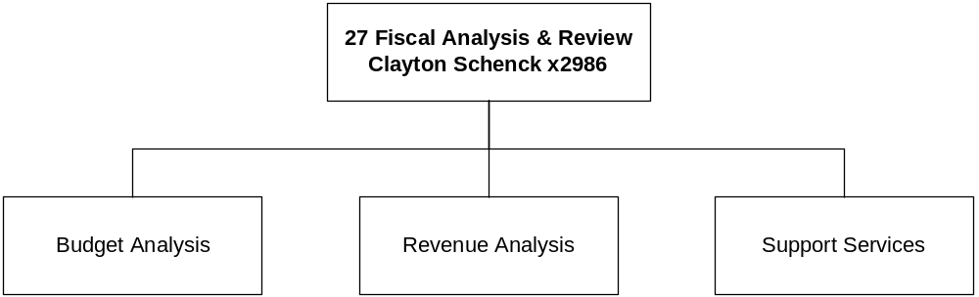

Program Description - The Legislative Fiscal Division provides the legislature with objective fiscal information and analysis relevant to Montana public policy and budget determination. Division services include: 1) fiscal analysis of state government and the furnishing of information bearing upon the financial matters of the state; 2) identification of ways to effect economy and efficiency in state government; 3) estimation of revenue and analysis of tax policy; 4) analysis of the executive budget; 5) compiling and analyzing fiscal information for legislators and legislative committees; and 6) staffing and support for legislative committees, including the preparation and processing of the General Appropriations Act. The Legislative Finance Committee provides guidance to the Legislative Fiscal Division.

Program Proposed Budget  Budget Item | Base  Budget  Fiscal 2002 | PL Base Adjustment  Fiscal 2004 | New  Proposals  Fiscal 2004 | Total  Exec. Budget  Fiscal 2004 | PL Base Adjustment  Fiscal 2005 | New  Proposals  Fiscal 2005 | Total  Exec. Budget  Fiscal 2005
FTE | 18.80 | 0.00 | 0.00 | 18.80 | 0.00 | 0.00 | 18.80
Personal Services | 1,086,713 | 119,171 | 0 | 1,205,884 | 127,530 | 0 | 1,214,243
Operating Expenses | 54,418 | 2,489 | 0 | 56,907 | 40,996 | 0 | 95,414
Total Costs | $1,141,131 | $121,660 | $0 | $1,262,791 | $168,526 | $0 | $1,309,657
General Fund | 1,141,131 | 121,660 | 0 | 1,262,791 | 168,526 | 0 | 1,309,657
Total Funds | $1,141,131 | $121,660 | $0 | $1,262,791 | $168,526 | $0 | $1,309,657

--------------------------------- Present Law Adjustments --------------------------------

Total Agency Impact | General Fund Total
FY04 $0 | FY04 $0
FY05 $45,000 | FY05 $45,000
PL- 8 - LFD Biennial Program Operations -
The Legislative Branch business cycle is biennial, related to the cyclical nature of legislative sessions, production and publication of the Montana Codes Annotated, interim study committees and activities, and biennial audit work. Revenue collections spike and ebb in response to the biennial cycle. The Legislative Fiscal Division budget is presented in annual format for budget review only; the budget will be established as biennial to respond to the need to responsibly manage the branch's cyclical expenditures and revenues.

Increases in operational costs relate to the non-base year regular legislative session and statewide present law adjustments. The categories affected include staff overtime, temporary services, printing, photocopy pool costs, and office supplies. Substantial printing costs are related to the budget analysis, session publications, budget summary pamphlets, and post-session reports.

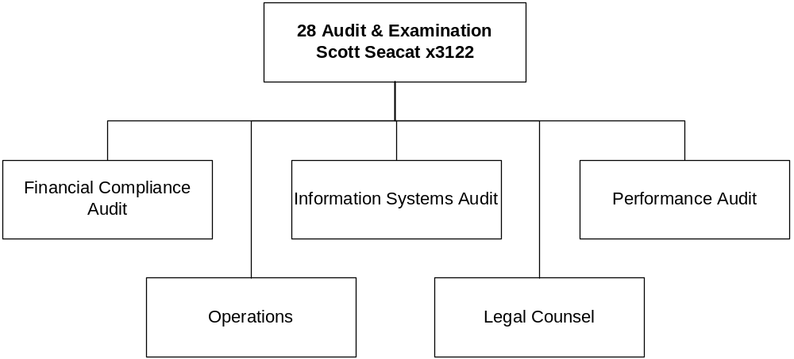

Program Description - The Legislative Audit Division conducts independent audits and provides factual and objective information to the legislative and executive managers of the public trust. Division services include: 1) conducting and reporting of biennial financial-compliance audits, performance audits, information systems audits, and special audits of state agency operations; 2) reporting of violation of penal statutes, instances of misfeasance, malfeasance, or nonfeasance, and shortages discovered in an audit that are covered by surety; 3) auditing records of entities under contract with the state; and 4) assisting the legislature, its committees, and its members by providing information related to the fiscal affairs of state government. The Legislative Audit Committee provides policy guidance to the Legislative Audit Division.

Program Proposed Budget  Budget Item | Base  Budget  Fiscal 2002 | PL Base Adjustment  Fiscal 2004 | New  Proposals  Fiscal 2004 | Total  Exec. Budget  Fiscal 2004 | PL Base Adjustment  Fiscal 2005 | New  Proposals  Fiscal 2005 | Total  Exec. Budget  Fiscal 2005
FTE | 56.00 | (1.50) | 0.00 | 54.50 | (1.50) | 0.00 | 54.50
Personal Services | 2,803,964 | 444,977 | 0 | 3,248,941 | 444,251 | 0 | 3,248,215
Operating Expenses | 294,825 | 35,148 | 25,000 | 354,973 | 27,280 | 0 | 322,105
Total Costs | $3,098,789 | $480,125 | $25,000 | $3,603,914 | $471,531 | $0 | $3,570,320
General Fund | 1,852,926 | 323,129 | 25,000 | 2,201,055 | 412,934 | 0 | 2,265,860
State/Other Special | 1,245,863 | 156,996 | 0 | 1,402,859 | 58,597 | 0 | 1,304,460
Total Funds | $3,098,789 | $480,125 | $25,000 | $3,603,914 | $471,531 | $0 | $3,570,320

--------------------------------- Present Law Adjustments --------------------------------

Total Agency Impact | General Fund Total
FY04 ($9,595) | FY04 $6,705
FY05 ($22,414) | FY05 ($8,271)
PL- 9 - LAD Biennial Program Operations -
The Legislative Branch business cycle is biennial, related to the cyclical nature of legislative sessions, production and publication of the Montana Codes Annotated, interim study committees and activities, and biennial audit work. Revenue collections spike and ebb in response to the biennial cycle. The Legislative Audit Division budget is presented in annual format for budget review only; the budget will be established as biennial to respond to the need to responsibly manage the branch's cyclical expenditures and revenues.

Included in the budget request is a 1.5 FTE reduction, resulting from a change in audit approach for the Montana University System. This reduction will not reduce audit services, rather it will save the state money by consolidating the university financial statements. Other changes from base include cyclical costs associated with a biennial independent audit of the legislative branch and audit division, the biennial Peer Review required by Government Auditing Standards, and costs associated with preparation of a branch disaster recovery plan and reactive system development needs.

---------------------------------------- New Proposals ----------------------------------------

Total Agency Impact | General Fund Total
FY04 $25,000 | FY04 $25,000
FY05 $0 | FY05 $0
NP- 10 - Branch EDP Security Review -
This proposal provides funding for costs associated with a one-time only independent electronic data processing (EDP) security review of the Legislative Branch computer environment. A similar proposal brought forward last biennium was eliminated from the program's budget.

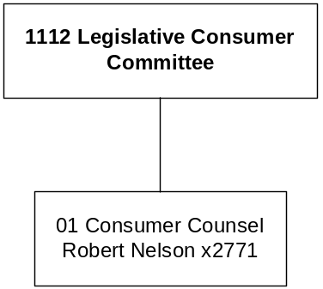

Mission Statement - To represent the utility and transportation consuming public of the State of Montana in hearings before the Public Service Commission or any other successor agency, and before state and federal courts and administrative agencies.

Statutory Authority - Article XIII, Section 2, Montana Constitution; Title 5, Chapter 15, and Title 69, Chapters 1 and 2, MCA.

Program Description - The Office of the Consumer Counsel was created by Article XIII, Section 2 of the 1972 Montana Constitution. The consumer counsel is charged with the duty of representing consumer interests in hearings before the Public Service Commission or any other successor agency. The agency also may initiate, intervene in, or otherwise participate in appropriate proceedings in the state and federal courts and proceedings before federal administrative agencies on behalf of the public of Montana.

Program Proposed Budget  Budget Item | Base  Budget  Fiscal 2002 | PL Base Adjustment  Fiscal 2004 | New  Proposals  Fiscal 2004 | Total  Exec. Budget  Fiscal 2004 | PL Base Adjustment  Fiscal 2005 | New  Proposals  Fiscal 2005 | Total  Exec. Budget  Fiscal 2005
FTE | 5.04 | 0.00 | 0.00 | 5.04 | 0.00 | 0.00 | 5.04
Personal Services | 366,805 | 37,264 | 0 | 404,069 | 37,261 | 0 | 404,066
Operating Expenses | 655,729 | 150,885 | 0 | 806,614 | 158,476 | 0 | 814,205
Total Costs | $1,022,534 | $188,149 | $0 | $1,210,683 | $195,737 | $0 | $1,218,271
State/Other Special | 1,022,534 | 188,149 | 0 | 1,210,683 | 195,737 | 0 | 1,218,271
Total Funds | $1,022,534 | $188,149 | $0 | $1,210,683 | $195,737 | $0 | $1,218,271

--------------------------------- Present Law Adjustments --------------------------------

Total Agency Impact | General Fund Total
FY04 $150,103 | FY04 $0
FY05 $157,117 | FY05 $0
PL- 1 - Present Law Base Adjustments -
The budget includes $125,000 contingency each year of the 2005 biennium for costs associated with unanticipated caseload, consistent with appropriations in prior biennia. The remaining adjustments are attributed to contract amounts and anticipated workload.

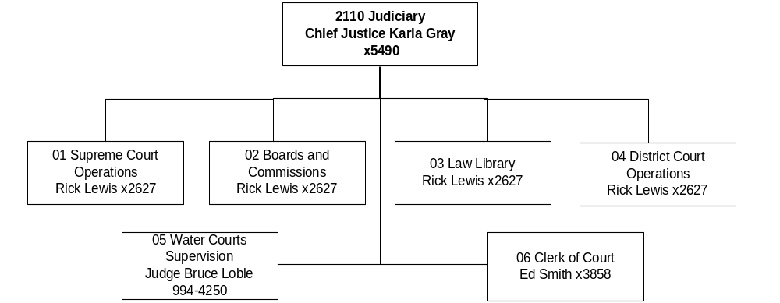

Mission Statement - The jurisdiction of the Supreme Court consists of all appellate and original jurisdiction in petitions for writs of habeas corpus and other such writs, general supervisory control over all Montana courts, and rule making for those courts.

Statutory Authority - Article III, Section 1, and Article VII, Montana Constitution; Title 3, MCA.

Agency Proposed Budget  Budget Item | Base  Budget  Fiscal 2002 | PL Base Adjustment  Fiscal 2004 | New  Proposals  Fiscal 2004 | Total  Exec. Budget  Fiscal 2004 | PL Base Adjustment  Fiscal 2005 | New  Proposals  Fiscal 2005 | Total  Exec. Budget  Fiscal 2005
FTE | 357.43 | 0.00 | 16.00 | 373.43 | 0.00 | 16.00 | 373.43
Personal Services | 8,364,385 | 11,877,687 | 656,641 | 20,898,713 | 11,851,000 | 659,694 | 20,875,079
Operating Expenses | 1,744,876 | 7,750,231 | 668,460 | 8,638,262 | 638,852 | 8,650,964 | 11,021,990
Equipment | 329,311 | 0 | 0 | 329,311 | 0 | 0 | 329,311
Grants | 0 | 0 | 480,849 | 480,849 | 0 | 480,849 | 480,849
Total Costs | $10,438,572 | $19,627,918 | $1,805,950 | $31,872,440 | $20,489,262 | $1,779,395 | $32,707,229
General Fund | 9,354,970 | 19,508,432 | (25,000) | 28,838,402 | 20,367,446 | (25,000) | 29,697,416
State/Other Special | 710,015 | 175,997 | 1,757,342 | 2,643,354 | 178,761 | 1,731,019 | 2,619,795
Federal Special | 373,587 | (56,511) | 73,608 | 390,684 | (56,945) | 73,376 | 390,018
Total Funds | $10,438,572 | $19,627,918 | $1,805,950 | $31,872,440 | $20,489,262 | $1,779,395 | $32,707,229

------------------- Agency General Fund Target - $58.53 million -------------------

The Judicial branch budget request is presented in the Table A-1 below in accordance 17-7-122(3), MCA, which states: “Judicial branch request must be included in the budget submitted by the governor, but expenditures above the current level funding need not be part of the balanced financial plan pursuant to 17-7-123, MCA."

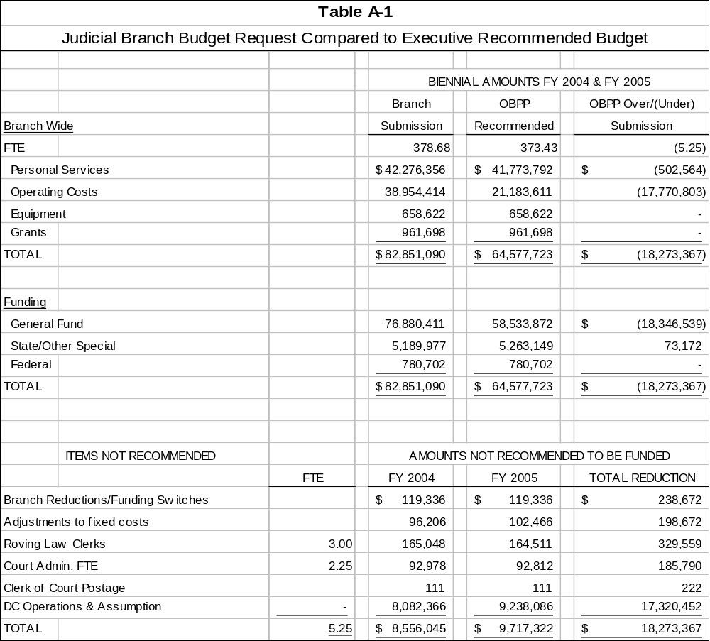

The Judicial Branch requested a 2005 biennium budget of $82,851,090 including $76,880,411 general fund. The executive budget recommends funding a 2005 biennium budget of $64,577,723 including $58,533,872 general fund for a difference of $18,346,539 general fund. However, $17,211,828 of the general fund difference is composed of projections on the new variable costs for District Court Assumption that will be addressed in separate legislation. Each of the items not recommended to be funded is described below.

Branch Reductions/Funding Switches -
The branch withdrew or determined alternative funding sources for $348,116 of budget requests in an attempt to achieve general fund budget targets established by the OBPP. Total reductions amount to $238,672. Reductions include $202,400 of general fund for phone upgrades ($2400), Judicial Standards Commission ($80,000), shelving for the Law Library ($120,000), and $36,272 in state special funds for the Water Courts personal services. Fund switches from general fund to state special funds amount to $109,444 for computer replacements ($59,444) and Courts of Limited Jurisdiction Training ($50,000).

Adjustments to Fixed Costs -
Most fixed costs, such as utilities and insurance, have projected increases in the 2005 biennium. The Judiciary over-budgeted for these in the original submission, so the amounts listed here reflect the necessary adjustments. (The fixed costs adjustments in program 4, District Courts, are included in the amount listed under DC Operations and Assumption.)

Roving Law Clerks -
This proposal would provide funding for the continuation of three law clerks for the Supreme Court Justices. The branch requested seven law clerks in the 2001 session and was granted three, with the caveat that they would be re-considered by the 2003 Legislature.

Court Administrative FTE -
This proposal would fund 2.25 FTE, including 1.00 FTE accounting technician to process district court expenses and 1.25 FTE to replace 1.25 FTE that are currently filled, but whose statutory authority was eliminated with the passage of SB 176.

Clerk of Court Postage -
Included in a Clerk of Court decision package for increases in operating authority was an amount for increased postage costs. This amount is not recommended to be funded because the OBPP already applied an inflationary factor to base year postage expenditures.

District Court Operations and Assumption -
District Court Operations refers to the 8.50 FTE authorized by 2003 Legislature for the Administration of DC Assumption, their associated personal services and operating costs, and the 42 District Court judges' salaries.

District Court Assumption refers to the personal services costs for all FTE and associated operating costs included in District Court Assumption as outlined in SB 176. This includes the operating costs of the District Court judges. A bill will be introduced at the request of the OBPP to deal with the variable costs, such as indigent defense, that are projected to be in excess of the funding mechanism provided for District Court Assumption. In the current fiscal year, those excess costs are the responsibility of the counties.

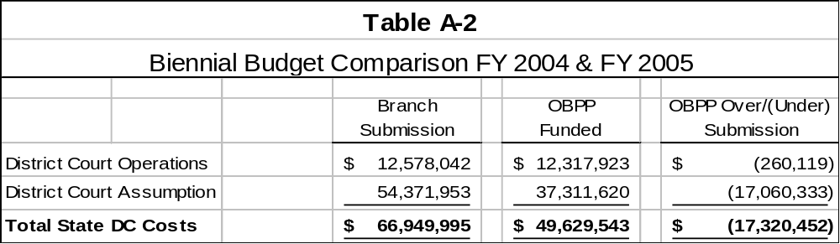

Included in the OBPP funded amounts are adjustments to DC Operations and DC Assumption that moved FTE between these subprograms. These adjustments were not included in the branch submission. This change allowed for delineation between the two definitions of DC Operations and DC Assumption above. This adjustment changed the FTE and amount budgeted between DC Operations and DC Assumption, but did not change the number of FTE or total budget for Program 4, District Courts. These changes account for the disparities between the $17,060,333 figure above, which represents the difference in the branch submission versus OBPP funded amount above in DC Assumption, as compared to the $17,211,828 difference between the projected variable costs for DC Assumption versus the funded amount in NP-8002 in program 04.

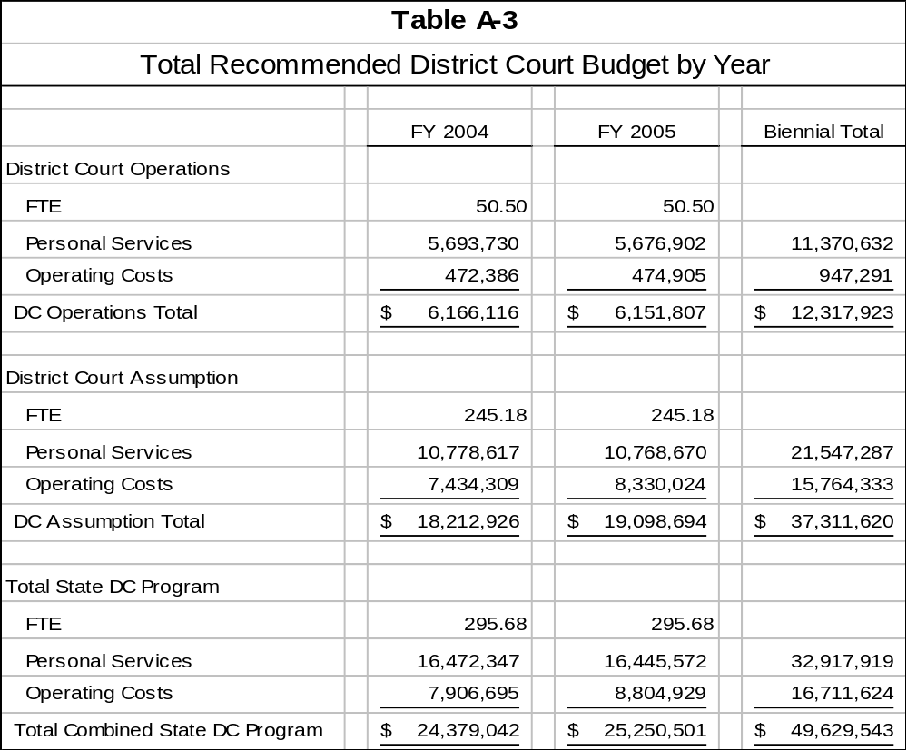

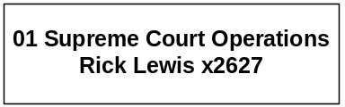

Program Description -
The Supreme Court has appellate jurisdiction for the State of Montana. It has original jurisdiction to issue, hear, and determine writs of habeas corpus and other such writs as may be provided by law. It also has general supervisory control over all other courts in the state. The Supreme Court is charged with establishing rules governing appellate procedure, the practice and procedure for all other courts, admission to the bar, and the conduct of its members. The Supreme Court consists of a Chief Justice and six justices. SB 176, approved by the 57th Legislature, mandated state funding of Montana District Courts with general fund revenue. The change to state funding made District Courts part of the Judicial Branch of state government and made the Supreme Court responsible for the management of District Court costs and operations. The Supreme Court also administers the local citizen review board program for foster care placements, the federal court assessment program, and the court-appointed special advocate program.

Program Proposed Budget  Budget Item | Base  Budget  Fiscal 2002 | PL Base Adjustment  Fiscal 2004 | New  Proposals  Fiscal 2004 | Total  Exec. Budget  Fiscal 2004 | PL Base Adjustment  Fiscal 2005 | New  Proposals  Fiscal 2005 | Total  Exec. Budget  Fiscal 2005
FTE | 34.75 | 0.00 | 16.00 | 50.75 | 0.00 | 16.00 | 50.75
Personal Services | 2,419,693 | (52,538) | 671,641 | 3,038,796 | (56,837) | 674,694 | 3,037,550
Operating Expenses | 950,362 | 204,279 | 668,460 | 1,823,101 | 193,964 | 638,852 | 1,783,178
Equipment | 0 | 0 | 0 | 0 | 0 | 0 | 0
Grants | 0 | 0 | 480,849 | 480,849 | 0 | 480,849 | 480,849
Total Costs | $3,370,055 | $151,741 | $1,820,950 | $5,342,746 | $137,127 | $1,794,395 | $5,301,577
General Fund | 2,941,468 | 113,252 | 0 | 3,054,720 | 99,072 | 0 | 3,040,540
State/Other Special | 55,000 | 95,000 | 1,747,342 | 1,897,342 | 95,000 | 1,721,019 | 1,871,019
Federal Special | 373,587 | (56,511) | 73,608 | 390,684 | (56,945) | 73,376 | 390,018
Total Funds | $3,370,055 | $151,741 | $1,820,950 | $5,342,746 | $137,127 | $1,794,395 | $5,301,577

--------------------------------- Present Law Adjustments --------------------------------

Total Agency Impact | General Fund Total
FY04 $7,703 | FY04 $7,703
FY05 $7,703 | FY05 $7,703
PL- 1001 - Pay Plan Implementation -
The District Court assumption bill directed the Judicial Branch to develop and implement a branch-wide classification and compensation plan by July 1, 2003. The National Center for State Courts, following extensive review, recommended a classification and pay plan, which was approved by the Montana Supreme Court in June 2002. The plan established a grade system with a minimum and maximum pay rate for each pay grade. The pay rates are based in large part on the Executive Branch pay plan. Employees were placed on the system at their county rate of pay. Starting in July 2003, employees above the maximum rate will be frozen until the pay matrix moves enough to "catch-up" with these employees. In Program 01, there are currently two employees below the minimum rate. In order to implement the plan, these employees must be moved to the minimum pay rate for the assigned grade.
________________________________________________________________________________________________

Total Agency Impact | General Fund Total
FY04 $95,000 | FY04 $0
FY05 $95,000 | FY05 $0
PL- 1003 - Legal Assistance for Domestic Violence Victims -
This request asks for a state special revenue appropriation for funds distributed from the marriage dissolution fee at the level of estimated revenues collected. The 1999 Legislature established this fee to provide legal assistance to indigent victims of domestic abuse.

---------------------------------------- New Proposals ----------------------------------------

Total Agency Impact | General Fund Total
FY04 $43,618 | FY04 $0
FY05 $43,473 | FY05 $0
NP- 1101 - Grant Manager -
The Judicial Branch is requesting 1.00 FTE grant funds manager to be responsible for developing a system to track all grant applications and awards, including managing the funds and preparing required financial and narrative reports. This position will be key to acquiring additional grant funding and to ensuring that funds received are spent within grant guidelines.
________________________________________________________________________________________________

Total Agency Impact | General Fund Total
FY04 $29,990 | FY04 $0
FY05 $29,903 | FY05 $0
NP- 1103 - Court Assessment Program -
This proposal requests 1.00 FTE and federal funding of $29,990 in FY 2004 and $29,903 in FY 2005 to continue the evaluation and improvement of how the judicial system handles child abuse and neglect proceedings. The 1997 Legislature originally authorized this program and the federal government has continued to extend funding.

------------------ Other Legislation Required to Implement HB 2 ------------------

Total Agency Impact | General Fund Total
FY04 $1,717,620 | FY04 $0
FY05 $1,691,297 | FY05 $0
NP - 8001 - Judicial Branch Information Technology -
The Judiciary requests approximately $3.4 million state special revenue funding for the 2005 biennium to provide for branch-wide information technology needs. The existing automation program is scheduled to sunset June 30, 2003. LC 167 would repeal the sunset and increase the surcharge from five to ten dollars. The current charge generates revenues of approximately $1 million per year. Doubling the surcharge would generate enough revenue to offset the request of $3.4 million over the biennium. This decision package is based on passage and approval of LC 167.

This proposal includes funding to provide 14.00 IT staff, related start-up and operating costs, and replacement equipment. The following table summarizes the branch IT request:

The existing (until 6/30/03) automation program provides system support, training, workstations, file servers, connectivity, and software to all Montana (MT) courts. The current IT environment includes two software applications used in MT courts. First, the Judicial Case Management System (JCMS) is an application developed by the Office of the Court Administrator (OCA) and is the primary product used by District Courts and District Court Clerks to capture and report information, manage cases, and collect and distribute money related to district court operations. The second program supported by the IT division is "Full Court." Full Court is a program licensed from Justice Systems Incorporated that provides case management functionality to the limited jurisdiction courts. Overall, the IT division uses available resources to provide the above described services and equipment to almost 1,000 state and county and city staff across the state.
________________________________________________________________________________________________

Total Agency Impact | General Fund Total
FY04 $29,722 | FY04 $0
FY05 $29,722 | FY05 $0
NP- 8003 - Computer Replacement -
This request is for computer replacement on a four-year replacement cycle. There are 88 devices with 25 percent or 22 machines being replaced each year of the biennium. These machines are for the Clerk of Court, Law Library, Supreme Court Justices and Court Administration personnel. This proposal is funded with a continuation of information technology surcharge funds, which are scheduled to sunset but recommended to be ongoing contingent on passage and approval of LC 167.

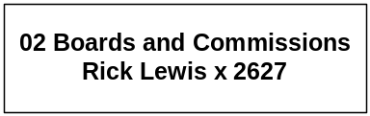

Program Description - The Boards and Commissions Program oversees functions assigned to the Supreme Court either by legislative or constitutional mandate. The program manages judicial discipline, rules, and other substantive matters aimed at improving and maintaining the administration of justice. Commissions and boards included in the program are the Judicial Standards Commission; Sentence Review Division; Commission on Practice; Commission on Courts of Limited Jurisdiction; and the Judicial Nominations Commission.

Program Proposed Budget  Budget Item | Base  Budget  Fiscal 2002 | PL Base Adjustment  Fiscal 2004 | New  Proposals  Fiscal 2004 | Total  Exec. Budget  Fiscal 2004 | PL Base Adjustment  Fiscal 2005 | New  Proposals  Fiscal 2005 | Total  Exec. Budget  Fiscal 2005
FTE | 3.00 | 0.00 | 0.00 | 3.00 | 0.00 | 0.00 | 3.00
Personal Services | 79,475 | 34,495 | 0 | 113,970 | 34,434 | 0 | 113,909
Operating Expenses | 169,218 | 941 | 0 | 170,159 | 1,015 | 0 | 170,233
Total Costs | $248,693 | $35,436 | $0 | $284,129 | $35,449 | $0 | $284,142
General Fund | 248,693 | 35,436 | (25,000) | 259,129 | 35,449 | (25,000) | 259,142
State/Other Special | 0 | 0 | 25,000 | 25,000 | 0 | 25,000 | 25,000
Total Funds | $248,693 | $35,436 | $0 | $284,129 | $35,449 | $0 | $284,142

---------------------------------------- New Proposals ----------------------------------------

Total Agency Impact | General Fund Total
FY04 $0 | FY04 ($25,000)
FY05 $0 | FY05 ($25,000)
NP- 2101 - Courts of Limited Jurisdiction Funding Switch -
This proposal requests $25,000 state special revenue each year to replace current general fund used to provide training for judges of courts of limited jurisdiction. Class registration fees will provide the source of state special revenue.

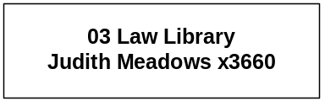

Program Description - The State Law Library houses reference materials used by the Supreme Court, lower courts, the Legislature, state officers and employees, members of the bar, and the general public. The collection includes legal materials from the federal government and all 50 states, as well as Canada. Some of the books and materials contained in the library include treatises, law reviews, reports, microfilm, and audio/video tapes for continuing legal education. Access to much of the information also is provided from the library's Internet site. The State Law Library is governed by a Board of Trustees which consists of the Supreme Court justices.

Program Proposed Budget  Budget Item | Base  Budget  Fiscal 2002 | PL Base Adjustment  Fiscal 2004 | New  Proposals  Fiscal 2004 | Total  Exec. Budget  Fiscal 2004 | PL Base Adjustment  Fiscal 2005 | New  Proposals  Fiscal 2005 | Total  Exec. Budget  Fiscal 2005
FTE | 7.50 | 0.00 | 0.00 | 7.50 | 0.00 | 0.00 | 7.50
Personal Services | 325,725 | (11,308) | 0 | 314,417 | (9,497) | 0 | 316,228
Operating Expenses | 128,123 | 698 | 0 | 128,821 | 709 | 0 | 128,832
Equipment | 329,311 | 0 | 0 | 329,311 | 0 | 0 | 329,311
Total Costs | $783,159 | ($10,610) | $0 | $772,549 | ($8,788) | $0 | $774,371
General Fund | 783,159 | (10,610) | 0 | 772,549 | (8,788) | 0 | 774,371
Total Funds | $783,159 | ($10,610) | $0 | $772,549 | ($8,788) | $0 | $774,371

Please note that a HB 576 section exists for this program.

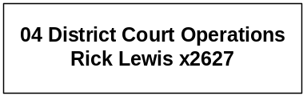

Program Description - District Court costs are funded by state general fund according to SB 176 approved by the 57th Legislature. The bill made the Supreme Court responsible for the management of all District Court costs and operational activities. District courts are general jurisdiction trial courts having original jurisdiction in all criminal felony cases, civil matters, and cases of law.

Program Proposed Budget  Budget Item | Base  Budget  Fiscal 2002 | PL Base Adjustment  Fiscal 2004 | New  Proposals  Fiscal 2004 | Total  Exec. Budget  Fiscal 2004 | PL Base Adjustment  Fiscal 2005 | New  Proposals  Fiscal 2005 | Total  Exec. Budget  Fiscal 2005
FTE | 295.68 | 0.00 | 0.00 | 295.68 | 0.00 | 0.00 | 295.68
Personal Services | 4,720,728 | 11,751,619 | 0 | 16,472,347 | 11,724,844 | 0 | 16,445,572
Operating Expenses | 365,438 | 7,541,257 | 0 | 7,906,695 | 8,439,491 | 0 | 8,804,929
Total Costs | $5,086,166 | $19,292,876 | $0 | $24,379,042 | $20,164,335 | $0 | $25,250,501
General Fund | 5,086,166 | 19,292,876 | 0 | 24,379,042 | 20,164,335 | 0 | 25,250,501
Total Funds | $5,086,166 | $19,292,876 | $0 | $24,379,042 | $20,164,335 | $0 | $25,250,501

--------------------------------- Present Law Adjustments --------------------------------

Total Agency Impact | General Fund Total
FY04 $70,296 | FY04 $70,296
FY05 $70,296 | FY05 $70,296
PL- 4001 - Pay Plan Implementation -
The District Court assumption bill directed the Judicial Branch to develop and implement a branch wide classification and compensation plan by July 1, 2003. The National Center for State Courts, following extensive review, recommended a classification and pay plan, which was approved by the Montana Supreme Court in June 2002. The plan established a grade system with a minimum and maximum pay rate for each pay grade. The pay rates are based in large part on the Executive Branch pay plan. Employees were placed on the system at their county rate of pay. Starting in July 2003, employees above the maximum rate will be frozen until the pay matrix moves enough to "catch-up" with these employees. In Program 04 there are 23 employees currently below the minimum rate. In order to implement the plan, these employees must be moved to the minimum pay rate for the assigned grade.
________________________________________________________________________________________________

Total Agency Impact | General Fund Total
FY04 $106,123 | FY04 $106,123
FY05 $108,245 | FY05 $108,245
PL- 4002 - Federal Building Rent -
The branch was authorized 8.50 FTE in the 2003 biennium for the administration of state assumption of district courts. The department of administration located office space in the federal building for these FTE. The associated rent is $106,123 in FY 2004 and $108,245 in FY 2005.
________________________________________________________________________________________________

Total Agency Impact | General Fund Total
FY04 $44,600 | FY04 $44,600
FY05 $44,600 | FY05 $44,600
PL- 4003 - Annualize Operating Costs for New Judges -
This proposal annualizes the operating costs for the two judges taking office January 1, 2003, in Ravalli County and Cascade County. The request for $44,600 per year includes funding for supplies, telephone, postage, and legal research for two judges and six staff.
________________________________________________________________________________________________

Total Agency Impact | General Fund Total
FY04 $7,116,397 | FY04 $7,116,397
FY05 $8,012,112 | FY05 $8,012,112
PL- 4004 - State District Court Costs -
The Fifty-seventh Legislature authorized SB 176 to provide for the state assumption of District Courts. As directed in SB 176, sizeable district court expenses are reported and paid in the following expenditure categories: court reporters; jury services; witness services; psychiatric examinations; indigent defense; CASA/GALs; youth court/juvenile probation; and youth in need of care. The executive projects the base costs for these items will be the amounts stated above.

------------------ Other Legislation Required to Implement HB 2 ------------------

Total Agency Impact | General Fund Total
FY04 $0 | FY04 $0
FY05 $0 | FY05 $0
NP- 8002 - State District Court Costs -
The Fifty-seventh Legislature authorized SB 176 to provide for the state assumption of District Courts. As directed in SB 176, sizeable district court expenses are reported and paid in the following expenditure categories: court reporters; jury services; witness services; psychiatric examinations; indigent defense; CASA/GALs; youth court/juvenile probation; and youth in need of care.

In FY 2003, current statute allows for the counties to take responsibility for the costs outlined above that exceed the FY 2003 appropriation to the Judiciary for variable costs. This is scheduled to sunset June 30, 2003, which after this time will be the state's responsibility. A bill will be introduced at the request of the OBPP to sort out responsibilities for the variable cost that are projected to be in excess of the funding mechanism provided for in the District Court assumption. These costs are projected to be about $17.2 million above the funding provided in SB176. It will be important to determine which entity is responsible for creating and managing the service, controlling the cost of each item, and paying for each item.



Program Description - The Water Courts Supervision Program, located in Bozeman, adjudicates claims of existing water rights in Montana and supervises the distribution of water among the four water divisions of the state, as defined in 3-7-102, MCA.

Program Proposed Budget  Budget Item | Base  Budget  Fiscal 2002 | PL Base Adjustment  Fiscal 2004 | New  Proposals  Fiscal 2004 | Total  Exec. Budget  Fiscal 2004 | PL Base Adjustment  Fiscal 2005 | New  Proposals  Fiscal 2005 | Total  Exec. Budget  Fiscal 2005
FTE | 11.00 | 0.00 | 0.00 | 11.00 | 0.00 | 0.00 | 11.00
Personal Services | 560,972 | 81,897 | (15,000) | 627,869 | 84,634 | (15,000) | 630,606
Operating Expenses | 94,043 | (900) | 0 | 93,143 | (873) | 0 | 93,170
Total Costs | $655,015 | $80,997 | ($15,000) | $721,012 | $83,761 | ($15,000) | $723,776
State/Other Special | 655,015 | 80,997 | (15,000) | 721,012 | 83,761 | (15,000) | 723,776
Total Funds | $655,015 | $80,997 | ($15,000) | $721,012 | $83,761 | ($15,000) | $723,776

---------------------------------------- New Proposals ----------------------------------------

Total Agency Impact | General Fund Total
FY04 ($15,000) | FY04 $0
FY05 ($15,000) | FY05 $0
NP- 5101 - Reduce Water Courts Personal Services -
The Water Court is currently funded from the RIT renewable resource account (02272), which has declining revenues and is used to fund programs within several agencies. The requested expenditures drove the fund balance negative. To scale back expenditures, but not disrupt normal operations, the court will reduce personal services adjusted base by $15,000 per year in the 2005 biennium.

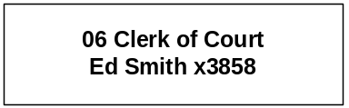

Program Description - The Clerk of Court Program performs support and operational duties for the Supreme Court, as outlined in Title 3, Chapter 2, part 4, MCA. The program keeps the court records and files, issues writs and certificates, approves bonds, files all papers and transcripts, and performs other duties as required.

Program Proposed Budget  Budget Item | Base  Budget  Fiscal 2002 | PL Base Adjustment  Fiscal 2004 | New  Proposals  Fiscal 2004 | Total  Exec. Budget  Fiscal 2004 | PL Base Adjustment  Fiscal 2005 | New  Proposals  Fiscal 2005 | Total  Exec. Budget  Fiscal 2005
FTE | 5.50 | 0.00 | 0.00 | 5.50 | 0.00 | 0.00 | 5.50
Personal Services | 257,792 | 73,522 | 0 | 331,314 | 73,422 | 0 | 331,214
Operating Expenses | 37,692 | 3,956 | 0 | 41,648 | 3,956 | 0 | 41,648
Total Costs | $295,484 | $77,478 | $0 | $372,962 | $77,378 | $0 | $372,862
General Fund | 295,484 | 77,478 | 0 | 372,962 | 77,378 | 0 | 372,862
Total Funds | $295,484 | $77,748 | $0 | $372,962 | $77,378 | $0 | $372,862

--------------------------------- Present Law Adjustments --------------------------------

Total Agency Impact | General Fund Total
FY04 $2,175 | FY04 $2,175
FY05 $2,175 | FY05 $2,175
PL- 6001 - Records Storage and Telephone Equipment -
By law (3-2-402, mca), the Clerk of the Supreme Court is responsible for the retention of Supreme Court records. At the end of June, 2002, the clerk's vault reached its capacity, resulting in the necessity to transfer closed cases from the years 1999 and 2000 to records management under the Secretary of State. In terms of storage space, the clerk fills approximately 100 record retention boxes of closed case files each calendar year. In addition to caseload storage, the clerk also has reached storage capacity for original Supreme Court opinions, which will also need to be archived. The clerk estimates that with the current storage backlog and what will accrue over the next biennium, the office will incur the need to store approximately 550 boxes of information at the records management facility at a charge of $3.54 per box per year or $1,947 each year of the biennium.

The Clerk acquired an additional telephone for the FTE approved by the 2001 Legislature. The equipment was not added until FY 2003 so there are no base year expenditures. The telephone adds an additional operations cost of $19 per month. Accordingly, the Clerk requests $228 in each fiscal year of the biennium to cover the telephone charge.

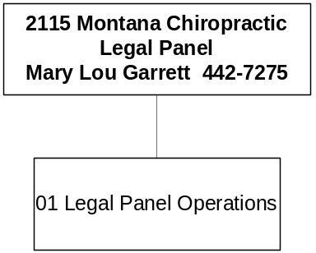

Mission Statement - To review potential malpractice claims against chiropractic physicians in order to prevent, if possible, filed court actions for professional liability in which the facts do not permit at least a reasonable inference of malpractice.

Statutory Authority - Title 27, Chapter 12, MCA.

Program Description - The Montana Chiropractic Legal Panel reviews all malpractice claims or potential claims against chiropractic physicians to: a) prevent, when possible, filed court actions against chiropractic physicians for professional liability in situations where the facts do not permit at least a reasonable inference of malpractice; and b) make possible the fair and equitable disposition of such claims against chiropractic physicians that are or reasonably may be well founded (Title 27, Chapter 12, MCA). A panel, consisting of three chiropractic physicians licensed in Montana and three attorneys who are members of the State Bar Association of Montana, is appointed to review each malpractice claim or potential claim. The panel is managed by a director appointed by the executive director of the Montana Chiropractic Association.

Program Proposed Budget  Budget Item | Base  Budget  Fiscal 2002 | PL Base Adjustment  Fiscal 2004 | New  Proposals  Fiscal 2004 | Total  Exec. Budget  Fiscal 2004 | PL Base Adjustment  Fiscal 2005 | New  Proposals  Fiscal 2005 | Total  Exec. Budget  Fiscal 2005
FTE | 0.00 | 0.00 | 0.00 | 0.00 | 0.00 | 0.00 | 0.00
Operating Expenses | 3,776 | 11,224 | 0 | 15,000 | 11,224 | 0 | 15,000
Total Costs | $3,776 | $11,224 | $0 | $15,000 | $11,224 | $0 | $15,000
State/Other Special | 3,776 | 11,224 | 0 | 15,000 | 11,224 | 0 | 15,000
Total Funds | $3,776 | $11,224 | $0 | $15,000 | $11,224 | $0 | $15,000

--------------------------------- Present Law Adjustments --------------------------------

Total Agency Impact | General Fund Total
FY04 $10,975 | FY04 $0
FY05 $10,972 | FY05 $0
PL- 1 - Operating Adjustment -
All panel functions are conducted through consulting and other professional services. The panel is requesting an increase for consulting and professional services, travel, and audit fees in anticipation of increased activity. Activity depends on the number of cases filed, which cannot always be predicted.

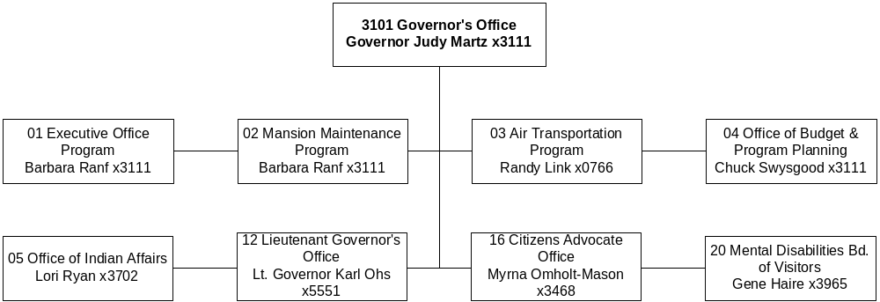

Mission Statement - To oversee and direct the activities of the executive branch of Montana state government, consistent with statutory and constitutional mandates, in a manner that provides necessary and affordable services to the citizens of Montana.

Statutory Authority - Primary authority is Article VI, Montana Constitution

Agency Proposed Budget  Budget Item | Base  Budget  Fiscal 2002 | PL Base Adjustment  Fiscal 2004 | New  Proposals  Fiscal 2004 | Total  Exec. Budget  Fiscal 2004 | PL Base Adjustment  Fiscal 2005 | New  Proposals  Fiscal 2005 | Total  Exec. Budget  Fiscal 2005
FTE | 57.00 | 0.00 | 0.00 | 57.00 | 0.00 | 0.00 | 57.00
Personal Services | 2,790,161 | 307,217 | 4,713 | 3,102,091 | 300,080 | 4,264 | 3,094,505
Operating Expenses | 1,549,903 | 2,092,000 | 294,196 | 3,936,099 | 43,589 | 308,604 | 1,888,187
Total Costs | $4,340,064 | $2,399,217 | $298,909 | $7,038,190 | $343,669 | $312,868 | $4,982,692
General Fund | 4,046,816 | 361,663 | (66,838) | 4,341,641 | 298,216 | (66,981) | 4,278,051
State/Other Special | 247,969 | 35,984 | 302,152 | 586,105 | 43,889 | 316,265 | 594,214
Federal Special | 45,279 | 2,001,570 | 63,595 | 2,110,444 | 1,564 | 63,584 | 110,427
Total Funds | $4,340,064 | $2,399,217 | $298,909 | $7,038,190 | $343,669 | $312,868 | $4,982,692

------------------- Agency General Fund Target - $8.12 million ---------------------

Steps outside of HB 2 required to meet the target:
Total Agency Impact | General Fund Total
FY04 ($175,000) | FY04 ($175,000)
FY05 ($175,000) | FY05 ($175,000)
NP- 8109 – Economic Development Statutory Elimination –
This request eliminates the remaining statutory appropriation to the Office of Economic Development. The August 2002 special session reduced the appropriation to $175,000 per year general fund. This decision package is contingent upon passage and approval of a bill.
________________________________________________________________________________________________

Total Agency Impact | General Fund Total
FY04 ($153,000) | FY04 ($153,000)
FY05 $0 | FY05 $0
NP- 8503 – Economic Development Transfer to General Fund –
A transfer of approximately $153,000 of unspent State-Tribal Economic Development Commission general fund back to the general fund is recommended. This decision package is contingent upon passage and approval of a bill.

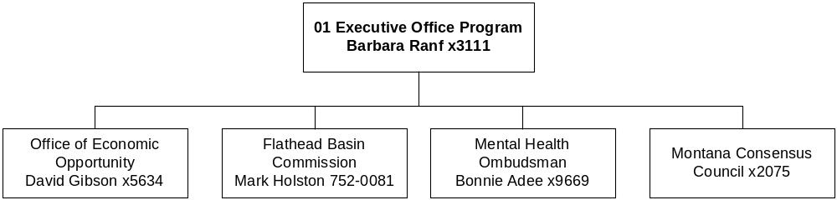

Program Description - The Executive Office Program aids the Governor in overseeing and coordinating the activities of the executive branch of Montana state government. The program provides administrative, legal, and press support and provides centralized services for the Office of the Governor. The Executive Office Program also administers programs with special impact on the citizens and governmental concerns of Montana. Special programs include the Office of Economic Opportunity, which was created to strengthen the foundations of the state's business environment and diversify and expand existing economic endeavors to achieve long-term economic stability, the Flathead Basin Commission, and the Montana Consensus Council.

Program Proposed Budget  Budget Item | Base  Budget  Fiscal 2002 | PL Base Adjustment  Fiscal 2004 | New  Proposals  Fiscal 2004 | Total  Exec. Budget  Fiscal 2004 | PL Base Adjustment  Fiscal 2005 | New  Proposals  Fiscal 2005 | Total  Exec. Budget  Fiscal 2005
FTE | 27.50 | 0.00 | 0.00 | 27.50 | 0.00 | 0.00 | 27.50
Personal Services | 1,367,624 | 147,331 | 32,704 | 1,547,659 | 143,523 | 32,572 | 1,543,719
Operating Expenses | 1,076,617 | 80,025 | 284,523 | 1,441,165 | 31,773 | 298,931 | 1,393,412
Total Costs | $2,444,241 | $227,356 | $317,227 | $2,988,824 | $175,296 | $331,503 | $2,937,131
General Fund | 2,198,563 | 173,232 | (23,520) | 2,348,275 | 113,273 | (23,346) | 2,288,490
State/Other Special | 215,398 | 52,555 | 277,152 | 545,105 | 60,460 | 291,265 | 553,214
Federal Special | 30,280 | 1,569 | 63,595 | 95,444 | 1,563 | 63,584 | 95,427
Total Funds | $2,444,241 | $227,356 | $317,227 | $2,988,824 | $175,296 | $331,503 | $2,937,131

--------------------------------- Present Law Adjustments --------------------------------

Total Agency Impact | General Fund Total
FY04 $0 | FY04 $0
FY05 $5,000 | FY05 $0
PL- 102 – Flathead Basin Commission Biennial Report –
The Flathead Basin Commission is required by law to submit a biennial report to the Legislature. This cost always appears in a non-base year of the biennium, so it must be added as a decision package in the second year of each biennium.
________________________________________________________________________________________________

Total Agency Impact | General Fund Total
FY04 $29,455 | FY04 $28,104
FY05 $1,767 | FY05 ($2,286)
PL- 111 – Replacement Computers –
Some computers need to be replaced according to the state standard approved four-year replacement cycle. In the Executive Office, the budget for FY 2004 includes a new server and tape backup, which will be used by the entire Governor’s Office. Related decision packages in the OBPP (program 4) and Mental Disabilities Board of Visitors (program 20) reduce all general fund budgets for this account to zero. This PL-111 in the Executive Office will consolidate the general fund budget for the PC replacement cycle for all programs in the agency to create more efficient management. Though the requested budget for replacement computers in program 1 is increasing, as compared to base year 2002 expenditures the general fund budget for computers in the entire agency is being reduced by $22,302 for the biennium.

---------------------------------------- New Proposals ----------------------------------------

Total Agency Impact | General Fund Total
FY04 $130,000 | FY04 $130,000
FY05 $130,000 | FY05 $130,000
NP- 101 - Executive Protection Contract -
It is requested that the contract with the Department of Justice to provide executive protection for Governor be continued.
________________________________________________________________________________________________

Total Agency Impact | General Fund Total
FY04 $125,000 | FY04 $0
FY05 $125,000 | FY05 $0
NP- 103 - Flathead Basin State Special Revenue -
During the 2003 biennium, the Flathead Basin Commission received various small contracts and grants with other agencies, primarily DEQ and DNRC, to do work related to water quality in the Flathead Basin. Spending authority for these grants and contracts was obtained through administrative appropriations. In order to minimize paperwork and simplify management of the grants and contracts, the Governor's Office requests state special revenue spending authority in the budget at the same level as the current biennium. Should the grants or contracts not continue, the spending authority could not be used.
________________________________________________________________________________________________

Total Agency Impact | General Fund Total
FY04 $115,660 | FY04 $0
FY05 $115,926 | FY05 $0
NP- 104 - Economic Development State Special Revenue Authorization-
During the 2005 Biennium, the Office of Economic Development has received contracts from other state agencies. In order to spend these funds, the Governor's Office has obtained administrative appropriations and obtained a modified FTE through the AAs. This request would establish the same level of spending authority in the 2005 biennium. If the funding does not materialize, the appropriation could not be used.
________________________________________________________________________________________________

Total Agency Impact | General Fund Total
FY04 ($13,908) | FY04 $0
FY05 ($13,909) | FY05 $0
NP- 110 - Reduce FBC Funding from Renewable Resources-
The Flathead Basin Commission (FBC) is funded with $117,837 from Renewable Resources state special revenue fund (02272). $111,486 is in the adjusted base for FBC from Renewable Resources, with additional amounts of $6,351 requested in two decision packages. Revenues to Renewable Resources from the Resource Indemnity Trust fund are insufficient to fund all of the currently funded programs in various agencies. This reduction to meet a biennial amount of $90,020 for FBC from Renewable Resources is required to give the Renewable Resource fund a positive ending fund balance.
________________________________________________________________________________________________

Total Agency Impact | General Fund Total
FY04 ($39,525) | FY04 ($39,525)
FY05 ($39,423) | FY05 ($39,423)
NP- 7106 - Eliminate 1.00 FTE -
Eliminate 1.00 FTE in the Office of Economic Opportunity.
________________________________________________________________________________________________

Total Agency Impact | General Fund Total
FY04 $0 | FY04 ($50,400)
FY05 $0 | FY05 ($50,339)
NP- 7107 - Consensus Council Fund Switch -
This decision package removes the general fund support from the Consensus Council and replaces it with a like amount of state special revenue authority. The request will require the program to become self-supporting. The reduction in general fund is $50,400 in FY 2004 and $50,399 in FY 2005.

------------------ Other Legislation Required to Implement HB 2 ------------------

Total Agency Impact | General Fund Total
FY04 $0 | FY04 ($63,595)
FY05 $0 | FY05 ($63,584)
NP- 8108 - Managed Care Ombudsman Fund Switch -
Revise the Managed Care Ombudsman to be a discretionary appointment by the Governor. It is recommended that general fund be eliminated, but the federal authority be retained, for a general fund savings of $127,179 for the biennium. This decision package is contingent upon passage and approval of a bill.
________________________________________________________________________________________________

Language Recommendations – “The legislature recognizes that the cost for extradition and transportation of prisoners is dependent upon factors beyond the control of the agency and may exceed the appropriation provided. In that event, the agency will need to request a supplemental appropriation from the 2005 legislature to provide required extradition and transportation of prisoners.”

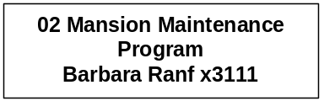

Program Description - The Mansion Maintenance Program maintains the Governor's official residence.

Program Proposed Budget  Budget Item | Base  Budget  Fiscal 2002 | PL Base Adjustment  Fiscal 2004 | New  Proposals  Fiscal 2004 | Total  Exec. Budget  Fiscal 2004 | PL Base Adjustment  Fiscal 2005 | New  Proposals  Fiscal 2005 | Total  Exec. Budget  Fiscal 2005
FTE | 1.50 | 0.00 | 0.00 | 1.50 | 0.00 | 0.00 | 1.50
Personal Services | 48,631 | 88 | 0 | 48,719 | (15) | 0 | 48,616
Operating Expenses | 31,014 | (212) | 0 | 30,802 | (126) | 0 | 30,888
Total Costs | $79,645 | ($124) | $0 | $79,521 | ($141) | $0 | $79,504
General Fund | 79,645 | (124) | 0 | 79,521 | (141) | 0 | 79,504
Total Funds | $79,645 | ($124) | $0 | $79,521 | ($141) | $0 | $79,504

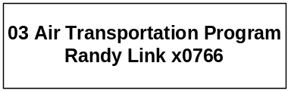

Program Description - The Air Transportation Program provides the Governor with air transportation.

Program Proposed Budget  Budget Item | Base  Budget  Fiscal 2002 | PL Base Adjustment  Fiscal 2004 | New  Proposals  Fiscal 2004 | Total  Exec. Budget  Fiscal 2004 | PL Base Adjustment  Fiscal 2005 | New  Proposals  Fiscal 2005 | Total  Exec. Budget  Fiscal 2005
FTE | 1.00 | 0.00 | 0.00 | 1.00 | 0.00 | 0.00 | 1.00
Personal Services | 54,023 | (1,926) | 0 | 52,097 | (1,928) | 0 | 52,095
Operating Expenses | 133,847 | 7,936 | 25,000 | 166,783 | 10,058 | 25,000 | 168,905
Total Costs | $187,870 | $6,010 | $25,000 | $218,880 | $8,130 | $25,000 | $221,000
General Fund | 171,870 | 6,010 | 0 | 177,880 | 8,130 | 0 | 180,000
State/Other Special | 16,000 | 0 | 25,000 | 41,000 | 0 | 25,000 | 41,000
Total Funds | $187,870 | $6,010 | $25,000 | $218,880 | $8,130 | $25,000 | $221,000

---------------------------------------- New Proposals ----------------------------------------

Total Agency Impact | General Fund Total
FY04 $25,000 | FY04 $0
FY05 $25,000 | FY05 $0
NP- 301 - Airplane State Special Revenue Authority -
The Air Transportation program provides air travel for the Governor. The aircraft is available to other state agencies and the Governor's Office bills these other agencies on an hourly basis for their use of the airplane. The purpose of this request is to establish adequate appropriation authority to spend the funds recovered from other state agencies in order to allow for maximum, efficient use of the aircraft.

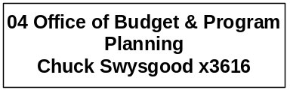

Program Description - The Office of Budget and Program Planning (OBPP) assists the Governor in preparing the Governor's Executive Budget and administering the state government budget. In addition, the OBPP prepares and monitors revenue estimates and collections, prepares and publishes fiscal notes on proposed legislation and initiatives, and acts as approving authority for operational plan changes, program transfers, and budget amendments in the executive branch, in accordance with Title 17, Chapter 7, MCA. The OBPP acts as the lead executive branch agency for compliance with the federal Single Audit Act.

Program Proposed Budget  Budget Item | Base  Budget  Fiscal 2002 | PL Base Adjustment  Fiscal 2004 | New  Proposals  Fiscal 2004 | Total  Exec. Budget  Fiscal 2004 | PL Base Adjustment  Fiscal 2005 | New  Proposals  Fiscal 2005 | Total  Exec. Budget  Fiscal 2005
FTE | 17.00 | 0.00 | (1.00) | 16.00 | 0.00 | (1.00) | 16.00
Personal Services | 848,543 | 135,211 | (54,782) | 928,972 | 132,636 | (55,017) | 926,162
Operating Expenses | 145,441 | (236) | 0 | 145,205 | (4,578) | 0 | 140,863
Total Costs | $993,984 | $134,975 | ($54,782) | $1,074,177 | $128,058 | ($55,017) | $1,067,025
General Fund | 993,984 | 134,975 | (54,782) | 1,074,177 | 128,058 | (55,017) | 1,067,025
Total Funds | $993,984 | $134,975 | ($54,782) | $1,074,177 | $128,058 | ($55,017) | $1,067,025

--------------------------------- Present Law Adjustments --------------------------------

Total Agency Impact | General Fund Total
FY04 $0 | FY04 $0
FY05 $10,000 | FY05 $10,000
PL- 401 - OBPP Session Costs -
Costs for printing the Executive Budget always appear in the second year of the biennium and thus are not included in the base budget. The number of copies to be printed has been reduced and the budget volumes are available on the Web site. Printing costs are added each budget cycle to the non-base year.
________________________________________________________________________________________________

.
Total Agency Impact | General Fund Total
FY04 ($18,267) | FY04 ($18,267)
FY05 ($18,267) | FY05 ($18,267)
PL- 111 - Replacement Computers -
Some computers need to be replaced according to the state standard approved four-year replacement cycle. Related decision packages in the OBPP (program 4) and Mental Disabilities Board of Visitors (program 20) reduce all general fund budgets for this account to zero. Decision package PL-111 in the Executive Office (program 1) consolidates the general fund budget for the PC replacement cycle for all programs in the agency. This is requested to create more efficient management of this system.

---------------------------------------- New Proposals ----------------------------------------

Total Agency Impact | General Fund Total
FY04 ($54,782) | FY04 ($54,782)
FY05 ($55,017) | FY05 ($55,017)
NP- 402 - OBPP FTE Reduction -
The Executive recommends a reduction of 1.00 FTE executive budget analyst to fund the OBPP alternative pay plan adjustment. In addition, the program will be required to absorb additional vacancy savings. The total reduction in the program is approximately $110,000 general fund for the biennium.

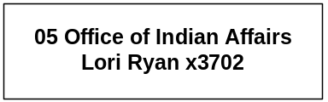

Program Description - The Coordinator of Indian Affairs Program serves as the Governor's liaison with state Indian tribes, provides information and policy support on issues confronting the Indians of Montana, and advises and makes recommendations on these issues to the Legislative and Executive Branches. The coordinator also serves the Montana congressional delegation as an advisor and intermediary in the field of Indian affairs and acts as spokesperson for representative Native American organizations and groups, both public and private, whenever that support is requested. The program is mandated by 2-15-217 and 90-11-101, MCA.

Program Proposed Budget  Budget Item | Base  Budget  Fiscal 2002 | PL Base Adjustment  Fiscal 2004 | New  Proposals  Fiscal 2004 | Total  Exec. Budget  Fiscal 2004 | PL Base Adjustment  Fiscal 2005 | New  Proposals  Fiscal 2005 | Total  Exec. Budget  Fiscal 2005
FTE | 2.00 | 0.00 | 0.00 | 2.00 | 0.00 | 0.00 | 2.00
Personal Services | 74,743 | 22,124 | 0 | 96,867 | 22,570 | 0 | 97,313
Operating Expenses | 38,915 | 2,001,096 | 0 | 2,040,011 | 1,473 | 0 | 40,388
Total Costs | $113,658 | $2,023,220 | $0 | $2,136,878 | $24,043 | $0 | $137,701
General Fund | 97,087 | 39,791 | 0 | 136,878 | 40,614 | 0 | 137,701
State/Other Special | 16,571 | (16,571) | 0 | 0 | (16,571) | 0 | 0
Federal Special | 0 | 2,000,000 | 0 | 2,000,000 | 0 | 0 | 0
Total Funds | $113,658 | $2,023,220 | $0 | $2,136,878 | $24,043 | $0 | $137,701

--------------------------------- Present Law Adjustments --------------------------------

Total Agency Impact | General Fund Total
FY04 $2,000,000 | FY04 $0
FY05 $0 | FY05 $0
PL- 501 - State-Tribal Economic Development Commission -
HB 21 adopted and approved through the 2001 legislative session extended the duration of the State-Tribal Economic Development Commission and amended 90-1-135, MCA, to state, "Money in the accounts that is not expended by June 30, 2005, must remain in the accounts for the commission's use." This request estimates the amounts that will be remaining in the accounts and will be available for use until June 30, 2005.

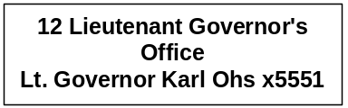

Program Description - The Office of the Lieutenant Governor is responsible for carrying out duties prescribed by statute established by Article VI, Section 4 of the Montana Constitution, as well as those delegated by the Governor. Statutory authority is Title 2, Chapter 15, part 3, MCA.

Program Proposed Budget  Budget Item | Base  Budget  Fiscal 2002 | PL Base Adjustment  Fiscal 2004 | New  Proposals  Fiscal 2004 | Total  Exec. Budget  Fiscal 2004 | PL Base Adjustment  Fiscal 2005 | New  Proposals  Fiscal 2005 | Total  Exec. Budget  Fiscal 2005
FTE | 3.00 | 0.00 | 1.00 | 4.00 | 0.00 | 1.00 | 4.00
Personal Services | 186,067 | (10,215) | 26,791 | 202,643 | (10,716) | 26,709 | 202,060
Operating Expenses | 39,395 | 4,454 | 0 | 43,849 | 5,695 | 0 | 45,090
Total Costs | $225,462 | ($5,761) | $26,791 | $246,492 | ($5,021) | $26,709 | $247,150
General Fund | 225,462 | (5,761) | 26,791 | 246,492 | (5,021) | 26,709 | 247,150
Total Funds | $225,462 | ($5,761) | $26,791 | $246,492 | ($5,021) | $26,709 | $247,150

---------------------------------------- New Proposals ----------------------------------------

Total Agency Impact | General Fund Total
FY04 $26,791 | FY04 $26,791
FY05 $26,709 | FY05 $26,709
NP- 1201 - Lt. Governor's Office Staff Support -
The office currently has 2.00 FTE support staff. An additional 1.00 FTE is requested to provide assistance to the Lt. Governor and to the policy advisors in the Governor's Office. There is currently a 1.00 FTE modified position, funded within the program's personal services appropriation.

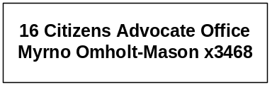

Program Description - The Citizens' Advocate Office exists to provide access to state government for Montana citizens. The office provides information to citizens and functions as a referral service for public comments, suggestions, and requests for information. The office provides a toll-free number to the public.

Program Proposed Budget  Budget Item | Base  Budget  Fiscal 2002 | PL Base Adjustment  Fiscal 2004 | New  Proposals  Fiscal 2004 | Total  Exec. Budget  Fiscal 2004 | PL Base Adjustment  Fiscal 2005 | New  Proposals  Fiscal 2005 | Total  Exec. Budget  Fiscal 2005
FTE | 1.50 | 0.00 | 0.00 | 1.50 | 0.00 | 0.00 | 1.50
Personal Services | 73,111 | 1,747 | 0 | 74,858 | 1,562 | 0 | 74,673
Operating Expenses | 12,942 | (321) | 0 | 12,621 | (235) | 0 | 12,707
Total Costs | $86,053 | $1,426 | $0 | $87,479 | $1,327 | $0 | $87,380
General Fund | 71,054 | 1,425 | 0 | 72,479 | 1,326 | 0 | 72,380
Federal Special | 14,999 | 1 | 0 | 15,000 | 1 | 0 | 15,000
Total Funds | $86,053 | $1,426 | $0 | $87,479 | $1,327 | $0 | $87,380

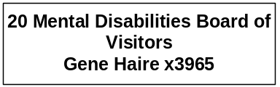

Program Description - The Mental Disabilities Board of Visitors is charged with reviewing patient care at Montana's community mental health centers, and at the institutions for the mentally ill and the developmentally disabled. The board provides legal services for the residents at those institutions. The Governor appoints five board members who may be (but are not required to be) consumers, doctors of medicine, or behavioral scientists. The board employs administrative and legal staff and contracts with medical professionals to carry out its responsibilities for patient representation and facility review. The Mental Disabilities Board of Visitors Program was created by the Developmental Disabilities Act of 1975 and the Mental Commitment and Treatment Act of 1975 and exists as a state mandate.

Program Proposed Budget  Budget Item | Base  Budget  Fiscal 2002 | PL Base Adjustment  Fiscal 2004 | New  Proposals  Fiscal 2004 | Total  Exec. Budget  Fiscal 2004 | PL Base Adjustment  Fiscal 2005 | New  Proposals  Fiscal 2005 | Total  Exec. Budget  Fiscal 2005
FTE | 3.50 | 0.00 | 0.00 | 3.50 | 0.00 | 0.00 | 3.50
Personal Services | 137,419 | 12,857 | 0 | 150,276 | 12,448 | 0 | 149,867
Operating Expenses | 71,732 | (742) | (15,327) | 55,663 | (471) | (15,327) | 55,934
Total Costs | $209,151 | $12,115 | ($15,327) | $205,939 | $11,977 | ($15,327) | $205,801
General Fund | 209,151 | 12,115 | (15,327) | 205,939 | 11,977 | (15,327) | 205,801
Total Funds | $209,151 | $12,115 | ($15,327) | $205,939 | $11,977 | ($15,327) | $205,801

--------------------------------- Present Law Adjustments --------------------------------

Total Agency Impact | General Fund Total
FY04 ($1,273) | FY04 ($1,273)
FY05 ($1,273) | FY05 ($1,273)
PL- 111 - Computer Replacement -
Some computers need to be replaced according to the state standard four-year replacement cycle. Related decision packages reduce all general fund budgets for this account to zero. Decision package PL 111 in the Executive Office (program 1) consolidates the general fund budget for the PC replacement cycle for all programs in the agency to create more efficient management. Though the requested budget for replacement computers in program 1 is increasing, as compared to base year 2002 expenditures the general fund budget for the entire agency is decreasing by $22,302 for the biennium.

---------------------------------------- New Proposals ----------------------------------------

Total Agency Impact | General Fund Total
FY04 ($15,327) | FY04 ($15,327)
FY05 ($15,327) | FY05 ($15,327)
NP- 2001 - General Operating Reduction -
The request reduces operating expenditures for the agency to meet target reductions from OBPP.

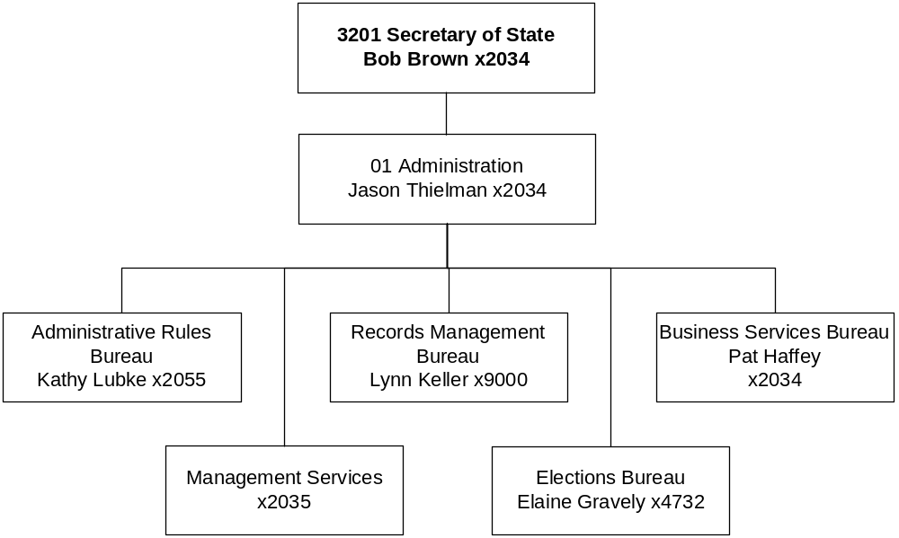

Mission Statement - To serve the voters, business community, and governmental agencies of Montana by overseeing the elections process, facilitating business activities, commissioning notaries, publishing the Administrative Rules of Montana, and preserving documents and records. The Secretary of State's Office works for and with its customers, continuously striving to improve service.

Statutory Authority - Article VI, Section 1, Montana Constitution; 2-4-311-312, 2-6-203, and 2-15-401, MCA.

The Secretary of State’s Office is entirely funded with proprietary funds. See Section P for budget information.

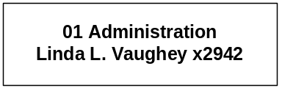

Mission Statement - To monitor and to enforce, in a fair and impartial manner, campaign practices and campaign finance disclosure, lobbying disclosure, business interest disclosure of statewide and state district candidates, elected state officials and state department directors; ethical standards of conduct for legislators, public officers and state employees; and to investigate legitimate complaints that arise concerning any of the above.

Statutory Authority - Title 13, Chapter 37 and Title 2, Chapter 2, MCA.

Program Description - The Commissioner of Political Practices is provided for in 13-37-102, MCA, which was enacted in 1975 as part of a campaign finance and practice law reform package, with duties and responsibilities set forth in Title 13, Chapter 37, part 1, MCA. Additional responsibilities for the office were created through passage of an initiative in 1980 which provided for both lobbying disclosure and disclosure of business interests of elected officials. In 1995 the Legislature enacted the code of ethics (Title 2, Chapter 2, MCA) and assigned to the Commissioner the responsibility for administering ethical standards of conduct for legislators, public officers and state employees. Statutory authority resided in Title 13, Chapter 37 and Title 2, Chapter 2, MCA.

Program Indicators-

Indicator | Actual FY2000 | Actual FY2001 | Actual FY2002 | Estimated FY2003 | Requested FY2004 | Requested FY2005
Lobbyists registered | 850 | 906 | 906 | 906 | 750 | 750
Committees registered  (all types) | 534 | 705 | 422 | 550 | 600 | 600
Candidates registered  (State, State District, and Local) | 1394 | 1660 | 1993 | 2000 | 1650 | 1950
Official complaints filed | 7 | 13 | 16 | 20 | 10 | 20

Program Proposed Budget  Budget Item | Base  Budget  Fiscal 2002 | PL Base Adjustment  Fiscal 2004 | New  Proposals  Fiscal 2004 | Total  Exec. Budget  Fiscal 2004 | PL Base Adjustment  Fiscal 2005 | New  Proposals  Fiscal 2005 | Total  Exec. Budget  Fiscal 2005
FTE | 5.00 | 0.00 | 0.00 | 5.00 | 0.00 | 0.00 | 5.00
Personal Services | 170,288 | 43,237 | (36,528) | 176,997 | 42,566 | (36,427) | 176,427
Operating Expenses | 161,377 | 4,659 | (20,120) | 145,916 | (159) | (20,120) | 141,098
Total Costs | $331,665 | $47,896 | ($56,648) | $322,913 | $42,407 | ($56,547) | $317,525
General Fund | 331,665 | 47,896 | (56,648) | 322,913 | 42,407 | (56,547) | 317,525
Total Funds | $331,665 | $47,896 | ($56,648) | $322,913 | $42,407 | ($56,547) | $317,525

---------------------- Agency General Fund Target - $640,000 ------------------------

---------------------------------------- New Proposals ----------------------------------------

Total Agency Impact | General Fund Total
FY04 ($56,648) | FY04 ($56,648)
FY05 ($56,547) | FY05 ($56,547)
NP- 1 - Eliminate Position & On-going Reductions -
This decision package eliminates position number 32200005, which is a vacant data manager position responsible for maintaining the agency database and other administrative support. The duties are being incorporated into the other two agency administrative support positions. In addition, this decision package continues the reductions of $16,850 general fund made under 17-7-140, MCA, along with the Legislature's special session reductions of $9,225.
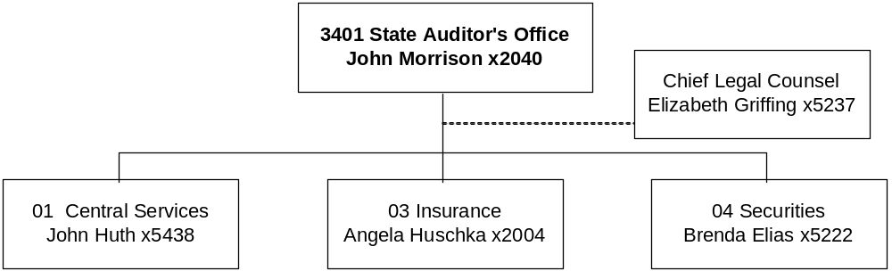

Mission Statement - The State Auditor is the Commissioner of Insurance and the Commissioner of Securities. The auditor also serves as a member of the Board of Land Commissioners and the Crop Hail Insurance Board. The auditor is charged with licensing, registering, and regulating insurance companies and producers, securities issuers, salespeople, broker-dealers, investment advisers, and investment adviser representative within the state.

Statutory Authority - Title 30, Chapter 10, MCA, Securities Regulation, and Title 33, MCA, Insurance.

Agency Proposed Budget  Budget Item | Base  Budget  Fiscal 2002 | PL Base Adjustment  Fiscal 2004 | New  Proposals  Fiscal 2004 | Total  Exec. Budget  Fiscal 2004 | PL Base Adjustment  Fiscal 2005 | New  Proposals  Fiscal 2005 | Total  Exec. Budget  Fiscal 2005
FTE | 69.50 | 4.00 | 0.00 | 73.50 | 4.00 | 0.00 | 73.50
Personal Services | 2,715,801 | 521,007 | 0 | 3,236,808 | 517,029 | 0 | 3,232,830
Operating Expenses | 790,438 | 243,268 | (43,397) | 990,309 | 305,139 | (43,397) | 1,052,180
Total Costs | $3,506,239 | $764,275 | ($43,397) | $4,227,117 | $822,168 | ($43,397) | $4,285,010
General Fund | 334,795 | 45,719 | (380,514) | 0 | 43,490 | (378,285) | 0
State/Other Special | 3,171,444 | 718,556 | 337,117 | 4,227,117 | 778,678 | 334,888 | 4,285,010
Total Funds | $3,506,239 | $764,275 | ($43,397) | $4,227,117 | $822,168 | ($43,397) | $4,285,010

---------------------- Agency General Fund Target - $640,000 ------------------------

The agency target is different than what is reflected in the table due to the recommended fund switch in Securities from general fund to state special revenue.

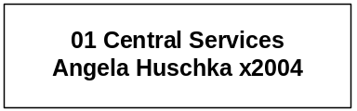

Program Description - The Central Management Division is responsible for the administrative, personnel, budgeting, and accounting functions for the State Auditor's Office. The division also provides support to the auditor in fulfilling the duties as a member of the state land and hail insurance boards.

Program Proposed Budget  Budget Item | Base  Budget  Fiscal 2002 | PL Base Adjustment  Fiscal 2004 | New  Proposals  Fiscal 2004 | Total  Exec. Budget  Fiscal 2004 | PL Base Adjustment  Fiscal 2005 | New  Proposals  Fiscal 2005 | Total  Exec. Budget  Fiscal 2005
FTE | 10.00 | 0.00 | 0.00 | 10.00 | 0.00 | 0.00 | 10.00
Personal Services | 342,208 | 92,567 | 0 | 434,775 | 91,911 | 0 | 434,119
Operating Expenses | 109,346 | (6,582) | 0 | 102,764 | (11,030) | 0 | 98,316
Total Costs | $451,554 | $85,985 | $0 | $537,539 | $80,881 | $0 | $532,435
State/Other Special | 451,554 | 85,985 | 0 | 537,539 | 80,881 | 0 | 532,435
Total Funds | $451,554 | $85,985 | $0 | $537,539 | $80,881 | $0 | $532,435

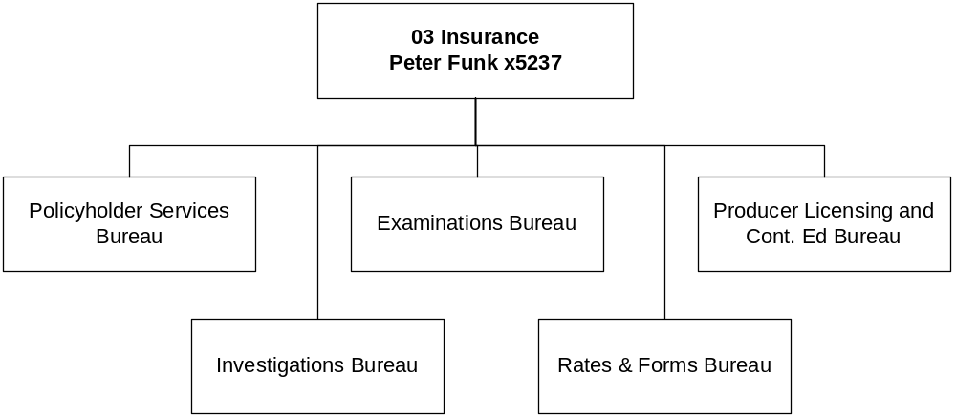

Program Description - The Insurance Division regulates the insurance industry in Montana. The Policyholder Services Bureau is responsible for resolving insurance consumer inquiries and complaints involving agents, coverage, and companies. The Examinations Bureau is responsible for monitoring the financial solvency of insurance companies, collecting premium taxes and company fees, and auditing insurance company annual statements. The Rates and Forms Bureau is responsible for reviewing form filings and rate filings to ensure compliance with the applicable insurance code. The Licensing Bureau is responsible for licensing and providing continuing education to insurance agents, agencies, and adjustors. The Investigations Bureau investigates insurance code and rule violations, including possible criminal violations, and refers cases to county attorneys for prosecution.

Program Proposed Budget  Budget Item | Base  Budget  Fiscal 2002 | PL Base Adjustment  Fiscal 2004 | New  Proposals  Fiscal 2004 | Total  Exec. Budget  Fiscal 2004 | PL Base Adjustment  Fiscal 2005 | New  Proposals  Fiscal 2005 | Total  Exec. Budget  Fiscal 2005
FTE | 47.50 | 3.00 | 0.00 | 50.50 | 3.00 | 0.00 | 50.50
Personal Services | 1,967,501 | 321,944 | 0 | 2,289,445 | 319,646 | 0 | 2,287,147
Operating Expenses | 566,962 | 172,921 | 0 | 739,883 | 245,922 | 0 | 812,884
Total Costs | $2,534,463 | $494,865 | $0 | $3,029,328 | $565,568 | $0 | $3,100,031
State/Other Special | 2,534,463 | 494,865 | 0 | 3,029,328 | 565,568 | 0 | 3,100,031
Total Funds | $2,534,463 | $494,865 | $0 | $3,029,328 | $565,568 | $0 | $3,100,031

--------------------------------- Present Law Adjustments --------------------------------

Total Agency Impact | General Fund Total
FY04 $119,372 | FY04 $0
FY05 $110,493 | FY05 $0
PL- 3 - Market Conduct Examiners -
Currently, insurance companies are aware that the SAO does not have a Market Conduct Division and, therefore, are more likely to engage in unfair consumer practices that can only be corrected by a market conduct examination. This request is for 2.00 FTE market conduct examiners to review insurer's market place practices to determine what they are and what they should be. Most of the costs associated with these positions will be recovered from the companies. Examination costs can be charged to the company and the company will reimburse the SAO for these costs.
________________________________________________________________________________________________

Total Agency Impact | General Fund Total
FY04 $58,479 | FY04 $0
FY05 $54,061 | FY05 $0
PL- 4 - Captive Insurance FTE -
The 2001 Legislature passed a bill that allows captive insurance companies to operate in Montana. The State Auditor's Office was appropriated $20,000 each year of the current biennium for operating only. Currently, the SAO has licensed three companies, and anticipates an additional two by the end of the year. This proposal requests 1.00 FTE insurance examiner to approve the applications of prospective captives and conduct the examinations of captive insurance companies licensed in Montana.
________________________________________________________________________________________________

Total Agency Impact | General Fund Total
FY04 $107,287 | FY04 $0
FY05 $211,287 | FY05 $0
PL- 6 - Contract Insurance Examinations -
This will adjust the line item for Insurance Contract Exams for the new biennium. The expenses will be offset by insurance companies reimbursing the examination costs. This is based upon the examination schedule for the 2005 biennium.

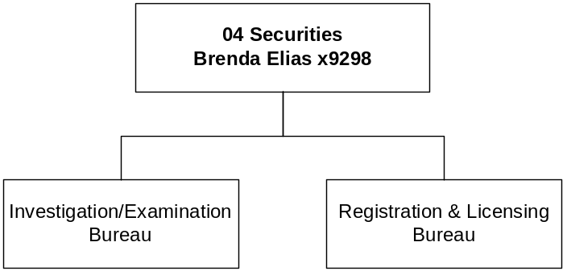

Program Description - The Securities Division is responsible for the administration and enforcement of the Securities Act of Montana and, in particular, for the registration of securities issuers, salespeople, broker-dealers, investment advisers, and investment adviser representatives. The division also is responsible for the investigation of unregistered and fraudulent securities transactions. The division has sole jurisdiction for investment advisor firms with assets of under $25 million. The Investigations Bureau investigates securities code and rule violations, including possible criminal violations, and refers cases to county attorneys for prosecution.

Program Proposed Budget  Budget Item | Base  Budget  Fiscal 2002 | PL Base Adjustment  Fiscal 2004 | New  Proposals  Fiscal 2004 | Total  Exec. Budget  Fiscal 2004 | PL Base Adjustment  Fiscal 2005 | New  Proposals  Fiscal 2005 | Total  Exec. Budget  Fiscal 2005
FTE | 12.00 | 1.00 | 0.00 | 13.00 | 1.00 | 0.00 | 13.00
Personal Services | 406,092 | 106,496 | 0 | 512,588 | 105,472 | 0 | 511,564
Operating Expenses | 114,130 | 76,929 | (43,397) | 147,662 | 70,247 | (43,397) | 140,980
Total Costs | $520,222 | $183,425 | ($43,397) | $660,250 | $175,719 | ($43,397) | $652,544
General Fund | 334,795 | 45,719 | (380,514) | 0 | 43,490 | (378,285) | 0
State/Other Special | 185,427 | 137,706 | 337,117 | 660,250 | 132,229 | 334,888 | 652,544
Total Funds | $520,222 | $183,425 | ($43,397) | $660,250 | $175,719 | ($43,397) | $652,544

--------------------------------- Present Law Adjustments --------------------------------

Total Agency Impact | General Fund Total
FY04 $50,229 | FY04 $0
FY05 $45,826 | FY05 $0
PL- 2 - Securities Examiner/Analyst -
Growth in securities activity in Montana corresponds with the increase in filings with the State Auditor's Office. Currently, the Securities Division has 2.50 FTE securities analysts. This requests an additional 1.00 FTE securities analyst to address the increase in both the number of issuers filing with the department and the number of individuals registered to sell as broker-dealer agents. With concerns of the stock market volatility, the new position would provide support and consultation for those efforts. In addition, the federal government recently passed legislation (Gramm-Leach-Bliley) that permits banks and insurance companies to expand their activities in the securities markets that will further increase demands.
________________________________________________________________________________________________

Total Agency Impact | General Fund Total
FY04 $78,626 | FY04 $0
FY05 $78,626 | FY05 $0

PL- 7 - Securities Contract Examinations -
This will adjust the line item for Securities Contract Exams for the new biennium based upon the examination schedule. Expenses will be offset by insurance companies reimbursing the examination costs.
________________________________________________________________________________________________

Total Agency Impact | General Fund Total
FY04 ($16,314) | FY04 $0
FY05 ($16,314) | FY05 $0
PL- 8 - Special Session Reductions -
The total amount of on-going reductions as a result of the special session for the biennium is $32,628 of general fund. Of this amount, $30,322 is taken from personal services and $2,306 is taken from operating.

---------------------------------------- New Proposals ----------------------------------------

Total Agency Impact | General Fund Total
FY04 $0 | FY04 ($380,514)
FY05 $0 | FY05 ($378,285)
NP- 1 - Securities Program Funding Switch -
This decision package proposes to eliminate the general fund appropriation for the securities program and fund the entire program with state special revenue collected from portfolio revenue. Currently, the program is funded with approximately $335,000 of general fund and $205,000 of state special revenue per year. The fund switch will have a net impact of zero on the general fund because the amount that would have been deposited into the general fund will not be appropriated from the general fund.
________________________________________________________________________________________________

Total Agency Impact | General Fund Total
FY04 ($43,397) | FY04 $0
FY05 ($43,397) | FY05 $0
NP- 2 - Additional Reductions -
In order to meet the biennial target consistent with other agencies, additional reductions of $86,794 were taken from operating for the biennium. When the state special revenue is not spent, it is deposited to the general fund as revenue.

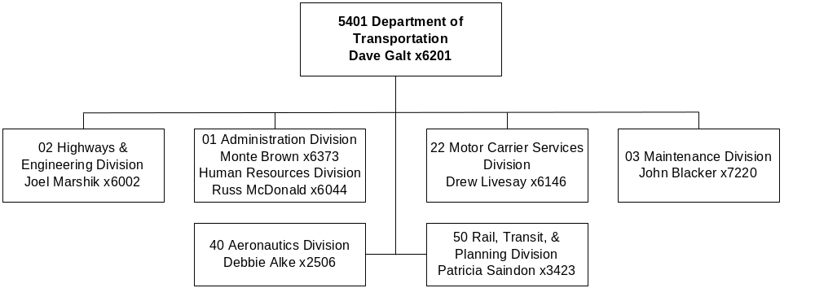

Mission Statement - To serve the public by providing a transportation system and services that emphasize quality, safety, cost effectiveness, economic vitality and sensitivity to the environment.

Statutory Authority - Title 2, Chapter 15, part 25, and Titles 23 and 60, MCA; USC 134 and 135; Title 23, Chapter 1, CFR.

Language - "The department may adjust appropriations in the general operations, construction, maintenance, and transportation planning programs between state special revenue and federal special revenue fund types if the total state special revenue authority for these programs is not increased by more than 10% of the total appropriations established by the legislature for each program. All transfers between fund types must be fully explained and justified by budget documents submitted to the office of budget and program planning, and all fund transfers of more than $1 million in any 30-day period must be communicated to the legislative finance committee in a written report."

"All federal special revenue appropriations in the department are biennial."

“All appropriations in the general operations, construction, maintenance, and transportation planning programs are biennial.”

Agency Proposed Budget  Budget Item | Base  Budget  Fiscal 2002 | PL Base Adjustment  Fiscal 2004 | New  Proposals  Fiscal 2004 | Total  Exec. Budget  Fiscal 2004 | PL Base Adjustment  Fiscal 2005 | New  Proposals  Fiscal 2005 | Total  Exec. Budget  Fiscal 2005
FTE | 2,170.16 | 5.55 | (12.03) | 2,163.68 | (45.63) | (12.03) | 2,112.50
Personal Services | 92,274,059 | 13,861,949 | (529,145) | 105,606,863 | 12,496,506 | (533,568) | 104,236,997
Operating Expenses | 322,091,651 | 105,638,598 | 8,673,021 | 436,403,270 | 109,771,809 | 3,820,000 | 435,683,460
Equipment | 1,133,344 | 102,656 | 0 | 1,236,000 | 102,656 | 0 | 1,236,000
Capital Outlay | 10,125,530 | 2,196,375 | 0 | 12,321,905 | 2,196,375 | 0 | 12,321,905
Grants | 6,989,629 | 3,400,696 | 0 | 10,390,325 | 2,367,696 | 0 | 9,357,325
Transfers | 25,452 | 0 | 0 | 25,452 | 0 | 0 | 25,452
Debt Service | 375 | 0 | 0 | 375 | 0 | 0 | 375
Total Costs | $432,640,040 | $125,200,274 | $8,143,876 | $565,984,190 | $126,935,042 | $3,286,432 | $562,861,514
State/Other Special | 149,258,584 | 72,365,330 | 478,874 | 222,102,788 | 93,921,879 | (756,400) | 242,424,063
Federal Special | 283,381,456 | 52,834,944 | 7,665,002 | 343,881,402 | 33,013,163 | 4,042,832 | 320,437,451
Total Funds | $432,640,040 | $125,200,274 | $8,143,876 | $565,984,190 | $126,935,042 | $3,286,432 | $562,861,514

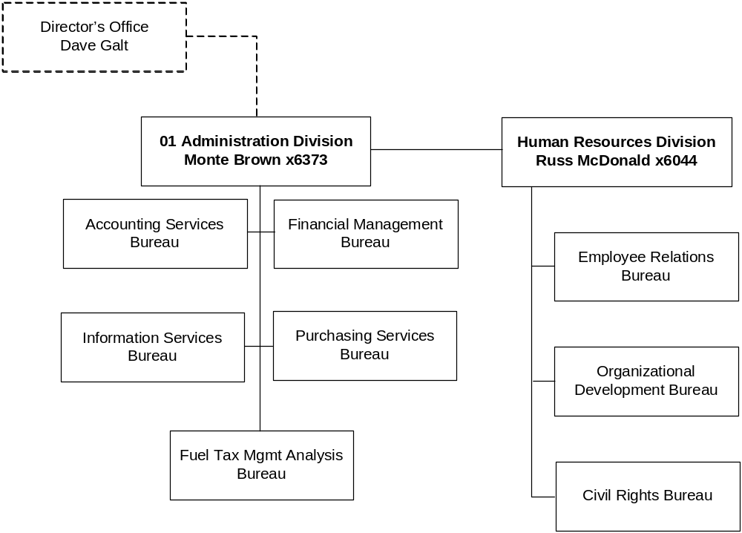

Program Description - The General Operations Program administers motor fuel taxes and provides administrative support services for the department, including general administration and management; accounting and budgeting; public affairs; information technology services; human resources activities; compliance review; and goods and services procurement. The General Operations Program is authorized by 2-15-2501(3), MCA.

Program Proposed Budget  Budget Item | Base  Budget  Fiscal 2002 | PL Base Adjustment  Fiscal 2004 | New  Proposals  Fiscal 2004 | Total  Exec. Budget  Fiscal 2004 | PL Base Adjustment  Fiscal 2005 | New  Proposals  Fiscal 2005 | Total  Exec. Budget  Fiscal 2005
FTE | 161.77 | 1.00 | (2.00) | 160.77 | 1.00 | (2.00) | 160.77
Personal Services | 6,951,701 | 1,093,427 | (77,334) | 7,967,794 | 1,100,393 | (77,863) | 7,974,231
Operating Expenses | 10,198,521 | 1,632,295 | 3,820,000 | 15,650,816 | 1,992,322 | 3,820,000 | 16,010,843
Equipment | 226,118 | 109,250 | 0 | 335,368 | 109,250 | 0 | 335,368
Grants | 75,000 | 0 | 0 | 75,000 | 0 | 0 | 75,000
Debt Service | 375 | 0 | 0 | 375 | 0 | 0 | 375
Total Costs | $17,451,715 | $2,834,972 | $3,742,666 | $24,029,353 | $3,201,965 | $3,742,137 | $24,395,817
State/Other Special | 11,156,774 | 3,707,715 | (257,334) | 14,607,155 | 4,074,629 | (257,863) | 14,973,540
Federal Special | 6,294,941 | (872,743) | 4,000,000 | 9,422,198 | (872,664) | 4,000,000 | 9,422,277
Total Funds | $17,451,715 | $2,834,972 | $3,742,666 | $24,029,353 | $3,201,965 | $3,742,137 | $24,395,817

--------------------------------- Present Law Adjustments --------------------------------

Total Agency Impact | General Fund Total
FY04 $34,064 | FY04 $0
FY05 $33,978 | FY05 $0
PL- 101 - Subgrant Monitoring / Local Gov't Certification -
In two previous audits, the Legislative Audit Division (LAD) recommended the agency establish procedures to ensure all federal funds subgranted are monitored in accordance with federal regulations. The agency's subgranting of funds is expected to increase, based in part on the initiation of new programs. This request is to provide 1.00 FTE at a cost of $34,064 state special revenue in FY 2004 and $33,978 state special revenue in FY 2005 to comply with the audit recommendation.
________________________________________________________________________________________________

Total Agency Impact | General Fund Total
FY04 $109,250 | FY04 $0
FY05 $109,250 | FY05 $0
PL- 103 - IT Equipment Lifecycle Replacements -
Currently, the department maintains a four-year lifecycle replacement schedule for PCs. This request is to establish a lifecycle replacement schedule for servers, storage and network equipment. The executive recommends $109,250 highway state special revenue each year of the biennium to establish and maintain the replacement schedule. Over the last two biennia, the Legislature appropriated the department's IT equipment authority into a one-time-only for servers and network gear, and a base level for other equipment. In addition, there was no OTO authority budgeted for FY 2003. This request plans for a stable and fixed level of authority for each fiscal year rather than more in one year and less the next.
________________________________________________________________________________________________

Total Agency Impact | General Fund Total
FY04 $75,439 | FY04 $0
FY05 $80,439 | FY05 $0
PL- 104 - Overtime and Differential Pay -
This request is to reestablish base year overtime and differential pay with associated benefits. The biennial cost is $155,878, which consists of $154,623 in highway state special revenue and $1,255 in federal special revenue.
________________________________________________________________________________________________

Total Agency Impact | General Fund Total
FY04 $25,000 | FY04 $0
FY05 $25,000 | FY05 $0
PL- 105 - IFTA Dues and Legal Fees -
IFTA (International Fuel Tax Association) annual dues have increased from $8,000 to $10,000 per year. In the last biennium, dues for both years were paid in the non-base year, leaving this item unfunded in the base. Additionally, there is no base for expenditures when dispute resolution goes beyond internal review. This request would add $25,000 highway state special revenue each year of the biennium.
________________________________________________________________________________________________

Total Agency Impact | General Fund Total
FY04 $2,076 | FY04 $0
FY05 $2,363 | FY05 $0
PL- 109 - Equipment Rental -
The request includes $4,439 state special revenue for the biennium to cover the general operations portion of the department's Equipment Program rate increase.
________________________________________________________________________________________________

Total Agency Impact | General Fund Total
FY04 ($216,869) | FY04 $0
FY05 ($216,869) | FY05 $0
PL- 110 - Alternative Payplan Conversion -
During FY 2002, the department converted to the alternative payplan authorized in HB 13. The alternative payplan allows the department to compensate employees at a level necessary to recruit and retain a qualified department staff. The annual cost of the conversion for the General Operations program is $215,522 state special revenue and $1,347 federal special revenue. The operating budget for the program is being reduced by a like amount to fund the conversion.

---------------------------------------- New Proposals ----------------------------------------

Total Agency Impact | General Fund Total
FY04 $4,000,000 | FY04 $0
FY05 $4,000,000 | FY05 $0
NP- 102 - Integrated Financial Systems -
During 2002, the department conducted an Integrated Financial Systems needs study which shows that integration of the department's financial systems would eliminate redundancy and duplication of data entry and storage. This integration will result in cost savings through more efficient use of personnel and more timely and easily accessed information. The technology has the potential not only to improve the efficiency within the department, but to be used by other state agencies to create similar efficiencies. An investment of $8 million federal special revenue in the 2005 biennium is being requested to provide for the use of a common data warehouse, a consistent coding structure, and links among various systems. Integrated financial systems will enable the department to identify and monitor the cost of certain activities or projects and to more readily share this information with the Legislature and the public. Federal funding for this project will be recovered through an increase to the indirect cost agreement between the department and the Federal Highway Administration.
________________________________________________________________________________________________

Total Agency Impact | General Fund Total
FY04 ($77,334) | FY04 $0
FY05 ($77,863) | FY05 $0
NP- 107 - FTE Reduction -
There are 2.00 FTE, a public information officer and an administrative support position, eliminated in this request. The duties of these positions will be absorbed by other positions in the department. The biennial savings of the reduction is $155,197 highway state special revenue.
________________________________________________________________________________________________

Total Agency Impact | General Fund Total
FY04 ($180,000) | FY04 $0
FY05 ($180,000) | FY05 $0
NP- 108 - Reduction in Contracted Audits -
The number of audits that are provided by contracted services would be reduced to provide more efficient auditing in the areas of the IFTA and IRP programs and Consultant Contracts. Some of these audits will be performed by existing staff and some audit areas, such as special projects, special fuel users, construction contracts and internal audits, will be reduced. A reduction of $360,000 in highways state special revenue for the biennium is being requested.

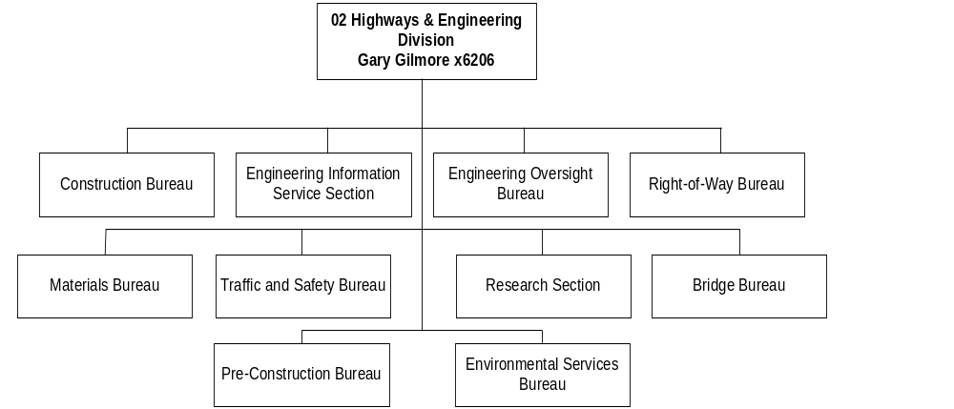

Program Description - The Construction Program is responsible for construction project planning and development from the time a project is included in the long-range work plan through the actual construction of the project. Program responsibilities include such tasks as project design, environmental documents and permits, right-of-way acquisitions, issuing contract bids, awarding contracts, and administering construction contracts. Contract administration is the documentation, inspection, and testing of highway construction projects from the time the contract is awarded to a private contractor until the project is completed and the work approved as meeting established construction standards. The program also provides traffic improvement and educational programs to promote public safety, health, and welfare. The Construction Program is mandated by 2-15-2501(1), MCA; Title 60, MCA; and 23 USC 116.

Program Indicators -
Indicator | Actual FY2000 | Actual FY2001 | Actual FY2002 | Estimated FY2003 |  | Requested FY2004 | Requested FY2005
Percentage of all projects finaled within 120 days of certificate of completion | 11.0% | 88.5% | 95.1% | 85.0% |  | 85.0% | 85.0%
Develop plans for and let 85% of planned fiscal year projects | 88.2% | 85.0% | 66.0% | 85.0% |  | 85.0% | 85.0%
Maintain statewide average construction engineering costs under 8.5% of total contract costs | 7.95% | 8.2% | 10.0% | 8.5% |  | 8.5% | 8.5%
Maintain statewide final costs under 10% above award amount | 1.4% | 2.5% | 3.3% |  | 2.5% | 2.5% | 2.5%

Program Proposed Budget  Budget Item | Base  Budget  Fiscal 2002 | PL Base Adjustment  Fiscal 2004 | New  Proposals  Fiscal 2004 | Total  Exec. Budget  Fiscal 2004 | PL Base Adjustment  Fiscal 2005 | New  Proposals  Fiscal 2005 | Total  Exec. Budget  Fiscal 2005
FTE | 1,045.09 | 0.55 | 1.00 | 1,046.64 | (50.63) | 1.00 | 995.46
Personal Services | 46,102,640 | 6,681,696 | 65,095 | 52,849,431 | 5,220,784 | 64,897 | 51,388,321
Operating Expenses | 263,671,706 | 94,184,216 | 1,003,021 | 358,858,943 | 98,216,647 | 0 | 361,888,353
Equipment | 800,192 | 0 | 0 | 800,192 | 0 | 0 | 800,192
Capital Outlay | 10,112,163 | 2,141,375 | 0 | 12,253,538 | 2,141,375 | 0 | 12,253,538
Grants | 2,819,983 | 0 | 0 | 2,819,983 | 0 | 0 | 2,819,983
Total Costs | $323,506,684 | $103,007,287 | $1,068,116 | $427,582,087 | $105,578,806 | $64,897 | $429,150,387
State/Other Special | 57,229,272 | 57,667,559 | 1,023,114 | 115,919,945 | 79,906,843 | 22,065 | 137,158,180
Federal Special | 266,277,412 | 45,339,728 | 45,002 | 311,662,142 | 25,671,963 | 42,832 | 291,992,207
Total Funds | $323,506,684 | $103,007,287 | $1,068,116 | $427,582,087 | $105,578,806 | $64,897 | $429,150,387

--------------------------------- Present Law Adjustments --------------------------------

Total Agency Impact | General Fund Total
FY04 $652,926 | FY04 $0
FY05 ($1,098,742) | FY05 $0
PL- 202 - CMS Adjustment -
The Construction Management System (CMS), which uses standards to develop projected budgets for the preliminary engineering and construction engineering functions, indicates a need for additional budget authority for 0.55 FTE in FY 2004 and a reduction in budget authority for 50.63 FTE in FY 2005. The total recommendation for the biennium is a net reduction of $445,816 comprised of $84,413 in highway state special revenue and $361,403 in federal special revenue authority.
________________________________________________________________________________________________

Total Agency Impact | General Fund Total
FY04 $2,141,375 | FY04 $0
FY05 $2,141,375 | FY05 $0
PL- 203 - Landowner Payments -
Since enactment of the Transportation Enhancement Act of the Twenty-first Century (TEA 21) the land payments have been averaging approximately $12 million a year. The base expenditures for FY 2002 were $10.1 million. The executive recommends $321,206 state special revenue and $1,820,169 federal special revenue in each year of the biennium to restore the landowner payments to the historical level.
________________________________________________________________________________________________

Total Agency Impact | General Fund Total
FY04 $57,589,998 | FY04 $0
FY05 $30,386,112 | FY05 $0
PL- 204 - Contractor Payments / Federal Aid Construction -
The executive recommends $8,004,019 state special revenue and $49,585,979 federal special revenue in FY 2004 and $4,223,147 state special revenue and $26,162,965 federal special revenue in FY 2005 for contractor payments on the federal aid construction program. The request is computed by using the Tentative Construction Program (TCP), which indicates when the various projects will be let and the type of work to be completed. The amount of contractor payments for the 2005 biennium will be greater than the FY 2002 base.
________________________________________________________________________________________________

Total Agency Impact | General Fund Total
FY04 $30,232,000 | FY04 $0
FY05 $57,380,000 | FY05 $0
PL- 206 - US Highway 93 -
Accelerating the construction on U.S. Highway 93 from Evaro Hill to Polson is recommended in order to provide the traveling public with a highway of double the current traffic capacity as well as to address severe safety problems. Funding will come from the sale of bonds. Since the highway is on the Flathead Indian Reservation, the project is eligible for 100 percent federal funding. As the bonds mature and are redeemed, the amount of state special revenue funds disbursed will be reimbursed by federal aid from the Federal Highway Administration (FHWA) and the bonds and interest will be paid off. The project will require $87,612,000 in state special revenue spending authority for the 2005 biennium.
________________________________________________________________________________________________

Total Agency Impact | General Fund Total
FY04 $562,220 | FY04 $0
FY05 $562,220 | FY05 $0
PL- 207 - CMS Aggregate Positions -
The Construction Program has certain positions that contain multiple employees with varying pay levels. Position budgets come from the most recent person in the position, and in most cases that employee is the lowest paid person in the position. This causes the department to be underfunded for the remaining employees in the position. This request includes $365,308 in highway state special revenue and $759,132 in federal special revenue for the biennium to fund the difference between actual pay rates and the pay rates established in the budget system and the associated benefits for these aggregate positions.
________________________________________________________________________________________________

Total Agency Impact | General Fund Total
FY04 $11,707,531 | FY04 $0
FY05 $16,034,002 | FY05 $0
PL- 209 - Contractor Payments / State Construction Program -
The department is required to spend a minimum amount of state funds on state-funded construction projects in order to receive a favorable ratio of federal participation on federal aid projects. Because the amount of state-funded construction in the FY 2002 base year is very low, this request increases the amount in the 2005 biennium by $27,741,533 highway state special revenue comprised of $11,707,531 in FY 2004 and $16,034,002 in FY 2005.
________________________________________________________________________________________________

Total Agency Impact | General Fund Total
FY04 $4,497,822 | FY04 $0
FY05 $4,497,822 | FY05 $0
PL- 210 - Overtime / Differential -
Base year overtime and differential pay with associated benefits is restored at a 2005 biennial cost of $8,995,644 including $2,359,448 in state special revenue and $6,636,196 in federal special revenue.
________________________________________________________________________________________________

Total Agency Impact | General Fund Total
FY04 $153,630 | FY04 $0
FY05 $174,700 | FY05 $0
PL- 212 - Equipment Rental -
The request includes $92,916 state special revenue and $235,414 federal special revenue for the biennium to cover the Construction Program portion of the department's Equipment Program rate increase.
________________________________________________________________________________________________

Total Agency Impact | General Fund Total
FY04 ($5,000,000) | FY04 $0
FY05 ($5,000,000) | FY05 $0
PL- 213 - Roadway Striping -
The executive recommends $5 million per year in federal special revenue be transferred to the Maintenance Program. A corresponding request (PL 302) can be found in that program to consolidate the function of roadway striping for the department.
________________________________________________________________________________________________

Total Agency Impact | General Fund Total
FY04 ($1,144,197) | FY04 $0
FY05 ($1,144,197) | FY05 $0
PL- 214 - Alternative Payplan Conversion -
During FY 2002, the department converted to the alternative payplan authorized in HB 13. The alternative payplan allows the department to compensate employees at a level necessary to recruit and retain a qualified department staff. The annual cost of the conversion for the Construction program is $469,464 state special revenue and $674,733 federal special revenue. The operating budget for the program is being reduced by a like amount to fund the conversion.

---------------------------------------- New Proposals ----------------------------------------

Total Agency Impact | General Fund Total
FY04 $68,116 | FY04 $0
FY05 $64,897 | FY05 $0
NP- 208 - Local Government Certification -
The department will be operating a pilot project that will allow local governments to receive federal highway funds from the Federal Highway Administration (FHWA) to be used by and administered for local highway purposes. The pilot program will include the communities of Billings, Great Falls and Missoula. It will be necessary for DOT to monitor the use of these funds and to assure that all rules and regulations associated with the use of these funds are followed so as not to jeopardize these and other federal funds that the department receives. This request is for an additional 1.00 FTE requiring one additional basic office package and personal computer. The 2005 biennium request totals $133,013 with $45,179 in highway state special revenue and $87,834 in federal special revenue.
________________________________________________________________________________________________

Total Agency Impact | General Fund Total
FY04 $1,000,000 | FY04 $0
FY05 $0 | FY05 $0
NP- 211 - Convert Metric measure to English measure -
The department is converting from a metric system of measure to an English system of measure as mandated by the Federal Highway Administration. Costs are primarily for outside consultants to revise agency manuals, drawings, standards, and software, but also include $50,000 for new construction hardware of steel tapes, chains, and survey rods. Mandated conversion will require $1,000,000 in highway state special revenue for the 2005 biennium.
________________________________________________________________________________________________

Language - “Item 2 includes a total of $63,690 for the 2005 biennium for the Montana natural resources information system. Quarterly payments must be made upon receipt of the bills from the state library, up to the total amount appropriated.”

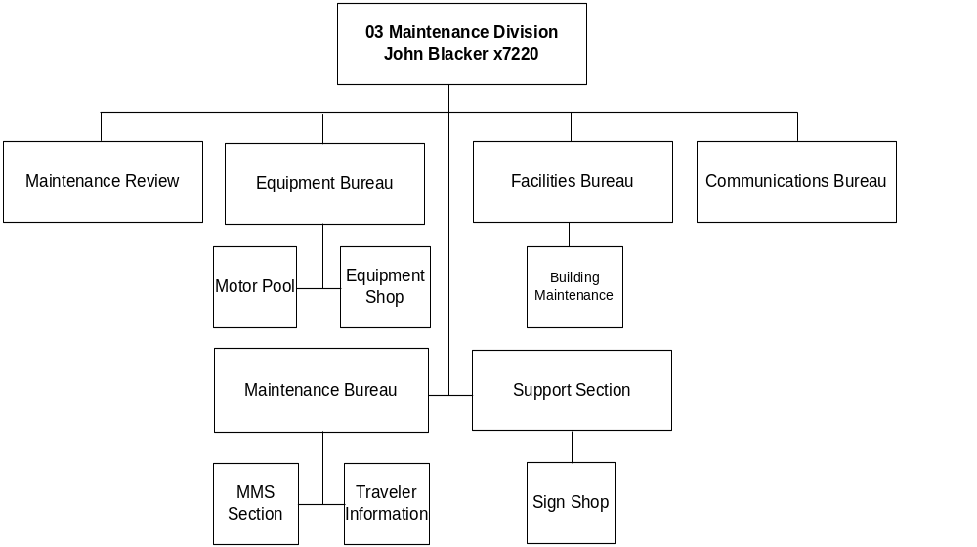

Program Description - The Maintenance Program provides for repairs and preventive maintenance of state highways and the various signs and structures within the highway right-of-way. Winter plowing and sanding and year-round repairs to the state highway system are the responsibility of the staff in the Maintenance Program. The Maintenance Program is authorized by 2-15-2501(1),Title 60, MCA; and 23 USC 116.

Program Proposed Budget  Budget Item | Base  Budget  Fiscal 2002 | PL Base Adjustment  Fiscal 2004 | New  Proposals  Fiscal 2004 | Total  Exec. Budget  Fiscal 2004 | PL Base Adjustment  Fiscal 2005 | New  Proposals  Fiscal 2005 | Total  Exec. Budget  Fiscal 2005
FTE | 779.20 | 0.00 | (11.03) | 768.17 | 0.00 | (11.03) | 768.17
Personal Services | 32,033,711 | 5,287,409 | (516,906) | 36,804,214 | 5,378,430 | (520,602) | 36,891,539
Operating Expenses | 45,454,460 | 8,975,579 | 0 | 54,430,039 | 9,181,142 | 0 | 54,635,602
Equipment | 71,275 | 0 | 0 | 71,275 | 0 | 0 | 71,275
Capital Outlay | 13,367 | 55,000 | 0 | 68,367 | 55,000 | 0 | 68,367
Total Costs | $77,572,813 | $14,317,988 | ($516,906) | $91,373,895 | $14,614,572 | ($520,602) | $91,666,783
State/Other Special | 73,481,092 | 8,371,057 | (516,906) | 81,335,243 | 8,667,641 | (520,602) | 81,628,131
Federal Special | 4,091,721 | 5,946,931 | 0 | 10,038,652 | 5,946,931 | 0 | 10,038,652
Total Funds | $77,572,813 | $14,317,988 | ($516,906) | $91,373,895 | $14,614,572 | ($520,602) | $91,666,783

--------------------------------- Present Law Adjustments --------------------------------

Total Agency Impact | General Fund Total
FY04 $96,540 | FY04 $0
FY05 $144,660 | FY05 $0
PL- 301 - Secondary Road Mile Increase -
SB 333, passed by the 1999 Legislature, made the department responsible for the maintenance of eligible paved secondary roads. An estimated 32.18 lane miles will become eligible in FY 2004 and 48.22 lane miles in FY 2005 at an estimated cost of $3,000 per lane mile. The recommendation includes the cost of performing routine maintenance on these additional lane miles and purchasing supplies such as traffic paint, winter materials and replacement signs at a cost of $96,540 state special revenue in FY 2004 and $144,660 state special revenue in FY 2005.
________________________________________________________________________________________________

Total Agency Impact | General Fund Total
FY04 $5,804,430 | FY04 $0
FY05 $5,804,430 | FY05 $0
PL- 302 - Roadway Striping -
The executive recommends $804,430 state special revenue and $5,000,000 federal special revenue in each year of the biennium for the roadway striping program. The request will consolidate all striping projects into the Maintenance Program and restore the state funding base to the historical level for maintenance striping. The $5 million per year in federal special revenue is a transfer of the striping function from the Construction Program for those projects that are federal aid eligible.
________________________________________________________________________________________________

Total Agency Impact | General Fund Total
FY04 $132,044 | FY04 $0
FY05 $134,861 | FY05 $0
PL- 303 - Noxious Weed Control -
The executive recommends $132,044 state special revenue in FY 2004 and $134,861 state special revenue in FY 2005 to fund the increased cost of controlling weeds on state owned right-of-way. Cost increases are due to additional lane miles of roadway that are now the department's responsibility as well as increased costs of weed control chemicals and application.
________________________________________________________________________________________________

Total Agency Impact | General Fund Total
FY04 $179,636 | FY04 $0
FY05 $199,097 | FY05 $0
PL- 304 - Rest Area Maintenance -
The executive recommends $179,636 state special revenue in FY 2004 and $199,097 state special revenue in FY 2005 for increases in rest area maintenance. Rest area maintenance contracts have been rewritten over the past biennium to include more stringent performance requirements. This increases the price of the contracts. In addition, new rest areas have been opened at Sweetgrass, Wibaux and Lost Trail. Rest areas have been renovated and enlarged at Jefferson City, Lima and near Saltese. The cost of the contracts for these rest areas is included in this request.
________________________________________________________________________________________________

Total Agency Impact | General Fund Total
FY04 $2,602,590 | FY04 $0
FY05 $2,602,590 | FY05 $0
PL- 306 - Overtime and Differential -
Base year overtime and differential pay with associated benefits, which is primarily for winter maintenance, is recommended to be reestablished at a biennial cost of $5,205,180 highway state special revenue.
________________________________________________________________________________________________

Total Agency Impact | General Fund Total
FY04 $81,588 | FY04 $0
FY05 $81,588 | FY05 $0
PL- 307 - Increased Contract Costs -
Costs for existing contracts have risen with the renewal of the contracts. They include land rental for radio sites, janitorial contracts, cleaning contracts for the DOT Headquarters facility and increased costs at some of the district facilities. The executive recommends $81,588 state special revenue each year of the biennium to address the increased contract costs.
________________________________________________________________________________________________

Total Agency Impact | General Fund Total
FY04 $30,000 | FY04 $0
FY05 $30,000 | FY05 $0
PL- 308 - Land Purchases -
The executive recommends $30,000 state special revenue each year of the biennium to be used to purchase land as part of the department's Long-Range Building Program.
________________________________________________________________________________________________

Total Agency Impact | General Fund Total
FY04 $165,350 | FY04 $0
FY05 $165,350 | FY05 $0
PL- 309 - Sign Template Stock -
The request includes $165,350 state special revenue each year of the biennium to replace sign template stock that has been depleted. This stock is needed to replace old or damaged signs on state highways as the circumstances arise.
________________________________________________________________________________________________

Total Agency Impact | General Fund Total
FY04 $24,589 | FY04 $0
FY05 $24,734 | FY05 $0
PL- 310 - New Core Drill Building -
The 2001 Legislature authorized the department to build a new building to house the Core Drill Unit. Additional authority is requested for janitorial supplies and supplies for routine maintenance for the new core drill building. Cost for the biennium is $49,324 of highway state special revenue.
________________________________________________________________________________________________

Total Agency Impact | General Fund Total
FY04 $850,309 | FY04 $0
FY05 $966,947 | FY05 $0
PL- 311 - Equipment Rental -
The request includes $1,187,256 state special revenue for the biennium to cover the Maintenance Program portion of the department's Equipment Program rate increase.
________________________________________________________________________________________________

Total Agency Impact | General Fund Total
FY04 $1,587,602 | FY04 $0
FY05 $1,587,602 | FY05 $0
PL- 312 - Pavement Preservation -
Due to the wet spring and the non-completion of a number of pavement preservation contracts, the base budget for pavement preservation is approximately $1.5 million below historical levels. This request would reestablish the pavement preservation program at approximately $14.5 million per year. The biennial cost is $3,175,204 highway state special revenue.
________________________________________________________________________________________________

Total Agency Impact | General Fund Total
FY04 $180,000 | FY04 $0
FY05 $180,000 | FY05 $0
PL- 313 - Travelers Information Service -
The new 511 travelers information service will start operating in 2003 to allow travelers to get the most recently-reported data and forecast information. Previous service, which was less automated and more labor-intensive, sometimes resulted in callers receiving outdated information. The executive recommends $180,000 state special revenue each year of the biennium to provide matching funds for the 511 service.
________________________________________________________________________________________________

Total Agency Impact | General Fund Total
FY04 $31,714 | FY04 $0
FY05 $31,714 | FY05 $0
PL- 314 - Training -
Training for employees in the career ladder progression was scheduled but couldn't be completed by fiscal year end. This training is required to meet the career ladder union agreement. To restore the base to the required level to meet the agreement, the request includes $31,714 state special revenue each year of the biennium.
________________________________________________________________________________________________

Total Agency Impact | General Fund Total
FY04 ($69,985) | FY04 $0
FY05 ($69,985) | FY05 $0
PL- 316 - Travel Reduction -
The request reduces the program travel budget by $69,985 state special revenue each year of the biennium. The reduction will bring the travel budget back in line with the 2003 travel level, while still allowing the program to continue getting personnel to training academies as required by union contract.
________________________________________________________________________________________________

Total Agency Impact | General Fund Total
FY04 ($184,434) | FY04 $0
FY05 ($184,434) | FY05 $0
PL- 317 - Alternative Payplan Conversion -
During FY 2002, the department converted to the alternative payplan authorized in HB 13. The alternative payplan allows the department to compensate employees at a level necessary to recruit and retain a qualified department staff. The annual cost of the conversion for the Maintenance program is $184,434 state special revenue. The operating budget for the program is being reduced by a like amount to fund the conversion.
________________________________________________________________________________________________

---------------------------------------- New Proposals ----------------------------------------

Total Agency Impact | General Fund Total
FY04 ($516,906) | FY04 $0
FY05 ($520,602) | FY05 $0
NP- 315 - FTE Reduction -
There are 11.03 FTE, including maintenance technicians and a maintenance supervisor, eliminated in this request. The reduction is based on a needs survey conducted by the Maintenance Program in FY 2002. The biennial savings of the reduction is $1,037,508 highway state special revenue.

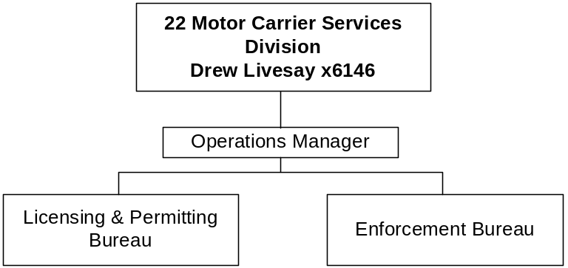

Program Description - The Motor Carrier Services Division enforces state and federal commercial motor carrier laws including laws on vehicle size and weight, insurance, licensing, fuel, and vehicle and driver safety. The Licensing and Permit Bureau registers interstate fleet vehicles, issues commercial vehicle licenses, issues oversize/overweight permits, and collects and distributes fees and taxes. The Enforcement Bureau operates a statewide weigh station and mobile enforcement program and assigns uniformed officers to inspect commercial vehicles for compliance with state and federal safety, registration, fuel, insurance and size/weight laws. The Motor Carrier Services Program is mandated by Title 61, Chapter 9, MCA.

Program Indicators -
Indicator | Actual  SFY2000 | Actual  SFY2001 | Actual  SFY2002 | Estimated SFY2003 | Requested SFY2004 ** | Requested SFY2005 **
Service and enforcement contacts* | 130,614 | 138,216 | 133,831 | 138,032 | 145,319 | 142,175
Trucks weighed | 599,697 | 566,538 | 605,225 | 590,487 | 587,417 | 594,376
* A contact includes issuing oversize/overweight permits, performing commercial vehicle and driver safety inspections, issuing citations, taking commercial vehicle samples, and licensing transactions. Truck weights are a separate but related performance category.
** During FY 2004 and FY 2005, the Motor Carrier Services Division will transition from numerical performance indicators into an hour-based system.

Program Proposed Budget  Budget Item | Base  Budget  Fiscal 2002 | PL Base Adjustment  Fiscal 2004 | New  Proposals  Fiscal 2004 | Total  Exec. Budget  Fiscal 2004 | PL Base Adjustment  Fiscal 2005 | New  Proposals  Fiscal 2005 | Total  Exec. Budget  Fiscal 2005
FTE | 111.50 | 0.00 | 0.00 | 111.50 | 0.00 | 0.00 | 111.50
Personal Services | 3,980,544 | 478,753 | 0 | 4,459,297 | 472,510 | 0 | 4,453,054
Operating Expenses | 795,104 | (6,765) | 0 | 788,339 | 44,953 | 0 | 840,057
Total Costs | $4,775,648 | $471,988 | $0 | $5,247,636 | $517,463 | $0 | $5,293,111
State/Other Special | 4,775,648 | 471,988 | 0 | 5,247,636 | 517,463 | 0 | 5,293,111
Total Funds | $4,775,648 | $471,988 | $0 | $5,247,636 | $517,463 | $0 | $5,293,111

-------------------------------- Present Law Adjustments --------------------------------

Total Agency Impact | General Fund Total
FY04 $0 | FY04 $0
FY05 $50,000 | FY05 $0
PL- 2201 - Wyoming/Montana Joint Port Project -
The Montana Department of Transportation (DOT) and the Wyoming Department of Transportation are constructing a "joint" port-of-entry weigh station on Interstate 90 between Sheridan, Wyoming, and the Montana border servicing north and south-bound traffic. The facility will be staffed with up to twenty (20) Wyoming Officers who will enforce Montana commercial vehicle laws on Montana's behalf. After completion of the new facility in late 2005, Montana's existing Crow Agency Weigh Station will be closed and dismantled, and the two (2) MCS Officers currently assigned to the Crow Agency Weigh Station will be reassigned to another Montana facility. DOT is requesting $50,000 state special revenue in FY 2005 to train Wyoming Officers to enforce State of Montana commercial vehicle laws, issue Montana oversize/overweight permits and collect Montana GVW fees.
________________________________________________________________________________________________

Total Agency Impact | General Fund Total
FY04 $145,274 | FY04 $0
FY05 $145,274 | FY05 $0
PL- 2202 - Overtime and Differential Pay -
This request is to reestablish base year overtime and differential pay with associated benefits. The biennial cost is $290,548 state special revenue.
________________________________________________________________________________________________

Total Agency Impact | General Fund Total
FY04 $20,000 | FY04 $0
FY05 $20,000 | FY05 $0
PL- 2203 - Increased Credit Card Usage -
In response to customer requests, MCS developed and implemented a credit card payment option for automated commercial motor carrier service transactions in late FY 1997. Increased customer use of these automated services has resulted in a corresponding increase in credit card fees from approximately $21,500 in FY 1998 to nearly $52,800 in FY 2002. MCS expects credit use to continue to grow and is therefore requesting an additional $40,000 in highway state special revenue for the 2005 biennium.
________________________________________________________________________________________________

Total Agency Impact | General Fund Total
FY04 $7,558 | FY04 $0
FY05 $8,595 | FY05 $0
PL- 2204 - Equipment Rental -
The request includes $16,153 state special revenue for the biennium to cover the Motor Carrier Services portion of the department's Equipment Program rate increase.
________________________________________________________________________________________________

Total Agency Impact | General Fund Total
FY04 ($41,016) | FY04 $0
FY05 ($41,016) | FY05 $0
PL- 2205 - Alternative Payplan Conversion -
During FY 2002, the department converted to the alternative payplan authorized in HB 13. The alternative payplan allows the department to compensate employees at a level necessary to recruit and retain a qualified department staff. The annual cost of the conversion for the Motor Carrier Services Division is $41,016 state special revenue. The operating budget for the program is being reduced by a like amount to fund the conversion.
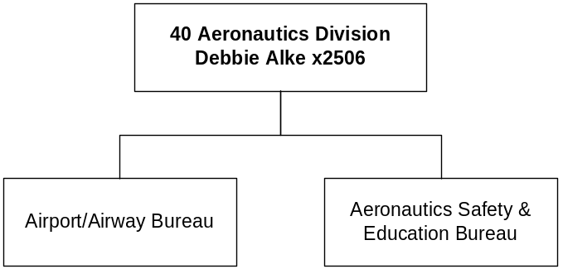

Program Description - The Montana Aeronautics Division: 1) facilitates the maintenance of airports and the various components of airport infrastructure, including visual and electronic navigational facilities and flying aids; 2) fosters, promotes, and supervises aviation and aviation safety through educational efforts and programs; 3) registers aircraft and pilots in accordance with Montana laws and regulations; and 4) coordinates and supervises aerial search and rescue operations. In accordance with the maintenance and safety aspects of the division's purpose, it administers a loan and grant program to municipal governments to fund airport improvement projects. The Aeronautics Board approves all loan and grant requests and advises on matters pertaining to aeronautics.

The division serves in a liaison capacity between the State of Montana and various entities including the U.S. Department of Transportation, the Federal Aviation Administration (FAA), other federal and state entities, and commercial airlines to assure the retention and continuation of airline service to the rural communities of the state. The division also is responsible for operation of the air carrier airport at West Yellowstone and for 12 other state-owned airports. Montana Aeronautics Division is authorized by 2-15-2501(2), and Title 67, MCA; and various federal laws.

Program Proposed Budget  Budget Item | Base  Budget  Fiscal 2002 | PL Base Adjustment  Fiscal 2004 | New  Proposals  Fiscal 2004 | Total  Exec. Budget  Fiscal 2004 | PL Base Adjustment  Fiscal 2005 | New  Proposals  Fiscal 2005 | Total  Exec. Budget  Fiscal 2005
FTE | 10.00 | 0.00 | 0.00 | 10.00 | 0.00 | 0.00 | 10.00
Personal Services | 408,651 | 49,033 | 0 | 457,684 | 49,757 | 0 | 458,408
Operating Expenses | 296,799 | 203,878 | 3,600,000 | 4,100,677 | 32,835 | 0 | 329,634
Equipment | 16,485 | (6,594) | 0 | 9,891 | (6,594) | 0 | 9,891
Grants | 301,054 | 731,946 | 0 | 1,033,000 | (301,054) | 0 | 0
Transfers | 25,452 | 0 | 0 | 25,452 | 0 | 0 | 25,452
Total Costs | $1,048,441 | $978,263 | $3,600,000 | $5,626,704 | ($225,056) | $0 | $823,385
State/Other Special | 1,048,441 | 798,263 | 180,000 | 2,026,704 | (225,056) | 0 | 823,385
Federal Special | 0 | 180,000 | 3,420,000 | 3,600,000 | 0 | 0 | 0
Total Funds | $1,048,441 | $978,263 | $3,600,000 | $5,626,704 | ($225,056) | $0 | $823,385

Please note that a HB 576 section exists for this program.

--------------------------------- Present Law Adjustments --------------------------------

Total Agency Impact | General Fund Total
FY04 $5,122 | FY04 $0
FY05 $5,122 | FY05 $0
PL- 4003 - Overtime and Differential -
This request is to reestablish base year overtime and differential pay with associated benefits. The biennial cost is $10,244 state special revenue.
________________________________________________________________________________________________

Total Agency Impact | General Fund Total
FY04 ($7,436) | FY04 $0
FY05 $20,576 | FY05 $0
PL- 4004 - Program/Service Cost Adjustments -
This request includes operating adjustments made in order to maintain an adequate fund balance in the aeronautics state special revenue fund. A net decrease of $7,436 is shown in FY 2004 and a net increase of $20,576 is shown in FY 2005. The FY 2005 request includes $30,000 for the Aeronautical Chart Revision required every four years by the FAA.
________________________________________________________________________________________________

Total Agency Impact | General Fund Total
FY04 $731,946 | FY04 $0
FY05 ($301,054) | FY05 $0
PL- 4005 - Grant Increases - Biennial Appropriations -
The executive recommends an increase of $731,496 state special revenue in FY 2004 and a decrease of $301,054 state special revenue in FY 2005. Combined with the base, this will establish a biennial appropriation of $1,032,550 for grants. The amount includes $800,000 for grants to local airports for safety and development projects, $225,000 for grants to assist air-carrier airports with pavement preservation, and $7,550 for grants to municipalities for courtesy cars at qualified airports where rental cars are not available. These grants are provided for in 67-1-301, MCA, and 67-10-903, MCA. A biennial appropriation is requested for the grant authority
________________________________________________________________________________________________

Total Agency Impact | General Fund Total
FY04 $200,000 | FY04 $0
FY05 $0 | FY05 $0
PL- 4006 - Statewide Plan Update - Biennial Appropriations -
The Federal Aviation Administration requires airport standard reviews and Capital Improvement Plan updates every five years. The executive recommends a biennial appropriation of $20,000 state special revenue and $180,000 federal special revenue to provide grants for these reviews and updates.

---------------------------------------- New Proposals ----------------------------------------

Total Agency Impact | General Fund Total
FY04 $1,800,000 | FY04 $0
FY05 $0 | FY05 $0
NP- 4001 - Runway Rehab West Yellowstone Airport - Biennial -
The West Yellowstone Airport runway is in need of a total rehabilitation of the runway pavement to maintain Federal Aviation Administration standards. This request is for a $1,800,000 federal special revenue biennial appropriation. The Federal Aviation Administration will provide 90 percent of the funding and the $200,000 match will come from the West Yellowstone Airport proprietary fund.
________________________________________________________________________________________________

Total Agency Impact | General Fund Total
FY04 $1,800,000 | FY04 $0
FY05 $0 | FY05 $0
NP- 4002 - Runway Rehab Lincoln Airport - Biennial Approp -
The Lincoln Airport runway is in need of a total rehabilitation of the runway pavement to maintain Federal Aviation Administration standards. This request for $1,800,000 in a 2005 biennial appropriation includes $1,620,000 federal special revenue and $180,000 state special revenue. The Federal Aviation Administration will participate with 90 percent of the funding.

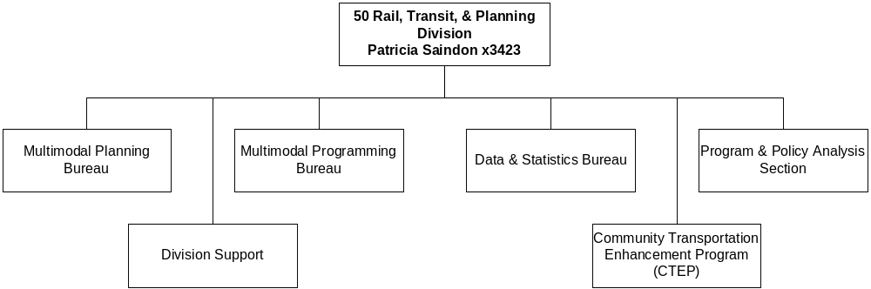

Program Description - The Rail, Transit and Planning Division provides: 1) an inventory of transportation infrastructure to allocate funds, maintain Department of Transportation eligibility for grant and federal funds, and aid the process of project prioritization and selection; 2) a statewide planning program and assistance to local area transportation planning; and 3) response to legislative or regulatory actions necessitating representation before courts, congressional hearings, the US DOT, the Surface Transportation Board, and others. This planning results in a program of projects which includes buses for transit systems, street and highway improvements, railroad track rehabilitation, transportation enhancements for non-motorized use and beautification improvements. The division is authorized by 7-14-102, 15-70-101, Title 60, Chapters 3 & 11, and Title 61, Chapter 2, part 1, MCA.

Program Indicators -
Indicator | Actual FY2000 | Actual FY2001 | Actual FY2002 | Estimated FY2003 | Requested FY2004 | Requested FY2005
Federal aid resources for Montana which lapsed and were made available to other states | 0% | 0% | 0% | 0% | 0% | 0%
High priority goals and objectives in the DOT long-range plan which progressed significantly or were completed | 95% | 96% | Plan Updated* | 93% of new goals* | 94%* | 95%*
*Actual goals will not be established until January 2003

Program Proposed Budget  Budget Item | Base  Budget  Fiscal 2002 | PL Base Adjustment  Fiscal 2004 | New  Proposals  Fiscal 2004 | Total  Exec. Budget  Fiscal 2004 | PL Base Adjustment  Fiscal 2005 | New  Proposals  Fiscal 2005 | Total  Exec. Budget  Fiscal 2005
FTE | 62.60 | 4.00 | 0.00 | 66.60 | 4.00 | 0.00 | 66.60
Personal Services | 2,796,812 | 271,631 | 0 | 3,068,443 | 274,632 | 0 | 3,071,444
Operating Expenses | 1,675,061 | 649,395 | 250,000 | 2,574,456 | 303,910 | 0 | 1,978,971
Equipment | 19,274 | 0 | 0 | 19,274 | 0 | 0 | 19,274
Grants | 3,793,592 | 2,668,750 | 0 | 6,462,342 | 2,668,750 | 0 | 6,462,342
Total Costs | $8,284,739 | $3,589,776 | $250,000 | $12,124,515 | $3,247,292 | $0 | $11,532,031
State/Other Special | 1,567,357 | 1,348,748 | 50,000 | 2,966,105 | 980,359 | 0 | 2,547,716
Federal Special | 6,717,382 | 2,241,028 | 200,000 | 9,158,410 | 2,266,933 | 0 | 8,984,315
Total Funds | $8,284,739 | $3,589,776 | $250,000 | $12,124,515 | $3,247,292 | $0 | $11,532,031

--------------------------------- Present Law Adjustments --------------------------------

Total Agency Impact | General Fund Total
FY04 $629,442 | FY04 $0
FY05 $629,442 | FY05 $0
PL- 5002 - Transade (Trans. Assist. for the Disabled/Elderly) -
SB 448, passed by the 2001 Legislature, places a 25-cent fee on all vehicle registrations except trailers and semi-trailers to provide operating funds to counties, incorporated cities and towns, transportation districts or nonprofit organizations for transportation services for persons 60 years of age or older and for persons with disabilities. Revenue collected from FY 2002 and FY 2003 will be spent during FY 2004 and FY 2005. The request includes $629,442 state special revenue each year of the biennium for this service.
________________________________________________________________________________________________

Total Agency Impact | General Fund Total
FY04 $1,528,000 | FY04 $0
FY05 $1,528,000 | FY05 $0
PL- 5003 - Federal Transit Administration Section 5309 -
The Federal Transit Administration (FTA) Section 5309 Program is for earmarked funds for transit capital assistance projects that are submitted through and supported by the Montana congressional delegation. The 2005 biennium allocation is estimated to be $3,056,000 in federal special revenue. The funds are to be used for the procurement and/or construction of transit facilities and the purchase of vehicles.
________________________________________________________________________________________________

Total Agency Impact | General Fund Total
FY04 $200,000 | FY04 $0
FY05 $200,000 | FY05 $0
PL- 5004 - Traffic Data Processing Software -
The executive recommends $49,188 state special revenue and $150,812 federal special revenue each year of the biennium to develop traffic data processing software. The current software is not supported and does not meet necessary specifications. The request is included in the department's approved Information Technology Strategic Plan.
________________________________________________________________________________________________

Total Agency Impact | General Fund Total
FY04 $298,244 | FY04 $0
FY05 $297,822 | FY05 $0
PL- 5005 - FTE/Operating for Weigh-in-Motion (WIM) and STARS -
The department received a congressional earmark several years ago to develop, operate and evaluate a pilot program entitled the State Truck Activity Reporting System (STARS). The Legislature approved 4.00 FTE one-time-only the last two biennia for the pilot program. This request includes making the 4.00 FTE permanent and provides operating costs required to support the program. The executive recommends $124,578 highway state special revenue and $471,488 federal special revenue for the biennium to maintain the new Weigh-in-Motion (WIM) infrastructure and STARS permanently.
________________________________________________________________________________________________

Total Agency Impact | General Fund Total
FY04 $14,281 | FY04 $0
FY05 $14,281 | FY05 $0
PL- 5006 - Overtime and Differential -
This request is to reestablish base year overtime and differential pay with associated benefits. The 2005 biennial cost is $28,562 comprised of $6,384 state special revenue and $22,178 federal special revenue.
________________________________________________________________________________________________

Total Agency Impact | General Fund Total
FY04 $484,977 | FY04 $0
FY05 $484,977 | FY05 $0
PL- 5008 – TEA 21 Federal Funding Increases -
The Transportation Enhancement Act of the Twenty-first Century (TEA 21) has increased the funding and requirements for implementing certain urban programs. Training of local city participants and utilization of these funds in the Billings, Great Falls and Missoula localities will require $459,332 state special revenue and $510,622 federal special revenue for the biennium.
________________________________________________________________________________________________

Total Agency Impact | General Fund Total
FY04 $46,804 | FY04 $0
FY05 $42,894 | FY05 $0
PL- 5009 - Seasonal Contracted Services -
The Road Inventory and Mapping Section hires employees to accomplish the required field road inventory each year. In the past this was done using temporary FTE. In the future, employees will be hired through a temporary placement agency using contracted services funds. In order to complete the field road inventory, an additional amount of contracted services authority is requested to fund two temporary employees and travel expenses at a cost of $21,776 highway state special revenue and $67,922 federal special revenue for the biennium.
________________________________________________________________________________________________

Total Agency Impact | General Fund Total
FY04 $26,594 | FY04 $0
FY05 $26,736 | FY05 $0
PL- 5010 - Travel Adjustment -
The program experienced reduced travel levels during FY 2002, primarily in the Urban and Planning Systems units. The executive recommends $6,303 state special revenue and $20,291 federal special revenue in FY 2004 and $6,336 state special revenue and $20,400 federals special revenue in FY 2005 to restore the travel budget to the necessary level.
________________________________________________________________________________________________

Total Agency Impact | General Fund Total
FY04 $84,578 | FY04 $0
FY05 $84,578 | FY05 $0
PL- 5011 - Senior/Disabled Vehicle Adjustment -
Each fiscal year, the department receives funding from the Department of Public Health and Human Services to purchase vehicles for agencies that serve the elderly and persons with disabilities. Due to a problem with certain vehicles that were purchased and delivered during FY 2002 but did not meet specifications, the full amount of this budget was not expended. It is expected that the full $75,000 per year will be spent in the 2005 biennium. In addition, similar federal grants were not expended totally in FY 2002. The base will be restored to the level required to expend the maximum amount of funds allocated by DPHHS and the federal government by an adjustment of $61,962 state special revenue and $107,194 federal special revenue for the biennium.
________________________________________________________________________________________________

Total Agency Impact | General Fund Total
FY04 $343,321 | FY04 $0
FY05 $0 | FY05 $0
PL- 5012 - Federal Earmark and Other Contracted Services -
Federal earmarked funds have been received for erecting geological signs and for implementing the Roadside Animal Detection System. In addition, a corridor study project called CANAMEX is in progress. These projects that began in FY 2002 cannot be completed until FY 2004. This adjustment provides the necessary authority to carry these projects to completion. This includes $68,664 in highway state special revenue and $274,657 in federal state special revenue for the biennium.
________________________________________________________________________________________________

Total Agency Impact | General Fund Total
FY04 $8,230 | FY04 $0
FY05 $9,362 | FY05 $0
PL- 5013 - Equipment Rental -
The request includes $3,940 state special revenue and $13,652 federal special revenue for the biennium to cover the Transportation Planning Program portion of the department's Equipment Program rate increase.
________________________________________________________________________________________________

Total Agency Impact | General Fund Total
FY04 ($165,212) | FY04 $0
FY05 ($165,212) | FY05 $0
PL- 5014 - Alternative Payplan Conversion -
During FY 2002, the department converted to the alternative payplan authorized in HB 13. The alternative payplan allows the department to compensate employees at a level necessary to recruit and retain a qualified department staff. The annual cost of the conversion for the Transportation Planning program is $52,559 state special revenue and $112,653 federal special revenue. The operating budget for the program is being reduced by a like amount to fund the conversion.

---------------------------------------- New Proposals ----------------------------------------

Total Agency Impact | General Fund Total
FY04 $250,000 | FY04 $0
FY05 $0 | FY05 $0
NP- 5001 - Multimodal Transportation Corridor Tech Assist -
The department continuously monitors the Montana transportation systems to determine whether there are any significant trends or changes that could impact the system, Montana businesses and communities. This request for $250,000 for the 2005 biennium will allow the department to obtain contracted services assistance to work with the Departments of Commerce and Agriculture, railroads, and local communities to evaluate the impacts on the system, including highways and economic impacts, and explore ways to preserve branch line service. Funding is $50,000 non-restricted state special revenue and $200,000 federal special revenue.

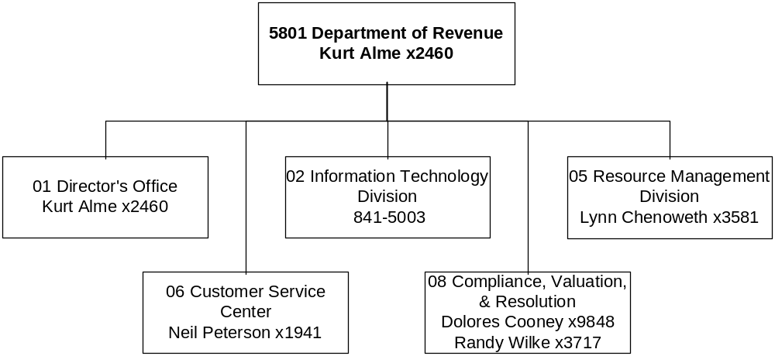

Mission Statement - To be a service oriented and accountable organization, where customers and employees are treated with courtesy, respect, and fairness; and where effective revenue, compliance, and collection services are provided to the public and to other governmental units in a fast, accurate, and cost effective manner.

Statutory Authority - Titles 2, 15, 16, 39, MCA

Agency Proposed Budget  Budget Item | Base  Budget  Fiscal 2002 | PL Base Adjustment  Fiscal 2004 | New  Proposals  Fiscal 2004 | Total  Exec. Budget  Fiscal 2004 | PL Base Adjustment  Fiscal 2005 | New  Proposals  Fiscal 2005 | Total  Exec. Budget  Fiscal 2005
FTE | 663.53 | 1.00 | (18.50) | 646.03 | 1.00 | (22.00) | 642.53
Personal Services | 24,006,775 | 2,253,898 | (721,385) | 25,539,288 | 2,258,936 | (836,149) | 25,429,562
Operating Expenses | 8,700,168 | 944,847 | 61,678 | 9,706,693 | 646,364 | 39,069 | 9,385,601
Equipment | 93,435 | 0 | 0 | 93,435 | 0 | 0 | 93,435
Debt Service | 6,375 | 0 | 0 | 6,375 | 0 | 0 | 6,375
Total Costs | $32,806,753 | $3,198,745 | ($659,707) | $35,345,791 | $2,905,300 | ($797,080) | $34,914,973
General Fund | 28,078,749 | 3,012,093 | (659,707) | 30,431,135 | 2,718,216 | (797,080) | 29,999,885
State/Other Special | 424,485 | 124,671 | 0 | 549,156 | 128,678 | 0 | 553,163
Federal Special | 2,328,482 | 43,635 | 0 | 2,372,117 | 33,835 | 0 | 2,362,317
Proprietary | 1,975,037 | 18,346 | 0 | 1,993,383 | 24,571 | 0 | 1,999,608
Total Funds | $32,806,753 | $3,198,745 | ($659,707) | $35,345,791 | $2,905,300 | ($797,080) | $34,914,973

------------------- Agency General Fund Target - $59.88 million -------------------

Actions included in the recommended new proposal plans for the Treasury Offset Program in program 06, NP-606, will generate net general fund revenue of about $505,000 in the biennium and the unclaimed property adjustment in program 06, PL-602, will generate net general fund of about $170,000. The reductions and the revenue together exceed the target.

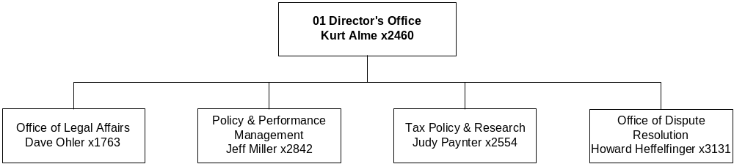

Program Description - The Director's Office provides management control, policy direction, strategic planning, and legal services to assist the tax and liquor programs in fulfilling their responsibilities. The legal services staff advise other program staff and handle tax appeals before the State Tax Appeal Board and state courts. The Director's Office also includes the Policy and Performance Management unit, the Tax Policy and Research unit, and the Office of Dispute Resolution.

The Policy and Performance Management unit supports the department's core processes and is responsible for coordinating the strategic development of operating policies, budgets, rules, performance management, change management, and strategic planning for the department. The Tax Policy and Research unit is responsible for estimating state revenue, coordinating Department of Revenue legislation and fiscal notes, reviewing all legislation related to revenue, and conducting revenue-related research. The Office of Dispute Resolution has consolidated the department's dispute resolution efforts, including tax and liquor appeals, into a single location and process.

Program Proposed Budget  Budget Item | Base  Budget  Fiscal 2002 | PL Base Adjustment  Fiscal 2004 | New  Proposals  Fiscal 2004 | Total  Exec. Budget  Fiscal 2004 | PL Base Adjustment  Fiscal 2005 | New  Proposals  Fiscal 2005 | Total  Exec. Budget  Fiscal 2005
FTE | 37.00 | 0.00 | (5.00) | 32.00 | 0.00 | (5.00) | 32.00
Personal Services | 2,024,982 | 21,398 | (252,345) | 1,794,035 | 22,185 | (251,735) | 1,795,432
Operating Expenses | 517,538 | 62,399 | (13,260) | 566,677 | (74,381) | (13,260) | 429,897
Equipment | 15,392 | 0 | 0 | 15,392 | 0 | 0 | 15,392
Total Costs | $2,557,912 | $83,797 | ($265,605) | $2,376,104 | ($52,196) | ($264,995) | $2,240,721
General Fund | 2,526,235 | (17,951) | (265,605) | 2,242,679 | (144,144) | (264,995) | 2,117,096
State/Other Special | 300 | (300) | 0 | 0 | (300) | 0 | 0
Federal Special | 800 | 102,553 | 0 | 103,353 | 92,753 | 0 | 93,553
Proprietary | 30,577 | (505) | 0 | 30,072 | (505) | 0 | 30,072
Total Funds | $2,557,912 | $83,797 | ($265,605) | $2,376,104 | ($52,196) | ($264,995) | $2,240,721

---------------------------------------- New Proposals ----------------------------------------

Total Agency Impact | General Fund Total
FY04 ($265,605) | FY04 ($265,605)
FY05 ($264,995) | FY05 ($264,995)
NP- 102 - Reduce Agency Support Functions-Policy Performance -
In order to achieve the required reductions, the department has had to carefully review all roles within the department and put them in priority order as directly related to the core mission of the department. Although the functions of Change Management, Performance Management, Management Specialist and Strategic Planning are important support components to a well-run and accountable organization the size of the department, they are, nonetheless, not as directly connected to the activities of tax compliance and statewide uniform appraisal processes as other positions within the department. The department is proposing in this decision package eliminating the following positions: Change Management (2.00 FTE), Performance Management (1.00 FTE), Management Analyst (1.00 FTE) and Strategic Planning (1.00 FTE).

Essential statutory duties of this process, such as maintaining goals and objectives, key performance indicators, developing strategic plans, addressing change management issues, and other duties of the above roles will be consolidated into the one remaining position. This will reduce capacity and effectiveness in these areas, but with the one remaining staff person the department will meet the minimum statutory requirements.

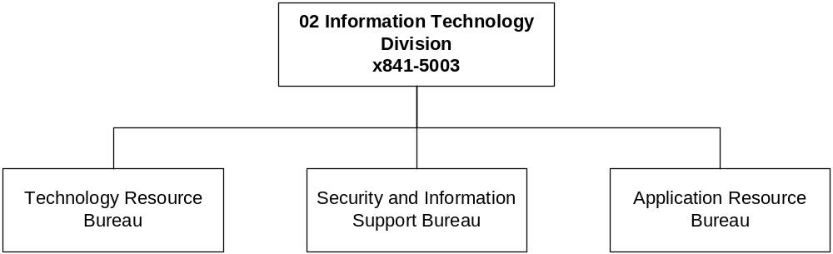

Program Description - The Information Technology Program is responsible for planning, coordinating, delivering, and controlling information resources for the department. The program is responsible for managing all computing services provided to the department, including integrating and managing desktop, mid-tier, and mainframe applications as well as network support services.

Program Proposed Budget  Budget Item | Base  Budget  Fiscal 2002 | PL Base Adjustment  Fiscal 2004 | New  Proposals  Fiscal 2004 | Total  Exec. Budget  Fiscal 2004 | PL Base Adjustment  Fiscal 2005 | New  Proposals  Fiscal 2005 | Total  Exec. Budget  Fiscal 2005
FTE | 36.25 | 0.00 | 0.00 | 36.25 | 0.00 | 0.00 | 36.25
Personal Services | 1,711,360 | 154,170 | 0 | 1,865,530 | 154,437 | 0 | 1,865,797
Operating Expenses | 793,176 | 355,707 | 300,000 | 1,448,883 | 113,118 | 300,000 | 1,206,294
Equipment | 20,047 | 0 | 0 | 20,047 | 0 | 0 | 20,047
Total Costs | $2,524,583 | $509,877 | $300,000 | $3,334,460 | $267,555 | $300,000 | $3,092,138
General Fund | 2,078,658 | 708,192 | 300,000 | 3,086,850 | 465,870 | 300,000 | 2,844,528
Federal Special | 374,214 | (190,849) | 0 | 183,365 | (190,849) | 0 | 183,365
Proprietary | 71,711 | (7,466) | 0 | 64,245 | (7,466) | 0 | 64,245
Total Funds | $2,524,583 | $509,877 | $300,000 | $3,334,460 | $267,555 | $300,000 | $3,092,138

--------------------------------- Present Law Adjustments --------------------------------

Total Agency Impact | General Fund Total
FY04 $250,000 | FY04 $250,000
FY05 $0 | FY05 $0
PL- 203 - Oracle Upgrade for POINTS (Restricted/Bien/OTO) -
The last upgrade to the POINTS Oracle software, from version 6.0 to 6i, was performed early in FY 2001. That project required a team of 10 developers for five months and cost approximately $225,000.

The DOR anticipates that future upgrades to Oracle software will occur on a two-three year cycle, with a similar level of effort, and require costs in the range of $250,000 - $300,000. Base year FY 2002 does not include funding for Oracle software upgrades. To maintain currency DOR must plan for one Oracle upgrade for the 2005 biennium.

---------------------------------------- New Proposals ----------------------------------------

Total Agency Impact | General Fund Total
FY04 $300,000 | FY04 $300,000
FY05 $300,000 | FY05 $300,000
NP- 210 - Discontinuing POINTS Phase II -
See NP-809 for the related costs in program 08 (Compliance, Valuation, and Resolution) associated to discontinuing POINTS phase II.

Additional Funding for POINTS Maintenance
Currently the department has 18.00 FTE in the Information Technology Applications Process. This number includes 16 programmer analysts and two managers. Of those, 11 programmer analysts and one manager are assigned to POINTS maintenance, augmented for the past three years by a 12 member full-time IT consultant and professional staff. This staffing level was consistent with the large-scale development effort the department had undertaken during this period. With the decision not to pursue funding to implement Phase II of the POINTS project, contractor-staffing levels will be reduced to five contract programmers. This combination of FTE and supplemental IT consultant and professional staff will be needed to perform POINTS maintenance over the next biennium.

The FY 2002 base funding for IT consultant and professional staff in the department IT program was $329,000. These funds are used to contract for specific skill sets through the MIS services contract. Services include development, analysis and programming in the following areas: maintaining the Oracle based One Stop Licensing System; visual basic programming and development; POINTS production recovery functions and peak processing support; interface analysis and programming between mainframe and Oracle environments; Database Administration for POINTS and legacy systems.

The skill areas shown above are either under represented or not resident within the department IT staff. Additional funding of $250,000 each year of the biennium will retain "resident" expert contract developers and programmer/analysts for highly complex modules in POINTS such as accounting, returns processing, case management, and forms & correspondence. This amount, when added to base funding, will cover the costs of five full-time IT consultant and professional staff at current MIS services contract rates.

Increased Mid-Tier Service Level Agreement Costs
Within state government the department is responsible for the largest share of payments for ITSD hosted mid-tier support through Service Level Agreements (SLA). The department's costs in base year FY 2002 for mid-tier services were approximately $720,000 divided between development efforts paid for from bonded funds and production expenditures from HB 2 funds. With the decision not to pursue funding to implement Phase II of the POINTS project the sizing of the department's mid-tier needs will be adjusted downward. Nonetheless, the base level funding will be insufficient to cover anticipated FY 2004 and FY 2005 requirements. The precise amount is a function of mid-tier space required to support the application and the rate structure established by ITSD.

With these anticipated reductions in the department's needs for the 2005 biennium, at current rates, estimated mid-tier costs would be more than $600,000 annually. Since the mid-tier environment is shared among many agencies, and rates are computed based on a percentage of the cost recovery method ITSD has in place, there could also be an increase in these rates for other agencies.

Given our estimates of department database needs, along with potential changes in rate calculations, the department estimates that an increase over the base year FY 2002 for mid-tier support will be $50,000 each year of the biennium.

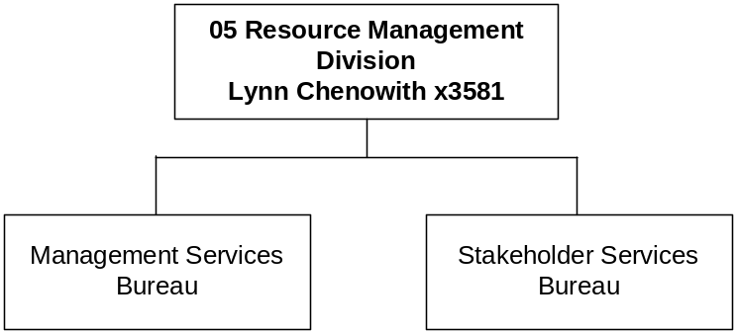

Program Description - The Resource Management Program provides service and support to the department by integrating the human resources, accounting, facilities management, communications, and training and education functions of the department. The Liquor Distribution unit is managed in this program.

Program Proposed Budget  Budget Item | Base  Budget  Fiscal 2002 | PL Base Adjustment  Fiscal 2004 | New  Proposals  Fiscal 2004 | Total  Exec. Budget  Fiscal 2004 | PL Base Adjustment  Fiscal 2005 | New  Proposals  Fiscal 2005 | Total  Exec. Budget  Fiscal 2005
FTE | 39.50 | 0.00 | (1.00) | 38.50 | 0.00 | (1.00) | 38.50
Personal Services | 1,679,893 | 67,535 | (31,651) | 1,715,777 | 69,573 | (31,620) | 1,717,846
Operating Expenses | 560,745 | (21,317) | (2,652) | 536,776 | (15,641) | (2,652) | 542,452
Equipment | 41,816 | 0 | 0 | 41,816 | 0 | 0 | 41,816
Total Costs | $2,282,454 | $46,218 | ($34,303) | $2,294,369 | $53,932 | ($34,272) | $2,302,114
General Fund | 1,172,470 | (77,395) | (34,303) | 1,060,772 | (75,906) | (34,272) | 1,062,292
Federal Special | 0 | 97,296 | 0 | 97,296 | 97,296 | 0 | 97,296
Proprietary | 1,109,984 | 26,317 | 0 | 1,136,301 | 32,542 | 0 | 1,142,526
Total Funds | $2,282,454 | $46,218 | ($34,303) | $2,294,369 | $53,932 | ($34,272) | $2,302,114

Please note that a HB 576 section exists for this program.

--------------------------------- Present Law Adjustments --------------------------------

Total Agency Impact | General Fund Total
FY04 ($34,303) | FY04 ($34,303)
FY05 ($34,272) | FY05 ($34,272)
NP- 504 - Reduce Agency Support Function-Resource Management -
In order to achieve the required reductions, the department has had to carefully review all roles within the department and put them in priority order as directly related to the core mission of the department. Although the following function in Resource Management is an important support component, it is not as directly connected to the activities of tax compliance and statewide uniform appraisal processes as other positions within the department. The department is proposing in this decision package eliminating a 1.00 FTE Training Officer position.

Due to other budget reductions, the department training program has been reduced and, therefore, a training position can be eliminated. There will be two training positions remaining in the department. One will be devoted primarily to POINTS training and the other will conduct agency-wide training and coordinate role specific training. Only core classes and training deemed immediately critical for our employees to do their jobs will be provided. Some classroom training will be replaced by a more structured on-the-job-training program. Educational programs designed for the public will also be reduced, resulting in a less informed and possibly more frustrated public.
________________________________________________________________________________________________

Language Recommendations – “Liquor division proprietary funds necessary to maintain adequate inventories, pay freight charges, and transfer profit and taxes to appropriate accounts are appropriated from the liquor enterprise fund (06005) to the department in amounts not to exceed $67,588,169 in fiscal year 2004 and $70,782,541 in fiscal year 2005.”

“In the liquor division, upon a termination that requires a payout of accrued leave balances, liquor division proprietary funds are appropriated from the liquor enterprise fund (06005) to the department in the amount equal to the payout of the accrued leave balances, not to exceed $30,000 for each of fiscal years 2004 and 2005.”

“In the event the department is unable to meet statutory service levels due to the increase in demand for liquor products, the department is allowed to hire additional temporary employees or pay overtime, whichever is determined to be the more cost effective, to maintain required service levels to stores. The department is appropriated from the liquor enterprise fund (06005) for additional costs not to exceed $40,000 for each of fiscal years 2004 and 2005.”

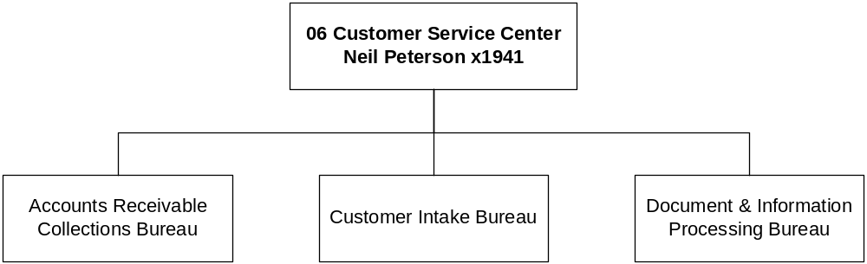

Program Description - The Customer Service Center Program combines the document and information processing, accounts receivable and collections, and customer intake processes into a single business unit designed to collect revenue, process documents, provide taxpayer information and process liquor licenses for the department and agency partners.

Program Indicators -
Indicator | Actual  1999 | Actual  2000 | Actual  2001 | Actual  2002 | 2003  Projected | 2004  Projected | 2005  Projected | 2006  Projected
Customer Service Call Center | 70% | 74% | 79% | 79% | 75% | 75% | 75% | 75%
Timeliness of Refunds | 45 Days | 46 Days | 45 Days | 31 Days | 45 Days | 45 Days | 45 Days | 45 Days
Electronically Filed Tax Returns | 59,300 (29%) | 77,255  (30%) | 109,045  (41%) | **139,500  (28%) | 174,000  (25%) | 208,800  (20%) | 240,120  (15%) | 270,120  (12%)
Employee Retention |  |  | 91% | 92% | 92% | 92% | 92% | 92%
** This is based on estimated electronically filed tax returns for the periods of January through September 2002.

NOTE: This table represents “calendar year” statistics. The figures and percentages identified above are (averages) based on quarterly or yearly statistics.

- Customer Service Call Center – These performance indicators are quality and efficiency measures. They represent the percentage of incoming phone calls answered by call center representatives without transferring them to a specialist. The percentages are based on the overall average and do not include abandoned calls.
- Timeliness of Refunds – These performance indicators are efficiency measures. They represent the average number of days for a tax refund to be issued for paper returns filed. It is based on the timeframe between the applicants’ “date of signature” to the date the refund was issued by the department. Refund claims received early in the filing season are normally processed within a matter of 2 weeks from date of signature. Claims received later in the processing season require a longer turn around time. Taking into account a more representative weighted averaging, internal processing improvements, and the increase utilization of electronic filing, the department expects to make significant improvement in the timeliness of refund processing.
- Electronically Filed Tax Returns – These performance indicators are efficiency measures. They represent the annual increase in the number of electronically filed returns received by the department (E-File, T-File, On-line filing). (**Calendar year 2002 data for this indicator is based on estimates through September.)
- Employee Retention – This performance indicator is a measure of quality for the department. This measures the percent turnover where percent equals the number of positions who vacate and leave the department (not internal movement, nor includes short term, temporary or vacancy savings) over total staff.

Program Proposed Budget  Budget Item | Base  Budget  Fiscal 2002 | PL Base Adjustment  Fiscal 2004 | New  Proposals  Fiscal 2004 | Total  Exec. Budget  Fiscal 2004 | PL Base Adjustment  Fiscal 2005 | New  Proposals  Fiscal 2005 | Total  Exec. Budget  Fiscal 2005
FTE | 119.00 | 1.00 | 0.00 | 120.00 | 1.00 | 0.00 | 120.00
Personal Services | 3,647,992 | 336,106 | 0 | 3,984,098 | 338,914 | 0 | 3,986,906
Operating Expenses | 2,030,746 | 142,433 | (88,000) | 2,085,179 | 159,223 | (97,000) | 2,092,969
Total Costs | $5,678,738 | $478,539 | ($88,000) | $6,069,277 | $498,137 | ($97,000) | $6,079,875
General Fund | 3,798,469 | 361,447 | (88,000) | 4,071,916 | 380,332 | (97,000) | 4,081,801
State/Other Special | 239,943 | 116,454 | 0 | 356,397 | 117,167 | 0 | 357,110
Federal Special | 877,561 | 638 | 0 | 878,199 | 638 | 0 | 878,199
Proprietary | 762,765 | 0 | 0 | 762,765 | 0 | 0 | 762,765
Total Funds | $5,678,738 | $478,539 | ($88,000) | $6,069,277 | $498,137 | ($97,000) | $6,079,875

Please note that a HB 576 section exists for this program.

--------------------------------- Present Law Adjustments --------------------------------

Total Agency Impact | General Fund Total
FY04 $52,446 | FY04 $0
FY05 $52,336 | FY05 $0
PL- 602 - Restore OTO from 03B - Unclaimed Property Auditor -
The Uniform Unclaimed Property Act adopted by the State of Montana July 1, 1997, requires a continuance of its audit program to ensure and increase compliance with the state's unclaimed property laws.

During the 2001 legislative session, the DOR was authorized state special revenue fund appropriation authority and 1.00 FTE for an unclaimed property auditor. This position was established to perform abandoned property audits and increase compliance with Montana's Unclaimed Property Statues. The Legislature identified the position and funding as an OTO, until the outcome of the position could be demonstrated.

In FY 2002, this auditor performed 39 audits with total collections of $218,014. Approximately 40 percent of the collections will be returned to the rightful owner, resulting in an increase of $130,808 in revenue to the State of Montana, of which approximately $44,000 is used to pay for the unclaimed property auditor position and the remainder going to the general fund. Therefore, the total net benefit to the state's general fund is anticipated to be approximately $170,000 for the biennium.

Unclaimed property is a commonly misunderstood and unknown obligation by many businesses. Unclaimed property's anonymous nature requires an active compliance program to ensure property is collected and distributed to its rightful owners. DOR's success in audit assessments is evidence of the need for an audit program; therefore, we are requesting to retain the 1.00 FTE for the unclaimed property auditor.
________________________________________________________________________________________________

Total Agency Impact | General Fund Total
FY04 $11,362 | FY04 $11,362
FY05 $11,481 | FY05 $11,481
PL- 604 - Compliance Staff Operating Costs -
During the August 2002 Special Session, the legislature approved the addition of 13.30 FTE to the DOR. The 13.30 FTE were comprised of 3.30 collectors in the Customer Service Center and 10.00 auditors in the Compliance Valuation & Resolution Program. The purpose of the additional FTE was to increase the DOR compliance staff to enhance individual income tax revenue. The personal services costs related to these FTE have been included in the DOR adjusted base. However, the FY 2002 base does not include for the additional operating costs for to the FTE. The related operating costs are for travel related to audits completed by the auditors, as well as rent, computer, and telephone connections, and supplies for the additional staff.

---------------------------------------- New Proposals ----------------------------------------

Total Agency Impact | General Fund Total
FY04 ($90,000) | FY04 ($90,000)
FY05 ($90,000) | FY05 ($90,000)
NP- 603 - Reduction of Computer Processing -
The department will reduce its ITSD charges over the next biennium by $180,000. The primary reason for this reduction is the running of batch processing jobs during off business hours. The main impact of this change will be a one-day delay in updating our databases. This change will primarily affect the BEV/MOD systems. The department has also looked at storage costs for data and determined there are additional reductions that can be realized in that area.
________________________________________________________________________________________________

Total Agency Impact | General Fund Total
FY04 $27,000 | FY04 $27,000
FY05 $18,000 | FY05 $18,000
NP- 606 - Treasury Offset Program -
The IRS Restructuring and Reform Act of 1998 authorized states to participate in the Federal Refund Offset Program. Under this act, states may now send a list of eligible taxpayers with delinquent state tax debts to the Treasury's Financial Management Service (FMS). FMS will withhold any federal tax refund to be applied against the state tax delinquency. This program is referred to as the Treasury Offset Program (TOP). In late 2000 there were 10 states participating in TOP, in early 2002 there were 23 states participating. According to the federal government there are over 800,000 state tax debts in the TOP database representing $2.9 billion. In FY 2000 the TOP program collections were $24.1 million, and in FY 2001 collections grew to $84.7 million.

We believe that the State of Montana can benefit greatly from TOP as well. Based on the success stories of other states involved in the program, we estimate that federal offset revenues for the State of Montana could be over $450,000 for the biennium. This projection differs from our original estimations because our comparisons are based on statistics from similar states, not statistical averages from all states participating.

We have also scaled back startup costs associated with this program by using TOP's smallest offset system version. Instead of using "Connect Direct" (on-line system) we plan to use their "Connect Mail Box" (standalone PC/modem) version. Using "Connect Mail Box" will reduce the volume of activity we can send back and forth to FMS. Because of this reduction in activity volume, our revenue projections are less than originally anticipated.

Anticipated revenue is $250,000 in FY 2004 and $300,000 in FY 2005 for $550,000 less costs $45,000 = $505,000 net revenue for the biennium.
________________________________________________________________________________________________

Total Agency Impact | General Fund Total
FY04 ($25,000) | FY04 ($25,000)
FY05 ($25,000) | FY05 ($25,000)
NP- 607 - Eliminate GenTran Maintenance Contract -
In base year 2002 the department had a maintenance contract to support the GenTran software. The GenTran software is used to transfer federal withholding tax information from the MTQ 941 quarterly report to the IRS. This software is used once a quarter. It is mature software and the department believes the risks associated with not keeping this maintenance contract are not substantial. In-house technology staff have been trained to support this software, if problems were to arise.

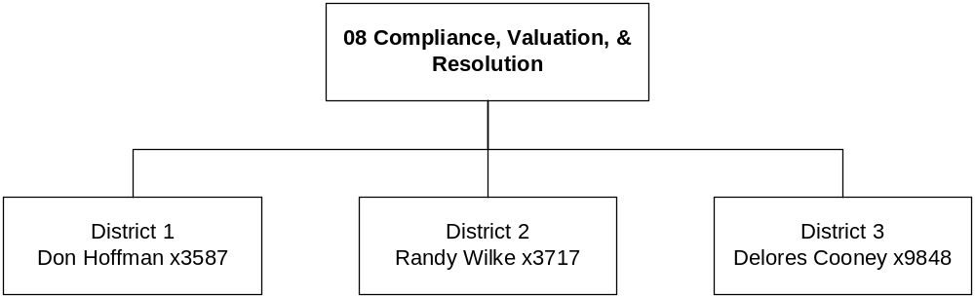

Program Description - The Compliance, Valuation, and Resolution Program administers audits and appraisals to ensure the tax paying entities are in compliance with laws. The program is responsible for consistent valuation of properties statewide for purposes of property taxation. The program is located throughout the state in eight regions to provide efficient operations and customer service.

Program Proposed Budget  Budget Item | Base  Budget  Fiscal 2002 | PL Base Adjustment  Fiscal 2004 | New  Proposals  Fiscal 2004 | Total  Exec. Budget  Fiscal 2004 | PL Base Adjustment  Fiscal 2005 | New  Proposals  Fiscal 2005 | Total  Exec. Budget  Fiscal 2005
FTE | 431.78 | 0.00 | (12.50) | 419.28 | 0.00 | (16.00) | 415.78
Personal Services | 14,942,548 | 1,674,689 | (437,389) | 16,179,848 | 1,673,827 | (552,794) | 16,063,581
Operating Expenses | 4,797,963 | 405,625 | (134,410) | 5,069,178 | 464,045 | (148,019) | 5,113,989
Equipment | 16,180 | 0 | 0 | 16,180 | 0 | 0 | 16,180
Debt Service | 6,375 | 0 | 0 | 6,375 | 0 | 0 | 6,375
Total Costs | $19,763,066 | $2,080,314 | ($571,799) | $21,271,581 | $2,137,872 | ($700,813) | $21,200,125
General Fund | 18,502,917 | 2,037,800 | (571,799) | 19,968,918 | 2,092,064 | (700,813) | 19,894,168
State/Other Special | 184,242 | 8,517 | 0 | 192,759 | 11,811 | 0 | 196,053
Federal Special | 1,075,907 | 33,997 | 0 | 1,109,904 | 33,997 | 0 | 1,109,904
Total Funds | $19,763,066 | $2,080,314 | ($571,799) | $21,271,581 | $2,137,872 | ($700,813) | $21,200,125

--------------------------------- Present Law Adjustments --------------------------------

Total Agency Impact | General Fund Total
FY04 $84,756 | FY04 $84,756
FY05 $92,659 | FY05 $92,659
PL- 801 - Request for Leased Vehicles -
The department currently operates a fleet of 83 owned vehicles and 74 vehicles leased from the State Motor Pool. During the 2001 legislative session, the DOR was required to mitigate a supplemental appropriation request for the Customer Service Center. Part of the mitigation resulted in the elimination of the department's decision package for additional leased vehicles for the 2003 biennium. The department was provided funding of $14,740 in the first year of the biennium for leased vehicles. This enabled the department to temporarily lease seven vehicles in FY 2002 from the state motor pool. Of the 83 department owned vehicles, currently 43 vehicles have in excess of 100,000 miles.

The department proposes to lease 21 more vehicles from the motor pool over the 2005 biennium. In turn, we propose to dispose of 21 department older less reliable vehicles, maintaining an overall fleet of 157 vehicles. The department owned and leased vehicles are used primarily by staff to perform field inspections, property appraisals, audits of in-state taxpayers, and travel for training and meetings.
________________________________________________________________________________________________

Total Agency Impact | General Fund Total
FY04 $69,230 | FY04 $69,230
FY05 $69,590 | FY05 $69,590
PL- 803 - Compliance Staff Operating Costs -
During the August 2002 Special Session, the Legislature approved the addition of 13.30 FTE to the DOR. The 13.30 FTE were comprised of 3.30 collectors in the Customer Service Center and 10.00 auditors in the Compliance Valuation & Resolution Program. The purpose of the additional FTE was to increase the compliance staff to enhance individual income tax revenue. The personal services costs related to these FTE have been included in the adjusted base. However, the FY 2002 base does not add operating costs for the FTE. The related operating costs are for travel related to audits completed by the auditors as well as, rent, computer and telephone connections, and supplies for the additional staff.
________________________________________________________________________________________________

Total Agency Impact | General Fund Total
FY04 $65,500 | FY04 $65,500
FY05 $65,500 | FY05 $65,500
PL- 804 - Increase in Contract Costs for CAMA System -
This adjustment to accommodate the increased cost of maintaining the legacy Computer Assisted Mass Appraisal System (CAMAS). Based on the recent enhancements to that legacy system made with the funding provided by HB 3, the vendor Cole Layer Trumble (CLT) has now estimated the annual maintenance costs will increase from base year 2002 of $105,200 to $170,700 per year. Given this is a proprietary software application, we do not have the option of performing this maintenance with our own staff. Contracting for this maintenance has been an annual expense for many years; this requests funding on what CLT has now estimated to be the future required level of maintenance.

---------------------------------------- New Proposals ----------------------------------------

Total Agency Impact | General Fund Total
FY04 ($12,600) | FY04 ($12,600)
FY05 ($12,600) | FY05 ($12,600)
NP- 805 - Eliminate Participation in External Organization -
The department currently participates the Federal Tax Administrators (FTA) organization. Participation in this organization allows the state to remain current with best practices, innovative ideas, national trends and provides a critical resource for analyzing and implementing new proposals. Because of budget constraints the department has had limited attendance with this organization over the 2003 biennium.

The department plans to eliminate participation in the FTA organization for the 2005 biennium. Maintaining contacts via publications and e-mail list serves will partially mitigate our inability to maintain active participation in this organization.
________________________________________________________________________________________________

Total Agency Impact | General Fund Total
FY04 ($140,000) | FY04 ($140,000)
FY05 ($140,000) | FY05 ($140,000)
NP- 806 - Reduction of Computer Replacements -
This decision package will reduce technology funding for the department. The department will reduce PC and related hardware purchases over the next biennium by $280,000. This reduction may hinder the department in maintaining a four year replacement cycle. However, given the fact that there may be a reduction in FTE in the department, a reduction of PC purchases over the next biennium appears feasible.
________________________________________________________________________________________________

Total Agency Impact | General Fund Total
FY04 ($14,000) | FY04 ($14,000)
FY05 ($14,000) | FY05 ($14,000)
NP- 807 - Eliminate MOU with Yellowstone County -
In base year 2002 the department had a memo of understanding with Yellowstone County for start-up costs related to the Geographic Information System. In the future the department will provide in-kind services, rather than payment to Yellowstone County; therefore, the department will save $28,000 of operating costs in the 2005 biennium.
________________________________________________________________________________________________

Total Agency Impact | General Fund Total
FY04 ($406,791) | FY04 ($406,791)
FY05 ($531,695) | FY05 ($531,695)
NP- 808 - Reduction of Property Tax Services -
In an effort to meet target budgets from the OBPP, this decision package proposes to reduce staffing in property tax and to eliminate amounts paid to Information Technology Services Division (ITSD) in the Department of Administration for support of the Geographic Information System (GIS) cadastral application.

The reduction in staff and operational expenses contained in this package will reduce property tax staffing levels to the lowest levels in the last ten years. It will have an impact on the department's ability to complete annual appraisal work and on the department's ability to mount future reappraisals.

Reappraisal
With respect to personal services, there are 13.00 FTE associated with this part of the negative decision package. There are six positions that will be eliminated July 1, 2003, and an additional seven positions January 1, 2004. The make-up of those FTE are:
Number of FTE Job Title
1.00 Regional Lead
1.00 Industrial Appraiser
3.00 Specialist
1.00 Property Valuation Specialist
7.00 Appraisers

The staff reductions associated with this decision package will curtail many of the key reappraisal activities associated with market model and income model development. These activities would help the department cost-effectively carry out the next reappraisal.

GIS Service Level Agreement with ITSD
There are no personal services associated with this budget reduction. However, the budget does impact operational expenses in the amount of $91,000.

The department currently has a service level agreement with the Department of Administration, Information Technology Services Division (ITSD), for Geographic Information System cadastral application and database support services. In support of the system, the department agreed to pay $45,500 in both FY 2002 and FY 2003. As part of a prior budget reduction, the department, with the approval of ITSD, will only pay $30,500 in FY 2003. The department's inability to fund maintenance of the GIS section of ITSD may impact the valuable resources and databases developed and maintained by this program. The cadastral maps serve as source documents for locating and valuing property. The GIS applications associated with this effort provide a major portion of the department's quality assurance abilities necessary to confirm appraisal quality.
________________________________________________________________________________________________

Total Agency Impact | General Fund Total
FY04 ($176,391) | FY04 ($176,391)
FY05 ($210,068) | FY05 ($210,068)
NP- 809 - Discontinuing POINTS Phase II -
See NP-210 for the related costs in program 02 (Information Technology) associated to discontinuing POINTS II.

Operating savings associated to discontinuing POINTS Phase II implementation
The decision to discontinue POINTS Phase II presents the opportunity to realize savings in two other areas. The first is a reduction in fixed costs rent for the Armory Building. Currently the department is leasing space in the old National Guard Armory sufficient to house the entire Applications Team, their management, the additional contractors associated to the development project (POINTS II), the business analysts assigned to the project and a team of testers. Once this technical and project team is scaled down, and team members are returned to previous roles within the department, the department will relocate the remaining IT applications team and the testers to existing space in the Liquor Warehouse. Considering an estimated one-time moving cost of $30,000 and rent savings of $198,180 for the biennium, the net negative decision package is $168,180 for the biennium.

The second area of identified savings is a reduction in the size of testing staff. Presently the department has 6.00 FTE assigned to a full time testing team. With the decision to discontinue POINTS II implementation, the need for testers will drop to 1.00 FTE testing lead and 2.00 FTE testers. This smaller team will continue testing responsibilities for any defect or enhancement that is made to the application in production. Therefore, the negative decision package associated to the elimination of 3.00 FTE testers will result in savings of $109,248 in FY 2004 and $109,031 in FY 2005.

------------------ Other Legislation Required to Implement HB 2 ------------------

Total Agency Impact | General Fund Total
FY04 $177,983 | FY04 $177,983
FY05 $207,550 | FY05 $207,550
NP- 8002 - Field Office Rent -
The department pays rent for office space for department staff in county buildings outside of Helena. The department has base year 2002 funding to pay rental costs, but does not have funding to pay increased costs in FY 2004 and FY 2005. Therefore, the department requested additional funding to cover increased field office rent costs in the 2005 biennium.

Section 15-8-102, MCA, provides counties the ability to charge the department rent for space that the department occupies in the county offices. The rate cannot exceed the amount charged by the Department of Administration to other state agencies. This law change was approved in the 1999 session. Prior to that change, counties were required to allow the department to occupy space in the counties without paying rent. This decision package is contingent on passage of legislation freezing the rate the department would pay to the counties for rent at the FY 2003 rate of $4.88/sq ft. This is an increase over base year 2002 funding at a rate of $4.77/sq ft. If this legislation is not passed and this decision package not approved, the department will have to request additional funding of $240,708 in FY 2004 and $281,545 in FY 2005, instead of the amounts currently requested of $177,983 in FY 2004 and $207,550 in FY 2005, a difference of $136,720 over the biennium.

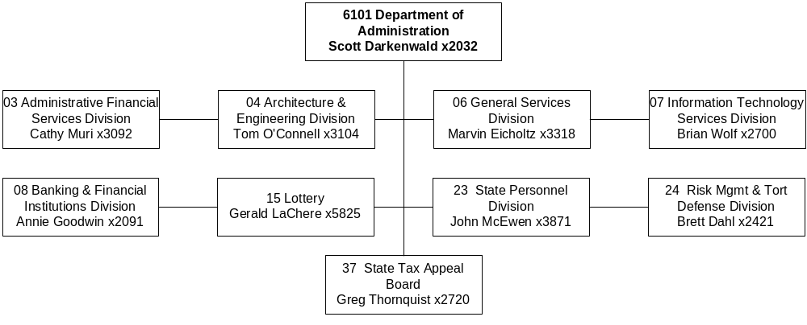
Mission Statement - The Department of Administration seeks to deliver superior and responsive services to agencies, employees and the public while minimizing costs and maximizing effectiveness. These services are delivered through:

1. continuing to refine procedures;
2. fostering government coordination and cooperation;
3. promoting access to services; and
4. developing innovative uses for emerging technologies.

Statutory Authority - Title 2, MCA.

Agency Proposed Budget  Budget Item | Base  Budget  Fiscal 2002 | PL Base Adjustment  Fiscal 2004 | New  Proposals  Fiscal 2004 | Total  Exec. Budget  Fiscal 2004 | PL Base Adjustment  Fiscal 2005 | New  Proposals  Fiscal 2005 | Total  Exec. Budget  Fiscal 2005
FTE | 145.38 | 1.75 | 0.54 | 147.67 | 1.75 | 0.54 | 147.67
Personal Services | 6,146,865 | 967,134 | 105,739 | 7,219,738 | 960,885 | (247,230) | 6,860,520
Operating Expenses | 7,423,915 | 1,111,715 | 1,848,289 | 10,383,919 | 1,248,498 | (224,800) | 8,447,613
Equipment | 462,735 | (414,000) | 0 | 48,735 | (414,000) | 0 | 48,735
Local Assistance | 23,313 | 0 | 0 | 23,313 | 0 | 0 | 23,313
Transfers | 933,055 | 0 | (382,018) | 551,037 | 0 | (382,169) | 550,886
Debt Service | 1,177,627 | 0 | 0 | 1,177,627 | (1,145,577) | 0 | 32,050
Total Costs | $16,167,510 | $1,664,849 | $1,572,010 | $19,404,369 | $649,806 | ($854,199) | $15,963,117
General Fund | 4,195,717 | 439,722 | (860,969) | 3,774,470 | 486,272 | (878,041) | 3,803,948
State/Other Special | 2,673,474 | 638,473 | 300,649 | 3,612,596 | 665,357 | 300,651 | 3,639,482
Federal Special | 503,119 | 29,932 | 2,379,657 | 2,912,708 | 28,944 | 130,531 | 662,594
Capital Projects | 933,055 | 11,542 | (433,055) | 511,542 | 18,369 | (433,055) | 518,369
Proprietary | 7,862,145 | 545,180 | 185,728 | 8,593,053 | (549,136) | 25,715 | 7,338,724
Total Funds | $16,167,510 | $1,664,849 | $1,572,010 | $19,404,369 | $649,806 | ($854,199) | $15,963,117

------------------- Agency General Fund Target - $7.61 million ---------------------



Program Description - The Governor Elect Program pays start-up costs for the incoming Governor, as required by 2-15-221, MCA.

Program Proposed Budget  Budget Item | Base  Budget  Fiscal 2002 | PL Base Adjustment  Fiscal 2004 | New  Proposals  Fiscal 2004 | Total  Exec. Budget  Fiscal 2004 | PL Base Adjustment  Fiscal 2005 | New  Proposals  Fiscal 2005 | Total  Exec. Budget  Fiscal 2005
FTE | 0.00 | 0.00 | 0.00 | 0.00 | 0.00 | 0.00 | 0.00
Operating Expenses | 0 | 0 | 0 | 0 | 50,000 | 0 | 50,000
Total Costs | $0 | $0 | $0 | $0 | $50,000 | $0 | $50,000
General Fund | 0 | 0 | 0 | 0 | 50,000 | 0 | 50,000
Total Funds | $0 | $0 | $0 | $0 | $50,000 | $0 | $50,000

--------------------------------- Present Law Adjustments --------------------------------

Total Agency Impact | General Fund Total
FY04 $0 | FY04 $0
FY05 $50,000 | FY05 $50,000
PL- 201 - Governor-elect appropriation -
Montana statute (2-15-221, MCA) requires the department to provide funding to a governor-elect and his/her staff for the period between the general election and the inauguration in the event of a change in office as a result of the 2004 general election. The department requests $50,000 in FY 2005.

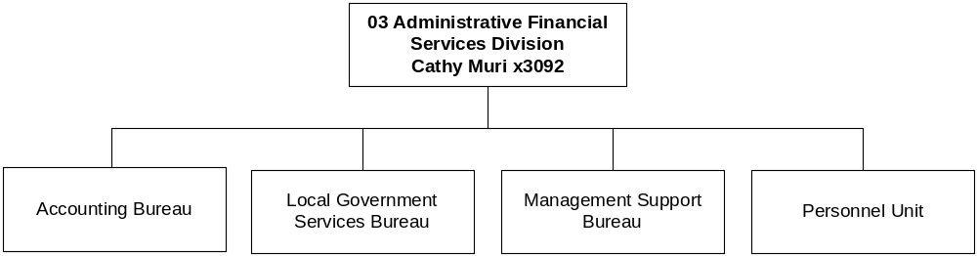

Program Description - The Administrative Financial Services Division consists of several units. The Director's Office is responsible for overall supervision and coordination of agency programs and administratively-attached boards and agencies. The Legal Unit provides legal services to agency and administratively-attached programs. The Accounting Bureau is the process owner of the financial portion of the Statewide Budgeting, Accounting and Human Resource Systems (SABHRS), establishes state accounting policies and procedures, administers the federal Cash Management Improvement Act, processes warrants for all state agencies, and prepares the state Comprehensive Annual Financial Report (CAFR). The Management Support Bureau and Personnel function provides financial, budgeting, accounting, personnel, payroll, and data processing functions for the department. Local Government Services Bureau provides technical assistance and training to local government accounting and financial personnel and defines, reviews and enforces auditing requirements for Montana's local governments. The Consumer Affairs Office advocates on behalf of Montana's consumers in matters of unfair or deceptive acts in the conduct of any business.

The Accounting Bureau participated in the conversion of accounting occupations to the competency project and adjusted pay by $28,517 in FY 2002. These increased expenditures were funded by operating cost savings in excess of $158,000 thereby eliminating the budget impact of the pay adjustments in the 2005 base budget.

Program Indicators -
Indicator | Actual  2000 | Actual  2001 | Actual  2002 | Estimated 2003 | Requested 2004 | Requested 2005
LGS Systems Program On Site Assistance (Hours) | 4340 | 5361 | 5140 | 5700 | 5700 | 5700
LGS Audit Review Program Local Government Audits | 455 | 449 | 471 | 470 | 470 | 470

LGS Audit Review Program
The number of audits reported above as actual for FY 2000, FY 2001, and FY 2002 represents the number of audit reports actually received by the program during those three fiscal years. The audits received during FY 2000 actually covered FY 1999, or were biennial audits and covered FY 1998 and FY 1999. The audits received during FY 2001 actually covered FY 2000, or were biennial audits and covered FY 1999 and FY 2000. The audits received during FY 2002 actually covered FY01, or were biennial audits and covered FY 2000 and FY 2001. Since audits are always conducted after the close of the last fiscal year of the audit period, there is always a lag in the time taken to perform the audits and when the audits are submitted to the program.

Program Proposed Budget  Budget Item | Base  Budget  Fiscal 2002 | PL Base Adjustment  Fiscal 2004 | New  Proposals  Fiscal 2004 | Total  Exec. Budget  Fiscal 2004 | PL Base Adjustment  Fiscal 2005 | New  Proposals  Fiscal 2005 | Total  Exec. Budget  Fiscal 2005
FTE | 31.92 | 1.75 | (6.33) | 27.34 | 1.75 | (6.33) | 27.34
Personal Services | 1,435,246 | 216,453 | (393,143) | 1,258,556 | 213,824 | (392,130) | 1,256,940
Operating Expenses | 452,632 | 54,071 | 45,111 | 551,814 | 30,333 | 44,259 | 527,224
Local Assistance | 22,133 | 0 | 0 | 22,133 | 0 | 0 | 22,133
Total Costs | $1,910,011 | $270,524 | ($348,032) | $1,832,503 | $244,157 | ($347,871) | $1,806,297
General Fund | 1,774,799 | 140,340 | (450,028) | 1,465,111 | 120,432 | (449,869) | 1,445,362
State/Other Special | 54,405 | 104,581 | 1,922 | 160,908 | 98,324 | 1,924 | 154,653
Federal Special | 39,775 | 22,859 | 100,074 | 162,708 | 22,745 | 100,074 | 162,594
Proprietary | 41,032 | 2,744 | 0 | 43,776 | 2,656 | 0 | 43,688
Total Funds | $1,910,011 | $270,524 | ($348,032) | $1,832,503 | $244,157 | ($347,871) | $1,806,297

Please note that a HB 576 section exists for this program.

--------------------------------- Present Law Adjustments --------------------------------

Total Agency Impact | General Fund Total
FY04 $6,333 | FY04 $6,333
FY05 $6,460 | FY05 $6,460
PL- 301 - Rent Increase LGS -
The Management Services Program of the Local Government Services Bureau is requesting additional authority for the upcoming rent increase for the space they occupy in the old federal building. This increase will be paid from the general fund and the estimated biennial cost for this increase will be $12,793.
________________________________________________________________________________________________

Total Agency Impact | General Fund Total
FY04 $38,090 | FY04 $38,090
FY05 $28,070 | FY05 $28,070
PL- 306 - Fund Burial Preservation Board -
The Burial Preservation Board was transferred from the Department of Commerce to the Department of Administration by Chapter 483, Laws of 2001. However, the Department of Administration received no funding for the board for the 2003 biennium. In addition, the Montana Repatriation Act was enacted in Chapter 558, Laws of 2001, to provide a mechanism to repatriate culturally-affiliated human skeletal remains or funerary objects taken from burial sites. The act requires the extensive drafting and adoption of administrative rules to carry out the mission. The act envisions that museums and other persons who are in possession of remains and objects shall have inventoried them and turned those inventories over to the board. The board has substantial duties determining claims made by Native Americans for the return of those remains and objects. The board must employ attorney hearing officers (22-3-913, MCA) to conduct hearings. The request is for 0.25 FTE administrative support and professional services for an attorney to staff the board to carry out these duties at a biennial cost of $66,160.
________________________________________________________________________________________________

Total Agency Impact | General Fund Total
FY04 $77,290 | FY04 $0
FY05 $71,111 | FY05 $0
PL- 307 - Increase FTE for Consumer Protection -
In order to handle the increasing workload caused by fully enforcing the Consumer Protection Act, additional staffing is needed. The request is for 1.00 FTE paralegal and 1.00 FTE investigator at a biennial cost of $148,401.
________________________________________________________________________________________________

Total Agency Impact | General Fund Total
FY04 $20,111 | FY04 ($10,120)
FY05 $20,074 | FY05 ($10,163)
PL- 309 - Indirect Fixed Costs -
Fund changes in department indirect/administrative costs for services received from other proprietary funded centralized service functions of the agency.
________________________________________________________________________________________________

Total Agency Impact | General Fund Total
FY04 $0 | FY04 $0
FY05 ($2,450) | FY05 ($2,450)
PL- 310 - Police Retirement Fund Reduction -
The actuarial report on the Police Retirement Fund is only done once a biennium. The actuarial report indicates funding for FY 2005 is not needed.

---------------------------------------- New Proposals ----------------------------------------

Total Agency Impact | General Fund Total
FY04 $100,000 | FY04 $0
FY05 $100,000 | FY05 $0
NP- 303 - Return Federal Portion of State Fund Dividend -
The State Fund periodically issues dividends to state agencies for good experience on workers' compensation claims. The federal government has requested the State Fund dividends returned to state agencies on behalf of federal programs be returned to the Health and Human Services Federal Program through a warrant. The current practice is that state agencies reduce draw downs of federal funds on individual programs by the amount of the State Fund dividend, which is difficult for their federal agencies to track. Estimated costs for the 2005 biennium will be $200,000.
________________________________________________________________________________________________

Total Agency Impact | General Fund Total
FY04 ($16,745) | FY04 ($16,745)
FY05 ($16,696) | FY05 ($16,696)
NP- 311 - Fund Switch 0.33 FTE -
It is recommended to fund 0.33 FTE of an existing 1.00 FTE in accounting (general fund) with warrant writer proprietary fund. This position currently has oversight responsibility for warrant writer, and this fund switch aligns the funding to be consistent with those duties. Since the general fund portion of this position is HB 2 authority and the proprietary portion is HB 576, there are two separate decision packages to accomplish this funding switch. See NP-312 in the proprietary section for the remainder of this fund switch.
________________________________________________________________________________________________

Total Agency Impact | General Fund Total
FY04 ($456,981) | FY04 ($456,981)
FY05 ($456,897) | FY05 ($456,897)
NP- 315 - Indirect Cost Allocation -
There is a funding change for the Director's Office and the Management Support Bureau in accordance with HB 21 adopted in the special session. NP-315 reduces HB 2 FTE that are proprietary funded in NP-316. Divisions within the department will share the cost of the Director's Office and will pay for budget work, fiscal note coordination and bill paying (those without accounting staff). NP-317 (HB 2) and NP-318 (HB 576) distribute the budget to programs in the department and give them authority to pay for the indirect cost recovery. This indirect cost recovery is also an audit recommendation.
________________________________________________________________________________________________

Total Agency Impact | General Fund Total
FY04 $25,694 | FY04 $23,698
FY05 $25,722 | FY05 $23,724
NP- 317 - Indirect Cost Allocation -
There is a funding change for the Director's Office and the Management Support Bureau. NP-315 reduces HB 2 FTE that are proprietary funded in NP-316. Divisions within the department will share the cost of the Director's Office and will pay for budget work, fiscal note coordination and bill paying (those without accounting staff). NP-317 (HB 2) and NP-318 (HB 576) distribute budget to programs in the department and give them authority to pay for the indirect recovery. This indirect cost recovery is also an audit recommendation.
________________________________________________________________________________________________

Language Recommendations - "Item 1 includes $267,661 general fund in fiscal year 2004 and $257,641 general fund in fiscal year 2005. In accordance with section 17-2-108 MCA, the general fund is to be reduced by the amount of money received from nonfederal sources and the state special revenue increased by a like amount, as approved by the approving authority. Decision package 309 in the consumer affairs function within administrative financial services requests a fund switch from state special revenue to general fund. In fiscal year 2002, the consumer protection counsel brought in $526,000 to the general fund."

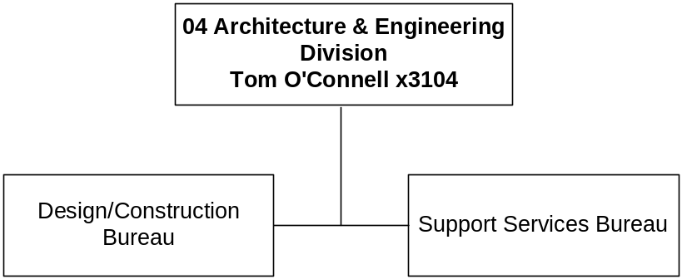

Program Description - The Architecture and Engineering Division (A&E) manages remodeling and construction of state buildings. Its functions include planning new projects and remodeling projects; advertising, bidding, and awarding construction contracts; administering contracts with architects, engineers, and contractors; disbursing building construction payments; and providing design services for small projects. The division also formulates a long-range building plan for legislative consideration each session. This division operates under the authority found in Titles 17 and 18, MCA, as well as other state mandates.

Program Proposed Budget  Budget Item | Base  Budget  Fiscal 2002 | PL Base Adjustment  Fiscal 2004 | New  Proposals  Fiscal 2004 | Total  Exec. Budget  Fiscal 2004 | PL Base Adjustment  Fiscal 2005 | New  Proposals  Fiscal 2005 | Total  Exec. Budget  Fiscal 2005
FTE | 17.00 | 0.00 | 0.00 | 17.00 | 0.00 | 0.00 | 17.00
Personal Services | 794,977 | 132,413 | 0 | 927,390 | 131,293 | 0 | 926,270
Operating Expenses | 296,554 | (470) | 8,298 | 304,382 | 8,369 | 8,294 | 313,217
Total Costs | $1,091,531 | $131,943 | $8,298 | $1,231,772 | $139,662 | $8,294 | $1,239,487
State/Other Special | 1,091,531 | 120,401 | 8,298 | 1,220,230 | 121,293 | 8,294 | 1,221,118
Capital Projects | 0 | 11,542 | 0 | 11,542 | 18,369 | 0 | 18,369
Total Funds | $1,091,531 | $131,943 | $8,298 | $1,231,772 | $139,662 | $8,294 | $1,239,487

--------------------------------- Present Law Adjustments --------------------------------

Total Agency Impact | General Fund Total
FY04 ($7,231) | FY04 $0
FY05 ($7,234) | FY05 $0
PL- 401 - Other Fixed Costs -
Fund changes in department indirect/administrative costs for services received from other proprietary funded centralized service functions of the agency.

---------------------------------------- New Proposals ----------------------------------------

Total Agency Impact | General Fund Total
FY04 $8,298 | FY04 $0
FY05 $8,294 | FY05 $0
NP- 318 - Indirect Cost Allocation -
To implement the funding change for the Director's Office and the Management Support Bureau, there is NP-315 to reduce HB 2 FTE that are proprietary funded in NP-316. A&E will share the cost of the Director's Office and pay for budget work and fiscal note coordination. NP-318 gives the authority to pay for the indirect recovery. This indirect cost recovery is also an audit recommendation.

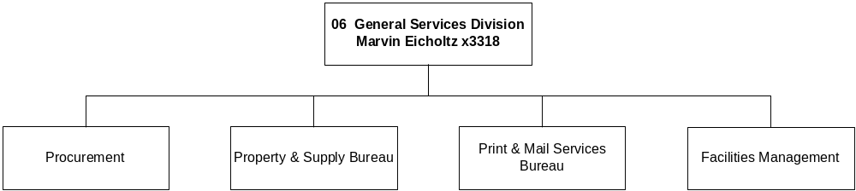
Program Description - The General Services Division is composed of four bureaus responsible for providing certain internal services to government agencies and the public. The Facilities Management Bureau manages the following services for state agencies in the capitol complex and several state-owned buildings in the Helena area either directly or through the administration of service contracts: repair, maintenance, construction, energy consumption, disaster response and recovery, space allocation, lease negotiation, security, janitorial, recycling, pest control, and garbage collection. The State Procurement Bureau procures or supervises the procurement of all supplies and services needed by the state and provides technical assistance to government agencies and the public to ensure compliance with the Montana Procurement Act. In addition, the bureau manages the state's vehicle fueling, energy procurement, and procurement card functions. The state general fund is reimbursed for a portion of the Bureau's administrative expenditures through the statewide cost allocation plan. The Print and Mail Services Bureau provides printing services to state agencies by operating a central facility for duplicating and binding, desktop publishing, layout and design, graphic illustration, and forms design. It operates three quick copy centers, administers the state photocopy pool, and approves the procurement of all printing and printing-related purchases for state agencies. Mail services for state agencies in the Helena area are provided through a centralized facility that manages incoming, outgoing, and interagency mail. In addition, the bureau operates a full service contract United States post office in the state capitol building. The Property and Supply Bureau manages the Central Stores program and the State and Federal Surplus Property programs. In addition, the division manages the state's vehicle fueling, energy procurement, and procurement card functions.

Program Indicators -
Indicator | Actual FY2000 | Actual FY2001 | Actual FY2002 | Estimated FY2003 | Requested FY2004 | Requested FY2005
Work Orders Issued | 6,159 | 6,205 | 5,397 | 6,750 | 5,397 | 6,750
Active Leases | 220 | 196 | 220 | 250 | 250 | 250
Number of Buildings serviced by GSD staff | 44 | 44 | 44 | 45 | 45 | 45

Program Proposed Budget  Budget Item | Base  Budget  Fiscal 2002 | PL Base Adjustment  Fiscal 2004 | New  Proposals  Fiscal 2004 | Total  Exec. Budget  Fiscal 2004 | PL Base Adjustment  Fiscal 2005 | New  Proposals  Fiscal 2005 | Total  Exec. Budget  Fiscal 2005
FTE | 10.05 | 0.00 | (0.50) | 9.55 | 0.00 | (0.50) | 9.55
Personal Services | 419,643 | 21,422 | (25,607) | 415,458 | 20,708 | (25,515) | 414,836
Operating Expenses | 465,124 | 57,910 | (404,480) | 118,554 | 73,245 | (421,785) | 116,584
Transfers | 933,055 | 0 | (382,018) | 551,037 | 0 | (382,169) | 550,886
Debt Service | 32,050 | 0 | 0 | 32,050 | 0 | 0 | 32,050
Total Costs | $1,849,872 | $79,332 | ($812,105) | $1,117,099 | $93,953 | ($829,469) | $1,114,356
General Fund | 916,817 | 79,332 | (379,050) | 617,099 | 93,953 | (396,414) | 614,356
Capital Projects | 933,055 | 0 | (433,055) | 500,000 | 0 | (433,055) | 500,000
Total Funds | $1,849,872 | $79,332 | ($812,105) | $1,117,099 | $93,953 | ($829,469) | $1,114,356

Please note that a HB 576 section exists for this program.
--------------------------------- Present Law Adjustments --------------------------------

Total Agency Impact | General Fund Total
FY04 ($761) | FY04 ($761)
FY05 ($777) | FY05 ($777)
PL- 601 - Adjust Management Services Fixed Costs -
Fund changes in department indirect/administrative costs for services received from other proprietary funded centralized services functions of the agency.

---------------------------------------- New Proposals ----------------------------------------

Total Agency Impact | General Fund Total
FY04 $7,677 | FY04 $7,677
FY05 $7,685 | FY05 $7,685
NP- 317 - Indirect Cost Allocation -
This action is related to the funding change for the Director's Office and the Management Support Bureau that will provide for indirect cost recovery in compliance with statutory direction from the special session and an audit recommendation.
________________________________________________________________________________________________

Total Agency Impact | General Fund Total
FY04 ($852,912) | FY04 ($419,857)
FY05 ($866,925) | FY05 ($433,870)
NP- 611 - Use Capitol Land Grant for Major Maintenance -
In the 2005 biennium, transfer $1 million of Capitol Land Grant fund 05008 (CLG) to the Facilities Management Bureau to fund major maintenance. The Enabling Act only allows for specific uses of these CLG funds, one of which is major maintenance (i.e., permanent improvement of state buildings). In the 2003 biennium, the bureau was supported with $1,866,110 of CLG for major maintenance, but less funds are available this biennium because less fire salvage timber has been harvested.
________________________________________________________________________________________________

Total Agency Impact | General Fund Total
FY04 $0 | FY04 $0
FY05 $0 | FY05 $0
NP- 612 - Transfer & Fund FTE in Fueling Program -
Transfer funding from Procurement Bureau to Statewide Fueling Network Program for Position 61104004 in response to Legislative Audit recommendations.
________________________________________________________________________________________________

Total Agency Impact | General Fund Total
FY04 $33,130 | FY04 $33,130
FY05 $29,771 | FY05 $29,771
NP- 614 - FTE for PeopleSoft Procurement Module -
The State Procurement Bureau is the "process owner" for the PeopleSoft Purchasing Module. After three years of working with the software, it has been determined that additional technical expertise is needed for the bureau and the state agencies to take advantage of the full functionality of the software. Managing data, trouble-shooting hardware and software problems, testing upgrades and software fixes, training bureau and agency staff, and adapting internal processes to the software requirements are all responsibilities that are not being met with existing staff. Request is for 0.50 FTE and the related operating costs.

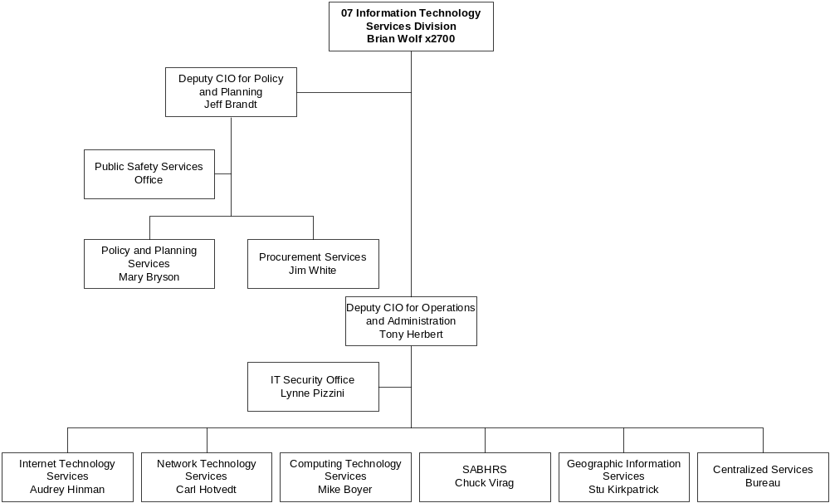

Program Description - Information Technology Services Division (ITSD) is a proprietary program that manages central computing and telecommunications services for state government. ITSD provides central mainframe and mid-tier computer services, and manages the statewide data network SummitNet used by all agencies throughout the state. ITSD provides local and long-distance telephone network services used by all agencies, including the university system, and manages the state's video network METNET. ITSD coordinates electronic government services for the state, and manages the states Internet presence discoveringmontana.com. ITSD also manages the Statewide Accounting, Budgeting, and Human Resources Systems (SABHRS) system for the state.

Through the office of the Chief Information Officer, the division develops the Statewide Strategic IT Plan, coordinates information technology for the state, and reviews and approves equipment and software acquisitions. The division also provides statewide information technology training, and supports consulting services contracts used by agencies in support of IT systems. .

The division also coordinates Geographic Information Systems (GIS) development, manages the state's 911 programs, and coordinates Public Safety Communications issues.

Program Proposed Budget  Budget Item | Base  Budget  Fiscal 2002 | PL Base Adjustment  Fiscal 2004 | New  Proposals  Fiscal 2004 | Total  Exec. Budget  Fiscal 2004 | PL Base Adjustment  Fiscal 2005 | New  Proposals  Fiscal 2005 | Total  Exec. Budget  Fiscal 2005
FTE | 2.00 | 0.00 | 3.00 | 5.00 | 0.00 | 3.00 | 5.00
Personal Services | 93,940 | 14,425 | 353,583 | 461,948 | 14,100 | 0 | 108,040
Operating Expenses | 497,212 | 21,709 | 1,926,929 | 2,445,850 | 18,722 | 31,386 | 547,320
Total Costs | $591,152 | $36,134 | $2,280,512 | $2,907,798 | $32,822 | $31,386 | $655,360
General Fund | 127,808 | 29,061 | 929 | 157,798 | 26,623 | 929 | 155,360
Federal Special | 463,344 | 7,073 | 2,279,583 | 2,750,000 | 6,199 | 30,457 | 500,000
Total Funds | $591,152 | $36,134 | $2,280,512 | $2,907,798 | $32,822 | $31,386 | $655,360

Please note that a HB 576 section exists for this program.

--------------------------------- Present Law Adjustments --------------------------------

Total Agency Impact | General Fund Total
FY04 $1,436 | FY04 $1,436
FY05 $1,439 | FY05 $1,439
PL- 707 - Allocation of Indirect/Administrative Costs -
Allocation of indirect/administrative costs from Management Support.

---------------------------------------- New Proposals ----------------------------------------

Total Agency Impact | General Fund Total
FY04 $929 | FY04 $929
FY05 $929 | FY05 $929
NP- 317 - Indirect Cost Allocation - HB 2 -
This action is related to the funding change for the Director's Office and the Management Support Bureau that will provide for indirect cost recovery in compliance with statutory direction from the special session and an audit recommendation.
________________________________________________________________________________________________

Total Agency Impact | General Fund Total
FY04 $2,250,000 | FY04 $0
FY05 $0 | FY05 $0
NP- 701 - Public Safety Communications (Biennial) -
The state is required to take a leadership role with regard to planning for public safety communications systems used by state, local and federal entities in Montana. Implementing standards and interoperable systems are objectives that need to be met, as well as integrating radio, 911, and GIS technologies for improved emergency response for the public. This decision package requests $2,250,000 biennial federal authority.
________________________________________________________________________________________________

Total Agency Impact | General Fund Total
FY04 $29,583 | FY04 $0
FY05 $30,457 | FY05 $0
NP- 709 - Statewide Roadway Centerline GIS - HB 2 -
The Montana Geographic Information Council has determined that a statewide standardized, addressed, digital transportation database is a top priority in the overall development of the Montana Spatial Data Infrastructure (MSDI). This item requests a portion of the funding required to continue to coordinate an enterprise effort to build, maintain and distribute digital transportation data. This request includes $500,000 in HB 2 federal funding each year of which there is a base expenditure of $463,344 carried forward each year. In related decision package NP-702, ITSD is requesting proprietary funding of $260,395 in FY 2004 and $259,204 in FY 2005.

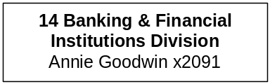

Program Description - The Division of Banking and Financial Institutions licenses, supervises, regulates and examines a variety of financial institutions operating in Montana. At present those institutions include 68 banks and trust companies, including 192 branch banks; 14 credit unions; 289 consumer finance companies; 155 sales finance companies; 82 deferred deposit lenders; 36 title loan companies; and 10 escrow companies. The division also would be responsible for the supervision, regulation and examination of any institutions operating under the state's savings and loan laws or the Foreign Capital Depository Act. All program functions are statutorily mandated in Titles 2, 31 and 32, MCA.

Supervision of regulated financial institutions is accomplished primarily through examinations. The safety and soundness of Montana state chartered banks, which hold in excess of $8.2 billion in deposits as of December 31, 2001, is under the supervision of the division. Banks are statutorily required to be examined at least once every 24 months. Credit unions, consumer loan, deferred deposit and title loan companies are to be examined annually. Escrow companies may be examined as necessary. Examinations investigate the methods of operation, review compliance with state and federal financial and banking laws and regulations, and, for the protection of bank and credit union depositors, determine whether the institutions are operating in a safe and sound manner. The division also provides a consumer complaint process to resolve matters with the regulated financial institutions.

The State Banking Board is administratively attached to the division. The board is responsible for making final determinations of applications for new bank charters and foreign capital depository charters; hearing appeals of division decisions on branch bank, merger, or relocation applications; and also acts in an advisory capacity with respect to the duties and powers given by statute or otherwise to the department as the duties and powers relate to banking and to the regulation of foreign capital depositories.

The Division of Banking and Financial Institutions has experienced significant recruitment and retention problems in prior years in its efforts to development and maintain a qualified, effective examination staff. Continued turnover and recruiting of senior staff by the private sector were addressed in FY02 by competency pay adjustments. These pay adjustments - supported by the regulated industry -- have provided staff retention and stable staffing, and allowed the Division's duties to be completed within statutory timeframes. The 2005 budget request continues to provide pay adjustment funding to recognize and reward professional growth among staff as they complete additional levels of examination training and assume greater job duties.

Program Indicators -
Indicator | Actual  FY2000 | Actual  FY2001 | Actual  FY2002 | Estimated FY2003 | Requested FY2004 | Requested FY2005
Examinations performed | 55 | 81 | 80 | 165 | 170 | 170
Licenses issued | 548 | 602 | 696 | 690 | 700 | 700

Program Proposed Budget  Budget Item | Base  Budget  Fiscal 2002 | PL Base Adjustment  Fiscal 2004 | New  Proposals  Fiscal 2004 | Total  Exec. Budget  Fiscal 2004 | PL Base Adjustment  Fiscal 2005 | New  Proposals  Fiscal 2005 | Total  Exec. Budget  Fiscal 2005
FTE | 24.25 | 0.00 | 5.50 | 29.75 | 0.00 | 5.50 | 29.75
Personal Services | 1,042,064 | 332,264 | 215,911 | 1,590,239 | 330,802 | 215,287 | 1,588,153
Operating Expenses | 458,121 | 81,227 | 71,476 | 610,824 | 114,938 | 71,199 | 644,258
Total Costs | $1,500,185 | $413,491 | $287,387 | $2,201,063 | $445,740 | $286,486 | $2,232,411
State/Other Special | 1,500,185 | 413,491 | 287,387 | 2,201,063 | 445,740 | 286,486 | 2,232,411
Total Funds | $1,500,185 | $413,491 | $287,387 | $2,201,063 | $445,740 | $286,486 | $2,232,411

--------------------------------- Present Law Adjustments --------------------------------

Total Agency Impact | General Fund Total
FY04 ($40,513) | FY04 $0
FY05 ($40,514) | FY05 $0
PL- 1401 - Indirect Administrative Costs -
Decrease in department indirect/administrative costs for services received from other proprietary funded centralized service functions of the agency.
________________________________________________________________________________________________

Total Agency Impact | General Fund Total
FY04 $139,000 | FY04 $0
FY05 $139,000 | FY05 $0
PL- 1402 - Financial Institution Examiner Career Ladder -
Request is to fund the salary proposal approved for use when the Division of Banking and Financial Institutions moved its financial institution examination personnel to a Professional Financial Institution Examiner Career Ladder Plan. The plan recognizes that the division's significant investment of time and training for its examiners, and the "attractiveness" of fully-trained examiners to competing private sector employers. Estimated biennial costs for the career ladder plan will be $278,000.
________________________________________________________________________________________________

Total Agency Impact | General Fund Total
FY04 $79,392 | FY04 $0
FY05 $81,252 | FY05 $0
PL- 1403 - Rent Increase for the Helena Office -
The division is requesting funding to pay increased rent resulting from relocation in FY 2002. The lease for the current building expires June 30, 2002, with no option of renewal or extension. Although the move was anticipated, no appropriation for the relocation was approved by the 2001 Legislature. This division will be relocating to the old federal building in Helena and the monthly rent is significantly higher than at the current location. Estimated additional rental costs for the 2005 biennium will be $160,644.
________________________________________________________________________________________________

Total Agency Impact | General Fund Total
FY04 $0 | FY04 $0
FY05 $28,000 | FY05 $0
PL- 1405 - Fund Accreditation Review of the Division -
The division requests funding to pay for an accreditation assessment performed by the Conference of State Bank Supervisors to help put the division and its employees in good standing with banking institutions and the taxpayers of Montana. The estimated biennial cost of $28,000 will pay the expenses of the accreditation team during their on-site assessment of the division, pay for the preparation of the report of findings and recommendation, and pay the costs of the meeting of the Accreditation Committee. This will not require any increase in the fees or charges against regulated businesses.
________________________________________________________________________________________________

Total Agency Impact | General Fund Total
FY04 $20,676 | FY04 $0
FY05 $22,138 | FY05 $0
PL- 1406 - Lease Motor Pool Vehicles -
The division is requesting funding to lease four additional passenger vehicles from the State Motor Pool beginning in FY 2004. Travel is a significant part of the bank examiners' jobs, and in recent years examiners' personal vehicles have become increasingly unsuitable for efficiently moving the necessary people and equipment to a job site. Estimated biennial costs for the additional vehicles will be $42,814.

---------------------------------------- New Proposals ----------------------------------------

Total Agency Impact | General Fund Total
FY04 $22,078 | FY04 $0
FY05 $22,101 | FY05 $0
NP- 317 - Indirect Cost Allocation - HB 2 -
There is a funding change for the Director's Office and the Management Support Bureau. NP-315 reduces HB-2 FTE that are proprietary funded in NP-316. Divisions within the Department would share the cost of the Director's Office and would pay for budget work, fiscal note coordination and bill paying (those without accounting staff). NP-317 distributes budget to programs in the department and give them authority to pay for the indirect recovery. This indirect cost recovery is an audit recommendation.
________________________________________________________________________________________________

Total Agency Impact | General Fund Total
FY04 $66,925 | FY04 $0
FY05 $66,782 | FY05 $0
NP- 1404 - Restore OTO from '03 Biennium - 1.50 FTE -
The division is requesting that the 1.50 FTE which the OBPP restored as modified positions on July 11, 2001, be made permanent FTE during the 2005 biennium. Loss of the positions and the individuals filling them would significantly impair the division's efforts to meet statutory obligations. Costs to the division and its constituents would not increase as the positions currently are filled. Estimated biennial costs for these positions will be $133,707.

The Division of Banking and Financial lost 4.50 FTE during the 2001 Legislative Session: 3.00 FTE were moved to the Governor's office to help staff the Economic Development office; 1.50 FTE were lost as a result of an amendment by Senator Cobb.

The loss of these positions created a significant hardship to the division in the face of rapidly growing responsibilities. In recent years both the number and size of financial businesses regulated by the division have grown rapidly and unexpectedly. At the end of calendar year 1995 there were 86 state-chartered banks with total assets of $4.7 billion operating from 120 locations. At the end of calendar year 2001 there were 67 state-chartered banks with total assets of $10.3 billion operating from 235 locations. Over the same time period credit unions grew from 14 in number with total assets of $310.0 million to 15 in number with total assets of $953.2 million. The number of licensed consumer loan companies increased from 39 at the end of 1995 to 480 at the end of 2001. The Montana Deferred Deposit Loan Act was passed by the 1999 Legislature. At the end of calendar 2001 there were 86 licensed deferred deposit lenders. The Montana Title Loan Act was passed in 2001. In early calendar 2002, 33 title lenders had been licensed.

Consumer loan companies, deferred deposit loan companies and title loan companies are required, by statute, to be examined by the division every year. This requirement has not been met for several years; initially because of staff turnover, but presently because of the explosive growth in the number of these businesses coupled with too few examiners.

Credit unions statutorily are required to be examined annually, either by the division or by an acceptable outside auditor. Since October 2000, when the division's long-time credit union examiner retired, the requirement has been met only through the assistance of the National Credit Union Administration.

Banks statutorily must be examined at least once every 24 months by the division or by a federal counterpart. In practice the largest banks are examined annually because of federal mandates while examinations of smaller banks are alternated with federal examination agencies. The significant growth in state bank assets in recent years is largely the result of federally chartered institutions converting to state charter. The corresponding increase in workload for a staff that has not grown in number has made it more difficult to meet examination commitments made to federal agencies. At times those agencies have been requested to perform examinations that had been expected to be the division's responsibility.

On July 11, 2001 the division requested that the 1.50 FTE be restored as modified positions to help accommodate the increased workload. OBPP approved the request and the positions were filled as follows: 1.00 FTE was filled by a Billings-based bank examiner, and 0.50 FTE was combined with a vacant 0.50 FTE and filled by an examiner devoted to small loan company work. Both positions were filled early in FY 2002 and have been fully utilized as intended. Loss of the positions and the individuals filling them would significantly impair the division's efforts to meet statutory obligations. Costs to the division and its constituents would not increase as the positions currently are filled.
________________________________________________________________________________________________

Total Agency Impact | General Fund Total
FY04 $198,384 | FY04 $0
FY05 $197,603 | FY05 $0
NP- 1407 - 4.00 FTE Bank Examiners -
Request is for 4.00 FTE new examiners, supporting office equipment, and additional travel authority to allow the division to perform periodic examinations of state-licensed banks, credit unions, consumer loan companies, deferred deposit lenders, title lenders and escrow companies, as required by law and to be paid for with cash reserves.

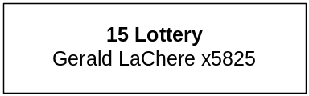

Program Description - The Montana Lottery designs and markets lottery games that allow players to purchase chances to win prizes. The Lottery presently offers a variety of instant/scratch and lotto-style games, some in cooperation with other lotteries through the Multi-State Lottery Association. A five-member Lottery Commission, appointed by the Governor, sets policy and oversees program activities and procedures. The net revenue, after prizes, sales commissions and operating expenses, is deposited in the state general fund on a quarterly basis.

Program Indicators -
Indicator | Actual FY2000 | Actual FY2001 | Actual FY2002 | Estimated FY2003 | Requested FY2004 | Requested FY2005
Transfer to General Fund  (in millions) | $5.80 | $6.10 | $7.40 | $6.80 | $7.00 | $7.20

Program Proposed Budget  Budget Item | Base  Budget  Fiscal 2002 | PL Base Adjustment  Fiscal 2004 | New  Proposals  Fiscal 2004 | Total  Exec. Budget  Fiscal 2004 | PL Base Adjustment  Fiscal 2005 | New  Proposals  Fiscal 2005 | Total  Exec. Budget  Fiscal 2005
FTE | 31.50 | 0.00 | 0.00 | 31.50 | 0.00 | 0.00 | 31.50
Personal Services | 1,265,659 | 57,085 | 0 | 1,322,744 | 56,466 | 0 | 1,322,125
Operating Expenses | 4,947,142 | 899,351 | 185,728 | 6,032,221 | 951,319 | 25,715 | 5,924,176
Equipment | 462,735 | (414,000) | 0 | 48,735 | (414,000) | 0 | 48,735
Debt Service | 1,145,577 | 0 | 0 | 1,145,577 | (1,145,577) | 0 | 0
Total Costs | $7,821,113 | $542,436 | $185,728 | $8,549,277 | ($551,792) | $25,715 | $7,295,036
Proprietary | 7,821,113 | 542,436 | 185,728 | 8,549,277 | (551,792) | 25,715 | 7,295,036
Total Funds | $7,821,113 | $542,436 | $185,728 | $8,549,277 | ($551,792) | $25,715 | $7,295,036

--------------------------------- Present Law Adjustments --------------------------------

Total Agency Impact | General Fund Total
FY04 ($42,327) | FY04 $0
FY05 ($42,285) | FY05 $0
PL- 1501 - Indirect Fixed Costs -
Department indirect/administrative costs for services received from other proprietary funded centralized service functions of the agency.
________________________________________________________________________________________________

Total Agency Impact | General Fund Total
FY04 $1,250 | FY04 $0
FY05 $1,250 | FY05 $0
PL- 1502 - Per Diem for Lottery Commissioners -
The Lottery division of the Department of Administration is requesting per diem for the Lottery Commissioners. MCA 23-7-201 & 202 establishes the five-member commission to be paid $50 per diem for each day engaged in duties related to the Lottery and requires that the Commission meet quarterly at a minimum. In addition, one Commissioner attends the annual North American Association of State and Provincial Lotteries conference. The conference is three days and requires 2 days of travel to and from the conference site. Therefore, the total biennial request is for $2,500 appropriation authority. The Lottery expended these amounts in base year 2002, but they are zero based.
________________________________________________________________________________________________

Total Agency Impact | General Fund Total
FY04 $0 | FY04 $0
FY05 ($1,145,577) | FY05 $0
PL- 1504 - Eliminate Debt Service Expense for FY 2005 -
The Lottery's last payment on its note is scheduled for April 29, 2004. Therefore, there will be no debt service requirement in FY 2005 only.
________________________________________________________________________________________________

Total Agency Impact | General Fund Total
FY04 $391,326 | FY04 $0
FY05 $529,557 | FY05 $0
PL- 1505 - Product Costs Increase -
An increase in product costs of $920,883 for the biennium is needed to keep the Lottery "fresh" and exciting and increase participation and interest. If the Lottery does not continue to change its games and offer desired products, sales revenues will decline and the transfers to the general fund will be negatively affected.

The total sales for FY 2002 are estimated to be $33.2 million and the contract with the vendor, who operates the Lottery's computerized terminal system, specifies payment at 8.35 percent of sales. Using a modest gain in sales of three percent per annum, would result in additional contracted services expenses of $168,826 in FY 2004 and $257,057 in FY 2005.

Merchandise for Resale is the Lottery's inventory of scratch/instant tickets. The Lottery must keep an inventory of such tickets for several reasons. The Lottery has multiple games available at any one time; there is a three month time period between the design and the printing of tickets; we introduce a new instant game approximately every six weeks; print runs are for eight to 12 games to take advantage of price breaks, and some games are depleted from stock faster than others. In addition, the Lottery wants to continue to offer new styles of games and play opportunities. Currently, the Lottery offers $1, $2, $3 and $5 instant tickets; we would like to offer higher price point and unique games over the biennium. This request is to print and package such merchandise at a cost of $175,000 in FY 2004 and $225,000 in FY 2005.

One of the unique games the Lottery would like to introduce in FY 2004 is a televised game show, where participation is determined as a prize on an instant ticket. This game is a multi-state game operated by the Multi-State Lottery Association, the same entity that operates Powerball, Hot Lotto and Wild Card. The association charges an annual dues amount to cover its operational costs. To participate in the game show, the Lottery would be required to pay dues of $47,500 each year.
________________________________________________________________________________________________

Total Agency Impact | General Fund Total
FY04 $6,920 | FY04 $0
FY05 $8,232 | FY05 $0
PL- 1506 - Increase Base for Rent -
The Lottery rents the office and warehouse space that it currently occupies. The lease contract in existence since 1987 expired 2/28/2002; increased rent was included in the FY 2002 and FY 2003 budget. A new contract is being finalized and it will require higher rent for FY 2004 and FY 2005. A monthly increase is reasonable considering the length of time since the rent was last adjusted and based upon current rates within Helena. The location is easy for our players and winners to locate. In addition, the space meets the Lottery's needs to have both office and warehouse space co-located at a single facility. Total cost for the biennium would be $15,152.
________________________________________________________________________________________________

Total Agency Impact | General Fund Total
FY04 $22,800 | FY04 $0
FY05 $10,800 | FY05 $0
PL- 1507 - Equipment replacement -
Computer equipment, printers, the on-line gaming system and software need to be replaced or updated. Total cost of replacement over the biennium is $33,600. If the printers and equipment are not purchased, the ability of Lottery staff to complete its duties would be curtailed. Failure to maintain the on-line gaming system could result in the cessation of lotto sales for extended periods of time. This would greatly reduce revenue and the general fund revenue.
________________________________________________________________________________________________

Total Agency Impact | General Fund Total
FY04 $35,000 | FY04 $0
FY05 $35,000 | FY05 $0
PL- 1509 - Retailer Support -
Marketing research has shown that most instant ticket sales are impulse buys. This means that to continue with the current level of sales and any attempt to increase sales must be supported by advertising at the retail outlet. The Lottery designs and prints point of sale (POS) materials, such as posters, brochures, terminal toppers and other informational pieces for display by the retailers. For POS to be effective they must be timely, attractive, and highly visible. They also must be replaced frequently to attract players' attention.

The Lottery is placing additional on-line terminals at retailers who currently only have instant ticket sales capability. These retailers will need to be supported at the same level as the current on-line retailers. The Lottery would like to replace POS on a quarterly basis at all retail locations at an approximate cost of $35,000 per fiscal year.

---------------------------------------- New Proposals ----------------------------------------

Total Agency Impact | General Fund Total
FY04 $25,728 | FY04 $0
FY05 $25,715 | FY05 $0
NP- 317 - Indirect Cost Allocation-HB2 -
Funding change for the Director's Office and the Management Support Bureau. NP-315 reduces HB 2 FTE that are proprietary funded in NP-316. Divisions within the department would share the cost of the Director's Office and would pay for budget work, fiscal note coordination and bill paying (those without accounting staff). NP-317 (HB 2) and NP-318 (HB 576) distribute budget to programs in the department and give them authority to pay for the indirect recovery. This indirect cost recovery is an audit recommendation.
________________________________________________________________________________________________

Total Agency Impact | General Fund Total
FY04 $160,000 | FY04 $0
FY05 $0 | FY05 $0
NP- 1508 - Professional Service Contracts (Rstrcted/Bien/OTO) -
The Lottery purchased and implemented the on-line gaming system in 1999, and it is operated by an outside vendor under a seven year contract. There have been changes and advances in the industry since the inception of this system. The Lottery would like to hire a consultant to analyze the current system's performance, life expectancy, and maintenance costs, in addition to available replacements and the advantages or disadvantages of replacing the system. The cost for the biennium is anticipated to be $160,000.

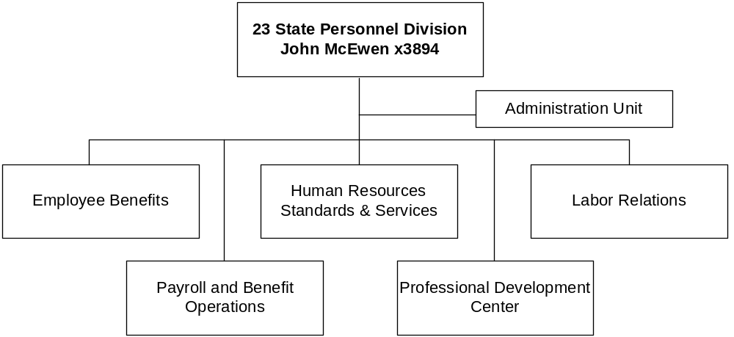

Program Description - The State Personnel Division provides state agencies with a variety of human resource management programs including training, position classification and pay, collective bargaining, employee relations, and assistance with compliance with state and federal employment law. The state general fund is reimbursed for administrative costs of the State Personnel Division through the statewide cost allocation and state fund cost allocation plans. The division publishes state rules, standards, and policies relating to recruitment, selection, discipline, grievance, performance appraisal, leave, and other personnel matters. The division administers benefits plans including health, life, long-term care, dental, and vision insurance, flexible spending accounts, a sick leave fund, employee incentive awards, health promotion, and a voluntary employee benefit health care expense trust. In addition, the division administers a lease and contract to provide day care services for Helena area state employees. The division also prepares, maintains, and distributes payroll for all state employees.

The division provided competency pay adjustments to certain of its HB 2 positions totaling $21,015 in FY 2002. The increased pay was financed by operating cost savings within the department.

The Human Resources Standards and Services Bureau and Labor Relations Bureau functions are governed by 2-18-2; 2-18-102; 2-18-301 through 303; 2-18-604; 2-18-1011 through 1013; 39-29-112; 39-30-106; and 39-31-101 through 409, MCA. The Payroll Unit is governed by 2-18-401, et seq, MCA. Employee benefits are governed by 2-18-701 et seq., 2-18-801 et seq., 2-18-1101 et seq., 2-18-1301 et seq., and 33-2-712, MCA. The Professional Development Center is governed by 2-18-102 (1)(b), MCA.

Program Indicators -
Indicator | Actual FY2000 | Estimated FY2001 | Estimated FY2002 | Estimated FY2003
Personnel Administration Program:
Grievances/Arbitrations | 30 | 30 | 30 | 30
Competency Demonstration Projects | 13 | 15 | 20 | 25
Number of employees covered under demonstration projects | 2,500 | 3,200 | 4,900 | 6,200
Classification actions processed | 200 | 200 | 200 | 200
Classification appeals | 4 | 15 | 10 | 10
Policy revisions | 4 | 4 | 8 | 4
Pay exception reviews | 13 | 13 | 13 | 13
Collective bargaining agreements conducted during the biennium | N/A | 65 | N/A | 65

Program Proposed Budget  Budget Item | Base  Budget  Fiscal 2002 | PL Base Adjustment  Fiscal 2004 | New  Proposals  Fiscal 2004 | Total  Exec. Budget  Fiscal 2004 | PL Base Adjustment  Fiscal 2005 | New  Proposals  Fiscal 2005 | Total  Exec. Budget  Fiscal 2005
FTE | 21.66 | 0.00 | (1.13) | 20.53 | 0.00 | (1.13) | 20.53
Personal Services | 909,750 | 115,194 | (45,005) | 979,939 | 114,374 | (44,872) | 979,252
Operating Expenses | 244,733 | 1,786 | 11,098 | 257,617 | 4,400 | 11,999 | 261,132
Total Costs | $1,154,483 | $116,980 | ($33,907) | $1,237,556 | $118,774 | ($32,873) | $1,240,384
General Fund | 1,127,130 | 116,980 | (36,949) | 1,207,161 | 118,774 | (36,820) | 1,209,084
State/Other Special | 27,353 | 0 | 3,042 | 30,395 | 0 | 3,947 | 31,300
Total Funds | $1,154,483 | $116,980 | ($33,907) | $1,237,556 | $118,774 | ($32,873) | $1,240,384

Please note that a HB 576 section exists for this program.

--------------------------------- Present Law Adjustments --------------------------------

Total Agency Impact | General Fund Total
FY04 ($2,954) | FY04 ($2,954)
FY05 ($2,985) | FY05 ($2,985)
PL- 2307 - Indirect Cost Allocation -
The State Personnel Division programs, including Personnel Administration, Employee Benefits, Central Payroll and Training, will require a change to indirect/administrative costs to fund to department's data processing, management services, human resources, and legal units. The division's total indirect fixed cost allocation is $59,912 in FY 2004 and $59,876 in FY 2005.

---------------------------------------- New Proposals ----------------------------------------

Total Agency Impact | General Fund Total
FY04 $8,246 | FY04 $8,056
FY05 $8,242 | FY05 $8,052
NP- 317 - Indirect Cost Allocation -
Funding change for the Director's Office and the Management Support Bureau. NP-315 reduces HB 2 FTE that are proprietary funded in NP-316. Divisions within the Department would share the cost of the Director's Office NP-317 distributes budget to programs in the department and give them authority to pay for the indirect recovery. This indirect cost recovery is an audit recommendation.
________________________________________________________________________________________________

Total Agency Impact | General Fund Total
FY04 $2,852 | FY04 $0
FY05 $3,757 | FY05 $0
NP- 2304 - Lease Rate for State Sponsored Daycare -
The 1999 and 2001 State Legislatures authorized the Department of Administration to collect money from state agencies to pay rent costs at the daycare facility located in Helena's Ray Bjork School. The state was authorized to help establish this daycare as a benefit to state employees. The amount collected from each agency is based on the number of Helena area employees. The state leases the space at Ray Bjork School from the Helena School District and the lease agreement provides that the lease rate can change annually, based on changes in the consumer price index (CPI) and other costs related to maintaining the building. In FY 2002 the lease rate was $27,272 and the rate increased to $29,325 in FY 2003. The department requests authority to collect $30,205 in FY 2004 and $31,110 in FY05 from state agencies for continued support of the Ray Bjork daycare facility.
________________________________________________________________________________________________

Total Agency Impact | General Fund Total
FY04 ($45,005) | FY04 ($45,005)
FY05 ($44,872) | FY05 ($44,872)
NP- 2306 - Eliminate 1.13 FTE Vacant -
Two positions that total 1.13 FTE and are currently held vacant to meet vacancy savings are offered for reductions.

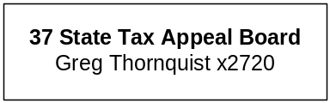

Program Description - The State Tax Appeal Board, established by Article VIII, Section 7, of the Montana Constitution and 15-2-101, MCA, provides a tax appeal system for all actions of the Department of Revenue. It hears appeals from decisions of the 56 county tax appeal boards and takes original jurisdiction in matters involving income taxes, corporate taxes, severance taxes, centrally-assessed property and new industry property, motor fuels taxes, vehicle taxes, and cabin site leases. The board travels throughout the state to hear appeals from decisions of the county tax appeal boards and to conduct informational meetings for the various county tax appeal boards. The State Tax Appeal Board directs the county tax appeal board secretaries, who are state employees, and pays their salaries and employee benefits from its personal services appropriation. The board also reviews and pays the expenses, including employee benefits, of those county tax appeal board secretaries who are county employees. In addition, the board pays the clerical-related expenses for all 56 county tax appeal boards, including supplies, postage and copies, but excluding office equipment.

Program Proposed Budget  Budget Item | Base  Budget  Fiscal 2002 | PL Base Adjustment  Fiscal 2004 | New  Proposals  Fiscal 2004 | Total  Exec. Budget  Fiscal 2004 | PL Base Adjustment  Fiscal 2005 | New  Proposals  Fiscal 2005 | Total  Exec. Budget  Fiscal 2005
FTE | 7.00 | 0.00 | 0.00 | 7.00 | 0.00 | 0.00 | 7.00
Personal Services | 185,586 | 77,878 | 0 | 263,464 | 79,318 | 0 | 264,904
Operating Expenses | 62,397 | (3,869) | 4,129 | 62,657 | (2,828) | 4,133 | 63,702
Local Assistance | 1,180 | 0 | 0 | 1,180 | 0 | 0 | 1,180
Total Costs | $249,163 | $74,009 | $4,129 | $327,301 | $76,490 | $4,133 | $329,786
General Fund | 249,163 | 74,009 | 4,129 | 327,301 | 76,490 | 4,133 | 329,786
Total Funds | $249,163 | $74,009 | $4,129 | $327,301 | $76,490 | $4,133 | $329,786

--------------------------------- Present Law Adjustments --------------------------------

Total Agency Impact | General Fund Total
FY04 ($26) | FY04 ($26)
FY05 ($31) | FY05 ($31)
PL- 3701 - Per Diem and Indirect Costs -
This request combines per diem of $2,095 for STAB and a decrease in department indirect/administrative costs for services received from proprietary funds.

---------------------------------------- New Proposals ----------------------------------------

Total Agency Impact | General Fund Total
FY04 $4,129 | FY04 $4,129
FY05 $4,133 | FY05 $4,133
NP- 317 - Indirect Cost Allocation-HB2 -
Funding change for the Director's Office and the Management Support Bureau. NP-315 reduces HB 2 FTE that are proprietary funded in NP-316. Divisions within the department would share the cost of the Director's Office. NP-317 (HB 2) and NP-318 (HB 576) distribute budget to programs in the department and give them authority to pay for the indirect recovery. This indirect cost recovery is an audit recommendation.

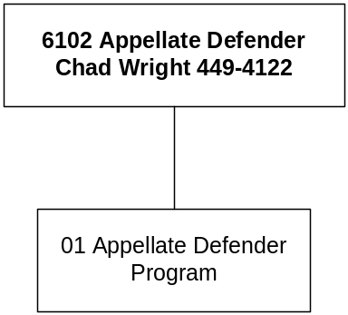

Mission Statement - To permit state courts to fulfill, in a cost-effective manner, federal and state constitutional and statutory obligations to appoint counsel to effectively represent indigent persons who wish to pursue their rights to challenge criminal convictions, by means of appeals to the supreme court or by other post-conviction challenges; to assist defense counsel in appeals on request; to aid the Appellate Defender Commission in promulgating standards for the appointment of trial and appellate counsel in Montana; and to develop and maintain a roster of defense attorneys eligible for appointment in Montana

Statutory Authority - State mandates are established at 46-8-210 through -213, MCA.

Program Description - The Office of the Appellate Defender is an agency administratively attached to the Department of Administration. Prior to creation of the agency by the 1995 legislature, the Appellate Defender Program was administratively attached to the Department of Administration and funded by a statutory appropriation. The appellate defender is hired by, and serves at the pleasure of, the Appellate Defender Commission. The appellate defender provides legal counsel for indigent persons who have been convicted and then appeal their district court conviction or petition for post-conviction relief from proceedings in district court. The appellate defender also aids the commission in compiling and keeping current a roster of Montana attorneys eligible for appointment by an appropriate court as trial and appellate defense counsel for the indigent.

Program Proposed Budget  Budget Item | Base  Budget  Fiscal 2002 | PL Base Adjustment  Fiscal 2004 | New  Proposals  Fiscal 2004 | Total  Exec. Budget  Fiscal 2004 | PL Base Adjustment  Fiscal 2005 | New  Proposals  Fiscal 2005 | Total  Exec. Budget  Fiscal 2005
FTE | 3.00 | 0.00 | 0.00 | 3.00 | 0.00 | 0.00 | 3.00
Personal Services | 133,911 | 13,653 | 0 | 147,564 | 13,879 | 0 | 147,790
Operating Expenses | 44,999 | (6,753) | 2,659 | 40,905 | (6,428) | 2,662 | 41,233
Total Costs | $178,910 | $6,900 | $2,659 | $188,469 | $7,451 | $2,662 | $189,023
General Fund | 0 | 185,810 | 2,659 | 188,469 | 186,361 | 2,662 | 189,023
State/Other Special | 178,910 | (178,910) | 0 | 0 | (178,910) | 0 | 0
Total Funds | $178,910 | $6,900 | $2,659 | $188,469 | $7,451 | $2,662 | $189,023

--------------------------------- Present Law Adjustments --------------------------------

Total Agency Impact | General Fund Total
FY04 ($4,084) | FY04 ($4,084)
FY05 ($3,757) | FY05 ($3,757)
PL- 1 - Fixed Cost Adjustments & On-going Reductions -
The request includes an increase in agency fixed costs including a rent increase of $314 in FY 2004 and $637 in FY 2005. In addition, after the snapshot the office recently converted to performance-based pay in an effort to move closer to parity with other state employee attorneys and to retain qualified staff, which increases personal services by $6,300 each year of the biennium. The adjustments also continue both the governor's reductions and the special session reductions totaling $21,396 for the biennium.

---------------------------------------- New Proposals ----------------------------------------

Total Agency Impact | General Fund Total
FY04 $2,659 | FY04 $2,659
FY05 $2,662 | FY05 $2,662
NP- 317 - Indirect Cost Recovery -
Department of Administration's Director's Office and Management Support Bureau are requesting to go to an indirect cost recovery plan, due to an audit recommendation. Part of the recovery allocates more budget authority to the Appellate Defender in the amount of $2,659 for FY 2004 and $2,662 in FY 2005.

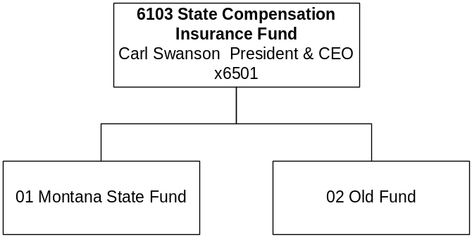

Mission Statement - Mission Statement:
'Montana's insurance carrier of choice and industry leader in service.'

Vision Statement:
'Montana State Fund is committed to the health and economic prosperity of Montana through superior service, leadership and caring individuals working in an environment of teamwork, creativity and trust.'

Statutory Authority - The State Compensation Insurance Fund (Montana State Fund) provides liability insurance for workers' compensation and occupational disease and may not refuse coverage to any employer requesting coverage (39-71-2313, MCA).

Section 39-71-2321, MCA, provides that all funds deposited in the State Fund may be expended as provide in 17-8-101(2)(b), under general laws, or contracts entered into in pursuance of law, permitting the disbursement. Based on this statutory provision the State Fund is not budgeted in the general appropriations act.

The State Fund is funded entirely with proprietary funds. See Section P for budget information.

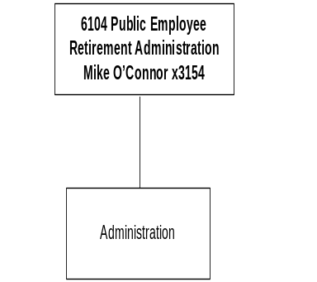

Mission Statement – The Montana Public Employee Retirement Administration will efficiently provide quality benefits; education and service to help our plan members and beneficiaries achieve a quality retirement.

Statutory Authority – Title 2, Chapter 15; Title 19, Chapters 2,3,5,6,7,8,9,13,17 and 50, MCA; and Internal Revenue Service Codes.

Program Description -- The Public Employees’ Retirement Board (PERB) is charged under the State’s Constitution as fiduciaries to administer ten retirement plans and the related member education. The retirement plans are eight defined benefit plans, a defined contribution plan and a deferred compensation plan. The defined benefit retirement plans are the Public Employees’ Retirement System, Municipal Police Officers’ Retirement System, Game Wardens’ and Peace Officers’ Retirement System, Sheriffs’ Retirement System, Judges’ Retirement System, Highway Patrol Officers’ Retirement System, Firefighters’ Unified Retirement System, and the Volunteer Firefighters’ Compensation Act. The defined contribution retirement plan was implemented as of July 1, 2002, and available only to eligible members of the Public Employees’ Retirement System (PERS). The deferred compensation plan (IRC § 457) is available to employees of the state, university and local subdivisions that contract with the plan.

The PERB also administers two educations funds. The PERS defined benefit retirement plan education fund was established to provide the tools necessary for the member to choose between the defined benefit retirement plan and the defined contribution retirement plan. The PERS defined contribution retirement plan also has an education fund to provide members with ongoing education. The PERB is allocated to the Department of Administration, which means that the PERB hires the staff for the Montana Public Employee Retirement Administration (MPERA), which carries out the daily administration of the plans. The MPERA has 33 employees. This agency accounts for over $3.2 billion held in trust. Monthly retirement disability and death benefits are paid to over 16,800 recipients. Annual benefit payments exceed $145 million. Over 500 state and local government employers report contributions for over 34,000 active members.

Indicator | Actual  1999 | Actual  2000 | Actual  2001 | Actual  2002 | Estimated  2003 | Estimated  2004 | Estimated 2005
Defined Benefit Retirement Plans:
Benefits | 128,654,433 | 135,925,468 | 143,127,966 | 157,749,114 | 165,535,557 | 173,563,100 | 181,984,543
Defined Benefit Assets | 3,245,111,997 | 3,497,845,464 | 3,317,431,288 | 3,068,956,608 | 3,102,715,131 | 3,158,564,003 | 3,215,418,155
Defined Contribution Retirement Plans:
Deferred Comp Assets | 179,924,000 | 202,162,660 | 200,280,113 | 196,420,108 | 206,239,988 | 216,550,805 | 227,377,104
PERS – Defined Contribution |  |  | (585,007) | (1,026,748) | 7,076,042 | 7,854,406 | 8,663,479

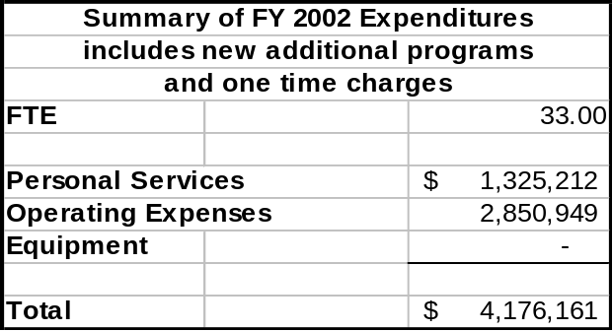
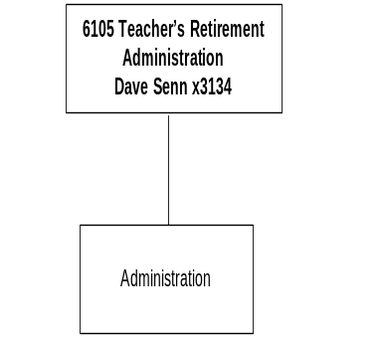

Mission Statement - To maintain a financially sound system that is actuarially funded that will provide the broadest and fairest possible range of disability, death and retirement benefits to teachers and other eligible members of the State of Montana as prescribed by state statutes.

Statutory Authority – Montana Constitution, Article VIII, Sections 13 and 15; Title 19, Chapter 20, MCA; and Internal Revenue Service codes.

Program Description - The Teachers' Retirement Board, which consists of six members appointed by the Governor, is responsible for the administration of the Teachers' Retirement System (TRS). To assist in fulfilling its duties, the board employs a full-time staff. The TRS administers retirement, disability, and survivor benefits for all Montana teachers and their beneficiaries.

Indicator | Actual  1999 | Actual  2000 | Actual  2001 | Actual  2002 | Estimated  2003 | Estimated  2004 | Estimated  2005
Contributions | 87,731,106 | 94121675 | 99878990 | 100,153,392 | 103,157,994 | 106,252,734 | 109,440,316
Benefits | 100,028,083 | 109231029 | 118841895 | 130,014,779 | 140,415,961 | 151,649,238 | 163,781,177



