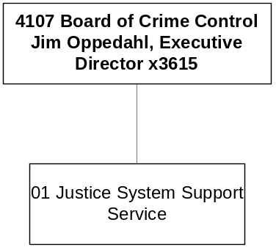

Mission Statement - To promote public safety, crime prevention, and victim assistance by strengthening the coordination and performance of both the criminal justice and juvenile justice systems in partnership with citizens, government, and communities.

Statutory Authority - 2-15-2006 and 44-4-301, MCA, create and define the board; 41-5-1901, MCA, youth detention services grants; Title 53, Chapter 9, part 1, MCA, Victims Compensation Act; 42 USC 4760 Anti-Drug Abuse Act; 42 USC 10603 Victims of Crime Act; 42 USC 3796 Stop Violence Against Women Act; 42 USC 3701 National Criminal History Improvement Program; 42 USC 5601 Juvenile Justice and Delinquency Prevention Act; and USC 13701 Violent Crime Control and Law Enforcement Act.

Program Description - The Montana Board of Crime Control is the state's designated planning and program development agency for the criminal justice system. The Crime Control Division provides financial support, technical assistance, and supportive services to state and local criminal justice agencies. The board provides funding to local, regional and statewide projects with the central goal of making Montana a safer state.

The Crime Control Division administers federal anti-drug and anti-crime grants, certifies peace officers and others in the Criminal Justice system, provides funding for juvenile justice programs and provides assistance and compensation to victims of crime. It also collects and analyzes crime data from Montana law enforcement agencies and publishes the annual Crime in Montana report. The division is established in 2-15-2006, MCA.

Language Recommendations - “All remaining federal pass-through grant appropriations, including reversions, for the 2003 biennium are authorized to continue and are appropriated in fiscal year 2004 and fiscal year 2005.”

Program Proposed Budget  Budget Item | Base  Budget  Fiscal 2002 | PL Base Adjustment  Fiscal 2004 | New  Proposals  Fiscal 2004 | Total  Exec. Budget  Fiscal 2004 | PL Base Adjustment  Fiscal 2005 | New  Proposals  Fiscal 2005 | Total  Exec. Budget  Fiscal 2005
FTE | 18.00 | 2.00 | 0.00 | 20.00 | 2.00 | 0.00 | 20.00
Personal Services | 764,425 | 142,242 | 0 | 906,667 | 143,017 | 0 | 907,442
Operating Expenses | 484,281 | 5,881 | 6,250 | 496,412 | 3,146 | 6,250 | 493,677
Equipment | 7,016 | 0 | 0 | 7,016 | 0 | 0 | 7,016
Grants | 10,842,347 | (184,415) | 0 | 10,657,932 | (184,415) | 0 | 10,657,932
Total Costs | $12,098,069 | ($36,292) | $6,250 | $12,068,027 | ($38,252) | $6,250 | $12,066,067
General Fund | 1,794,097 | (149,038) | 0 | 1,645,059 | (146,968) | 0 | 1,647,129
State/Other Special | 0 | 0 | 0 | 0 | 0 | 0 | 0
Federal Special | 10,303,972 | 112,746 | 6,250 | 10,422,968 | 108,716 | 6,250 | 10,418,938
Total Funds | $12,098,069 | ($36,292) | $6,250 | $12,068,027 | ($38,252) | $6,250 | $12,066,067

------------------- Agency General Fund Target - $3.29 million ---------------------

--------------------------------- Present Law Adjustments --------------------------------

Total Agency Impact | General Fund Total
FY04 $46,612 | FY04 $0
FY05 $44,486 | FY05 $0
PL- 3 - Criminal Justice Analyst -
Federal formula block grant funds are recommended for 1.00 FTE criminal justice analyst to provide the board, state and local criminal justice practitioners, and public policy makers with analytical and statistical information upon which to make informed and cost-effective decisions. Primary tasks of the analyst will be to conduct research and analysis of criminal and juvenile justice issues that affect the performance of the justice system and to increase the participation of law enforcement in the National Incident Based Reporting System by enhancing law enforcement use of automated record systems and reporting capabilities. Federal funds also support the operating costs and initial workstation.
________________________________________________________________________________________________

Total Agency Impact | General Fund Total
FY04 $43,254 | FY04 $4,325
FY05 $41,139 | FY05 $4,114
PL- 4 - Juvenile Justice -
The Juvenile Justice Unit within the Grants Management Bureau is recommended for 1.00 FTE to provide increased services and proactive responses for juvenile justice in Montana. The Juvenile Justice Unit has experienced a 155 percent growth in federal funds since FY 1997 and the number of grants increased from 18 to 60. Federal funds will pay 90 percent of the position and related operating expenses; the 10 percent general fund match has been offset by agency reductions in other areas.
________________________________________________________________________________________________

Total Agency Impact | General Fund Total
FY04 ($220,294) | FY04 ($220,294)
FY05 ($220,293) | FY05 ($220,293)
PL- 7001 - Target reductions -
These reductions are being made to reduce agency budget request to target. These general fund reductions are $220,293 in FY 2004 and $220,293 in FY 2005.

---------------------------------------- New Proposals ----------------------------------------

Total Agency Impact | General Fund Total
FY04 $6,250 | FY04 $0
FY05 $6,250 | FY05 $0
NP- 5 - Legal Services -
Currently, the MBCC receives services from the Department of Justice Appellate Legal Services Bureau and legal services team. Workload has been growing steadily to the point where they can no longer provide the needed MBCC services. The request is for a contract with the Agency Legal Services Bureau for most MBCC legal needs, projected at 200-plus hours per year, based on review of prior years. These expenditures will be paid for with federal grant monies.

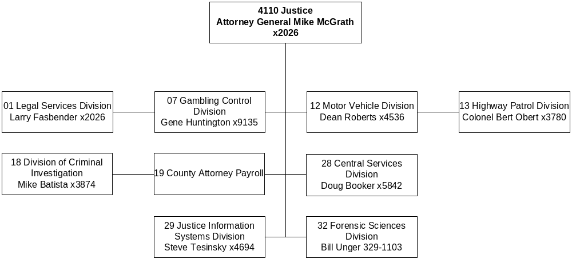

Mission Statement - To pursue activities and programs that seek to ensure and promote the public interest, safety and well-being through leadership, advocacy, education, regulation, and enforcement.

Statutory Authority - 2-15-501, 2-15-2001 through -2021, and Title 44, MCA.

Agency Proposed Budget  Budget Item | Base  Budget  Fiscal 2002 | PL Base Adjustment  Fiscal 2004 | New  Proposals  Fiscal 2004 | Total  Exec. Budget  Fiscal 2004 | PL Base Adjustment  Fiscal 2005 | New  Proposals  Fiscal 2005 | Total  Exec. Budget  Fiscal 2005
FTE | 713.20 | 3.00 | (1.45) | 714.75 | 3.00 | (3.45) | 712.75
Personal Services | 30,662,678 | 3,137,141 | (73,687) | 33,726,132 | 3,247,205 | (226,058) | 33,683,825
Operating Expenses | 14,289,109 | 848,676 | (221,070) | 14,916,715 | 335,517 | (31,634) | 14,592,992
Equipment | 1,592,615 | 141,565 | 0 | 1,734,180 | 266,481 | 0 | 1,859,096
Benefits & Claims | 804,398 | 83,982 | 0 | 888,380 | 83,982 | 0 | 888,380
Transfers | 0 | 0 | 25,000 | 25,000 | 0 | 25,000 | 25,000
Debt Service | 770,160 | 1,289,144 | 3,900,000 | 5,959,304 | (6,856) | 0 | 763,304
Total Costs | $48,118,960 | $5,500,508 | $3,630,243 | $57,249,711 | $3,926,329 | ($232,692) | $51,812,597
General Fund | 23,647,394 | 2,055,727 | (2,359,202) | 23,343,919 | 1,624,662 | (2,309,335) | 22,962,721
State/Other Special | 21,081,629 | 3,058,398 | 5,409,741 | 29,549,768 | 1,913,404 | 1,512,395 | 24,507,428
Federal Special | 2,700,049 | 224,648 | 622,083 | 3,546,780 | 230,954 | 606,871 | 3,537,874
Proprietary | 689,888 | 161,735 | (42,379) | 809,244 | 157,309 | (42,623) | 804,574
Total Funds | $48,118,960 | $5,500,508 | $3,630,243 | $57,249,711 | $3,926,329 | ($232,692) | $51,812,597

------------------- Agency General Fund Target - $46.31 million -------------------

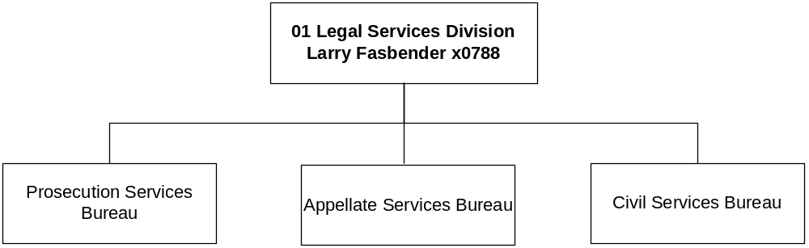

Program Description - The Legal Services Division provides 1) the Attorney General with legal research and analysis; 2) legal counsel for state government officials, bureaus, and boards; 3) legal assistance to local governments and Indian tribes; and 4) legal assistance, training, and support for county prosecutors.

Indian Legal Jurisdiction provides representation and coordination of trial and appellate lawsuits involving the State of Montana and the Indian tribes, supervision of private attorneys contracted by the state to assist with those cases, and advice to state agencies on questions involving Indian legal matters.

County Prosecutor Services provides special prosecution assistance to counties in the prosecution and disposition of major felonies and in cases in which county attorneys or city attorneys have conflicts of interest. County Prosecutor Services also provides prosecutor services to the Eastern Coal Counties Drug Task Force and the Western Montana Special Investigation Section and coordinates training and continuing legal education for county attorneys, city attorneys, and law enforcement personnel.

Office of Victim Services and Restorative Justice is a consolidated effort to elevate the status and respond to the needs of victims of crime in Montana. The office also provides the cross-training and coordination with local law enforcement to more fully address the broad needs of victims.

Program Indicators -

Indicator | Actual  FY2000 | Actual FY2001 | Actual  FY2002 | Estimated FY2003 | Requested FY2004 | Requested FY2005
Criminal Appeals & Complex Civil Litigation – New Cases Opened | 324 | 350 | 481 | 350 | 355 | 355
Issue AG Opinions & Letters of Advice | 15 | 21 | 29 | 25 | 30 | 30
Assist and provide training to County Attorneys – New Matters Opened | 175 | 119 | 107 | 135 | 140 | 140

Program Proposed Budget  Budget Item | Base  Budget  Fiscal 2002 | PL Base Adjustment  Fiscal 2004 | New  Proposals  Fiscal 2004 | Total  Exec. Budget  Fiscal 2004 | PL Base Adjustment  Fiscal 2005 | New  Proposals  Fiscal 2005 | Total  Exec. Budget  Fiscal 2005
FTE | 50.00 | 0.00 | 0.00 | 50.00 | 0.00 | 0.00 | 50.00
Personal Services | 2,563,501 | 169,652 | 19,366 | 2,752,519 | 172,515 | 19,228 | 2,755,244
Operating Expenses | 789,099 | 123,923 | 10,794 | 923,816 | (266,558) | 10,794 | 533,335
Equipment | 0 | (4,593) | 0 | (4,593) | (4,593) | 0 | (4,593)
Benefits & Claims | 804,398 | 83,982 | 0 | 888,380 | 83,982 | 0 | 888,380
Debt Service | 2,500 | 0 | 0 | 2,500 | 0 | 0 | 2,500
Total Costs | $4,159,498 | $372,964 | $30,160 | $4,562,622 | ($14,654) | $30,022 | $4,174,866
General Fund | 3,439,681 | 346,826 | (36,032) | 3,750,475 | (42,134) | (36,008) | 3,361,539
State/Other Special | 366,095 | (59,427) | 0 | 306,668 | (58,272) | 0 | 307,823
Federal Special | 353,722 | 85,565 | 66,192 | 505,479 | 85,752 | 66,030 | 505,504
Total Funds | $4,159,498 | $372,964 | $30,160 | $4,562,622 | ($14,654) | $30,022 | $4,174,866

--------------------------------- Present Law Adjustments --------------------------------

Total Agency Impact | General Fund Total
FY04 $83,982 | FY04 $0
FY05 $83,982 | FY05 $0
PL- 101 - Crime Victims Federal Authority -
The federal government matches state general fund expenditures on claims paid to victims of crime through the Crime Victims Compensation Program. The federal match is based on general fund expenditures during a 12 month period measured two years prior to the current federal fiscal year. Beginning in FY 2004 the federal share will increase from 40 percent to 60 percent. The department is requesting an increase of federal spending authority of $83,982 in each year of the biennium to pay victims of crime.
________________________________________________________________________________________________

Total Agency Impact | General Fund Total
FY04 $93,012 | FY04 $93,012
FY05 ($306,988) | FY05 ($306,988)
PL- 103 - Major Litigation -
These costs are associated with litigation in which the Legal Services Division must provide representation for the State of Montana. The on-going cases include mining regulation, laws regulating game farms, the constitutionality of the state public defender system, and enforcement of the state tobacco settlement. Funding will also be needed for an anticipated challenge to the state system for school funding. These expenditures typically involve lawsuits filed against the State of Montana. The anticipated cost of defense varies depending on whether a case is disposed of by legal motions or after trial, and if the case requires expensive consultants and expert witnesses. Biennial appropriations are split between the two fiscal years; however, budget preparation requires the full amount to be shown in the first year of the biennium. General fund of $93,012 is requested to return the major litigation biennial appropriation to the $400,000 level. This is the level established by the 57th Legislature, which is $100,000 less than the historical figure of $500,000.
________________________________________________________________________________________________

Total Agency Impact | General Fund Total
FY04 ($80,265) | FY04 ($80,265)
FY05 ($80,289) | FY05 ($80,289)
PL- 7002 - On-going Special Session Reductions -
On-going special session reductions for the Legal Services Division total $160,554 of general fund for the biennium. This includes cuts for travel, office supplies, equipment, personal services one percent, and 20 percent reduction in funding the pay plan.

---------------------------------------- New Proposals ----------------------------------------

Total Agency Impact | General Fund Total
FY04 $66,192 | FY04 $0
FY05 $66,030 | FY05 $0
NP- 102 - Funding Authority for Restorative Justice Office -
The department is requesting federal funding authority for the Restorative Justice Program. The 57th Legislature established the program with HB 637. The legislation acknowledged the high cost of incarcerating offenders and recognized that jail time may not be the most effective strategy for restoring victims, reforming offenders and decreasing recidivism. Instead, the restorative justice program allows appropriate offenders who are at low risk for violence to participate in community programs based on restorative justice. Federal authority of $66,192 is requested for FY 2004 and $66,030 for FY 2005. This is for 1.00 FTE and operating expenses.
________________________________________________________________________________________________

Total Agency Impact | General Fund Total
FY04 ($36,032) | FY04 ($36,032)
FY05 ($36,008) | FY05 ($36,008)
NP- 7001 - Legal Services FTE Reduction -
This decision package includes eliminating an administrative support position that will become vacant and save $72,040 of general fund over the biennium. Holding this position open was part of special session reductions.

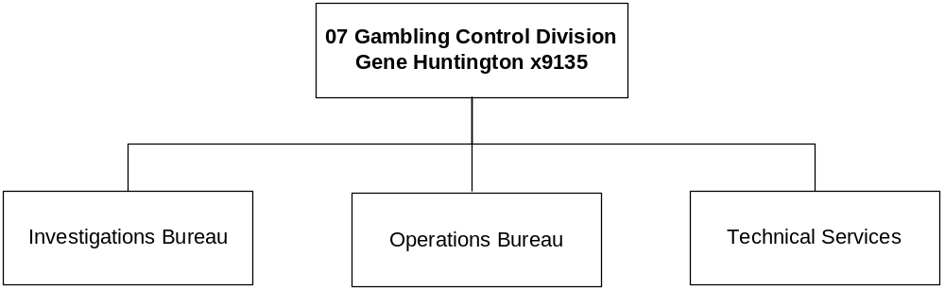

Program Description - The Gambling Control Division was established by the 1989 Legislature to regulate the gambling industry in Montana. The division has criminal justice authority and conducts routine field inspections and investigations related to gambling activities. In addition to collecting and distributing licensing fees for gambling machines and activities, the division is responsible for collecting the gambling tax assessed on the net proceeds of gambling activities, and investigative functions relating to alcoholic beverage licensing and tobacco enforcement. The gambling control program operates as a state mandate. An appointed Gaming Advisory Council of nine members provides advisory services to the Attorney General to ensure uniform statewide regulation of gambling activities.

Program Indicators -

Indicator | Actual FY2000 | Actual FY2001 | Actual FY2002 | Estimated FY2003 | Requested FY2004 | Requested FY2005
Video Gambling Machine Tax Collected¹ | $40.5M | $41.56M | $43.84M | $45.51M | $47.24M | $49.03M
All Gambling Permits Issued² | 19,915 | 21,498 | 20,864 | 20,272 | 19,698 | 19,140
Liquor & Gambling License Investigations³ | 688 | 715 | 703 | 703 | 703 | 703
Footnotes: 1. Assumes 3.8% annual revenue growth. 2. Assumes VGM permits will decline by 3% per year and other permits will decline 1% per year. 3. Assumes total number of investigations will remain stable with combined applications constituting 42.9%, liquor only 40.8% and gambling only 16.2%.

Program Proposed Budget  Budget Item | Base  Budget  Fiscal 2002 | PL Base Adjustment  Fiscal 2004 | New  Proposals  Fiscal 2004 | Total  Exec. Budget  Fiscal 2004 | PL Base Adjustment  Fiscal 2005 | New  Proposals  Fiscal 2005 | Total  Exec. Budget  Fiscal 2005
FTE | 47.50 | 0.00 | (3.00) | 44.50 | 0.00 | (3.00) | 44.50
Personal Services | 2,001,223 | 216,894 | (138,273) | 2,079,844 | 214,393 | (139,114) | 2,076,502
Operating Expenses | 894,642 | 11,070 | (113,350) | 792,362 | 16,123 | (113,350) | 797,415
Equipment | 0 | 56,000 | 0 | 56,000 | 42,000 | 0 | 42,000
Debt Service | 1,815 | 0 | 0 | 1,815 | 0 | 0 | 1,815
Total Costs | $2,897,680 | $283,964 | ($251,623) | $2,930,021 | $272,516 | ($252,464) | $2,917,732
General Fund | 380,000 | (41,800) | (107,350) | 230,850 | (41,800) | (107,350) | 230,850
State/Other Special | 1,851,853 | 166,993 | (102,434) | 1,916,412 | 158,864 | (103,031) | 1,907,686
Proprietary | 665,827 | 158,771 | (41,839) | 782,759 | 155,452 | (42,083) | 779,196
Total Funds | $2,897,680 | $283,964 | ($251,623) | $2,930,021 | $272,516 | ($252,464) | $2,917,732

--------------------------------- Present Law Adjustments --------------------------------

Total Agency Impact | General Fund Total
FY04 $176,200 | FY04 ($41,800)
FY05 $162,200 | FY05 ($41,800)
PL- 701 - Budget Adjustments -
The division requests to annualize the operating expenses for positions that were held vacant during the base year, renew authority to contract for an imaging system, cover communications expenses for the automated accounting and reporting system (AARS), and to re-establish its vehicle replacement cycle of four vehicles in FY 2004 and three vehicles in FY 2005. The total requested funding for FY 2004 is $154,780 from state special revenue and $63,220 from proprietary funds. In FY 2005 the requested funding is $144,840 from state special revenue and $59,160 from proprietary. These adjustments are offset by continuing the special session reductions of $38,000 in operating costs and $3,800 in personal services each fiscal year.
________________________________________________________________________________________________

Total Agency Impact | General Fund Total
FY04 ($85,430) | FY04 ($85,430)
FY05 ($85,216) | FY05 ($85,216)
PL- 702 - Maintain AARS at Current Level -
The division is funding AARS related FTE from the appropriated amounts set by the last Legislature. Funding FTE requires a corresponding reduction in contracted services to maintain AARS current level expenditures. Personal service costs will be $85,430 in FY 2004 and $85,216 in FY 2005.
________________________________________________________________________________________________

Total Agency Impact | General Fund Total
FY04 ($5,781) | FY04 $0
FY05 ($6,239) | FY05 $0
PL- 704 - Delete Motor Pool Lease Vehicle -
The division will no longer lease a vehicle from the State Motor Pool. This will reduce the division base by $5,781 in FY 2004, and $6,239 in FY 2005. The funding sources are gambling state special revenue and liquor proprietary funds.

---------------------------------------- New Proposals ----------------------------------------

Total Agency Impact | General Fund Total
FY04 ($144,273) | FY04 $0
FY05 ($145,114) | FY05 $0
NP- 703 - Reduce FTE -
The gambling state special revenue fund, which consists of the state share of gambling permit and license fees, has declined. The division found it necessary to propose the elimination of 3.00 FTE, which became vacant during the 2003 biennium and have not been filled. There is a reduction of $144,273 in FY 2004 ($102,434 in gambling state special revenue and $41,839 in liquor proprietary funds), and $145,114 in FY 2005 ($103,031 in gambling and $42,083 in liquor funds).
________________________________________________________________________________________________

Total Agency Impact | General Fund Total
FY04 ($107,350) | FY04 ($107,350)
FY05 ($107,350) | FY05 ($107,350)
NP- 705 - Additional Reduction in AARS -
The executive recommends reducing part of the annual $380,000 general fund budget for the Automated Accounting and Reporting System by $107,350 for each fiscal year. This amount is what the division originally planned to spend on data collection servers. As a result, volunteer locations will now have to purchase these computers in order to participate in the system.

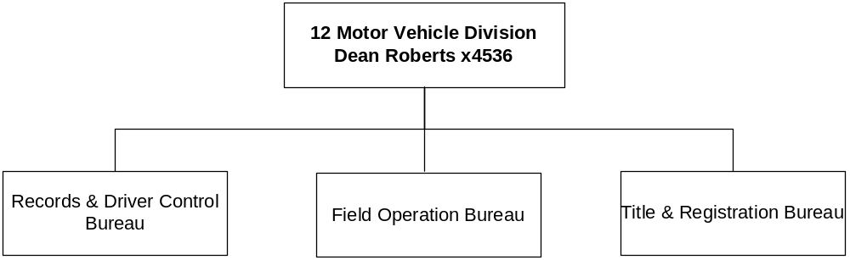

Program Description - The Motor Vehicle Division (MVD), under provision of Title 61 and Title 23, MCA, and certain federal statutes is responsible for: 1) examination and licensure of all drivers; 2) creation and maintenance of permanent driver and motor vehicle records; 3) titling and registration of all vehicles including boats, snowmobiles and ATVs; 4) inspection and verification of vehicle identification numbers; 5) licensure and compliance control of motor vehicle dealers and manufacturers; and 6) providing motor voter registration.

Program Indicators -

Indicator | Actual FY2000 | Actual FY2001 | Actual FY2002 | Estimated FY2003 | Requested FY2004 | Requested FY2005
Issue titles for new and used vehicles:
Title Transactions | 496,969 | 388,104 | 444,422 | 448,800 | 453,200 | 457,700
Provide for motor vehicle registration
Vehicles Registered | 1,115,676 | 1,141,617 | 1,117,152 | 1,128,300 | 1,139,500 | 1,150,800
Renewal Notices Issued | 861,753 | 887,744 | 908,652 | 917,700 | 926,800 | 936,000
Process motor vehicle lien filings/releases
Lien filings processed | 193,690 | 152,190 | 185,614 | 187,400 | 189,200 | 191,000
Lien releases processed | 88,592 | 129,212 | 130,118 | 131,400 | 132,700 | 134,000
Regulate motor vehicle dealers/manufacturers in MT*
Dealers and Manufacturers licensed | 1,460 | 1,584 | 1,438 | 1,440 | 1,440 | 1,440
Provide driver licensing services statewide
Driver’s licenses issued** | 146,861 | 121,505 | 123,070 | 124,300 | 125,500 | 126,700
Motor voter registrations processed | 26,102 | 19,798 | 20,168 | 20,300 | 20,500 | 20,700
Perform special extended driver licensing investigations and hearings
Special investigations and hearings conducted | 52 | 30 | 47 | 50 | 55 | 60
Provide vehicle identification number (VIN) inspection services
VIN inspections | 964 | 993 | 1,263 | 1,275 | 1,300 | 1,325
Create, maintain and disseminate driver records
Documents imaged*** | 625,652 | 183,630 | 288,339 | 400,000 | 404,000 | 408,040
Convictions recorded | 106,315 | 94,004 | 97,611 | 98,500 | 99,600 | 100,600
Administer license revocations, suspension, cancellations and reinstatements
Revocations, suspensions, cancellations, and probationary licenses issued | 27,813 | 28,835 | 29,811 | 30,800 | 31,900 | 33,000
* Dealer law change, ** Conversion to 8-yr driver licensing system completed in October 1999, *** Archived paper files conversion
**** Minor in possession law change
Program Proposed Budget  Budget Item | Base  Budget  Fiscal 2002 | PL Base Adjustment  Fiscal 2004 | New  Proposals  Fiscal 2004 | Total  Exec. Budget  Fiscal 2004 | PL Base Adjustment  Fiscal 2005 | New  Proposals  Fiscal 2005 | Total  Exec. Budget  Fiscal 2005
FTE | 161.60 | 0.00 | (7.45) | 154.15 | 0.00 | (9.45) | 152.15
Personal Services | 4,654,484 | 523,869 | (179,091) | 4,999,262 | 528,411 | (250,938) | 4,931,957
Operating Expenses | 3,849,765 | 574,878 | (443,872) | 3,980,771 | 399,872 | (238,696) | 4,010,941
Debt Service | 155,132 | 1,289,144 | 3,900,000 | 5,344,276 | (6,856) | 0 | 148,276
Total Costs | $8,659,381 | $2,387,891 | $3,277,037 | $14,324,309 | $921,427 | ($489,634) | $9,091,174
General Fund | 8,220,327 | 1,098,747 | (622,963) | 8,696,111 | 928,283 | (489,634) | 8,658,976
State/Other Special | 439,054 | 1,289,144 | 3,900,000 | 5,628,198 | (6,856) | 0 | 432,198
Total Funds | $8,659,381 | $2,387,891 | $3,277,037 | $14,324,309 | $921,427 | ($489,634) | $9,091,174

--------------------------------- Present Law Adjustments --------------------------------

Total Agency Impact | General Fund Total
FY04 $452,135 | FY04 $452,135
FY05 $253,811 | FY05 $253,811
PL- 1201 - Motor Vehicle Operations Adjustments -
Base budget adjustments for the Title and Registration Bureau are necessary in the areas of printing, postage and freight, travel, leased vehicles, and telephone system maintenance. A total of $452,135 in FY 2004 and $253,811 in FY 2005 in general fund is requested. This request includes $251,415 for the new license plate issue mandated in FY 2004. (See NP-8001 on the next page for the companion recommendation.)
________________________________________________________________________________________________

Total Agency Impact | General Fund Total
FY04 $49,249 | FY04 $49,249
FY05 $52,647 | FY05 $52,647
PL- 1202 - Driver Licensing Operations Adjustments -
In order for the Motor Vehicle Division to continue to meet ongoing driver licensing and driver control responsibilities, budget adjustments are necessary to restore zero-based overtime and increase operating for computer processing services, rent, and vehicle maintenance. These adjustments for present law operations total $101,896 of general fund for the biennium. The budgets for the Motor Vehicle Division Administrative Section, Field Operations Bureau, and Records and Driver Control Bureau have been combined in this package.
________________________________________________________________________________________________

Total Agency Impact | General Fund Total
FY04 $1,289,144 | FY04 $0
FY05 ($6,856) | FY05 $0
PL- 1203 - HB 577 Debt Payments -
Budget adjustments for HB 577 debt payments are necessary to fund the Motor Vehicle System, Phase One, Titling System project. A total of $1,296,000 in state special revenue authority is requested for the biennium as a biennial appropriation.

---------------------------------------- New Proposals ----------------------------------------

Total Agency Impact | General Fund Total
FY04 ($179,091) | FY04 ($179,091)
FY05 ($276,904) | FY05 ($276,904)
NP- 1205 - Eliminate 9.45 FTE -
A total of 9.45 FTE in the division are recommended to be eliminated for a general fund savings of $455,995 for the biennium. These positions consist of two administrative support positions, approximately five licensing/permitting clerks, and two compliance specialists.
________________________________________________________________________________________________

Total Agency Impact | General Fund Total
FY04 ($40,000) | FY04 ($40,000)
FY05 ($40,000) | FY05 ($40,000)
NP- 1206 - Reduction of Motor Pool Vehicles -
This budget savings will be achieved through reducing eight State Motor Pool vehicles. Instead of using motor pool vehicles, the division will use recycled highway patrol cars. The estimated savings total $80,000 of general fund for the biennium.

------------------ Other Legislation Required to Implement HB 2 ------------------

Total Agency Impact | General Fund Total
FY04 ($251,415) | FY04 ($251,415)
FY05 $0 | FY05 $0
NP- 8001 - Delay Requirement for New License Plates -
Legislation (LC 162) will be presented to the 2003 Legislature to delay the new general issuance of license plates from calendar year 2004 to year 2008. The general fund savings for this biennium in the department is $251,415. There also will be a significant savings in the Department of Corrections.
________________________________________________________________________________________________

Total Agency Impact | General Fund Total
FY04 ($152,457) | FY04 ($152,457)
FY05 ($172,730) | FY05 ($172,730)
NP- 8002 - Reduce Number of Decals -
Upon passage and approval of legislation, only one registration decal for the rear of all motor vehicles including recreational vehicles will be required in the future. This bill will generate a savings of $325,187 of general fund over the biennium.
________________________________________________________________________________________________

Total Agency Impact | General Fund Total
FY04 $3,900,000 | FY04 $0
FY05 $0 | FY05 $0
NP- 8003 - Motor Vehicle Registration Automation -
The executive supports the department moving forward with Phase Two of the motor vehicle business process automation project initiated last legislative session in HB 577. It will cost $20 million to reengineer the motor vehicle registration and driver license business processes and computer systems. The department requests this project be funded through another loan issued by the Board of Investments. The costs would be paid within 10 years from the date of issue. The $2.2 million per year payment for the loan would be serviced through a $5 per title transaction fee. The department will request legislation.

Of the nearly $2.4 million that this $5/year increase would generate, approximately $2.2 million would be needed to repay the loan. Authorization for $3.9 million state special revenue for the biennium is requested in HB 2 to repay the loan.

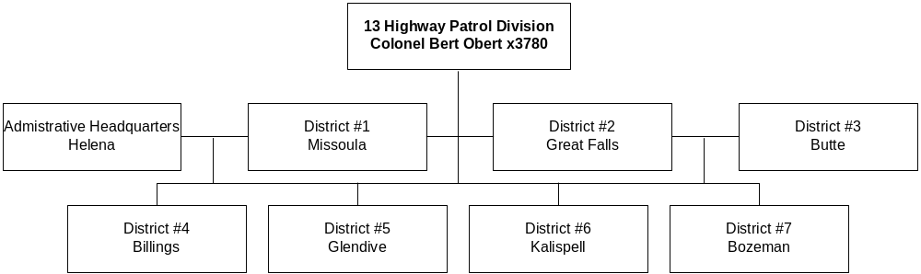

Program Description - The Highway Patrol Division (HPD) is responsible for patrolling the highways of Montana, enforcing traffic laws, and investigating traffic crashes. The patrol gives assistance and information to motorists and first aid to those injured in traffic crashes, transports blood and medical supplies in emergency situations, and assists other law enforcement agencies when requested. The patrol provides 24 x seven communication and radio dispatch for the Highway Patrol and other state agencies. The Motor Carrier Safety Assistance program (MCSAP) attempts to reduce commercial motor vehicle accidents in the state by participating in the Commercial Vehicle Safety Alliance (CVSA) and its North American Driver/Vehicle Inspection program in all levels of inspections as well as safety review audits.

Program Indicators -

Indicator | Actual FY2000 | Actual FY2001 | Actual FY2002 | Estimated FY2003 | Requested FY2004 | Requested FY2005
Increase seatbelt enforcement by 2% per year | * n/a | * n/a | 12,704 | 12,958 | 13,217 | 13,481
Install mobile data terminals in 10% of Patrol cars per year | * n/a | * n/a | 10 | 13 | 21 | 21
Increase commercial vehicle inspections by 3% per year | 10,045 | 12,104 | 12,164 | 12,529 | 12,904 | 13,291
Maintain Patrol traffic availability | 45.4% | 44.9% | 46.7% | 46.7% | 46.7% | 46.7%
* These are new indicators beginning in FY 2002.

Program Proposed Budget  Budget Item | Base  Budget  Fiscal 2002 | PL Base Adjustment  Fiscal 2004 | New  Proposals  Fiscal 2004 | Total  Exec. Budget  Fiscal 2004 | PL Base Adjustment  Fiscal 2005 | New  Proposals  Fiscal 2005 | Total  Exec. Budget  Fiscal 2005
FTE | 272.55 | 0.00 | 2.00 | 274.55 | 0.00 | 2.00 | 274.55
Personal Services | 12,593,945 | 1,318,351 | 108,737 | 14,021,033 | 1,335,792 | 108,654 | 14,038,391
Operating Expenses | 4,509,527 | 125,598 | 24,846 | 4,659,971 | 198,054 | 24,846 | 4,732,427
Equipment | 1,448,215 | 179,860 | 0 | 1,628,075 | 317,426 | 0 | 1,765,641
Total Costs | $18,551,687 | $1,623,809 | $133,583 | $20,309,079 | $1,851,272 | $133,500 | $20,536,459
General Fund | 1,164,745 | 2,249 | 0 | 1,166,994 | 38,548 | 0 | 1,203,293
State/Other Special | 16,614,943 | 1,574,176 | 133,583 | 18,322,702 | 1,762,134 | 133,500 | 18,510,577
Federal Special | 771,999 | 47,384 | 0 | 819,383 | 50,590 | 0 | 822,589
Total Funds | $18,551,687 | $1,623,809 | $133,583 | $20,309,079 | $1,851,272 | $133,500 | $20,536,459

--------------------------------- Present Law Adjustments --------------------------------

Total Agency Impact | General Fund Total
FY04 $739,193 | FY04 $26,238
FY05 $897,989 | FY05 $62,633
PL- 1301 - Base Adjustments Operations -
The Highway Patrol budget supports the uniformed officers in seven districts, officers and support staff in headquarters, the aircraft unit, radio technicians, and the three communication/dispatch centers. The adjustments in this proposal are the result of increased operation costs in critical areas where the MHP has little or no control over the costs. The major increases occur in overtime, prisoner per diem, and equipment. A total of $1,723,968 is requested for the biennium. This increase is funded with $1,548,311 of state special gas tax and $175,657 of general fund.

In addition, the executive recommends continuing special session reductions totaling $86,786 of general fund for the biennium.
________________________________________________________________________________________________

Total Agency Impact | General Fund Total
FY04 $32,110 | FY04 $0
FY05 $32,110 | FY05 $0
PL- 1302 - Base Adjustments Recruit Training School -
The MHP annually conducts a Recruit Training School to train new recruits to fill vacancies. The Recruit Training School consists of 14 weeks of on-campus training and eight weeks of field training. The increase is necessary due to fewer recruits entering the recruit school. The MHP is requesting to annualize the cost to provide for 25 recruits per year in the Recruit Training School. A total increase of $64,220 ($32,110 in FY 2004 and $32,110 in FY 2005) in state special gas tax is requested for the biennium.
________________________________________________________________________________________________

Total Agency Impact | General Fund Total
FY04 $291,466 | FY04 $0
FY05 $295,472 | FY05 $0
PL- 1303 - Operating Adjustments MCSAP -
The Motor Vehicle Inspection Bureau is responsible for the Motor Carrier Safety Assistance Program (MCSAP) for the entire state. Bureau personnel perform inspections and compliance reviews, enter and upload data, provide training, assistance and investigation at crash scenes involving commercial motor vehicles. The bureau also enforces adopted federal and state regulations regarding hazardous material and safety by inter-state and intra-state commercial motor carriers. Increases are related to salary authority, overtime, and equipment (vehicle replacement). A total of $586,938 is requested for the biennium of which $582,993 is federal funds and $3,945 is state special gas tax funds.

---------------------------------------- New Proposals ----------------------------------------

Total Agency Impact | General Fund Total
FY04 $133,583 | FY04 $0
FY05 $133,500 | FY05 $0
NP- 1304 - Executive Protection -
The Montana Highway Patrol is requesting 2.00 FTE and spending authority for salaries and expenses to continue executive protection for the Governor. The authority requested is $133,583 in FY 2004 and $133,500 in FY 2005 of state special funds. The MHP will bill the governor's office for services and will be reimbursed with general fund money from the Governor's budget. No state special gas tax funds are requested.

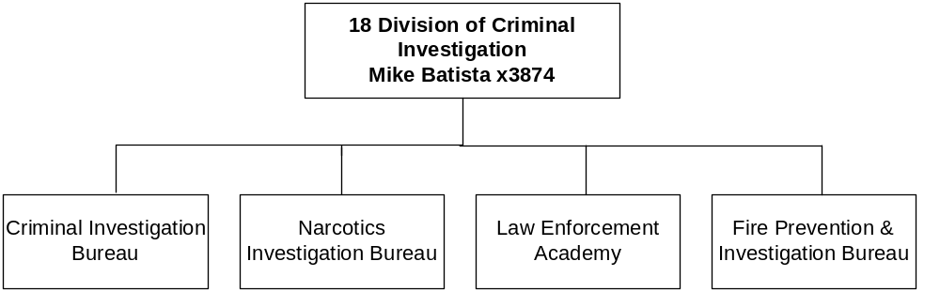

Program Description - The Division of Criminal Investigation includes the administration, management, and coordination of criminal investigative services and training performed by the Investigations Bureau, the Narcotics Bureau, the Fire Prevention and Investigation Bureau, and the Law Enforcement Academy Bureau. Investigators conduct criminal investigations of homicide, fraud, robbery, assault, corruption, arson, organized crime, computer crime, dangerous drug activity, and other felony crimes. The division also has specialized criminal investigation units for the following fraud investigation: 1) workers' compensation, 2) public assistance, 3) Medicaid, and 4) legislative audits. The Fire Prevention and Investigation Bureau is responsible for safeguarding life and property from fire, explosion, and arson through investigative, inspection, and fire code interpretation and enforcement functions. The Montana Law Enforcement Academy provides a professional education and training program in criminal justice for Montana law enforcement officers and other criminal justice personnel. The academy provides an annual curriculum specifically designed to meet the needs of the adult and juvenile criminal justice systems. The Division of Criminal Investigation operates under both state and federal mandates.

Program Indicators -

Indicator | Actual FY2000 | Actual FY2001 | Actual FY2002 | Estimated FY2003 | Requested FY2004 | Requested FY2005
Investigations and cases | 596 | 543 | 478 | Unable to Predict
Fire/Life Safety Inspections | 620 | 923 | 1044 | 750 | 750 | 750
Training provided by non-MLEA staff | 93 | 207 | 279 | 175 | 175 | 175
Number of Programs offered by MLEA | 287 | 567 | 568 | 475 | 475 | 475
Officers trained at MLEA | 1576 | 2606 | 1824 | 2000 | 2000 | 2000
Officers trained regionally for POST credit | 3599 | 6007 | 6963 | 5500 | 5500 | 5500

Program Proposed Budget  Budget Item | Base  Budget  Fiscal 2002 | PL Base Adjustment  Fiscal 2004 | New  Proposals  Fiscal 2004 | Total  Exec. Budget  Fiscal 2004 | PL Base Adjustment  Fiscal 2005 | New  Proposals  Fiscal 2005 | Total  Exec. Budget  Fiscal 2005
FTE | 74.50 | 2.00 | 3.00 | 79.50 | 2.00 | 3.00 | 79.50
Personal Services | 3,315,464 | 386,850 | 115,091 | 3,817,405 | 395,705 | 114,485 | 3,825,654
Operating Expenses | 1,709,536 | (45,570) | 228,036 | 1,892,002 | (37,330) | 213,646 | 1,885,852
Equipment | 18,830 | (333) | 0 | 18,497 | (333) | 0 | 18,497
Transfers | 0 | 0 | 25,000 | 25,000 | 0 | 25,000 | 25,000
Debt Service | 78,844 | 0 | 0 | 78,844 | 0 | 0 | 78,844
Total Costs | $5,122,674 | $340,947 | $368,127 | $5,831,748 | $358,042 | $353,131 | $5,833,847
General Fund | 3,456,108 | 282,433 | (1,312,819) | 2,425,722 | 295,714 | (1,317,773) | 2,434,049
State/Other Special | 356,722 | 5,676 | 1,175,853 | 1,538,251 | 6,109 | 1,179,405 | 1,542,236
Federal Special | 1,309,844 | 52,838 | 505,093 | 1,867,775 | 56,219 | 491,499 | 1,857,562
Total Funds | $5,122,674 | $340,947 | $368,127 | $5,831,748 | $358,042 | $353,131 | $5,833,847

--------------------------------- Present Law Adjustments --------------------------------

Total Agency Impact | General Fund Total
FY04 $10,000 | FY04 $10,000
FY05 $10,000 | FY05 $10,000
PL- 1801 - Required Public Safety Communicators Courses -
The Montana Law Enforcement Academy (MLEA) of the Division of Criminal Investigation requests funding in order to double the number of Public Safety Communicators basic courses it provides. Since July 2001, all public safety communicators (dispatchers) are required to attend this basic course within one year of hire in accordance with 7-31-203(2)(b), MCA. This new requirement has dramatically increased demand for basic dispatcher training. The division requests a total of $20,000 in general fund for the 2005 biennium. This request will be completely offset by the $165 per trainee tuition the division collects and deposits into the general fund.
________________________________________________________________________________________________

Total Agency Impact | General Fund Total
FY04 ($12,263) | FY04 ($12,263)
FY05 ($12,263) | FY05 ($12,263)
PL- 1804 - FTE for Maintenance of MLEA -
The Division of Criminal Investigation requests 2.00 FTE custodians to improve janitorial services at the Montana Law Enforcement Academy. The 2001 Legislature appropriated over $49,000 per year for janitorial services at the academy. The janitorial contract allowed for two people to spend two hours per day cleaning about 10 buildings, which total over 90,000 square feet. This request is to transfer the funds from operating expenses to personal services and authorize the FTE so DCI can hire 2.00 FTE for eight hours a day to clean and maintain the buildings with no increase in funding. In addition, the executive recommends continuing the special session reductions in operating and equipment totaling $24,526 general fund savings for the biennium.

---------------------------------------- New Proposals ----------------------------------------

Total Agency Impact | General Fund Total
FY04 $189,811 | FY04 $0
FY05 $189,811 | FY05 $0
NP- 1802 - Eastern Montana Drug Task Force -
The executive recommends spending authority within the Division of Criminal Investigation for 1.00 FTE criminal investigator and 1.00 FTE administrative support to manage the Eastern Montana Drug Task Force. For the past 15 years, local law enforcement in eastern Montana have managed this grant-funded task force. In FY 2002 management difficulties prompted the task force to request that DCI assume these management responsibilities. Since DCI already manages two similar task forces, the division has the experience to assume its operation. The division requests a total of $379,622, which includes $94,906 of state special revenue and $284,716 of federal funds.
________________________________________________________________________________________________

Total Agency Impact | General Fund Total
FY04 $54,769 | FY04 $0
FY05 $54,769 | FY05 $0
NP- 1803 - High Intensity Drug Traffic Area Funding -
There is requested 1.00 FTE crime analyst and the federal funding necessary for the division to participate in the Rocky Mountain High Intensity Drug Trafficking Area (HIDTA) program. The mission of the Rocky Mountain HIDTA is to more effectively combat drug trafficking problems by improving cooperation and coordination among the federal, state and local law enforcement agencies involved. In 2001, Montana's congressional delegation successfully worked to have Montana included in this federal drug enforcement program. As a HIDTA state, Montana will receive $1 million in federal funding each year to combat methamphetamine production and distribution, and other drug trafficking. For the 2005 biennium, the division requests 1.00 FTE and $109,538 federal funds, which is the division's share of Montana HIDTA funds.
________________________________________________________________________________________________

Total Agency Impact | General Fund Total
FY04 $25,000 | FY04 $0
FY05 $25,000 | FY05 $0
NP- 1805 - Legislative Contract Authority -
This proposal recommends state special revenue legislative contract authority (LCA) to allow the division flexibility to spend tuition collected by students attending professional courses at the MLEA. The courses are primarily to train experienced law enforcement officers in changes in law enforcement practices, advanced skill-based courses and management courses. LCA was approved for the 2003 biennium; however, since it is always a one-time-only appropriation, $50,000 in authority is requested for the 2005 biennium.
________________________________________________________________________________________________

Total Agency Impact | General Fund Total
FY04 $231,890 | FY04 $0
FY05 $217,133 | FY05 $0
NP- 1806 - Homeland Security Program -
This decision package requests 1.00 FTE criminal investigator and 2.00 FTE crime analysts to support Montana Homeland Security initiatives with $449,023 federal funds for the 2005 biennium. Montana has an important role in preventing and mitigating terrorist activities from occurring on U.S. soil, especially Montana's shared border with Canada, which is by all accounts unsecured and the identities of those crossing the border unknown to most law enforcement agencies. The staff and federal funds will enhance the state's intelligence, collection and analysis capabilities.
________________________________________________________________________________________________

Total Agency Impact | General Fund Total
FY04 ($133,343) | FY04 ($209,419)
FY05 ($133,582) | FY05 ($210,821)
NP- 7001 - Eliminate 3 FTE/ 1 FTE Fund Switch -
The executive recommends eliminating 3.00 FTE within the Division of Criminal Investigation. These positions consist of two deputy fire marshals and one administrative support position. These reductions were part of the special session reductions. The fund switch for the grant writer position will replace general fund with federal funds. The total general fund savings for all positions is $420,240 for the biennium.

------------------ Other Legislation Required to Implement HB 2 ------------------

Total Agency Impact | General Fund Total
FY04 $0 | FY04 ($1,103,400)
FY05 $0 | FY05 ($1,106,952)
NP- 8003 - Fund Switch MLEA Pending Legislation -
The executive is supporting a fund switch for the Montana Law Enforcement Academy. Legislation will be presented to the 2003 Legislature to allow a fund switch from general fund to state special revenue. The funding source for the state special revenue account will be generated from a surcharge on civil and criminal cases in all courts of limited jurisdictions. In FY 2002, there were an estimated 165,971 cases in these categories. A seven-dollar surcharge would offset the current general fund budget of $1,103,400 in FY 2004 and $1,106,952 in FY 2005.

Program Description - The County Attorney Payroll program pays approximately half of the salary and benefits for the attorneys who serve Montana's 56 counties, as required by 7-4-2502, MCA. County compensation boards within each county determine county attorney salaries. By law, the state's contribution is limited to the general fund amount the Legislature appropriates for this program. The state's contribution may be less than half of the board-approved salary.

Program Proposed Budget  Budget Item | Base  Budget  Fiscal 2002 | PL Base Adjustment  Fiscal 2004 | New  Proposals  Fiscal 2004 | Total  Exec. Budget  Fiscal 2004 | PL Base Adjustment  Fiscal 2005 | New  Proposals  Fiscal 2005 | Total  Exec. Budget  Fiscal 2005
FTE | 21.55 | 0.00 | 0.00 | 21.55 | 0.00 | 0.00 | 21.55
Personal Services | 1,634,822 | 136,152 | (147,634) | 1,623,340 | 214,639 | (226,121) | 1,623,340
Total Costs | $1,634,822 | $136,152 | ($147,634) | $1,623,340 | $214,639 | ($226,121) | $1,623,340
General Fund | 1,634,822 | 136,152 | (147,634) | 1,623,340 | 214,639 | (226,121) | 1,623,340
Total Funds | $1,634,822 | $136,152 | ($147,634) | $1,623,340 | $214,639 | ($226,121) | $1,623,340

--------------------------------- Present Law Adjustments --------------------------------

Total Agency Impact | General Fund Total
FY04 ($59,559) | FY04 ($59,559)
FY05 ($59,559) | FY05 ($59,559)
PL- 1901 - County Attorney Pay -
State statute 7-4-2502(2)(a), MCA, provides that one-half of county attorney salaries are paid from the state treasury, providing the county informs the department of the amount required in time for inclusion in the budget. Because not all counties hired the FTE for which FY 2003 budgets were requested the unspent funds were used to attain the 17-7-140, MCA, budget reductions and the special session reductions. This present law decision package continues $119,118 of general fund reductions over the biennium, consistent with other programs in state government continuing those reductions.

---------------------------------------- New Proposals ----------------------------------------

Total Agency Impact | General Fund Total
FY04 ($147,634) | FY04 ($147,634)
FY05 ($226,121) | FY05 ($226,121)
NP- 1902 - Reductions in Personal Services -
This reduction in personal services offsets an increase in budgeted amounts for 50 percent of county attorney salaries which should not have been rolled forward automatically. The 57th Legislature changed the statute so the salaries are set annually by county compensation boards. At the same time, statute was amended in 17-7- 112(2)(b), MCA, to limit the state's share to the amount appropriated. The general fund reduction is $373,755 for the biennium.

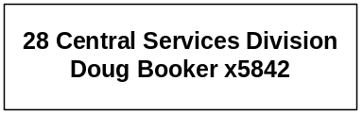

Program Description - The Central Services Division provides the administrative, personnel, budgetary, accounting, and fiscal support for the Department of Justice. The program also administers the County Attorney Payroll.

Program Proposed Budget  Budget Item | Base  Budget  Fiscal 2002 | PL Base Adjustment  Fiscal 2004 | New  Proposals  Fiscal 2004 | Total  Exec. Budget  Fiscal 2004 | PL Base Adjustment  Fiscal 2005 | New  Proposals  Fiscal 2005 | Total  Exec. Budget  Fiscal 2005
FTE | 15.00 | 0.00 | 0.00 | 15.00 | 0.00 | 0.00 | 15.00
Personal Services | 563,937 | 94,281 | 0 | 658,218 | 94,500 | 0 | 658,437
Operating Expenses | 125,247 | 50,511 | 0 | 175,758 | (4,562) | 0 | 120,685
Total Costs | $689,184 | $144,792 | $0 | $833,976 | $89,938 | $0 | $779,122
General Fund | 294,457 | 59,992 | (11,610) | 342,839 | 36,656 | (11,610) | 319,503
State/Other Special | 380,865 | 81,836 | 12,150 | 474,851 | 51,425 | 12,150 | 444,440
Proprietary | 13,862 | 2,964 | (540) | 16,286 | 1,857 | (540) | 15,179
Total Funds | $689,184 | $144,792 | $0 | $833,976 | $89,938 | $0 | $779,122

--------------------------------- Present Law Adjustments --------------------------------

Total Agency Impact | General Fund Total
FY04 ($7,298) | FY04 ($7,298)
FY05 ($6,860) | FY05 ($6,860)
PL- 7001 - On-going Special Session Reductions -
This present law adjustment consists of on-going special session reductions in personal services and operating expenses that save the general fund $14,158 for the biennium.

---------------------------------------- New Proposals ----------------------------------------

Total Agency Impact | General Fund Total
FY04 $0 | FY04 ($11,610)
FY05 $0 | FY05 ($11,610)
NP- 2804 - Fund Switch -
The executive proposes to replace $11,610 of general fund in FY 2004 and FY 2005 with state special revenue so that the Natural Resource Damage Program pays its own administrative costs consistent with passage and approval of HB 21 in the special session.

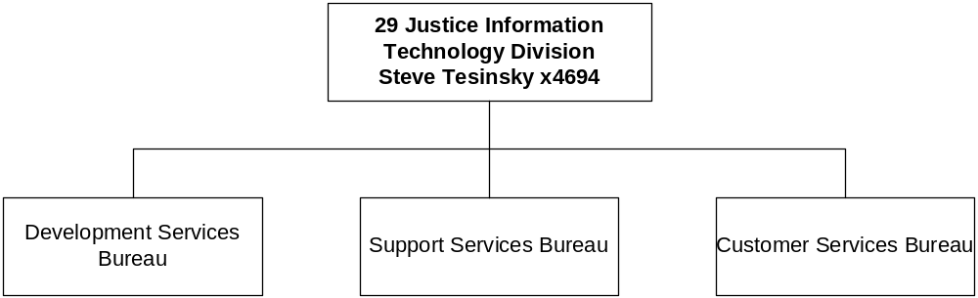

Program Description - The Justice Information Technology Services Division provides a full range of information technology and criminal justice services for the department including: 1) system development and maintenance of the motor vehicle titling and registration system; 2) the driver license and history system; 3) the criminal history record information system and the Montana Uniform Crime Reporting System; 4) support for the Department of Justice internal computers and systems; 5) identification services for the criminal justice community through criminal history record checking and fingerprint processing; and 6) system development and support for the Criminal Justice Information Network (CJIN). CJIN links law enforcement/criminal justice agencies with information sources at local, state, and national levels by interfacing with the National Law Enforcement Telecommunications System, the National Crime Information Center (NCIC), and numerous State of Montana files.

Program Indicators -

Benchmarks | Actual  FY 01 | Actual  FY 02 | Estimated  FY 03 | Requested FY 04 | Requested FY 05

Perform criminal history record checks
Checks for the public | 58,420 | 61,308 | 66,850 | 76,877 | 88,408
Checks for criminal justice agencies | 229,520 | 232,099 | 243,703 | 255,888 | 268,682
Process fingerprint cards
Criminal arrest cards | 9,220 | 13,084 | 21,444 | 22,000 | 22,000
Civil cards | 3,785 | 5,488 | 7,920 | 9,504 | 11,405

Assist and train law enforcement
Calls to Help-desk | 2,236  (Part year) | 7,626 | 7,800 | 7,800 | 7,800
Participants in instructor-led courses | not tracked | 1,416 | 936 | 1,200 | 1,200
Participants in web-based courses | 1,300 | 2,610 | 2,069 | 3,000 | 2,500
Mobile (in-car) workstations | 46 | 208 | 394 | 420 | 450
Web-based users | 0 | 10 | 15 | 1,000 | 1,000

Provide System Support of the Statewide Criminal Justice Information Network
Person Hours |  |  | 6,038 | 7,256 | 8,000

Provide Support of Department of Justice Workstations, Servers and Networks
Person Hours |  |  | 9,768 | 10,256 | 10,769

Programming Development Effort
Hours spend on development (State FTE plus 3 contractors available until Dec. 2002 |  |  | 13,960 | 0 | 0
Hours spent on development (State FTE only) |  |  | 11,136 | 16,167 | 16,167
Average time to complete a Motor Vehicle Division Work Request

Program Proposed Budget  Budget Item | Base  Budget  Fiscal 2002 | PL Base Adjustment  Fiscal 2004 | New  Proposals  Fiscal 2004 | Total  Exec. Budget  Fiscal 2004 | PL Base Adjustment  Fiscal 2005 | New  Proposals  Fiscal 2005 | Total  Exec. Budget  Fiscal 2005
FTE | 46.00 | 0.00 | 3.00 | 49.00 | 0.00 | 3.00 | 49.00
Personal Services | 1,978,408 | 148,380 | 101,679 | 2,228,467 | 146,751 | 101,416 | 2,226,575
Operating Expenses | 1,346,555 | 1,357 | 68,116 | 1,416,028 | 9,040 | 68,116 | 1,423,711
Equipment | 6,767 | (53,579) | 0 | (46,812) | (53,579) | 0 | (46,812)
Debt Service | 527,303 | 0 | 0 | 527,303 | 0 | 0 | 527,303
Total Costs | $3,859,033 | $96,158 | $169,795 | $4,124,986 | $102,212 | $169,532 | $4,130,777
General Fund | 2,900,485 | 112,305 | (120,794) | 2,891,996 | 118,721 | (120,839) | 2,898,367
State/Other Special | 768,893 | 0 | 290,589 | 1,059,482 | 0 | 290,371 | 1,059,264
Federal Special | 179,456 | (16,147) | 0 | 163,309 | (16,509) | 0 | 162,947
Proprietary | 10,199 | 0 | 0 | 10,199 | 0 | 0 | 10,199
Total Funds | $3,859,033 | $96,158 | $169,795 | $4,124,986 | $102,212 | $169,532 | $4,130,777

--------------------------------- Present Law Adjustments --------------------------------

Total Agency Impact | General Fund Total
FY04 ($88,480) | FY04 ($88,480)
FY05 ($88,480) | FY05 ($88,480)
PL- 7001 - On-going Special Session Reductions -
The special session reductions for total $176,960 general fund savings over the biennium are continued. This consists of $15,520 in office supplies, $107,158 in equipment, and $54, 282 in personal services.

------------------ Other Legislation Required to Implement HB 2 ------------------

Total Agency Impact | General Fund Total
FY04 $169,795 | FY04 ($120,794)
FY05 $169,532 | FY05 ($120,839)
NP- 8001 - Criminal Justice Information System FTE -
The Department of Justice Information Technology Services Division is requesting 3.00 FTE funded by state special revenue contingent on passage and approval of separate legislation. These positions include 2.00 FTE fingerprint technicians and 1.00 FTE unit supervisor, as well as contracted services for an attorney. The proposed legislation requests a charge commensurate with cost for performing name-based background checks, which are increasing in number. The revenue will fund these staff who will develop a more efficient process for conducting criminal background checks for non-criminal justice users. This decision package requests authority totaling $339,327 for the biennium.

In addition a request for a fund switch, based on the same legislation, will replace 67 percent of general fund for 6.00 FTE, with state special revenue.

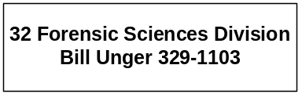

Program Description - The Forensic Science Division, which includes the State Crime Lab in Missoula and the State Medical Examiner, provides for a statewide system of death investigation, forensic science training, scientific criminal investigation and analysis for specimens submitted by law enforcement officials, coroners, and state agencies. The division tests firearms, toolmarks, hair, fiber, drugs, blood, body fluids, and tissues. The laboratory also analyzes blood and urine samples in connection with driving under the influence of alcohol or drugs (DUI) and provides the certification, maintenance, and training of all law enforcement personnel on breath testing instruments.

Program Indicators -

Indicator | Actual  FY2000 | Actual  FY2001 | Actual  FY2002 | Estimated FY2003 | Requested FY2004 | Requested FY2005
Cases Received from Law Enforcement | 3,901 | 4,554 | 5,038 | 5,473 | 5,968 | 6,464

Program Proposed Budget  Budget Item | Base  Budget  Fiscal 2002 | PL Base Adjustment  Fiscal 2004 | New  Proposals  Fiscal 2004 | Total  Exec. Budget  Fiscal 2004 | PL Base Adjustment  Fiscal 2005 | New  Proposals  Fiscal 2005 | Total  Exec. Budget  Fiscal 2005
FTE | 24.50 | 1.00 | 1.00 | 26.50 | 1.00 | 1.00 | 26.50
Personal Services | 1,356,894 | 142,712 | 46,438 | 1,546,044 | 144,499 | 46,332 | 1,547,725
Operating Expenses | 1,064,738 | 6,909 | 4,360 | 1,076,007 | 20,878 | 3,010 | 1,088,626
Equipment | 118,803 | (35,790) | 0 | 83,013 | (34,440) | 0 | 84,363
Debt Service | 4,566 | 0 | 0 | 4,566 | 0 | 0 | 4,566
Total Costs | $2,545,001 | $113,831 | $50,798 | $2,709,630 | $130,937 | $49,342 | $2,725,280
General Fund | 2,156,769 | 58,823 | 0 | 2,215,592 | 76,035 | 0 | 2,232,804
State/Other Special | 303,204 | 0 | 0 | 303,204 | 0 | 0 | 303,204
Federal Special | 85,028 | 55,008 | 50,798 | 190,834 | 54,902 | 49,342 | 189,272
Total Funds | $2,545,001 | $113,831 | $50,798 | $2,709,630 | $130,937 | $49,342 | $2,725,280

--------------------------------- Present Law Adjustments --------------------------------

Total Agency Impact | General Fund Total
FY04 $55,008 | FY04 $0
FY05 $54,902 | FY05 $0
PL- 3201 - Latent Print Examiner -
This request is for 1.00 FTE latent print examiner position. An additional examiner would enable the division to reduce a one-year backlog and meet its goal of a four-week turnaround time. Such a turnaround time is necessary to efficiently process cases for criminal justice agencies around the state. This critical position was originally requested to be funded 75 percent federal funds and 25 percent general fund. The request now is for 100 percent federal authority.
________________________________________________________________________________________________

Total Agency Impact | General Fund Total
FY04 ($66,070) | FY04 ($66,070)
FY05 ($53,095) | FY05 ($53,095)
PL- 3202 - Forensic Laboratory Lease -
The Forensic Science Division leases space from a private vendor. The Department of Administration entered into a 15 year lease for our current laboratory space on February 1, 2000. This lease allows for a $1.00 per square foot rent increase five years after inception or on February 1, 2005. The lease is for 31,145 square feet. The monthly increase is $2,595 for five months of FY 2005 at a cost of $12,975 general fund. In addition, the executive requests to continue the special session reductions in operating, personal services, and equipment for a general fund savings of $132,140.

---------------------------------------- New Proposals ----------------------------------------

Total Agency Impact | General Fund Total
FY04 $50,798 | FY04 $0
FY05 $49,342 | FY05 $0
NP- 3203 - Chemist -
The decision package requests federal authority through the High Intensity Drug Trafficking Area Program (HIDTA) to fund 1.00 FTE chemist. The position will work in the chemistry section of the laboratory analyzing solid dosage drugs submitted by law enforcement, including illegal street drugs, prescription drugs, tampered products and animal poisons. The federal authority will total $50,798 in FY 2004 and $49,342 in FY 2005 to fund the FTE and associated expenses.

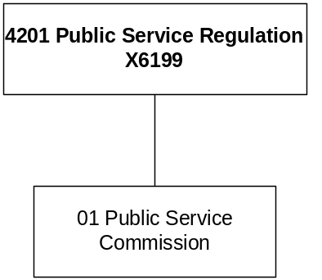

Mission Statement - To fairly balance the long-term interests of Montana utility and transportation companies and the customers they serve.

Statutory Authority - Title 69

Program Description - The Department of Public Service Regulation (PSR) regulates the public utility and transportation industries. Five commissioners elected from districts throughout Montana oversee this program.

Program Indicators-
Indicator | Actual  FY2000 | Actual  FY2001 | Actual  FY2002 | Estimated FY2003 | Requested FY2004 | Requested FY2005
Dockets | 326 | 378 | 339 | 365 | 365 | 365
Informal Utility  Consumer Complaints | 2870 | 2554 | 2614 | 3000 | 3000 | 3000

Program Proposed Budget  Budget Item | Base  Budget  Fiscal 2002 | PL Base Adjustment  Fiscal 2004 | New  Proposals  Fiscal 2004 | Total  Exec. Budget  Fiscal 2004 | PL Base Adjustment  Fiscal 2005 | New  Proposals  Fiscal 2005 | Total  Exec. Budget  Fiscal 2005
FTE | 39.00 | 0.00 | 0.00 | 39.00 | 0.00 | 0.00 | 39.00
Personal Services | 2,002,952 | 194,730 | 0 | 2,197,682 | 193,056 | 0 | 2,196,008
Operating Expenses | 543,014 | 46,716 | 0 | 589,730 | (66,981) | 0 | 476,033
Total Costs | $2,545,966 | $241,446 | $0 | $2,787,412 | $126,075 | $0 | $2,672,041
State/Other Special | 2,533,459 | 240,171 | 0 | 2,773,630 | 124,948 | 0 | 2,658,407
Federal Special | 12,507 | 1,275 | 0 | 13,782 | 1,127 | 0 | 13,634
Total Funds | $2,545,966 | $241,446 | $0 | $2,787,412 | $126,075 | $0 | $2,672,041

--------------------------------- Present Law Adjustments --------------------------------

Total Agency Impact | General Fund Total
FY04 $76,454 | FY04 $0
FY05 ($23,546) | FY05 $0
PL- 1 - Consultants -
The Public Service Commission requests funds for hiring consultants. The amount of the consultant funds requested is $100,000 for the biennium, which is the same as approved by the 2001 Legislature. These funds are used if PSC staff is unable to handle the additional workload or a special project arises.
________________________________________________________________________________________________

Total Agency Impact | General Fund Total
FY04 ($31,334) | FY04 $0
FY05 ($31,662) | FY05 $0
PL- 2 - Rent Increase/Computer Replacement -
Rent increases, based on a contract negotiated by the Department of Administration, will be $8,119 in FY 2004 and $13,195 in FY 2005. There also is budgeted the replacement of four desk top computers in FY 2004 based on the approved four-year replacement cycle. In this request there is also an alternative pay plan adjustment.
________________________________________________________________________________________________

Total Agency Impact | General Fund Total
FY04 ($11,939) | FY04 $0
FY05 ($11,939) | FY05 $0
PL- 3 - Universal Access Program -
Funding for the Universal Access Program was removed from the PSC budget during the 2002 special session and the reduction is continued into the 2005 biennium.

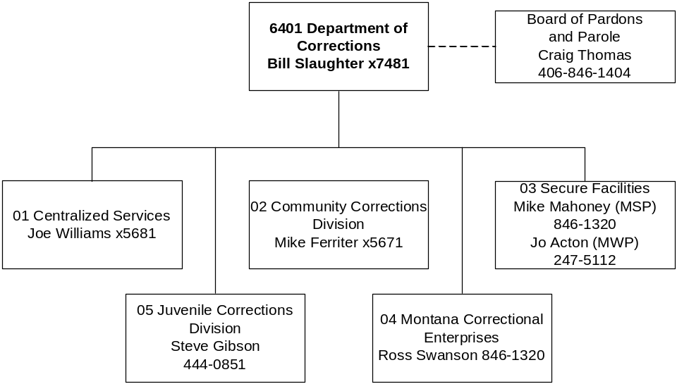

Mission Statement - The Department of Corrections is dedicated to public safety and trust by holding adult and juvenile offenders accountable for their actions against victims through custody, supervision, treatment, work, restitution and skill development.

Statutory Authority - 2-15-2301, 53-1-201 and 53-1-202, MCA.

Agency Proposed Budget  Budget Item | Base  Budget  Fiscal 2002 | PL Base Adjustment  Fiscal 2004 | New  Proposals  Fiscal 2004 | Total  Exec. Budget  Fiscal 2004 | PL Base Adjustment  Fiscal 2005 | New  Proposals  Fiscal 2005 | Total  Exec. Budget  Fiscal 2005
FTE | 1,092.80 | 0.00 | 0.00 | 1,092.80 | 0.00 | 0.00 | 1,092.80
Personal Services | 43,498,841 | 3,883,925 | (19,600) | 47,363,166 | 3,935,378 | (14,160) | 47,420,059
Operating Expenses | 47,640,104 | 7,693,116 | (2,975,408) | 52,357,812 | 6,654,104 | (566,068) | 53,728,140
Equipment | 324,500 | 0 | 0 | 324,500 | 0 | 0 | 324,500
Capital Outlay | 50 | 0 | 0 | 50 | 0 | 0 | 50
Benefits & Claims | 8,040,196 | (1,000,000) | 0 | 7,040,196 | (1,000,000) | 0 | 7,040,196
Debt Service | 224,949 | 0 | 0 | 224,949 | 0 | 0 | 224,949
Total Costs | $99,728,640 | $10,577,041 | ($2,995,008) | $107,310,673 | $9,589,482 | ($580,228) | $108,737,894
General Fund | 96,890,254 | 10,323,427 | (2,995,008) | 104,218,673 | 9,328,179 | (580,228) | 105,638,205
State/Other Special | 1,668,004 | 488,127 | 0 | 2,156,131 | 485,321 | 0 | 2,153,325
Federal Special | 750,280 | (353,227) | 0 | 397,053 | (353,227) | 0 | 397,053
Proprietary | 420,102 | 118,714 | 0 | 538,816 | 129,209 | 0 | 549,311
Total Funds | $99,728,640 | $10,577,041 | ($2,995,008) | $107,310,673 | $9,589,482 | ($580,228) | $108,737,894

------------------ Agency General Fund Target - $209.86 million ------------------
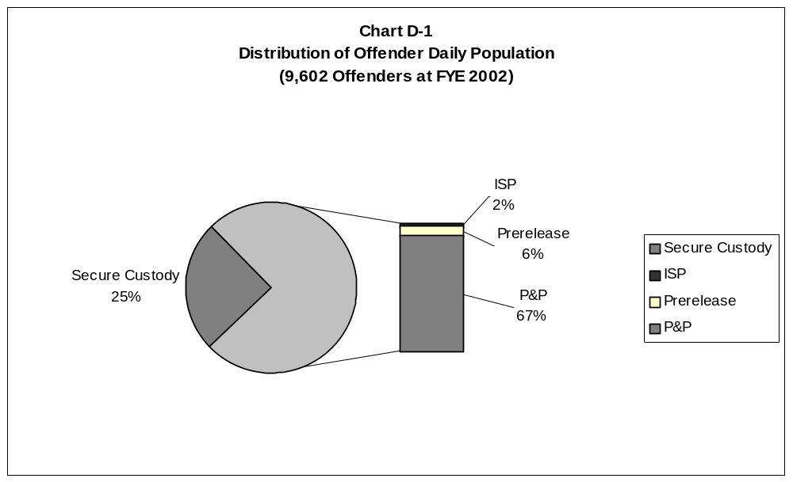

Chart D-1 shows the FYE 2002 daily population of offenders at 9,602. There were 25 percent in secure custody and 75 percent in all other supervision categories.

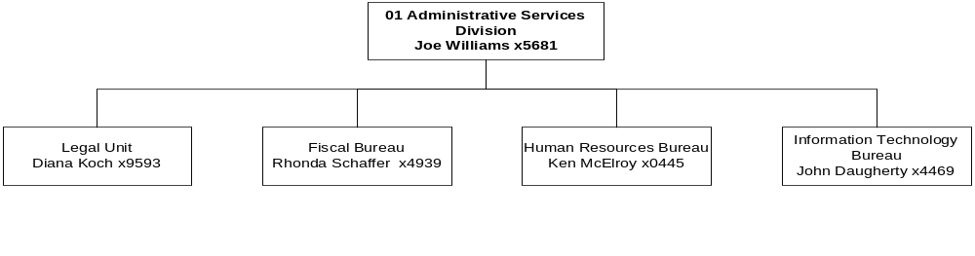
Program Description - The Administration and Support Services Program includes the Director's Office, Administrative Services Division, Professional Services Division and the administratively attached Board of Pardons. This program provides to the department, government entities and the public various administrative and management support; human resource, budget, fiscal, and legal information; technical correctional services; policy and staff development; research; facility management; and access to health care services.

Program Indicators -
Indicator | Actual FY2000 | Actual FY2001 | Actual FY2002 | Estimated FY2003 | Requested FY2004 | Requested FY2005
VINE:  VINE Registered Numbers | 369 | 450 | 500 | 550 | 625 | 700
VINE:  Calls made to VINE | 11,731 | 12,488 | 13,101 | 13,500 | 14,250 | 15,00
Board of Pardons & Parole:  Offenders Release to  Parole | 440 | 493 | 489 | 575 | 625 | 675
Board of Pardons & Parole:  Parole Interviews | 935 | 1112 | 1064 | 1150 | 1250 | 1250
PSD:  Basic Training sessions at the Montana Law Enforcement Academy | 9  (One session funded by Msla Cty) | 8 | 8 | 8 | 9 | 9
ASD:  Employee recruitments processed:  Helena Office  MSP  PHYCF | 148  72  28 | 138  90  30 | 125  88  45 | 140  120  40 | 150  135  50 | 165  150  55
ASD:  ACIS modules replaced by Profiles modules | N/A | Offender Demographic Offender movement | Legal information, Classification | Legal information, Classification | To be determined | To be determined
ASD:  Statistical Information Requests Completed | 149 | 123 | 192 | 200 | 230 | 240
ASD:  # of Help Desk calls resolved | 9,837 | 7962 | 7441 | 7400 | 7400 | 7400

Program Proposed Budget  Budget Item | Base  Budget  Fiscal 2002 | PL Base Adjustment  Fiscal 2004 | New  Proposals  Fiscal 2004 | Total  Exec. Budget  Fiscal 2004 | PL Base Adjustment  Fiscal 2005 | New  Proposals  Fiscal 2005 | Total  Exec. Budget  Fiscal 2005
FTE | 91.50 | 0.00 | 0.00 | 91.50 | 0.00 | 0.00 | 91.50
Personal Services | 3,960,266 | 385,201 | 0 | 4,345,467 | 383,959 | 0 | 4,344,225
Operating Expenses | 5,303,576 | 635,914 | 0 | 5,939,490 | 926,481 | 0 | 6,230,057
Debt Service | 27,543 | 0 | 0 | 27,543 | 0 | 0 | 27,543
Total Costs | $9,291,385 | $1,021,115 | $0 | $10,312,500 | $1,310,440 | $0 | $10,601,825
General Fund | 9,220,046 | 991,447 | 0 | 10,211,493 | 1,274,228 | 0 | 10,494,274
State/Other Special | 4,321 | 2,281 | 0 | 6,602 | (525) | 0 | 3,796
Proprietary | 67,018 | 27,387 | 0 | 94,405 | 36,737 | 0 | 103,755
Total Funds | $9,291,385 | $1,021,115 | $0 | $10,312,500 | $1,310,440 | $0 | $10,601,825

--------------------------------- Present Law Adjustments --------------------------------

Total Agency Impact | General Fund Total
FY04 $22,700 | FY04 $22,700
FY05 $22,700 | FY05 $22,700
PL- 1 - Board Member Per Diem and Travel Increase -
This is a request to fund zero-based $50 per day pay statutorily required per diem for Parole Board members and also to fund a recent Montana Supreme Court ruling that found offenders must appear before a majority of the board.
________________________________________________________________________________________________

Total Agency Impact | General Fund Total
FY04 $20,000 | FY04 $20,000
FY05 $15,000 | FY05 $15,000
PL- 2 - Brd Member Base Per Diem and ACA Re-accreditation -
This is a request to fund zero-based items and also fund ACA reaccredidation. Board members are entitled to be reimbursed for travel expenses for days in which the member is engaged in the performance of board duties. The projected per diem is $15,000 per fiscal year. In January 2001, the Montana Parole Board qualified for American Corrections Association accreditation for three years. The cost of being accredited is $5,000 for the biennium.
________________________________________________________________________________________________

Total Agency Impact | General Fund Total
FY04 $373,544 | FY04 $373,544
FY05 $690,714 | FY05 $690,714
PL- 26 - Outside Medical Adjustment -
An inflationary adjustment of 5 percent per year for outside medical treatment is based on the allowed inflation rate by the budget office. This is offset by an alternative payplan adjustment required by the executive of ($2,371) per year.

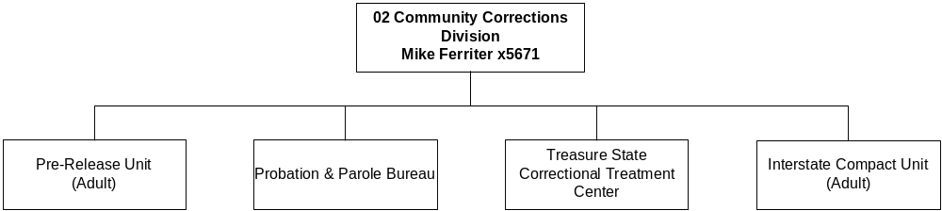

Program Description - The Community Corrections Program includes adult probation and parole, juvenile parole, male and female community corrections programs, the boot camp, the female juvenile correctional facility, juvenile transition centers, and juvenile out-of-home placements. The department contracts with non-profit corporations in Great Falls, Butte, Missoula, Billings, and Helena for pre-release services.

Program Indicators -
Indicator | Actual  FY2000 | Actual FY2001 | Actual  FY2002 | Estimated FY2003 | Requested FY2004 | Requested FY2005
Prerelease Centers  Population as of 6/30 | 535 | 493 | 531 | 531 | 531 | 531
Restitution collected | $1,466,937 | $2,181,364 | $1,827,638 | $1,900,000 | $2,000,000 | $2,100,000

Adult Probation & Parole Caseload
Missoula | 91 | 77 | 94 | 96 | 98 | 98
Helena | 64 | 61 | 60 | 62 | 63 | 63
Bozeman | 63 | 70 | 77 | 79 | 100 | 100
Butte | 75 | 61 | 64 | 66 | 67 | 67
Great Falls | 68 | 70 | 66 | 68 | 69 | 69
Billings | 70 | 58 | 61 | 63 | 64 | 64
Kalispell | 87 | 69 | 74 | 76 | 77 | 77

Program Proposed Budget  Budget Item | Base  Budget  Fiscal 2002 | PL Base Adjustment  Fiscal 2004 | New  Proposals  Fiscal 2004 | Total  Exec. Budget  Fiscal 2004 | PL Base Adjustment  Fiscal 2005 | New  Proposals  Fiscal 2005 | Total  Exec. Budget  Fiscal 2005
FTE | 205.00 | 0.00 | 0.00 | 205.00 | 0.00 | 0.00 | 205.00
Personal Services | 8,526,396 | 349,171 | 0 | 8,875,567 | 364,528 | 0 | 8,890,924
Operating Expenses | 12,670,357 | 3,234,492 | 0 | 15,904,849 | 3,552,006 | 0 | 16,222,363
Equipment | 24,243 | 0 | 0 | 24,243 | 0 | 0 | 24,243
Debt Service | 27,713 | 0 | 0 | 27,713 | 0 | 0 | 27,713
Total Costs | $21,248,709 | $3,583,663 | $0 | $24,832,372 | $3,916,534 | $0 | $25,165,243
General Fund | 20,944,881 | 3,583,663 | 0 | 24,528,544 | 3,916,534 | 0 | 24,861,415
State/Other Special | 303,828 | 0 | 0 | 303,828 | 0 | 0 | 303,828
Total Funds | $21,248,709 | $3,583,663 | $0 | $24,832,372 | $3,916,534 | $0 | $25,165,243

--------------------------------- Present Law Adjustments --------------------------------

Total Agency Impact | General Fund Total
FY04 $623,433 | FY04 $623,433
FY05 $623,952 | FY05 $623,952
PL- 3 - Alternatives to Prison - Treatment and Employment -
The executive requests an increase of $623,433 in FY 2004 and $623,952 in FY 2005 to the Community Corrections budget to cope with the increasing number of inmates being sent directly to the community corrections setting or being moved from secure custody to the community corrections setting. To maintain offenders on probation or parole supervision is the most cost-effective method to manage offender populations.
________________________________________________________________________________________________

Total Agency Impact | General Fund Total
FY04 $21,347 | FY04 $21,347
FY05 $21,347 | FY05 $21,347
PL- 7 - Cook/Chill Base Adjustment for TSCTC -
This request is to fund the cost increase necessary to pay the allocated share of Montana State Prison's cook/chill rate structure in accordance with state law regarding internal service funds adopted in the special session.
________________________________________________________________________________________________

Total Agency Impact | General Fund Total
FY04 $344,628 | FY04 $344,628
FY05 $542,774 | FY05 $542,774
PL- 10 - Base and Inflation Increase for Pre-release Centers -
Funding for base inflationary costs and annualization of operating costs for the pre-release centers serving our prison system is recommended. Adequate funding is required for the current pre-release centers to operate at contract capacity. In FY 2002, the Helena center operated under capacity and the PRCs in Great Falls, Missoula, Butte and Billings periodically operated under capacity. With the state prison population continuing to expand, it is necessary to promote cost-effective measures to reduce overcrowding. In addition, there is an ongoing use of pre-release beds for DOC commitments, parole violators and probation status offenders.
________________________________________________________________________________________________

Total Agency Impact | General Fund Total
FY04 $2,240,750 | FY04 $2,240,750
FY05 $2,312,723 | FY05 $2,312,723
PL- 11 - Base and Inflation Increase for DUI Facility -
This request annualizes the costs associated with operating the felony DUI WATCH program. The executive is recommending general fund of $2,240,750 in FY 2004 and $2,312,723 in FY 2005. The 2001 Legislature authorized the department to contract with a private service provider to operate a facility for felony DUI offenders. The facility, with a capacity of 140 inmates, opened on February 1, 2002, and not only provides more intensive treatment, but also saves general fund over placement in secure custody.

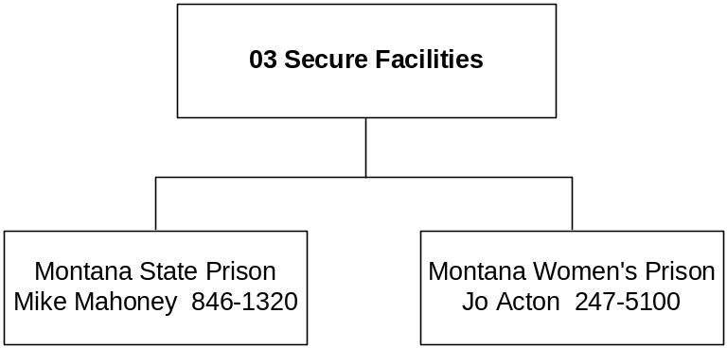

Program Description - The Secure Facilities Program includes the Montana State Prison and the Montana Women's Prison.

Program Indicators -

Indicator | Actual FY2000 | Actual 2001 | Actual 2002 | Estimated 2003 | Estimated 2004 | Estimated 2005

Montana Women’s Prison:
Education participation of total population | 86% | 81 % | 82% | 80% | 80% | 80%
Corrective Thinking participation of population | 20% | 23% | 30% | 30% | 30% | 37%
Chemical Dependency program completion prior to release | 40% | 56% | 85% | 82% | 86% | 87%
Parenting program participation of total population | 77% | 82% | 88% | 90% | 90% | 90%

Montana State Prison:
Number of inmates that pass GED exam | 91 | 94 | 97 | 100 | 100 | 100
Number of inmates that discharge from CD program as treatment plan complete | 235 | 229 | 350 | 350 | 350 | 350
Classification Reviews | 4082 | 5018 | 5109 | 5609 | 6011 | 6000
Percentage of inmates employed by total population | 71% | 71% | 69% | 70% | 70% | 70%
Disciplinary Reports | 2966 | 3515 | 2576 | 2601 | 2500 | 2300
Inmate Assault on Inmate | 27 | 38 | 36 | 36 | 34 | 32
Inmate Assault on Staff | 8 | 11 | 18 | 25 | 10 | 8
Number of Escapes | 0 | 1 | 0 | 0 | 0 | 0

Program Proposed Budget  Budget Item | Base  Budget  Fiscal 2002 | PL Base Adjustment  Fiscal 2004 | New  Proposals  Fiscal 2004 | Total  Exec. Budget  Fiscal 2004 | PL Base Adjustment  Fiscal 2005 | New  Proposals  Fiscal 2005 | Total  Exec. Budget  Fiscal 2005
FTE | 578.45 | 0.00 | 0.00 | 578.45 | 0.00 | 0.00 | 578.45
Personal Services | 22,628,824 | 2,325,324 | 0 | 24,954,148 | 2,357,881 | 0 | 24,986,705
Operating Expenses | 27,156,550 | 600,154 | 0 | 27,756,704 | 1,355,003 | 0 | 28,511,553
Equipment | 292,757 | 0 | 0 | 292,757 | 0 | 0 | 292,757
Capital Outlay | 50 | 0 | 0 | 50 | 0 | 0 | 50
Debt Service | 159,994 | 0 | 0 | 159,994 | 0 | 0 | 159,994
Total Costs | $50,238,175 | $2,925,478 | $0 | $53,163,653 | $3,712,884 | $0 | $53,951,059
General Fund | 49,316,699 | 2,357,978 | 0 | 51,674,677 | 3,145,384 | 0 | 52,462,083
State/Other Special | 841,188 | 567,500 | 0 | 1,408,688 | 567,500 | 0 | 1,408,688
Federal Special | 80,288 | 0 | 0 | 80,288 | 0 | 0 | 80,288
Total Funds | $50,238,175 | $2,925,478 | $0 | $53,163,653 | $3,712,884 | $0 | $53,951,059

Please note that a HB 576 section exists for this program.

--------------------------------- Present Law Adjustments --------------------------------

Total Agency Impact | General Fund Total
FY04 $1,499,498 | FY04 $1,499,498
FY05 $1,499,498 | FY05 $1,499,498
PL- 5 - Adjustment for Employee & Inmate Personal Services -
The executive recommends this request be approved as costs of overtime, differential pay, holidays worked, comp time pay out, holiday pay out, and related benefits are zero based. These items are necessary and are re-established each biennium.
________________________________________________________________________________________________

Total Agency Impact | General Fund Total
FY04 $221,153 | FY04 $221,153
FY05 $221,153 | FY05 $221,153
PL- 8 - Cook/Chill Rate Adjustment Montana State Prison -
This authority increase is necessary to pay the allocated share of Montana State Prison's cook/chill rate structure in accordance with state laws and policies regarding internal service funds.
________________________________________________________________________________________________

Total Agency Impact | General Fund Total
FY04 $1,280,431 | FY04 $1,280,431
FY05 $1,280,431 | FY05 $1,280,431
PL- 12 - Montana Women's Prison Expansion -
Expansion of the Montana Women's Prison authorized by the previous Legislature must be annualized. The expansion of MWP will require an increase in operating costs, utilities, and contracted services as well as equipment. Population of the facility will increase from the current 80 offenders to 197 by FYE 2004.
________________________________________________________________________________________________

Total Agency Impact | General Fund Total
FY04 $283,750 | FY04 $0
FY05 $283,750 | FY05 $0
PL- 15 - Increase in Inmate Canteen Authority -
This is a request for additional state special revenue authority to fund purchases for the inmate canteen at the Montana State Prison (MSP). MSP has decreased the ability of inmates to order items from outside vendors and receive items from family members. This has caused more inmate dependence on the canteen system to procure personal need hygiene/food items. Inmate demand for products has increased due to increased population at MSP and also due to canteen requisitions being processed to allow for overall lower costs to inmates, therefore increasing demand.
________________________________________________________________________________________________

Total Agency Impact | General Fund Total
FY04 ($1,222,094) | FY04 ($1,222,094)
FY05 ($478,248) | FY05 ($478,248)
PL- 25 - Contract Placement Present Law Decrease -
This requested decrease to the contract beds budget authority for the 2005 biennium is possible due to the department's efforts to move inmates through the system as quickly as possible, use of the conditional release program and changes in sentencing patterns by judges who are aware of the state's financial crisis. All this is being done with public safety as the number one priority. The projected savings to the general fund, due to a new growth projection of approximately 3.55 percent each year, is $1,222,094 in FY 2004 and $478,248 in FY 2005.

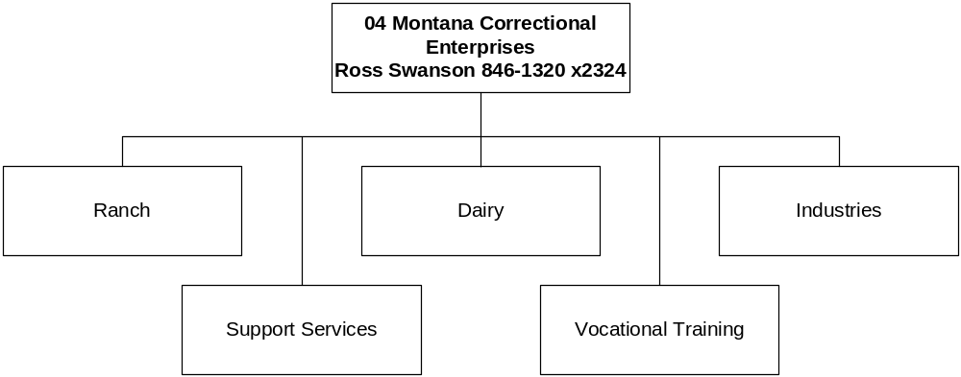

Program Description - The Montana Correctional Enterprises (MCE) Program includes the ranch, industries, dairy, license plate, and vocational education programs at the Montana State Prison facility. MCE also has industry programs located at the Montana Women's Prison, Cascade County Regional Detention Facility, and Crossroads Correctional Facility. MCE programs provide employment and vocational educational training opportunities to offenders. Approximately three hundred fifty (350) offenders are involved in education, training and employment with MCE programs.

Program Indicators -
Indicator | Actual FY2000 | Actual  2001 | Actual  2002 | Estimated 2003 | Estimated 2004 | Estimated 2005

MCE Program:
MCE Program Revenue | $5,980,407 | $5,322,970 | $5,583,308 | $6,015,806 | $5,535,000 | $5,435,000
Number of Inmate Workers – MSP | 240 | 298 | 300 | 300 | 300 | 300
Number of Inmate Workers – Other Facilities | 75 | 70 | 60 | 40 | 150 | 150
Crime Victim Payments – PIE Programs | $21,611 | $51,481 | $52,758 | $34,000 | $72,000 | $72,000
Family Support Deductions – PIE Programs | $13,146 | $38,134 | $39,080 | $20,000 | $42,000 | $42,000

Program Proposed Budget  Budget Item | Base  Budget  Fiscal 2002 | PL Base Adjustment  Fiscal 2004 | New  Proposals  Fiscal 2004 | Total  Exec. Budget  Fiscal 2004 | PL Base Adjustment  Fiscal 2005 | New  Proposals  Fiscal 2005 | Total  Exec. Budget  Fiscal 2005
FTE | 15.00 | 0.00 | 0.00 | 15.00 | 0.00 | 0.00 | 15.00
Personal Services | 638,268 | 221,828 | (19,600) | 840,496 | 218,586 | (14,160) | 842,694
Operating Expenses | 655,003 | 2,975,931 | (2,975,408) | 655,526 | 566,943 | (566,068) | 655,878
Total Costs | $1,293,271 | $3,197,759 | ($2,995,008) | $1,496,022 | $785,529 | ($580,228) | $1,498,572
General Fund | 940,187 | 3,106,432 | (2,995,008) | 1,051,611 | 693,057 | (580,228) | 1,053,016
Proprietary | 353,084 | 91,327 | 0 | 444,411 | 92,472 | 0 | 445,556
Total Funds | $1,293,271 | $3,197,759 | ($2,995,008) | $1,496,022 | $785,529 | ($580,228) | $1,498,572

Please note that a HB 576 section exists for this program.

--------------------------------- Present Law Adjustments --------------------------------

Total Agency Impact | General Fund Total
FY04 $151,307 | FY04 $83,201
FY05 $151,307 | FY05 $83,201
PL- 16 - MCE Voc Ed and License Plate Factory Inmate Payroll -
This request is for the Vocational Education proprietary fund inmate payroll that reflects wages for thirty-two (32) inmates involved in motor vehicle maintenance, apprenticeship training and the Toyota Project.
________________________________________________________________________________________________

Total Agency Impact | General Fund Total
FY04 $2,995,008 | FY04 $2,995,008
FY05 $580,228 | FY05 $580,228
PL- 18 - MCE License Plate Factory -Plate Reissue request -
MCE License Plate Factory is required by law to produce license plates. To comply with 61-3-332, MCA, the MCE License Plate Factory must produce plates for a reissue every four years. Last session the Legislature approved a new digital license plate system in SB 393 and HB 191. It is believed that the intent was to convert the entire license plate system over to the digital system this biennium.

------------------------------- Requiring Other Legislation -------------------------------

Total Agency Impact | General Fund Total
FY04 ($2,995,008) | FY04 ($2,995,008)
FY05 ($580,228) | FY05 ($580,228)
NP- 8001 - MCE License Plate reissue Delete -
This request is a companion to PL-18 and is contingent upon passage and approval of proposed legislation to change the statutory requirements for license plate reissue every four years. [LC 162]

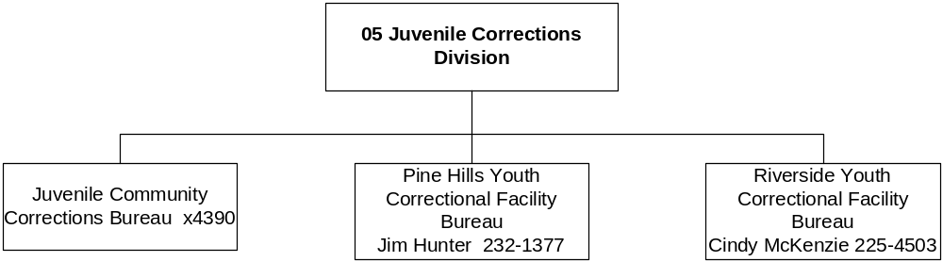

Program Description - The Juvenile Corrections Division is responsible for all state operated youth programs including, Pine Hills Youth Correctional Facility for males located in Miles City, Riverside Youth Correctional Facility for females in Boulder, statewide juvenile community corrections including parole services for youth released from state operated secure care facilities, youth transition center, specialized foster care services, interstate compact service for probation and parole in and out of state, juvenile detention licensing, monitoring and funding for state district probation placements, research and training for the division and other agencies, and administrative support services.

Program Indicators -

Indicator | Actual  FY2000 |  | Actual  2001 |  | Actual  2002 | Estimated FY2003 |  | Requested FY2004 | Requested FY2005
PHYCF  Amount Paid to victims  Youth in Restitution Program  Community Services hours worked  Youth in Community Service Pgm  RYCF  Community Service  On-grounds  On-grounds & Off-grounds |  | $19,519  31  2654  16  384 hours |  | $21,439  28  5514  62  450 hours | $28,560  46  6546  66  590 hours |  | $30,560  55  7000  75  640 hours | $32,560  60  7200  80  680 hours |  | $33,560  62  7300  82  700 hours
Third party funding-juvenile placements as of 10/30/00 | $261,737 |  | $289,903 |  | $312,638 | $337,638 |  | $352,638 | $362,638

Education
PHYCF  Pre & Post Testing  (grade level raised within 90 days)  Reading Comprehension  Language Expression  Math Computation | 0.5  1.2  1.0 |  | 1.5  1.2  1.1 |  | 1.2  2.0  1.0 | 1.5  2.0  1.1 |  | 1.5  2.0  1.1 | 1.5  2.0  1.1
PHYCF Diploma | 3 |  | 3 |  | 3 | 4 |  | 5 | 5
PHYCF GED | 32 |  | 15 |  | 25 | 25 |  | 26 | 27
RYCF Diploma | 1 |  | 4 |  | 1 | 2 |  | 2 | 3
RYCF GED | 2 |  | 5 |  | 4 | 3 |  | 4 | 4

Felony Recidivism
PHYCF | 5.19% |  | 4.60% |  | 11.76% | 8% |  | 7% | 6%
PHYCF | 6% |  | 0% |  | 6% | 4% |  | 5% | 4%
PHYCF – New Admissions with prior Residential placements | 70.7% |  | 71.3% |  | 71.3% | 72% |  | 71% | 69%

Program Proposed Budget  Budget Item | Base  Budget  Fiscal 2002 | PL Base Adjustment  Fiscal 2004 | New  Proposals  Fiscal 2004 | Total  Exec. Budget  Fiscal 2004 | PL Base Adjustment  Fiscal 2005 | New  Proposals  Fiscal 2005 | Total  Exec. Budget  Fiscal 2005
FTE | 202.85 | 0.00 | 0.00 | 202.85 | 0.00 | 0.00 | 202.85
Personal Services | 7,745,087 | 602,401 | 0 | 8,347,488 | 610,424 | 0 | 8,355,511
Operating Expenses | 1,854,618 | 246,625 | 0 | 2,101,243 | 253,671 | 0 | 2,108,289
Equipment | 7,500 | 0 | 0 | 7,500 | 0 | 0 | 7,500
Benefits & Claims | 8,040,196 | (1,000,000) | 0 | 7,040,196 | (1,000,000) | 0 | 7,040,196
Debt Service | 9,699 | 0 | 0 | 9,699 | 0 | 0 | 9,699
Total Costs | $17,657,100 | ($150,974) | $0 | $17,506,126 | ($135,905) | $0 | $17,521,195
General Fund | 16,468,441 | 283,907 | 0 | 16,752,348 | 298,976 | 0 | 16,767,417
State/Other Special | 518,667 | (81,654) | 0 | 437,013 | (81,654) | 0 | 437,013
Federal Special | 669,992 | (353,227) | 0 | 316,765 | (353,227) | 0 | 316,765
Total Funds | $17,657,100 | ($150,974) | $0 | $17,506,126 | ($135,905) | $0 | $17,521,195

--------------------------------- Present Law Adjustments --------------------------------

Total Agency Impact | General Fund Total
FY04 $7,328 | FY04 $7,328
FY05 $7,328 | FY05 $7,328
PL- 9 - Contract Adjustments for Riverside -
A cost increase is necessary to pay the allocated share of the MSP cook chill rate structure in accordance with state law regarding internal service funds passed in the special session.
________________________________________________________________________________________________

Total Agency Impact | General Fund Total
FY04 $230,820 | FY04 $230,820
FY05 $230,820 | FY05 $230,820
PL- 13 - PHYCF Expansion Unit Request -
This request annualizes the operating costs for the expansion at the Pine Hills Correctional Youth Facility, which is 24x7. The new construction project allowed an increase in capacity from 120 beds to 144 beds and was completed in the spring of 2002. Therefore, the FY 2002 base reflects an increase in the average daily population and FTE for only a partial year. The ADP is projected at 135 for FY 2004 and FY 2005.
________________________________________________________________________________________________

Total Agency Impact | General Fund Total
FY04 ($1,000,000) | FY04 ($1,000,000)
FY05 ($1,000,000) | FY05 ($1,000,000)
PL- 7001 - Continue reduction in Juvenile Placement disburse -
This executive recommendation continues the $1 million reduction in Juvenile Placement disbursements taken in the FY 2003 Governor's reductions in both fiscal years of the 2005 biennium.

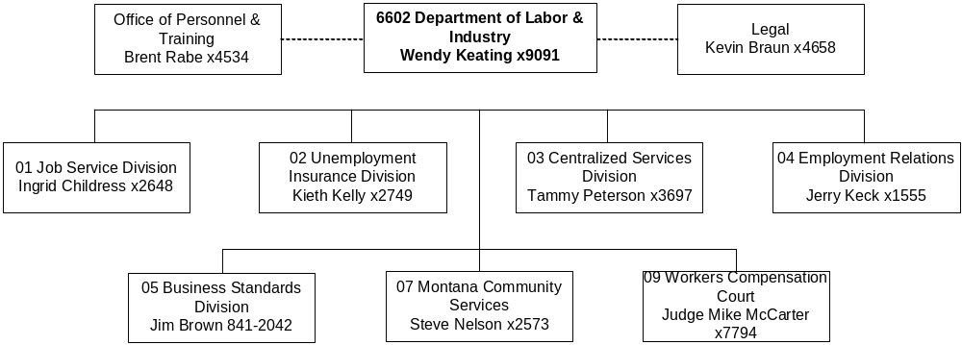

Mission Statement - To promote the well-being and opportunities of Montana workers and employers and to uphold the rights and responsibilities of both.

Statutory Authority - Primarily Titles 18, 39, 49, 50, and 90, MCA, and the federal Corporation for National Service.

Agency Proposed Budget  Budget Item | Base  Budget  Fiscal 2002 | PL Base Adjustment  Fiscal 2004 | New  Proposals  Fiscal 2004 | Total  Exec. Budget  Fiscal 2004 | PL Base Adjustment  Fiscal 2005 | New  Proposals  Fiscal 2005 | Total  Exec. Budget  Fiscal 2005
FTE | 659.64 | 0.00 | 1.50 | 661.14 | 0.00 | 1.50 | 661.14
Personal Services | 24,534,708 | 2,869,083 | 45,174 | 27,448,965 | 2,875,250 | 45,038 | 27,454,996
Operating Expenses | 15,249,372 | 1,533,813 | 18,623 | 16,801,808 | 1,534,518 | 16,123 | 16,800,013
Equipment | 432,003 | 30,000 | 0 | 462,003 | 30,000 | 0 | 462,003
Capital Outlay | 965 | 0 | 0 | 965 | 0 | 0 | 965
Grants | 16,013,711 | 952,778 | 0 | 16,966,489 | 952,777 | 0 | 16,966,488
Benefits & Claims | 258,597 | 0 | 0 | 258,597 | 0 | 0 | 258,597
Transfers | 131,551 | 0 | 0 | 131,551 | 0 | 0 | 131,551
Total Costs | $56,620,907 | $5,385,674 | $63,797 | $62,070,378 | $5,392,545 | $61,161 | $62,074,613
General Fund | 1,969,954 | (106,871) | 0 | 1,863,083 | (109,017) | 0 | 1,860,937
State/Other Special | 22,630,948 | 3,127,791 | (1,036,730) | 24,722,009 | 3,155,911 | (1,039,139) | 24,747,720
Federal Special | 31,976,879 | 2,339,924 | 1,100,527 | 35,417,330 | 2,320,926 | 1,100,300 | 35,398,105
Proprietary | 43,126 | 24,830 | 0 | 67,956 | 24,725 | 0 | 67,851
Total Funds | $56,620,907 | $5,385,674 | $63,797 | $62,070,378 | $5,392,545 | $61,161 | $62,074,613

------------------- Agency General Fund Target - $3.72 million ---------------------

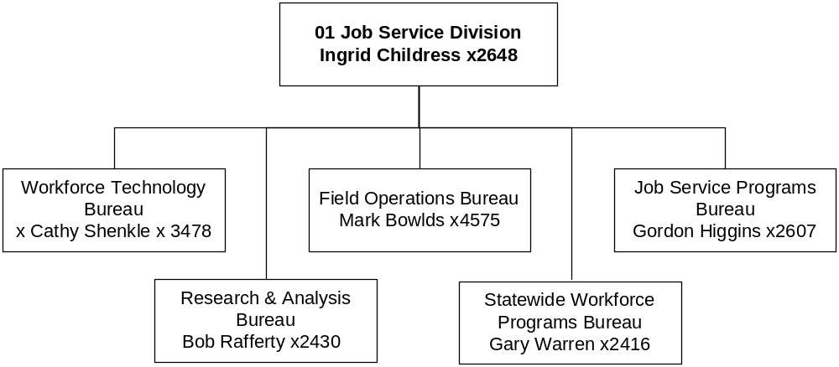

Program Description - The Workforce Services Division operates through five bureaus. The Field Operations Bureau functions through a network of 17 Job Service Centers. The division is a gateway to government services in the area of employment and training services. JSD performs services that include retraining and reemployment services for laid-off workers and employment and training services for people transitioning from welfare to work, as well as for youth, veterans, seasonal/migrant farm workers, and general job seekers. Other bureaus include Workforce Technology, Statewide Workforce Programs, Job Service Programs, and Research and Analysis.

Program Indicators -
Indicator | Actual FY2000 | Actual  2001 | Actual  2002 | Estimated FY2003 | Requested FY2004 | Requested FY2005
Applicants Registered | 68,818 | 70,985 | 75,961 | 75,000 | 75,000 | 75,000
MCIS Sites | 308 | 308 | 257 | 257 | 257 | 257
MCIS Internet home users | N/A | N/A | N/A | 3,000 | 10,000 | 15,000
Statistical Data Inquiry – Employment Services | 844,740 | 859,760 | 902,138 | 931,900 | 962,660 | 994,430
Statistical Data Inquiry – Research & Analysis | 598,619 | 1,273,476 | 1,442,171 | 1,520,000 | 1,600,000 | 1,650,000
Apprenticeship Training Participants | 939 | 969 | 1,067 | 1,163 | 1,267 | 1,381
Jobs for Montana’s Graduates | 603 | 769 | 670 | 725 | 750 | 800

Program Proposed Budget  Budget Item | Base  Budget  Fiscal 2002 | PL Base Adjustment  Fiscal 2004 | New  Proposals  Fiscal 2004 | Total  Exec. Budget  Fiscal 2004 | PL Base Adjustment  Fiscal 2005 | New  Proposals  Fiscal 2005 | Total  Exec. Budget  Fiscal 2005
FTE | 301.60 | 0.00 | 0.00 | 301.60 | 0.00 | 0.00 | 301.60
Personal Services | 11,095,498 | 950,242 | 0 | 12,045,740 | 958,318 | 0 | 12,053,816
Operating Expenses | 5,250,516 | 396,683 | 0 | 5,647,199 | 364,604 | 0 | 5,615,120
Equipment | 96,193 | 0 | 0 | 96,193 | 0 | 0 | 96,193
Capital Outlay | 965 | 0 | 0 | 965 | 0 | 0 | 965
Grants | 14,174,852 | (77,222) | 0 | 14,097,630 | (77,223) | 0 | 14,097,629
Transfers | 131,551 | 0 | 0 | 131,551 | 0 | 0 | 131,551
Total Costs | $30,749,575 | $1,269,703 | $0 | $32,019,278 | $1,245,699 | $0 | $31,995,274
General Fund | 916,054 | (105,030) | 0 | 811,024 | (105,156) | 0 | 810,898
State/Other Special | 6,781,481 | 672,849 | (1,100,527) | 6,353,803 | 676,933 | (1,100,300) | 6,358,114
Federal Special | 23,052,040 | 701,884 | 1,100,527 | 24,854,451 | 673,922 | 1,100,300 | 24,826,262
Total Funds | $30,749,575 | $1,269,703 | $0 | $32,019,278 | $1,245,699 | $0 | $31,995,274
Please note that a HB 576 section exists for this program.

--------------------------------- Present Law Adjustments --------------------------------

Total Agency Impact | General Fund Total
FY04 $21,926 | FY04 ($75,415)
FY05 $20,869 | FY05 ($75,414)
PL- 12 - Operating Increase -
The executive recommends an increase in operating authority to cover increases in the agency's indirect cost allocation plan, which is funded by state special revenues. This package also includes reductions to meet the general fund target for the agency. These reductions amount to $77,222 in FY 2004 and $77,223 in FY 2005 from the Apprenticeship Program.
________________________________________________________________________________________________

Total Agency Impact | General Fund Total
FY04 $141,261 | FY04 $0
FY05 $141,289 | FY05 $0
PL- 18 - Natural Resource Worker Scholarship Pg. – SB 322 -
This is a request to continue funding for the Natural Resource Worker Scholarship Program created by SB 322 in the 2001 session and is funded out of the RIT. The funding was not established until FY 2003 so there were no expenditures in the base year. This program is funded up to $150,000 per year, which is the total of this request, when what is currently in the base for the 0.25 FTE that was also authorized in this bill is added.

---------------------------------------- New Proposals ----------------------------------------

Total Agency Impact | General Fund Total
FY04 $0 | FY04 $0
FY05 $0 | FY05 $0
NP- 7001 - ESA/Reed Act Fund Switch -
This funding switch is requested in order to cover the employment security account (ESA) funding for Project ChalleNGe with federal Reed Act monies. The Executive recommends that the match required for the Project ChalleNGe program, administered by the Department of Military Affairs, be funded with ESA funds and those expenditures be offset with Reed Act funding which is eligible to be used for these expenditures.

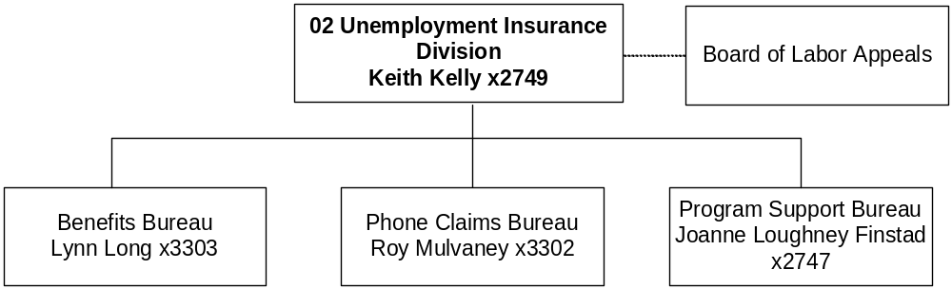

Program Description - The Unemployment Insurance (UI) Division administers the state unemployment insurance law and related federal programs, which provide temporary, partial wage replacement to involuntary unemployed individuals. The UI Division is organized into three bureaus: UI Benefits, UI Program Support, and UI Phone Claims. The UI Contributions Bureau was reorganized by the 1997 Legislature under HB 561, which delegated UI tax collection activity to the Department of Revenue. The UI Benefits Bureau receives, processes, and pays UI benefit claims and adjudicates disputed benefit claims. The UI Program Support Bureau manages the Montana Integrated System To Improve Customer Service (MISTICS), and the UI benefit accounting and payment system. The UI Phone Claims Bureau has two phone centers (Billings and Helena) for claimants to file unemployment claims, and for employers to make UI related inquiries.

Program Indicators -
Indicator | Actual  FY2000 | Actual  2001 | Actual  2002 | Estimated FY2003 | Requested FY2004 | Requested FY2005
Initial Claims | 48,339 | 55,854 | 64,520** | 65,857 | 69,785 | 75,063
Weeks Claimed | 373,905 | 452,108 | 527,935** | 504,925 | 535,545 | 576,573
Non-monetary Determinations | 18,368 | 23,597 | 22,425 | 27,355 | 28,995 | 31,202
Appeals | 1,371 | 1,248 | 1,252 | 1,539 | 1,631 | 1,756

**Initial Claims include 6,020 TEUCA payments (Temporary Extended Unemployment Compensation Act).
**Weeks Claimed include 36,100 of TEUCA (Temporary Extended Unemployment Compensation Act).

Program Proposed Budget  Budget Item | Base  Budget  Fiscal 2002 | PL Base Adjustment  Fiscal 2004 | New  Proposals  Fiscal 2004 | Total  Exec. Budget  Fiscal 2004 | PL Base Adjustment  Fiscal 2005 | New  Proposals  Fiscal 2005 | Total  Exec. Budget  Fiscal 2005
FTE | 107.50 | 0.00 | 0.00 | 107.50 | 0.00 | 0.00 | 107.50
Personal Services | 3,771,812 | 469,592 | 0 | 4,241,404 | 468,996 | 0 | 4,240,808
Operating Expenses | 2,255,957 | 138,496 | 0 | 2,394,453 | 148,842 | 0 | 2,404,799
Total Costs | $6,027,769 | $608,088 | $0 | $6,635,857 | $617,838 | $0 | $6,645,607
State/Other Special | 283,213 | 21,742 | 0 | 304,955 | 21,742 | 0 | 304,955
Federal Special | 5,744,556 | 586,346 | 0 | 6,330,902 | 596,096 | 0 | 6,340,652
Total Funds | $6,027,769 | $608,088 | $0 | $6,635,857 | $617,838 | $0 | $6,645,607

Please note that a HB 576 section exists for this program.

--------------------------------- Present Law Adjustments --------------------------------

Total Agency Impact | General Fund Total
FY04 $88,218 | FY04 $0
FY05 $88,667 | FY05 $0
PL- 4 - Increase in operating costs -
This present law adjustment requests additional appropriation to fund increases anticipated in operating costs for the department's internal cost allocation plan which are funded from both federal and state special revenues. The pay plan increase projection multiplied by the internal cost allocation rate would be approximately $10,450 for the biennium. In addition, increased usage of computer processing thru the mid-tier and central imaging totals $39,550 each fiscal year. Also included in this request is authority to restore zero-based expenditures required by 2-15-124, MCA, to members of the Board of Labor Appeals $50/day for each day engaged in board duties.

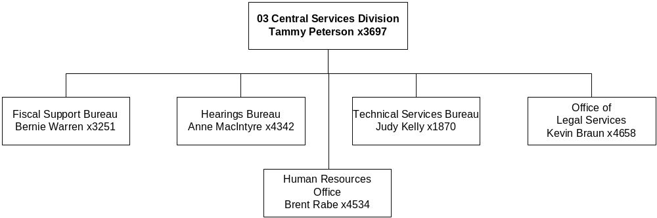

Program Description - The Commissioner's Office and the Legal and Centralized Services Division provide program direction, legal, administration, and support services to the department. Legal and Centralized Services provides the central support functions of the department through five bureaus: 1) Fiscal Support; 2) Technical Services; 3) Human Resources; 4) Hearings; and 5) Legal Services.

Program Indicators -
Indicator | Actual FY2000 | Actual  FY2001 | Actual  FY2002 | Estimated FY2003 | Requested FY2004 | Requested FY2005
Classification Actions | 88 | 99 | 145 | 122 | 122 | 122
Cases Processed | 1,743 | 1,564 | 1,452 | 1,375 | 1,375 | 1,375
Federal Programs | 78 | 78 | 78 | 75 | 75 | 75

Program Proposed Budget  Budget Item | Base  Budget  Fiscal 2002 | PL Base Adjustment  Fiscal 2004 | New  Proposals  Fiscal 2004 | Total  Exec. Budget  Fiscal 2004 | PL Base Adjustment  Fiscal 2005 | New  Proposals  Fiscal 2005 | Total  Exec. Budget  Fiscal 2005
FTE | 20.50 | 0.00 | 0.00 | 20.50 | 0.00 | 0.00 | 20.50
Personal Services | 969,374 | 132,230 | 0 | 1,101,604 | 131,443 | 0 | 1,100,817
Operating Expenses | 298,452 | 19,754 | 0 | 318,206 | 19,342 | 0 | 317,794
Total Costs | $1,267,826 | $151,984 | $0 | $1,419,810 | $150,785 | $0 | $1,418,611
General Fund | 159,270 | 13,547 | 0 | 172,817 | 13,816 | 0 | 173,086
State/Other Special | 653,702 | 97,746 | 0 | 751,448 | 96,747 | 0 | 750,449
Federal Special | 411,728 | 15,861 | 0 | 427,589 | 15,497 | 0 | 427,225
Proprietary | 43,126 | 24,830 | 0 | 67,956 | 24,725 | 0 | 67,851
Total Funds | $1,267,826 | $151,984 | $0 | $1,419,810 | $150,785 | $0 | $1,418,611

Please note that a HB 576 section exists for this program.

--------------------------------- Present Law Adjustments --------------------------------

Total Agency Impact | General Fund Total
FY04 $31,203 | FY04 $7,079
FY05 $31,298 | FY05 $7,079
PL- 11 - Misc. Operating Increase -
This request includes an increase for the department's internal cost allocation plan that has been allocated among the different funds within this division responsible for paying into this pool.

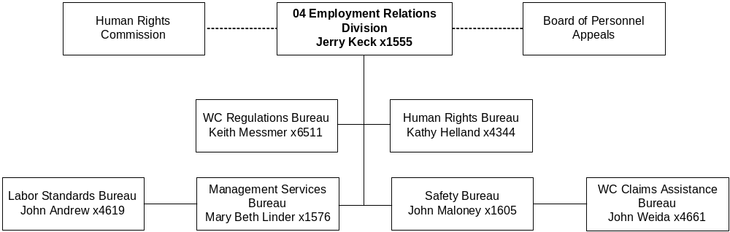

Program Description - The Employment Relations Division provides six service areas: 1) Workers' Compensation (WC) Regulation, which regulates WC insurance coverage requirements, policy compliance, medical regulations, and cost containment, and WC Claims Assistance Bureau, which assists organizations and individuals to arrive at early, less expensive settlements of their disputes; 2) Labor Standards Bureau, which enforces state and federal labor laws related to the payment of wages, and provides collective bargaining mediation; 3) Safety Bureau, which administers federal and state industrial safety laws; 4) Human Rights Bureau, which enforces Montana Human Rights Act and Governmental Code of Fair Practices through investigations, conciliation, hearings, and education and is responsible for enforcing laws which prohibit discrimination in employment, housing, public accommodations, financing and credit transactions, insurance, education, and government services; 5) Contractor Registration and Independent Contractor Exemption programs, which register contractors; and 6) Board of Personnel Appeals, which deals with issues related to wage and hour, and collective bargaining disputes between employers and employees and is administratively attached.

Program Indicators -
Indicator | Actual FY1998 | Actual FY1999 | Actual FY2000 | Actual FY2001 | Actual FY2002 | EstimatedFY2003 | Requested FY2004 | Requested FY2005
Safety Inspections | 344 | 412 | 404 | 483 | 458 | 481 | 491 | 500
Mine Inspections | 79 | 155 | 170 | 210 | 192 | 202 | 225 | 225
Safety & Mine Training Classes |  |  | 158 | 255 | 398 | 270 | 260 | 250
Safety & Mine Number Trained |  |  | 2211 | 3452 | 3850 | 2611 | 2515 | 2418
Wage & Hour Cases Filed | 1,052 | 1138 | 1223 | 989 | 953 | 1000 | 1000 | 1000
Collective Bargaining Cases |  |  | 185 | 159 | 160 | 160 | 160 | 160
Human Rights Intake Inquiries |  |  | 7446 | 6385 | 6290 | 6541 | 7000 | 7385
Human Rights Cases |  |  | 357 | 416 | 420 | 424 | 428 | 433
Workers’ Compensation Claims |  |  | 33075 | 33549 | 33700 | 33851 | 34022 | 34153
Workers” Compensation Mediations |  |  | 1168 | 1195 | 1260 | 1319 | 1381 | 1446
Electronic Data Transmissions |  |  | 21358 | 47355 | 55837 | 60000 | 65000 | 70000
Independent Contractor Exemptions |  |  | 24902 | 27043 | 29204 | 31540 | 31600 | 31650
Registered Construction Contractors |  |  | 9811 | 10082 | 11273 | 12738 | 14394 | 16264

Program Proposed Budget  Budget Item | Base  Budget  Fiscal 2002 | PL Base Adjustment  Fiscal 2004 | New  Proposals  Fiscal 2004 | Total  Exec. Budget  Fiscal 2004 | PL Base Adjustment  Fiscal 2005 | New  Proposals  Fiscal 2005 | Total  Exec. Budget  Fiscal 2005
FTE | 116.51 | 0.00 | 0.00 | 116.51 | 0.00 | 0.00 | 116.51
Personal Services | 4,637,473 | 410,970 | 0 | 5,048,443 | 408,370 | 0 | 5,045,843
Operating Expenses | 2,356,730 | 106,599 | 0 | 2,463,329 | 105,250 | 0 | 2,461,980
Equipment | 103,222 | 0 | 0 | 103,222 | 0 | 0 | 103,222
Benefits & Claims | 258,597 | 0 | 0 | 258,597 | 0 | 0 | 258,597
Total Costs | $7,356,022 | $517,569 | $0 | $7,873,591 | $513,620 | $0 | $7,869,642
General Fund | 869,937 | (15,388) | 0 | 854,549 | (17,677) | 0 | 852,260
State/Other Special | 5,751,732 | 546,310 | 0 | 6,298,042 | 544,650 | 0 | 6,296,382
Federal Special | 734,353 | (13,353) | 0 | 721,000 | (13,353) | 0 | 721,000
Total Funds | $7,356,022 | $517,569 | $0 | $7,873,591 | $513,620 | $0 | $7,869,642

Please note that a HB 576 section exists for this program.

--------------------------------- Present Law Adjustments --------------------------------

Total Agency Impact | General Fund Total
FY04 $50,000 | FY04 $0
FY05 $50,000 | FY05 $0
PL- 2 – Automated Reporting -
The Employment Relations Division is requesting authority in information technology consulting services to augment current processes used for electronic reporting of required information to the workers' compensation database. These improvements would provide improved electronic access for small employers, insurance companies and the State Compensation Insurance Fund to report required data on injuries and proof of coverage directly to ERD without having to pay for reporting through a value added network and are funded with state special revenue.
________________________________________________________________________________________________

Total Agency Impact | General Fund Total
FY04 $65,622 | FY04 $0
FY05 $66,046 | FY05 $0
PL- 10 – Operating Cost Adjustments -
The division is requesting operating adjustments for ongoing operating costs to restore the per diem expense authority for the Board of Personnel Appeals and the Human Rights Commission and fund an increase in the Centralized Services Cost Allocation Plan. Funding for this request is state special revenue.

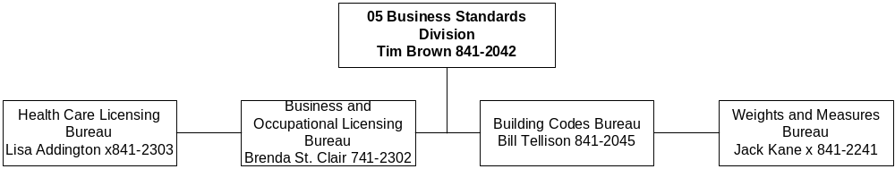

Program Description - The Business Standards Division consists of four bureaus: Building Codes Bureau, Weights & Measures Bureau, Health Care Licensing Bureau and Business & Occupational Licensing Bureau. The Building Codes Bureau (BCB) establishes and enforces minimum building, plumbing, mechanical, electrical, energy, elevator and boiler codes for use throughout Montana, including factory built buildings, and approves and certifies local government code enforcement programs to utilize codes adopted by the bureau. BCB also assists the Board of Plumbers and State Electrical Board with license law enforcement by checking for proper licensing when inspecting projects for code compliance. The Weights & Measures Bureau (WMB) is responsible for licensing, inspecting, testing and certifying all weighing and measuring devices used in making commercial transactions in the Montana. WMB also enforces laws and regulations pertaining to the quantity control of prepackaged goods, the quality control of petroleum products and is responsible for maintaining the state standards of mass and volume applied when calibrating other mass and volume standards used in testing commercial devices. The Health Care Licensing Bureau (HCLB) provides administrative, clerical and compliance support for 19 licensing boards and one program that license professionals and individuals working in the health care field. The licensing boards and program in HCLB include 118 board members and 6 advisory counsel members appointed by the Governor. The Business & Occupational Licensing Bureau (BOLB) provides administrative, clerical and compliance support for 14 licensing boards and four licensing programs that license professionals and individuals working in non-health-care-related professions and occupations. The licensing boards in BOLB include 80 board members appointed by the Governor.

Program Proposed Budget  Budget Item | Base  Budget  Fiscal 2002 | PL Base Adjustment  Fiscal 2004 | New  Proposals  Fiscal 2004 | Total  Exec. Budget  Fiscal 2004 | PL Base Adjustment  Fiscal 2005 | New  Proposals  Fiscal 2005 | Total  Exec. Budget  Fiscal 2005
FTE | 104.53 | 0.00 | 1.50 | 106.03 | 0.00 | 1.50 | 106.03
Personal Services | 3,648,645 | 859,905 | 45,174 | 4,553,724 | 863,354 | 45,038 | 4,557,037
Operating Expenses | 4,859,224 | 842,742 | 18,623 | 5,720,589 | 866,952 | 16,123 | 5,742,299
Equipment | 232,588 | 30,000 | 0 | 262,588 | 30,000 | 0 | 262,588
Grants | 115 | 30,000 | 0 | 30,115 | 30,000 | 0 | 30,115
Total Costs | $8,740,572 | $1,762,647 | $63,797 | $10,567,016 | $1,790,306 | $61,161 | $10,592,039
State/Other Special | 8,740,572 | 1,762,647 | 63,797 | 10,567,016 | 1,790,306 | 61,161 | 10,592,039
Total Funds | $8,740,572 | $1,762,647 | $63,797 | $10,567,016 | $1,790,306 | $61,161 | $10,592,039

Please note that a HB 576 section exists for this program.

Program Indicators -
Indicator | Actual FY2000 | Actual FY2001 | Actual FY2002 | Estimated FY2003 | Requested FY2004 | Requested FY2005
Plumbing:
Permits | 2841 | 2627 | 3122 | 3150 | 3150 | 3150
Inspections | 10494 | 9852 | 11382 | 11400 | 11400 | 11400
Comp. Orders | 64 | 39 | 23 | 25 | 25 | 25
License Checks | 1194 | 1110 | 1281 | 1300 | 1300 | 1300
MECHANICAL:
Permits | 798 | 720 | 715 | 725 | 725 | 725
Inspections | 2540 | 2547 | 2539 | 2600 | 2600 | 2600
Comp. Orders | 15 | 21 | 9 | 10 | 10 | 10
ELECTRICAL:
Permits | 13087 | 11734 | 12181 | 12200 | 12200 | 12200
Inspections | 23663 | 22933 | 23562 | 23600 | 23600 | 23600
Comp. Orders | 81 | 20 | 19 | 20 | 20 | 20
License Checks | 1735 | 1520 | 1428 | 1450 | 1450 | 1450
BOILERS:
Total Inspections | 5948 | 5158 | 5430 | 5500 | 5500 | 5500
State | 2526 | 2381 | 2642 | 2650 | 2650 | 2650
Insurance | 3422 | 2777 | 2788 | 2800 | 2800 | 2800
Total Certifications | 5594 | 4988 | 5247 | 5300 | 5300 | 5300
State | 2237 | 2079 | 2462 | 2500 | 2500 | 2500
Insurance | 3357 | 2909 | 2785 | 2800 | 2800 | 2800
ELEVATORS:
Inspections | 1315 | 1410 | 1459 | 1460 | 1460 | 1460
Certificates | 1600 | 1562 | 1975 | 1980 | 1980 | 1980
BUILDINGS:
Permits | 1030 | 1144 | 1057 | 1060 | 1060 | 1060
Inspections | 9996 | 13436 | 10722 | 10800 | 10800 | 10800
WEIGHTS & MEASURES BUREAU:
Scales Licensed | 6692 | 6700 | 3794 | 6800 | 6800 | 6800
Scales – Tested, Inspected, Certified | 6434 | 6516 | 6342 | 6120 | 6120 | 6120
Inspection % | 96.14% | 97% | 93% | 90% | 90% | 90%
Pumps & Meters Licensed | 14451 | 14500 | 14579 | 14600 | 14600 | 14600
Pumps – Tested, Inspected, Certified | 12788 | 11699 | 12552 | 12410 | 12410 | 12410
Inspection % | 88.4% | 80% | 86% | 85% | 85% | 85%
LPG Meters Licensed | 589 | 600 | 604 | 605 | 605 | 605
LPG Meters – Tested, Inspected, Certified | 529 | 533 | 428 | 514 | 514 | 514
Inspection % | 89.8% | 89% | 71% | 85% | 85% | 85%
Packages Measured | 500 | 500 | 500 | 500 | 500 | 500
Packages Tested, Inspected | 335 | 186 | 382 | 500 | 500 | 500
Inspection % | 67% | 37% | 75% | 100% | 100% | 100%
Octane Test Measure | 300 | 300 | 300 | 300 | 300 | 300
Octane Tested | 384 | 17 | 73 | 300 | 300 | 300
Inspection % | 128% | 6% | 24% | 100% | 100% | 100%
HEALTHCARE LICENSING BUREAU:
Applications Processed* | 2568 | 2944 | 3401 | 3503 | 5204 | 6596
Applicants Examined | 2460 | 1817 | 1971 | 1815 | 4011 | 5383
New Licenses Issued | 2421 | 2966 | 3049 | 2891 | 5060 | 5616
Licenses Renewed | 30835 | 28130 | 32133 | 32899 | 35041 | 35656
Total Licenses | 35243 | 35529 | 35521 | 36379 | 39034 | 40919
New Complaints Processed | 443 | 438 | 463 | 476 | 514 | 519
Investigations Completed | 109 | 116 | 93 | 112 | 119 | 131
Inspections Completed** | 696 | 535 | 728 | 1209 | 1225 | 1268
Public Meetings Conducted | 163 | 166 | 174 | 192 | 189 | 194
Disciplinary Actions Taken | 69 | 110 | 80 | 117 | 118 | 125
BUSINESS & OCCUPATIONAL LICENSING BUREAU:***
Applications Processed | 5372 | 4961 | 6560 | 7134 | 7221 | 7197
Applicants Examined | 1783 | 1825 | 1948 | 1933 | 1964 | 1956
New Licenses Issued | 5371 | 5698 | 6323 | 6245 | 6336 | 6349
Licenses Renewed | 20887 | 19405 | 26000 | 21376 | 27994 | 19727
Total Licenses | 42567 | 43635 | 43721 | 43678 | 43884 | 43779
New Complaints Processed | 726 | 921 | 535 | 635 | 557 | 631
Investigations Completed | 170 | 306 | 157 | 190 | 192 | 192
Inspections Completed | 2742 | 3470 | 2166 | 2165 | 3515 | 3515
Public Meetings Conducted | 109 | 122 | 123 | 114 | 112 | 112
Disciplinary Actions Taken | 348 | 1627 | 292 | 1581 | 381 | 1581
*The increase in FY04&05 is the result of the Board of Medical Examiners implementing licensing of First Responders in conjunction with the Department of Public Health & Human Services.
**Inspections are down in FY00,01,&02 due to a death of an inspector for Radiological Technicians and Clinical Labs Boards.
***Three boards have a biennial renewal process and one board has a triennial renewal process.

--------------------------------- Present Law Adjustments --------------------------------

Total Agency Impact | General Fund Total
FY04 $27,281 | FY04 $0
FY05 $28,131 | FY05 $0
PL- 3 - Restore OTO - BOLB & BCB Vehicle Request -
The Business & Occupational Licensing Bureau is requesting five leased vehicles from the State Motor Pool for the State Electrical Board, Board of Cosmetologists, Board of Barbers, and the Board of Outfitters. There will be an estimated cost savings of $5,40 each year if the bureau utilizes lease vehicles rather than using Motor Pool Fleet or paying for personal cars used for state business. This proposal would also increase the funding for two new vehicles within Building Codes Bureau of the Business Standards Division. During the 2001 Legislature, a portion of the bureau's vehicle replacement funding was made OTO and this request is to request that vehicle replacement funding.
________________________________________________________________________________________________

Total Agency Impact | General Fund Total
FY04 $70,000 | FY04 $0
FY05 $70,000 | FY05 $0
PL- 6 - Legal Contingency Fund -
This request is to establish a legal proceeding contingency fund, which will support all boards and programs in legal matters and will ensure that cases will not be delayed. The funding for this request will be provided by the appropriate board fee revenues. With the growing number of cases it is difficult to anticipate costs. This funding will support an operating expense increase of $70,000 in FY 2004 and an increase of $70,000 in FY 2005.
________________________________________________________________________________________________

Total Agency Impact | General Fund Total
FY04 $30,000 | FY04 $0
FY05 $30,000 | FY05 $0
PL- 7 - Real Estate Regulation Grants Increase -
This request is for $30,000 each year of the biennium to fund education grants to private education providers offering quality continuing education in rural areas and in specialty topic areas, where revenue will not meet expenses. The funding will come from the real estate recovery Account (37-1-501, MCA). Availability of continuing education is very limited in outlying areas. The grants are not intended to provide 100 percent funding for an educational course.
________________________________________________________________________________________________

Total Agency Impact | General Fund Total
FY04 $144,200 | FY04 $0
FY05 $108,927 | FY05 $0
PL- 8 - BCB & W&M Operating Increase -
This proposal increases the funding for administration and operating costs within the Building Codes Bureau as follows; Inspector base year travel increase due to vacancies ($31,685 each year); rental savings (-$1,665 in FY 2004 & -$241 in FY 2005); and increase indirect costs to support BSD Admin ($76,262.00 in FY 2004 & $77,796 in FY 2005). Total increase for Building Codes Bureau is $106,282 in FY 2004 & $109,240 in FY 2005. This request would also increase the funding for operating costs in the Bureau of Weights & Measures, including increases in travel expenses, administrative recharges, rent, indirect costs. In this request there is also an alternative pay plan adjustment made.
________________________________________________________________________________________________

Total Agency Impact | General Fund Total
FY04 $50,000 | FY04 $0
FY05 $50,000 | FY05 $0
PL- 9 - Oracle System Support -
This request will increase funding in the Business Standards Division for POL Oracle systems for all professional and occupational licensing boards for consulting services by $50,000 each year. The cost will be allocated to all the boards.
________________________________________________________________________________________________

Total Agency Impact | General Fund Total
FY04 $655,499 | FY04 $0
FY05 $716,097 | FY05 $0
PL- 13 - Board Operating Increase -
This request is to adjust authority for the boards in order to pay recharge to support bureau and division functions. This request also contains an alternative pay plan adjustment.

---------------------------------------- New Proposals ----------------------------------------

Total Agency Impact | General Fund Total
FY04 $63,797 | FY04 $0
FY05 $61,161 | FY05 $0
NP- 5 - Board FTE Requests -
The 2001 legislative session mandated registration of pharmacy technicians and revised the pharmacy practice act, which will require 1.00 FTE funded by registration fees from pharmacy technicians. Additionally, given the increase in numbers of plumbers, a 0.50 FTE and increased funding for the Board of Plumbers to meet mandatory continuing education requirements is also requested to ensure that all licensed plumbers will be updated to the Uniform Plumbing Codes.

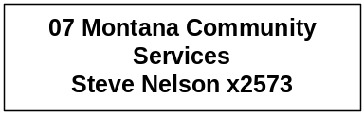

Program Description - Office of Community Services provides administration of federal Corporation for National Service programs (AmeriCorps and Campus Corps), community service, and volunteer efforts statewide, including the Volunteer Montana program. The office was created by the 1993 Legislature at the request of the Governor (MCA 90-14-101ff) in order to support community-based volunteer programs focused on addressing critical community needs. The vision of the office and its Commission on Community Service is to cultivate service as a lifelong "habit of the heart" for all citizens, and in particular, instill an ethic of community service in young Montanans. To that end, in the 2004-2005 biennium, the office is committed to:

- Encouraging all Montana citizens to engage in service activities in their community; involving youth in the life and work of communities; and expanding service opportunities for all Montanans.
- Contracting with and monitoring grants to community organizations utilizing part-time and full-time volunteers in an effort to make a difference, as well as work with other partners from the Corporation for National Service, which includes primarily the Office of Public Instruction, the University of Montana Campus Compact, and the Corporation State Office.
- Assisting some forty communities through training, technical assistance, monitoring and, where feasible, community "seed grants" in order to realize local action plans that encompass the Montana's Promise Initiative. Communities are working to ensure they have available for their children and youth the following five resources for healthy, productive living: 1) an ongoing relationship with a caring adult; 2) safe places and structured activities after school to learn and grow; 3) a healthy start in life; 4) marketable skills through effective education; and 5) opportunities for community service.
- Coordinating and overseeing annual training and technical assistance activities for national service programs in Montana, through AmeriCorps*USA, the National Senior Service Corps, and Learn & Serve America.

Program Indicators -
Indicator | Actual FY2000 | Actual  2001 | Actual  2002 | Estimated FY2003 | Requested FY2004 | Requested FY2005
AmericaCorps members | 197 | 190 | 181 | 274 | 300 | 300

Program Proposed Budget  Budget Item | Base  Budget  Fiscal 2002 | PL Base Adjustment  Fiscal 2004 | New  Proposals  Fiscal 2004 | Total  Exec. Budget  Fiscal 2004 | PL Base Adjustment  Fiscal 2005 | New  Proposals  Fiscal 2005 | Total  Exec. Budget  Fiscal 2005
FTE | 4.00 | 0.00 | 0.00 | 4.00 | 0.00 | 0.00 | 4.00
Personal Services | 113,621 | 42,242 | 0 | 155,863 | 41,790 | 0 | 155,411
Operating Expenses | 106,530 | 6,944 | 0 | 113,474 | 6,974 | 0 | 113,504
Grants | 1,838,744 | 1,000,000 | 0 | 2,838,744 | 1,000,000 | 0 | 2,838,744
Total Costs | $2,058,895 | $1,049,186 | $0 | $3,108,081 | $1,048,764 | $0 | $3,107,659
General Fund | 24,693 | 0 | 0 | 24,693 | 0 | 0 | 24,693
Federal Special | 2,034,202 | 1,049,186 | 0 | 3,083,388 | 1,048,764 | 0 | 3,082,966
Total Funds | $2,058,895 | $1,049,186 | $0 | $3,108,081 | $1,048,764 | $0 | $3,107,659

--------------------------------- Present Law Adjustments --------------------------------

Total Agency Impact | General Fund Total
FY04 $1,000,000 | FY04 $0
FY05 $1,000,000 | FY05 $0
PL- 702 - Grant Funding Increase -
This request will provide the Office of Community Service the necessary federal authority to expend the increase in federal AmeriCorps Program grants. The three new planning grants are to develop programs with Statewide Headstart, Yellowstone Council on Aging, and Community Connections for Youth through MSU-Billings.
________________________________________________________________________________________________

Total Agency Impact | General Fund Total
FY04 $3,645 | FY04 $0
FY05 $3,630 | FY05 $0
PL- 703 - Misc. Expenses Increase -
The executive recommends an increase in federal special revenue in operating to cover the agency's indirect cost allocation plan and fund the Office of Community Service share of this increase.

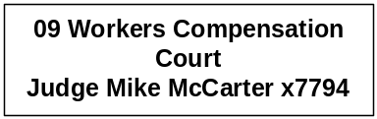

Program Description - The Workers' Compensation Court provides a forum for Montana employees and the insurance industry to resolve disputes arising from work-related injuries and occupational disease. The court is attached to the department for administrative purposes.

Program Indicators -

Indicator | Actual FY2000 | Actual  2001 | Actual  2002 | Estimated FY2003 | Requested FY2004 | Requested FY2005
Petitions Filed | 255 | 228 | 239 | 260 | 275 | 275
Trials | 64 | 57 | 61 | 65 | 70 | 70
Settlement Conferences |  | 14 | 23 | 30 | 30 | 35

Program Proposed Budget  Budget Item | Base  Budget  Fiscal 2002 | PL Base Adjustment  Fiscal 2004 | New  Proposals  Fiscal 2004 | Total  Exec. Budget  Fiscal 2004 | PL Base Adjustment  Fiscal 2005 | New  Proposals  Fiscal 2005 | Total  Exec. Budget  Fiscal 2005
FTE | 5.00 | 0.00 | 0.00 | 5.00 | 0.00 | 0.00 | 5.00
Personal Services | 298,285 | 3,902 | 0 | 302,187 | 2,979 | 0 | 301,264
Operating Expenses | 121,963 | 22,595 | 0 | 144,558 | 22,554 | 0 | 144,517
Total Costs | $420,248 | $26,497 | $0 | $446,745 | $25,533 | $0 | $445,781
State/Other Special | 420,248 | 26,497 | 0 | 446,745 | 25,533 | 0 | 445,781
Total Funds | $420,248 | $26,497 | $0 | $446,745 | $25,533 | $0 | $445,781

--------------------------------- Present Law Adjustments --------------------------------

Total Agency Impact | General Fund Total
FY04 $22,125 | FY04 $0
FY05 $22,708 | FY05 $0
PL- 14 - Operating Expenses Increase -
This request to increase operating funding in the Worker's Compensation Court includes an increase in rent ($1,125 in FY 2004 & $1,708 in FY 2005); funding for Workers' Compensation Judge and staff attorney to attend judicial training ($1,530 for biennium); travel ($11,000 each year of biennium); and funding for court reporters ($10,000 each year of the biennium). If the worst-case scenario does not materialize, the authority will revert.

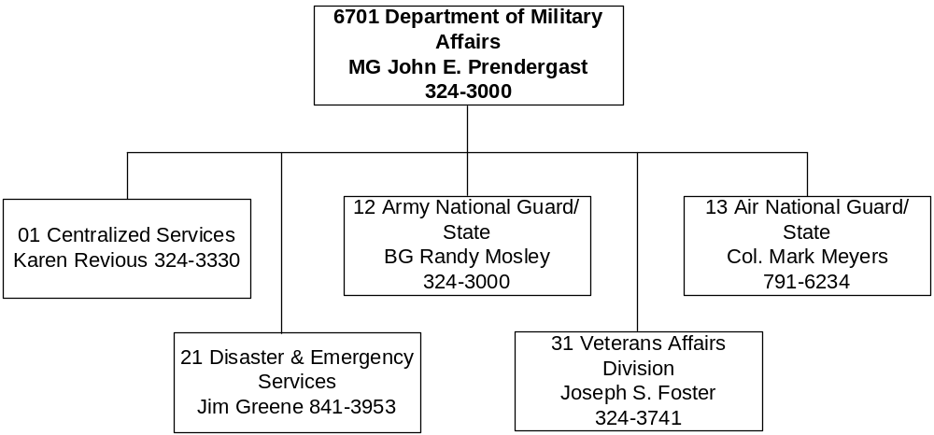

Mission Statement - To provide for safety and well being for citizens of Montana through mission-ready forces, for federal and state activations, emergency services as directed by the Governor, and services to Montana Veterans.

Statutory Authority - Article I, U.S. Constitution; Article VI, Section 13, Montana Constitution, Title 10, MCA

Agency Proposed Budget  Budget Item | Base  Budget  Fiscal 2002 | PL Base Adjustment  Fiscal 2004 | New  Proposals  Fiscal 2004 | Total  Exec. Budget  Fiscal 2004 | PL Base Adjustment  Fiscal 2005 | New  Proposals  Fiscal 2005 | Total  Exec. Budget  Fiscal 2005
FTE | 114.00 | 1.50 | 50.40 | 165.90 | 1.50 | 50.40 | 165.90
Personal Services | 4,529,507 | 627,264 | 1,682,031 | 6,838,802 | 627,291 | 1,678,341 | 6,835,139
Operating Expenses | 4,867,500 | 808,811 | 1,760,457 | 7,436,768 | 776,150 | 1,854,155 | 7,497,805
Equipment | 22,542 | 18,000 | 15,000 | 55,542 | 15,000 | 15,000 | 52,542
Grants | 685,992 | 0 | 2,777,000 | 3,462,992 | 0 | 2,777,000 | 3,462,992
Benefits & Claims | 2,280 | 0 | 0 | 2,280 | 0 | 0 | 2,280
Total Costs | $10,107,821 | $1,454,075 | $6,234,488 | $17,796,384 | $1,418,441 | $6,324,496 | $17,850,758
General Fund | 2,974,227 | 250,798 | (61,068) | 3,163,957 | 227,709 | (61,338) | 3,140,598
State/Other Special | 151,344 | 106,208 | 1,370,522 | 1,628,074 | 95,376 | 1,460,300 | 1,707,020
Federal Special | 6,982,250 | 1,097,069 | 4,925,034 | 13,004,353 | 1,095,356 | 4,925,534 | 13,003,140
Total Funds | $10,107,821 | $1,454,075 | $6,234,488 | $17,796,384 | $1,418,441 | $6,324,496 | $17,850,758

------------------- Agency General Fund Target - $6.30 million ---------------------

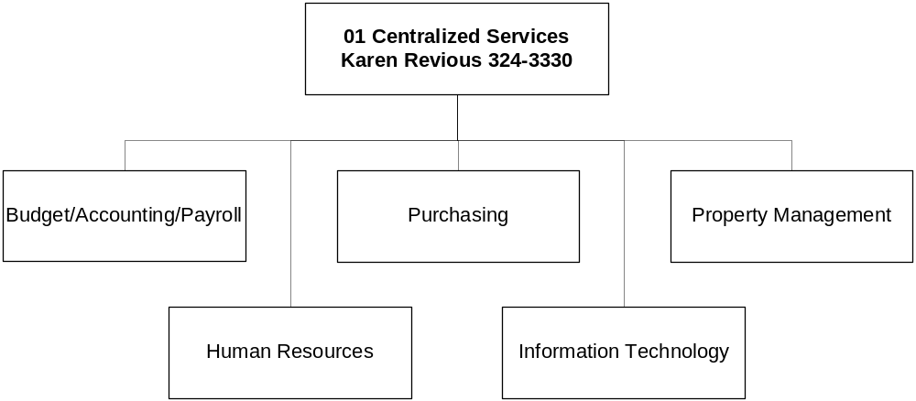

Program Description - The Centralized Services Division provides departmental administration through the Office of the Adjutant General and department-wide support for accounting, fiscal management, personnel, labor relations, and purchasing and property management oversight. The program operates in accordance with Title 2, Chapter 15, part 12 and Title 10, MCA.

Program Proposed Budget  Budget Item | Base  Budget  Fiscal 2002 | PL Base Adjustment  Fiscal 2004 | New  Proposals  Fiscal 2004 | Total  Exec. Budget  Fiscal 2004 | PL Base Adjustment  Fiscal 2005 | New  Proposals  Fiscal 2005 | Total  Exec. Budget  Fiscal 2005
FTE | 8.20 | 1.00 | 0.00 | 9.20 | 1.00 | 0.00 | 9.20
Personal Services | 395,039 | 101,433 | 0 | 496,472 | 100,053 | 0 | 495,092
Operating Expenses | 53,875 | (16,689) | 0 | 37,186 | (17,276) | 0 | 36,599
Benefits & Claims | 2,280 | 0 | 0 | 2,280 | 0 | 0 | 2,280
Total Costs | $451,194 | $84,744 | $0 | $535,938 | $82,777 | $0 | $533,971
General Fund | 394,510 | 43,895 | 0 | 438,405 | 42,127 | 0 | 436,637
Federal Special | 56,684 | 40,849 | 0 | 97,533 | 40,650 | 0 | 97,334
Total Funds | $451,194 | $84,744 | $0 | $535,938 | $82,777 | $0 | $533,971

--------------------------------- Present Law Adjustments --------------------------------

Total Agency Impact | General Fund Total
FY04 $39,639 | FY04 $0
FY05 $39,548 | FY05 $0
PL- 3 - Restore OTO - State Cooperative Agreements Mgr -
Centralized Services Division is requesting funds to make a 1.00 FTE onboard compliance specialist position permanent. This position was approved in the last legislative session with one-time-only funding. The department receives federal funding from National Guard Bureau through cooperative agreements. There currently are 12 cooperative agreements, which include 9 appendices for different types of funding totaling $11,500,000 for operations and maintenance and $115,000,000 for construction. This position oversees the Federal-State Cooperative Agreement process. It reviews and tracks all expenditures made with funds from the cooperative agreements and is responsible for ensuring that reimbursements from the federal government for expenditures made by the state are requested in compliance with the Cash Management Improvement Act. This position is critical for ensuring that all allowable expenditures are reimbursed by the federal government.
________________________________________________________________________________________________

Total Agency Impact | General Fund Total
FY04 ($19,533) | FY04 ($19,533)
FY05 ($19,534) | FY05 ($19,534)
PL- 7003 - Reduce current level in Centralized Services -
This is a request by the executive to reduce the budget in Centralized Services to meet the departmental general fund target. This is a continuation of reductions made in the FY 2003 special session and the FY 2003 Governor's reductions. Also in this decision package is an alternative payplan adjustment.

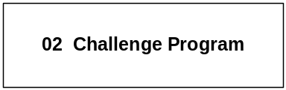

Program Description - The Montana National Guard Youth ChalleNGe Program is a volunteer program for youth ages 16 to 18 who have stopped attending secondary school before graduating. ChalleNGe is a 17-month, voluntary two-phased military modeled training program targeting unemployed drug-free and law-free high school dropouts. The program provides an opportunity for high school at risk youth to enhance their life skills, increase their educational levels, and their employment potential. Phase I of the program is a 22-week residential stay on the campus of Western Montana College of the University of Montana in Dillon focusing on physical training, classroom instruction, personal development, and life skills. Phase II is a year-long mentoring relationship with a specially-trained member of the community where the youth resides to provide a positive role model and to assist the student in gaining employment or enrolling in post-secondary schooling.

Program Proposed Budget  Budget Item | Base  Budget  Fiscal 2002 | PL Base Adjustment  Fiscal 2004 | New  Proposals  Fiscal 2004 | Total  Exec. Budget  Fiscal 2004 | PL Base Adjustment  Fiscal 2005 | New  Proposals  Fiscal 2005 | Total  Exec. Budget  Fiscal 2005
FTE | 0.00 | 0.00 | 47.40 | 47.40 | 0.00 | 47.40 | 47.40
Personal Services | 0 | 0 | 1,540,469 | 1,540,469 | 0 | 1,536,229 | 1,536,229
Operating Expenses | 0 | 59,557 | 1,210,837 | 1,270,394 | 48,827 | 1,214,522 | 1,263,349
Total Costs | $0 | $59,557 | $2,751,306 | $2,810,863 | $48,827 | $2,750,751 | $2,799,578
State/Other Special | 0 | 30,527 | 1,100,522 | 1,131,049 | 19,531 | 1,100,300 | 1,119,831
Federal Special | 0 | 29,030 | 1,650,784 | 1,679,814 | 29,296 | 1,650,451 | 1,679,747
Total Funds | $0 | $59,557 | $2,751,306 | $2,810,863 | $48,827 | $2,750,751 | $2,799,578

---------------------------------------- New Proposals ----------------------------------------

Total Agency Impact | General Fund Total
FY04 $2,751,306 | FY04 $0
FY05 $2,750,751 | FY05 $0
NP- 1 - Restore OTO - Montana NG Youth Challenge Program -
This request is to restore funding for the Montana Youth ChalleNGe program, which was previously funded with federal funds and a general fund match, but designated one-time by the last Legislature. For the 2005 biennium it is proposed that the match come from the employment security account (ESA) administered by the Department of Labor and Industry. The Youth ChalleNGe program is a five-month residential program, with a one-year post-residential mentoring component for 16-to-18-year-old youths who are drug-free, unemployed high school dropouts. Core components of the program are citizenship, academic excellence (GED/high school diploma attainment), life-coping skills, community service, health and hygiene, skills training, leadership/followership, and physical training.

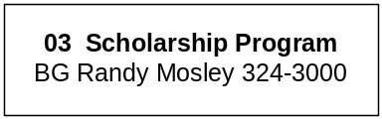

Program Description - The Montana National Guard Scholarship Program provides scholarships of up to $500 per semester to eligible Montana National Guard personnel enrolled as undergraduate students in colleges, universities, or training programs. The program assists Montana in recruiting and retaining personnel in both the Army and Air National Guard and in enhancing its operational readiness to assume both state and federal active duty missions. Scholarships also reward guard members for their service to the state by helping defray their educational costs at Montana post-secondary institutions.

Program Proposed Budget  Budget Item | Base  Budget  Fiscal 2002 | PL Base Adjustment  Fiscal 2004 | New  Proposals  Fiscal 2004 | Total  Exec. Budget  Fiscal 2004 | PL Base Adjustment  Fiscal 2005 | New  Proposals  Fiscal 2005 | Total  Exec. Budget  Fiscal 2005
FTE | 0.00 | 0.00 | 0.00 | 0.00 | 0.00 | 0.00 | 0.00
Operating Expenses | 0 | 0 | 0 | 0 | 0 | 0 | 0
Total Costs | $0 | $0 | $0 | $0 | $0 | $0 | $0
General Fund | 0 | 0 | 0 | 0 | 0 | 0 | 0
Total Funds | $0 | $0 | $0 | $0 | $0 | $0 | $0

The Montana National Guard Scholarship program was funded at $250,000 general fund by the 2001 Legislature. Because the appropriation was approved as a one-time-only appropriation, no base budget is shown. In order for the agency to meet the general fund target, the program is not funded in the Executive Budget for the 2005 biennium.

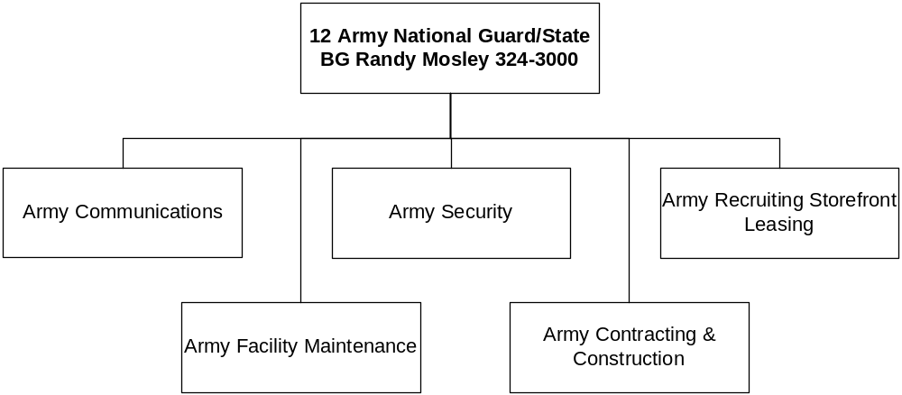

Program Description - The Army National Guard, until federalized, is a state military organization which provides trained and equipped military units for use in the event of a state or national emergency. The Federal/State Cooperative Agreement provides funding for facilities management, environmental, and communications support to the organization by: 1) providing professional and skilled personnel for the administration, planning, and execution of statewide repair and maintenance functions on facilities and training areas; 2) planning, programming and contracting for construction; 3) ensuring all activities and facilities comply with environmental regulations; and 4) providing state-wide communication services, security contracts, and leases for buildings and land used by the Army National Guard. The program is mandated by the U.S. and Montana Constitutions and Title 10, Chapters 1-3, MCA.

Program Proposed Budget  Budget Item | Base  Budget  Fiscal 2002 | PL Base Adjustment  Fiscal 2004 | New  Proposals  Fiscal 2004 | Total  Exec. Budget  Fiscal 2004 | PL Base Adjustment  Fiscal 2005 | New  Proposals  Fiscal 2005 | Total  Exec. Budget  Fiscal 2005
FTE | 32.30 | 0.00 | 2.00 | 34.30 | 0.00 | 2.00 | 34.30
Personal Services | 1,161,198 | 356,263 | 82,520 | 1,599,981 | 354,077 | 83,353 | 1,598,628
Operating Expenses | 3,559,723 | 439,676 | 505,000 | 4,504,399 | 419,778 | 595,000 | 4,574,501
Equipment | 20,075 | 18,000 | 15,000 | 53,075 | 15,000 | 15,000 | 50,075
Total Costs | $4,740,996 | $813,939 | $602,520 | $6,157,455 | $788,855 | $693,353 | $6,223,204
General Fund | 1,163,402 | 44,043 | 0 | 1,207,445 | 21,870 | 0 | 1,185,272
State/Other Special | 17,561 | 8,439 | 270,000 | 296,000 | 8,439 | 360,000 | 386,000
Federal Special | 3,560,033 | 761,457 | 332,520 | 4,654,010 | 758,546 | 333,353 | 4,651,932
Total Funds | $4,740,996 | $813,939 | $602,520 | $6,157,455 | $788,855 | $693,353 | $6,223,204

--------------------------------- Present Law Adjustments --------------------------------

Total Agency Impact | General Fund Total
FY04 $85,637 | FY04 ($58,517)
FY05 $85,855 | FY05 ($58,117)
PL- 5 - Army Facilities Operations -
This request reflects this division's share of the reductions necessary to meet the agency's general fund target for the 2005 biennium. Reductions made in the FY 2003 special session and the FY 2003 Governor's reductions are continued. The requested federal funding of $144,154 in FY 2004 and $143,972 in FY 2005 is to fund some operating increases and equipment purchases that are 100 percent federally funded. There is also an alternative pay plan adjustment in this request.
________________________________________________________________________________________________

Total Agency Impact | General Fund Total
FY04 $266,000 | FY04 $0
FY05 $266,000 | FY05 $0
PL- 9 - MtNG Distance Learning Network - Comm. Adjust -
The Montana Army National Guard is requesting $266,000 of federal spending authority for each fiscal year to maintain voice and data communications at a level necessary to support existing military communications operational needs.
________________________________________________________________________________________________

Total Agency Impact | General Fund Total
FY04 $7,000 | FY04 $0
FY05 $0 | FY05 $0
PL- 13 - Construction Replacement Computers -
The Contracting and Construction Division is requesting $7,000 of federal funding for replacement of four computer systems and upgrading one laptop computer in FY 2004.

---------------------------------------- New Proposals ----------------------------------------

Total Agency Impact | General Fund Total
FY04 $332,520 | FY04 $0
FY05 $333,353 | FY05 $0
NP- 8 - Environmental Program Operations -
This request is to change two federally-funded modified positions to 2.00 FTE permanent and increase the federal spending authority to match the increase in federal funding for the program. The National Guard Environmental program is responsible for ensuring the department is in full compliance with all state and federal environmental laws and requirements. The division is requesting $332,520 in FY 2004 and $333,353 in FY 2005.
________________________________________________________________________________________________

Total Agency Impact | General Fund Total
FY04 $270,000 | FY04 $0
FY05 $360,000 | FY05 $0
NP- 14 - ARNG Distance Learning -
The Montana National Guard Distance Learning Network (MTNG DLN) is requesting state special revenue spending authority, $270,000 in FY 2004 and $360,000 in FY 2005, to be able to accept and expend funds for shared use of the network and to repair and maintain equipment and facilities. These funds would be collected from local, state or federal government or private individuals for use of the classrooms. The Department has established a state special revenue fund for the MTNG DLN to allow the network to accept funds for shared use and to accumulate funds to replace equipment during life cycle management.

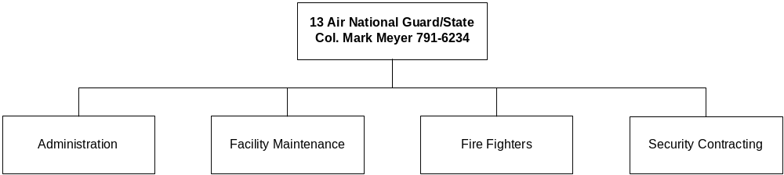

Program Description - The Air National Guard program, until federalized, is a state military organization which provides trained and equipped military units for use in the event of a state or national emergency. The federal/state cooperative agreement provides for administrative, facilities maintenance, and fire protection support to the Air National Guard base at Gore Hill near Great Falls. The Air National Guard Program operates under both federal and state mandates in accordance with its dual missions and is mandated by the United States and Montana Constitutions and Title 10, Chapter 1-3, MCA

Program Proposed Budget  Budget Item | Base  Budget  Fiscal 2002 | PL Base Adjustment  Fiscal 2004 | New  Proposals  Fiscal 2004 | Total  Exec. Budget  Fiscal 2004 | PL Base Adjustment  Fiscal 2005 | New  Proposals  Fiscal 2005 | Total  Exec. Budget  Fiscal 2005
FTE | 33.00 | 0.00 | 0.00 | 33.00 | 0.00 | 0.00 | 33.00
Personal Services | 1,303,255 | 83,352 | 0 | 1,386,607 | 85,825 | 0 | 1,389,080
Operating Expenses | 876,269 | 306,160 | 0 | 1,182,429 | 304,963 | 0 | 1,181,232
Total Costs | $2,179,524 | $389,512 | $0 | $2,569,036 | $390,788 | $0 | $2,570,312
General Fund | 188,423 | 120,359 | 0 | 308,782 | 119,985 | 0 | 308,408
Federal Special | 1,991,101 | 269,153 | 0 | 2,260,254 | 270,803 | 0 | 2,261,904
Total Funds | $2,179,524 | $389,512 | $0 | $2,569,036 | $390,788 | $0 | $2,570,312

--------------------------------- Present Law Adjustments --------------------------------

Total Agency Impact | General Fund Total
FY04 $272,349 | FY04 $75,588
FY05 $272,348 | FY05 $75,587
PL- 4 - Air Guard Operations -
This is a request for funding to provide adequate support for the continued operations and maintenance of 47 buildings and 141 acres at the Air National Guard base in Great Falls. This request also reflects this division's share of the reductions necessary to meet the agency's general fund target for the 2005 biennium. There is a continuation of reductions made in the FY 2003 special session and the FY 2003 Governor's reductions.

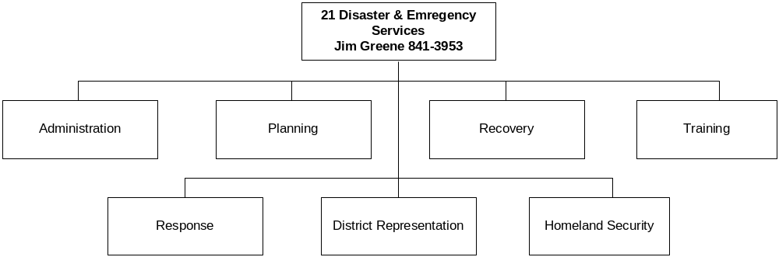

Program Description - The Disaster and Emergency Services Division: 1) works with local, state, and federal officials to prepare, update, and coordinate emergency preparedness, mitigation, response, and recovery plans; 2) provides technical assistance and coordination of the state response to assist political subdivisions in time of emergencies; and 3) receives, records, and disburses federal funds to eligible political subdivisions. Political subdivisions must provide matching funds for all federal reimbursement programs except disaster recovery and Federal Emergency Management Agency Terrorism program. The division is responsible for disaster planning activities, responding quickly and effectively to disasters and emergencies, being a source of information and 24-hour contact point, and coordinating state assistance to local governments. The program is provided for in Title 10, Chapter 3, MCA.

Program Proposed Budget  Budget Item | Base  Budget  Fiscal 2002 | PL Base Adjustment  Fiscal 2004 | New  Proposals  Fiscal 2004 | Total  Exec. Budget  Fiscal 2004 | PL Base Adjustment  Fiscal 2005 | New  Proposals  Fiscal 2005 | Total  Exec. Budget  Fiscal 2005
FTE | 21.00 | 0.00 | 2.00 | 23.00 | 0.00 | 2.00 | 23.00
Personal Services | 979,771 | 27,218 | 95,110 | 1,102,099 | 28,048 | 94,827 | 1,102,646
Operating Expenses | 225,773 | (11,640) | 44,620 | 258,753 | (12,876) | 44,633 | 257,530
Equipment | 2,467 | 0 | 0 | 2,467 | 0 | 0 | 2,467
Grants | 685,992 | 0 | 2,777,000 | 3,462,992 | 0 | 2,777,000 | 3,462,992
Total Costs | $1,894,003 | $15,578 | $2,916,730 | $4,826,311 | $15,172 | $2,916,460 | $4,825,635
General Fund | 505,871 | 18,998 | (25,000) | 499,869 | 19,111 | (25,270) | 499,712
State/Other Special | 13,700 | 0 | 0 | 13,700 | 0 | 0 | 13,700
Federal Special | 1,374,432 | (3,420) | 2,941,730 | 4,312,742 | (3,939) | 2,941,730 | 4,312,223
Total Funds | $1,894,003 | $15,578 | $2,916,730 | $4,826,311 | $15,172 | $2,916,460 | $4,825,635

---------------------------------------- New Proposals ----------------------------------------

Total Agency Impact | General Fund Total
FY04 $2,967,000 | FY04 $0
FY05 $2,967,000 | FY05 $0
NP- 210 - Terrorism Preparedness and Equipment -
The objectives of this request are to enhance the capacity of state and local first responders to respond to a Weapons of Mass Destruction terrorism incident involving chemical, biological, nuclear, radiological, incendiary, or explosive devices. The U.S. Department of Justice federal funding allocated for this request provides equipment, exercise and training support for first responders at the state and local level. The basis for the federal allocation comes from the Statewide Domestic Preparedness Strategy, which was a requirement for receiving funding. The funding includes personal services for three temporary employees who will manage exercise development and implementation, and grant management.
________________________________________________________________________________________________

Total Agency Impact | General Fund Total
FY04 ($50,270) | FY04 ($25,000)
FY05 ($50,540) | FY05 ($25,270)
NP- 7002 - Reduce Current Level FTE - DES -
This request will reduce current level FTE in Disaster and Emergency Services by 1.00 FTE. This reduction is necessary to ensure the division helps in meeting the department's 2005 biennium general fund target. There is also an alternative pay plan adjustment in this request.

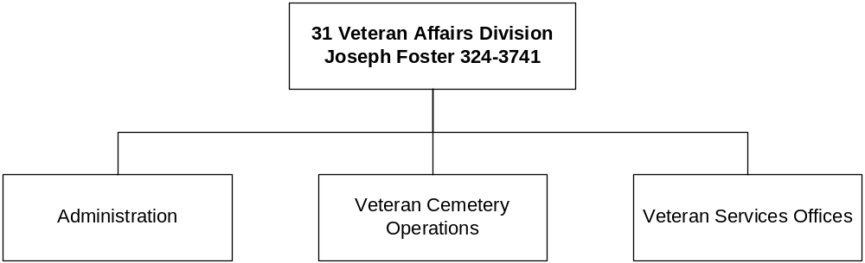

Program Description - The Veterans Affairs Division assists discharged veterans and their families, cooperates with state and federal agencies, promotes the general welfare of veterans, and provides information on veterans' benefits. The program also administers the veterans' cemeteries located at Miles City and at Fort Harrison, in Helena. The Board of Veterans' Affairs is administratively attached to the Department of Military Affairs, and operates under a state mandate provided in Title 10, Chapter 2, MCA.

Program Proposed Budget  Budget Item | Base  Budget  Fiscal 2002 | PL Base Adjustment  Fiscal 2004 | New  Proposals  Fiscal 2004 | Total  Exec. Budget  Fiscal 2004 | PL Base Adjustment  Fiscal 2005 | New  Proposals  Fiscal 2005 | Total  Exec. Budget  Fiscal 2005
FTE | 19.50 | 0.50 | (1.00) | 19.00 | 0.50 | (1.00) | 19.00
Personal Services | 690,244 | 58,998 | (36,068) | 713,174 | 59,288 | (36,068) | 713,464
Operating Expenses | 151,860 | 31,747 | 0 | 183,607 | 32,734 | 0 | 184,594
Total Costs | $842,104 | $90,745 | ($36,068) | $896,781 | $92,022 | ($36,068) | $898,058
General Fund | 722,021 | 23,503 | (36,068) | 709,456 | 24,616 | (36,068) | 710,569
State/Other Special | 120,083 | 67,242 | 0 | 187,325 | 67,406 | 0 | 187,489
Total Funds | $842,104 | $90,745 | ($36,068) | $896,781 | $92,022 | ($36,068) | $898,058

--------------------------------- Present Law Adjustments --------------------------------

Total Agency Impact | General Fund Total
FY04 $60,432 | FY04 $0
FY05 $60,263 | FY05 $0
PL- 18 - Veterans Cemeteries Operations -
This request is for state special spending authority and the increase of a part-time position (0.50 FTE) to a full-time 1.00 FTE position necessary for the continued operation of the two veterans cemeteries. Funding for this request comes from the sale of veteran's license plates, donations and plot allowance.

---------------------------------------- New Proposals ----------------------------------------

Total Agency Impact | General Fund Total
FY04 ($36,068) | FY04 ($36,068)
FY05 ($36,068) | FY05 ($36,068)
NP- 7001 - Reduce FTE - Veterans Affairs Div. -
This request will reduce the Veterans Affairs Division current level staff by 1.00 FTE. This reduction is this division's share of the department's effort to meet its 2005 biennium general fund target request.

