Overview of 2005 Biennium Executive Budget

Background – The late 1990s were good years for most Montanans. State government participated in the boom cycle, building roads and bridges, renovating and constructing buildings, expanding services from child care to health care, catching up on a long backlog of natural resources work, supporting the arts, history and libraries, and laying a foundation for economic development and electronic government services to our citizens in the 21st century. Everyone worked very hard to prepare for Y2K and were relieved when hundreds of systems converted with only a few glitches.

Economic storm clouds began to appear on the horizon in the summer of 2001 as the national economy entered a recession. The Office of Budget and Program Planning started meeting with each state agency to discuss the philosophy of this administration: We would begin to reduce expenditures, adjust services to avoid supplementals, scale back expectations of state agencies and special interest groups about proposals for the 2003 Legislature, and plan how to live within our means.

As the economic storm clouds built around us, surrounding states began calling special sessions to balance their FY 2002 budgets. After the tragic events of September 11, 2001, attacks on the World Trade Center and the Pentagon, markets declined and the recession deepened. Montana’s economy was not impacted as significantly as other states, but we continued to see a slippage in revenues from what was projected by the 2001 Legislature. By April 2002, the Governor and the budget director announced plans to initiate the statutorily-required steps to implement budget reductions up to 10 percent under 17-7-140, MCA.

Agencies identified potential general fund reductions and fund balance transfers and reported on how the customers and employees would be affected. By May 24, 2002, a plan was prepared that reduced general fund in the Executive Branch agencies by 3.5 percent and among elected officials by 3.2 percent, with the percentage reductions ranging from $166,557 or 1.1 percent in the Department of Natural Resources and Conservation due to having absorbed more than $6 million of fire suppression costs to $184,415 or 10 percent in the Board of Crime Control. In the first action to balance the FY 2003 state budget, which began July 1, 2002, the general fund reductions totaled $23.25 million and the fund transfers totaled $14.60 million, as ordered by the Governor in June, 2002.

By mid-June 2002, it was clear earlier action to reduce spending would not be enough to offset the continued loss of state revenue. On June 28, the Governor issued a Proclamation calling the Fifty-seventh Legislative Assembly into Special Session on August 5, 2002, to make further reductions in the FY 2003 state budget. Again, the agency directors and staff set to work looking for each and every general fund savings and least painful reduction to Montana citizens. After many negotiating sessions with state agencies, the Governor’s recommendations to bring the 2003 biennial budget into balance were published on July 19 with an additional $45.26 million of spending reductions, transfers and revenue reallocations. After a six-day session, the Legislature adopted and the Governor approved $59 million in budget balancing actions, leaving an ending fund balance projection of $27 million.

With the 2003 biennium budget balanced once more, the state rating agencies, Moody’s and Standard and Poor’s, recognized Montana as one of the first states to solidly address FY 2003 revenue shortfalls and issued bond ratings of Aa3 and AA-, respectively, and gave Montana a stable outlook ranking for FY 2003.

The agencies and the OBPP started working on developing the 2005 biennium budget. All of the general fund Governor’s reductions and the special session reductions for FY 2003 that were sustainable were treated as though they had occurred in each year of the 2003 biennium. That is, they were subtracted from both the FY 2002 actual expenditures [the base budget] and from the FY 2003 appropriation to create a general fund target for the 2005 biennium. In addition, the 2005 biennium present law adjustments to annualize the pay plan, cover the deficit in insurance and tort claims, pay for utililty cost increases in state buildings, etc. were distributed to all agencies, which means those costs were absorbed in the recommended general fund targets. Agency targets were reviewed and adjusted on a case-by-case basis.

Agency directors and staff spent thousands of hours adjusting budgets, scaling back expenditures, studying options and making plans that would create the least amount of disruption in the most critical services. The recommended budget eliminates some programs and functions from state government and reduces the vast majority of services that use general fund. The reductions will mean some people will no longer receive some services. Care has been taken to try to ensure that services are continued to those who are most in need.

Legislation will be needed to implement some of the spending reductions, proposed funding switches and the continuation of fund transfers begun during the August 2002 Special Session. When these additional bills affect HB 2 General Appropriations Act authority, they have been included in the narrative for each agency as new proposals numbered in the 8XXX series for legislative consideration.

Budget recommendations vary from agency to agency, with some of the more significant items highlighted below.

General fund fiscal balance restored by FY 2005

In FY 2005 the general fund is restored to balance with revenues slightly exceeding expenditures for the first time since FY 2000. The recession of 2001 and effects of the bursting of the technology stock bubble reduced 2003 biennium revenues $180 million below that anticipated in the regular session in the spring of 2001. The moderate actions taken by the Governor and the Legislature in special session to constrain expenditure growth are continued in this budget and, coupled with revenue growth returning to normal rates, bring the state general fund back into fiscal balance by 2005. This does not represent a serious retrenchment in the commitment to services provided to citizens of Montana. Adjusted for the move of the school guarantee fund to state special revenue, FY 2005 represents a new high for general fund revenues and expenditures for Montana. The fiscal balance is illustrated in Chart 1 below.

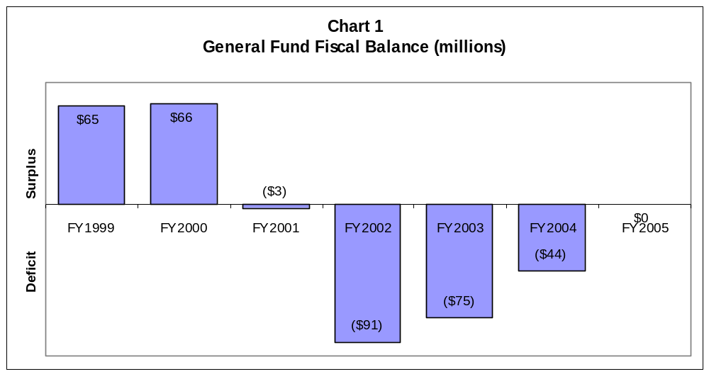

Funds transferred from Coal Trust Fund – Restoration Plan Statutorily Established

The budget transfers $93 million from the constitutional coal trust fund and proposes a statutory plan to restore the principal of the trust. In spite of establishing a fiscal balance in FY 2005, the deficits of 2001-2004 deplete the $176 million fund balance on hand at the end of FY 2000 and, without a transfer from the trust fund, will leave a $36 million negative fund balance in FY 2005. Having reached a sustainable spending level by 2005 we believe it is not prudent to further reduce services or to increase taxes solely for the purpose of reestablishing the fund balance.

EXECUTIVE BRANCH AGENCIES

K- 12 Education - As the first quarter of the school year draws to a close, there is much on the minds of the administration, educators, parents and students in this state. At the top of that list for many is this question: how can we work together to strengthen Montana’s excellent education system while living within current budget constraints?

One reflection of the interest in public schools during the interim was the Governor’s Public School Funding Advisory Council (hereafter referred to as the Advisory Council). This group held hearings across the state to find out what solutions are out there for K-12 funding. These are the people’s recommendations and they received the highest consideration in preparing the budget.

Education, like much of Montana, is experiencing difficult financial times. There has been deserved attention about the possible need for increased appropriations to operate our public schools. Quality schools are a priority for the Martz Administration and this budget reflects that importance. The needs of educating our students are met in this budget, showing a sincere attempt to minimize any adverse impact to Montana’s schools because of declining state revenues.

In the year 2000, the United States spent 3.3 percent of the gross national product, or 3.3 percent of all the goods and services that were produced in the nation were for K-12 education. In the state of Montana, we spent 4.6 percent of our gross state product, or 4.6 percent of all the goods and services produced in the state for K-12 education.
Declining Enrollment and Fixed School Costs - In many areas of Montana’s government the number of citizens utilizing services has steadily increased. Corrections, health services, and family assistance have all been asked to serve more Montanans. K-12 public education on the other hand has experienced a decreasing number of students. The peak enrollment in Montana’s schools occurred in FY 1996 with 165,547 students. In FY 2004 enrollment is expected to be only 146,556 students. This is an 11.5 percent drop in the number of students over eight years. It is logical that fewer students will cost less money. Yet, the question arises as to how quickly can districts adjust to the lower number of students. Portions of school district budgets are fixed costs that take time to reduce. Currently, when a district loses a student, the ANB entitlement for that student is reduced in the following year. Districts have had a difficult time adjusting the fixed costs that quickly.
The Advisory Council looked at this issue and proposed using a three-year average for determining ANB. In developing this budget, the three-year average proposal had a very high priority. We looked at the significant growth in recent years in the Treasure State Endowment Program interest. In 1992, the voters approved that this revenue be set aside for local infrastructure. The first year of this program was in FY 1994 with $928,696 in interest earnings for local infrastructure needs. In FY 2004, just ten years later, in excess of $8 million will be available for local infrastructure. In keeping with that intent, this proposal uses half of the interest from the Treasure State Endowment program for school facility payments currently paid for with general fund. The plan frees up a little over $4 million general fund each year, which will be used to begin three-year averaging in FY 2005.
Educator Recruitment and Retention - Montana is experiencing a shortage of educators in several areas. The shortage also extends outside of curriculum areas and severely impacts certain geographic areas in Montana. This is why the need for an educator recruitment program has long been recognized. This new program will help schools with critical shortages. The program would pay up to $12,000 toward student loans of new teachers over 4 years.
This program will also assist with the problem surrounding initial turnover. By accepting a loan repayment plan in exchange for four years of service, new teachers will be not be lost after their first year in education.
Rising insurance costs and higher salaries in some other states are often cited as reasons for teachers to leave their job in Montana. The Advisory Council recognized the need for school insurance reform and the administration will be monitoring the several pieces of legislation already formulated. In particular we are interested in the statewide insurance pool that uses the purchasing ability of a very large group to improve benefits and services while keeping costs to a minimum.
Like insurance, the salary struggles are not limited to education. In 2001, the national average wage was $36,124, while in Montana it was $25,194. On average, Montanans earn 30.4 percent less than workers nationally. Nationally, teachers earn $43,250, while in Montana teachers earn $33,249 or 23.1 percent less than their national peers. All Montanans share in low wages and we must continue to strive for better paying jobs for all professions.
New Medicaid Eligibility for School Based Services – The Department of Health and Human Services (DPHHS) has historically provided the general fund match for school-based services under Medicaid. DPHHS, OPI and the Governor’s Office have been working cooperatively to restructure school-based services, by using the $35 million general fund spent per year on special education as a match for Medicaid payments. DPHHS also proposes to revise rules for existing services and add new services that would qualify for coverage under Medicaid.
This proposal will allow schools to qualify for Medicaid funding for services that they currently provide under IEPs (Individual Education Plans) and simplify the process of submitting medical claims as much as possible. For example, an IEP may require a school to provide extensive Personal Care Aides for students with special needs. These services traditionally have not been a covered service under Medicaid, but under the proposed changes these services will become a Medicaid covered service for school-based providers.
The proposed changes are also intended to refinance services such as the Comprehensive School and Community Treatment (CSCT) program. CSCT helped schools receive psychological services brought to students on their campuses. Unfortunately, budget reductions in the past year have eliminated the CSCT program.
The combination of these efforts should allow schools to replace the CSCT program, and help schools stretch their state special education funding farther. This proposal will bring stable funding that schools can rely on for Medicaid match. As a result of these changes for school-based services, up to $13 million in new federal funding could be available to schools in FY 2004 and each year thereafter.
Entitlement Increases - The level of school entitlements is also of concern for the administration. New avenues deserved exploration in order to meet the need of Montana’s schools.
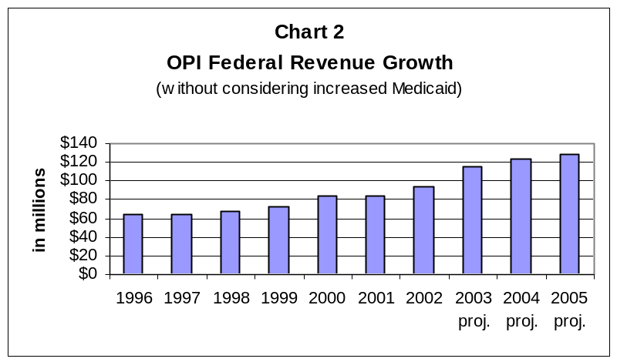In looking at the entire school funding picture, and considering the significant amount of new federal revenue both in direct grants and Medicaid anticipated for schools, it became apparent that there would be increases in retirement as a result of these increases in federal programs.
Currently, the retirement costs for all personnel employed by the districts are charged to the state and county via the retirement fund. This means federal programs, transportation, food services, and the other funds charge the retirement, social security and unemployment insurance to the state and county taxpayers. This is an atypical accounting procedure. Usually federal grants pay for the full personal services costs associated with the new program. With the newly expanding federal programs, this is becoming a greater burden on taxpayers. Chart 2 shows the increasing federal expenditures through OPI.
The revenue to the retirement fund is primarily comprised of state general fund and county levies. When the district receives additional federal revenue for a specific purpose, it can augment that grant by the cost of the retirement, which is permissively charged to the county and state. With the significant increases in federal authority, this amount will be significant.

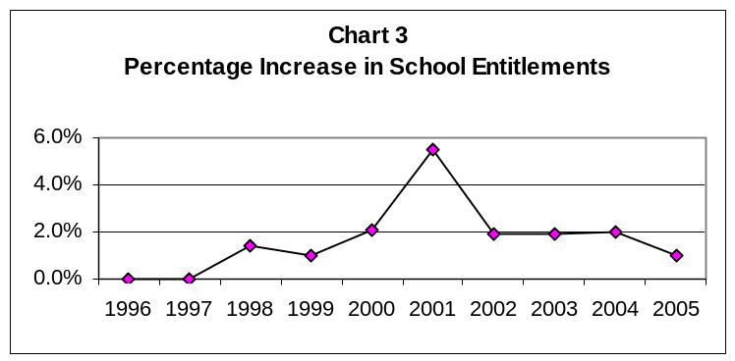The administration has brought forth a proposal that changes statute to allow only salaries paid from the general fund to be charged to the retirement fund. It is anticipated to save the state general fund $4.3 million in FY 2004 and $3.6 million in FY 2005. Likewise, the proposal saves county taxpayers about $11 million per year. Tax relief is not the purpose of this proposal. In order keep taxpayers and districts reasonably close to the current law, the proposal offsets this reduction with a decrease in the direct state aid percentage from 44.7 percent to 42.6 percent. Both of these efforts combined create the ability to increase entitlements 2 percent in FY 2004 and 1 percent in FY 2005 and still remain within the targeted levels for K-12. Chart 3 demonstrates the administration’s strong commitment to education even when budgets are extremely tight as they are now.

K-12 Conclusion - Montana students achieve at some of the highest levels in the country. The administration understands that these results will begin to decline if we fail to help Montana’s students. It is much easier to maintain a quality system than it is to build one.
That is why a message of hope for students is needed in these difficult times. They will continue to achieve at a high level and, when the financial difficulty is fading from memory, Montana’s schools will still be strong.
The education budget recommendations of the administration are consistent with a balanced view of all services provided in the state. This budget continues that tradition of Montana’s strong commitment to our students.

Department of Public Health and Human Services - The DPHHS budget has been prioritized with four controlling factors: 1) growth in caseloads; 2) federal funds being shifted out of programs to cover additional public assistance caseloads; 3) slower than anticipated revenue growth; and 4) maximizing use of federal funds for eligible services. The DPHHS budget presents a balance among available revenues, the breadth and scope of services provided, and the continuing demands of caseload growth in needed services, most prominently in the Medicaid program which adds approximately $36 million general fund in this budget. This balancing effort between resources and need has been the hallmark of the agency’s efforts over this biennium.

In the last quarter of FY 2002, DPHHS took several mitigation actions to its budget to stay within the funds appropriated for biennium. Subsequently, the budget was reduced for FY 2003, first by the Governor and then by the Legislature, to stay within available revenue. Throughout the 2003 biennium the department has continued to deliver the services as charged by the Legislature, administration, and, where applicable, the federal government.

The 2005 biennium budget represents a prioritization of funding for programs to maintain the 2003 biennium level of funding. Critical to this plan has been the ability to absorb the $36 million increase in Medicaid. Chart 4 portrays the growth of people – children and adults – eligible for Medicaid services increasing 5.7 percent in FY 2002.

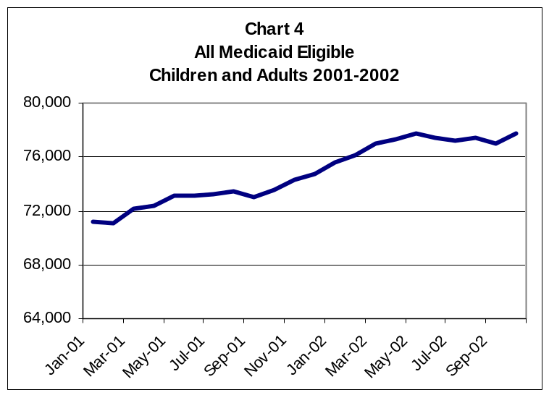

The cost of Medicaid is determined by the number of people who require health services, the number of services they use, and the cost of those services. One indicator is the number of people who are disabled who require Medicaid assistance. This group of people, for the most part, requires Medicaid services that are higher cost than other groups. Chart 5 is presented to show the history of service for this group of Medicaid recipients.

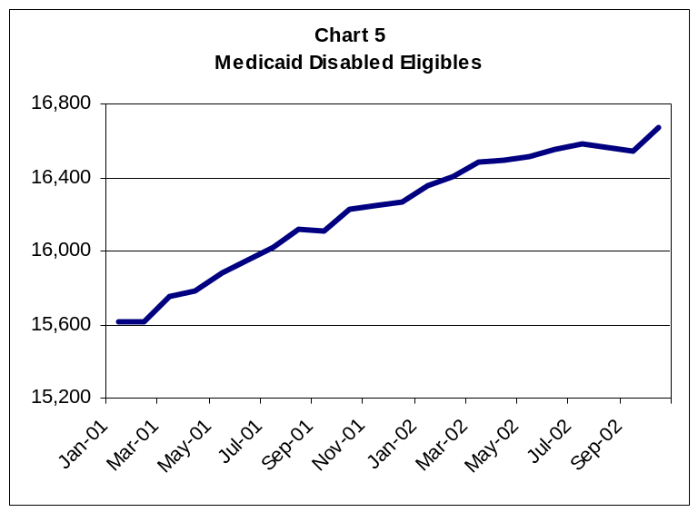

The decline in cash assistance caseload under welfare reform is illustrated in the Chart 6. With the reduction in TANF caseload, the agency invested federal TANF funds in other areas, specifically child care, foster care, and disability services. With the caseload increase in the last two years, the availability of funds to provide these other public assistance benefits has been limited. Therefore, the budget for the department was structured without these services being replaced with general fund.

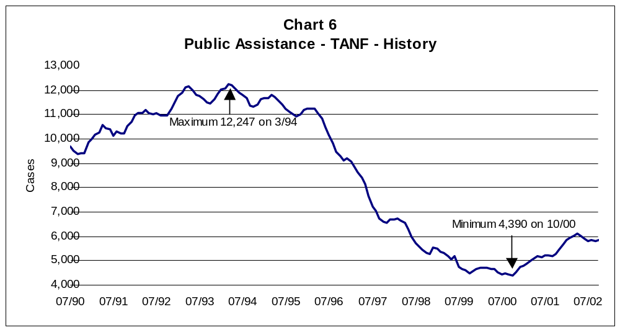

To accommodate the Medicaid caseload growth and to stay within available revenue, the Addictive and Mental Disorders Division has developed a plan that has three key components:

- Reduce the size and restructure the mental health services plan (MHSP) for mental health services for adults and children who have serious mental and emotional disorders and who have family incomes below 150 percent of the federal poverty level. MHSP has been a quasi-entitlement program since 1999 and the cost of services for non-Medicaid mental health adults has risen 26 percent in the last 2 years primarily resulting from increases in the pharmacy benefit. MHSP will be restructured to provide contracts for a fixed numbers of individuals. Each contract agency will have a certain capacity of MHSP clients for which the department will fund services. Separate adult and youth caps will be established. Criteria for eligibility for MHSP services will be tightened to assure the most in need are served. This reduces the costs of MHSP for children and adults to $9 million for the biennium.
- Cap the Montana State Hospital patient capacity at 135 and create 45 community-based inpatient psychiatric beds to offset the reduced capacity at Montana State Hospital (MSH). This will promote use of least restrictive services; provide an alternative to simply expanding the MSH capacity; and reduce general fund cost by establishing three 15-bed "Behavioral Health Inpatient Facilities" (BHIF) in three communities for Medicaid recipients between the ages of 21 and 64. The BHIFs will provide more dispersed capacity and will allow for Medicaid federal funding. Legislation will be required to implement this decision package. The department believes the creation of 45 BHIF beds, with appropriate utilization management, will enable MSH to operate within a 135 patient census.
- Restructure services for Montana mental health nursing care center. MMHNCC has experienced a slow but steady decline in utilization for more than a decade, as expanded community mental health and private nursing home services have provided alternative care options. The current MMHNCC patient census is approximately 105 including about 35 individuals who are younger than 65. State policy and Olmstead compliance suggest that these younger residents should not be in a state-operated psychiatric nursing home if a community-based alternative can be found or created. The department proposes to create an intensive community support program for these 35 residents to serve them outside the institution, to close a wing at the center, and to reduce the capacity to 75. The savings from this reduced cost at the center will leverage federal money for community programs and provide services for this group of residents in a less restrictive, more integrated setting.

The department has continued its efforts to create permanent placements for children for whom return to the home would be contrary to their welfare. The intent of the Child and Family Services Division is to protect the children and to preserve the family unit if at all possible. Chart 7 demonstrates that the children who are in adoptive placements now exceed the number who are in foster care.

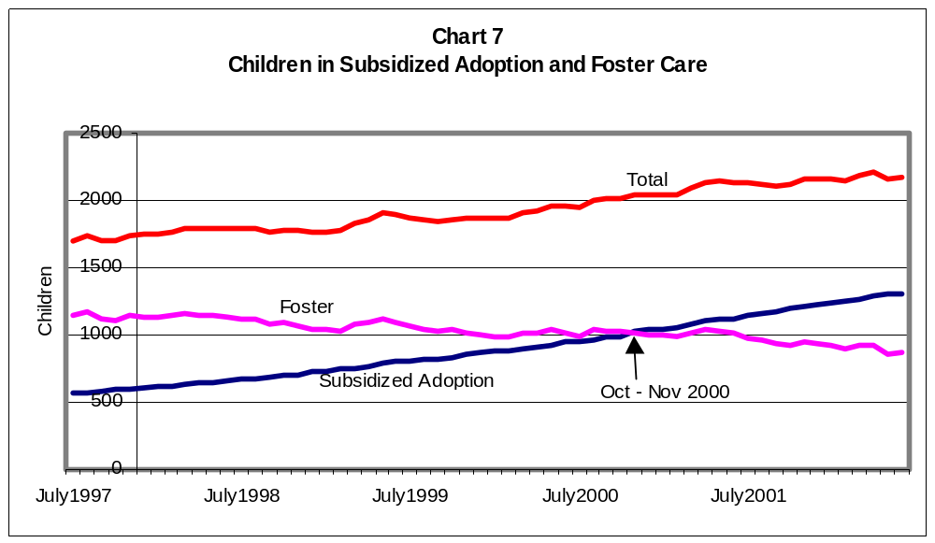

The number of people who are served by the Disability Services Division has increased by almost 60 percent since 1990. Chart 8 provides an overview of the number of adults and children who have received these services. Despite this effort, there remains a waiting list for these services.

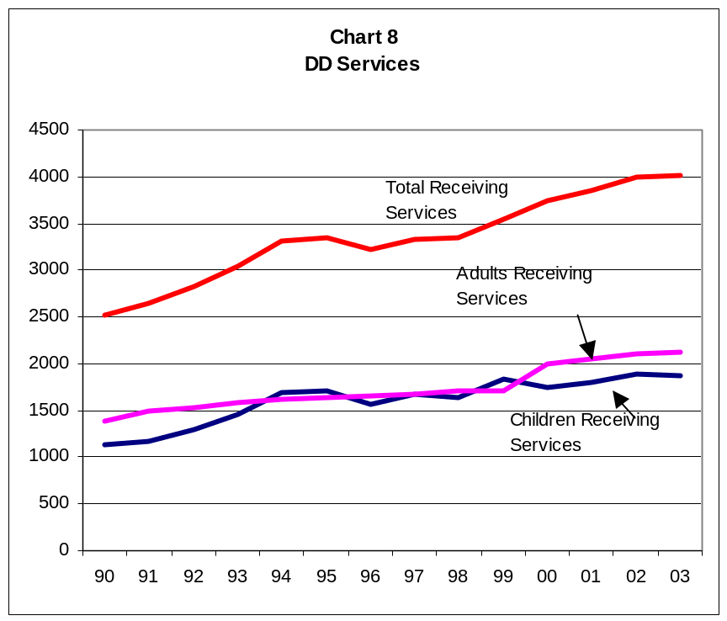

Finally, it is useful to review the level of state funding that has been available for the wide range of services provided by the DPHHS over the last few years. Current revenue concerns should be considered as all of state government is being required to slow the growth of spending. Chart 9 shows the historical growth in appropriations for the department.

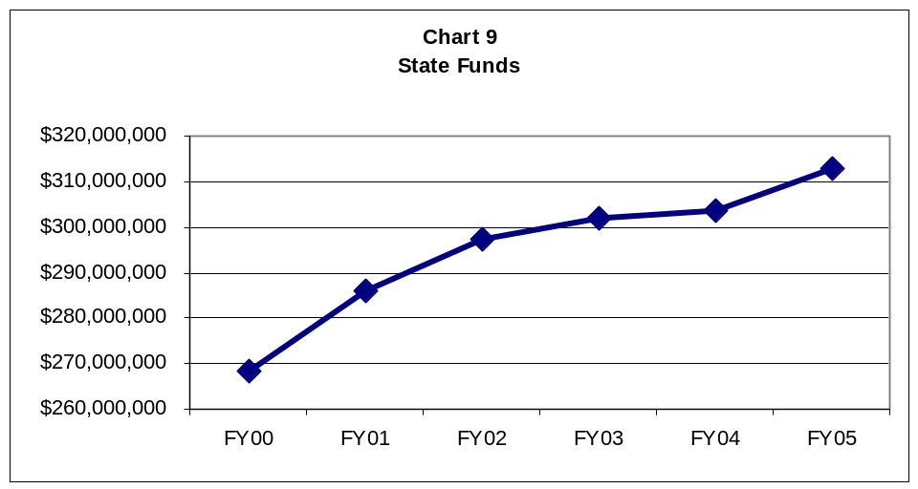

Montana University System – The Montana University System, including the community colleges, is scheduled to receive $273.4 million of general fund for the 2005 biennium excluding pay plan. This is the same amount as the system received in the current 2003 biennium.

State support for the educational units is $206.6 million of general fund and $24.6 million in six-mill levy revenue.

The Montana Board of Regents enacted significant tuition increases in the previous biennium. These increases, along with an increase in projected students for the 2005 biennium, will generate additional revenue to help fund the general operating budgets of the campuses. The tuition rate in the 2005 executive budget is expected to increase about 4 percent above the initial FY 2003 tuition rates. The executive budget estimates $305 million for tuition for the 2005 biennium.

The Agricultural Experiment Station, Extension Services, Bureau of Mines, Forestry and Conservation Experiment Station and the Fire Services Training School, along with the three Community Colleges were also held to the same level of funding as in the 2003 biennium.

Chart 10 shows the level of general fund and millage appropriated each biennium since 1991 and tuition expended.

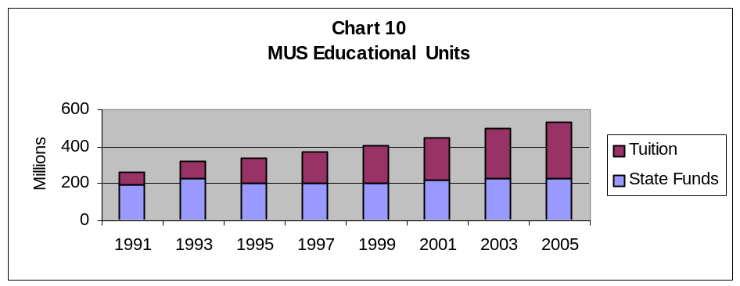

The MUS receives and spends a considerable amount of money beyond what is reviewed in the legislative process. The entire budget of the MUS is expected to climb over $800 million during FY 2003.

The current unrestricted fund (CUF) accounts for activity related to the general operations of the campuses. The revenue sources of the CUF include state general fund, 6 mill levy and tuition and fees. The CUF is approximately 35 percent of the entire MUS budget. The second most significant portion of the entire budget is restricted funds that comprise about 30 percent of the total. These restricted funds include federal and state grants and financial aid. Chart 11 shows the entire budget for all campuses since 1998.

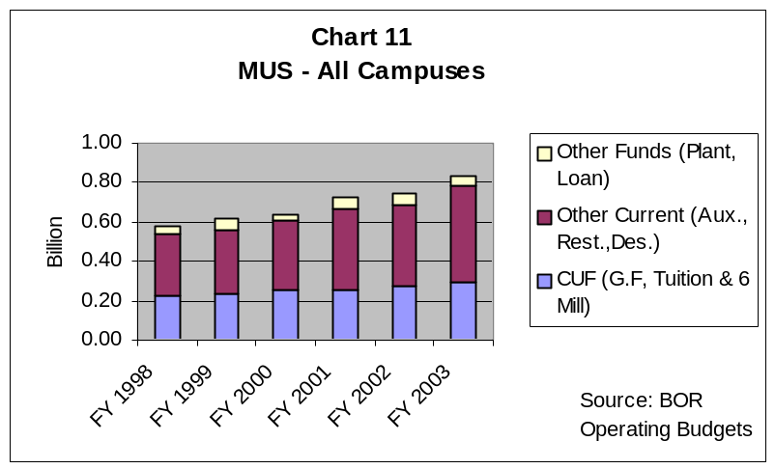

Department of Corrections – The general fund target is $209.86 million, which is a reduction of about $30 million from what was requested during EPP earlier in the year. This target was achieved through a combination of spending reductions and lower population projections for contract prison beds. The use of the conditional release program and changes in sentencing patterns by judges who are aware of the state financial predicament assisted the department’s efforts to move inmates through the system as quickly, safely and legally as possible. All of the mitigation measures are being taken with public safety as the number one priority.

The reduced bed estimate can be directly attributed to the agency efforts in moving eligible offenders committed to the department into community corrections settings, resulting in much lower costs per day. Thus far, 238 offenders have been released from prison into community corrections and only 13 have been revoked back to prison. The department’s goal to release 400 offenders into community corrections, in FY 2003, will alleviate a major portion of the general fund shortfall, originally projected at $9 million for the year.

Additionally, a savings from the 4th offender DUI WATCH program at the Xanthopoulos Building on the Warm Springs Campus has the ability to treat 140 offenders for 180 days, rather than a 270 to 395 day stay in prison or pre-release. Use of the Missoula Regional facility as a short-term assessment center for department commitments and probation revocations also will reduce prison stays even further. The end result should show more general fund savings.

The general fund recommended in the executive budget will allow the department to reinstate some of the inmate training and treatment program cuts made at the regional prisons during the FY 2003 budget reductions. Chart 12 below shows the actual and budgeted average daily adult population growth by category.

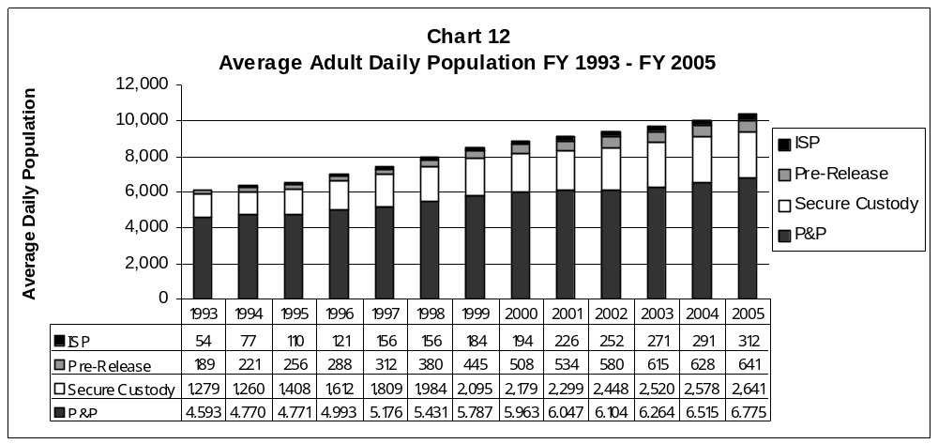

Department of Justice - The Department of Justice 2005 biennium budget reflects several significant changes. First, the Motor Vehicle Division is proposing to continue developing its new computer system that will replace the obsolete system and improve business processes to integrate titling, registration and driver licensing. Phase II of the project will be funded by another loan from the Board of Investments of $18,000,000 and the debt service is recommended to be repaid by a $5 per title transaction fee. The department also will be proposing legislation for the Montana Law Enforcement Academy that will relieve the general fund by approximately $2 million per biennium through a fee in courts of origianl jurisdiction and a fund switch from general fund to state special revenue. Finally, the department will manage throughout all divisions to budget within the general fund reductions that will continue as a result of the special session.

Department of Natural Resources and Conservation – Payment of unbudgeted fire suppression costs places a significant burden upon existing department funding sources. Fire expenditures are paid first from the general fund in Forestry and then from other program budgets. Regular budgeted general fund dollars that are expended on fire suppression expenses are normally recovered through a supplemental request to the Legislature. The problem with this process is that the department must try to carry the expenditure load for one and one-half years until the supplemental request is approved. The department has run into significant budget problems during the last several years due to organizational changes and significant expenditures on fire suppression. As a way to partially alleviate this situation, the administration will recommend in LC 321 that the Governor’s emergency statutory authority be increased from $12 million to $25 million and that federal reimbursement for mutual aid to other states and entities may be expended.

In addition, the Crow Tribe escrow account is funded in accordance with the settlement agreement through increased deposits of $500,000 per year general fund.

Economic Development – Both in the Governor’s Office and in the Department of Commerce, economic development programs and activities are recommended for elimination or very significant reductions to help deal with the general fund revenue shortfall. Economic development remains one of the administration’s highest priorities. We must support the businesses we have in Montana and develop higher paying jobs across the entire spectrum of our economy.

In the Department of Commerce, it is recommended to eliminate Research and Commercialization for $3.65 million per year, Certified Communities for $50,000 and Export Trade for $250,000. Treasure State Endowment Program grants for water and sewer projects also are reduced by $8.458 million so the TSEP money can be used for school facility payments in K-12. In the Governor’s Office the statutory appropriation to the Office of Economic Opportunity is eliminated for a general fund savings of $700,000 over the 2005 biennium and the Washington, D.C. office will not be opened. In addition, in the HB 2 appropriation there is 1.00 FTE recommended for elimination for a 2005 biennium general fund savings of $78,948.

We are making some very significant economic development progress and it is vitally important that we continue our efforts, albeit at a more modest level. The New Economy Index, published by the NIC: The eGovernment Company, ranks the 50 states regularly. From 1999 until 2002, we moved from 31 in the country to 18 for the proportion of our on-line population, from 42 to 20 for the number of managerial professional and technical jobs, and, very important for our future, from 41 to 16 for the number of scientists and engineers.

Department of Revenue - The executive has had the difficult task of trying to identify the fine line between cutting expenditures in the Department of Revenue and not reducing revenues to the state generated by those expenditures. Critical analysis indicates those areas recommended for reduction will have the least impact on revenue collections, which has been a difficult task when the entire department is organized around collecting revenue. Department-wide, there are proposals to reduce from base FY 2002 approximately 22.00 FTE and related operating expenditures, for a total reduction of approximately $5.7 million from the department’s original budget submittal. These reductions include technical maintenance and upgrades, agency administrative support functions, property tax services, freezing rent paid to counties for space occupied by department employees at the FY 2003 rate, eliminating various operating costs and discontinuing development of POINTS Phase II.

The department looked at new methods for collecting revenue without placing additional burden on those Montanans who already pay their fair share. In the 2005 biennium, the department plans to participate in the Treasury Offset Program, together with about half of the other states. This program enables states to send a list of eligible taxpayers with delinquent state tax debts to the U.S. Treasury’s Financial Management Service (FMS). FMS withholds any federal tax refund to be applied against the state tax delinquency.

The most significant reduction made by the department relates to the decision to discontinue the development of POINTS Phase II. POINTS Phase II was to include individual income tax and corporation tax. The key factors to this decision include the state’s significant budget deficit and a delayed implementation timeline causing increased development costs.

Department of Military Affairs – The $6.3 million general fund target was about $3.5 million less than the spring budget plan. Significant reductions were made in program budgets and the $250,000 National Guard Scholarship Program is recommended to be eliminated in the 2005 biennium. The employment security account funds from the Department of Labor and Industry will continue providing the state match for the Project Youth ChalleNGe Program federal funds.

Agriculture and Livestock – The four-year drought continues to take its toll on both the Department of Agriculture and the Department of Livestock. Lower production means less state special revenue to support the agencies and, therefore, programs are reduced accordingly. Nonetheless, the agencies met or exceeded their targets. The Growth Through Agriculture Program HB 2 and statutory appropriation will be reduced by $502,706 and $1,250,000 respectively for the 2005 biennium. It will be recommended that some services, which have been provided with general fund, will begin charging fees commensurate with the costs in the future.

Department of Environmental Quality – Most significantly, there is recommended in HB 10 a $9 million G.O. bond to pay for the state match to the U.S. Environmental Protections Agency superfund funds for fast-track cleanup in Libby and Troy. The debt service will be paid from hazardous waste CERCLA funds. There is a complete write-up of the proposal in Section F. In addition, the department will be requesting legislative action on several bills to increase fees commensurate with costs.

Long-Range Building Program – During the special session, the coal severance tax revenue for the cash portion of the LRBP was reduced by $644,000 and deposited to the general fund. The executive recommends the reduction continue for two more years, providing an additional $1.226 million for the general fund. In addition, the construction disputes from the Capitol renovation and the Montana State Hospital expansion have been resolved. These reductions and actions leave only enough cash in the LRBP account to recommend funding for the four highest construction priorities in the state. [Section F contains the budget recommendations.]

Treasure State Endowment Program – As mentioned above, the TSEP grants are recommended to be reduced by $8.458 million and the funds be used to replace a like amount of general fund in the K-12 school facility payments. In addition, it is recommended that a bill be adopted to increase the share of coal severance tax trust fund flow to TSEP from 50 percent to 75 percent until June 30, 2013. This in the long term will make more money available for infrastructure programs.

Reclamation and Development Grants – Revenue for the RDGP projects was cut by 50 percent during the August Special Session and it will take three years for the program to recover. The recommendations for grants are contained in HB 7 and in Section F.

Cultural and Aesthetic Grants – During special session, lodging facility use tax replaced $198,575 of general fund remaining in the grant program. Since that revenue is not available in the 2005 biennium for a fund switch, instead of the $600,000 general fund match requested, the executive requests $499,150 general fund for the recommended arts, history and cultural grants projects.

THE JUDICIAL BRANCH

The Judiciary – As required by 17-7-122(3), MCA, the 2005 biennium budget requested by the Judicial Branch is presented in the executive budget. However, on the general fund balance sheet in the recommended budget, $952,915 of that request is not funded, including requests for 5.25 FTE, and including the $17.2 million of increased variable costs for District Court assumption discussed below.

The 2003 Legislature passed SB 176, which required state assumption of District Courts starting in FY 2003 as administered by the Supreme Court Administrator’s Office. The premise of this legislation was to provide fair and equitable treatment of Montana citizens from one jurisdiction to another. The transition to state assumption was accomplished on July 1, 2002, after enormous effort by the Chief Justice and staff of the Judicial Branch, together with assistance from the Department of Administration and the Office of Budget and Program Planning. Because the FY 2002 base budget year was still at the county government level, the OBPP granted an exception in the 2005 biennium budgeting process and allowed the projected FY 2003 expenditures to be used as a base. Assumption increased state employees by about 245.18 FTE.

Although the premise of the District Court legislation was sound, the assessment of which services were or were not being assumed and their related financial costs was flawed. Currently, without FY 2003 actual expenditures, it is projected that the required general fund increase in excess of the original funding mechanism of SB 176 will be $17.2 million for the 2005 biennium. Given the magnitude of the anticipated general fund deficit, the state cannot absorb another $17.2 million increase to continue the District Court services as provided or implied in the original legislation. Therefore, the Office of Budget and Program Planning will propose legislation to sort out responsibilities for the myriad of variable services and costs in the District Courts and the counties, to ensure accountability for service referrals that drive up costs, and to distribute the costs to the responsible parties.

THE LEGISLATIVE BRANCH
The general fund target for the Legislative Branch was calculated in the same manner as all other agency targets. In accordance with 17-7-122, MCA, the Legislative Branch budget request is presented as submitted.

Organization of the Recommended Executive Budget - Sections A through E present the HB 2 General Appropriations Act recommendations for general fund, state special revenue, federal special revenue and proprietary funds that are appropriated in that bill. Each of these five sections will be referred to one of the Joint House/Senate Appropriations Subcommittees. Under the agency main table or the program table, if there is a notation that a HB 576 section exists, that means that the balance of a program is in a non-appropriated proprietary account, which may be found in Section P in Volume II.

Also in Volume II are Section F, which is referred to the Joint Appropriations Subcommittee on Long-Range Planning, the Information Technology Summary required by passage and approval of SB 131 last session, and the Reference Section that includes a number of tables and reports on agency budget summaries, calculations included in the budgets, an economic overview, the statewide ADA report, Unified Prevention budget and the Governor’s Tourism Tax and Individual Income Tax Advisory Councils Final Reports.

State employee pay plan

The budget includes $8.18 general fund million to allow increases in the monthly state contribution for employee health insurance of $44 in fiscal year 2004 and $50 in fiscal year 2005.

Legislation Required – On pages 2 and 3 of the Reference Section, the bills are listed that will be required to implement all of the executive budget recommendations.

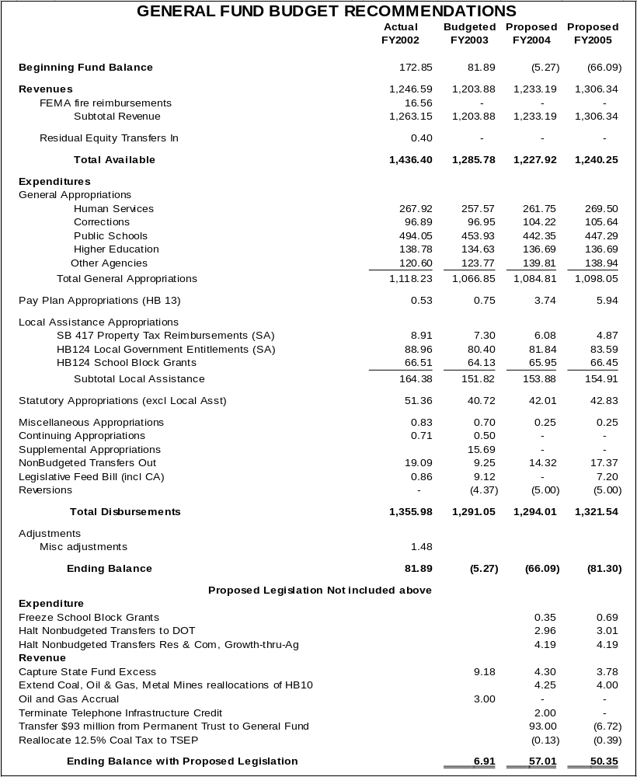

Summary of Legislation Listed on Balance Sheet

Postpone growth in school block grants
School block grants established by HB 124 of the 2001 session and HB 18 of the 2002 special session are currently scheduled to be the average of the FY 2002 and FY 2003 block grants plus a 0.76 percent growth rate in each year of the biennium. This legislation postpones the growth in block grants, by holding the average of the FY 2002 and FY 2003 block grants constant through the 2005 biennium and allowing the block grants to resume growth after this biennium.

Halt Nonbudgeted Transfers to Department of Transportation
Temporarily halts transfers to the Department of Transportation to replace lost vehicle revenues established in HB 124 of the 2003 legislature. This action was taken for fiscal year 2003 by the special session of the legislature; this bill will extend the provision thru fiscal year 2005.

Halt Nonbudgeted Transfers to Research and Commercialization and Growth thru Agriculture
Temporarily halts transfers to the Department of Commerce for research and commercialization and reduces by 50 percent the transfer to the Department of Agriculture for growth-thru-agriculture established in HB 1 of the 2000 special session of the legislature. This action was taken for fiscal year 2003 by the special session of the legislature; this bill will extend the provision thru fiscal year 2005.

Capture State Fund Excess
As was initiated in SB 19 of the August special session, transfer excess funds from claims occurring before July 1, 1990 to the general fund from fiscal years 2002 thru 2004.

Extend Coal, Oil & Gas, Metal Mines revenue reallocations proposed in Special Session HB10
The executive proposed in special session to temporarily reallocate a greater share of these revenues to the general fund, sharing the burden of expenditure reductions faced by general fund services with services these funded by state special allocations. With some changes these proposed reallocations were enacted by the legislature for fiscal year 2003. This will extend the proposed reallocations thru fiscal year 2005.

Oil and Gas Accrual
Title 15, MCA, will be changed to simplify the local distribution of oil and natural gas tax revenue. Under current law the state’s portion is first collected by the state, then sent to the counties, and eventually returned to the state. The proposal will allow the state to retain the state’s portion rather than being routed to the counties and then returned to the state. The state’s portion will not increase because of the change, but a timing difference will result in an additional $3 million accrual for fiscal year 2003. The proposal should result in oil and natural gas revenue being a more stable revenue source for local governments and schools.

Eliminate Telephone Infrastructure Credit
Current law (MCA 15-53-201 through 203) provides a temporary credit against the retail telecommunications excise tax for companies that invest in advanced telecommunications infrastructure. This credit is available only for investments made in fiscal 2004, and the total amount of credits is limited to $2 million. Repeal of this credit would increase revenue from the retail telecommunications excise tax by $2 million in fiscal 2004.

Transfer $93 million from Permanent Trust to General Fund
This transfer would be made at the end of fiscal year 2004 to prevent interest loss in fiscal 2004. Proposed legislation would deposit to the permanent trust any unanticipated increase in general fund balance in each year until the amount transferred has been replaced. Based on recent history the trust fund would be made whole within 6-8 years.

Continue the allocation of 37.5% of coal tax revenues to the Treasure State Endowment Fund
The TSEF is contained within the permanent Coal Tax Trust Fund. It is currently allocated 37.5 percent of the coal tax or 75 percent of the deposits into the coal tax permanent fund. Under current statute, this percentage is scheduled to drop to 25 percent of the coal tax as of July 1, 2003. The proposed legislation will continue the allocation at 37.5 percent of the coal tax.

U.S. Department of Commerce, Bureau of Economic Analysis http://www.bea.gov/bea/regional/data.htm and National Center for Education Statistics, http://nces.ed.gov/pubs2002/quarterly/summer/3-7.asp#Table-3
U.S. Department of Labor, Bureau of Labor Statistics, http://data.bls.gov/labjava/outside.jsp?survey=en
American Federation of Teachers, AFT Survey and Analysis of Trends 2001, http://www.aft.org/convention/download/01survey_tables.pdf

