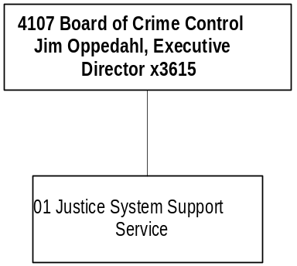

Mission Statement - To promote public safety, crime prevention, and victim assistance by strengthening the coordination and performance of both the criminal justice and juvenile justice systems in partnership with citizens, government, and communities.

Statutory Authority - 2-15-2006 and 44-4-301, MCA, create and define the board; 41-5-1001, MCA, grants for youth detention services; Title 53, Chapter 9, part 1, MCA, Victims Compensation Act; 42 USC 4760 Anti-Drug Abuse Act; 42 USC 10603 Victims of Crime Act; 42 USC 3796 Stop Violence Against Women Act; 42 USC 3701 National Criminal History Improvement Program; 42 USC 5601 Juvenile Justice and Delinquency Prevention Act; and USC 13701 Violent Crime Control and Law Enforcement Act.

Program Description - The Montana Board of Crime Control is the state's designated planning and program development agency for the criminal justice system. The Crime Control Division provides financial support, technical assistance, and supportive services to state and local criminal justice agencies. The board provides funding to local, regional and statewide projects with the central goal of making Montana a safer state.

The Crime Control Division administers federal anti-drug and anti-crime grants, certifies peace officers and others in the Criminal Justice system, provides funding for juvenile justice programs and provides assistance and compensation to victims of crime. It also collects and analyzes crime data from Montana law enforcement agencies and publishes the annual Crime in Montana report. The division is established in 2-15-2006, MCA.

Language Recommendations-
"All remaining federal pass-through grant appropriations, including reversions, for the 2001 biennium are authorized to continue into FY 2002 and FY 2003."

Program Proposed Budget  Budget Item | Base  Budget  Fiscal 2000 | PL Base Adjustment  Fiscal 2002 | New  Proposals  Fiscal 2002 | Total  Exec. Budget  Fiscal 2002 | PL Base Adjustment  Fiscal 2003 | New  Proposals  Fiscal 2003 | Total  Exec. Budget  Fiscal 2003
FTE | 21.00 | 3.00 | 0.00 | 24.00 | 3.00 | 0.00 | 24.00
Personal Services | 814,971 | 122,311 | 0 | 937,282 | 127,937 | 0 | 942,908
Operating Expenses | 455,474 | 84,775 | 18,000 | 558,249 | 81,264 | 18,000 | 554,738
Equipment | 7,014 | 486 | 0 | 7,500 | 6,486 | 0 | 13,500
Grants | 8,671,100 | 1,277,055 | 692,000 | 10,640,155 | 1,277,055 | 692,000 | 10,640,155
Benefits & Claims | 807,017 | 0 | 0 | 807,017 | 0 | 0 | 807,017
Total Costs | $10,755,576 | $1,484,627 | $710,000 | $12,950,203 | $1,492,742 | $710,000 | $12,958,318
General Fund | 2,511,110 | 89,436 | 0 | 2,600,546 | 100,819 | 0 | 2,611,929
Federal Special | 8,244,466 | 1,395,191 | 710,000 | 10,349,657 | 1,391,923 | 710,000 | 10,346,389
Total Funds | $10,755,576 | $1,484,627 | $710,000 | $12,950,203 | $1,492,742 | $710,000 | $12,958,318

Significant Present Law Adjustments -
- Increase subgrant 2.00 FTE fiscal support for 17 agency operations and 17 federal block grant programs
- Expand Crime Victims Compensation Program staff by 1.00 FTE
- Increase office rent due to relocation
- Contract for computer network services
- Replace computer network equipment
- Use Motor Pool lease program to replace two vehicles
- Contract to facilitate Juvenile Detention Program coordination
- Increase spending authority for federal pass through grants

The Crime Control Division administers federal anti-drug, anti-crime and victim assistance grants, which increase by $1,297,055 each year of the 2003 biennium. The board provides funding to local , regional and statewide projects with the central goal of making Montana a safer state.

New Proposals -
- Administer $342,000 federal funds each year for awards to local governments for underage drinking program
- Expand Residential Substance Abuse Programs for juveniles and adults with $350,000 federal funds per year
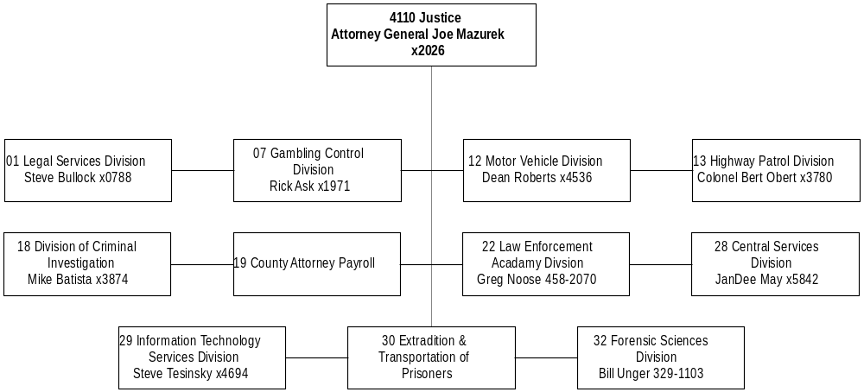
Mission Statement - The Department of Justice will pursue activities and programs that seek to ensure and promote the public interest, safety and well-being through leadership, advocacy, education, regulation, and enforcement.

Statutory Authority - 2-15-501, 2-15-2001 through -2021, and Title 44, MCA.

Executive Budget Recommendation –
- Adjust base budgets
- Fund Title and Registration Bureau imaging project
- Dedicated purchase of additional data collection units in HB 15
- Study the Title and Registration and Driver Licensing computer applications

Language - The following HB 2 language is recommended:
"The department is authorized to transfer the retirement contributions provided in 19-6-404 and 61-5-121(a) in fiscal years 2002 and 2003 from the highway patrol retirement clearing account in the state special revenue fund to the Montana highway patrol officers' retirement pension fund. An appropriation must be established each year in the amount $1 million or more if necessary to meet statutory requirements."

"The legislature recognizes that the costs associated with litigation in which the legal services division is required to provide representation to the state of Montana may exceed the appropriation provided. In that event, the department will need to request a supplemental appropriation from the 2003 legislature to adequately represent the state."

"The appropriations for legislative contract authority are subject to all of the following provisions:
1) legislative contract authority applies only to federal and private funds.
2) legislative contract authority expenditures must be reported on the state accounting records and kept separate from present law operations. In preparing the 2005 biennium executive budget, the office of budget and program planning may not include expenditures from the item in the present law base.
3) a report must be submitted by the department to the legislative fiscal analyst following the end of each fiscal year, listing legislative contract authority grants received and the amount of expenditures and FTE for each grant.”

Agency Proposed Budget  Budget Item | Base  Budget  Fiscal 2000 | PL Base Adjustment  Fiscal 2002 | New  Proposals  Fiscal 2002 | Total  Exec. Budget  Fiscal 2002 | PL Base Adjustment  Fiscal 2003 | New  Proposals  Fiscal 2003 | Total  Exec. Budget  Fiscal 2003
FTE | 700.95 | 10.25 | 0.00 | 711.20 | 10.25 | 0.00 | 711.20
Personal Services | 27,780,269 | 2,837,254 | 0 | 30,617,523 | 3,128,404 | 0 | 30,908,673
Operating Expenses | 13,684,875 | 1,675,706 | 331,500 | 15,692,081 | 1,704,641 | 181,500 | 15,571,016
Equipment | 1,783,827 | 386,463 | 0 | 2,170,290 | 510,013 | 0 | 2,293,840
Transfers | 0 | 0 | 850,000 | 850,000 | 0 | 850,000 | 850,000
Debt Service | 617,569 | 2,600 | 0 | 620,169 | 2,600 | 0 | 620,169
Total Costs | $43,866,540 | $4,902,023 | $1,181,500 | $49,950,063 | $5,345,658 | $1,031,500 | $50,243,698
General Fund | 21,562,997 | 2,467,091 | 312,500 | 24,342,588 | 2,607,445 | 162,500 | 24,332,942
State/Other Special | 19,881,780 | 2,042,150 | 38,454 | 21,962,384 | 2,333,130 | 38,454 | 22,253,364
Federal Special | 2,399,789 | 389,663 | 830,546 | 3,619,998 | 403,234 | 830,546 | 3,633,569
Proprietary | 21,974 | 3,119 | 0 | 25,093 | 1,849 | 0 | 23,823
Total Funds | $43,866,540 | $4,902,023 | $1,181,500 | $49,950,063 | $5,345,658 | $1,031,500 | $50,243,698

LEGAL SERVICES DIVISION
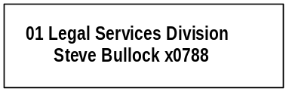

Program Description - The Legal Services Division provides 1) the Attorney General with legal research and analysis; 2) legal counsel for state government officials, bureaus, and boards; 3) legal assistance to local governments and Indian tribes; and 4) legal assistance, training, and support for county prosecutors.

Indian Legal Jurisdiction provides representation and coordination of trial and appellate lawsuits involving the State of Montana and the Indian tribes, supervision of private attorneys contracted by the state to assist with those cases, and advice to state agencies on questions involving Indian legal matters.

County Prosecutor Services provides special prosecution assistance to counties in the prosecution and disposition of major felonies and in cases in which county attorneys or city attorneys have conflicts of interest. County Prosecutor Services also provides prosecutor services to the Eastern Coal Counties Drug Task Force and the Western Montana Special Investigation Section and coordinates training and continuing legal education for county attorneys, city attorneys, and law enforcement personnel.

Program Indicators –

Indicator | Actual FY1998 | Actual FY1999 | Actual FY2000 | Estimated FY2001 | Requested FY2002 | Requested FY2003
Criminal Appeals & Complex Civil Litigation – New Cases Opened | 243 | 305 | 324 | 340 | 340 | 340
AG Opinions & Advisory Letters Issued | 20 | 19 | 15 | 15 | 15 | 15
Assistance/Training to County Attorneys – New Matters Opened | 96 | 147 | 175 | 185 | 185 | 185
Legal Assistance to State Agencies – New Cases Opened ( ALS & Bankruptcy) | 136 | 378 | 324 | 350 | 350 | 350

Program Proposed Budget  Budget Item | Base  Budget  Fiscal 2000 | PL Base Adjustment  Fiscal 2002 | New  Proposals  Fiscal 2002 | Total  Exec. Budget  Fiscal 2002 | PL Base Adjustment  Fiscal 2003 | New  Proposals  Fiscal 2003 | Total  Exec. Budget  Fiscal 2003
FTE | 46.25 | 0.50 | 0.00 | 46.75 | 0.50 | 0.00 | 46.75
Personal Services | 2,128,540 | 317,166 | 0 | 2,445,706 | 330,093 | 0 | 2,458,633
Operating Expenses | 612,855 | 227,625 | 0 | 840,480 | 234,671 | 0 | 847,526
Equipment | 6,890 | 0 | 0 | 6,890 | 0 | 0 | 6,890
Debt Service | 1,391 | 0 | 0 | 1,391 | 0 | 0 | 1,391
Total Costs | $2,749,676 | $544,791 | $0 | $3,294,467 | $564,764 | $0 | $3,314,440
General Fund | 2,407,043 | 417,793 | 31,000 | 2,855,836 | 435,949 | 31,000 | 2,873,992
State/Other Special | 279,238 | 38,165 | (31,000) | 286,403 | 39,519 | (31,000) | 287,757
Federal Special | 63,395 | 88,833 | 0 | 152,228 | 89,296 | 0 | 152,691
Total Funds | $2,749,676 | $544,791 | $0 | $3,294,467 | $564,764 | $0 | $3,314,440

Significant Present Law Adjustments -
- Adjust base budget for the Legal Services Division
- Add 0.50 FTE administrative support at no cost
- Audit non-participating tobacco manufacturers in accordance with law passed and approved last session
- Maintain the major state litigation biennial appropriation at $500,000

New Proposals -
- Decrease State Fund position to half time and increase other prosecution staff by a like amount

AGENCY LEGAL SERVICES

Proprietary Rates

Program Description -The Agency Legal Services Bureau provides legal assistance to state agencies on a contractual basis. The bureau is funded on a proprietary basis, charging hourly fees and case-related costs to client agencies. Services include litigation, hearing examiner work, and general counsel. The Bankruptcy Program, which is attached to this bureau, also provides legal services to state agencies on a contractual basis in the area of bankruptcy and collections. The rates for legislative action are contained in the proprietary table for fund 06500 and fund 06535 in Section R.
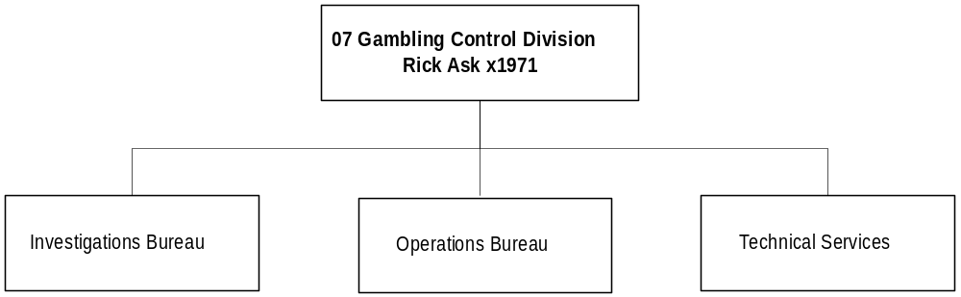
Program Description - The Gambling Control Division was established by the 1989 Legislature to regulate the gambling industry in Montana. The division has criminal justice authority and conducts routine field inspections and investigations related to gambling activities. In addition to collecting licensing fees for gambling machines and activities, the division is responsible for collecting and distributing the gambling tax assessed on the net proceeds of gambling activities, and investigative functions relating to alcoholic beverage licensing and tobacco enforcement. The gambling control program operates as a state mandate. An appointed gaming advisory council of nine members provides advisory services to the Attorney General to ensure uniform statewide regulation of gambling activities.

Program Indicators –

Indicator | Actual FY1998 | Actual FY1999 | Actual FY2000 | Estimated FY2001 | Requested FY2002 | Requested FY2003
VGM* Tax Collected | $36.7M | $38.0M | $40.5M | $41.4M | $42.4M | $43.4M
Gambling Permits | 19,324 | 19,994 | *19,915 | 20,373 | 20,842 | 21,321
Liquor & Gambling License Investigations | 788 | 795 | 688 | 704 | 720 | 737

*The decrease in gambling permits issued was due to a decrease in video gambling machine permits issued. The department has been informed by gambling operators that the reason for the decrease was that they were waiting for the Automated Accounting and Reporting System to be designed and a contract signed before they were going to invest in new machines or lease new machines in a location. Not all of the Montana approved models were going to be supported by manufacturers to link to the automated system. The system has been designed; all of the machine models manufacturers will support to link to the system have been identified; and a contract was recently signed with a system vendor. Therefore, we should see a correction back to growth trends projected for the ’99 session in FY01 and future years.

Program Proposed Budget  Budget Item | Base  Budget  Fiscal 2000 | PL Base Adjustment  Fiscal 2002 | New  Proposals  Fiscal 2002 | Total  Exec. Budget  Fiscal 2002 | PL Base Adjustment  Fiscal 2003 | New  Proposals  Fiscal 2003 | Total  Exec. Budget  Fiscal 2003
FTE | 47.00 | 2.00 | 0.00 | 49.00 | 2.00 | 0.00 | 49.00
Personal Services | 1,890,222 | 188,803 | 0 | 2,079,025 | 200,893 | 0 | 2,091,115
Operating Expenses | 960,550 | 117,826 | 50,000 | 1,128,376 | 146,035 | 50,000 | 1,156,585
Equipment | 56,418 | 0 | 0 | 56,418 | (12,250) | 0 | 44,168
Debt Service | 138 | 0 | 0 | 138 | 0 | 0 | 138
Total Costs | $2,907,328 | $306,629 | $50,000 | $3,263,957 | $334,678 | $50,000 | $3,292,006
General Fund | 901,388 | 58,734 | 0 | 960,122 | 64,572 | 0 | 965,960
State/Other Special | 2,005,940 | 247,895 | 50,000 | 2,303,835 | 270,106 | 50,000 | 2,326,046
Total Funds | $2,907,328 | $306,629 | $50,000 | $3,263,957 | $334,678 | $50,000 | $3,292,006

Significant Present Law Adjustments -
- Adjust base budget to annualize Gambling Control Division operating expenses
- Add FTE as approved last session for the newly-operational Automated Accounting and Reporting System

New Proposals -
- Install a document imaging system to improve efficiency
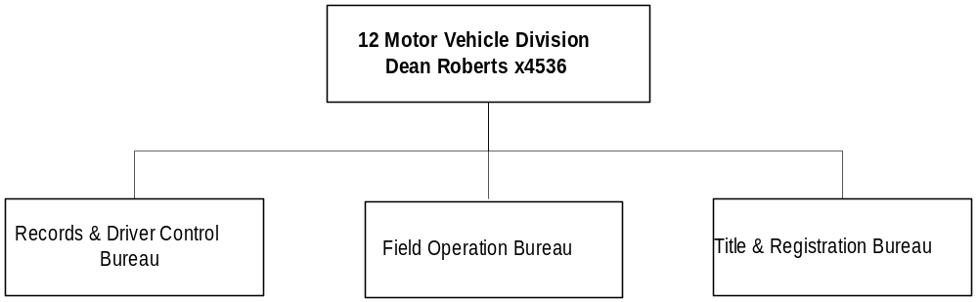

Program Description - The Motor Vehicle Division (MVD), under provision of Title 61 and Title 23, MCA, and certain federal statutes is responsible for: 1) examination and licensure of all drivers; 2) creation and maintenance of permanent driver and motor vehicle records; 3) titling and registration of all vehicles including boats, snowmobiles and ATVs; 4) inspection and verification of vehicle identification numbers; 5) licensure and compliance control of motor vehicle dealers and manufacturers; and 6) providing motor voter registration.

Program Indicators -

Indicator | Actual FY1998 | Actual FY1999 | Actual FY2000 | Estimated FY2001 | Requested FY2002 | Requested FY2003
Vehicle Titles Issued | 410,008 | 435,093 | 496,969 | 506,900 | 517,000 | 527,000
Vehicle Registrations | 1,017,593 | 1,242,028 | 1,442,128 | 1,514,200 | 1,589,900 | 1,669,300
Driver Licenses Issued | 197,192 | 195,596 | 155,648 | 143,560 | 146,430 | 149,360
Convictions Entered on Record | 88,878 | 123,647 | 106,315 | 105,500 | 106,000 | 106,500

Program Proposed Budget  Budget Item | Base  Budget  Fiscal 2000 | PL Base Adjustment  Fiscal 2002 | New  Proposals  Fiscal 2002 | Total  Exec. Budget  Fiscal 2002 | PL Base Adjustment  Fiscal 2003 | New  Proposals  Fiscal 2003 | Total  Exec. Budget  Fiscal 2003
FTE | 160.60 | 0.00 | 0.00 | 160.60 | 0.00 | 0.00 | 160.60
Personal Services | 4,421,596 | 288,650 | 0 | 4,710,246 | 316,321 | 0 | 4,737,917
Operating Expenses | 3,433,169 | 329,177 | 281,500 | 4,043,846 | 361,491 | 131,500 | 3,926,160
Equipment | 16,671 | 0 | 0 | 16,671 | 0 | 0 | 16,671
Debt Service | 148,276 | 0 | 0 | 148,276 | 0 | 0 | 148,276
Total Costs | $8,019,712 | $617,827 | $281,500 | $8,919,039 | $677,812 | $131,500 | $8,829,024
General Fund | 7,616,656 | 617,827 | 281,500 | 8,515,983 | 677,812 | 131,500 | 8,425,968
State/Other Special | 403,056 | 0 | 0 | 403,056 | 0 | 0 | 403,056
Total Funds | $8,019,712 | $617,827 | $281,500 | $8,919,039 | $677,812 | $131,500 | $8,829,024

Significant Present Law Adjustments -
- Adjust base budget for the Records and Driver Control Bureau
- Annualize operating expenses for the Title and Registration Bureau
- Change statutory appropriation for transfer of motor vehicle registration fees to the retirement fund

New Proposals -
- Replace antiquated microfilming with imaging at the Title and Registration Bureau
- Study motor vehicle title and registration and the driver licensing computer applications
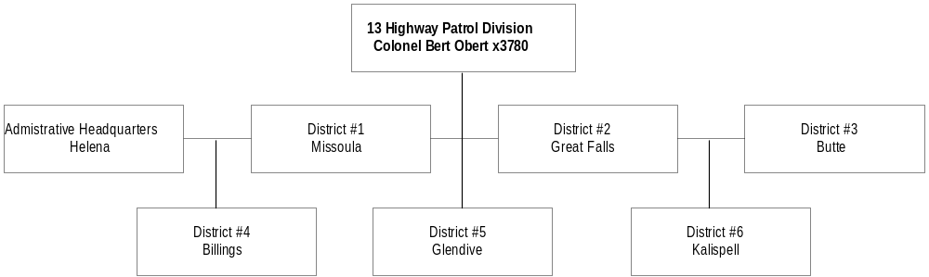
Program Description - The Highway Patrol Division (HPD) is responsible for patrolling the highways of Montana, enforcing traffic laws, and investigating traffic accidents. The patrol gives assistance and information to motorists and first aid to those injured in traffic accidents, transports blood and medical supplies in emergency situations, and assists other law enforcement agencies when requested. The patrol provides 24-hour, seven-day-a-week communication and radio dispatch for the Highway Patrol and other state agencies. The Motor Carrier Safety Assistance program (MCSAP) attempts to reduce commercial motor vehicle accidents in the state by participating in the Commercial Vehicle Safety Alliance (CVSA) and its North American Driver/Vehicle Inspection program in all levels of inspections as well as safety review audits.

Program Indicators -
Indicator | Actual FY1998 | Actual FY1999 | Actual FY2000 | Estimated FY2001 | Requested FY2002 | Requested FY2003
Calls for Service | 71,654 | 69,870 | 71,404 | 71,500 | 71,800 | 72,000
Injury Crashes | 3,412 | 3,344 | 3,530 | 3,691 | 3,817 | 3,969
Fatality Crashes | 239 | 177 | 211 | 211 | 211 | 211
Com. Vehicle Crashes | 881 | 1,065 | 1,076 | 1,076 | 1,076 | 1,076

Program Proposed Budget  Budget Item | Base  Budget  Fiscal 2000 | PL Base Adjustment  Fiscal 2002 | New  Proposals  Fiscal 2002 | Total  Exec. Budget  Fiscal 2002 | PL Base Adjustment  Fiscal 2003 | New  Proposals  Fiscal 2003 | Total  Exec. Budget  Fiscal 2003
FTE | 270.55 | 3.00 | 0.00 | 273.55 | 3.00 | 0.00 | 273.55
Personal Services | 11,435,943 | 1,120,999 | 0 | 12,556,942 | 1,273,772 | 0 | 12,709,715
Operating Expenses | 4,479,609 | 466,691 | 0 | 4,946,300 | 511,934 | 0 | 4,991,543
Equipment | 1,371,949 | 251,270 | 0 | 1,623,219 | 394,070 | 0 | 1,766,019
Transfers | 0 | 0 | 150,000 | 150,000 | 0 | 150,000 | 150,000
Total Costs | $17,287,501 | $1,838,960 | $150,000 | $19,276,461 | $2,179,776 | $150,000 | $19,617,277
General Fund | 1,042,073 | 37,706 | 0 | 1,079,779 | 70,723 | 0 | 1,112,796
State/Other Special | 15,552,254 | 1,675,390 | 0 | 17,227,644 | 1,976,448 | 0 | 17,528,702
Federal Special | 693,174 | 125,864 | 150,000 | 969,038 | 132,605 | 150,000 | 975,779
Total Funds | $17,287,501 | $1,838,960 | $150,000 | $19,276,461 | $2,179,776 | $150,000 | $19,617,277

Significant Present Law Adjustments -
- Restore overtime and ensure operating expense adjustments for the Highway Patrol
- Provide zero-based overtime and adjustments in operating expenses for the Motor Vehicle Inspection Bureau
- Fund the Recruit Training School annualized costs
- Add three communication operators for the Highway Patrol dispatch centers

New Proposals -
- Allow legislative contract authority (LCA) for federal funds in HB 2 for the Highway Patrol

Language Recommendations –
- Transfer of retirement contribution to the highway patrol retirement account language appropriation
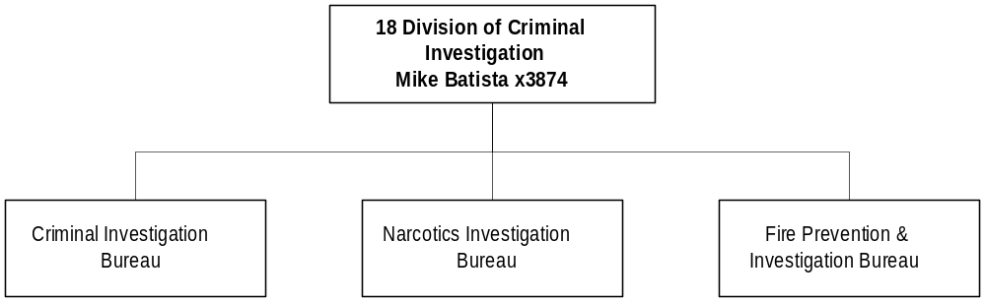
Program Description - The Division of Criminal Investigation includes the administration, management, and coordination of criminal investigative services performed by the Investigations Bureau, the Narcotics Bureau, and the Fire Prevention and Investigation Bureau. Criminal investigators conduct criminal investigations of homicide, fraud, robbery, assault, corruption, arson, organized crime, dangerous drug activity, and other felony crimes. The program activity includes conducting criminal investigations of state agencies and providing investigative training to law enforcement officers. The division also has specialized criminal investigation units for the following fraud investigation: 1) workers' compensation, 2) public assistance, 3) Medicaid, and 4) legislative audits. The Fire Prevention and Investigation Bureau is responsible for safeguarding life and property from fire, explosion, and arson through investigative, inspection, and fire code interpretation and enforcement functions. The Division of Criminal Investigation operates under both state and federal mandates.

Program Indicators -

Indicator | Actual FY1998 | Actual FY1999 | Actual FY2000 | Estimated FY2001 | Requested FY2002 | Requested FY2003
Investigations/cases | 543 | 528 | 596 | Can’t Predict | Can’t Predict | Can’t Predict
Fire/Life Safety Inspections | 973 | 837 | 620 | Can’t Predict | Can’t Predict | Can’t Predict
Training Provided to Local Agencies | 75 | 67 | 93 | Can’t Predict | Can’t Predict | Can’t Predict

Program Proposed Budget  Budget Item | Base  Budget  Fiscal 2000 | PL Base Adjustment  Fiscal 2002 | New  Proposals  Fiscal 2002 | Total  Exec. Budget  Fiscal 2002 | PL Base Adjustment  Fiscal 2003 | New  Proposals  Fiscal 2003 | Total  Exec. Budget  Fiscal 2003
FTE | 60.50 | 0.00 | 0.00 | 60.50 | 0.00 | 0.00 | 60.50
Personal Services | 2,608,277 | 156,618 | 0 | 2,764,895 | 172,936 | 0 | 2,781,213
Operating Expenses | 1,001,227 | 88,212 | 0 | 1,089,439 | 93,446 | 0 | 1,094,673
Equipment | 79,503 | 15,000 | 0 | 94,503 | 15,000 | 0 | 94,503
Transfers | 0 | 0 | 150,000 | 150,000 | 0 | 150,000 | 150,000
Debt Service | 275 | 0 | 0 | 275 | 0 | 0 | 275
Total Costs | $3,689,282 | $259,830 | $150,000 | $4,099,112 | $281,382 | $150,000 | $4,120,664
General Fund | 2,214,742 | 224,015 | 0 | 2,438,757 | 238,359 | 0 | 2,453,101
State/Other Special | 355,806 | (3,556) | (30,546) | 321,704 | (2,300) | (30,546) | 322,960
Federal Special | 1,118,734 | 39,371 | 180,546 | 1,338,651 | 45,323 | 180,546 | 1,344,603
Total Funds | $3,689,282 | $259,830 | $150,000 | $4,099,112 | $281,382 | $150,000 | $4,120,664

Significant Present Law Adjustments -
- Adjust base budget for the Division of Criminal Investigation

New Proposals -
- Switch funding in the Billings Division of Criminal Investigation office from the State Fund special revenue to federal funds
- Continue legislative contract authority (LCA) for the Division of Criminal Investigation
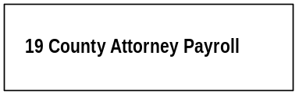

Program Description - The County Attorney Payroll program pays one-half the salary and benefits of the 56 county attorneys from the state general fund, as required by 7-4-2502, MCA.

Program Proposed Budget  Budget Item | Base  Budget  Fiscal 2000 | PL Base Adjustment  Fiscal 2002 | New  Proposals  Fiscal 2002 | Total  Exec. Budget  Fiscal 2002 | PL Base Adjustment  Fiscal 2003 | New  Proposals  Fiscal 2003 | Total  Exec. Budget  Fiscal 2003
FTE | 21.30 | 0.75 | 0.00 | 22.05 | 0.75 | 0.00 | 22.05
Personal Services | 1,556,508 | 150,378 | 0 | 1,706,886 | 195,937 | 0 | 1,752,445
Total Costs | $1,556,508 | $150,378 | $0 | $1,706,886 | $195,937 | $0 | $1,752,445
General Fund | 1,556,508 | 150,378 | 0 | 1,706,886 | 195,937 | 0 | 1,752,445
Total Funds | $1,556,508 | $150,378 | $0 | $1,706,886 | $195,937 | $0 | $1,752,445

Significant Present Law Adjustments -
- Adjust county attorney payroll for change in status, COLA and longevity

LAW ENFORCEMENT ACADEMY DIV

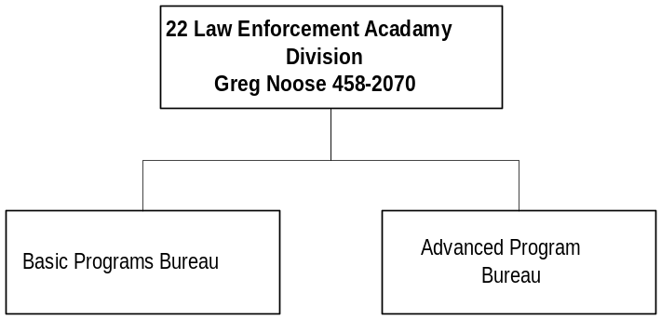

Program Description - The Montana Law Enforcement Academy provides a professional education and training program in criminal justice for Montana law enforcement officers and other criminal justice personnel. The academy provides an annual curriculum specifically designed to meet the needs of the adult and juvenile criminal justice systems.

Program Indicators -

Indicator | Actual FY1998 | Actual FY1999 | Actual FY2000 | Estimated FY2001 | Requested FY2002 | Requested FY2003
Number of Programs | 233 | 235 | 287 | 275 | 275 | 275
Officers Trained at Academy | 1,558 | 1440 | 1576 | 1500 | 1500 | 1500
Officers Trained Regionally | 2,497 | 2972 | 3599 | 3200 | 3200 | 3200

Program Proposed Budget  Budget Item | Base  Budget  Fiscal 2000 | PL Base Adjustment  Fiscal 2002 | New  Proposals  Fiscal 2002 | Total  Exec. Budget  Fiscal 2002 | PL Base Adjustment  Fiscal 2003 | New  Proposals  Fiscal 2003 | Total  Exec. Budget  Fiscal 2003
FTE | 11.50 | 1.00 | 0.00 | 12.50 | 1.00 | 0.00 | 12.50
Personal Services | 432,818 | 62,166 | 0 | 494,984 | 64,562 | 0 | 497,380
Operating Expenses | 521,136 | 114,357 | 0 | 635,493 | 97,349 | 0 | 618,485
Transfers | 0 | 0 | 150,000 | 150,000 | 0 | 150,000 | 150,000
Debt Service | 79,484 | 2,600 | 0 | 82,084 | 2,600 | 0 | 82,084
Total Costs | $1,033,438 | $179,123 | $150,000 | $1,362,561 | $164,511 | $150,000 | $1,347,949
General Fund | 1,033,438 | 79,516 | 0 | 1,112,954 | 64,789 | 0 | 1,098,227
State/Other Special | 0 | 0 | 50,000 | 50,000 | 0 | 50,000 | 50,000
Federal Special | 0 | 99,607 | 100,000 | 199,607 | 99,722 | 100,000 | 199,722
Total Funds | $1,033,438 | $179,123 | $150,000 | $1,362,561 | $164,511 | $150,000 | $1,347,949

Significant Present Law Adjustments -
- Provide for training schedules, meal costs and related operating at the Law Enforcement Academy
- Continue the Stop Violence Against Women federal grant

New Proposals -
- Allow legislative contract authority (LCA) for the Law Enforcement Academy

CENTRAL SERVICES DIVISION
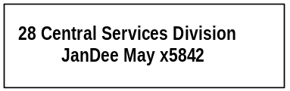

Program Description - The Central Services Division provides the administrative, personnel, budgetary, accounting, and fiscal support for the Department of Justice. The program also administers the County Attorney Payroll and Transportation of Prisoners program expenditures.

Program Proposed Budget  Budget Item | Base  Budget  Fiscal 2000 | PL Base Adjustment  Fiscal 2002 | New  Proposals  Fiscal 2002 | Total  Exec. Budget  Fiscal 2002 | PL Base Adjustment  Fiscal 2003 | New  Proposals  Fiscal 2003 | Total  Exec. Budget  Fiscal 2003
FTE | 13.25 | 2.00 | 0.00 | 15.25 | 2.00 | 0.00 | 15.25
Personal Services | 468,305 | 117,628 | 0 | 585,933 | 121,351 | 0 | 589,656
Operating Expenses | 122,664 | 34,839 | 0 | 157,503 | (32,339) | 0 | 90,325
Total Costs | $590,969 | $152,467 | $0 | $743,436 | $89,012 | $0 | $679,981
General Fund | 254,296 | 65,095 | 0 | 319,391 | 37,809 | 0 | 292,105
State/Other Special | 324,913 | 84,253 | 0 | 409,166 | 49,354 | 0 | 374,267
Proprietary | 11,760 | 3,119 | 0 | 14,879 | 1,849 | 0 | 13,609
Total Funds | $590,969 | $152,467 | $0 | $743,436 | $89,012 | $0 | $679,981

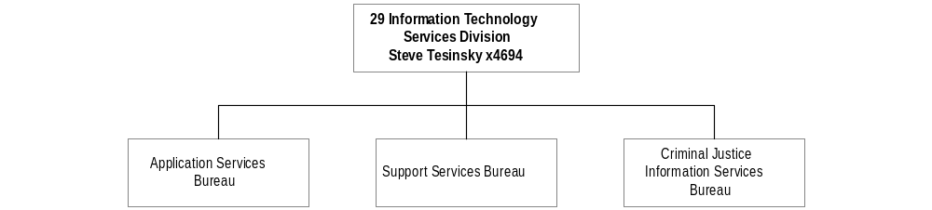
Program Description - The Justice Information Systems Division provides a full range of information technology and criminal justice services for the Department of Justice including: 1) system development and maintenance of the motor vehicle registration system; 2) the driver history system; 3) the criminal history record information system and the Montana Uniform Crime Reporting System; 4) support for the Department of Justice computer system; 5) identification services for the criminal justice community through criminal history record checking and fingerprint processing; and 6) system development and support for the Criminal Justice Information Network (CJIN). CJIN links law enforcement/criminal justice agencies with information sources at local, state, and national levels by interfacing with the National Law Enforcement Telecommunications System, the National Crime Information Center (NCIC), and numerous State of Montana files.

Program Indicators -
Indicator | Actual FY1998 | Actual FY1999 | Actual FY2000 | Estimated FY2001 | Requested FY2002 | Requested FY2003
Criminal Fingerprints  Processed | 31,353 | 34,389 | 36753 | 37,000 | 39,700 | 42,400
Record Checks | 26,959 | 35,238 | 36,198 | 39,215 | 42,232 | 45,249
System Development  Requests | 127 | 67 | 34 | 40 | 50 | 60
CJIN Devices Supported | 212 | 219 | 226 | 250 | 300 | 350
CJIN Operators Trained | 816 | 879 | 1117 | 1200 | 1300 | 1400
Computer Installations | 450 | 295 | 155 | 150 | 450 | 350

Program Proposed Budget  Budget Item | Base  Budget  Fiscal 2000 | PL Base Adjustment  Fiscal 2002 | New  Proposals  Fiscal 2002 | Total  Exec. Budget  Fiscal 2002 | PL Base Adjustment  Fiscal 2003 | New  Proposals  Fiscal 2003 | Total  Exec. Budget  Fiscal 2003
FTE | 46.00 | 1.00 | 0.00 | 47.00 | 1.00 | 0.00 | 47.00
Personal Services | 1,576,351 | 358,705 | 0 | 1,935,056 | 369,699 | 0 | 1,946,050
Operating Expenses | 1,497,674 | 184,087 | 0 | 1,681,761 | 187,861 | 0 | 1,685,535
Equipment | 169,589 | 0 | 0 | 169,589 | 0 | 0 | 169,589
Transfers | 0 | 0 | 300,000 | 300,000 | 0 | 300,000 | 300,000
Debt Service | 384,972 | 0 | 0 | 384,972 | 0 | 0 | 384,972
Total Costs | $3,628,586 | $542,792 | $300,000 | $4,471,378 | $557,560 | $300,000 | $4,486,146
General Fund | 2,486,200 | 542,792 | 0 | 3,028,992 | 557,560 | 0 | 3,043,760
State/Other Special | 657,371 | 0 | 0 | 657,371 | 0 | 0 | 657,371
Federal Special | 474,801 | 0 | 300,000 | 774,801 | 0 | 300,000 | 774,801
Proprietary | 10,214 | 0 | 0 | 10,214 | 0 | 0 | 10,214
Total Funds | $3,628,586 | $542,792 | $300,000 | $4,471,378 | $557,560 | $300,000 | $4,486,146

Significant Present Law Adjustments -
- Adjust base budget for the Justice Information Systems Division
- Add an administrative support position at no cost increase

New Proposals -
- Allow legislative contract authority (LCA) for Justice Information Systems Division
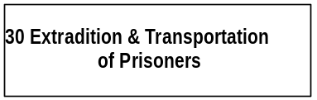

Program Description - The Extradition and Transportation of Prisoners program reimburses county sheriffs for allowable expenses associated with transporting prisoners to Montana detention centers and for expenses of extraditing prisoners to Montana.

Program Proposed Budget  Budget Item | Base  Budget  Fiscal 2000 | PL Base Adjustment  Fiscal 2002 | New  Proposals  Fiscal 2002 | Total  Exec. Budget  Fiscal 2002 | PL Base Adjustment  Fiscal 2003 | New  Proposals  Fiscal 2003 | Total  Exec. Budget  Fiscal 2003
FTE | 0.00 | 0.00 | 0.00 | 0.00 | 0.00 | 0.00 | 0.00
Operating Expenses | 164,479 | 1,178 | 0 | 165,657 | 2,390 | 0 | 166,869
Total Costs | $164,479 | $1,178 | $0 | $165,657 | $2,390 | $0 | $166,869
General Fund | 164,479 | 1,178 | 0 | 165,657 | 2,390 | 0 | 166,869
Total Funds | $164,479 | $1,178 | $0 | $165,657 | $2,390 | $0 | $166,869

Significant Present Law Adjustments -
- Provide for increased travel costs for the transportation and extradition of prisoners

Language Recommendations - The following HB 2 language is recommended:
"Any remaining balance up to $51,000 from the program budget in FY 2002 and in FY 2003 combined may be used to purchase vans for county sheriffs and peace officers to transport prisoners rather than reverting to the general fund."

FORENSIC SCIENCE DIVISION

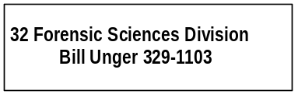

Program Description - The Forensic Science Division, which includes the State Crime Lab in Missoula and the State Medical Examiner, provides for a statewide system of death investigation, forensic science training, and scientific criminal investigation and analysis for specimens submitted by law enforcement officials, coroners, and state agencies. The division tests firearms, toolmarks, hair, fiber, drugs, blood, body fluids, and tissues. The laboratory also analyzes blood, breath, and urine samples in connection with driving under the influence of alcohol or drugs (DUI) and provides the certification, maintenance, and training of all law enforcement personnel on breath testing instruments.

Program Indicators -

Indicator | Actual FY1998 | Actual FY1999 | Actual FY2000 | Estimated FY2001 | Requested FY2002 | Requested FY2003
Cases Received from Law Enforcement | 4,106 | 3,611 | 3,901 | 4,212 | 4,549 | 4,913

Program Proposed Budget  Budget Item | Base  Budget  Fiscal 2000 | PL Base Adjustment  Fiscal 2002 | New  Proposals  Fiscal 2002 | Total  Exec. Budget  Fiscal 2002 | PL Base Adjustment  Fiscal 2003 | New  Proposals  Fiscal 2003 | Total  Exec. Budget  Fiscal 2003
FTE | 24.00 | 0.00 | 0.00 | 24.00 | 0.00 | 0.00 | 24.00
Personal Services | 1,261,709 | 76,141 | 0 | 1,337,850 | 82,840 | 0 | 1,344,549
Operating Expenses | 891,512 | 111,714 | 0 | 1,003,226 | 101,803 | 0 | 993,315
Equipment | 82,807 | 120,193 | 0 | 203,000 | 113,193 | 0 | 196,000
Transfers | 0 | 0 | 100,000 | 100,000 | 0 | 100,000 | 100,000
Debt Service | 3,033 | 0 | 0 | 3,033 | 0 | 0 | 3,033
Total Costs | $2,239,061 | $308,048 | $100,000 | $2,647,109 | $297,836 | $100,000 | $2,636,897
General Fund | 1,886,174 | 272,057 | 0 | 2,158,231 | 261,545 | 0 | 2,147,719
State/Other Special | 303,202 | 3 | 0 | 303,205 | 3 | 0 | 303,205
Federal Special | 49,685 | 35,988 | 100,000 | 185,673 | 36,288 | 100,000 | 185,973
Total Funds | $2,239,061 | $308,048 | $100,000 | $2,647,109 | $297,836 | $100,000 | $2,636,897

Significant Present Law Adjustments -
- Adjust base budget to annualize rent and other expenses
- Activate lab accreditation process

New Proposals -
- Allow legislative contract authority (LCA) for Forensic Science Division

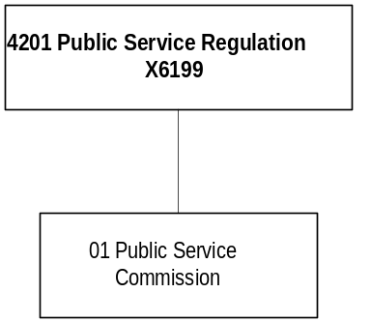

Mission Statement - To fairly balance the long-term interests of Montana utility and transportation companies and the customers they serve.

Statutory Authority - Title 69

Program Description - The Department of Public Service Regulation (PSR) regulates the public utility and railroad industries. Five commissioners elected from districts throughout Montana oversee this program.

Program Indicators –

Indicator | Actual FY1998 | Actual FY1999 | Actual FY2000 | Estimated FY2001 | Requested FY2002 | Requested FY2003
Dockets | 397 | 426 | 326 | 350 | 350 | 350
Informal Utility  Consumer Complaints | 2698 | 2959 | 2870 | 3000 | 3000 | 3000

Program Proposed Budget  Budget Item | Base  Budget  Fiscal 2000 | PL Base Adjustment  Fiscal 2002 | New  Proposals  Fiscal 2002 | Total  Exec. Budget  Fiscal 2002 | PL Base Adjustment  Fiscal 2003 | New  Proposals  Fiscal 2003 | Total  Exec. Budget  Fiscal 2003
FTE | 39.50 | 0.00 | 0.00 | 39.50 | 0.00 | 0.00 | 39.50
Personal Services | 1,877,177 | 81,379 | 0 | 1,958,556 | 96,170 | 0 | 1,973,347
Operating Expenses | 439,015 | 852,786 | 0 | 1,291,801 | 18,565 | 0 | 457,580
Equipment | 0 | 0 | 0 | 0 | 0 | 0 | 0
Total Costs | $2,316,192 | $934,165 | $0 | $3,250,357 | $114,735 | $0 | $2,430,927
State/Other Special | 2,300,576 | 936,018 | 0 | 3,236,594 | 116,588 | 0 | 2,417,164
Federal Special | 15,616 | (1,853) | 0 | 13,763 | (1,853) | 0 | 13,763
Total Funds | $2,316,192 | $934,165 | $0 | $3,250,357 | $114,735 | $0 | $2,430,927

Significant Present Law Adjustments -
- Hire consultants to handle special projects or additional workload
- Adjust rent, computer replacement and copier leases
- Shift Pipeline Safety Program funding
- Continue assistance with the Montana Universal Access Program funds collected in the 1999 biennium

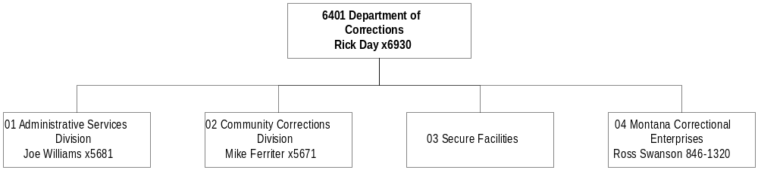
Mission Statement - The Department of Corrections is dedicated to public safety and trust by holding adult and juvenile offenders accountable for their actions against victims through custody, supervision, treatment, work, restitution and skill development.

Statutory Authority - 2-15-2301 and 53-1-201, MCA.

Executive Budget Recommendation –
- Continue funding 28.00 FTE probation and parole staff
- Accelerate correctional officer pay for recruitment and retention
- Continue 31.00 FTE security staff at Montana State Prison
- Expand Montana Women's Prison to 165 female inmates by FYE 2003
- Adjust operating costs for expansion at Pine Hills Youth Correctional Facility
- Expand industries program for inmates at regional and private facilities
- Increase outside medical for increased adult population

Agency Proposed Budget  Budget Item | Base  Budget  Fiscal 2000 | PL Base Adjustment  Fiscal 2002 | New  Proposals  Fiscal 2002 | Total  Exec. Budget  Fiscal 2002 | PL Base Adjustment  Fiscal 2003 | New  Proposals  Fiscal 2003 | Total  Exec. Budget  Fiscal 2003
FTE | 1,024.45 | 66.35 | 6.50 | 1,097.30 | 90.35 | 6.50 | 1,121.30
Personal Services | 38,659,466 | 6,424,116 | 377,181 | 45,460,763 | 6,835,874 | 378,702 | 45,874,042
Operating Expenses | 43,407,446 | 8,803,242 | (292,860) | 51,917,828 | 14,402,202 | (342,319) | 57,467,329
Equipment | 489,919 | (161,478) | 0 | 328,441 | (177,036) | 0 | 312,883
Grants | 30,218 | 0 | 0 | 30,218 | 0 | 0 | 30,218
Benefits & Claims | 8,829,960 | (692,259) | 0 | 8,137,701 | (803,000) | 0 | 8,026,960
Debt Service | 83,088 | 0 | 0 | 83,088 | 0 | 0 | 83,088
Total Costs | $91,500,097 | $14,373,621 | $84,321 | $105,958,039 | $20,258,040 | $36,383 | $111,794,520
General Fund | 89,104,188 | 13,490,943 | 84,321 | 102,679,452 | 19,354,862 | 36,383 | 108,495,433
State/Other Special | 1,601,137 | 129,353 | 0 | 1,730,490 | 126,706 | 0 | 1,727,843
Federal Special | 457,885 | 504,464 | 0 | 962,349 | 528,070 | 0 | 985,955
Proprietary | 336,887 | 248,861 | 0 | 585,748 | 248,402 | 0 | 585,289
Total Funds | $91,500,097 | $14,373,621 | $84,321 | $105,958,039 | $20,258,040 | $36,383 | $111,794,520

TABLE D-1
FY 2000 Projections
Male Institutional Population

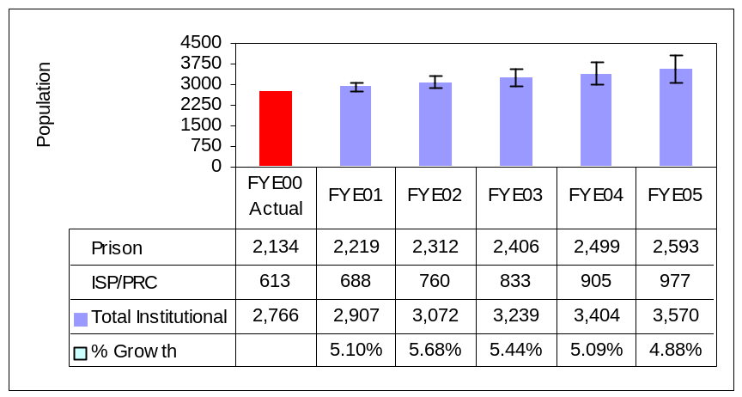

TABLE D-2
FY 2000 Projections
Female Institutional Population

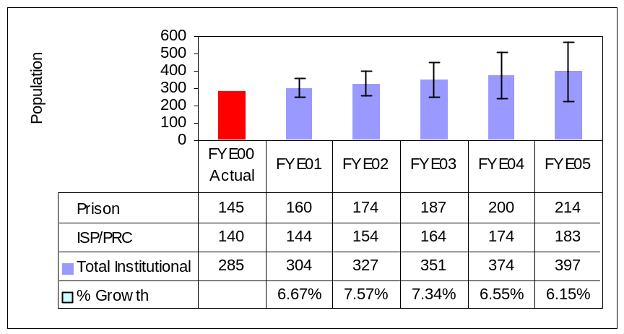

TABLE D-3
FY 2000 Projections
Probation & Parole Population
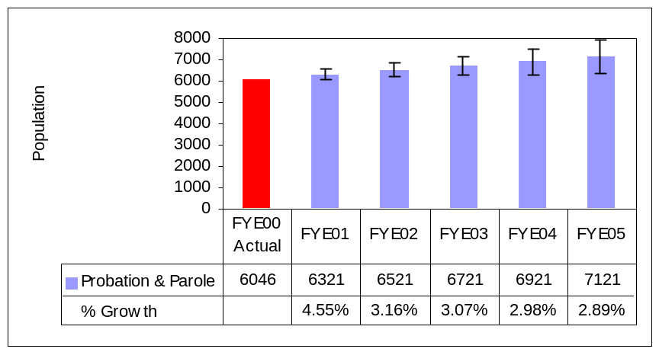

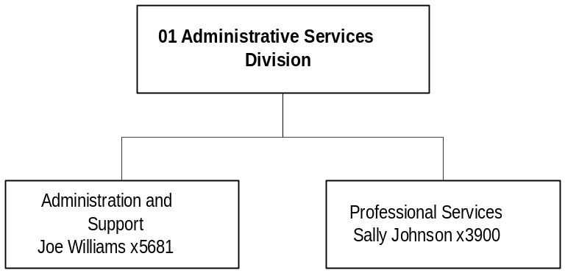

Program Description - The Administration and Support Services Program includes the Director's Office, Administrative Services Division, Professional Services Division and the administratively attached Board of Pardons. This program provides to the department, government entities and the public various administrative and management support; human resource, budget, fiscal, and legal information; technical correctional services; policy and staff development; research; facility management; and access to health care services.

Program Proposed Budget  Budget Item | Base  Budget  Fiscal 2000 | PL Base Adjustment  Fiscal 2002 | New  Proposals  Fiscal 2002 | Total  Exec. Budget  Fiscal 2002 | PL Base Adjustment  Fiscal 2003 | New  Proposals  Fiscal 2003 | Total  Exec. Budget  Fiscal 2003
FTE | 151.65 | 0.00 | 6.50 | 158.15 | 0.00 | 6.50 | 158.15
Personal Services | 6,403,877 | 2,223,715 | 377,181 | 9,004,773 | 1,788,975 | 378,702 | 8,571,554
Operating Expenses | 6,893,142 | 1,090,646 | (292,860) | 7,690,928 | 1,298,554 | (342,319) | 7,849,377
Equipment | 33,709 | 0 | 0 | 33,709 | 0 | 0 | 33,709
Debt Service | 8,205 | 0 | 0 | 8,205 | 0 | 0 | 8,205
Total Costs | $13,338,933 | $3,314,361 | $84,321 | $16,737,615 | $3,087,529 | $36,383 | $16,462,845
General Fund | 13,283,400 | 3,298,516 | 84,321 | 16,666,237 | 3,076,523 | 36,383 | 16,396,306
State/Other Special | 2,695 | 1,626 | 0 | 4,321 | (1,337) | 0 | 1,358
Proprietary | 52,838 | 14,219 | 0 | 67,057 | 12,343 | 0 | 65,181
Total Funds | $13,338,933 | $3,314,361 | $84,321 | $16,737,615 | $3,087,529 | $36,383 | $16,462,845

Program Indicators –

Indicator | Actual FY1998 | Actual FY1999 | Actual FY2000 | Estimated FY2001 | Requested FY2002 | Requested FY2003
VINE Registered Numbers | 246 | 308 | 369 | 450 | 500 | 550
Calls made to VINE | 5,902 | 9,890 | 11,731 | 12,500 | 13,000 | 13,500
Board of Pardons & Parole:  Offenders Release to  Parole | 497 | 503 | 440 | 482 | 498 | 514
Board of Pardons & Parole:  Parole Interviews | 949 | 992 | 935 | 1058 | 1105 | 1153
PSD: Offsite Medical Cost/Inmate/Day  Adult Male  Adult Female  Juvenile Male  Juvenile Female | 3.10  3.50  1.73  .66 | 2.89  5.04  4.60  2.81 | $1.84  1.56  3.48  4.11  3.97 | $1.90 | $1.97 | $2.04
PSD: Regional and Private Prison occupied % of capacity | 94.9% | 92.6% | 88.1% | 96.8% | 94.5% | 96.7%
PSD: Correctional Officers received Basic POST certification | None | None | 106 | 150 | 75 | 50
PSD: Basic Training sessions at MLEA | 5 | 7 | 9  (1 funded by Msla Cty) | 9 | 8 | 8
ASD: Employee recruitments processed:  Helena Office  MSP  PHYCF | 76  79  9 | 109  51  7 | 148  72  28 | 200  63  16 | 220  63  12 | 240  63  12
ASD: As of 10/30/00  Third party funding – juvenile placements | $275,039 | $272,846 | $261,737 | $275,000 | $275,000 | $275,000
ASD: ACIS modules replaced by Profiles modules | N/A | N/A | N/A | Offender Demographics, Offender movements | Legal information, Classification
ASD: Facility Condition Inventories completed | 1 | 2 | 0 | 1 | 24 | 24
ASD: Statistical Information Requests Completed | Not available | 214 | 149 | 225 | 170 | 235
ASD: # of Help Desk calls resolved | Not available | 9,132 estimated | 9,837 | 10,328 | 10,845 | 11,387
Significant Present Law Adjustments -
- Accelerate correctional officer pay for recruitment and retention
- Maintain board member per diem
- Increase Outside medical for increased adult population

New Proposals -
- Begin to immunize for Hepatitis C in the 2003 biennium
- Retain a 1.00 FTE victim officer approved last session

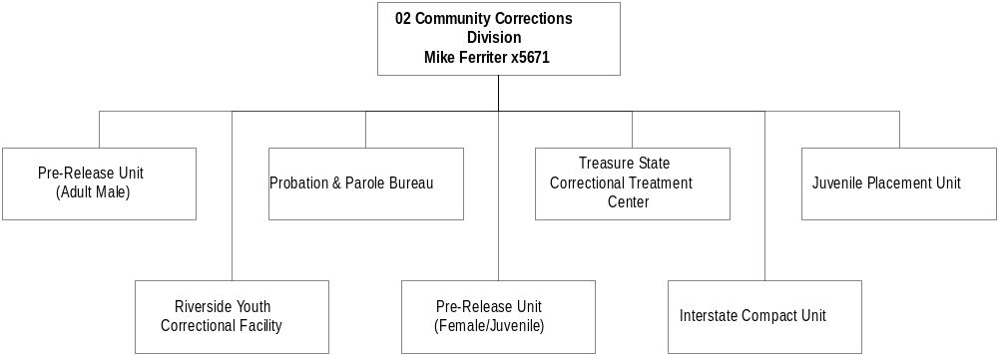

Program Description - The Community Corrections Program includes adult probation and parole, juvenile parole, male and female community corrections programs, the boot camp, the female juvenile correctional facility, juvenile transition centers, and juvenile out-of-home placements. The department contracts with non-profit corporations in Great Falls, Butte, Missoula, Billings, and Helena for pre-release services.

Program Proposed Budget  Budget Item | Base  Budget  Fiscal 2000 | PL Base Adjustment  Fiscal 2002 | New  Proposals  Fiscal 2002 | Total  Exec. Budget  Fiscal 2002 | PL Base Adjustment  Fiscal 2003 | New  Proposals  Fiscal 2003 | Total  Exec. Budget  Fiscal 2003
FTE | 238.50 | 28.00 | 0.00 | 266.50 | 31.00 | 0.00 | 269.50
Personal Services | 9,691,238 | 778,524 | 0 | 10,469,762 | 926,216 | 0 | 10,617,454
Operating Expenses | 13,538,810 | 2,962,184 | 0 | 16,500,994 | 5,348,740 | 0 | 18,887,550
Equipment | 68,996 | (23,290) | 0 | 45,706 | (20,000) | 0 | 48,996
Benefits & Claims | 8,520,550 | (692,259) | 0 | 7,828,291 | (803,000) | 0 | 7,717,550
Debt Service | 42,808 | 0 | 0 | 42,808 | 0 | 0 | 42,808
Total Costs | $31,862,402 | $3,025,159 | $0 | $34,887,561 | $5,451,956 | $0 | $37,314,358
General Fund | 31,104,645 | 2,780,039 | 0 | 33,884,684 | 5,206,836 | 0 | 36,311,481
State/Other Special | 517,239 | 56,651 | 0 | 573,890 | 56,651 | 0 | 573,890
Federal Special | 240,518 | 188,469 | 0 | 428,987 | 188,469 | 0 | 428,987
Total Funds | $31,862,402 | $3,025,159 | $0 | $34,887,561 | $5,451,956 | $0 | $37,314,358

TABLE D-4 TABLE D-5

Community Programs have 75%

Of Adult Population
Fiscal Year End 2003

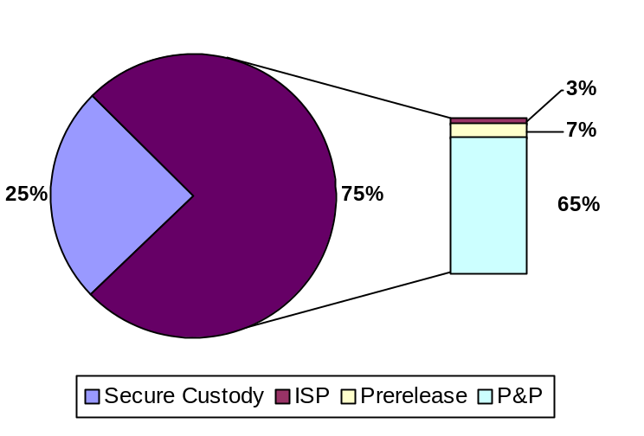

Community Programs have 75%

Of Adult Population
Fiscal Year End 2000
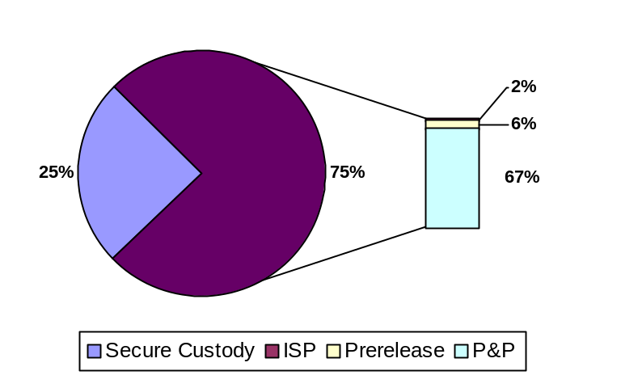

Secure custody includes all prisons, Treasure State Correctional Training Center, and county jail holding.

The graphs above show that secure custody remains constant at 25% of the adult population while the Intensive Supervisor Program (ISP) increases from 2 percent to 3 percent. The Prerelease centers increase from 6 percent to 7 percent and the Probation and Parole population decreases from 67 to 65 percent. It is important to keep a balance of community and secure custody and services as an issue of public safety.

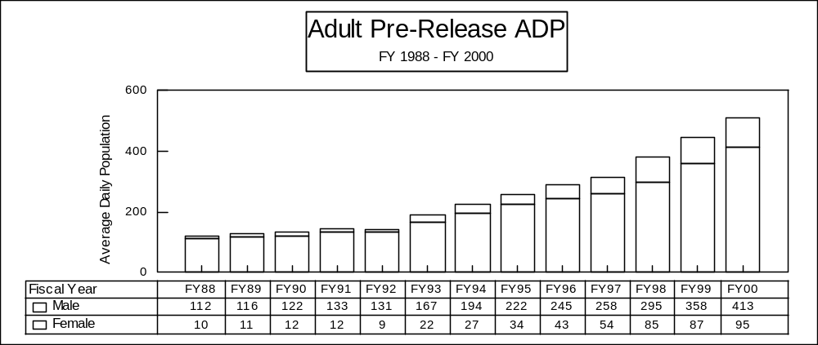

Program Indicators –

Indicator | Actual FY1998 | Actual FY1999 | Actual FY2000 | Estimated FY2001 | Requested FY2002 | Requested FY2003
Juveniles in out-of-state placements funded by DOC as of 6/30 | 60 | 67 | 57 | 57 | 52 | 52
Judicial Districts involved in collaborative funding project (Pilot Project/JDIP) | 2 | 2 | 11 | 11 | 23 | 23
Prerelease Centers  Population as of 6/30 | 444 | 460 | 535 | 576 | 619 | 719
Restitution collected | $1,255,813 | $1,512,229 | $1,466,937 | $1,760,324 | $2,112,389 | $2,534,867
Probation revocations *Jail sanction legislation effective in FY2000 | 492 | 486 | 580 | 493 | 419 | 356
Urine Samples Taken | Not available | Not available | 7,650 | 7,998 | 8,251 | 8,504
Total number of drug/alcohol screens performed on urine samples | Not available | Not available | 18,045 | 18,795 | 19,389 | 19,984
% of positive drug screens | Not available | Not available | 8.9% | 9.7% | 8% | 8%
Adult Probation & Parole
Caseload – Optimum level
Missoula | 95 | 101 | 91.3 | 70 | 70 | 70
Helena | 109 | 81.51 | 64 | 70 | 70 | 70
Bozeman | 83 | 72 | 63 | 70 | 70 | 70
Butte | 82 | 91.7 | 75 | 70 | 70 | 70
Great Falls | 76 | 77.8 | 68 | 70 | 70 | 70
Billings | 84 | 85 | 70 | 70 | 70 | 70
Kalispell | 100 | 100.5 | 86.69 | 70 | 70 | 70

Significant Present Law Adjustments -
- Continue funding 28.00 FTE probation and parole staff at a biennial general fund cost of $2.59 million
- Adjust pre-release center beds for increased offender population
- Adjust present law personal services for zero-based overtime and holiday pay
- Recognize savings from out-of-state placement due to completion of Pine Hills expansion construction

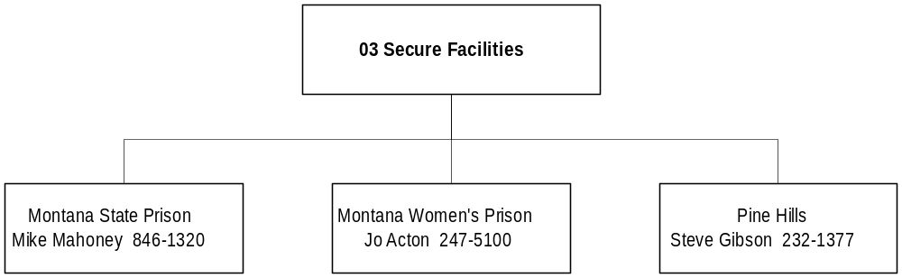

Program Description - The Secure Facilities Program includes the Montana State Prison, Montana Women's Prison, and the Pine Hills Youth Correctional Facility.

Program Indicators –

Indicator | Actual FY1998 | Actual FY1999 | Actual FY2000 | Estimated FY2001 | Requested FY2002 | Requested FY2003

Pine Hills School
Restitution | $14,052 | $17,006 | $19,519 | $21,000 | $21,000 | $23,000
Number of youth involved in restitution program | 39 | 45 | 31 | 47 | 50 | 55
Number of youth involved in the Community Service Program | 24 | 16 | 16 | 26 | 30 | 33
Number of Community Service Hours worked | 1575 | 2169 | 2654 | 3000 | 3300 | 3600
Number of juveniles admitted to CD program | N/A | N/A | 14 | 48 | 48 | 48

Montana Women’s Prison
Education participation of total population | 84% | 86% | 86% | 86% | 86% | 88%
Corrective Thinking participation of population | 41% | 39% | 20% | 28% | 32% | 40%
Chemical Dependency program completion prior to release | 38% | 40% | 40% | 42% | 44% | 50%
Parenting program participation of total population | 68% | 69% | 77% | 78% | 82% | 85%

Montana State Prison
Number of inmates that pass GED exam | 99 | 75 | 91 | 94 | 97 | 100
Number of inmates that discharge from CD program as treatment plan complete | 220 | 265 | 235 | 242 | 249 | 257
Number of inmates on waiting list for treatment programs as of 6/30 each year | Not available | 1608 | 1461 | 1432 | 1403 | 1375

Program Proposed Budget  Budget Item | Base  Budget  Fiscal 2000 | PL Base Adjustment  Fiscal 2002 | New  Proposals  Fiscal 2002 | Total  Exec. Budget  Fiscal 2002 | PL Base Adjustment  Fiscal 2003 | New  Proposals  Fiscal 2003 | Total  Exec. Budget  Fiscal 2003
FTE | 619.80 | 36.35 | 0.00 | 656.15 | 57.35 | 0.00 | 677.15
Personal Services | 21,979,838 | 3,265,118 | 0 | 25,244,956 | 3,959,585 | 0 | 25,939,423
Operating Expenses | 22,242,127 | 4,670,915 | 0 | 26,913,042 | 7,676,067 | 0 | 29,918,194
Equipment | 387,214 | (122,988) | 0 | 264,226 | (142,036) | 0 | 245,178
Grants | 30,218 | 0 | 0 | 30,218 | 0 | 0 | 30,218
Benefits & Claims | 309,410 | 0 | 0 | 309,410 | 0 | 0 | 309,410
Debt Service | 32,075 | 0 | 0 | 32,075 | 0 | 0 | 32,075
Total Costs | $44,980,882 | $7,813,045 | $0 | $52,793,927 | $11,493,616 | $0 | $56,474,498
General Fund | 43,682,312 | 7,425,974 | 0 | 51,108,286 | 11,082,623 | 0 | 54,764,935
State/Other Special | 1,081,203 | 71,076 | 0 | 1,152,279 | 71,392 | 0 | 1,152,595
Federal Special | 217,367 | 315,995 | 0 | 533,362 | 339,601 | 0 | 556,968
Total Funds | $44,980,882 | $7,813,045 | $0 | $52,793,927 | $11,493,616 | $0 | $56,474,498

Significant Present Law Adjustments -
- Continue 31.00 FTE security staff at Montana State Prison at a biennial general fund cost of $1.68 million
- Adjust operating costs at Pine Hills for 118 and 135 average daily population each year, respectively
- Expand Montana Women's Prison to 165 female inmates by FYE 2003
- Expand male and female contract bed capacity for projected population
- Adjust present law personal services for zero-based overtime, inmate pay, etc.
- Replace general fund with a federal grant for residential substance abuse treatment

MONT CORRECTIONAL ENTERPRISES

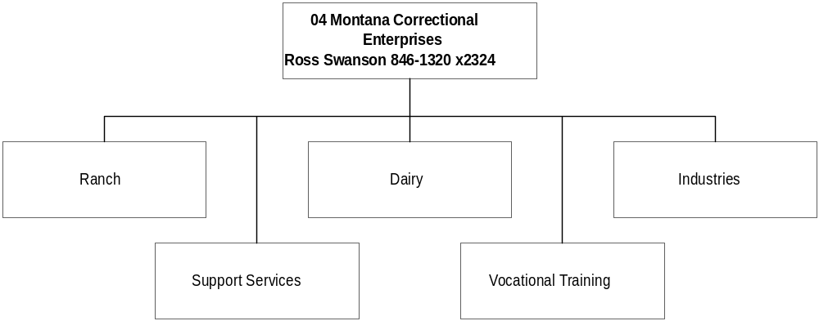

Program Description - The Montana Correctional Enterprises (MCE) Program includes the ranch, industries, dairy, license plate, and vocational education programs at the Montana State Prison facility. MCE also has industry programs located at the Montana Women's Prison, Cascade County Regional Detention Facility, Crossroads Correctional Facility, and the Missoula Regional Prison. MCE programs provide employment and vocational educational training opportunities to offenders. At the end of FY 2000 approximately three hundred fifty (350) offenders were involved in education, training and employment with MCE programs.

Program Indicators -

Indicator | Actual FY1998 | Actual FY1999 | Actual FY2000 | Estimated FY2001 | Requested FY2002 | Requested FY2003
MCE Program Revenue | $5,228,121 | $4,967,225 | $5,980,407 | $6,107,025 | $5,936,768 | $6,015,806
# of Inmate Workers – MSP | 260 | 258 | 240 | 260 | 280 | 285
#of Inmate Workers – Other Facilities | 4 | 24 | 75 | 125 | 150 | 150
Crime Victim Payments –  PIE Programs | $0 | $2,279 | $21,611 | $68,400 | $70,000 | $72,000
Family Support Deductions – PIE Pgm. | $0 | $812 | $13,146 | $38,229 | $40,000 | $42,000

Program Proposed Budget  Budget Item | Base  Budget  Fiscal 2000 | PL Base Adjustment  Fiscal 2002 | New  Proposals  Fiscal 2002 | Total  Exec. Budget  Fiscal 2002 | PL Base Adjustment  Fiscal 2003 | New  Proposals  Fiscal 2003 | Total  Exec. Budget  Fiscal 2003
FTE | 14.50 | 2.00 | 0.00 | 16.50 | 2.00 | 0.00 | 16.50
Personal Services | 584,513 | 156,759 | 0 | 741,272 | 161,098 | 0 | 745,611
Operating Expenses | 733,367 | 79,497 | 0 | 812,864 | 78,841 | 0 | 812,208
Equipment | 0 | (15,200) | 0 | (15,200) | (15,000) | 0 | (15,000)
Total Costs | $1,317,880 | $221,056 | $0 | $1,538,936 | $224,939 | $0 | $1,542,819
General Fund | 1,033,831 | (13,586) | 0 | 1,020,245 | (11,120) | 0 | 1,022,711
Federal Special | 0 | 0 | 0 | 0 | 0 | 0 | 0
Proprietary | 284,049 | 234,642 | 0 | 518,691 | 236,059 | 0 | 520,108
Total Funds | $1,317,880 | $221,056 | $0 | $1,538,936 | $224,939 | $0 | $1,542,819

Significant Present Law Adjustments -
- Fund zero-based inmate payroll and overtime costs for Vocational Education and License Plate Factory programs
- Continue MCE food bank program for canning and wild game processing
- Expand HB 2 industries program by 2.00 FTE, providing supervision for 200 inmates at the regional and private facilities
- Adopt proprietary fund inmate pay and overtime requests

New Proposals -
- Purchase new ranch and industries equipment and construction materials for use at MSP and the regional and private facilities

Proprietary Rates

Program Description -The Montana Correctional Enterprise (MCE) Industry program includes furniture, upholstery, print, sign, telemarketing and laundry operations at the Montana State Prison facility. In addition telemarketing programs are operated at the Montana Women’s Prison and the regional and private prison locations throughout Montana.

The MCE Ranch and Dairy operation includes range cattle, dairy, crops, feedlot and composting, which are located at the Montana State Prison facility.

The MCE Vocational Education program operates a motor vehicle maintenance shop, Toyota operation, telemarketing for Gold West Country, the Montana Food Bank cannery and educational classrooms at the Montana State Prison Facility.

Revenues and Expenses -
Montana Correctional Enterprises (MCE) Industry revenues are derived from product sales to state and private customers. The expenses are determined by operational needs, cash flow, economic return, customer orders, product inventory levels. Overall revenue levels are dependant on marketing efforts, legislative restrictions, state agency purchases, retail outlet dealer sales, expansion and adjustment of the product line, continuation of the Certified Industry Program, private sector complaints, private customer contracts, and the success of the programs at the Montana Women's Prison, regional and private facilities.

MCE Ranch and Dairy revenues are based on the market value of products sold. Expenditures are dependant on operational needs, cash flow, economic return, weather conditions, product market prices, and discussion with the Ranch Advisory Committee.

MCE Vocational Education Motor Vehicle Maintenance (MVM) revenues are based on customer vehicle and equipment repair and maintenance needs. Toyota revenues are based on contracts with the Toyota Company for producing motor vehicle cut-aways and trainers. Gold West telemarketing revenues are based on contract. The expenditure levels are determined by revenues and the need for parts and supplies for the repairs and contract projects. The MCE Vocational Education Food Bank revenues will be a reimbursement of actual costs incurred.

Rate Explanation -The MCE Industries rates for furniture, upholstery, print and sign shops are based on competitive product pricing.

The MCE Industries laundry rates have been at the same level since the inception of the laundry program in 1996, with the exception of the Montana Development Center (MDC), which decreased, due to the frequency of the laundry deliveries. MCE is requesting a 2 cent per pound rate increase due to personal services annual cost of living and longevity increases and a 42.74% increase in the natural gas contract prices. The current laundry rates are as follows: Montana State Prison - $.37 per pound, Montana State Hospital - $.36 per pound and Montana Developmental Center - $.46 per pound. The break even cost for laundry operations prior to this requested increase was approximately $.33 per pound without delivery costs. Any profit is maintained within the Industries account to be used for future laundry equipment replacement, as well as the overall Industries enterprise operation.

The Industries telemarketing rates are based on contracts with private companies.
MCE Ranch and Dairy rates are based on the current market prices of cattle, crops and dairy products.
MCE Vocational Education Motor Vehicle Maintenance (MVM) and Toyota pricing are based on the cost of parts and an hourly labor charged. The labor charge covers the cost of the four FTE associated with the MVM and Toyota operations.

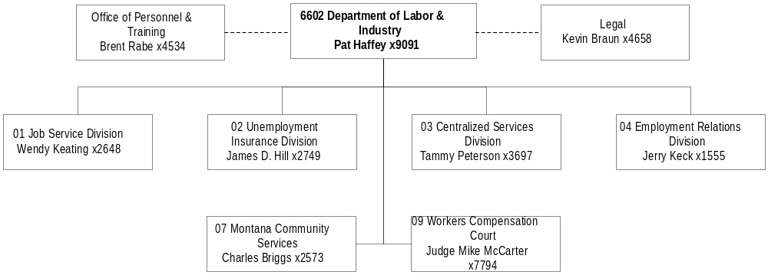

Mission Statement - To promote the well-being and opportunities of Montana workers and employers and to uphold the rights and responsibilities of both.

Statutory Authority - Primarily Titles 18, 39, 49, 50, and 90, MCA, and the federal Corporation for National Service.

Executive Budget Recommendation –
- Support the Jobs for Montana Graduates Programs in various communities
- Conduct annual statewide career conferences
- Align federal appropriations to reflect Montana's share of federal allocations
- Adjust Human Rights funding (general fund) to match workload

Agency Proposed Budget  Budget Item | Base  Budget  Fiscal 2000 | PL Base Adjustment  Fiscal 2002 | New  Proposals  Fiscal 2002 | Total  Exec. Budget  Fiscal 2002 | PL Base Adjustment  Fiscal 2003 | New  Proposals  Fiscal 2003 | Total  Exec. Budget  Fiscal 2003
FTE | 550.10 | 13.00 | 2.00 | 565.10 | 13.00 | 2.00 | 565.10
Personal Services | 18,747,770 | 2,596,573 | 72,153 | 21,416,496 | 2,718,041 | 72,403 | 21,538,214
Operating Expenses | 10,571,955 | (372,567) | 133,416 | 10,332,804 | (386,922) | 133,318 | 10,318,351
Equipment | 348,126 | (111,379) | 0 | 236,747 | (111,379) | 0 | 236,747
Capital Outlay | 162,470 | (162,470) | 0 | 0 | (162,470) | 0 | 0
Grants | 15,869,491 | 2,747,303 | 150,000 | 18,766,794 | 2,747,303 | 150,000 | 18,766,794
Benefits & Claims | 378,087 | 0 | 0 | 378,087 | 0 | 0 | 378,087
Transfers | 0 | 111,338 | 0 | 111,338 | 111,436 | 0 | 111,436
Debt Service | 86,895 | (83,785) | 0 | 3,110 | (83,785) | 0 | 3,110
Total Costs | $46,164,794 | $4,725,013 | $355,569 | $51,245,376 | $4,832,224 | $355,721 | $51,352,739
General Fund | 1,510,870 | 361,998 | 275,569 | 2,148,437 | 365,593 | 275,721 | 2,152,184
State/Other Special | 13,001,709 | 971,806 | 80,000 | 14,053,515 | 974,582 | 80,000 | 14,056,291
Federal Special | 31,604,562 | 3,378,856 | 0 | 34,983,418 | 3,479,414 | 0 | 35,083,976
Proprietary | 47,653 | 12,353 | 0 | 60,006 | 12,635 | 0 | 60,288
Total Funds | $46,164,794 | $4,725,013 | $355,569 | $51,245,376 | $4,832,224 | $355,721 | $51,352,739

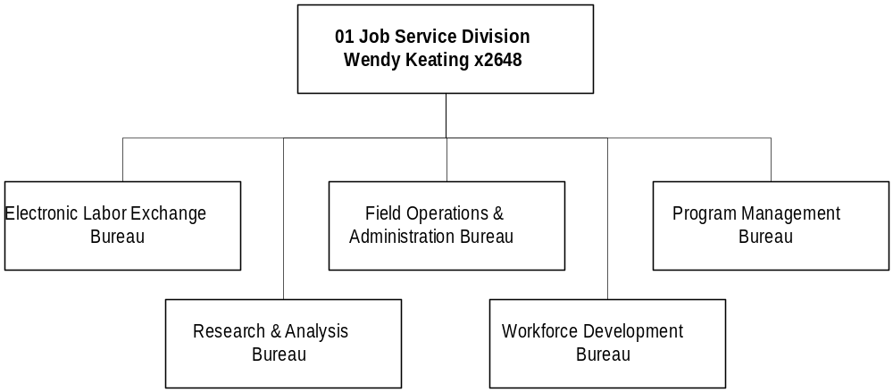

Program Description - The Job Service Division (JSD) operates through five bureaus. The Field Operations Bureau functions through a network of 17 Job Service Centers. The division is a gateway to government services in the area of employment and training services. JSD performs services that include retraining and reemployment services for laid-off workers and employment and training services for people transitioning from welfare to work, as well as for youth, veterans, seasonal/migrant farm workers, and general job seekers. Other bureaus include Electronic Labor Exchange, Workforce Development, Program Management, and Research and Analysis.

Program Indicators -
Indicator | Actual FY1998 | Actual FY1999 | Actual FY2000 | Estimated FY2001 | Requested FY2002 | Requested FY2003
Applicants Registered | 71,489 | 66,792 | 68,818 | 69,500 | 72,000 | 72,000
MCIS Sites | 220 | 242 | 308 | 308 | 270 | 270
Statistical Data Inquiry –  Employment Services | 133,122 | 827,046 | 844,740 | 862,812 | 881,271 | 900,124
Statistical Data Inquiry –  Research & Analysis | 372,698 | 520,347 | 598,619 | 688,412 | 791,673 | 910,425
Apprenticeship Training Participants | 889 | 894 | 939 | 1,014 | 1,098 | 1,186
Jobs for Montana’s Graduates | 356 | 446 | 603 | 650 | 700 | 725

Program Proposed Budget  Budget Item | Base  Budget  Fiscal 2000 | PL Base Adjustment  Fiscal 2002 | New  Proposals  Fiscal 2002 | Total  Exec. Budget  Fiscal 2002 | PL Base Adjustment  Fiscal 2003 | New  Proposals  Fiscal 2003 | Total  Exec. Budget  Fiscal 2003
FTE | 299.35 | 2.00 | 2.00 | 303.35 | 2.00 | 2.00 | 303.35
Personal Services | 9,807,192 | 1,211,878 | 72,153 | 11,091,223 | 1,273,988 | 72,403 | 11,153,583
Operating Expenses | 5,707,403 | (962,761) | 133,416 | 4,878,058 | (1,036,187) | 133,318 | 4,804,534
Equipment | 281,455 | (134,744) | 0 | 146,711 | (134,744) | 0 | 146,711
Capital Outlay | 162,470 | (162,470) | 0 | 0 | (162,470) | 0 | 0
Grants | 14,317,296 | 1,628,303 | 150,000 | 16,095,599 | 1,628,303 | 150,000 | 16,095,599
Benefits & Claims | 0 | 0 | 0 | 0 | 0 | 0 | 0
Transfers | 0 | 111,338 | 0 | 111,338 | 111,436 | 0 | 111,436
Debt Service | 83,785 | (83,785) | 0 | 0 | (83,785) | 0 | 0
Total Costs | $30,359,601 | $1,607,759 | $355,569 | $32,322,929 | $1,596,541 | $355,721 | $32,311,863
General Fund | 595,109 | 85,899 | 275,569 | 956,577 | 87,323 | 275,721 | 958,153
State/Other Special | 6,046,489 | 765,940 | 80,000 | 6,892,429 | 742,819 | 80,000 | 6,869,308
Federal Special | 23,710,321 | 756,770 | 0 | 24,467,091 | 767,249 | 0 | 24,477,570
Proprietary | 7,682 | (850) | 0 | 6,832 | (850) | 0 | 6,832
Total Funds | $30,359,601 | $1,607,759 | $355,569 | $32,322,929 | $1,596,541 | $355,721 | $32,311,863

Significant Present Law Adjustments -
- Reflect federal funding correctly, as the One Stop federal program is phased out and the Trade Adjustment Assistance Act and Workforce Investment Act are augmented

New Proposals -
- Restore one-time general fund for Jobs for Montana's Graduates and continue program expansion at a total biennial cost of $551,290
- Host annual statewide career conference with state special registration fees of $80,000

Proprietary Rates

Program Description –

Montana Career Information System (06051)
The Montana Career Information System (MCIS) has been active in Montana since 1980. The purpose of MCIS is to deliver current career and labor market information to Montanans in an easy-to-use, easy-to-understand format. This is the only career information delivery system in the country that has specific Montana labor market information included in each file. MCIS is currently being used at over 200 sites throughout the state by a wide variety of users: job service offices, vocational rehabilitation offices, high schools, community colleges, universities, tribal colleges, education and training agencies, and adult education programs.

Revenues and Expenses -
Working Capital = $23,946 for 60 days.

Rate Explanation -The Montana Career Information System (MCIS) is funded by user fees not to exceed $1,500 per site. Discounted rates are available for small schools and groups.

UNEMPLOYMENT INSURANCE DIVISION

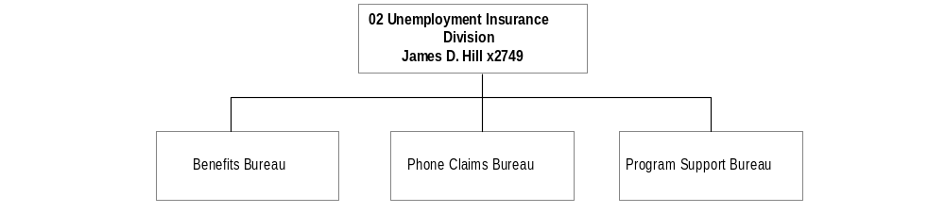

Program Description - The Unemployment Insurance (UI) Division administers the state unemployment insurance law and related federal programs, which provide temporary, partial wage replacement to involuntary unemployed individuals. The UI Division is organized into three bureaus: UI Benefits, UI Program Support, and UI Phone Claims. The UI Contributions Bureau was reorganized by the 1997 Legislature under HB 561, which delegated UI tax collection activity to the Department of Revenue. The UI Benefits Bureau receives, processes, and pays UI benefit claims and adjudicates disputed benefit claims. The UI Program Support Bureau manages the Benefit Automated Rewrite System (BeAR), and the UI benefit accounting and payment system. The UI Phone Claims Bureau has two phone centers (Billings and Helena) for claimants to file unemployment claims, and for employers to make UI related inquiries.

Program Indicators –

Indicator | Actual FY1998 | Actual FY1999 | Actual FY2000 | Estimated FY2001 | Requested FY2002 | Requested FY2003
Initial Claims | 58,573 | 54,262 | 48,339 | 57,146 | 66,293 | 74,352
Weeks Claimed | 425,351 | 408,512 | 373,905 | 412,273 | 480,624 | 536,401
Non-monetary Determinations | 18,383 | 18,673 | 18,368 | 19,016 | 22,403 | 24,648
Appeals | 1,333 | 1,333 | 1,371 | 1,371 | 1,590 | 1,770

Program Proposed Budget  Budget Item | Base  Budget  Fiscal 2000 | PL Base Adjustment  Fiscal 2002 | New  Proposals  Fiscal 2002 | Total  Exec. Budget  Fiscal 2002 | PL Base Adjustment  Fiscal 2003 | New  Proposals  Fiscal 2003 | Total  Exec. Budget  Fiscal 2003
FTE | 105.50 | 4.00 | 0.00 | 109.50 | 4.00 | 0.00 | 109.50
Personal Services | 3,815,246 | 575,465 | 0 | 4,390,711 | 598,349 | 0 | 4,413,595
Operating Expenses | 1,697,075 | 635,687 | 0 | 2,332,762 | 699,485 | 0 | 2,396,560
Equipment | (23,600) | 23,600 | 0 | 0 | 23,600 | 0 | 0
Benefits & Claims | 0 | 0 | 0 | 0 | 0 | 0 | 0
Transfers | 0 | 0 | 0 | 0 | 0 | 0 | 0
Debt Service | 3,104 | 0 | 0 | 3,104 | 0 | 0 | 3,104
Total Costs | $5,491,825 | $1,234,752 | $0 | $6,726,577 | $1,321,434 | $0 | $6,813,259
State/Other Special | 285,705 | 2,948 | 0 | 288,653 | 2,948 | 0 | 288,653
Federal Special | 5,206,120 | 1,231,804 | 0 | 6,437,924 | 1,318,486 | 0 | 6,524,606
Total Funds | $5,491,825 | $1,234,752 | $0 | $6,726,577 | $1,321,434 | $0 | $6,813,259

Significant Present Law Adjustments -
- Increase federal appropriations to reflect the Montana allocation of UI grants

COMMISSIONER'S OFFICE/CSD

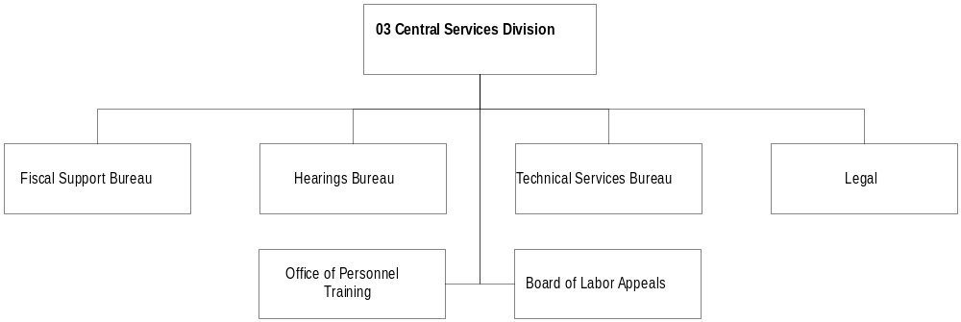 Program Description - The Commissioner's Office and the Legal and Centralized Services Division provide program direction, legal, administration, and support services to the department. Legal and Centralized Services provides the central support functions of the department through five bureaus: 1) Fiscal Support; 2) Information Services; 3) Personnel and Training; 4) Hearings; and 5) Legal Services. Administratively attached is the three-member Board of Labor Appeals, which hears appeals concerning the administration of Montana Unemployment Insurance laws and employer/employee relationships.

Program Indicators –

Indicator | Actual FY1998 | Actual FY1999 | Actual FY2000 | Estimated FY2001 | Requested FY2002 | Requested FY2003
Classification Actions | 177 | 128 | 88 | 95 | 95 | 95
Cases Processed | 2,025 | 1,718 | 1,743 | 1,700 | 1,700 | 1,700
Federal Programs | 84 | 80 | 78 | 77 | 77 | 77

Program Proposed Budget  Budget Item | Base  Budget  Fiscal 2000 | PL Base Adjustment  Fiscal 2002 | New  Proposals  Fiscal 2002 | Total  Exec. Budget  Fiscal 2002 | PL Base Adjustment  Fiscal 2003 | New  Proposals  Fiscal 2003 | Total  Exec. Budget  Fiscal 2003
FTE | 20.50 | 0.00 | 0.00 | 20.50 | 0.00 | 0.00 | 20.50
Personal Services | 863,365 | 26,115 | 0 | 889,480 | 32,683 | 0 | 896,048
Operating Expenses | 299,791 | 26,577 | 0 | 326,368 | 24,453 | 0 | 324,244
Total Costs | $1,163,156 | $52,692 | $0 | $1,215,848 | $57,136 | $0 | $1,220,292
General Fund | 133,561 | 32,726 | 0 | 166,287 | 33,168 | 0 | 166,729
State/Other Special | 552,457 | (9,152) | 0 | 543,305 | (7,213) | 0 | 545,244
Federal Special | 437,167 | 15,915 | 0 | 453,082 | 17,696 | 0 | 454,863
Proprietary | 39,971 | 13,203 | 0 | 53,174 | 13,485 | 0 | 53,456
Total Funds | $1,163,156 | $52,692 | $0 | $1,215,848 | $57,136 | $0 | $1,220,292

Significant Present Law Adjustments -
- Support administrative aspect of the Human Rights Act workload at a $10,996 general fund biennial cost

Proprietary Rates

Program Description - Cost Allocation Plan (CAP) -- The Commissioner's Office and the Legal/Centralized Services Division are funded through a cost allocation plan under which the various other divisions in the agency are assessed a percentage of their personal services cost to support centralized functions. The services provided through this accounting entity are administration, accounting, purchasing, budgeting, personnel, training, mail distribution, and information services.

Input/Output Control Operations Functions -- The Legal/Centralized Services Division recovers costs of a unit called the Input/Output control Operations Function, which provides traffic control of data input, jobs for the mainframe computer system, and report output.

Revenues and Expenses -
Change in Services or Fees. There will no change.
Working Capital Discussion. 60 days of personal services, operations, and miscellaneous operating less non-cash expenses equals approximately $316,383.00. This figure is the minimum amount necessary to maintain on-going operations. Our working capital balance is used in calculating the final CAP rate.
Fund Equity and Reserved Fund Balance. The program has no requirement to reserve fund balance.
Cash Flow Discussion. There is no cash flow fluctuation.

Rate Explanation - Cost Allocation Plan (CAP) - It is the intent of the legislature that the rates charged for these functions be the rates agreed upon by the United State Department of Labor federal cost negotiator. It is anticipated that the assessment will be as much as 10 percent and 12 percent of a program's actual personal services costs incurred in FY 2002 and FY 2003.

Input/Output Control Operation Functions - Internal users are directly charged for the services received and are billed quarterly.

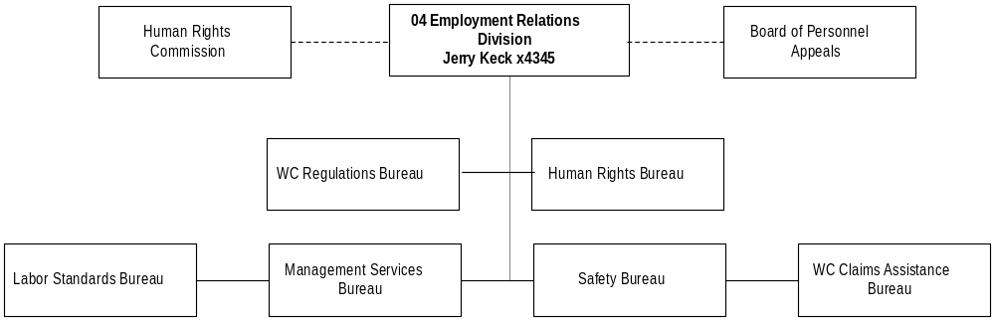
Program Description - The Employment Relations Division (ERD) provides five service areas: 1) Workers' Compensation (WC) Regulation, which regulates WC insurance coverage requirements, policy compliance, medical regulations, and cost containment, and WC Claims Assistance Bureau, which assists organizations and individuals to arrive at early, less expensive settlements of their disputes; 2) Labor Standards Bureau, which enforces state and federal labor laws related to the payment of wages, and provides collective bargaining mediation; 3) Safety Bureau, which administers federal and state industrial safety laws; 4) Human Rights Bureau, which enforces Montana Human Rights Act and Governmental Code of Fair Practices through investigations, conciliation, hearings, and education and is responsible for enforcing laws which prohibit discrimination in employment, housing, public accommodations, financing and credit transactions, insurance, education, and government services; 5) Contractor Registration and Independent Contractor Exemption programs, which register contractors; and 6) Board of Personnel Appeals, which deals with issues related to wage and hour, and collective bargaining disputes between employers and employees and is administratively attached.

Program Indicators –

Indicator | Actual FY1998 | Actual FY1999 | Actual FY2000 | Estimated FY2001 | Requested FY2002 | Requested FY2003
Safety Inspections | 344 | 412 | 404 | 432 | 458 | 481
Mine Inspections | 79 | 155 | 170 | 180 | 192 | 202
Wage & Hour Cases Filed | 1,052 | 1138 | 1223 | 1284 | 1300 | 1348
UEF Claims Filed | 130 | 102 | 69 | 100 | 105 | 112

Program Proposed Budget  Budget Item | Base  Budget  Fiscal 2000 | PL Base Adjustment  Fiscal 2002 | New  Proposals  Fiscal 2002 | Total  Exec. Budget  Fiscal 2002 | PL Base Adjustment  Fiscal 2003 | New  Proposals  Fiscal 2003 | Total  Exec. Budget  Fiscal 2003
FTE | 115.75 | 5.00 | 0.00 | 120.75 | 5.00 | 0.00 | 120.75
Personal Services | 3,830,270 | 744,020 | 0 | 4,574,290 | 771,114 | 0 | 4,601,384
Operating Expenses | 2,585,937 | (173,120) | 0 | 2,412,817 | (178,784) | 0 | 2,407,153
Equipment | 90,271 | (235) | 0 | 90,036 | (235) | 0 | 90,036
Benefits & Claims | 378,087 | 0 | 0 | 378,087 | 0 | 0 | 378,087
Debt Service | 6 | 0 | 0 | 6 | 0 | 0 | 6
Total Costs | $6,884,571 | $570,665 | $0 | $7,455,236 | $592,095 | $0 | $7,476,666
General Fund | 757,305 | 168,373 | 0 | 925,678 | 170,102 | 0 | 927,407
State/Other Special | 5,715,686 | 157,440 | 0 | 5,873,126 | 176,441 | 0 | 5,892,127
Federal Special | 411,580 | 244,852 | 0 | 656,432 | 245,552 | 0 | 657,132
Proprietary | 0 | 0 | 0 | 0 | 0 | 0 | 0
Total Funds | $6,884,571 | $570,665 | $0 | $7,455,236 | $592,095 | $0 | $7,476,666

Significant Present Law Adjustments -
- Adjust operating costs to reflect OTO expenditures
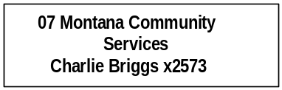

Program Description - Montana Community Services provides administration of federal Corporation for National Service programs (AmeriCorps and Campus Corps), community service, and volunteer efforts statewide, including the Volunteer Montana program. The office was created by the 1993 Legislature at the request of the Governor (MCA 90-14-101ff) in order to support community-based volunteer programs focused on addressing critical community needs. The vision of the office and its Commission on Community Service is to cultivate service as a lifelong "habit of the heart" for all citizens, and in particular, instill an ethic of community service in young Montanans. To that end, in the 2003 biennium, the office is committed to:

- Encouraging all Montana citizens to engage in service activities in their community; involving youth in the life and work of communities; and expanding service opportunities for all Montanans.
- Contracting with and monitoring grants to community organizations utilizing part-time and full-time volunteers in an effort to make a difference, as well as work with other partners from the Corporation for National Service, which includes primarily the Office of Public Instruction, the University of Montana Campus Compact, and the Corporation State Office.
- Assisting some forty communities through training, technical assistance, monitoring and, where feasible, community "seed grants" in order to realize local action plans that encompass the Montana's Promise Initiative. Communities are working to ensure they have available for their children and youth the following five resources for healthy, productive living: 1) an ongoing relationship with a caring adult; 2) safe places and structured activities after school to learn and grow; 3) a healthy start in life; 4) marketable skills through effective education; and 5) opportunities for community service.
- Coordinating and overseeing annual training and technical assistance activities for national service programs in Montana, through AmeriCorps*USA, the National Senior Service Corps, and Learn & Serve America.

Program Indicators –

Indicator | Actual FY1998 | Actual FY1999 | Actual FY2000 | Estimated FY2001 | Requested FY2002 | Requested FY2003
AmericaCorps members | 211 | 225 | 197 | 271 | 375 | 400

Program Proposed Budget  Budget Item | Base  Budget  Fiscal 2000 | PL Base Adjustment  Fiscal 2002 | New  Proposals  Fiscal 2002 | Total  Exec. Budget  Fiscal 2002 | PL Base Adjustment  Fiscal 2003 | New  Proposals  Fiscal 2003 | Total  Exec. Budget  Fiscal 2003
FTE | 3.00 | 2.00 | 0.00 | 5.00 | 2.00 | 0.00 | 5.00
Personal Services | 134,128 | 36,218 | 0 | 170,346 | 37,808 | 0 | 171,936
Operating Expenses | 182,945 | 72,489 | 0 | 255,434 | 71,824 | 0 | 254,769
Grants | 1,552,195 | 1,119,000 | 0 | 2,671,195 | 1,119,000 | 0 | 2,671,195
Total Costs | $1,869,268 | $1,227,707 | $0 | $3,096,975 | $1,228,632 | $0 | $3,097,900
General Fund | 24,895 | 75,000 | 0 | 99,895 | 75,000 | 0 | 99,895
State/Other Special | 4,999 | 23,192 | 0 | 28,191 | 23,201 | 0 | 28,200
Federal Special | 1,839,374 | 1,129,515 | 0 | 2,968,889 | 1,130,431 | 0 | 2,969,805
Total Funds | $1,869,268 | $1,227,707 | $0 | $3,096,975 | $1,228,632 | $0 | $3,097,900

Significant Present Law Adjustments -
- Accept an additional $1.129 million federal dollars from the Corporation for National Service
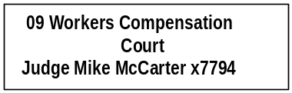

Program Description - The Workers' Compensation Court provides a forum for Montana employees and the insurance industry to resolve disputes arising from work-related injuries and occupational disease. The court is attached to the department for administrative purposes.

Program Indicators –

Indicator | Actual FY1998 | Actual FY1999 | Actual FY2000 | Estimated FY2001 | Requested FY2002 | Requested FY2003
Petitions Filed | 235 | 266 | 255 | 281 | 309 | 337
Trials | 61 | 57 | 64 | 71 | 85 | 100

Program Proposed Budget  Budget Item | Base  Budget  Fiscal 2000 | PL Base Adjustment  Fiscal 2002 | New  Proposals  Fiscal 2002 | Total  Exec. Budget  Fiscal 2002 | PL Base Adjustment  Fiscal 2003 | New  Proposals  Fiscal 2003 | Total  Exec. Budget  Fiscal 2003
FTE | 6.00 | 0.00 | 0.00 | 6.00 | 0.00 | 0.00 | 6.00
Personal Services | 297,569 | 2,877 | 0 | 300,446 | 4,099 | 0 | 301,668
Operating Expenses | 98,804 | 28,561 | 0 | 127,365 | 32,287 | 0 | 131,091
Total Costs | $396,373 | $31,438 | $0 | $427,811 | $36,386 | $0 | $432,759
State/Other Special | 396,373 | 31,438 | 0 | 427,811 | 36,386 | 0 | 432,759
Total Funds | $396,373 | $31,438 | $0 | $427,811 | $36,386 | $0 | $432,759

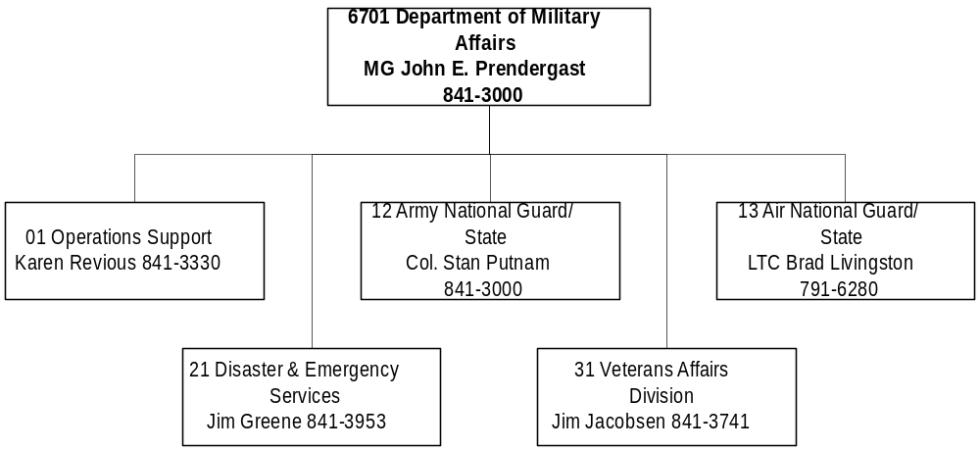

Mission Statement - To provide for safety and well being for citizens of Montana through mission-ready forces, for federal and state activations, emergency services as directed by the Governor, and services to Montana Veterans.

Statutory Authority - Article I, U.S. Constitution; Article VI, Section 13, Montana Constitution; Title 10, MCA

Executive Budget Recommendation –
- Maintain the Montana National Guard Youth ChalleNGe Program for youth ages 16-18
- Continue the Montana Guard Scholarship Program to assist with recruiting and retention
- Strengthen Army Guard facilities with 7.00 FTE for maintenance, construction, operations, and planning support
- Sustain armory paint projects
- Restore zero-based overtime and holiday pay for state fire fighters in the Air National Guard
- Augment current security contract to provide additional coverage using federal funds
- Annualize DES general fund in accord with legislative intent from last session
- Enhance FEMA federal pass through funds to counties to assist them with disaster planning
- Establish 1.00 FTE and federal authority for Terrorism/Weapons of Mass Destruction project
- Create state special revenue funding for the operation of the Eastern Montana State Veterans Cemetery

Agency Proposed Budget  Budget Item | Base  Budget  Fiscal 2000 | PL Base Adjustment  Fiscal 2002 | New  Proposals  Fiscal 2002 | Total  Exec. Budget  Fiscal 2002 | PL Base Adjustment  Fiscal 2003 | New  Proposals  Fiscal 2003 | Total  Exec. Budget  Fiscal 2003
FTE | 105.20 | 7.80 | 45.00 | 158.00 | 7.80 | 45.00 | 158.00
Personal Services | 4,069,148 | 482,221 | 1,458,914 | 6,010,283 | 508,466 | 1,464,541 | 6,042,155
Operating Expenses | 4,369,972 | 628,395 | 1,869,899 | 6,868,266 | 715,062 | 1,515,149 | 6,600,183
Equipment | 41,767 | 15,000 | 0 | 56,767 | 49,830 | 0 | 91,597
Grants | 374,771 | 265,229 | 491,290 | 1,131,290 | 265,229 | 49,018 | 689,018
Benefits & Claims | 11,215 | (8,935) | 0 | 2,280 | (8,935) | 0 | 2,280
Debt Service | 7,093 | (7,093) | 0 | 0 | (7,093) | 0 | 0
Total Costs | $8,873,966 | $1,374,817 | $3,820,103 | $14,068,886 | $1,522,559 | $3,028,708 | $13,425,233
General Fund | 2,793,106 | 332,794 | 1,470,000 | 4,595,900 | 401,074 | 1,120,000 | 4,314,180
State/Other Special | 82,946 | 114,651 | 2,500 | 200,097 | 114,651 | 2,500 | 200,097
Federal Special | 5,997,914 | 927,372 | 2,347,603 | 9,272,889 | 1,006,834 | 1,906,208 | 8,910,956
Total Funds | $8,873,966 | $1,374,817 | $3,820,103 | $14,068,886 | $1,522,559 | $3,028,708 | $13,425,233

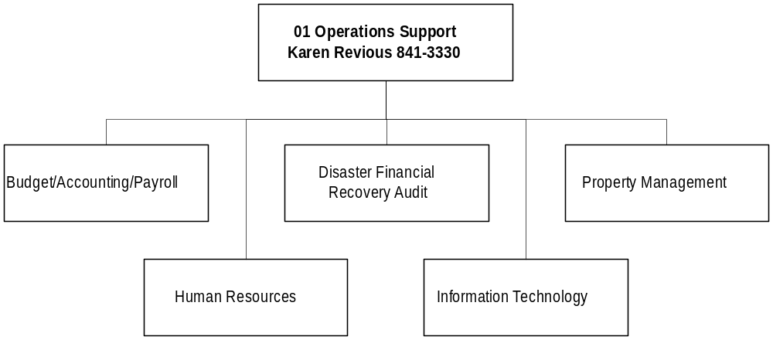

Program Description - The Operations Support Program provides departmental administration through the Office of the Adjutant General and department-wide support for accounting, fiscal management, personnel, labor relations, and purchasing and property management oversight. The program operates in accordance with Title 2, Chapter 15, part 12 and Title 10, MCA.

Program Proposed Budget  Budget Item | Base  Budget  Fiscal 2000 | PL Base Adjustment  Fiscal 2002 | New  Proposals  Fiscal 2002 | Total  Exec. Budget  Fiscal 2002 | PL Base Adjustment  Fiscal 2003 | New  Proposals  Fiscal 2003 | Total  Exec. Budget  Fiscal 2003
FTE | 6.60 | 0.60 | 1.00 | 8.20 | 0.60 | 1.00 | 8.20
Personal Services | 304,136 | 55,321 | 36,548 | 396,005 | 57,378 | 37,153 | 398,667
Operating Expenses | 53,838 | 2,584 | 0 | 56,422 | 3,656 | 0 | 57,494
Benefits & Claims | 2,280 | 0 | 0 | 2,280 | 0 | 0 | 2,280
Total Costs | $360,254 | $57,905 | $36,548 | $454,707 | $61,034 | $37,153 | $458,441
General Fund | 324,696 | 57,695 | 0 | 382,391 | 60,566 | 0 | 385,262
Federal Special | 35,558 | 210 | 36,548 | 72,316 | 468 | 37,153 | 73,179
Total Funds | $360,254 | $57,905 | $36,548 | $454,707 | $61,034 | $37,153 | $458,441

Significant Present Law Adjustments -
- Increase administrative officer from 0.40 FTE to 1.00 FTE to account for disasters

New Proposals -
- Add 1.00 FTE compliance specialist using federal special revenue for the Obligation Tracking System

Program Description - The Montana National Guard Youth ChalleNGe Program is a volunteer program for youth ages 16 to 18 who have stopped attending secondary school before graduating. ChalleNGe is a 17-month, voluntary two-phased military modeled training program targeting unemployed drug-free and law-free high school dropouts. The program provides an opportunity for high school at risk youth to enhance their life skills, increase their educational levels, and their employment potential. Phase I of the program is a 22 week residential stay on the campus of Western Montana College of the University of Montana in Dillon focusing on physical training, classroom instruction, personal development, and life skills. Phase II is a year-long mentoring relationship with a specially-trained member of the community where the youth resides to provide a positive role model and to assist the student in gaining employment or enrolling in post-secondary schooling.

Program Proposed Budget  Budget Item | Base  Budget  Fiscal 2000 | PL Base Adjustment  Fiscal 2002 | New  Proposals  Fiscal 2002 | Total  Exec. Budget  Fiscal 2002 | PL Base Adjustment  Fiscal 2003 | New  Proposals  Fiscal 2003 | Total  Exec. Budget  Fiscal 2003
FTE | 0.00 | 0.00 | 43.00 | 43.00 | 0.00 | 43.00 | 43.00
Personal Services | 0 | 0 | 1,382,601 | 1,382,601 | 0 | 1,387,351 | 1,387,351
Operating Expenses | 0 | 0 | 1,417,399 | 1,417,399 | 0 | 1,412,649 | 1,412,649
Total Costs | $0 | $0 | $2,800,000 | $2,800,000 | $0 | $2,800,000 | $2,800,000
General Fund | 0 | 0 | 1,120,000 | 1,120,000 | 0 | 1,120,000 | 1,120,000
Federal Special | 0 | 0 | 1,680,000 | 1,680,000 | 0 | 1,680,000 | 1,680,000
Total Funds | $0 | $0 | $2,800,000 | $2,800,000 | $0 | $2,800,000 | $2,800,000

New Proposals -
- Maintain the Montana National Guard Youth ChalleNGe Program

SCHOLARSHIP PROGRAM

Program Description - The Montana National Guard Scholarship Program provides scholarships of up to $500 per semester to eligible Montana National Guard personnel enrolled as undergraduate students in colleges, universities, or training programs. The program assists Montana in increasing its assigned personnel strength in both the Army and Air National Guard and in enhancing its operational readiness to assume both state and federal active duty missions. Scholarships also reward guard members for their service to the state by helping defray their educational costs at Montana post-secondary institutions.

Program Proposed Budget  Budget Item | Base  Budget  Fiscal 2000 | PL Base Adjustment  Fiscal 2002 | New  Proposals  Fiscal 2002 | Total  Exec. Budget  Fiscal 2002 | PL Base Adjustment  Fiscal 2003 | New  Proposals  Fiscal 2003 | Total  Exec. Budget  Fiscal 2003
FTE | 0.00 | 0.00 | 0.00 | 0.00 | 0.00 | 0.00 | 0.00
Operating Expenses | 0 | 0 | 350,000 | 350,000 | 0 | 0 | 0
Total Costs | $0 | $0 | $350,000 | $350,000 | $0 | $0 | $0
General Fund | 0 | 0 | 350,000 | 350,000 | 0 | 0 | 0
Total Funds | $0 | $0 | $350,000 | $350,000 | $0 | $0 | $0

New Proposals -
- Continue the Montana Guard Scholarship Program to assist with recruiting and retention

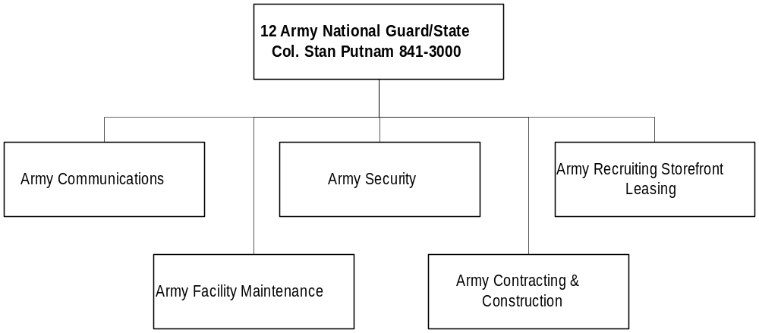

Program Description - The Army National Guard provides a trained and equipped military organization for use in the event of a state or national emergency. This program provides facilities management, environmental, and communications support to the organization by: 1) providing professional and skilled personnel for the administration, planning, and execution of statewide repair and maintenance functions on facilities and training areas; 2) planning, programming and contracting for construction; 3) ensuring all activities and facilities comply with environmental regulations; and 4) providing state-wide communication services, security contracts, and leases for buildings and land used by the Army National Guard. The program is mandated by the U.S. and Montana constitutions and Title 10, Chapters 1-3, MCA.

Program Indicators –
Indicator | Actual FY1998 | Actual FY1999 | Actual FY2000 | Estimated FY2001 | Requested FY2002 | Requested FY2003
Army Guard Facilities Square Footage | 1,271,000 | 1,400,000 | 1,510,000 | 1,535,000 | 1,788,000 | 1,898,000
Utility Costs per sq. ft. | $.63 | $.66 | $.59 | $.65 | $.64 | $.60

Program Proposed Budget  Budget Item | Base  Budget  Fiscal 2000 | PL Base Adjustment  Fiscal 2002 | New  Proposals  Fiscal 2002 | Total  Exec. Budget  Fiscal 2002 | PL Base Adjustment  Fiscal 2003 | New  Proposals  Fiscal 2003 | Total  Exec. Budget  Fiscal 2003
FTE | 26.30 | 7.00 | 0.00 | 33.30 | 7.00 | 0.00 | 33.30
Personal Services | 1,011,635 | 276,160 | 0 | 1,287,795 | 283,332 | 0 | 1,294,967
Operating Expenses | 3,222,333 | 479,450 | 2,500 | 3,704,283 | 587,978 | 2,500 | 3,812,811
Equipment | 41,767 | 15,000 | 0 | 56,767 | 32,500 | 0 | 74,267
Debt Service | 7,093 | (7,093) | 0 | 0 | (7,093) | 0 | 0
Total Costs | $4,282,828 | $763,517 | $2,500 | $5,048,845 | $896,717 | $2,500 | $5,182,045
General Fund | 1,150,302 | 163,828 | 0 | 1,314,130 | 216,283 | 0 | 1,366,585
State/Other Special | 3,138 | 22,862 | 2,500 | 28,500 | 22,862 | 2,500 | 28,500
Federal Special | 3,129,388 | 576,827 | 0 | 3,706,215 | 657,572 | 0 | 3,786,960
Total Funds | $4,282,828 | $763,517 | $2,500 | $5,048,845 | $896,717 | $2,500 | $5,182,045

Significant Present Law Adjustments -
- Strengthen Army Guard facilities with 7.00 FTE for maintenance, construction, operational and planning support
- Sustain armory paint projects with two interiors and two exteriors in the biennium
- Lower out-of-state travel base to five-year average

New Proposals -
- Create state special revenue authority for Distance Learning so non-military users may pay for a portion of the project, which is otherwise 100 percent federally-funded
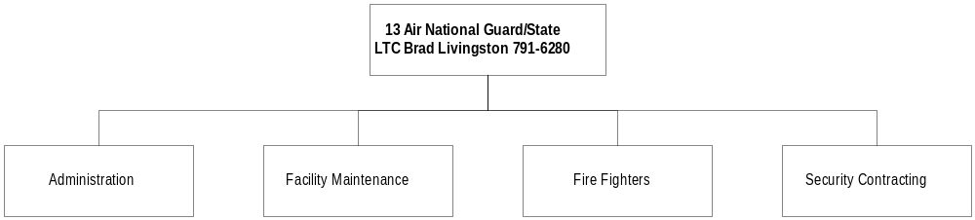

Program Description - The Air National Guard program maintains a trained and equipped military organization for use in the event of a state or national emergency. The program staff provides administrative, facilities maintenance, and fire protection support to the Air National Guard base at Gore Hill near Great Falls. The Air National Guard Program operates under both federal and state mandates in accordance with its dual missions to maintain a trained and ready military force and a state civil disaster response capability.

Program Indicators –

Indicator | Actual FY1998 | Actual FY1999 | Actual FY2000 | Estimated FY2001 | Requested FY2002 | Requested FY2003
Spent | 412,775 | 426,597 | 398,190 | 395,000 | 398,000 | 408,000
Construction Cost | 39,688,147 | 35,045,073 | 38,153,974 | 37,153,974 | 39,803,974 | 40,998,093
Percent | 1.04% | 1.22% | 1.04% | 1.06% | .99% | 1.0%

Program Proposed Budget  Budget Item | Base  Budget  Fiscal 2000 | PL Base Adjustment  Fiscal 2002 | New  Proposals  Fiscal 2002 | Total  Exec. Budget  Fiscal 2002 | PL Base Adjustment  Fiscal 2003 | New  Proposals  Fiscal 2003 | Total  Exec. Budget  Fiscal 2003
FTE | 33.00 | 0.00 | 0.00 | 33.00 | 0.00 | 0.00 | 33.00
Personal Services | 1,299,731 | 102,908 | 0 | 1,402,639 | 111,460 | 0 | 1,411,191
Operating Expenses | 687,734 | 153,417 | 0 | 841,151 | 143,868 | 0 | 831,602
Total Costs | $1,987,465 | $256,325 | $0 | $2,243,790 | $255,328 | $0 | $2,242,793
General Fund | 196,218 | 6,183 | 0 | 202,401 | 13,473 | 0 | 209,691
Federal Special | 1,791,247 | 250,142 | 0 | 2,041,389 | 241,855 | 0 | 2,033,102
Total Funds | $1,987,465 | $256,325 | $0 | $2,243,790 | $255,328 | $0 | $2,242,793

Significant Present Law Adjustments -
- Restore zero-based overtime and holiday pay for state fire fighters in the Air National Guard
- Augment current security contract to provide additional coverage using federal funds

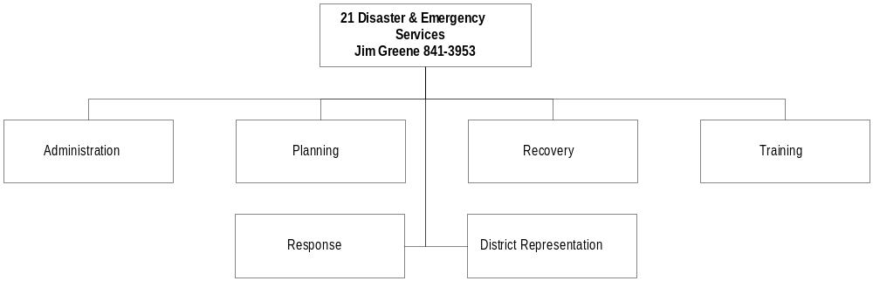
Program Description - The Disaster and Emergency Services Division: 1) works with local, state, and federal officials to prepare, update, and coordinate emergency preparedness, mitigation, response, and recovery plans; 2) provides technical assistance and coordination of the state response to assist political subdivisions in time of emergencies; and 3) receives, records, and disburses federal funds to eligible political subdivisions. Political subdivisions must provide matching funds for all federal reimbursement programs except disaster recovery and Federal Emergency Management Agency Terrorism program. The division is responsible for disaster planning activities, responding quickly and effectively to disasters and emergencies, being a source of information and a 24-hour contact point, and coordinating state assistance to local governments. The program is provided for in Title 10, Chapter 3, MCA.

Program Indicators –
Indicator | Actual FY1998 | Actual FY1999 | Actual FY2000 | Estimated FY2001 | Requested FY2002 | Requested FY2003
Local Government Disaster Training Classes | 37 | 45 | 97 | 45 | 50 | 50
State Declarations | 2 | 5 | 6 | 2 | NA | NA

Program Proposed Budget  Budget Item | Base  Budget  Fiscal 2000 | PL Base Adjustment  Fiscal 2002 | New  Proposals  Fiscal 2002 | Total  Exec. Budget  Fiscal 2002 | PL Base Adjustment  Fiscal 2003 | New  Proposals  Fiscal 2003 | Total  Exec. Budget  Fiscal 2003
FTE | 20.00 | 0.00 | 1.00 | 21.00 | 0.00 | 1.00 | 21.00
Personal Services | 829,179 | 21,399 | 39,765 | 890,343 | 25,589 | 40,037 | 894,805
Operating Expenses | 302,349 | (117,463) | 100,000 | 284,886 | (117,463) | 100,000 | 284,886
Equipment | 0 | 0 | 0 | 0 | 17,330 | 0 | 17,330
Grants | 374,771 | 265,229 | 491,290 | 1,131,290 | 265,229 | 49,018 | 689,018
Benefits & Claims | 8,935 | (8,935) | 0 | 0 | (8,935) | 0 | 0
Total Costs | $1,515,234 | $160,230 | $631,055 | $2,306,519 | $181,750 | $189,055 | $1,886,039
General Fund | 454,972 | 56,981 | 0 | 511,953 | 71,755 | 0 | 526,727
State/Other Special | 18,541 | 3,056 | 0 | 21,597 | 3,056 | 0 | 21,597
Federal Special | 1,041,721 | 100,193 | 631,055 | 1,772,969 | 106,939 | 189,055 | 1,337,715
Total Funds | $1,515,234 | $160,230 | $631,055 | $2,306,519 | $181,750 | $189,055 | $1,886,039

Significant Present Law Adjustments -
- Federal spending adjustment
- Annualize general fund in accord with legislative intent from the last session
- Eliminate benefits and claims funding for a one-time back pay cost
- Reduce out-of-state travel
- Enhance FEMA federal pass through funds to counties to assist them with disaster planning and training efforts
- Replace existing server

New Proposals -
- Establish 1.00 FTE and federal authority for Terrorism/Weapons of Mass Destruction project
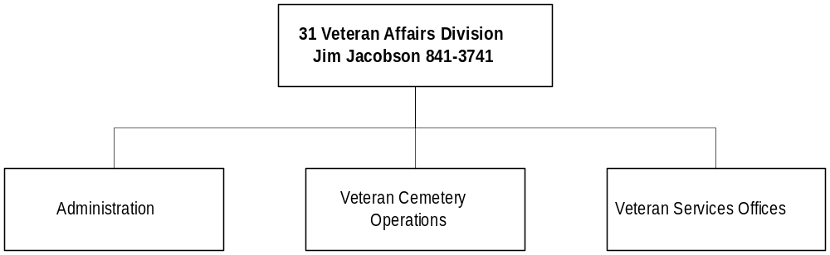

Program Description - The Veterans Affairs Division assists discharged veterans and their families, cooperates with state and federal agencies, promotes the general welfare of veterans, and provides information on veterans' benefits. The program also administers the veterans' cemeteries located at Miles City and at Fort Harrison, in Helena. The Board of Veterans' Affairs is administratively attached to the Department of Military Affairs, and operates under a state mandate provided in Title 10, Chapter 2, MCA.

Program Indicators –

Indicator | Actual FY1998 | Actual FY1999 | Actual FY2000 | Estimated FY2001 | Requested FY2002 | Requested FY2003
Benefits for Montana Veterans | $32M | $34M | $42M | $43M | $44M | $45M
Veteran Cemetery Burials | 115 | 126 | 149 | 180 | 210 | 240

Program Proposed Budget  Budget Item | Base  Budget  Fiscal 2000 | PL Base Adjustment  Fiscal 2002 | New  Proposals  Fiscal 2002 | Total  Exec. Budget  Fiscal 2002 | PL Base Adjustment  Fiscal 2003 | New  Proposals  Fiscal 2003 | Total  Exec. Budget  Fiscal 2003
FTE | 19.30 | 0.20 | 0.00 | 19.50 | 0.20 | 0.00 | 19.50
Personal Services | 624,467 | 26,433 | 0 | 650,900 | 30,707 | 0 | 655,174
Operating Expenses | 103,718 | 110,407 | 0 | 214,125 | 97,023 | 0 | 200,741
Equipment | 0 | 0 | 0 | 0 | 0 | 0 | 0
Total Costs | $728,185 | $136,840 | $0 | $865,025 | $127,730 | $0 | $855,915
General Fund | 666,918 | 48,107 | 0 | 715,025 | 38,997 | 0 | 705,915
State/Other Special | 61,267 | 88,733 | 0 | 150,000 | 88,733 | 0 | 150,000
Federal Special | 0 | 0 | 0 | 0 | 0 | 0 | 0
Total Funds | $728,185 | $136,840 | $0 | $865,025 | $127,730 | $0 | $855,915

Significant Present Law Adjustments -
- Expand Missoula field office service technician from 0.80 FTE to 1.00 FTE
- Maximize state special revenue accounts at the Montana State Veterans Cemetery
- Establish state special revenue funding for the operation of the Eastern Montana State Veterans Cemetery
- Support computer replacement and purchase of two copiers

