PROPRIETARY FUNDS

Introduction - Statute does not require enterprise or internal service funds to conform to the same budget development terms and procedures as other funds appropriated by the Legislature. In most cases, planned expenditures by the agencies responsible for these accounts are not reviewed or appropriated by the Legislature.

However, the executive is required by 17-7-123, MCA, to submit as part of the budget to the Legislature “a report on: enterprise funds including retained earnings and contributed capitol, projected operations and charges, and projected fund balances; and (b) fees and charges in the internal service fund type, including changes in the level of fees and charges, projected use of the fees and charges, and projected fund balances . . .” Any proprietary funds that are appropriated in HB 2 are not included in this report. HB 2 funds are shown in the Volume I agency tables, with a cross-reference to HB 576, which is the coding used to designate the non-HB 2 proprietary funds. The “HB 576” coding began in FY 1996 after passage and approval of Chapter 556, Laws of 1995. The coding has been continued as a shorthand matter of convenience.

Presented in this Proprietary Funds section are program narratives, program tables, specific narrative regarding each proprietary fund, the uniformly compiled fund balance tables, which are headed “Report on Internal Service and Enterprise Funds, 2005 Biennium” and applicable rates for internal service funds. This presentation will appear similar to that in the HB 2 sections A through E.

The executive has requested that the proprietary programs discuss relevant decision packages that affect the fund balance and impact the rates. In December 2001, the Legislative Finance Committee discussed internal service funds and encouraged the executive to create decision packages to provide additional information. They should be considered only a tool when reviewing rates for internal service funds, because the Legislature approves the maximum fees and charges for a biennium, rather than approving specific spending authority as in HB 2.

Enterprise Funds - The emphasis of this reporting format is on the analysis of fund balances. Enterprise funds (typically funds “060xx”) account for operations that are financed and operated in a manner similar to private enterprise, where the intent is to provide goods or services to the general public. Each agency that manages an enterprise fund is prepared to justify and provide documentation for the charges.

Internal Service Funds - The emphasis of this reporting format is on the analysis of fees and charges. The internal service funds (typically funds “065xx”) account for the financing of goods and services provided by one agency to other agencies of state government. Per 17-7-123(6)(b), MCA, “Fees and charges in the internal service fund type must be approved by the legislature in the general appropriations act. Fees and charges in a biennium may not exceed the level approved by the legislature in the general appropriation act effective for that biennium.”

The internal service fund tables list the rates upon which the Legislature must act. Agencies calculated these rates by considering federal guidelines, primarily OMB Circular A-87, since the rates must apply to and approved by federal programs, as well as by considering cash flow, working capitol needs, and current and projected fund equity.

Proprietary Rates

Program Proposed Budget  Budget Item | Base  Budget  Fiscal 2002 | PL Base Adjustment  Fiscal 2004 | New  Proposals  Fiscal 2004 | Total  Exec. Budget  Fiscal 2004 | PL Base Adjustment  Fiscal 2005 | New  Proposals  Fiscal 2005 | Total  Exec. Budget  Fiscal 2005
FTE | 0.00 | 0.00 | 0.00 | 0.00 | 0.00 | 0.00 | 0.00
Operating Expenses | 43,090 | 0 | 0 | 43,090 | 0 | 0 | 43,090
Total Costs | $43,090 | $0 | $0 | $43,090 | $0 | $0 | $43,090
Proprietary | 43,090 | 0 | 0 | 43,090 | 0 | 0 | 43,090
Total Funds | $43,090 | $0 | $0 | $43,090 | $0 | $0 | $43,090

Please note that a HB 2 section exists for this program.

Program Description - Law Library Searches/Research Enterprise Fund - The law library is billed by the on-line provider for the air time, and the law library in turn bills the requesting entity for the cost of the search performed.

Revenues and Expenses - The Law Library staff performs on-line searches/research for public and private entities. The law library is billed by the on-line provider for the air time and the Law Library, in turn, bills the entity requesting the search/research, collects the money and pays the provider.

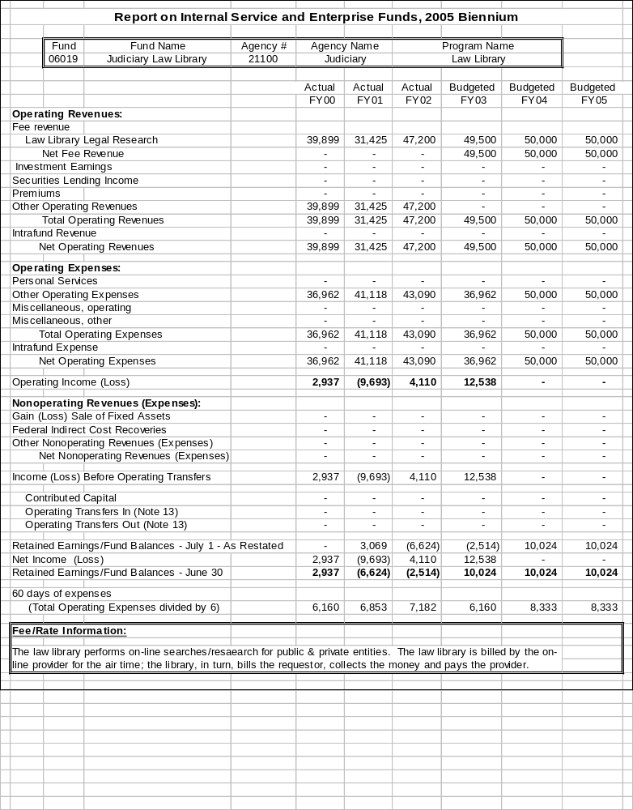

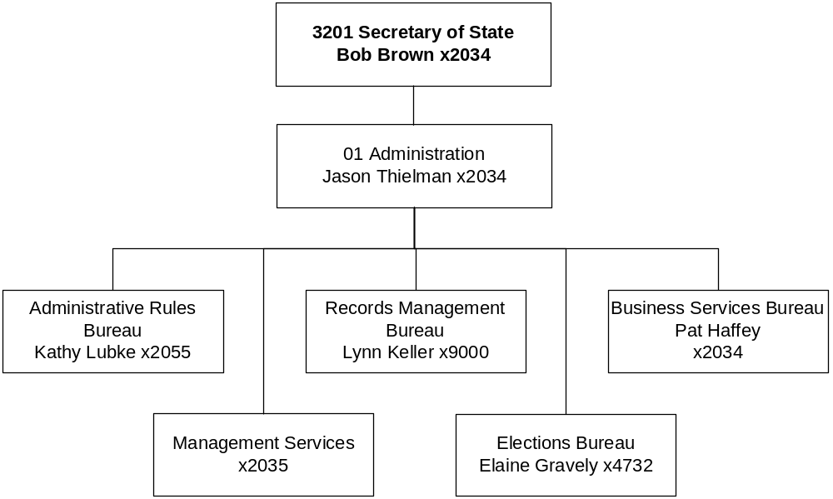

Proprietary Rates

Program Proposed Budget  Budget Item | Base  Budget  Fiscal 2002 | PL Base Adjustment  Fiscal 2004 | New  Proposals  Fiscal 2004 | Total  Exec. Budget  Fiscal 2004 | PL Base Adjustment  Fiscal 2005 | New  Proposals  Fiscal 2005 | Total  Exec. Budget  Fiscal 2005
FTE | 43.80 | 7.45 | 0.00 | 51.25 | 7.45 | 0.00 | 51.25
Personal Services | 1,774,081 | 75,237 | 60,000 | 1,909,318 | 73,230 | 45,000 | 1,892,311
Operating Expenses | 1,048,075 | 49,580 | 546,000 | 1,643,655 | 39,277 | 289,000 | 1,376,352
Equipment | 28,913 | 0 | 90,000 | 118,913 | 0 | 25,000 | 53,913
Total Costs | $2,851,069 | $124,817 | $696,000 | $3,671,886 | $112,507 | $359,000 | $3,322,576
Proprietary | 2,851,069 | 124,817 | 696,000 | 3,671,886 | 112,507 | 359,000 | 3,322,576
Total Funds | $2,851,069 | $124,817 | $696,000 | $3,671,886 | $112,507 | $359,000 | $3,322,576

Program Description - The Office of the Secretary of State conducts its daily operations through a single program, the Business and Government Services Program. The program receives its entire funding from one enterprise fund and one internal service fund.

Revenues and Expenses - The Office of the Secretary of State administers two proprietary funds. The first, an internal service fund, receives revenue from fees charged to state agencies for managing agency records. The second fund is an enterprise fund that receives revenues from fees charged to businesses and corporations for corporate filings, registration of assumed business names and trademarks, for publishing and distributing the Administrative Rules of Montana (ARM) and the Montana Administrative Register (MAR) and for election filing fees and notary fees. The Legislature does not set rates for the enterprise fund.

Rate Explanation - Internal service fund rates are based upon a best estimate of the cost to provide each individual service. Fees are fixed for all customers and 100 percent of the costs of operating the Secretary of State's internal service fund operations are recovered by fees.

--------------------------------- Present Law Adjustments --------------------------------

Total Agency Impact | General Fund Total
FY04 $186,908 | FY04 $0
FY05 $187,397 | FY05 $0
PL- 1 - Increase FTE for Enterprise Fund -
This proposal requests 7.45 FTE. The 5.00 FTE seasonal staff will be available from four to eleven months out of the year. Savings from reducing contractor costs, decreasing training time, and creating a pool of returning staff will offset the costs associated with these seasonal positions. In addition, the request includes 0.95 FTE exempt staff, 1.00 FTE mailroom clerk, and 0.50 FTE administrative support.

---------------------------------------- New Proposals ----------------------------------------

Total Agency Impact | General Fund Total
FY04 $696,000 | FY04 $0
FY05 $359,000 | FY05 $0
NP- 2 - IT Plan -
The Secretary of State's Corporations system was originally developed in 1982, and stores 150,000 business files including 300,000 paper document files, some of which date back over 100 years. The system is used by internal staff to respond to over 52,000 customer service calls each year. The public can access the information on-line as well. The system is used to distribute over 56,000 annual reports that are reviewed for compliance and entered back into the system. Compliance officers use the system to review another 60,000 documents for compliance with statutes regulating registration of business structures including profit and nonprofit corporations, partnerships, limited partnerships, limited liability partnerships, limited liability companies, and professional limited liability companies, assumed business names and trademarks. This application is now 20 years old and ITSD no longer has the capabilities to support it. The project will be financed with existing resources.

Administrative Rules of Montana receives over 8,000 replacement pages per year to the published copy of ARM. Many of these pages are not properly formatted requiring many hours to properly format. Staff from both the Secretary of State and the submitting agency spend too much time formatting and correcting these pages. Through process re-engineering and automation, these pages could be ready both for hard copy printing and submission to the Internet in much less time. The project will be financed with existing resources.

The office has approximately 1500 cu.ft. of boxes or 3,000,000 historically-significant corporate records, e.g., articles of incorporation, by-laws, annual reports. All documents will be filmed and scanned simultaneously and then indexed. The equipment used will be Hybrid Document Scanners capable of creating a digital image and microfilm at the same time. The project will be financed with existing resources.

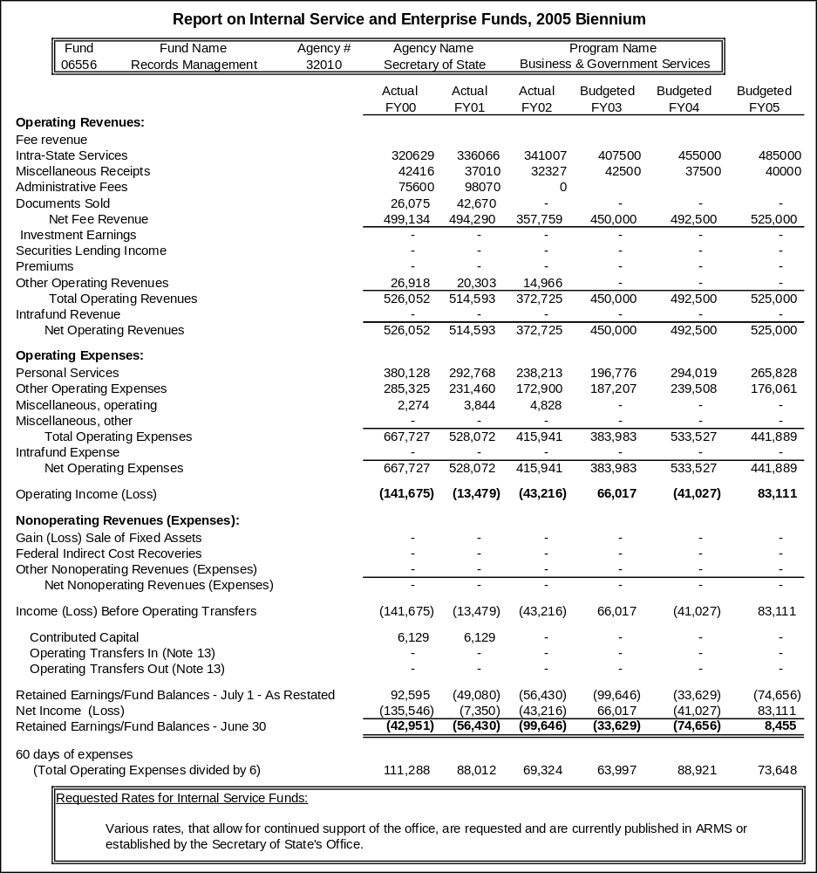
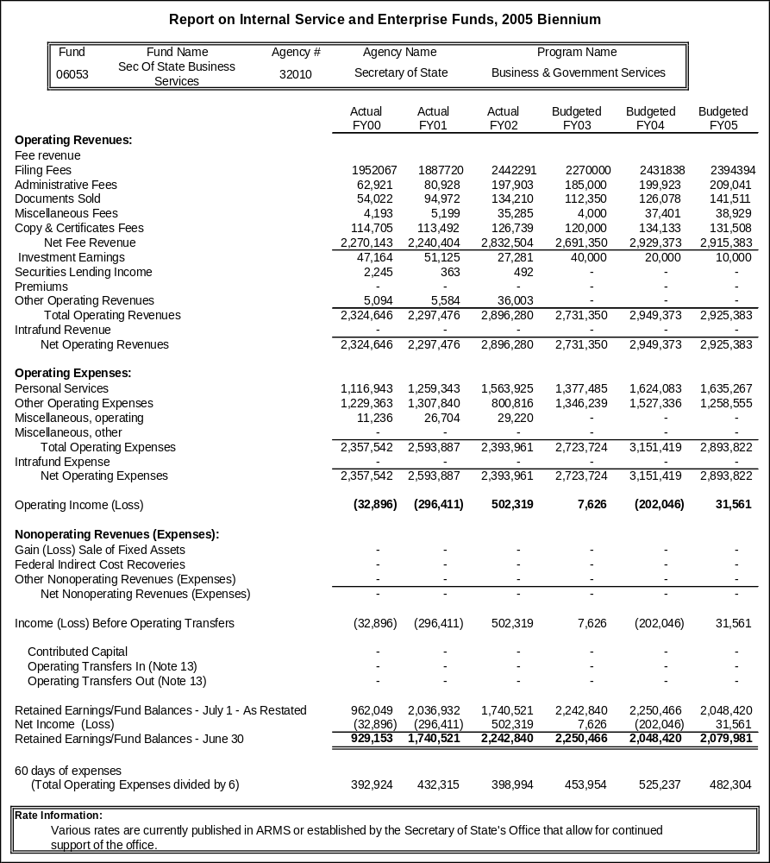
Proprietary Rates

Program Proposed Budget  Budget Item | Base  Budget  Fiscal 2002 | PL Base Adjustment  Fiscal 2004 | New  Proposals  Fiscal 2004 | Total  Exec. Budget  Fiscal 2004 | PL Base Adjustment  Fiscal 2005 | New  Proposals  Fiscal 2005 | Total  Exec. Budget  Fiscal 2005
FTE | 6.00 | 0.00 | 0.00 | 6.00 | 0.00 | 0.00 | 6.00
Personal Services | 244,720 | 15,024 | 0 | 259,744 | 15,063 | 0 | 259,783
Operating Expenses | 1,131,919 | 341,859 | 0 | 1,473,778 | 431,617 | 0 | 1,563,536
Equipment | 2,043,298 | 3,114,341 | 0 | 5,157,639 | 2,004,154 | 0 | 4,047,452
Debt Service | 318,652 | 0 | 0 | 318,652 | 0 | 0 | 318,652
Total Costs | $3,738,589 | $3,471,224 | $0 | $7,209,813 | $2,450,834 | $0 | $6,189,423
Proprietary | 3,738,589 | 3,471,224 | 0 | 7,209,813 | 2,450,834 | 0 | 6,189,423
Total Funds | $3,738,589 | $3,471,224 | $0 | $7,209,813 | $2,450,834 | $0 | $6,189,423

Program Description - The State Motor Pool operates and maintains a fleet of vehicles available to all state offices and employees who conduct official state business. The State Motor Pool has two basic components: 1) the daily rental fleet and 2) the out-stationed lease fleet. The daily rental program operates out of the Helena headquarters facility and provides vehicles for short-term use. The leasing program provides vehicles for extended assignment (biennial lease) to agencies statewide.

Other Options to Use of the Program - Use of the program is optional to agencies when personnel are required to travel by vehicle for official state business, but is encouraged in the Montana Operations Manual. Other options for state employees are: 1) other state-owned vehicles not part of the State Motor Pool fleet; 2) personal vehicles, with authorization provided by the agency director; or 3) vehicles from a private rental agency contract. State law encourages use of the program through a reimbursement rate for use of personal vehicles for state business travel that are set $0.03 per mile lower than the Internal Revenue Services rate unless a State Motor Pool vehicle is not available.

Significant Program Growth - The program has increased from 318 units in FY 1994 to 783 in FY 2002. During that time, annual mileage increased from 4.1 million to 11.1 million miles. This growth in the number of vehicles and miles traveled is largely due to the practice of the Office of Budget and Program Planning stipulating agencies to lease new vehicles from the State Motor Pool instead of budgeting agencies to purchase vehicles directly.

FYE1996 278 Units 4,467,473 miles
FYE1997 319 Units 5,357,648 miles
FYE1998 389 Units 6,503,851 miles
FYE1999 494 Units 8,007,999 miles
FYE2000 589 Units 10,212,742 miles
FYE2001 715 Units 11,106,543 miles
FYE2002 821 Units 11,451,900 miles (pre-auction unit totals) Projected
FYE2003 836 Units 11,673,100 miles (pre-auction unit totals) Projected
FY 2004 834 Units 11,042,738 miles (53 units sold & deleted from fleet) Projected
FY 2005 864 Units 11,354,160 miles Projected

Fluctuations in mileage and in the fleet totals in FY 2002 and FY 2003 are due to the motor pool taking various actions to mitigate for the projected program loss. Actions include running more vehicles in the fleet and purchasing fewer replacement units to decrease the loan and loan interest payments.

Revenue Description - Revenue is generated through vehicle rental fees and from the gain on sale of surplus assets. Vehicle rental fees provide the majority -- about 98 percent in FY 2002 -- of the revenue for the program. Rental fee revenues are functionally tied to the travel requirements of various user agencies. The program also receives revenue resulting from accident damages reimbursed by private individuals or insurance companies. The amount generally covers the expenditures to repair the damage.
Vehicle rental fees come from two service classes: 1) short-term rentals and 2) long-term leases. Short-term rentals serve agency personnel generally located in the Helena area who need to travel to other state locations and return to Helena at the culmination of the travel event. Long-term leases serve agencies with personnel housed in offices in Helena and in other parts of the state and who frequently travel as a normal part of their work assignments. Long-term vehicles are not picked up or returned to the State Motor Pool facilities but are typically housed and managed out of agency office locations and only returned to the State Motor Pool facilities for maintenance or reassignment.

Expense Description - The State Motor Pool is responsible for expenses associated with the acquisition, repair, maintenance, and routine operating costs for the fleet. The program pays all costs directly associated with vehicle operations including liability insurance. Motor Pool is reimbursed for costs directly attributable to operator abuse and accident costs caused by an outside party. User agencies can pay for optional full coverage insurance costs associated with employee use of State Motor Pool vehicles. This option is strongly encouraged as it benefits the motor pool by not having to pay for repairs due to accident. It also benefits the user, as repairs can be made and in some cases, when a vehicle is in an accident and considered totaled, the vehicle can be replaced and not restricted by the motor pool's budget.

The majority of the costs of the program are indirect costs, as they cannot be traced directly to specific miles driven by State Motor Pool vehicles. Indirect costs are supported by the assigned rates allocated to the seven classes of vehicles. Direct costs, such as gasoline, oil, and tires, are supported by the usage rates for all seven classes of vehicles. The allocations of indirect costs and direct costs use the same methodology for all rates to which they apply. The program has included a 3 percent increase in projected costs. This has been an industry standard of increase for vehicle purchase costs and projected costs of repairs and maintenance. As unit purchase prices increase, the parts to repair increase accordingly.

The program uses loans from the Board of Investments (BOI) to fund vehicle purchases. Interest rates on BOI loans are adjusted annually and vary from one purchase cycle to the next. The outstanding loan balance and interest and principal payments have the greatest impacts on motor pool rental rates.

Working Capital Discussion - Rental rates are set to recover sufficient revenue to meet loan principal and interest payments, operating costs, and allow maintenance of no more than a 60-day working capital balance. If the program does not generate sufficient revenue to make interest and principal payments, a short-term loan would be obtained or assets would have to be sold to satisfy the loan obligations. The program billing and payment cycles support the accumulation of a 60-day working capital balance. User agencies are billed monthly and payments are requested to pay for services by the end of the next month. This allows the program to make monthly expense payments and accumulate adequate working capital to pay quarterly interest payments on the BOI loans and the annual payment on loan principal due June 30th. The program was not able to attain an adequate working capital level during the base year. The program has included a factor to increase the working capital balance in the 2005 biennium rate request.

Fund Equity and Reserve Fund Balance - The program rents vehicles for use by other state government entities. The number of vehicles in the program has grown to 783 vehicles, nearly 2 ½ times the 1994 fleet size. Because of this growth and federal regulations, the program needed to borrow funds to purchase new vehicles.
As such, the balance sheet for the program has $13.8 million in equipment assets with vehicles comprising nearly 100 percent of total assets. The equipment assets are depreciated to nearly 30 percent of their cost, for a book value of $9.6 million financed by $7.7 million of long-term debt. The resultant fund equity is $2.1 million or 15.2 percent of total assets. An adjustment to decrease the balance in fund equity is included in the rates. The adjustment is for net income gains from 1998 - 2002. The gains will be reflected in the rates as a decrease and is split equally between each fiscal year.

Rate Explanation - The State Motor Pool rental rates are based on a two-tiered rate structure. Users pay a usage rate and an assigned rate. The usage rate is charged for actual miles driven and allows the program to recover costs directly related to the operation of the vehicle, such as repair labor and parts, fuel, lubricants, tires, and tubes. The assigned rate allows the program to cover fixed costs associated with state ownership, such as insurance, principal and interest payments on BOI loans, depreciation, and other indirect expenses. The two-tiered rate structure first used in the 2003 biennium provides: 1) more stable revenue to make loan payments and other cost obligations; and 2) equity among all vehicles classes so that one vehicle class does not subsidize another vehicle class.

The motor pool management system cost history for the two-tiered rate related to direct and indirect costs for each vehicle class was used to project final costs for FY 2002 and FY 2003 and budgeted costs for FY 2004 and F Y2005. Adjustments to current costs were made to allow for additional lease vehicles in the fleet for the 2005 biennium, for increases to the interest rate and operational costs.

The rates using the two-tiered structure are applied as follows for the two components of the State Motor Pool:

Daily rental:
Cost (per occurrence) = (HR x AR) + (AM x MR),
Out-stationed lease:
Cost (annual) = (2920 x AR) + (AM x MR),

where:
HR = number of hours the vehicle was used (Flat rate - 8 hours for each day of use, including weekends);
AR = per hour assigned rate;
AM = actual miles traveled
MR = per mile operated rate.

For the 2005 biennium, the State Motor Pool requests legislative approval of the rates shown in Table 1.

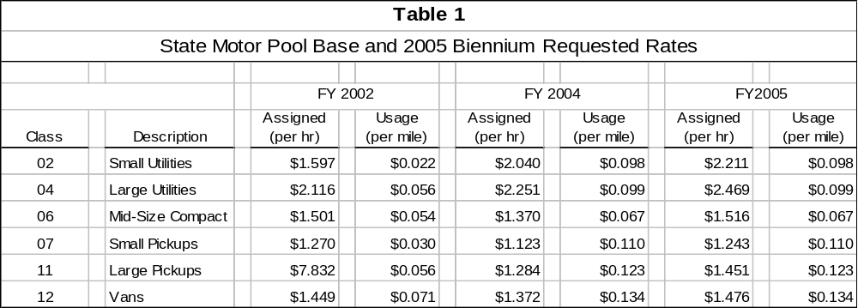

--------------------------------- Present Law Adjustments --------------------------------

Total Agency Impact | General Fund Total
FY04 $3,146 | FY04 $0
FY05 $3,146 | FY05 $0
PL- 701 - Overtime and Differential -
This request is to reestablish base year overtime and differential pay with associated benefits. The biennial cost is $6,292 of proprietary funds.
________________________________________________________________________________________________

Total Agency Impact | General Fund Total
FY04 $3,114,341 | FY04 $0
FY05 $2,004,154 | FY05 $0
PL- 702 - Additional Units -
The Office of Budget and Program Planning promotes the use of the State Motor Pool to all state agencies in order to capture the efficiencies of a centralized program, as recommended in a legislative audit several biennia ago. When the need for new or replacement vehicles arises in a state agency, the agency is required to show a savings before the vehicle can be included in its budget rather than in the motor pool. The program would purchase 273 vehicles in FY 2004 and 194 vehicles in FY 2005, including both new and replacement vehicles. The cost of purchasing approved new vehicles as well as replacements for existing fleet vehicles for the 2005 biennium is $5,118,495 of proprietary funds.
________________________________________________________________________________________________

Total Agency Impact | General Fund Total
FY04 $267,473 | FY04 $0
FY05 $313,956 | FY05 $0
PL- 703 - Fuel for Increased Units -
The request includes $267,473 proprietary fund in FY 2004 and $313,956 proprietary funds in FY 2005 to purchase fuel for the additional vehicles added to the State Motor Pool fleet in these fiscal years.

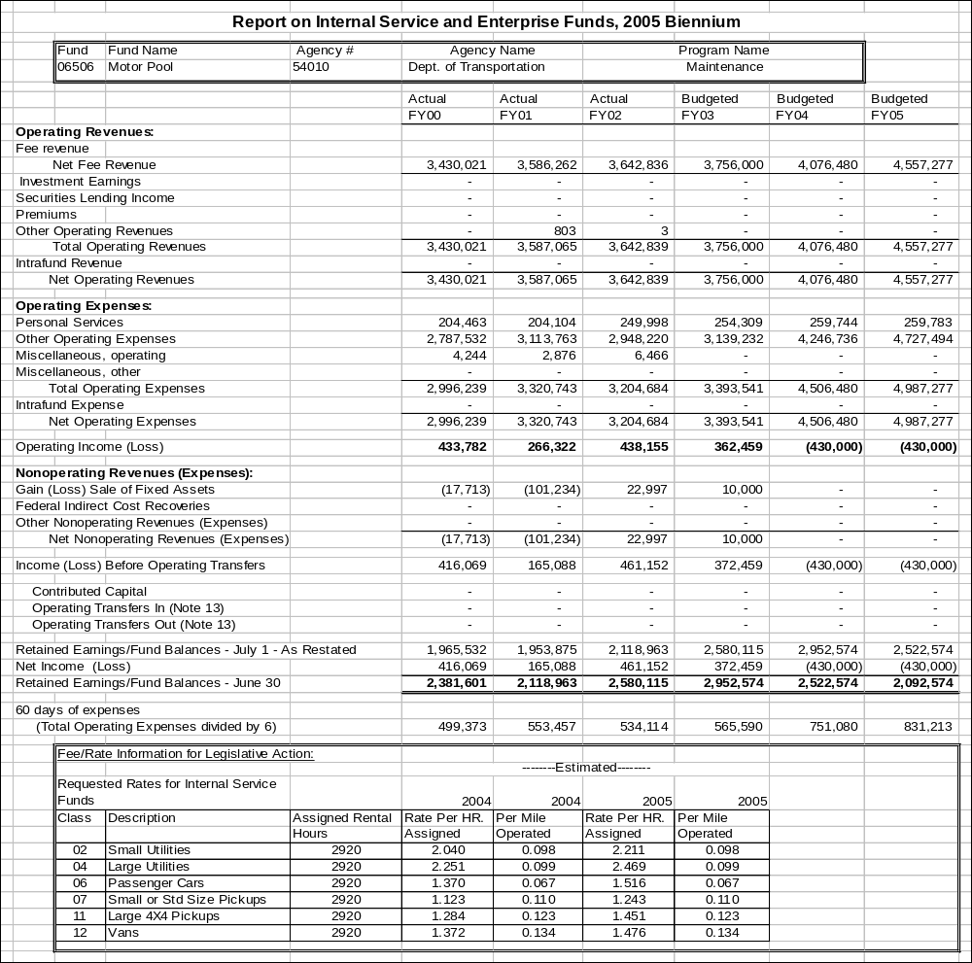
Proprietary Rates

Program Proposed Budget  Budget Item | Base  Budget  Fiscal 2002 | PL Base Adjustment  Fiscal 2004 | New  Proposals  Fiscal 2004 | Total  Exec. Budget  Fiscal 2004 | PL Base Adjustment  Fiscal 2005 | New  Proposals  Fiscal 2005 | Total  Exec. Budget  Fiscal 2005
FTE | 122.00 | 0.00 | 0.00 | 122.00 | 0.00 | 0.00 | 122.00
Personal Services | 5,060,598 | 665,948 | 0 | 5,726,546 | 684,389 | 0 | 5,744,987
Operating Expenses | 7,225,978 | 402,828 | 0 | 7,628,806 | 526,267 | 0 | 7,752,245
Equipment | 5,743,784 | 676,145 | 0 | 6,419,929 | 676,145 | 0 | 6,419,929
Total Costs | $18,030,360 | $1,744,921 | $0 | $19,775,281 | $1,886,801 | $0 | $19,917,161
Proprietary | 18,030,360 | 1,744,921 | 0 | 19,775,281 | 1,886,801 | 0 | 19,917,161
Total Funds | $18,030,360 | $1,744,921 | $0 | $19,775,281 | $1,886,801 | $0 | $19,917,161

Program Description - The Equipment Program is responsible for the acquisition, disposal, repair and maintenance of a fleet of approximately 4,600 individual units. The fleet is comprised of light duty vehicles, single and tandem axle dump trucks, specialized snow removal units, roadway maintenance units and other specialized equipment. Exclusively the Department of Transportation's various programs such as Construction, Motor Carrier Services, Maintenance, and Right-of-Way use the fleet. All units are assigned to the various user programs and are charged rental on a bi-weekly basis. There are 122.00 FTE in the Equipment Program.

Program Growth - The program has increased the fleet size over the last two biennia due to: increased construction program funding from TEA 21, the department's assumption of secondary roads and need for staffing adequate to support, repair and maintain the fleet.

FYE1997 4041 Units 20,115,826 miles
FYE1998 4039 Units 17,508,471 miles
FYE1999 4169 Units 18,712,127 miles
FYE2000 4282 Units 19,602,485 miles
FYE2001 4632 Units 21,962,128 miles
FYE2002 4609 Units 22,855.416 miles

Revenue Description - Revenue is generated through the vehicle/equipment rental fees and from the gain on sale of surplus assets. Vehicle rental fees provide the majority of the revenue for the program.

Revenues for the fleet are functionally tied to the severity of the winter, construction program workload, and travel requirements of the various department users. Annual mileage and hours of usage can vary significantly. The program anticipates an increase in miles of travel and hour of usage due to the department's goal of improving the service to the traveling public. The rental rates will be set to cover anticipated increased expenditures for fuel, cutting edges for snowplows and repair parts that are a result of the increased usage. The rates will be sufficient to recover revenue to meet the program obligations.

Expense Description - The Equipment Program is responsible for expense associated with the acquisition, repair, maintenance, and routine operating costs for the fleet. The program pays all cost directly associated with vehicle/equipment operation including liability insurance. Equipment is reimbursed for accident costs caused by an outside party and is reimbursed for any warranty work that was completed by the department's personnel.

Indirect costs are costs that cannot be traced directly to specific usage of the vehicles and equipment. Indirect costs are supported by the assigned rates allocated to each of the equipment fleet class-subclasses. Direct costs, such as gasoline, oil, and tires, are supported by the usage rates for the fleet. The allocations of indirect costs and direct costs use the same methodology for all rates to which they apply.

The program is requesting an increase in equipment replacement to keep the program soluble with its current replacement schedule. The increase is a more accurate reflection of anticipated actual depreciation. If the increase is not approved, the program will not have the ability to replace fleet units at their set life schedules. Units would have to be maintained longer, resulting in increased operational costs.

Working Capital Discussion - Equipment rental rates are set to recover sufficient revenue to purchase assets, cover normal operating expenses and maintain no more than a 60-day working capital balance. Revenue is generated through rental rates, gain on sale of surplus assets, and damage settlements. The primary source of revenue is from user rental rates charged for the use and possession of vehicles and equipment. Rental rates are based on a dual rate structure for actual miles driven (usage rate) and a possession rate (assigned rate). Actual miles of travel and hours of usage are reported biweekly and billings are generated on the same schedule as payrolls. Approximately $700,000 in rental revenue is generated every two weeks. Rental revenue varies with the season, weather conditions and workloads. Auction revenue varies depending number and types of units being sold. The program also receives incidental revenues for accident damages that are reimbursed by private individuals or insurance companies. The amount generally covers the expenditures to repair the damage. If the program doesn't generate sufficient revenue to meet these obligations then the program would have to either liquidate assets or receive a loan.

Fund Equity and Reserved Fund Balance - The fund equity balance shows an increase that is a result of the fleet increase required to assume maintenance of the secondary roads. Revenues are anticipated to equal operation expenditures and the working cash is projected to be less than the 60 days maximum allowable by the end of each fiscal year. Each fiscal year since 1999, federal money has been available to purchase equipment. The equipment is then donated to the Equipment Program and the donated equipment contributes to the increase in the fund equity balance. The Equipment Program will have to maintain the equipment and will replace the units when life cycle and cost dictates replacement.

Cash Flow Discussion - The Equipment Program is internal to the Department of Transportation only. The cash flow is dependent on rental revenue and auction proceeds. If we incur a heavy winter season, there is higher usage and additional rental is received. The Equipment Program cash balance is generally less than the allowable 60-day maximum. With less than 60-day cash the program, at times, does not have sufficient cash to cover obligations that must be paid at the beginning of each fiscal year (auto liability insurance). To meet those obligations, the program negotiates an inter-entity loan from the Highway State Special Revenue Account. The loan covers day-to-day operating expenses, and the annual insurance payment, until revenues have a chance to catch up with expenses. The loan is repaid by fiscal year end. The rental rates will generate sufficient revenues to purchases assets, cover normal operating expenses and not exceed the 60-day operating cash balance.

Rate Explanation - The rental rates are based on a two-tiered rate structure. The users pay a usage rate and an assigned rate. The usage rate is a per mile or hourly rate that is applied to a vehicle or piece of equipment for the actual miles/hours used and is designed to recover "direct costs" that include labor, parts, fuel, lubricants, tires and tubes. The assigned rate is designed to recover "fixed costs" such as insurance, depreciation, and indirect costs. Rental rates are adjusted yearly. The rates are based on the actual operational costs for each sub-class for the base rental period. These costs are adjusted to reflect changes in operations or operating costs from the base. The program's financial position also is considered in the rate development process in order to maintain a cash balance that will not exceed the 60-day maximum cash balance requirement. The program is requesting approval of the rental rates on a 60-day working capital basis. The effects are internal to the DOT and the program is held accountable to ensure the rates recover only needed operational monies.

--------------------------------- Present Law Adjustments --------------------------------

Total Agency Impact | General Fund Total
FY04 $876,145 | FY04 $0
FY05 $876,145 | FY05 $0
PL- 801 - Equipment Replacement Increase -
The request is for $876,145 proprietary funds each year of the biennium for the purchase of supplies and equipment that have reached the end of their functional life and need to be replaced. Average replacement equates to about 450 units replaced per year.
________________________________________________________________________________________________

Total Agency Impact | General Fund Total
FY04 $87,429 | FY04 $0
FY05 $87,429 | FY05 $0
PL- 802 - Overtime and Differential -
Base year overtime and differential pay with associated benefits are reestablished at a biennial cost of $174,858 proprietary funds.
________________________________________________________________________________________________

Total Agency Impact | General Fund Total
FY04 $50,000 | FY04 $0
FY05 $50,000 | FY05 $0
PL- 803 - Fleet Management System -
The executive recommends $50,000 proprietary funds each year of the biennium to modify the Fleet Management System in order to coordinate with the department-wide Common Cost Coding Initiative.

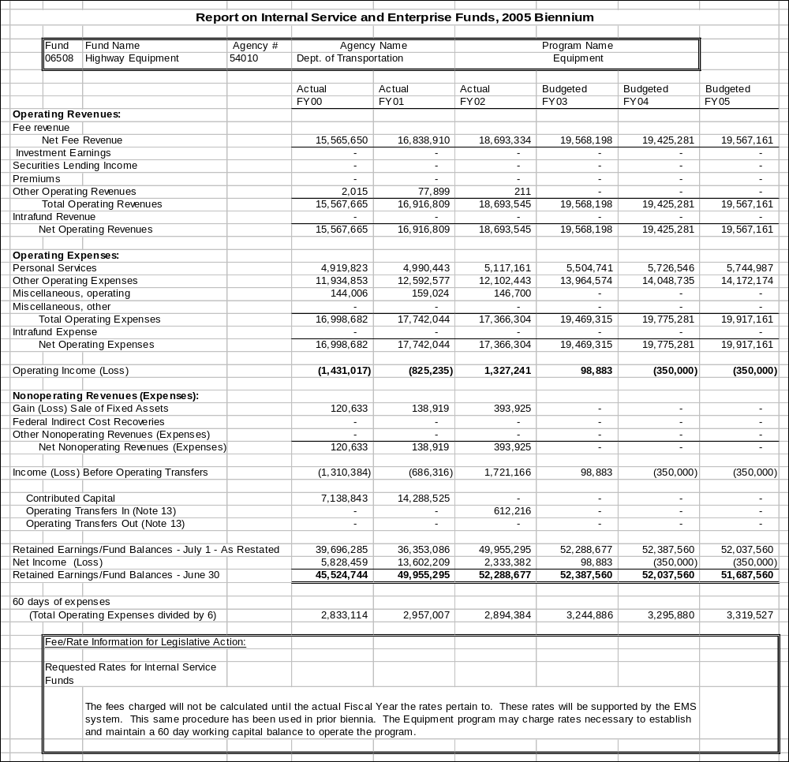
Proprietary Rates

Program Proposed Budget  Budget Item | Base  Budget  Fiscal 2002 | PL Base Adjustment  Fiscal 2004 | New  Proposals  Fiscal 2004 | Total  Exec. Budget  Fiscal 2004 | PL Base Adjustment  Fiscal 2005 | New  Proposals  Fiscal 2005 | Total  Exec. Budget  Fiscal 2005
FTE | 1.29 | 0.00 | 0.00 | 1.29 | 0.00 | 0.00 | 1.29
Personal Services | 34,071 | 11,803 | 0 | 45,874 | 11,728 | 0 | 45,799
Operating Expenses | 29,498 | 3,812 | 200,000 | 233,310 | 4,035 | 0 | 33,533
Total Costs | $63,569 | $15,615 | $200,000 | $279,184 | $15,763 | $0 | $79,332
Proprietary | 63,569 | 15,615 | 200,000 | 279,184 | 15,763 | 0 | 79,332
Total Funds | $63,569 | $15,615 | $200,000 | $279,184 | $15,763 | $0 | $79,332

Program Description - The West Yellowstone Airport provides a fly-in gateway to the town of West Yellowstone, Yellowstone Park, and surrounding US Forest Service area recreational opportunities. The airport is seasonal in its operation matching the peak tourist demand of the area from June 1st to September 30th annually. The airport serves as an Inter-Agency Fire Control Center with both smoke jumpers and fire retardant bombers located at the airport. The airport accomplishes these missions with extensive facilities to accommodate aircraft that range in size from C-5 Galaxy to Cessna 172, general aviation type aircraft.

Facilities are a terminal building that has as tenants a cafe, gift shop, two car rental agencies, fixed based operation (FBO) serving general aviation, and Skywest Airlines. The airport has an 8,399' X 150' runway with full parallel taxiway. The airport is fully instrumented for landings in inclement weather. Additionally, the airport has a crash fire rescue building with a crash fire rescue truck for airport emergencies. The airport is certified by the Federal Aviation Administration in the Limited Operating Class category.

Fees for provided services are market based. There are no increases planned in the 2005 biennium for landing fees, building fees, fuel flowage fees, sales receipts, and non-aero rentals.

The West Yellowstone Airport is funded with an enterprise proprietary fund. There are 1.29 FTE budgeted to this fund.

Revenues and Expenses -
Change in Services or Fees: No change in services or fees will occur in the 2005 biennium.

Working Capital Discussion: Annual expenses at the airport average $80,000/year. Based on this history, the fund must maintain a balance of $14,000 to comply with the 60-day expense formula.

Fund Equity and Reserved Fund Balance: The West Yellowstone Airport proprietary fund balance continues to increase. Management objectives are to continue to increase the fund balance.

Cash Flow Discussion: There is no fluctuation of cash into the program. A steady increase in the fund balance continues each year. There is not any significant reoccurring cash obligations that must be covered by cash on hand or loans.

Rate Explanation - Fees for provided services are market based. There are no increases planned in the 2005 biennium for landing fees, building fees, fuel flowage fees, sales receipts, and non-aero rentals.

--------------------------------- Present Law Adjustments --------------------------------

Total Agency Impact | General Fund Total
FY04 $1,886 | FY04 $0
FY05 $1,886 | FY05 $0
PL- 4014 - Program/Service Cost Adjustments - Prop -
The request includes $1,886 proprietary funds for miscellaneous operating adjustments including janitorial services, fuel, travel, utilities, and trash removal.

---------------------------------------- New Proposals ----------------------------------------

Total Agency Impact | General Fund Total
FY04 $200,000 | FY04 $0
FY05 $0 | FY05 $0
NP- 4011 - Runway Rehab West Yellowstone Airport - Prop -
The West Yellowstone Airport runway rehabilitation 10 percent match will be $200,000 of proprietary funds in a biennial appropriation.

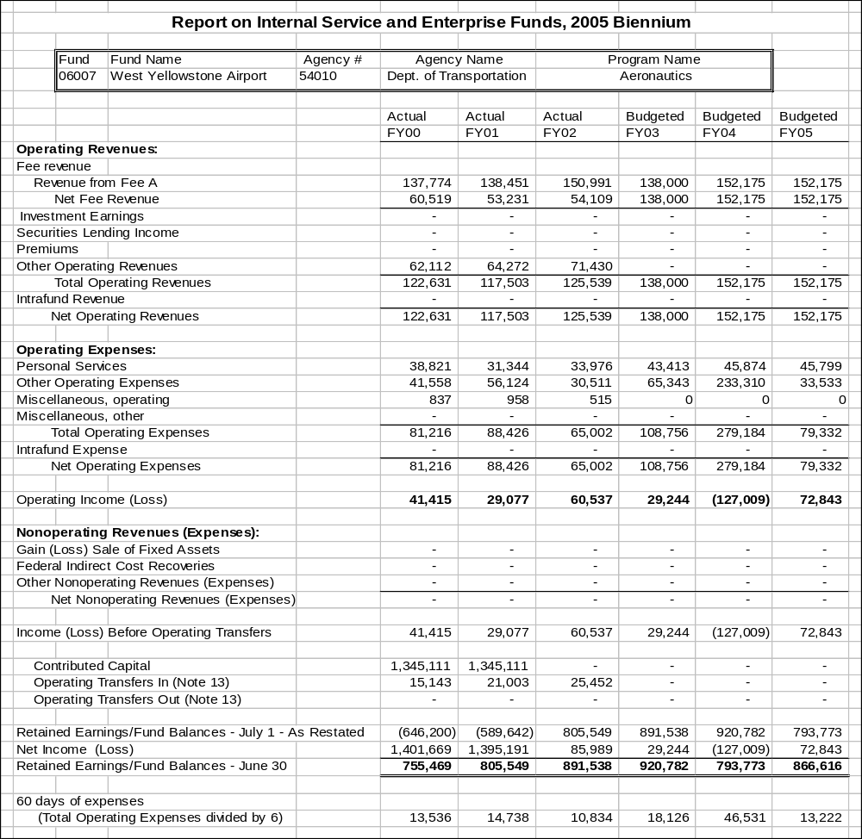

Proprietary Rates

Program Proposed Budget  Budget Item | Base  Budget  Fiscal 2002 | PL Base Adjustment  Fiscal 2004 | New  Proposals  Fiscal 2004 | Total  Exec. Budget  Fiscal 2004 | PL Base Adjustment  Fiscal 2005 | New  Proposals  Fiscal 2005 | Total  Exec. Budget  Fiscal 2005
FTE | 3.50 | 0.00 | 0.00 | 3.50 | 0.00 | 0.00 | 3.50
Personal Services | 96,927 | 19,935 | 0 | 116,862 | 19,640 | 0 | 116,567
Operating Expenses | 22,521 | 421 | 0 | 22,942 | 2,083 | 0 | 24,604
Total Costs | $119,448 | $20,356 | $0 | $139,804 | $21,723 | $0 | $141,171
Proprietary | 119,448 | 20,356 | 0 | 139,804 | 21,723 | 0 | 141,171
Total Funds | $119,448 | $20,356 | $0 | $139,804 | $21,723 | $0 | $141,171

Please note that a HB 2 section exists for this program.

Program Description - Section 17-4-103, MCA, allows the Department of Revenue (DOR) to assist state agencies in the collection of delinquent accounts. State law also allows the department to retain a percent of the collections for the costs of assistance. The department established the Collections Services Program, which is the only internal service fund in the department, to perform the duties required for collecting on delinquent accounts. Currently there are 3.50 FTE dedicated to collecting revenue on the delinquent accounts. This program supports the central bad debt collection function for the State of Montana that was previously at the Department of Administration and State Auditor's Office.

Revenues and Expenses - The department charges a 10 percent commission for collecting on delinquent accounts. These funds are used to pay the expenses of the Collection Services Program. Approximately 84 percent of the costs are for paying salaries and benefits of the employees in this program. The remaining costs are related to rent, computer access and processing, and the program portion of the statewide fixed costs. The revenue account related to this activity is 520231 (debt collections).

Rate Explanation - The accounts receivable commission is currently 10 percent. The department is not requesting a change in the rate charged for the 2005 biennium.

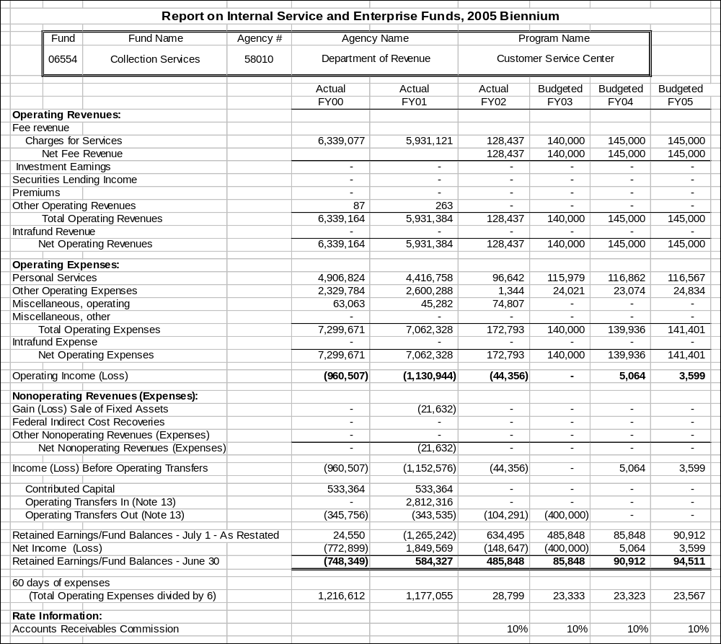

Proprietary Rates

Program Proposed Budget  Budget Item | Base  Budget  Fiscal 2002 | PL Base Adjustment  Fiscal 2004 | New  Proposals  Fiscal 2004 | Total  Exec. Budget  Fiscal 2004 | PL Base Adjustment  Fiscal 2005 | New  Proposals  Fiscal 2005 | Total  Exec. Budget  Fiscal 2005
FTE | 18.83 | 0.50 | 6.33 | 25.66 | 0.50 | 6.33 | 25.66
Personal Services | 700,354 | 105,501 | 393,143 | 1,198,998 | 106,632 | 392,130 | 1,199,116
Operating Expenses | 800,748 | 230,071 | 105,650 | 1,136,469 | 55,462 | 106,543 | 962,753
Total Costs | $1,501,102 | $335,572 | $498,793 | $2,335,467 | $162,094 | $498,673 | $2,161,869
Proprietary | 1,501,102 | 335,572 | 498,793 | 2,335,467 | 162,094 | 498,673 | 2,161,869
Total Funds | $1,501,102 | $335,572 | $498,793 | $2,335,467 | $162,094 | $498,673 | $2,161,869

Please note that a HB 2 section exists for this program.

Program Description - Legal Services Unit (Fund 06504)
The Legal Unit of the Director's Office advises all divisions within the department on legal matters. The unit receives the majority of its funding through the legal services internal service fund by charging the non-general fund divisions for services provided. The program funds 2.08 FTE. This number increased by 0.75 FTE in the 2003 biennium due to the additional support of four programs through the reorganization of Department of Commerce. The only alternative to this program would be contracting for legal assistance or hiring an attorney within the divisions.

Network Support Unit (Fund 06560)
The Network Support Unit administers all data processing functions of the department except those of the ITSD. The unit provides network support services, including installing software and hardware, responding to computer problems, and answering software questions. The unit also provides computer-programming services. The program funds 3.00 FTE, including the 1.00 FTE increase in the 2003 biennium due to the programs added in the reorganization of Department of Commerce. The program provided $1,214 of competency pay adjustment to network staff in FY 2002, which was funded by equipment budget savings.

Warrant Writer Program (Fund 06564)
The department provides the services of the Warrant Writer Program to most state agencies for check writing and automatic-deposit capabilities for financial transactions. The program produces and processes warrants and tracks them on the warrant writer system. The program generates, mails, tracks, and cashes each warrant. The services the program offers include direct deposit, warrant consolidation, stopping of payments, warrant cancellations, emergency warrants, duplicate warrants, warrant certification, warrant research, payee file data, and federal 1099-MISC processing. The program funds 5.00 FTE and is authorized through 17-8-305, MCA. The program provided $7,105 of competency pay adjustment to accounting staff in FY 2002, which was funded from equipment budget savings. No alternative exists for agencies that need checks processed and funds transferred to vendors electronically if they use the state accounting system.

The system handles about two million payment transactions per year. Payment transactions include warrant writing and electronic transfers for vendor payments, retirement payments for public employees and teachers, payroll, worker's compensation, income tax refunds, special refunds, and public assistance benefit payments. In addition, the program maintains a central payee file to facilitate payment processing. The program is also responsible for consolidation of 1099-MISC information for the Internal Revenue Service. The program coordinates compliance with IRS rules governing 1099 MISC-filings and error reports.

Human Resource Unit (Fund 06570)
The Human Resource Unit processes payroll and provides new employee orientation for all divisions within the department, including attached-to agencies, assists with recruitment and selection, classifies positions and develops personnel policies and procedures. The program funds 2.75 FTE. One FTE was added in the 2003 biennium to provide support for the programs transferred in the reorganization of Department of Commerce. The only alternative to this internal service fund would be to fund the function through the general fund.

Management Services Unit (Fund 06534)
The Management Services Unit coordinates preparation of the department's biennial budget for submission to the Office of Budget and Program Planning (OBPP) and presentation to the Legislature, processes budget change documents on approved budgets through the OBPP, and monitors approved budgets for compliance with state law and legislative intent. This unit also provides accounting assistance to the non-general funded divisions within the department. The unit funds 1.00 FTE, which was transferred in the 2003 biennium to support the four programs added in the reorganization of the Department of Commerce. An alternative to this unit would be to hire budgeting/accounting staff within each program in the department.

Audit Review Program (Fund 06042)
The Audit Review program is responsible for administering the provisions of the Montana Single Audit Act (Title 2, Chapter 7, part 5, MCA), which specifies the audit requirements for all Montana local governments entities. The program performs the following services:
- Mails out to and receives annual financial reports from approximately 900 local governments;
- Enters selected financial data from the reports into a database;
- Obtains and enters into the database information regarding school district revenues,
- Determines which local government entities are subject to audit under the Act and notifies them of the audit requirements;
- Accepts applications from and maintains a roster of independent auditors authorized to conduct local government audits;
- Prepares and keeps current a legal compliance supplement for use by independent auditors in conducting local government audits,
- Receives and approves audit contracts for local government audits;
- Verifies that all local governments required to have audits do so;
- Receives and reviews local government audit reports to determine whether the audits have been conducted in accordance with required standards; (The audits are designed to protect the taxpayers' interests by verifying that the financial conditions and operations are responsibly accounted for and reported and that local officials are complying with appropriate statutes and regulations.)
- Notifies state agencies of audit findings related to financial assistance programs that they administer;
- Receives and reviews each local government's response to the audit report findings and determines whether the entity has developed a satisfactory plan to correct deficiencies noted in the audit report;
- Maintains on file copies of all local government entity audit reports and the local governments responses to audit findings, and makes those reports and responses available upon request to state and federal agencies and the public;
- Provides technical advice on accounting, auditing, and legal compliance matters to local governments and certified public accountants conducting local government audits;
- Investigates or refers to auditors for follow-up action complaints or allegations received from the public, either directly or through the Legislative Auditor's hotline;
- Provides information regarding local government audits, audit findings, entity responses to findings, and legal compliance and accounting requirements to the public; and
- Evaluates requests for special audits and arranges for such audits if determined to be necessary. (Note: Section 2-7-503(5) & (6), MCA, states that the department "...may at any time conduct or contract for a special audit or review of the affairs of any local government entity referred to in this part. The special audit or review must, to the extent practicable, build upon audits performed pursuant to this part. (6) The fee for the special audit or review must be a charge based upon the costs incurred by the department in relation to the special audit or review. The audit fee must be paid by the local government entity to the state treasurer and deposited in the enterprise fund to the credit of the department." Based upon an executive recommendation, the 54th Legislative Assembly privatized the State Audit Program that actually conducted local government audits. Until that time, local governments could elect to have either the state or a private auditor conduct its audit. With the privatization of the Audit Program came the legislative recognition that the state would no longer have any practicing local government audit staff. Now private auditors do all local government audits, including special audits.)

The work of the Audit Review program is mandated primarily in Title 2, Chapter 7, part 5, MCA.

Revenues and Expenses - Legal Unit (SABHRS Account 62108)

Changes in Services or Fees: The Legal Unit added 0.75 FTE in the 2003 biennium to support four new programs added with reorganization of the Department of Commerce. The total budget increased because of the additional FTE but the allocation per program generally went down with the exception of Consumer Protection which uses 0.50 FTE of the additional FTE. The calculation that gives the amount of revenue the unit should derive from the internal service fund is based on the assumption (derived from a time study) that the Legal Unit will devote 2.08 FTE of the 2.25 FTE to the legal matters of the non-general fund divisions. The fund must derive at least enough revenue to pay the personal services and associated operating costs of the 2.08 FTE. The costs of the remaining 0.17 FTE are paid by the general fund (and are included in the main budget table).

Working Capital Discussion: Collection of the Legal Unit fees is done during July of each fiscal year. Because collection is done once a year, rates are developed to only recover expenses.

Fund Equity and Reserved Fund Balance: No fund balance is required to be reserved for this program. Fund balance is currently negative because of the large amount of accrued leave. However, proposed rates will generate adequate cash to fund the program and will not increase the FY 2004 fund balance.

Cash Flow Discussion: Fees are collected in July/August and used to fund expenditures throughout the fiscal year.

Fees are paid as follows: State special revenue $21,759; proprietary $74,570; and pension trust $24,176.

Revenues and Expenses - Network Support Unit (SABHRS Account 62827)

Changes in Services or Fees: Fees will be assessed on a per user basis instead of per computer and server. The department is consolidating servers to be more cost effective. Fees are decreased for the upcoming biennium ($690 per user in FY 2004; $688 per user in FY 2005) due to the increased user base with the addition of four new programs from Department of Commerce.

Working Capital Discussion: Billing for the Network Support Unit is in July, which allows this program to operate with around 45 days of working capital. Working capital is factored into the rate after expenditures are calculated. If working capital is too high, revenues (and the rates that generate the revenue) are reduced.

Fund Equity and Reserved Fund Balance: No fund balance is required to be reserved for this program. Fund balance at FYE 2002 was just under 60 days. Rates proposed for the 2005 biennium will draw that fund balance down to around 45 days.

Cash Flow Discussion: Fees are received in July/August of each fiscal year, and cash is gradually drawn down during the fiscal year.

Fees are paid as follows: General fund $46,794; proprietary $66,795; state special revenue $18,931.

Revenues and Expenses - Human Resource Unit (SABHRS Account 62827)

Changes in Services or Fees: The Human Resource Unit received 1.00 FTE in the 2003 biennium to provide services to the four former Department of Commerce programs.

Working Capital Discussion: Billing for the Human Resource Unit is in July, which allows this program to develop rates to cover expenses with minimal working capital. Working capital is factored into the rate after expenditures are calculated. If working capital is too high, revenues (and the rates that generate the revenue) are reduced.

Fund Equity and Reserved Fund Balance: No fund balance is required to be reserved for this program. Fund balance at FYE 2002 was negative because of the large liability for accrued leave. Rates proposed for the 2005 biennium will not increase existing fund balance but will provide adequate cash to operate.

Cash Flow Discussion: Fees are received in July/August of each fiscal year, and cash is gradually drawn down during the fiscal year.

Fees are funded as follows: Proprietary fund $77,775; pension trust $10,764; and state special revenue $25,259.

General funded divisions do not pay a fee. A 0.25 FTE funded by general fund in Administrative Financial Services Division covers work done for general fund programs.

Revenues and Expenses - Management Services (SABHRS Account 62827)

Changes in Services or Fees: The Management Services Unit received 1.00 FTE in the 2003 biennium due to four new programs from commerce.

Working Capital Discussion: Billing for Management Services Unit is monthly, which requires the program to operate with around 45 days of working capital. Working capital is factored into the rate after expenditures are calculated. If working capital is too high, revenue (and the rates that generate the revenue) is reduced.

Fund Equity and Reserved Fund Balance: No fund balance is required to be reserved for this program. Fund balance at FYE 2002 was higher than 60 days. Rates proposed for the 2005 biennium will draw down fund balance.

Cash Flow Discussion: Fees are received monthly, which requires the program to maintain around 45 days working capital to cover operations until payment is made.

Fees are funded as follows: General fund $5,000; proprietary fund $25,000; special revenue fund $20,000.

Revenues and Expenses - Warrant Writer Unit (SABHRS Account 62113)

Changes in Services or Fees: Fees were reduced in FY 2004 and FY 2005 from base rates in each category because volume increased fund balance beyond projections.

Working Capital Discussion: Billing for warrants is done monthly and is based on actual warrants issued. Turnaround time for payment is around 45 days. Working capital is factored into the rate after expenditures are calculated. If working capital is too high, revenues (and the rates that generate the revenue) are reduced.

Fund Equity and Reserved Fund Balance: No fund balance is required to be reserved for this program. Fund balance at FYE 2002 was around 50 days. Rates proposed for the 2005 biennium will draw down fund balance.

Cash Flow Discussion
Billings are sent out the first of the week for the previous month's activities, and funds are generally received within 45 days.
 | FY 2000 | FY 2001 | FY 2002 | FY 2003 | FY 2004 | FY 2005
Historical Trends:
Mailers | 1,227,496 | 1,219,706 | 1,169,822 | 1,193,871 | 1,237,437 | 1,250,570
Non-mailers | 193,514 | 231,615 | 187,117 | 192,857 | 289,360 | 365,447
Emergency Warrants | 224 | 1,193 | 191 | 196 | 170 | 171
Duplicates  Not billed | Not billed | Not billed | 1,529 | 1,409 | 1,768 | 1,768
Externals | 253,937 | 238,683 | 245,021 | 247,931 | 164,751 | 159,824
Direct Deposits | 304,296 | 376,385 | 304,708 | 317,006 | 467,570 | 507,230

Comparing two biennia of warrant activity by agencies developed these trends.

Customer payments by fund type are not known for the Warrant Writer Unit, but all fund types pay for this service.

Rate Explanation - Network Support Unit
The financial objective of the Network Support Unit is to operate on a break-even basis. The unit charges other divisions in the department a fixed fee per user to cover the costs of providing network support services.

The unit requests that the Legislature approve a rate of $690 per user for FY 2004 and $688 per user for FY 2005. This rate is a decrease from the charge of $714 per computer and $1,072 per server for FY 2002 and $732 per computer and $1,098 per server for FY 2003 for network service charges. The department is consolidating users under one server, which is more cost effective.

Fund balance at FYE 2002 was $28,407, which is slightly less than 60 days. A portion of this fund balance, approximately $5,100, is attributed to equipment. The rates proposed for the 2005 biennium draw down fund balance because this rate is collected in July of each fiscal year, and a 45 day fund balance is adequate.

The Network Support Unit funds 3.00 FTE. Personal services are 77 percent of the budget. The remaining expenditures are fixed costs, computer equipment and software.

Rate Explanation - Legal Unit
The financial objective of the Legal Unit is to operate on a break-even basis. The unit charges other non-general funded divisions in the department a percentage of its operations budget based on a time-use study. A fixed amount attributable to the percentage the service is used by a program is requested as the rate.

Fund balance at FYE 2002 was ($10,687) because of a large liability for accrued leave ($27,457). Rates were developed to recover expenses of the program and not build fund balance.

The Legal Unit funds 2.08 FTE. Personal services are 88 percent of the budget. The remaining expenditures are fixed costs.

Rate Explanation - Human Resource Unit
A rate per FTE of $330 in FY 2004 and $331 in FY 2005 is requested in this program. The Human Resource Unit is responsible for handling payroll/personnel issues and should be tied to FTE within a program.

Fund balance at FYE 2002 was ($27,026) mostly because of a large accrued leave balance of ($22,991). Rates were developed to recover expenses of the program and not build fund balance.

The Human Resource Unit funds 2.75 FTE. Personal services are 83 percent of the budget. The remaining expenditures are fixed costs.

Rate Explanation - Management Services Unit
A rate based on percentage of appropriation by division is requested in this program. This position supports Department budget functions for non-general funded divisions, and workload is driven by appropriation level.

Fund balance at FYE 2002 was $27,207, which is greater than 60 days. Rates were developed to draw down the fund balance to 45 days.

The Management Services Unit funds 1.00 FTE. Personal services are 86 percent of the budget. The remaining expenditures are fixed costs.

Rate Explanation - Warrant Writer Unit
The rates requested are by category - mailer, non-mailer, emergency, duplicate, external and direct deposit warrant. This rate structure does not differ from the last biennium. The unit funded 5.00 FTE for FY 2002.

Expenses of the program are calculated and fund balance is factored in. If fund balance is high, revenues (rates) are reduced to under-recover. The FYE 2002 fund balance was around 50 days. Rates were reduced by 5 percent in the 2005 biennium because the program can operate with 45 days fund balance. Billings are sent to agencies one week after month-end. Agencies generally pay within 45 days. The program needs to retain 45 days working capital to pay costs of operation including postage until agencies pay their invoices.

Demand for each warrant category is made by comparing two biennia of actual activity to project usage for the upcoming biennium. Mailer warrants factor in warrant stock cost, postage and printing while non-mailer warrants factor in warrant stock cost and printing. Both types of warrants pay for the required reconciliation between SABHRS Accounts Payable Module and our bank account. Direct deposits pay a 5 cent charge for bank processing. Duplicate and emergency warrants pay for personnel time to process each individual request. All categories share in general operating expenses of the program.

Major cost drivers include contract printing of warrants; warrant stock and postage to mail warrants. Warrant stock cost and ITSD print rates will remain the same as FY 2002. Postage is projected to increase 3 cents per item.

--------------------------------- Present Law Adjustments --------------------------------

Total Agency Impact | General Fund Total
FY04 $7,188 | FY04 $0
FY05 $7,333 | FY05 $0
PL- 302 - Rent Increase LGS Proprietary -
The Audit Review Section of the Local Government Services Bureau is requesting additional authority for the upcoming rent increase for the space they occupy in the old federal building. The increase will be paid from the proprietary fund and the estimated biennial cost will be $14,521.

________________________________________________________________________________________________

Total Agency Impact | General Fund Total
FY04 $150,000 | FY04 $0
FY05 $0 | FY05 $0
PL- 305 - Audit Review Pgm Oracle Database (Biennial/OTO) -
The Local Government Services Bureau is requesting additional one-time biennial authority of $150,000 to convert its current audit program software from Informix to Oracle. The Audit Review program is preparing to contract for an analysis and review of its business practices with the goal of obtaining a plan and cost estimate for converting and updating the database.
________________________________________________________________________________________________

Total Agency Impact | General Fund Total
FY04 $28,888 | FY04 $0
FY05 $28,809 | FY05 $0
PL- 308 - Legal Unit FTE -
When four divisions were moved to Department of Administration through the Department of Commerce reorganization (SB 445), the Legal Unit was required to provide legal assistance for these divisions. A 0.50 FTE was added to the existing Legal Unit to provide that support in a modified position and now needs to be made permanent.
________________________________________________________________________________________________

Total Agency Impact | General Fund Total
FY04 ($2,778) | FY04 $0
FY05 ($2,779) | FY05 $0
PL- 309 - Indirect Fixed Costs -
Fund changes in department indirect/administrative costs for services received from other proprietary funded centralized service functions of the agency.

---------------------------------------- New Proposals ----------------------------------------

Total Agency Impact | General Fund Total
FY04 $16,745 | FY04 $0
FY05 $16,696 | FY05 $0
NP- 312 - Fund Switch 0.33 FTE - HB 576 -
It is recommended to fund 0.33 FTE of an existing 1.00 FTE in accounting (general fund) with warrant writer proprietary fund. This position currently has oversight responsibility for warrant writer, and this fund switch aligns the funding with those duties. Since the general fund portion of this position is HB 2 authority and the proprietary portion is HB 576, there are two separate decision packages to accomplish this funding switch. See NP-311 for the remainder of this fund switch.
________________________________________________________________________________________________

Total Agency Impact | General Fund Total
FY04 $459,079 | FY04 $0
FY05 $458,986 | FY05 $0
NP- 316 - Indirect Cost Allocation - HB 576 -
Funding change for the Director's Office and the Management Support Bureau. NP-315 reduces HB 2 FTE that are proprietary funded in NP-316. Divisions within the department would share the cost of the Director's Office. NP-317 (HB 2) and NP-318 (HB 576) distribute budget to programs in the department and give them authority to pay for the indirect recovery. This indirect cost recovery is an audit recommendation.
________________________________________________________________________________________________

Total Agency Impact | General Fund Total
FY04 $149 | FY04 $0
FY05 $149 | FY05 $0
NP- 317 - Indirect Cost Allocation – HB 2 -
There is a funding change for the Director's Office and the Management Support Bureau. NP-317 (HB 2) and NP-318 (HB 576) distribute budget to programs in the department and give them authority to pay for the indirect recovery. This indirect cost recovery is also an audit recommendation.
________________________________________________________________________________________________

Total Agency Impact | General Fund Total
FY04 $22,820 | FY04 $0
FY05 $22,842 | FY05 $0
NP- 318 - Indirect Cost Allocation - HB576 -
To implement the funding change for the Director's Office and the Management Support Bureau, NP 315 reduces HB 2 FTE that are proprietary funded in NP 316. Divisions within the department will share the cost of the Director's Office. NP 317 (HB 2) and NP 318 (HB 576) distribute budget to programs in the department and give them authority to pay for the indirect recovery.

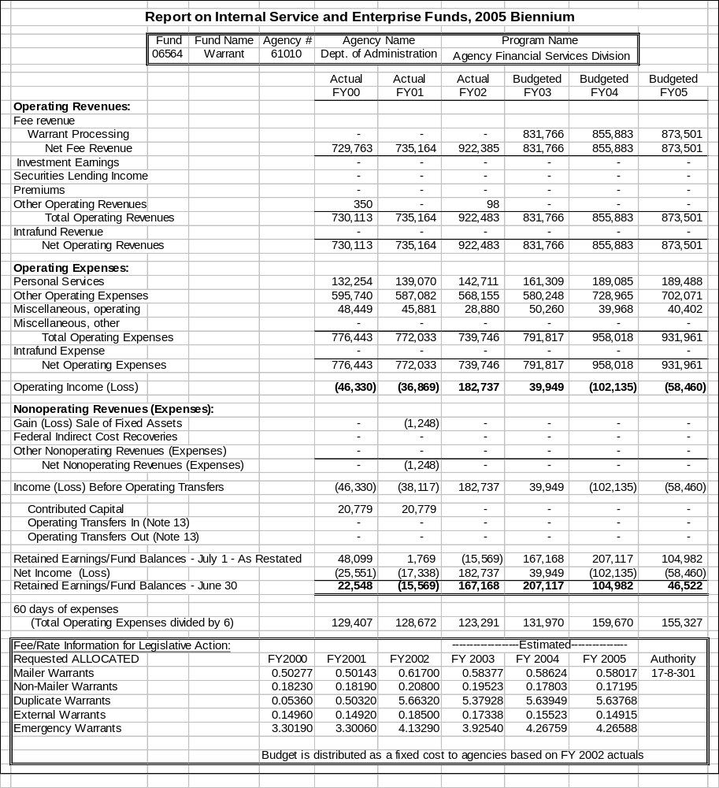
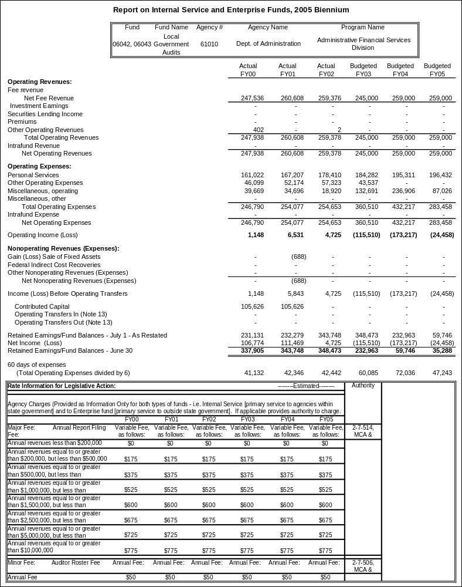
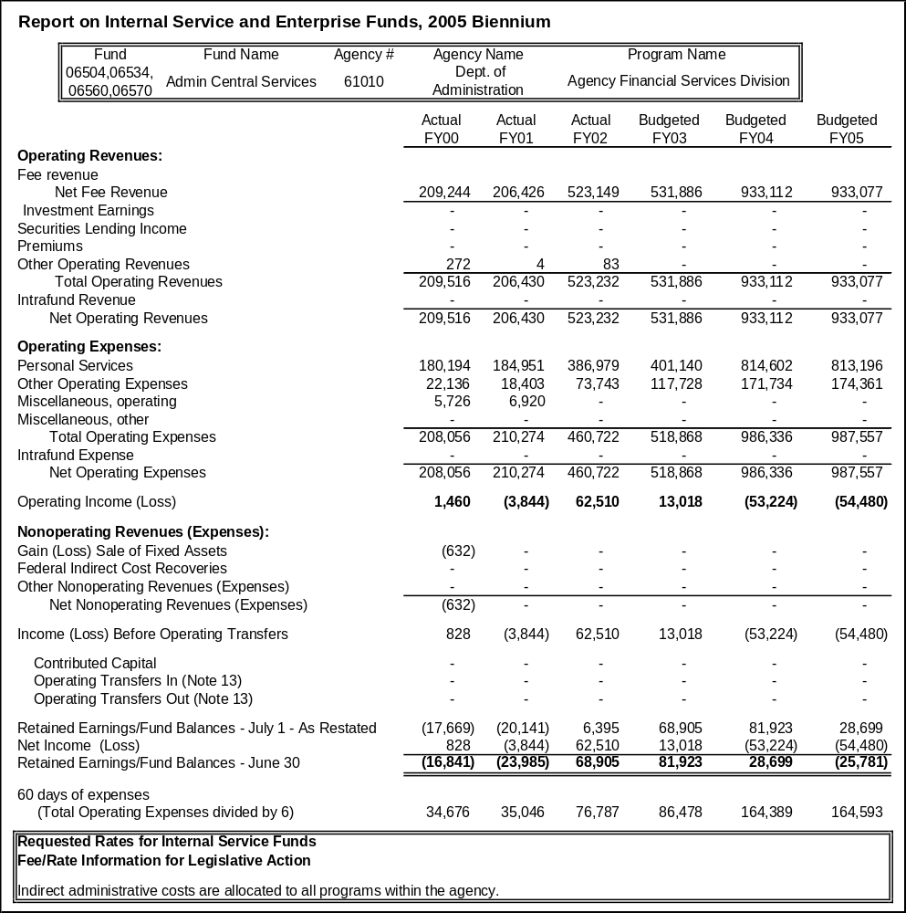

Proprietary Rates

Program Proposed Budget  Budget Item | Base  Budget  Fiscal 2002 | PL Base Adjustment  Fiscal 2004 | New  Proposals  Fiscal 2004 | Total  Exec. Budget  Fiscal 2004 | PL Base Adjustment  Fiscal 2005 | New  Proposals  Fiscal 2005 | Total  Exec. Budget  Fiscal 2005
FTE | 83.95 | 0.00 | 1.00 | 84.95 | 0.00 | 1.00 | 88.95
Personal Services | 2,712,468 | 353,527 | 51,037 | 3,117,032 | 447,845 | 50,886 | 3,211,199
Operating Expenses | 16,385,101 | 1,174,265 | 61,433 | 17,620,799 | 1,526,458 | 61,403 | 17,972,962
Equipment | 359,587 | 60,937 | 0 | 420,524 | 100,937 | 0 | 460,524
Debt Service | 45,369 | (45,369) | 0 | 0 | (45,369) | 0 | 0
Total Costs | $19,502,525 | $1,543,360 | $112,470 | $21,158,355 | $2,029,871 | $112,289 | $21,644,685
Proprietary | 19,502,525 | 1,543,360 | 112,470 | 21,158,355 | 2,029,871 | 112,289 | 21,644,685
Total Funds | $19,502,525 | $1,543,360 | $112,470 | $21,158,355 | $2,029,871 | $112,289 | $21,644,685

Please note that a HB 2 section exists for this program.

Program Description -
The General Services Division is composed of four bureaus responsible for providing certain internal services to government agencies and the public. The Facilities Management Bureau manages the following services for state agencies in the capitol complex and several state-owned buildings in the Helena area either directly or through the administration of service contracts: repair, maintenance, construction, energy consumption, disaster response and recovery, space allocation, lease negotiation, security, janitorial, recycling, pest control, and garbage collection. The State Procurement Bureau procures or supervises the procurement of all supplies and services needed by the state and provides technical assistance to government agencies and the public to ensure compliance with the Montana Procurement Act. The Print and Mail Services Bureau provides printing services to state agencies by operating a central facility for duplicating and binding, desktop publishing, layout and design, graphic illustration, and forms design. It operates three quick copy centers, administers the state photocopy pool, and approves the procurement of all printing and printing-related purchases for state agencies. Mail services for state agencies in the Helena area are provided through a centralized facility that manages incoming, outgoing, and interagency mail. In addition, the bureau operates a full service contract United States post office in the state capitol building. The Property and Supply Bureau manages the Central Stores Program and the State and Federal Surplus Property programs. In addition, the division manages the state's vehicle fueling and procurement card functions.

Facilities Management Bureau (Fund 06528)
The Facilities Management Bureau scope of responsibility is established in 2-17-101, MCA, and 2-17-811, MCA, which states the Department of Administration is custodian of all state property in the state capitol area which is the geographic area within a 10-mile radius of the state Capitol.

The Facilities Management Bureau provides facilities management assistance, including repair, maintenance, and construction services to state agencies in the Helena Area and provides statewide leasing assistance to agencies to negotiate co-location of agencies to procure leased space for field offices. Facilities management also manages the state recycling program in the Helena area for office waste paper products. Customers include all agencies and units within state government.

Mail and Print Services Bureau

Mail Services Section (Fund 06523)
Mail Services provides a centralized mailing service. Services provided by the program include: 1) mail pick-up and delivery in agency offices; 2) metering of out-going U.S. mail; 3) bar coding mailings to qualify for postal rate savings; 4) delivery of inter-agency printed communications, also known as "Deadhead Mail"; 5) operation of a Postal Contract Station with locked mail boxes in the Capitol; 6) United Parcel Service (UPS); and 7) express mail service. Section 2-17-301 requires the Department of Administration to maintain and supervise any central mailing and messenger service. Customers include all agencies and units within state government.
Print Services Section (Fund 06530)
Print Services provides printing, duplicating, desktop publishing, layout and design, graphic and illustrative art, forms design, reprographics, binding and quick copy, and photocopier pools services for state agencies. Print Services has three basis components: 1) Internal printing; 2) External (contracted) printing; and 3) Photocopy Pool. Section 18-7-101, MCA, requires the Department of Administration to supervise and attend to all public printing within the state and to contract for any printing used by the state and 2-17-301, MCA, charges the department with the responsibility of administering the State Photocopy Pool. Customers include all agencies and units within state government. Use of the photocopy pool is optional. A state agency may buy its own copier through the State Procurement Bureau. All printing or purchasing of printing is requested through Print Services. Print Services determines the most cost effective method of project completion. Not all requests for printing are completed internally. Nearly 65 percent of printing expenditures are procured through commercial vendors.

Property and Supply Bureau
The Property and Supply Bureau manages the Central Stores Program and the State and Federal Surplus Property programs.

Central Stores Program(Fund 06531)
The Central Stores program develops standard specifications, procures, warehouses, and delivers commonly used items to all state agencies and participating local governments. Section 18-4-221 MCA, requires the department to procure or supervise the procurement of all supplies and services needed by the state. Customers include all agencies and units within state government and participating local governments. State agencies account for 94.1 percent and local governments for 5.9 percent of revenue.

Section18-4-302(3), MCA, mandates state agencies to use Central Stores unless an alternate supplier's publicly advertised price, established catalog price, or discount price offered to the agency is less than the price offered by the stores program if the office supply conforms in all material respects to the terms, conditions and quality offered by the stores program.

Surplus Property Program (Fund 06066)
The Surplus Property Programs are accounted for in enterprise fund 06066.

The Property & Supply Bureau operates the surplus property program to administer the sale of state and federal surplus property no longer needed by agencies. MCA 18-4-221, requires the department to sell, trade, or otherwise dispose of surplus supplies belonging to the state. The Federal Surplus program acquires surplus property from federal agencies (18-5-201 through 205, MCA.) This property is distributed to state agencies or other eligible organizations. The surplus property programs services include extending the life of state property by providing a mechanism to transfer surplus property between agencies, providing accountability in the disposal of surplus state property, providing agencies with a surplus equipment pick up service, and providing a screening service to locate federal surplus property for state and local agencies.

State Fueling Network Program (Fund 06561)
The Statewide Vehicle Fueling Program provides for fueling of public vehicles through an integrated commercial/public fueling network. The program automates the accounting and transaction processing functions associated with vehicle fueling, offers a system of security, maintains agency tax-exempt status for transactions anywhere on the network, and provides monthly comprehensive fuel management reports that fleet managers can use to track and control fuel costs. Customers include state government agencies and units, county and local municipalities.

State Procurement Card Program (Fund 06571)
The State Procurement Card Program administers the state procurement contract for the automated processing of small purchases.

Revenues and Expenses -
General Services Division Facilities Management Bureau (Fund 06528) - Facilities Management provides all services in the program description above with 6.5 percent of the revenue from the general fund, 92 percent collected through rental rates and 1.5 percent from construction cost recovery and from the recycling program.

Agencies pay for program services with the following SABHRS accounts:
62527 - Rent - DoA buildings
62891 - Handyman Charges

Facilities Management records revenues into the fund (06528) by using the following SABHRS accounts:
525044 - Office Rent Charges
525045 - Misc. Maintenance/Handyman Charges
525046 - Project Work

Historical and projected trends associated with program indicators are provided:

Indicator | Actual  FY 1998 | Actual  1999 | Actual FY2000 | Actual FY2001 | Actual FY2002 | Estimated FY2003 | Requested FY2004 | Requested FY2005
Work Orders Issued | 7,580 | 6,682 | 5,845 | 6,205 | 5,397 | 6,750 | 5,397 | 6,750
State Owned Rented Office Space (sq. ft.) | 869,501 | 876,298 | 885,808 | 873,259 | 878,412 | 882,640 | 907,830 | 907,830
State Owned Rented Storage Space | 62,394 | 83,299 | 83,299 | 79,190 | 82,467 | 90,381 | 92,429 | 92,429
Private Leased Space – Helena- (sq. ft.) | 338,492 | 378,310 | 408,575 | 444,382 | 452,778 | 475,417 | 499,188 | 524,147
Private Leased Space – Other- (sq. ft.) | 446,180 | 408,740 | 441,439 | 529,328 | 640,842 | 672,884 | 706,528 | 741,855
Active Leases | 240 | 250 | 220 | 196 | 220 | 250 | 250 | 250
Number of Buildings serviced by GSD staff | 41 | 44 | 44 | 44 | 44 | 45 | 45 | 45
Recycled Paper (in tons) | 2003.3 | 262.1 | 254.2 | 313 | 320 | 345 | 345 | 345

Major classes of expenses for the Facilities Management Bureau are personal services, other (contracted) services, utilities, and repair and maintenance. Personal services can be forecast based on assigned FTE, which is requested at 23.10 FTE in FY 2004 and FY 2005.

In January 2002, the Department of Administration assumed the STARC Building, increasing square footage responsibility by 55,000 square feet. Projected expenses in FY 2004 and FY 2005 reflect the increased responsibility.

Other services including all the major contracts for insurance, janitorial, mechanical, elevator, pest control and security are expected to increase, over FY 2002 by 19.8 percent in FY 2004 and by 29.8 percent in FY 2005. These increases are directly related to increases in property insurance, prevailing wage rate increases for non-construction work, and the additional square footage.

Utilities are expected to increase over FY 2002 by 4.4 percent in FY 2004 and by 4.2 percent in FY 2005. These are directly projected increases for city water and sewer and sanitation services.

Mail and Print Services Bureau
Mail Services Section (Fund 06523): Mail Services provides all services as presented in the program description. The centralized mailing operations including pick-up and delivery, metering of out-going mail, bar coding operations and express mail and United Parcel provide 94 percent of mail services revenue. Inter-agency mail accounts for 5 percent of revenue and the contract station provides 1 percent. Agencies pay for program services with the following SABHRS accounts:
62304 - Postage and Mailing - Centralized mailing operations
62307 - Messenger Services - Dept of Administration - Interagency mail operations

The U. S. Postal Service contributes to the operation of the Postal Contract Station located in the Capitol Building.

Mail Services records revenues into the fund (06523) by using the following SABHRS accounts:
525048 - Post Office Contract
525049 - Centralized Mail Operations
525059 - Interagency Mail

Historical and projected trends associated with volume of services provided are:

Centralized Mail Operations
Number of pieces of mail processed (millions):

Fiscal Year | 2000 | 2001 | 2002 | 2003 | 2004 | 2005
Interagency Mail | 10.0 | 9.0 | 9.4 | 9.5 | 9.5 | 9.5
Number of Units (in tons) | 1.8 | 1.5 | 1.4 | 1.4 | 1.3 | 1.3

Major classes of expenses for Mail Services operations are personal services, postage, equipment repair/maintenance and equipment replacement. Personal services can be forecast based on assigned FTE, along with historical trending for overtime costs. Postage expense for Mail Services operations has significantly increased over the years due to U.S. Post Office rate increases. Historically agency mailings have remained fairly consistent as evidenced by yearly mail processed as shown above. Equipment costs can come in the form of equipment repair/maintenance and equipment replacement. Routine equipment maintenance and scheduled equipment replacement can be forecast with accuracy, however unscheduled repair or equipment replacement cannot be accurately forecast.

Major classes of expenses for inter-agency mailing operations are personal services, vehicle leases, and maintenance. Personal services can be forecasted based on assigned FTE, along with historical trending for overtime costs. Vehicle costs can be forecasted based on historical trends. Unscheduled repairs on vehicles cannot be accurately forecasted. Overhead costs for administration, accounting and supplies are allocated to Mail Services programs based on FTE.

For FY 2002 Mail Services had 16.76 FTE.

Print Services Section (Fund 06530): Print Services provides all services as presented in the program description. Internal printing which charges user agencies for graphic design and layout, desktop publishing, reprographics, duplicating, bindery and quick copy provides 27 percent of print services revenue. External printing provides 56 percent of revenue and the photocopy pool generates 17 percent.

Agencies pay for program services with the following SABHRS accounts:
62190 - Printing-Print Services - Internal and external print charges
62193 - Photocopy Pool Services - Photocopy pool charges.

Print Services records all revenues into the fund (06530) by using SABHRS revenue account 525088, (printing coordination).

Historical and projected trends associated with volume of services provided are:

Fiscal Year | 2000 | 2001 | 2002 | 2003 | 2004 | 2005
Internal Printing - Number of impressions (millions):  * Legislative Year | 53.3 | 56.9* | 53 | 57* | 53 | 57*
External Printing - Dollar amount of contracted printing (millons): | 2.86 | 2.96 | 2.96 | 2.96 | 2.96 | 2.96
Photocopy Pool - Number of copiers: | 253 | 269 | 265 | 271 | 265 | 271

Major classes of expenses for internal printing are personal services, direct materials used in production such as paper and ink, equipment repair/maintenance and equipment replacement. Personal services can be forecast based on assigned FTE, along with historical trending for overtime costs. Direct material costs vary with the demand for printing from user agencies. Historically, agency printing demand has remained fairly consistent as evidenced by yearly internal printing impressions as shown above. Equipment costs can come in the form of equipment repair/maintenance and equipment replacement. Routine equipment maintenance and scheduled equipment replacement can be forecast with accuracy, however, unscheduled repair or equipment replacement cannot be accurately forecast. Graphic design and layout services and desktop publishing service costs are also driven by personnel and equipment costs. While personnel costs can be forecast the same as printing, equipment costs are more driven by computer equipment and software purchases and upgrades to maintain currency with recent technology.
Major classes of expenses for external printing are pass-through printing costs (commercial vendor printing charges) and personnel services. Although the cost has historically remained fairly consistent, the commercial vendor costs can vary greatly depending upon complexity, quantity and inflation.

Major classes of expenses for the photocopy pool are pass-through photocopy costs (payment made to contracted vendors) and personnel services.

Overhead costs for administration, accounting, and supplies are allocated to the three Print Services programs based on FTE. During legislative years, personnel costs and direct materials used in production are higher for internal printing as a result of session-related workload increases. For FY 2002 print services had 25.94 FTE.

Property and Supply Bureau
Central Stores Program (Fund 06531): Central Stores objective is to recover sufficient revenue to maintain current operations, inventory levels, and equipment maintenance and replacement. Maintaining a 60-day working capital if inventory is considered a non-cash item is adequate to meet this objective. This program has no need to reserve fund balance.

Agencies are billed daily and accounts are collected within 30-45 days. This billing and payment cycle allows Central Stores to pay monthly expenses and maintain adequate inventory levels.

Central Stores provides services as presented in the program description. Agencies pay for program services with expenditure accounts that appropriately fit the items being purchased, including these for commonly purchased items:
62211 Coarse Paper, Central Stores
62219 Forms Purchase, Central Stores
62226 Fine Paper, Central Stores
62236 Office Supplies, Central Stores
62256 Janitorial Supplies, Central Stores
62296 Computer Paper, Central Stores

Historical and projected trends associated with the volume of services provided are:

FY 2000 | FY 2001 | FY 2002 | FY 2003 | FY 2004 | FY 2005
$4,219,466 | $5,236,176 | $4,864,224 | $4,707,000 | $4,707,000 | $4,707,000

The major costs for Central Stores are goods purchased for resale and personal services. Goods purchased for resale costs depend upon demand from user agencies. There are no projected significant changes in service volume. Factors that contribute to uncertainty in forecasting this cost are agency needs for our service and general price increases from vendors. Variations in expense patterns depend on demand from user agencies. Future expenses can be projected by adding an inflation factor to base year purchases. Knowledge of manufacturer price increases can also help project future expenses. Personal services can be forecast based on assigned FTE. The program has 9.65 FTE funded through user fees.

Surplus Property Program (Fund 06066): The objective of the Surplus Property Program is to recover sufficient revenue to maintain current operations and scheduled equipment maintenance and replacement. This program has no need to reserve fund balance.

Agencies are billed weekly and accounts are collected within 30-45 days. Cash increases after the annual auction and decreases as agencies are reimbursed for their auction items and auction expenses are paid. The major expenses associated with the Surplus Property Program are personal services and freight to get federal property to the surplus warehouse. The program has 7.50 FTE funded through user fees. There are no projected significant changes in service volume.

State Fueling Network Program (Fund 06561): Revenue is generated through an administration fee charged on fuel purchases. Agencies pay for the program services with the following SABHRS account: 62216 - Gasoline

The program records revenues into the fund (06561) using the following SABHRS account: 525092 - Statewide Fueling Network

Historical and projected trends associated with volume of services provided are:

Number of Gallons (millions):

Fiscal Year | 2000 | 2001 | 2002 | 2003 | 2004 | 2005
 | 3.4 | 3.9 | 4.4 | 4.4 | 4.4 | 4.4

Major classes of expenses for the statewide Fueling Program are supplies, communications and travel.

State Procurement Card Program (Fund 06571): Revenue is generated through card charges to user agencies and rebates if target goals are met. Agencies pay for the program services with the following SABHRS account: 62750 - Maintenance Contracts
The program records revenues into the fund (06571) using the following SABHRS account: 525076 - Procurement Card Fee

Historical and projected trends associated with volume of services provided are:

Dollar amount charged on all cards (millions):

Fiscal Year | 2000 | 2001 | 2002 | 2003 | 2004 | 2005
 | 16.1 | 18.4 | 21.2 | 21.2 | 21.2 | 21.2

Major classes of expenses for the State Procurement Card Program are maintenance costs and computer programming charges and travel.

Rate Explanation - Facilities Management Bureau (Fund 06528): Facilities Management rates are set to recover sufficient revenue to meet all personal services, operation costs, equipment replacement costs and to maintain an adequate working capital balance. The program billing and payment cycles support the accumulation of an adequate working capital balance. User agencies are billed monthly and agencies are requested to pay for services by the end of the next month.

Rent, on a cost per square foot basis, is assessed each agency occupying space in the buildings controlled by the Department of Administration. The rates are established to cover the cost of personal services and operating expenses including maintenance and equipment. Project work completed for agencies by in-house staff or contracted with and outside vendor is on a cost recovery basis.

The following rates have been requested for the next biennium:

 |  | ------------Budgeted---------- |  |  |  | ------Requested------
 |  | FYE 00 | FYE 01 | FYE 02 | FY 03** | FY 04 | FY 05
 | Office Rent (per sq. ft.) | 5.13 | 5.37 | 4.766 | 4.881 | 5.988 | 6.228
 | Storage Rent (per sq. ft.t) | 2.12 | 2.12 | 2.12 | 2.12 | 2.27 | 2.29
 | Project Mgmt (In-house) | 15 percent | 15 percent | 15 percent | 15 percent | 15 percent | 15 percent
 | Project Mgmt (Contracted) | 5 percent | 5 percent | 5 percent | 5 percent | 5 percent | 5 percent

**In FY 2002 & 2003, the Legislature approved using capitol land grant funding to subsidize the maintenance program, resulting in a low cost per square foot of $4.77 in FY 2002 and $4.881 in FY 2003. In the 2005 biennium request, all available capitol land grant funding has been used again.

Mail and Print Services Bureau:
Mail Services Section (Fund 06523): Mail Services rates are set to recover sufficient revenue to meet personal services and operations costs and allow maintaining no more than a 60-day working capital balance. The program billing and payment cycles support the accumulation of a 60-day working capital balance. User agencies are billed monthly and agencies are requested to pay for services by the end of the next month. This allows Mail Services to pay monthly expenses of personal services and maintain current operations. There is 67 percent of the equity balance attributed to working capital. The remaining fund equity is attributed to equipment.

Mail Services provides measurable services to specific agencies based on end result - 20 mixed weight letters for first class mailing. Direct, indirect and administrative overhead can be attributed to the program. Therefore, costs can best be recovered by charging for each unit of service. Rates for each service include fixed, variable, indirect and administrative overhead costs. Periodically, rates are adjusted based on 60-day working capital.

Mail Services - Central Operations is requesting a 60-day working capital rate for the 2005 biennium. Inter-agency mail operations is requesting a rate defined as the total amount allocated to agencies (fixed cost) for the 2005 biennium.

Print Services Section (Fund 06530): Print Services rates are set to recover sufficient revenue to meet personal services and operations costs and allow maintaining no more than a 60-day working capital balance. The program billing and payment cycles support the accumulation of a 60-day working capital balance. User agencies are billed monthly and agencies are requested to pay for services by the end of the next month. This allows Print Services to pay monthly expenses of personal services and maintain current operations. There is 60 percent of the equity balance attributed to working capital and 40 percent of the total equity balance to equipment.

Print Services provides services to agencies based on an end result, e.g., 100 copies of 10 originals, collated, stapled and 3 hole punched. Overall volume of services are projected to remain constant. Direct and indirect costs can be attributed to each program. Therefore, costs can best be recovered by charging for each unit of service provided for by internal and photocopy pool programs. External printing recovers costs by charging a percentage markup on the cost of the printing job.

Rates for each service are determined as follows: each service was broken into fixed, variable direct costs, indirect costs and administrative overhead in a past study. To recover costs, appropriate minor adjustments are made to base figures. The rates have remained substantially the same for the last 10 years.

Print Services requests a 60-day working capital rate for the 2005 biennium.

Property and Supply Bureau
Central Stores Program (Fund 06531): Central Stores requests a 60-day working capital rate for the 2005 biennium. This allows for adequate cost recovery for direct, indirect, and administrative expenses.

Central Stores objective is to recover sufficient revenue to maintain current operations, inventory levels, and equipment maintenance and replacement. Maintaining a 60-day working capital if inventory is considered a non-cash item is adequate to meet this objective. Agencies are billed daily and accounts are collected within 30-45 days. This billing and payment cycle allows Central Stores to pay monthly expenses and maintain adequate inventory levels. This program has no need to reserve fund balance. The balance sheet accounts that contribute most significantly to fund balance are cash, receivables, inventory and equipment. Ninety percent of the fund equity balance can be attributed to working capital, 30 percent of working capital consists of inventory.

Surplus Property Program (Fund 06066): The State Surplus Property Program retains a handling fee of 8 percent for items that are sold for more than $150, plus extraordinary expenses if applicable. The Federal Surplus property program fees are an allocation of freight expense and 14 percent of acquisition cost. This is included in the Federal Plan of Operation, which has been approved by the Federal General Services Administration. These rates allow sufficient revenue to maintain current operations and scheduled equipment maintenance and replacement.

Statewide Fueling Network Program (Fund 06561): Statewide Vehicle Fueling Program rates are set to recover sufficient revenue to meet some operating costs. Personal services are funded through the General Fund to encourage agencies to use this program for their fuel purchases. The Legislature approved an administrative fee of 0.5 percent of the gross fuel purchases as the rate for the 2003 biennium.

The Statewide Vehicle Fueling program requests that the Legislature approve an administrative fee of 0.5 percent of the gross fuel purchases as the rate for the 2005 biennium.

State Procurement Card Program (Fund 06571): State Procurement Card Program rates are set to recover sufficient revenue to meet some operating costs. Personal services are funded through the General Fund to encourage agencies to use this program for their small purchases. The Legislature approved an administrative fee of $1.00 per card per month as the rate for the 2003 biennium. The State Procurement Card Program requests that the Legislature approve an administrative fee rate of $1.00 per card per month as the rate for the 2005 biennium.

--------------------------------- Present Law Adjustments --------------------------------

Total Agency Impact | General Fund Total
FY04 $5,239 | FY04 $0
FY05 $5,311 | FY05 $0
PL- 601 - Adjust Management Services Fixed Costs -
Fund changes in department indirect/administrative costs for services received from other proprietary funded centralized services functions of the agency.
________________________________________________________________________________________________

Total Agency Impact | General Fund Total
FY04 ($75) | FY04 $0
FY05 ($75) | FY05 $0
PL- 602 - Eliminate Energy Procurement Operating Budget -
Eliminate the operating expense appropriation for the Energy Procurement Program. Program no longer needs funding for operating expenses.
________________________________________________________________________________________________

Total Agency Impact | General Fund Total
FY04 $18,650 | FY04 $0
FY05 $15,650 | FY05 $0
PL- 603 - Procurement Card -
This decision package requests additional operating authority for the Procurement Card program totaling $18,650 in FY 2004 and $15,650 in FY 2005. The requested authority is for additional programming charges, mid-tier storage costs at ITSD, replacement PC, postage, travel, and pro-card education.
________________________________________________________________________________________________

Total Agency Impact | General Fund Total
FY04 $12,000 | FY04 $0
FY05 $15,000 | FY05 $0
PL- 604 - Mail Services Section -
Request restoration of zero-based overtime of $12,000 for FY 2004 and $15,000 for FY 2005. Overtime is needed to cover rush postage jobs. Amounts requested are based on historical averages.
________________________________________________________________________________________________

Total Agency Impact | General Fund Total
FY04 $18,000 | FY04 $0
FY05 $30,000 | FY05 $0
PL- 605 - Print Services Section -
Requesting overtime for FY 2004 of $18,000 and $30,000 for FY 2005 to cover rush printing jobs and fiscal year end printing. The additional $12,000 for FY 2005 is requested to cover overtime at the legislative print shop.
________________________________________________________________________________________________

Total Agency Impact | General Fund Total
FY04 $168,431 | FY04 $0
FY05 $313,057 | FY05 $0
PL- 606 - Print Services Addl Direct Material Costs -
An additional $168,431 is requested in each fiscal year to cover inflationary increases in the costs of goods purchased for resale. The estimated increase is five percent over FY 2002 actual costs. An additional $144,626 is requested in FY 2005 for paper and photocopying costs associated with the FY 2005 legislative session.
________________________________________________________________________________________________

Total Agency Impact | General Fund Total
FY04 $473,590 | FY04 $0
FY05 $707,484 | FY05 $0
PL- 607 - Facilities Management Bureau Addl Operating Costs -
Janitorial contracts are awarded on an annual basis with renewal options not to exceed three to five years depending on specification needs. Increases reflected in the first year of the biennium relate to the addition of the STARC Building, re-bidding of several contracts that expire, and prevailing wage and product increases experienced by the contractor and passed on to the agency. In the second year of the biennium, increases are directly related to re-bidding of several buildings; to the legislative session which requires six day a week service and to continued increases in prevailing wage and supplies requested increase is $70,328 for FY 2004 and $160,551 for FY 2005.

Included in the 62110 category are elevator maintenance, mechanical maintenance and pest control service. These maintenance contracts are awarded on an annual basis with renewal options. The elevator contract has been expanded to included elevators in the State Fund Building and at the New Liquor Warehouse. Also, we anticipate a 20 percent increase when the contract is re-bid due to the aging condition of many elevators. The mechanical contract is estimated to increase 12 percent annually due to prevailing wage increases, additional equipment required, the addition of the STARC Building to the contract, and aging conditions of existing equipment. Request is for an additional $177,192 in FY 2004 and an additional $311,322 in FY 2005.

Annual inspections are done on all fire extinguishers placed in buildings throughout the Capitol Complex. Increase is due to the addition of several extinguishers on the complex and at the STARC Building that will require servicing during the next biennium. An additional $99 is requested for each year of the biennium for Fire Suppression Services.

Security protection is contracted with the private sector. This budget request maintains the pricing from the last biennium in FY 2004 and FY 2005 at $288,475. The agency is requesting an additional $25,000 per year to allow for security training to state employees.

The agency is mandated to have fire sprinkler systems and fire alarm systems inspected according to National Electrical Codes and NFPA 25 on an annual basis. Request is for an additional $8,250 each year.

Per union contract, members are entitled to $170 per year for safety eyeglasses. The agency has 10 union members that qualify for this benefit. An additional $599 is requested each year to fund the required $1,700.

New annual contract for photocopier pool services went into effect July 1, 2002. An additional $456 each year is needed to pay for this new contract.

The agency leases land from the Helena Regional Airport at the Aviation Support Facility. Lease agreement has an inflationary factor of 50 percent of the CPI per year. This equates to a $1,461 increase in FY 2004 and $1,840 in FY 2005.

A lifetime contract has been signed for Gas Cylinders so the base was reduced to zero for both fiscal years.

Increased electricity expenditure reflects the addition of the STARC Building in January 2002. Year to date expenditures only reflect six months of expenses for the STARC Building. Anticipated increases are $39,645 in FY 2004 and $43,610 in FY 2005.
Increased natural gas expenditure to reflect the addition of the STARC Building in January 2002. Year to date expenditures only reflect six months of expenses for the STARC Building. An additional increase of $8,719 is anticipated each year.

Increase reflects the addition of the STARC Building that is not reflected in our base. The City of Helena has recommended a 3 percent increase in FY 2004 and 1.75 percent increase from FY 2004 to FY 2005. This equates to a $8,833 increase in FY 2004 and a $12,884 increase in FY 2005.

Budget request for garbage and trash removal includes the addition of the STARC Building. Also reflects an estimated 10 percent increase in operating costs anticipated by the vendor. This is an increase of $18,287 in FY 2004 and $19,446 in FY 2005.

FY 2002 does not reflect the true maintenance expenditures incurred by the program. Projects that exceeded the program's construction/maintenance authority are administratively attached to the Architecture and Engineering Division. Due to the scope of the projects, spending authority was transferred to the Architecture and Engineering Division so funding could be continued into the next fiscal year to complete the work. Request is to increase the appropriation by $342,672 each year to the original FY 2002 base.

The Facilities Management Bureau assumed the financial responsibilities for the STARC Building in January 2002. The expenditures in FY 2002 for Taxes and Assessments do not reflect assessments that must be paid for this building and land. Increase requested is $2,747 for each year.
________________________________________________________________________________________________

Total Agency Impact | General Fund Total
FY04 ($45,369) | FY04 $0
FY05 ($45,369) | FY05 $0
PL- 609 - Eliminate Print Services Installment Purchase -
The installment purchase account 69400 is no longer necessary. Print Services paid off the debt for the high-speed photocopier in FY 2002.
________________________________________________________________________________________________

Total Agency Impact | General Fund Total
FY04 $72,005 | FY04 $0
FY05 $112,005 | FY05 $0
PL- 610 - Increase Equipment Budget for Print Services -
Print Services FY 2002 base budget for equipment was $62,995. An increase of $72,005 is requested for FY 2004 and an increase of $112,005 for FY 2005. There will be no rate increase to fund this equipment.

---------------------------------------- New Proposals ----------------------------------------

Total Agency Impact | General Fund Total
FY04 $61,433 | FY04 $0
FY05 $61,403 | FY05 $0
NP- 318 - Indirect Cost Allocation - HB576 -
This action is related to the funding change for the Director's Office and the Management Support Bureau that will provide for indirect cost recovery in compliance with statutory direction from the special session and an audit recommendation.
________________________________________________________________________________________________

Total Agency Impact | General Fund Total
FY04 $51,037 | FY04 $0
FY05 $50,886 | FY05 $0
NP- 612 - Transfer & Fund FTE in Fueling Program -
Transfer funding from Procurement Bureau to Statewide Fueling Network Program for Position 61104004 in response to Legislative Audit recommendations.
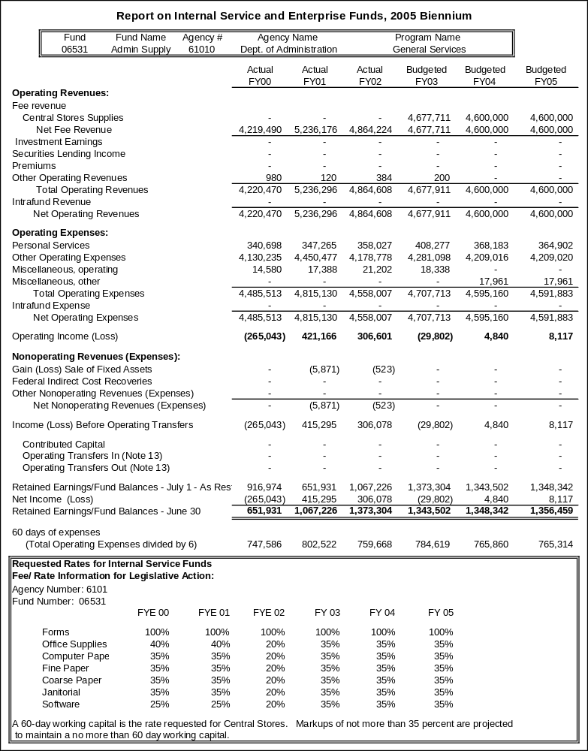
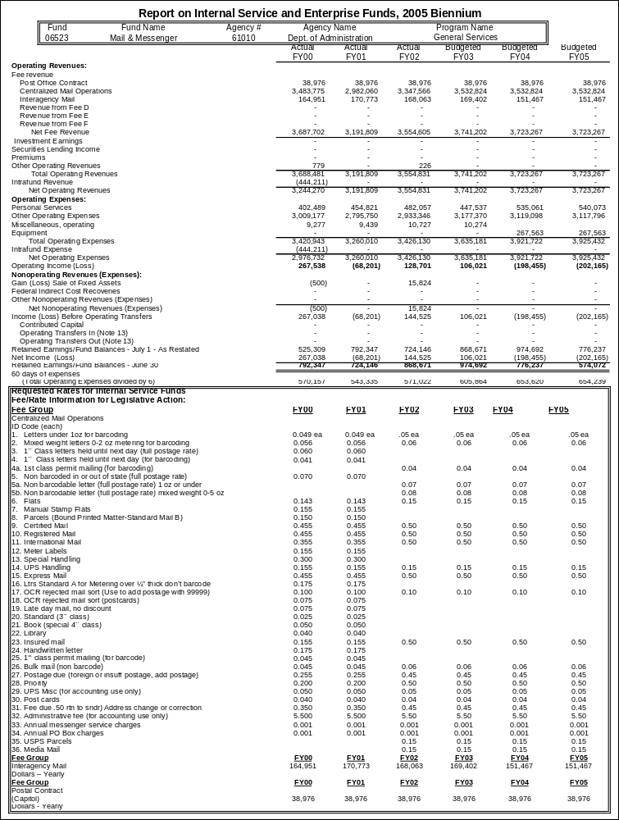

** In FY 2002 and FY 2003, the Legislature approved using capitol land grant funding to subsidize the maintenance program, resulting in a low cost per square foot of $4.77 in FY 2002 and $4.881 in FY 2003. In the 2005 biennium request, all available capital land grant funding has been used again.
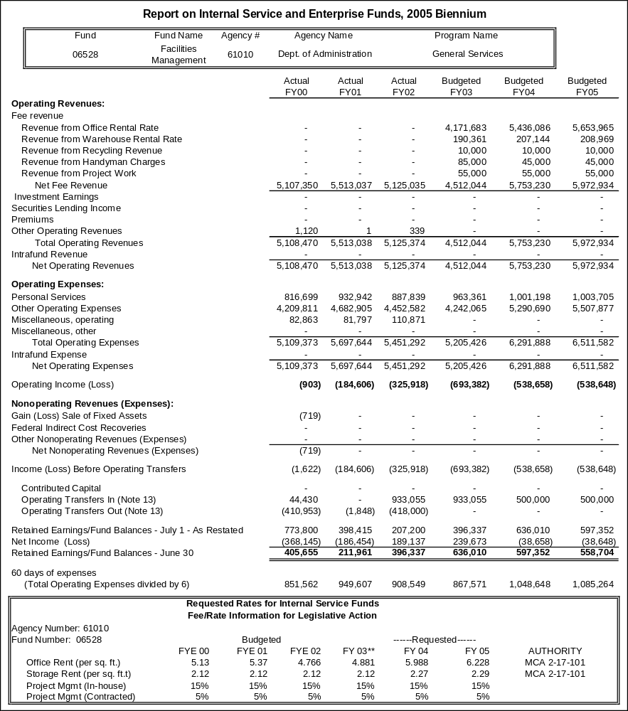

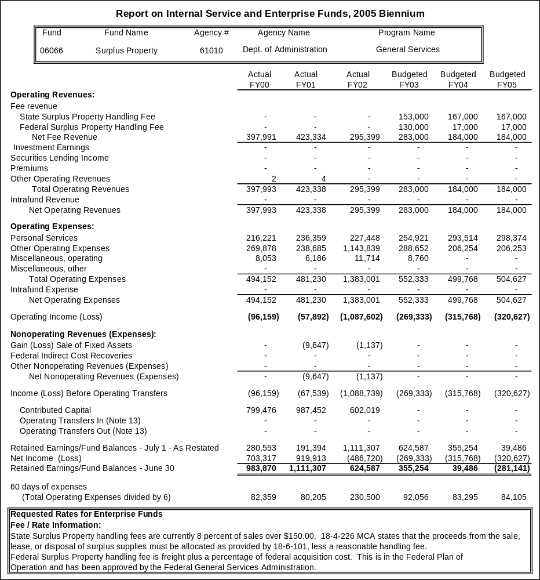
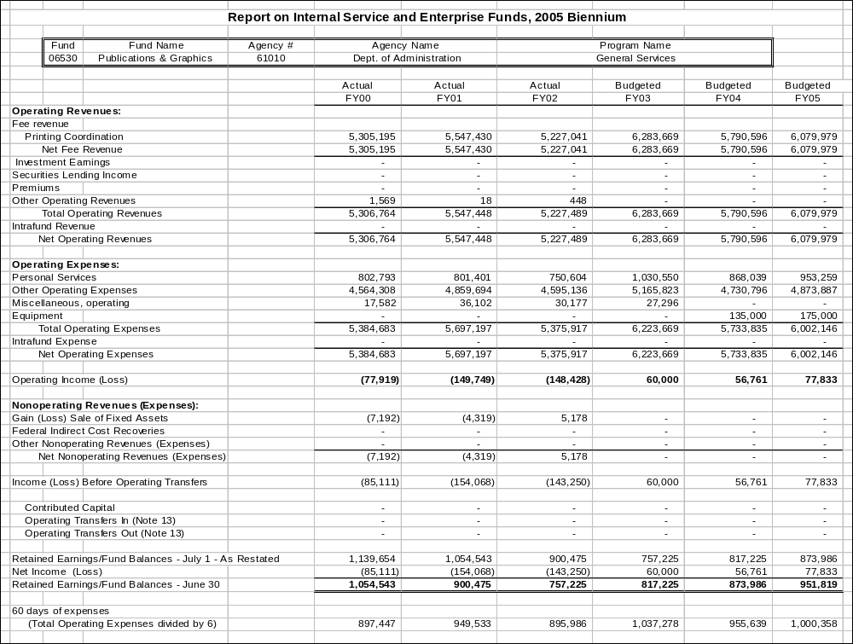

See page 147 for rate tables for fund 06530.

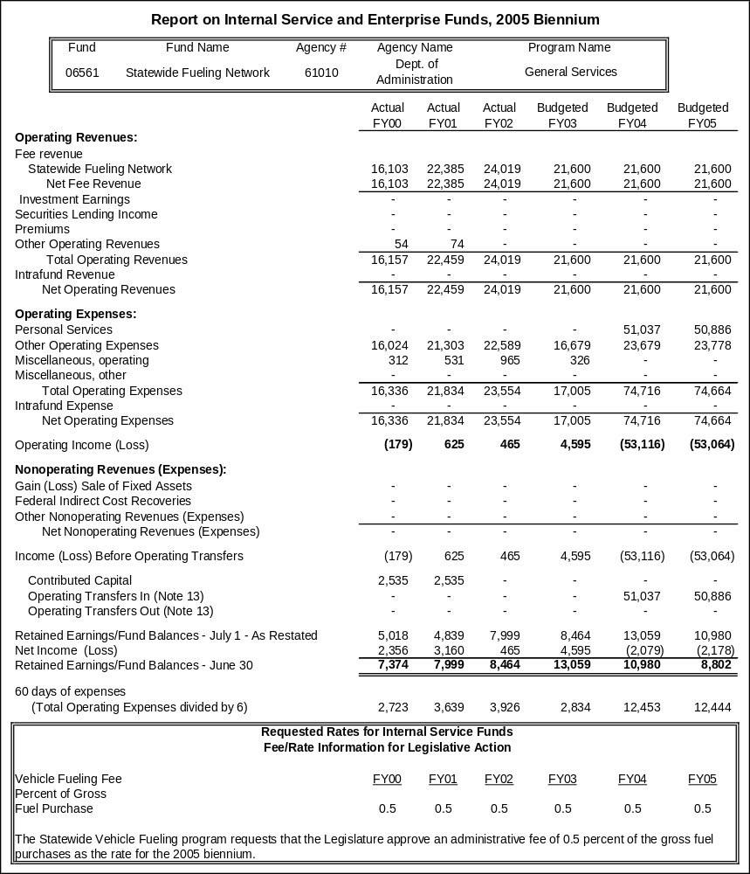

Proprietary Rates

Program Proposed Budget  Budget Item | Base  Budget  Fiscal 2002 | PL Base Adjustment  Fiscal 2004 | New  Proposals  Fiscal 2004 | Total  Exec. Budget  Fiscal 2004 | PL Base Adjustment  Fiscal 2005 | New  Proposals  Fiscal 2005 | Total  Exec. Budget  Fiscal 2005
FTE | 177.50 | (1.00) | 2.00 | 178.50 | (1.00) | 2.00 | 178.50
Personal Services | 9,352,100 | 473,991 | 117,730 | 9,943,821 | 467,515 | 117,372 | 9,936,987
Operating Expenses | 17,099,097 | 399,796 | 670,397 | 18,169,290 | 448,013 | 679,285 | 18,226,395
Equipment | 583,513 | 0 | 10,000 | 593,513 | 0 | 0 | 583,513
Debt Service | 1,624,335 | 0 | 0 | 1,624,335 | 0 | 0 | 1,624,335
Total Costs | $28,659,045 | $873,787 | $798,127 | $30,330,959 | $915,528 | $796,657 | $30,371,230
Proprietary | 28,659,045 | 873,787 | 798,127 | 30,330,959 | 915,528 | 796,657 | 30,371,230
Total Funds | $28,659,045 | $873,787 | $798,127 | $30,330,959 | $915,528 | $796,657 | $30,371,230

Please note that a HB 2 section exists for this program.

Program Description -The Information Technology Services Division (ITSD) manages Information Technology (IT) services for state government. IT includes:

- Shared statewide desktop and data network services
- Central mainframe computer processing
- Mid-tier access and production services
- Local and long-distance telephone networking
- IT planning, research and coordination
- Design, development, and continuous maintenance support of IT applications
- Personal computer (PC) and office automation support and consultation
- Design and development of telephone equipment, networking applications, and other telecommunication needs
- Internet and intranet services
- Electronic government planning and coordination
- Central imaging
- Geographic information systems (GIS) coordination
- Disaster recovery facilities for critical data processing applications
- IT training

ITSD also manages the State Accounting, Budgeting and Human Resource System (SABHRS) operational support unit, which is responsible for the operation and maintenance of the state budget development system (MBARS) and the PeopleSoft human resource, financial, and asset management systems.

The ITSD operates generally under state mandates as specified in Title 2, Chapter 17, parts 3 and 5, MCA.

Funding for the ITSD is primarily from charges to state agencies for mainframe and mid-tier computer processing, desktop services, and state telephone support services as well as direct charges to state agencies and other entities. In order to coordinate state communication function, the division also receives a significant amount of "pass-through" funds paid on behalf of state agencies to communications vendors such as AT&T and Qwest.

ITSD costs are based on predicted utilization and projects planned in all service categories. As services and costs increase or decrease, the management of ITSD strives to ensure that the fees being charged to state agencies remain commensurate with the costs. ITSD will fund 178.50 FTE in HB 576 in FY 2004 and FY 2005, or 3.00 FTE fewer than the 2003 biennium, from the revenues generated in all areas. The division adopted competency pay in FY 2002 and offered $179,568 of pay adjustments that extend into the 2005 biennium. Operating cost reductions in excess of $2.4 million financed the pay adjustments.

ITSD services are enterprise and statewide in nature, and therefore agencies are required to use these services. If exceptional conditions exist, agencies may be granted exceptions to meet specific agency needs. All services are offered and provided to all state and local agencies.

Revenues and Expenses -
(1) Change in Services or Fees: ITSD fees are based on predicted utilization and expenses. As utilization increases over the predicted expenses, ITSD is able to lower its fees appropriately. As the demand for products and services increases so do the expenses. New technology, software, equipment and support must be provided to keep up with the growing demand and needs of ITSD customers. With the need for expanding networks, ITSD is required to expand the Local Area and Wide Area networks, add additional sites and support new applications being developed for the delivery of services by state agencies and federal regulations.

One major cost driver in all of ITSD services is fixed personal services expense that is projected on assigned FTE with a 1 percent increase in both FY 2004 and FY 2005. There are a number of major cost drivers associated with the desktop services rate including communications costs and software costs. These are projected on current utilization as well as contracted agreements.

SABHRS administrative costs major cost drivers include contracted services and software expense, which are based on base year expenditures and contracted amounts. Mainframe processing major cost drivers include software expenses based on contracted amounts, supplies based on base year expenditures and depreciation and debt service interest expense based on current schedules and on projected purchases.

Telephone equipment and long-distance major cost drivers include communication and maintenance expenses which are based on base year and contracted amounts and supplies which are also projected from base year.

(2) Working Capital discussion: ITSD is requesting a 45-day working capital to maintain ongoing operational costs. This amount of working capital is required for monthly payments to vendors in a timely manner. ITSD was at 17 days as of FYE 2002. This has been extremely difficult financially to ITSD, which has been behind in accounts payable and had to defer purchases needed to provide services to customers. This reduction in days has mainly occurred for two reasons. First, ITSD has experienced losses due to unanticipated decreases in utilization and revenue from major agencies as agencies reduced their budgets and, second, not being able to collect fixed costs from agencies that are budgeted for desktop services. ITSD has been contacting agencies about their connected devices and has found in some instances that agencies are not reporting the correct number of devices to ITSD, so these agencies are not paying the correct amount of fixed costs to ITSD for which they received budget. Unless the utilization projections listed in ITSD's FY 2003 Cost Recovery Model are received, ITSD will experience a further reduction in working capital. ITSD will need to receive a general fund loan if this continues or ITSD will fail to be able to operate.

ITSD recommended rates for the 2005 biennium assume full participation of the agencies as budgeted, including Department of Revenue POINTS II and the State Fund. If POINTS II and/or State Fund are removed from the ITSD customer base, an increase in rates or further adjustments will be required.

Based on a MAXIMUS recommendation and conversations with the staff of the Legislative Audit Division, ITSD has considered working capital when determining rates for the 2005 biennium. ITSD has increased rates to offset loss from the base year and to bring working capital up to about 43 days.

(3) Fund Equity and Reserved Fund Balance: A portion of the fund balance to this proprietary fund does relate to the investment in equipment. Management does not predict any major changes in the fund balance from the 2002 biennium level.

(4) Cash Flow Discussion: ITSD invoices state agencies and other entities for services rendered in mainframe and mid-tier processing, desktop services, and telecommunications services monthly. Receipt of revenues is typically collected within 30-60 days; however, ITSD does occasionally have delayed payments from agencies. Major expenses are annual payments for software and maintenance, the majority of which occur during the beginning of the fiscal year, bi-monthly payroll, and monthly communications and hardware maintenance.

ITSD provides the following services for a specific charge to all state and local agencies.
- 62174 is Desktop Services that includes shared statewide desktop and data network services.
- 62148 is SABHRS administrative costs that includes the operations and maintenance of the budget development system (MBARS) and the PeopleSoft human resource, financial, and asset management systems.
- Mainframe processing is included in a combination of Disk Storage charges, Batch, TSO, IDMS, CICS CPU seconds charges and Read/Write Computer Transactions. These are located in accounts 62142, 62168, 62172, 62177, 62178, 62180. ITSD will no longer have Tape Storage Charges (62141). These will be combined in with CPU seconds.
- 62370 includes telephone equipment charges which are for basic and electronic telephone sets.
- 62385 is for long-distance telephone charges.

Desktop services utilization includes data connections to the state network. ITSD is projecting an approximate 3 percent average increase over the 2005 biennium. Currently this is based on input from a data connection survey requested from each agency. ITSD relies on this information when calculating rates. When these projections are not met by the agency, ITSD has to recover lost revenues from other service categories or reduce expenditures by reducing services provided for all.

SABHRS utilization is currently not tracked and charges are based on projected expenses. Mainframe processing is expecting an approximate 2 percent decrease over the 2005 biennium. This is based on past trends and agency input.

Telephone equipment utilization is projected from base year volume. Long-distance utilization is decreasing by approximately 30 percent from projected FY 2003 due primarily to university system student long-distance no longer participating with this program and increased use in cell phones and phone cards.

The customer payments received by ITSD include several funding sources.

One variation in expense patterns includes software expenses, which are higher in the initial purchase year and then only include fixed maintenance costs for subsequent years. There will also be some variations with equipment depreciation when the cycle of depreciation expires and the purchases of new equipment do not coincide.

There are 178.50 FTE funded in the base year.

Rate Explanation - Desktop services rates are charged on a monthly or yearly basis per workstation or installation.

SABHRS administrative costs are based on FTE with exceptions to the Benefits Bureau of the Department of Administration and the Montana University System, which are agreed upon amounts.

Mainframe and mid-tier charges are based upon central processing unit (CPU) seconds or other per transaction rates and client server contracts.

Voice telecommunications rates are charged based on equipment and long-distance usage.

Customers are billed at the actual fee or rate based upon the methodology used to develop those rates.

ITSD rates are based on predicted expenditures, utilization and projects planned in all service categories. ITSD strives to ensure that the rates being charged to state agencies remain commensurate with the expenditures. ITSD projects utilization numbers for service categories based on current level, trends and feedback from agencies. History has shown that these numbers do not always materialize and have shown to have negative impact on ITSD rate recovery.

ITSD determines its rates using an in-house database called "The Cost Recovery Information System " (CRIS). In FY 2002, ITSD with the help and input from several agencies, solicited proposals from qualified consulting firms to conduct an independent review and analysis, and to provide recommendations for improvements to the cost recovery methodologies and processes. MAXIMUS was hired for this review. ITSD is currently making the few changes to CRIS to follow MAXIMUS' recommendations. CRIS is designed to determine rates based on base year and projected expenditures, base year and projected utilization numbers and an allocation method for each service category to make sure ITSD rates are fair and maintain fees commensurate with costs.

ITSD has in the past had the authority to maintain a 60-day working capital. In the 2003 Legislative Session that authority was decreased to 45 days. The objective of having a working capital is to adequately recover costs to maintain current operations and plan for any unanticipated program changes or equipment purchases.

ITSD is requesting a 45-day working capital in the 2005 biennium to maintain ongoing operational costs. This amount of working capital is required for monthly payments to vendors in a timely manner.

The largest balance sheet accounts that contribute most significantly to ITSD fund equity balance is the 1704 equipment and 1709 accumulated depreciation accounts which are due to the large volume of equipment needed by ITSD to provide its services. Other significant accounts would be 1809 intangible assets and 2104 lease obligation. The amount of fund equity attributed to working capital is about $1.4 million.

CRIS uses several allocation methods for distributing indirect costs to separate rates. The methods used are:
1. Based on FTE
2. Based on Budgeted dollars or Revenue
3. Based on Workload
4. Based on Time
5. Based on Best Judgment

--------------------------------- Present Law Adjustments --------------------------------

Total Agency Impact | General Fund Total
FY04 ($116,594) | FY04 $0
FY05 ($116,273) | FY05 $0
PL- 704 - Elimination of Positions -
This decision package is to eliminate 3.00 FTE inactive positions. These include position numbers 61166148, 61166491 and 61166485.
________________________________________________________________________________________________

Total Agency Impact | General Fund Total
FY04 $53,139 | FY04 $0
FY05 $53,051 | FY05 $0
PL- 705 - Computer Security Specialist -
Because of the increased demands in the security area, the Security Section within ITSD has found it difficult to meet the demands of the state enterprise security requirements. Increased activity in the computer virus arena alone has added an increased workload to the security area. In 1999 the state reported 2,049 virus incidents. In 2000 there were 6,786 reports and in 2001 there were 53,358 reports documented. This is an increase of 2600 percent in virus activity from 1999 through 2001. To meet these demands, ITSD is requesting 1.00 FTE in the Security Section.

Within a recent network and operations security risk assessment, various areas were noted as being lacking because of personnel resource issues. These areas include investigation of incidents in a timely manner, communication of policy and procedures to agencies, review of physical access to network devised, monitoring of logs on a daily basis, movement of external connections to the outside of the network, and updating of our disaster recovery plan.

Because of the increased need for addressing these risks as well as other important security projects, the Security Section is requesting funding in FY 2004 and FY 2005 to make permanent a 1.00 FTE (61166713) hired in FY 2002 for these purposes.
________________________________________________________________________________________________

Total Agency Impact | General Fund Total
FY04 $53,011 | FY04 $0
FY05 $52,854 | FY05 $0
PL- 706 - Training Coordinator -
ITSD is requesting to make permanent 1.00 FTE hired in FY 2002 for the continued support of training coordination and design efforts. This type of service has been requested by state agencies to help coordinate technology training for ITSD and state agencies; identify and acquire appropriate forms of training such as manuals, computer-based training resources, web-based training, and instructor-led training; provide information and support to agencies regarding applicable training for their employees to progress through a career ladder; manage all training contracts; create and design marketing materials, promotional materials and other items for customer relations purposes; coordinate the development, printing and/or online publishing of documents for the division; and provide design options and input into the user interface of the intranet applications developed by the Web Based Services Section for MINE. Funding for this position will ensure continued cost savings, to more than cover the cost of this FTE, by consolidating statewide IT training efforts.
________________________________________________________________________________________________

Total Agency Impact | General Fund Total
FY04 $37,668 | FY04 $0
FY05 $37,781 | FY05 $0
PL- 707 - Allocation of Indirect/Administrative Costs -
Allocation of indirect/administrative costs from Management Support.
________________________________________________________________________________________________

Total Agency Impact | General Fund Total
FY04 $265,297 | FY04 $0
FY05 $389,525 | FY05 $0
PL- 708 - Balancing to ITSD Cost Recovery Information System -
This decision package is to balance ITSD's budget projected on MBARS with its Cost Recovery Information System (CRIS). These adjustments include moving budgets between bureaus due to reorganizations, increases in communication expenses, software and equipment maintenance expenses and projected depreciation and debt service.

---------------------------------------- New Proposals ----------------------------------------

Total Agency Impact | General Fund Total
FY04 $222,971 | FY04 $0
FY05 $222,861 | FY05 $0
NP- 318 - Indirect Cost Allocation - HB 576 -
There is a funding change for the Director's Office and the Management Support Bureau. NP-318 (HB 576) distributes budget to give the program authority to pay for the indirect recovery. This indirect cost recovery is an audit recommendation.
________________________________________________________________________________________________

Total Agency Impact | General Fund Total
FY04 $259,821 | FY04 $0
FY05 $258,628 | FY05 $0
NP- 702 - Statewide Roadway Centerline GIS - HB 576 -
The Montana Geographic Information Council has determined that a statewide standardized, addressed, digital transportation database is a top priority in the overall development of the Montana Spatial Data Infrastructure (MSDI). This item requests a portion of the funding required to continue to coordinate an enterprise effort to build, maintain and distribute digital transportation data. This request is for proprietary funding of $259,821 in FY 2004 and $258,628 in FY 2005. The related decision package NP-709 in HB 2 includes $500,000 in HB 2 federal funding each year.
________________________________________________________________________________________________

Total Agency Impact | General Fund Total
FY04 $315,335 | FY04 $0
FY05 $315,168 | FY05 $0
NP- 703 - Project Management Support -
This request is for ITSD, with the collaboration of state agencies, to provide support and staff assistance in agency project management. Technology is changing rapidly and an increasing demand is being placed on information systems to deliver business solutions faster and with fewer resources. To meet these new demands, state IT projects must be conducted in a disciplined, well-managed and consistent manner to promote the delivery of quality products and result in projects that are completed on time and within budget.
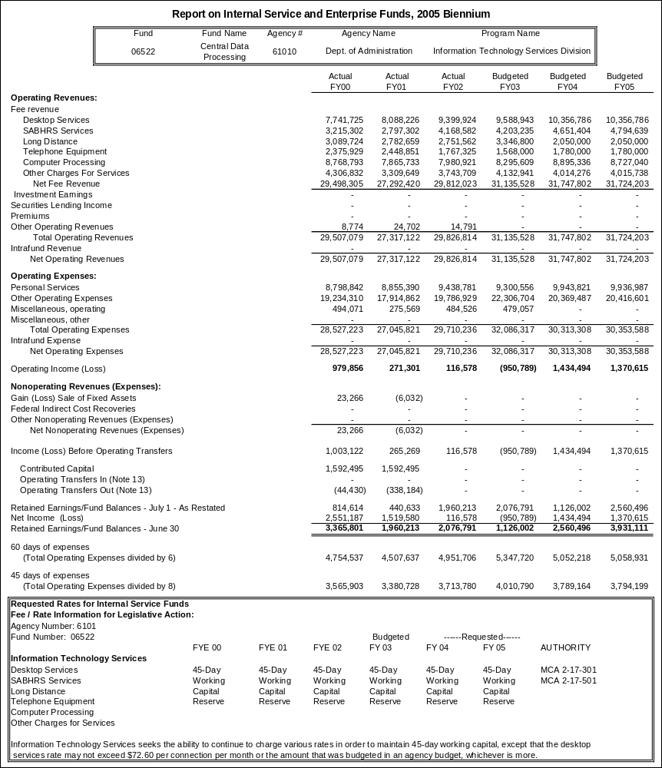
Proprietary Rates

Program Proposed Budget  Budget Item | Base  Budget  Fiscal 2002 | PL Base Adjustment  Fiscal 2004 | New  Proposals  Fiscal 2004 | Total  Exec. Budget  Fiscal 2004 | PL Base Adjustment  Fiscal 2005 | New  Proposals  Fiscal 2005 | Total  Exec. Budget  Fiscal 2005
FTE | 21.47 | 0.62 | 0.00 | 22.09 | 0.62 | 0.00 | 22.09
Personal Services | 896,340 | 11,401 | 0 | 907,741 | 11,951 | 0 | 908,291
Operating Expenses | 3,013,575 | 480,778 | 106,399 | 3,600,752 | 566,013 | 106,393 | 3,685,981
Benefits & Claims | 75,450,862 | 12,467,258 | 0 | 87,918,120 | 17,987,389 | 0 | 93,438,251
Total Costs | $79,360,777 | $12,959,437 | $106,399 | $92,426,613 | $18,565,353 | $106,393 | $98,032,523
Proprietary | 79,360,777 | 12,959,437 | 106,399 | 92,426,613 | 18,565,353 | 106,393 | 98,032,523
Total Funds | $79,360,777 | $12,959,437 | $106,399 | $92,426,613 | $18,565,353 | $106,393 | $98,032,523

Please note that a HB 2 section exists for this program.

Program Description - The State Personnel Division manages four proprietary programs: 1) the Training program, also referred to as the Professional Development Center; 2) the Employee Benefits program, which includes the state's health and other benefit insurance plans; 3) the State Payroll/Benefits Operations program; and 4) the Flexible Spending Accounts program.

Training Program (Fund 06525)
The Professional Development Center (PDC) provides training and other services, such as facilitation, mediation, and curriculum design, to state agencies on a fee reimbursement basis. About 1 percent of program revenue comes from the sale of guidebooks and other publications. PDC is funded as an internal service fund with revenues generated through fees charged for services. The program has a staff of 3.00 FTE professional and also funds a small portion of an accounting technician position in the division. Statutory authority comes from 2-18-102, MCA.

Demand for services has historically been measured by the number of participants served. This measure is variable and difficult to predict from quarter to quarter. Total participants served over the past five years is as follows:
FY 1998 2,898
FY 1999 2,279
FY 2000 3,289
FY 2001 3,145
FY 2002 3,286

Alternate Sources: Agencies can use several alternative sources for training and related services, such as seminars sponsored by national training firms, conferences and symposia, contracted training consultants, in-house training programs, and courses through post-secondary education institutions. PDC acts as one provider in the marketplace.

Customers Served: PDC customers are all agencies and units in Montana state government. Additional customer base includes local government agencies and private, nonprofit agencies. Agencies do not have a mandate to use PDC services; they can purchase training from any source.

Major Changes: None.

Employee Benefits Program (Fund 06559)
The Employee Benefits program is charged with providing state employees, retirees and their families with adequate medical, dental, life and other related group benefits in an efficient manner and at an affordable cost. The program operates a self-insured health and dental plan. Life and long -term care insurance are purchased from private sector vendors. The program contracts with private companies to provide claims processing services, health screening, managed care services and an employee assistance program.

The core service provided by the program is a medical, dental and life insurance benefit. Plan members have several plan options to choose from including two indemnity plans, Traditional and Basic, and a managed care plan administered by three different carriers, New West Health Services, Blue Cross and Blue Shield of Montana, and Peak Health Plan through their provider networks.

The program is funded by the state contribution for group benefits and by premiums and fees paid by plan members. The program currently supports 12.39 FTE and is requesting an additional 0.62 FTE for the 2005 biennium. Competency pay adjustments totaling $11,857 were made in FY 2002. The adjustments were partially financed by operating cost savings. Statutory authority is at 2-18-701 et seq. and 2-18-801 et seq., MCA.

Alternate Sources: As an alternative to providing a self-insured health plan, the state could purchase an insured plan from the private sector. Historical studies of comparable insurance plans have shown that this alternative would be more expensive. The state has operated a self-insured plan since the early 1980s.

Customers Served: Approximately 31,000 people are covered by the benefit plans provided by the Employee Benefits Program in the following categories: 11,800 regular full-time and part-time Executive, Legislative and Judicial branch employees; 3,100 retirees; 100 COBRA participants; and 16,000 dependents.

Major Changes: None.

State Payroll/Benefits Operations Program (Fund 06563)
The Payroll/Benefits Operations Bureau operates the PeopleSoft payroll, benefits and HR system to process, distribute, report and account for payroll, benefits and associated withholding and deductions for 13,000+ state employees in the Executive, Legislative and Judicial branches. The bureau establishes and maintains standards, processes and procedures to be followed by state agencies in preparing and submitting payroll, benefits and related HR data into the system. The system operated by the bureau provides information and processing in support of division and statewide functions and programs including employee benefits (group insurance, FSA, deferred compensation) classification, pay, labor relations, policy and training. The program staff is 6.00 FTE. Competency pay adjustments totaling $11,970 were made in FY02. The adjustments were partially financed by operating cost savings. Statutory authority is at 2-18-401et seq., MCA.

Alternative Sources: As an alternative to providing a centralized payroll and benefit operations system, each agency could provide their own payroll processing, or contract with private firms that provide equivalent services.

Customers Served: Payroll services are provided to 34 state agencies employing over 13,000 people and the Montana District Courts with approximately 280 employees.

Major Changes: None.

Flexible Spending Accounts Program (Fund 06027)
The state offers its employees the opportunity to participate in a medical care and a dependent care flexible spending account which allows them to pay for qualified expenses with pre-tax dollars. The Employee Benefits Bureau contracts with a FLEX account administrator whose fees are based on the number of employees participating in the plan. Employees designate a portion of their paycheck to be directed to the flexible spending accounts and are charged a monthly service fee, which is also collected through the payroll process. As participants in the plan incur medical or dependent care costs, which are not reimbursed to them through other sources, they file a claim with the administrator who in turn reimburses the participant with funds from the flexible spending accounts, which are maintained by the state, up to the employee's annual election amount. Annual elections that are not claimed are forfeited by the employee, and are retained by the fund to help cover operating costs. The Flexible Spending Account program is accounted for as an enterprise fund. No FTE are funded by this program.

Revenues and Expenses -
Training Program (Fund 06525)
- Change in Services or Fees. The Professional Development Center operates on a budget of about $275,000 a year. The budget is typically split into the following expense categories:

Personal services | 60 %
Variable costs | 35 %
Fixed costs (prior to 2004) | 5 %

The major cost driver for all PDC rates is personal services, supporting 3.08 FTE. Other cost drivers that have a significant impact on rates are consulting services, printing, training supplies, communications, and travel, which vary according to the demand for PDC services. Prior to FY 2004, PDC fixed costs accounted for about 5 percent of the program budget. In the 2005 biennium, fixed costs and new indirect costs allocated to the program will make up 11 percent of the budget. The table below depicts historic and projected services, based on open-enrollment and contract services and shows how participation in training varies from year to year. Service levels provided in FY 2004 are projected to be similar to levels in FY 2002 and are expected to increase moderately in FY 2005. Training rates for the 2005 biennium are based on the proportion of fixed costs, including personal services, to the overall anticipated expenses of the program, in an effort to ensure that demand driven revenues are sufficient to cover the total program cost.

Fiscal Year | Open Enrollment Participants | Open Enrollment Hours | Contract Service Participants | Contract Service Hours
FY 1997 | 1001 | 875 | 2333 | 676
FY 1998 | 908 | 813 | 1990 | 726
FY 1999 | 883 | 882 | 1396 | 599
FY 2000 | 1368 | 1115 | 1921 | 444
FY 2001 | 1292 | 1162 | 1853 | 377
FY 2002 | 1473 | 1145 | 1813 | 420
FY 2003 – projected* | 1150 | 1100 | 1500 | 400
FY 2004 - projected | 1450 | 1150 | 1700 | 440
FY 2005 - projected | 1600 | 1200 | 1800 | 500
* The budget cuts for FY 2003 will likely decrease what agencies spend on training

(2) Working Capital Discussion. The average time between PDC providing a service and collecting revenue is 45 days. In order to cover on-going expenses over a 45-day period, PDC should maintain a working capital reserve of $25,800. The major portion of training expenditures do not fluctuate much on a monthly basis. Revenues fluctuate to a much greater extent. Historically, revenues have been low in the first fiscal quarter and increased in each subsequent quarter as agencies gain more comfort in directing their discretionary funds to personnel training. A 45-day working capital would permit PDC to keep up with its fixed and on-going expenditures when demand for services is lower than the average fiscal year revenue expected , and would cover periods of potentially short cash during the accounts receivable collection cycle. Currently, PDC has no working capital. Over past years, the program has often been in the situation where it needed to borrow funds from other programs to cover its day-to-day operations. The rates being requested for the 2005 biennium allow PDC to raise a 45-day working capital reserve over the biennium by including the reserve amount in its fixed costs for the rate calculation.

(3) Fund Equity and Reserved Fund Balance. The PDC has no requirement to reserve any of its fund balance. Management desires to maintain a fund balance sufficient to provide a 45-day working capital. There is $83,142 of the fund equity at FYE 2002 attributable to collections from agencies for the Labor Management Training Initiative which was agreed to during economic negotiations during the 2001 Legislative Session. These funds will be spent in FY 2003 for the purposes outlined in the initiative. The remaining fund balance attributable to PDC functions is ($17,020) after netting the program's compensated absences liability from total fund equity. The rates being requested for the 2005 biennium allow PDC to fund this outstanding liability over the course of the biennium.

(4) Cash Flow Discussion. As stated above, the average length of time between PDC providing training services and collecting revenues for these services is 45 days. During the first two quarters of the fiscal year when demand for PDC services is lower, cash receipts tend to be at their lowest levels. Cash outflows remain fairly constant during this time period as more than 60 percent of PDC expenses are generally fixed in nature and occur independent of its revenue stream. This is the time of year when PDC runs short of cash. Toward the end of the year agencies process their training invoices more readily and send more people to training.

Specific Services and SABHRS accounts. The primary services provided by PDC are open enrollment training courses and contract training. For open enrollment trainings, the PDC schedules, promotes, and conducts courses that are open to students from all agencies. PDC charges a set fee per student for attendance. During most of FY 2000 and all of FY 2001, the typical fee had been $65 for a half-day course and $90 for a full-day course. For all of FY 2002, the typical fee was $70 for a half-day and $95 for a full-day.

PDC also conducts four management course series that last six or seven days, with an average cost of $375 per student. If any open-enrollment training involves travel outside Helena, the fee remains the same and PDC absorbs the travel and facility expenses.

PDC also contracts with individual agencies to provide training for its staff. The agency schedules, promotes, and provides the facility for training. PDC provides the instruction and class materials. On a contract, PDC charges a flat fee, depending on the length of the training and the number of events the agency has contracted. For FY 1995 through FY 2001, the typical contract fee was $450 for a half day and $700 for a full day. Since the start of FY 2002, the typical contract fee has been $500 for a half day and $750 for a full day. If the training involves travel outside Helena, travel expenses are added to the contract fee. If an agency contracts for more than one training event, PDC discounts the fee, based on the number of events. Discounts range from 7 percent to 30 percent. These discounts follow a written, consistent fee schedule.

For facilitation, mediation, consulting, and curriculum development PDC charges an hourly rate of $55 and adds travel expenses, if any, to the invoice. On average, these services account for 15 percent of total revenue each year.

Two minor revenue categories are publication sales and room rentals. PDC maintains half a dozen booklets available for sale, with prices ranging from $1 to $15. The booklet price covers costs of development, printing, and distribution. PDC rents out the meeting rooms in the Metcalf Building to other parties when PDC isn't using them, charging a fee to cover rent and coffee service provided in the room. Revenue from publications and meeting rooms is usually less than 1 percent of total annual revenue.

Deposits for all PDC services are recorded in the following organizations (orgs) on SABHRS under the Department of Administration (61010). In each of these orgs, PDC records revenue in account 522091. All base year funding was proprietary.

Open Enrollment Management Classes | 2325
Other Scheduled Classes-Open Enrollment | 2326
Contract Training | 2327
Consulting and Other Services | 2328
Room Rentals | 2329
Sale of Merchandise | 2331
Conferences | 2332
Governmental Accounting Classes | 2334

Customers record payments to PDC in two main areas: 62809 Education / Training Costs and 62102 Consulting and Professional Services.

Employee Benefits Program (Fund 06559)
(1) Change in Services and Fees. No significant changes in service are contemplated. Fees must be increased as discussed below. The primary cost driver in the fund is the cost of health and prescription drug claims. Medical claim costs are increasing at a rate of approximately 8 percent annually. Drug claims are increasing 16 percent annually.

(2) Working Capital Discussion. The Benefits and Health Insurance program maintains a substantial reserve to allow it to cover health claims against the self-insured plan. Insurance regulations require a certain reserve to be maintained in order to protect the well-being of participants in the plan. In addition the program maintains a reserve to cover its pending liability for claims that have been incurred but not reported at any point in time. Reserve levels are monitored closely by the program with the assistance of its benefit consultant to ensure that the plan is complying with the insurance industries standard practices and requirements.

(3) Fund Equity and Reserved Fund Balance. The reserves for the self-insured plan are calculated as a percentage of claims and consist of two components; incurred but not reported (IBNR) reserves and claims fluctuation reserves. A portion of the claims fluctuation reserve, known as the "Grandfathered benefit" reserve, is set aside to pay the claim liability incurred when the state changed the timing on collecting premiums in August 1998. The switch was from collecting premiums prior to commencement of the month of coverage to collecting premiums during the month of coverage. Employees in service on or before August 1998 are entitled to this Grandfathered reserve.

(4) Cash Flow Discussion. It is projected that about $6.9 million per month in claims will be paid in FY 2004 and $7.4 million in FY 2005. Premiums are collected either bimonthly with paycheck processing or at the beginning of the month depending on whether the premium is for active employees, retirees, legislators, or COBRA employees. Premium rates in FY 2002 were set lower than anticipated claims as part of the program's plan to reduce the amount of its reserves. In FY 2002 claims and other operating costs exceeded premium revenues by $8.1 million, which has left the reserve balance dangerously low.

The cost of providing medical care is rising at a significant rate. Based on FY 2002 expenses of $70.6 million for medical, dental and prescription claims, these expenditures are projected to be $82.8 million in FY 2004 and $88.8 million in FY 2005.

Claims cost make up approximately 94 percent of program expenditures. Administrative costs comprise about 6.1 percent of total program expenditures, including contracting with vendors to process claims, managed care review, and administrative costs directly within the department.

The program records premium revenues received from the state contribution, out-of-pocket premiums for dependents, retirees, COBRA, and legislators in revenue accounts 525039, 525040, 525041, 525042, 525077, and 525079 in fund 06559 under org 2302. Contracted claims administrator fees are recorded in account 62102, 62199 and 62868. Medical and dental claims are paid out of account 67299 and 67205. Prescription drug claims are paid from account 67206. Managed care services are paid from accounts 67203, 67204 and 67208. Vision services are paid from 67209. Long-term care premiums are paid from account 67210 and Life Insurance premiums are paid from 67299.

State Payroll/Benefit Operations Program (Fund 06563)
- Change in Services or Fees. The major cost drivers for the Payroll/Benefit Operations Bureau are personal services for 6.00 FTE, audit fees, computer services/laser printing, and warrant writing fees, totaling 86 percent of total expenses. The fixed costs are based on fees developed by other divisions/agencies for services provided to the bureau. The distribution of expenses is as follows:

Personal Services | 63.03 %
Warrant Writing | 4.00 %
Audit Fees | 11.50 %
Computer Services & Laser Printing | 7.85 %
Other Services | 4.94 %
Supplies & Materials | 1.07 %
Communications | 1.94 %
Travel | 0.31 %
Rent | 1.99 %
Repair & Maint. | 0.19 %
Other Expenses | 3.18 %

Increases in personal services are difficult to forecast. Historically Peoplesoft HR upgrades have increased overtime expenses, as staff members are required to perform normal production duties as well as devote considerable time to the analysis, training, and implementation of the newest software release. Upgrade efforts are currently scheduled for the spring of 2003 and the fall of 2005. A trend is also developing to centralize additional payroll processes. As business processes are re-evaluated and re-designed it is becoming necessary to centralize specific tasks to increase the functionality of the software.

(2) Working Capital Discussion. Included in the payroll rates is the accumulation of a 45-day working capital amount of $52,980 by the end of FY 2005. Of this total there is $26,490 included in the calculation of both the FY 2004 and FY 2005 rates. The working capital is needed to fund the payroll process prior to the quarterly receipt of fees from each agency in order to ensure the uninterrupted processing of the state payroll on a bi-weekly cycle.

(3) Fund Equity and Reserved Fund Balance. The payroll fund currently has fund balance of $15,946 which is the net balance of the program compensated leave liability and cash. Management aims to increase fund equity to maintain a 45-day working capital reserve. The program does not have a requirement to reserve any of its fund equity.

(4) Cash Flow Discussion. Payroll fees from agencies are collected quarterly. Personal services and operating costs are paid with payroll fee receipts on a regular and stable basis throughout the year. There are no irregular cash outlays that occur in the payroll fund.

A discussion of the specific services provided to payroll program customers is given in the proprietary Program Description. The payroll program is accounted for as a proprietary fund and uses the following SABHRS accounts. Revenue for all payroll-processing services are recorded under the Department of Administration (61010), in Org. 2335, fund 06563. Account 521049-Payroll Processing Fees, represents 99.9 percent of revenue collected. Central payroll processing costs are allocated to each agency based on the average number of employees processed and paid bi-weekly by each agency the previous biennium. Account 526040 Misc. Receipts, represents 0.1 percent of revenue collected. This second revenue account includes small payments from the United Way for processing charitable donations withheld through payroll deduction.

Agencies record payments of payroll processing fees in account 62114 - Payroll Service Fees. The following schedule shows the average number of employee payroll checks and advices processed and paid for the past three years, and projections through the 2005 biennium.

Fiscal Year | Ave. # of Employees  Processed and Paid
FY 200 | 12,029
FY 2001 | 14,706
FY 2002 | 13,334
FY 2003 (est) | 13,464
FY 2004 (est) | 13,334
FY 2005 (est) | 13,464
Note: fires in the summer of 2000 increased employee counts

Flexible Spending Account (FSA) Program
(1) Change in Services or Fees. The primary cost driver for the program is claim cost. Claim costs typically are by revenues since claims are only reimbursed up to the level which a participant elects on an annual basis. However, a participant in the medical FSA could potentially request reimbursement for a claim that exceeds his contributions to date and then terminate his employment with the state before contributing his total elected amount. The fund is not able to seek reimbursement for the paid out claim under IRS regulations. Forfeitures of unclaimed annual elections offsets the risk of contributions not being received. The second largest cost driver is the cost of the claims administrator. Currently the claim administrator charges $2.15 per member per month. This rate is subject to inflation and other cost increases by the administrator on an annual basis. Bank service charges are a fairly minor program cost. Because the administrator reimburses the participants directly from a state bank account, the state must maintain a separate and distinct bank account for this activity. In calendar year 2002 the IRS increased the annual election amounts for FSA accounts and this is expected to create an increase in the amount of claims processed. The state health insurance plan is also expecting that out-of-pocket premiums will be increasing beginning in January 2003 and this may result in participants providing for these additional costs through their FLEX plan.

(2) Working Capital Discussion. The net amount of forfeited elections over claim reimbursements that are not matched by contributions provides funds that are available to cover minor internal operating costs. The program has not established rates that would permit a build-up of working capital to fund the program when claims exceed contributions. Rates charged to the participants are passed through to the FSA administrator.

(3) Fund Equity and Reserved Fund Balance. The program is not required to reserve any fund balance.

(4) Cash Flow Discussion. The program does run short of cash to pay claims as a result of the timing difference between when a medical claim can be reimbursed and when contributions for medical claims are received. Historically claims in the first half of the calendar year exceed contributions. The fund becomes flush by the end of the calendar year as claim amounts have reached the participants' election amounts.

Rate Explanation –
Professional Development Center (Fund 06525)
The PDC establishes rates by separating fixed and overhead costs from the variable costs directly associated with producing a specific service, such as a workshop. The total projected fixed costs are divided by an estimate of total billable hours to allocate fixed costs to billable staff hours.

Estimated billable hours for the 3.00 FTE professionals in the program stem from an analysis of past fiscal years. General preparation time, planning, administrative tasks, personal leave, and unbilled travel time are subtracted from the total available hours. This analysis indicates that 25 percent of total staff time can be billed to specific products or services.

An analysis of expenditures shows that 35 percent of total costs can be associated with specific products or services. The remaining 65 percent are personal services and other fixed cost that must be allocated through staff time. One half of the 45-day working capital requirement has been added to the fixed costs for the rate calculations in order to establish the full working capital requirement by the end of the biennium.

The base rate for services is calculated as:
[(Total Costs x 65 percent)+0.5(Working Capital)+0.5(Unfunded Leave)] / (Total Hours x 25 percent) = Staff Cost per Hr

The base rate is used to set the price of individual workshops by analyzing the staff time required to develop and provide the workshop, along with other variable costs (printing, facility rent, materials, travel, etc.) associated with conducting the training. The base rate is also used to set a general schedule of prices where staff time and variable expenses can be consistently projected.

The base rates for FY 2004 and FY 2005 are projected as follows:
FY 2004 ($274,555 x .65) + 0.5(25,800)+0.5(17,020)] / (6240 x .25) = $128.12 / hour
FY 2005 ($275,669 x .65) + 0.5(25,800)+0.5(17,020)] / (6240 x .25) = $128.59 / hour

Justification for a 45-day working capital is provided in the narrative section for proprietary Revenues and Expenses. The cash and accounts receivable balance sheet accounts most significantly contribute to fund equity. The program does not have any outstanding accounts or loans payable. The vast majority of fund equity available at FYE 2002 is attributed to the Labor Management Training Initiative fund and will be expended in FY 2003 for those purposes.

With the above rates established, setting actual prices for services becomes more an art than a science. The PDC differs from nearly every other fee-for-service program in state government. One, it doesn't have a captive market. Besides using PDC, agencies may establish their training in-house or buy it from other providers. Two, training is a discretionary expense by agencies. Managers approve or disapprove each training request, and it's often the first expense to get cut when budgets are tight.

In this environment, PDC aims to provide high-quality training at a competitive cost. The fees need to be market-based as well as cost-based. The PDC analyzes expenses, historic participation rates, projected participation, and projected revenue, coupled with information about competitors' fees. That provides the reasonable basis for setting the following fees.

Type of service | FY 2004 | FY 2005
Open enrollment courses
Two-day course, per participant | 155 | 160
One-day course, per participant | 97 | 99
Half-day course, per participant | 75 | 77
Eight-day management series | 435 | 445
Six-day management series | 380 | 385
Four-day administrative assistant series | 280 | 285
Contract courses
Full day of training, flat fee | 760 | 780
Half day of training, flat fee | 500 | 520
Other services
Consulting or facilitating, hourly fee | 55 | 55
All other services, hourly fee | 50 | 50

Employee Benefits Program (Fund 06559)
The rate provided in HB 2 is the state contribution, i.e., the employer share of premium toward health care coverage. As a component of employee compensation, the state contribution is a subject of collective bargaining.

The objective for the state contribution is to provide sufficient dollars to underwrite affordable coverage for all participants in the plan including sufficient dollars to cover the "employee only" cost of providing a core medical, dental and life insurance benefit. Historically, there have been a few dollars of the state contribution left over that employees can apply toward dependent coverage, additional life insurance or to place into a medical or dependent care flexible spending account (FSA).

Income for the program in FY 2002 was $66.8 million. The state share portion of this income was $43.1 million or 65 percent. The remaining income was from participant paid premiums and investment earnings. Total expenses during FY 2002 were $74.9 million. Excess reserves made up the difference.

Projected income for the next biennium needs to match projected expenses as described below. The self-insured benefit plan has been spending at a deficit for the past several years. By the end of FY 2002, excess reserves were exhausted.

Standard insurance industry analytical techniques are used to project plan costs, establish sufficient actuarial reserves and set premium amounts for the various plan options. In managing the plan the department has the opportunity to increase income by increasing participant premiums or to reduce expenses by reducing the amount of plan coverage. Plan coverage changes include increasing participant deductibles and co-payments, eliminating the payment for some medical services, or looking for opportunities to reduce the cost of services provided.

The following schedule shows historical rates for the state contribution for employee insurance coverage as well as historical medical and pharmacy cost trends. Rates for FY 2004 and FY 2005 have not been determined at this time.

Fiscal Year | Monthly Employer  Contribution | Percent Inc. Over Prev. | Medical Cost Trend | Pharmacy Cost Trend
1994 | $210 | N/A | N/A | N/A
1995 | $230 | 9.5 % | N/A | N/A
1996 | $220 | -4.3 % | N/A | N/A
1997 | $225 | 2.3 % | N/A | N/A
1998 | $245 | 8.9 % | 9.0 % | 20.8 5
1999 | $270 | 10.2 % | 8.9 % | 33.2 %
2000 | $285 | 5.5 % | 8.7 % | 9.2 %
2001 | $295 | 3.5 % | 7.1 % | 5.1 %
2002 | $325 | 10.2 % | 12.6 %** | 12.0 %**
2003* | $366 | 11.1 % | 8 %** | 16.0 %**
*The FY 03 rate becomes effective January 1, 2003.
**Projected trend rates

The balance sheet accounts contributing most significantly to the fund equity balance are the investment accounts (long-term securities, STIP, and long-term securities on loan) and the liability for claims incurred but not yet reported.

Flexible Spending Accounts (Fund 06027)
The rate charged to participants in the Flexible Spending Account plans is established through the competitive bid procurement process and contract negotiations with the successful bidder for the claims administration contract. The price charged by the administrator is the price paid by the participant.

--------------------------------- Present Law Adjustments --------------------------------

Total Agency Impact | General Fund Total
FY04 $12,873,360 | FY04 $0
FY05 $18,530,342 | FY05 $0
PL- 2301 - Employee Benefit Program, Administration, & Claims -
The Employee Benefits Program has added several new benefit plans in an effort to control increasing health care costs to the state's self-insured plan. Claim costs have risen substantially over the past few years and this trend is expected to continue, both in the state's plan and nationally. Contracts for claim administrators and insurance providers are being reprocured and it is expected that the cost of these services will increase.

Additional Employee Benefit Services: The benefit programs, and contracted providers, must be monitored and evaluated to ascertain the effectiveness of the services the state receives. The number and complexity of the different health plans available to state employees has increased the number of customer inquiries being received by the bureau beyond a level that can be handled by existing staff. The Employee Benefits Bureau is requesting 0.62 FTE to meet its responsibility for oversight and administration of the health benefit plans which include managed care, life insurance, long-term care insurance, vision benefits program, employee assistance program, day care program, and the flexible spending account program. The total biennial cost for the requested FTE is $50,220.

Flexible Spending Accounts: Claim costs in the state's Flexible Spending accounts are anticipated to increase in the 2005 biennium as a result of projected annual increases in member participation in the medical flex program and increases in the dollar amount of claims pledged and processed in both the dependent and medical care flex accounts. It is anticipated that overall the annual increase in dependent care claims processed will be 3 percent each year after FY 2002. Medical care claims are expected to increase 15 percent each year over the claim volume experienced in FY 2002. The State Employee Benefits Program obtained a new FLEX administrator mid-way through FY 2002 with a substantially lower administrative cost per participating member. The administrative costs paid for the second half of FY02 were approximately $9,000 less than the administrative costs paid in the first half of the base year. The administrative fee rate is set on an annual basis in conjunction with the calendar year. It is estimated that the contracted administration fee will increase 5 percent each year through FY 2005. The FLEX program will have additional internal operating costs for statewide audit fees and SFCAP allocated to it in the 2005 biennium for the first time.

Claim Costs and Administration of Health Benefit Plans: Medical and dental claim costs are projected to increase 8 percent during the next biennium. Nationally health insurance claims are increasing at an even faster rate. Prescription drug claim costs are expected to continue increasing 16 percent annually.

Claim Administrator costs, and other contracted benefit providers working with the state, are expected to increase at least 5 percent annually. The program has actively sought out cost containment arrangements with benefit providers such as the Montana Direct Hospital contract, which helps lower hospitalization costs to the plan, and is participating in large employer purchasing pools. Administration of these new arrangements will increase the program's consulting costs.
________________________________________________________________________________________________

Total Agency Impact | General Fund Total
FY04 $26,468 | FY04 $0
FY05 $26,463 | FY05 $0
PL- 2303 - Indirect Cost Allocation – HB 576 -
The State Personnel Division programs, including Personnel Administration, Employee Benefits, Central Payroll and Training, will require additional authority to cover indirect/administrative costs to fund to department's data processing, management services, human resources, and legal units. The division's total indirect fixed cost allocation will be $59,912 in FY 2004 and $59,876 in FY 2005; only the increase is shown here.

---------------------------------------- New Proposals ----------------------------------------

Total Agency Impact | General Fund Total
FY04 $11,788 | FY04 $0
FY05 $11,782 | FY05 $0
NP- 318 - Indirect Cost Allocation - HB576 -
Funding change for the Director's Office and the Management Support Bureau. NP-318 distributes budget and give the program authority to pay for the indirect recovery. This indirect cost recovery is an audit recommendation.
________________________________________________________________________________________________

Total Agency Impact | General Fund Total
FY04 ($40,389) | FY04 $0
FY05 ($40,389) | FY05 $0
NP- 2302 - Elimination of Service -
During economic negotiations with labor unions during the 2001 legislative session, the state agreed to provide a labor management training initiative fund of $150,000 for the 2003 biennium with the purpose of coordinating labor relations training and skill development in order to enhance the long-term relationships between the state and participating unions. The labor management training initiative fund was accounted for in the State Personnel Division Training Program under fund 06525 and $40,390 went toward providing training under this initiative. The initiative was a one-time expense that is not expected to carry into the 2005 biennium.
________________________________________________________________________________________________

Total Agency Impact | General Fund Total
FY04 $135,000 | FY04 $0
FY05 $135,000 | FY05 $0
NP- 2305 - State Recruitment Advertising -
The State Personnel Division would like to propose that advertising for state agency position vacancies in Montana newspapers be consolidated into a single display ad that runs each Sunday in the State's five major newspapers (Missoula, Butte, Great Falls, Helena, and Billings). It is estimated that the once-a-week, consolidated advertisement would cost $135,000 annually, as opposed to the estimated $1.1 million currently spent by state agencies in advertising vacant positions. The consolidated advertisement would eliminate redundant information regarding the state as an employer and would refer people to the state's web site for detailed information related to each advertised position. The State Personnel Division proposes that the cost of running the consolidated advertisements be distributed to agencies on a FTE basis and be accounted for in a new internal service fund (06590).
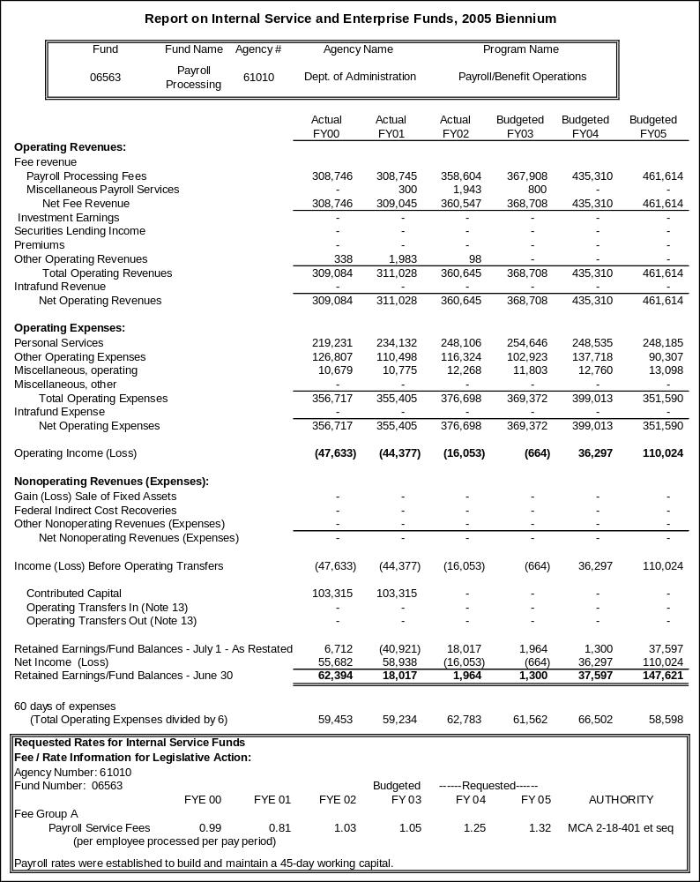

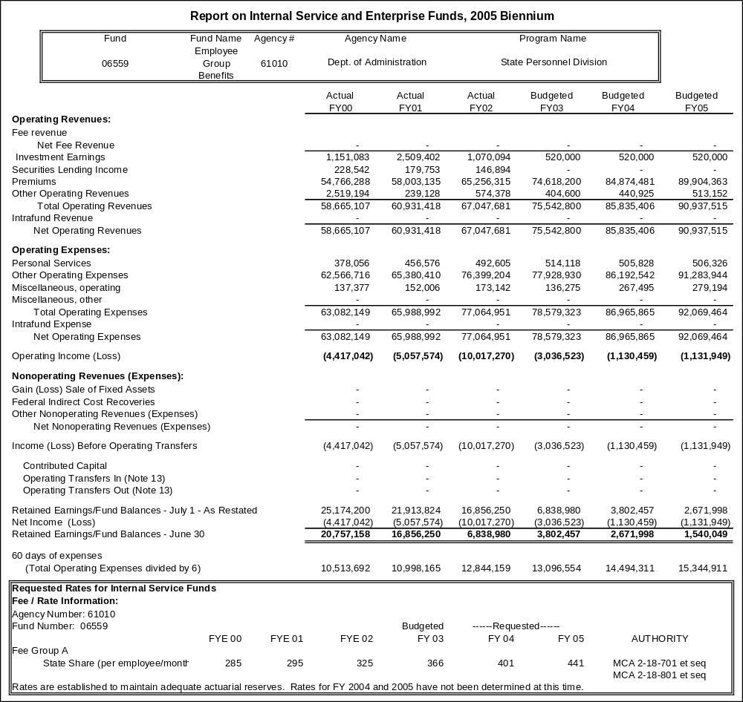

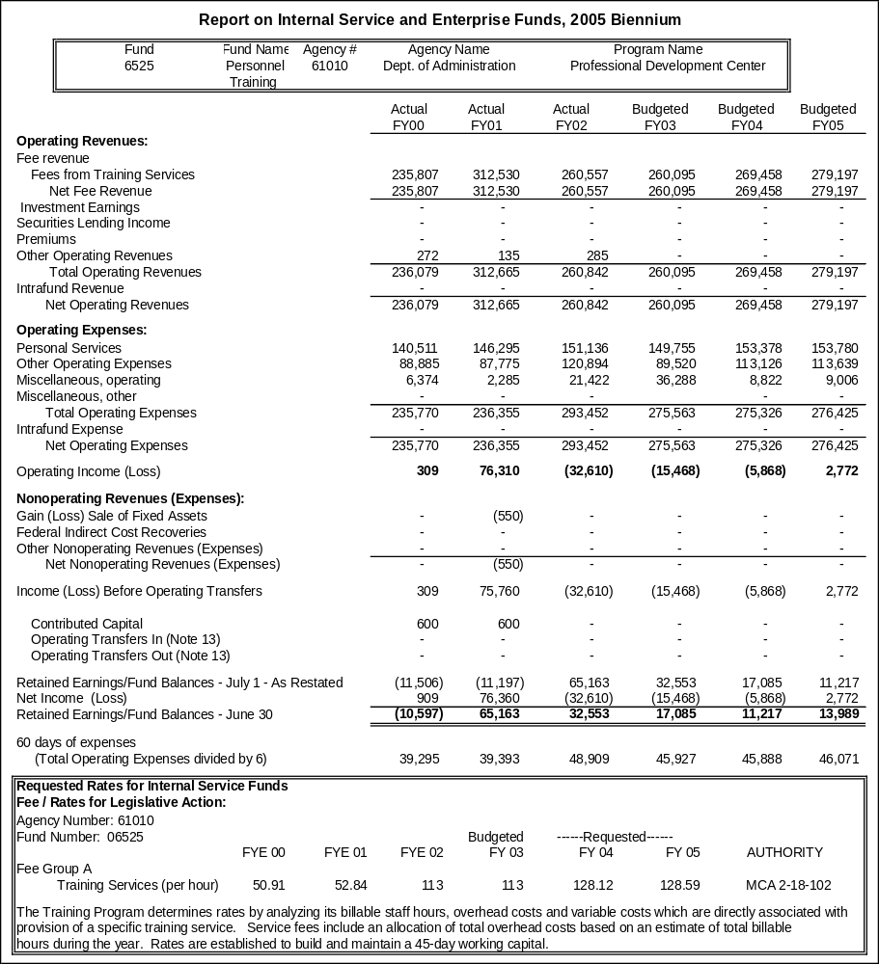

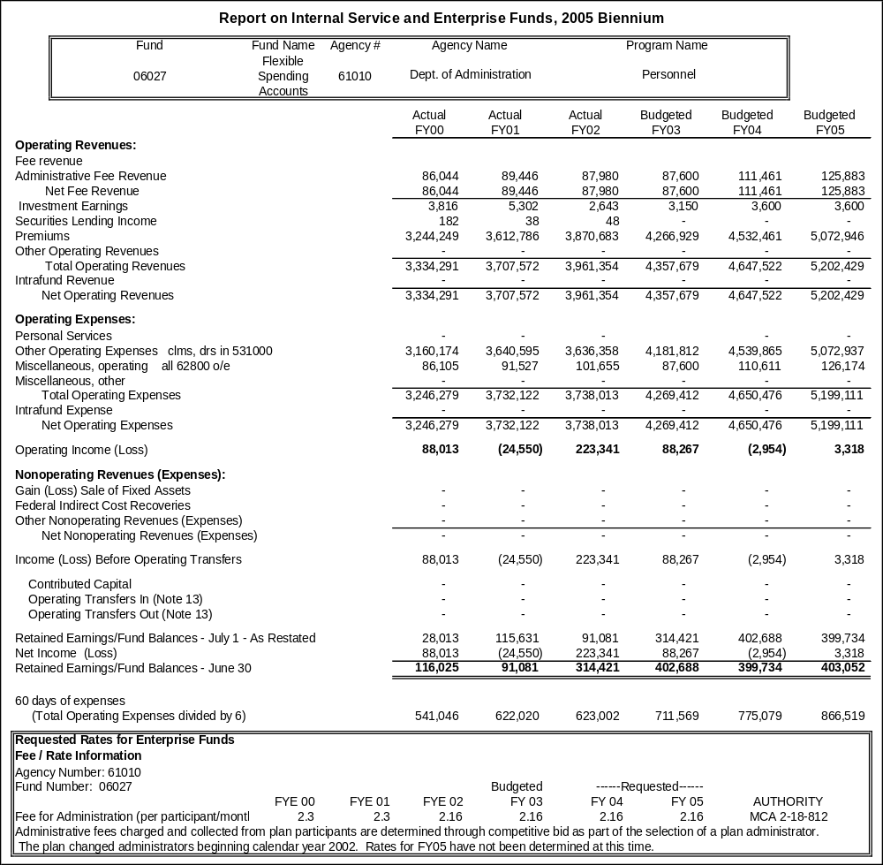

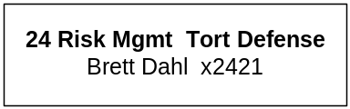

Proprietary Rates

Program Proposed Budget  Budget Item | Base  Budget  Fiscal 2002 | PL Base Adjustment  Fiscal 2004 | New  Proposals  Fiscal 2004 | Total  Exec. Budget  Fiscal 2004 | PL Base Adjustment  Fiscal 2005 | New  Proposals  Fiscal 2005 | Total  Exec. Budget  Fiscal 2005
FTE | 16.00 | 0.00 | 0.00 | 16.00 | 0.00 | 0.00 | 16.00
Personal Services | 650,653 | 87,068 | 0 | 737,721 | 87,749 | 0 | 738,402
Operating Expenses | 3,978,549 | 1,640,064 | 34,480 | 5,653,093 | 1,626,350 | 34,463 | 5,639,362
Benefits & Claims | 8,234,140 | 0 | 0 | 8,234,140 | 0 | 0 | 8,234,140
Total Costs | $12,863,342 | $1,727,132 | $34,480 | $14,624,954 | $1,714,099 | $34,463 | $14,611,904
Proprietary | 12,863,342 | 1,727,132 | 34,480 | 14,624,954 | 1,714,099 | 34,463 | 14,611,904
Total Funds | $12,863,342 | $1,727,132 | $34,480 | $14,624,954 | $1,714,099 | $34,463 | $14,611,904

Please note that a HB 2 section exists for this program.

Program Description - In accordance with §2-9-201, MCA, the Department of Administration is authorized to accumulate a self-insurance fund (fund 06532) to pay for losses, purchase insurance, and to fund operations. Payments into the self-insurance fund are made from a legislative appropriation. Funding for insurance is authorized in agency budgets by the Office of Budget and Program Planning and approved by the Legislature each biennium in accordance with §17-7-501, MCA. All charges are recorded in 62104. Proceeds from the self-insurance fund are statutorily appropriated for the payment of property/casualty claims in accordance with §2-9-305, MCA.

The Risk Management & Tort Defense Division (RMTD) purchases catastrophic commercial property and casualty insurance to cover aviation and property losses that fall above self-funded deductibles for state agencies, boards, councils, commissions, and the university system. Through in-house staff and contracted services, the division self-administers (i.e., self-insures) general liability, vehicle liability, professional liability, errors & omissions, inland marine, leased/loaned vehicles, and foster care exposures.

The division provides risk management/safety training and consultative services to state agencies to prevent and/or minimize the adverse effects of physical or financial loss. The division also investigates, evaluates, and defends agencies, officers, and employees of the State of Montana in tort liability claims (i.e. personal injury or property damage to third parties) and coordinates the adjudication and settlement of claims involving damage to state property.

Currently, there are no alternatives to self-insurance. Since the early 1980s, the State of Montana has self-insured most property and liability exposures and purchased catastrophic excess (of high deductible) coverage from commercial insurance companies where feasible and cost-effective. Insurance industry underwriting losses from the terrorist attacks of September 11, 2001 (estimated at $50 billion), coupled with a 'hard market' (i.e., reduced investment income from stocks and bonds) have had an enormous impact on the availability and affordability of commercial excess insurance.

Many insurance carriers in today’s market are unwilling to accept the kinds of risks that state government presents when other, more profitable alternatives are available. A recent evaluation of the cost savings realized by self-insuring versus purchasing commercial insurance estimated annual cost savings of $2 million per year.

In February of each fiscal year, the Risk Management & Tort Defense Division contracts with Tillinghast Inc., an actuarial consulting firm, to project the State of Montana's estimated unpaid loss and loss adjustment expenses (i.e., payments for settlements, judgments, verdicts, attorneys' fees, adjusters' fees, and associated costs) for each fiscal year as of June 30th. Actuarial evaluations provide an estimate of the funding that would be necessary if all of the state's claims and lawsuits for prior fiscal years came due at the same time. For example, actuarial projections of unpaid losses as of June 30, 2002, are estimated at $29,848,481. If the state had to pay all of these losses at once then it would need $29.85 million on June 30, 2002. Actuarial projected future loss costs for FY 2004 and FY 2005 determined the ultimate projected loss for those fiscal years to be respectively $10,130,230 and $10,805,580.

Since claims and lawsuits are filed at different times and paid out over as many as 10 years it is not probable that all claims would come due at once. Recent projections, however, indicate that the state's unfunded liability is increasing. These projections should not be ignored.

Revenues and Expenses -
Proposed increases in auto comprehensive/collision insurance are primarily attributable to increases in the number of exposure units insured. Proposed increases in aviation (i.e., aircraft and airports), property (i.e., boilers & machinery, employee fidelity bond, and fine arts) are the result of increases in the values of these assets, unfavorable insurance market conditions, and the terrorist attacks on September 11, 2001.

State agencies own or lease an estimated 9,300 vehicles per year. These vehicles are used for diverse functions including highway maintenance, law enforcement, construction, regulatory activities, and 'off-road' travel. Due to the time and distance involved in traveling state highways, state and university departments and employees accumulate millions of driving miles each year in-state and out-of-state. The diverse and 'high risk' nature of vehicle operations coupled with the time and distance involved in traveling present significant liability exposure for state agencies. Efforts to mitigate risk through defensive driver training, implementation of policies and procedures, and effective claims management by the Department of Administration have been very successful. Approximately 3,000 state employees have attended training since 1996.

State agencies own and operate 22 aircraft (including helicopters) that are used for diverse functions such as law enforcement, game management, transportation of state employees, firefighting and aerial topography. In addition, the state owns and operates 15 state airports, which connect Montana citizens and visitors in rural and urban areas and assist state agencies to more effectively conduct state business. The number of flights into West Yellowstone alone totals 3,000 per year. Historically, the state has had very few aviation losses; however, the potential for catastrophic losses requires protection in the form of catastrophic insurance. Currently, the division purchases liability insurance on an 'excess basis' with limits of $5 million per occurrence and a deductible of $1.5 million per occurrence. Terrorist attacks resulted in the losses of hundreds of lives and billions of dollars in aircraft damages. Aviation insurance carriers already 'reeling' from declining investment income in stock markets, no longer had the capacity and surplus to absorb these losses. As a result, the state's aviation insurance premiums are budgeted to increase significantly in FY 2004 and FY 2005.

Montana state government operates prisons, hospitals, and institutions. In addition, state agencies are responsible for designing and maintaining highways, law enforcement, supervising parolees, natural and wildlife resource management, placing and supervising foster children, educating students, and many other vital public functions that create enormous liability exposure and/or are not otherwise available. An increase in the frequency and the severity of general liability claims is attributed, in part, to an increase in exposure. For example, the number inmates incarcerated in prisons operated or supervised by the Department of Corrections in 1996 was 1,612 as compared to 2,423 currently. During that same period of time, the number of parolees has increased from 5,114 to 6,347. The number of foster children supervised by the Department of Public Health and Human Services has also increased. On July 1, 2000, the Department of Transportation assumed responsibility for an additional 7,500 miles of secondary highways formerly maintained by cities and counties.

Also, an unfavorable legal environment and adverse court decisions have resulted in liberal jury verdicts and court-awarded settlements. Since FY 1998, the division has experienced two historical 'worst years' of loss experience. General liability premium increases for FY 2004 and FY 2005 are required in order to re-pay a $4.7 million general fund loan and to fund projected loss costs in FY 2004 and FY 2005. Earned premium for FY 2004 and FY 2005 includes re-payment of general fund loan of $4.7 million required in FY 2002. This loan must be re-paid within one calendar year; therefore, it is anticipated that another general fund loan of $6 million will be needed in FY 2003 to cover a shortfall in revenue associated with re-payment of the first general fund loan and projected FY 2003 operational costs. Projected earned premium in FY 2004 and FY 2005 contemplates re-payment of the general fund loan needed in FY 2003 in the amount of $3 million each year of the biennium.

During FY 2002, expenditures for settlements and verdicts totaled approximately $8,234,140. These expenditures reflect inflation in medical costs, attorneys' fees, court awards, and an unfavorable tort environment. The net effect has been a decrease in the cash balance of the state self-insurance fund.

State agencies and universities own or lease 3,300 properties with an estimated current replacement cost value of $2.4 billion. In addition, the state owns 288 boilers and hundreds of fine art objects with an estimated market value of over $100 million. In accordance with §2-9-102, MCA, the division self-funds losses that fall below commercial insurance deductibles of $150,000 per occurrence. The division purchases catastrophic excess insurance to cover unexpected losses that are beyond the ability of the state to self-fund.

Increases in insured values and the costs of excess property insurance premium account for much of the increase through FY 2003. On September 11, 2001, the property/casualty insurance industry experienced the worst year of catastrophic hull (i.e., physical damage) and liability losses in its history. Terrorist attacks resulted in the losses of thousands of lives and billions of dollars in property damage, business interruption, and consequential damage.

Property insurance carriers already 'reeling' from declining investment income in stock markets, no longer had the capacity and surplus to absorb an estimated $50 billion in costs without an infusion of new capital. As a result, the state's property insurance premiums are budgeted to increase dramatically in FY 2004 and FY 2005.

The program anticipates revenue of $14,770,015 in FY 2004 and $15,452,767 in FY 2005. These amounts are approximately 683 percent and 92 percent increases, respectively, over base year revenue. At that level of funding, the program will generate enough revenue to fund the average of losses sustained in the last three years. The program actual base year operations expenditures were $12,863,342 and 16.00 FTE. The program anticipates actual expenditures of $14,873,742 in FY 2004 and $14,860,712 in FY 2005, which are both increases of approximately 16 percent over base year expenditures, not including estimated tort claims liability.

Rate Explanation -The goal of the program is to maintain insurance rates sufficient to sustain losses in each year of the biennium equal to the average losses sustained in the last three years. In the last three years the state sustained an average loss of $6.1 million per year. The program's goal is therefore to generate enough premiums to cover operating expenses and sustain back-to-back losses of $6.1 million per year. The program has not adjusted the $6.1 million three-year average loss for inflation.

To set rates for the commercial insurance premium cost portion of the program, which is allocated to agency budgets as part of fixed costs, the program calculates the actual base year premiums paid to commercial carriers and adds on a percentage of increase. The program determines the amount of the percentage increase by talking to industry experts and brokers to get their opinions about how much commercial premiums will be in the upcoming biennium.

In accordance with §2-9-202, MCA, the division is responsible for the apportionment of all insurance costs to state agencies. Those costs are recovered by the division in the form of insurance premium subject to appropriations by the Legislature.

The philosophy of the division is that each state agency should bear a proportionate share of expense commensurate with their loss experience (i.e., loss payments) and exposure (i.e., number and type of vehicles, property, boilers & machinery, etc.)

The division incurs significant expense in the investigation, defense, and settlement of claims and lawsuits. Those agencies with higher losses will pay higher insurance premiums. No one agency is expected to bear the burden of paying for total costs of unexpected losses from their authorized budgets.

The Risk Management & Tort Defense Division allocates costs as follows:

Auto Liability & Physical Damage: Costs are apportioned to state agencies based upon their historical loss experience as well as the number of vehicles owned, leased, or borrowed. The state contracts with Tillinghast Inc. of Denver, Colo., to conduct the allocation.

Aviation (Aircraft & Airports): Costs for aircraft are based upon year, make, model, and value of the aircraft and are determined by the insurance carriers. Costs for airports are apportioned to state agencies based upon the number of airports and are determined by the insurance carriers.

General Liability: Costs are apportioned to state agencies based upon their historical loss experience as well as the number of full-time equivalents (FTEs). The state contracts with Tillinghast Inc. to conduct the allocation.

Property (boilers & machinery, crime, fine arts, and miscellaneous): Costs are apportioned to state agencies based upon the estimated replacement cost value for buildings and fine arts reported as owned/leased/loaned. Costs for boilers are apportioned based upon the number of boilers. Costs for crime coverage are based on the number of FTE.

--------------------------------- Present Law Adjustments --------------------------------

Total Agency Impact | General Fund Total
FY04 $24,163 | FY04 $0
FY05 $24,159 | FY05 $0
PL- 2401 - Indirect Fixed Costs -
Department indirect/administrative costs for services received from other proprietary funded centralized service functions of the agency.
________________________________________________________________________________________________

Total Agency Impact | General Fund Total
FY04 $1,598,067 | FY04 $0
FY05 $1,598,067 | FY05 $0
PL- 2402 - Insurance Procurement and Administration -
Due to recent acts of terrorism and other national events, the property casualty insurance market has hardened significantly and the Division of Risk Management and Tort Defense's insurance brokers have advised the division of the following increases from FY 2002 expenditures by line of coverage for FY 2004 and an additional 10 percent increase for FY 2005:

Aircraft Liability: 50 percent or $26,090 and 10 percent or $7,827
Aircraft Hull: 20 percent or $9,387 and 10 percent or $5,632
Airport Liability: 30 percent or $1,575 and 10 percent or $683
Boiler & Machinery: 25 percent or $4,312 and 10 percent or $2,156
Commercial Property: 100 percent or $613,200 and 10 percent or $122,640
Crime: 50 percent or $24,225 and 10 percent or $7,267

Estimated additional costs for the 2005 biennium will be $1,503,781.

---------------------------------------- New Proposals ----------------------------------------

Total Agency Impact | General Fund Total
FY04 $34,480 | FY04 $0
FY05 $34,463 | FY05 $0
NP- 318 - Indirect Cost Allocation-HB576 -
Funding change for the Director's Office and the Management Support Bureau. NP-318 (HB 576) distributes budget to this program for the indirect recovery. This indirect cost recovery is an audit recommendation.
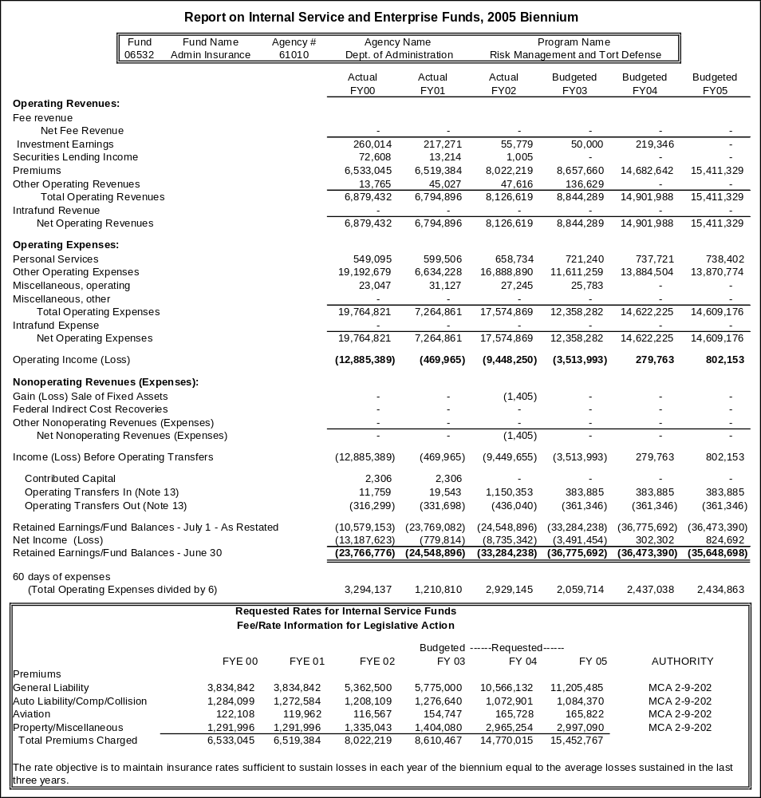

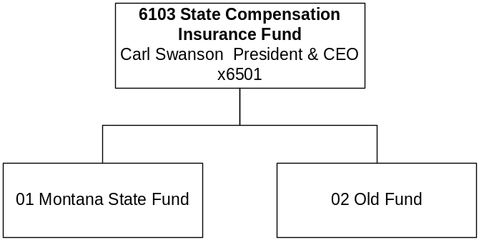

Mission Statement - Mission Statement:
'Montana's insurance carrier of choice and industry leader in service.'

Vision Statement:
'Montana State Fund is committed to the health and economic prosperity of Montana through superior service, leadership and caring individuals working in an environment of teamwork, creativity and trust.'

Statutory Authority - The State Compensation Insurance Fund (Montana State Fund) provides liability insurance for workers' compensation and occupational disease and may not refuse coverage to any employer requesting coverage (39-71-2313, MCA).

Section 39-71-2321, MCA, provides that all funds deposited in the State Fund may be expended as provide in 17-8-101(2)(b), under general laws, or contracts entered into in pursuance of law, permitting the disbursement. Based on this statutory provision the State Fund is not budgeted in the general appropriations act.

Management and control of the Montana State Fund is vested solely in a seven-member board of directors (Board) appointed by the Governor. The Board is vested with full power, authority, and jurisdiction over the Montana State Fund. The board may perform all acts necessary or convenient in the exercise of any power, authority, or jurisdiction over the state fund, either in the administration of the state fund or in connection with the insurance business to be carried on under the provisions of this part, as fully and completely as the governing body of a private mutual insurance carrier, in order to fulfill the objectives and intent of this part, 39-71-2315, MCA

The MSF President / CEO shall annually submit to the board for its approval an estimated budget of the entire expense of administering the state fund for the succeeding fiscal year, with due regard to the business interests and contract obligations of the state fund. A copy of the approved budget must be delivered to the Governor and the Legislature. Upon approval of the estimated budget for the succeeding fiscal year, the state fund shall, no later than October 1 of each year, submit the approved annual budget for review to the Legislative Finance Committee, 39-71-2363, MCA.

The Board has the authority to establish the rates to be charged by the Montana State Fund for insurance. The Board shall engage the services of an independent actuary who is a member in good standing with the American academy of actuaries to develop and recommend actuarially sound rates. Rates must be set at amounts sufficient, when invested, to carry the estimated cost of all claims to maturity, to meet the reasonable expenses of conducting the business of the State Fund, and to amass and maintain an excess of surplus over the amount produced by the National Association of Insurance Commissioners' risk-based capital requirements for a casualty insurer, 39-71-2330, MCA.

Because surplus is desirable in the insurance business, the Board shall annually determine the level of surplus that must be maintained by the Montana State Fund pursuant to this section, but shall maintain a minimum surplus of 25% of annual earned premium. The state fund shall use the amount of the surplus above the risk-based capital requirements to secure the state fund against various risks inherent in or affecting the business of insurance and not accounted for or only partially measured by the risk-based capital requirements, 39-71-2330, MCA.

The Board has the authority to declare dividends if there is an excess of assets over liabilities. However, dividends may not be paid until adequate actuarially determined reserves are set aside, 39-71-2316 (8), MCA.

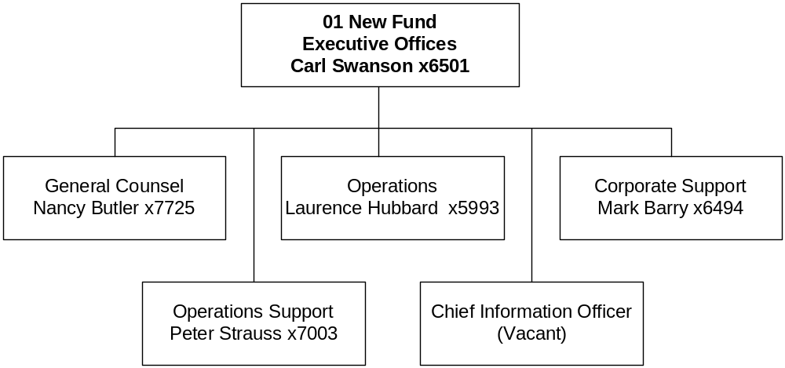

Proprietary Rates

Program Proposed Budget  Budget Item | Base  Budget  Fiscal 2002 | PL Base Adjustment  Fiscal 2004 | New  Proposals  Fiscal 2004 | Total  Exec. Budget  Fiscal 2004 | PL Base Adjustment  Fiscal 2005 | New  Proposals  Fiscal 2005 | Total  Exec. Budget  Fiscal 2005
FTE | 240.00 | 5.50 | 0.00 | 245.50 | 6.00 | 0.00 | 246.00
Personal Services | 12,644,050 | 1,659,348 | 0 | 14,303,398 | 2,075,872 | 0 | 14,719,922
Operating Expenses | 10,276,249 | 2,731,489 | 0 | 13,007,738 | 2,680,362 | 0 | 12,956,611
Equipment | 698,581 | 164,419 | 0 | 863,000 | 10,419 | 0 | 709,000
Benefits & Claims | 69,142,390 | 16,830,920 | 0 | 85,973,310 | 26,725,528 | 0 | 95,867,918
Debt Service | 14,653 | 347 | 0 | 15,000 | 347 | 0 | 15,000
Total Costs | $92,775,923 | $21,386,523 | $0 | $114,162,446 | $31,492,528 | $0 | $124,268,451
Proprietary | 92,775,923 | 21,386,523 | 0 | 114,162,446 | 31,492,528 | 0 | 124,268,451
Total Funds | $92,775,923 | $21,386,523 | $0 | $114,162,446 | $31,492,528 | $0 | $124,268,451

Program Description -The State Compensation Insurance Fund (State Fund) provides liability insurance for workers' compensation and occupational disease and may not refuse coverage to any employer requesting coverage (Title 39, Chapter 71, MCA). The Montana Workers' Compensation Act requires all employers in Montana who have employees in service to carry workers' compensation insurance. The Department of Labor and Industry regulates the workers' compensation industry in Montana. Three plans exist for coverage: Plan I-Self-Insured; Plan II-Private Insurance Companies; or Plan III-State Compensation Insurance Fund (State Fund). The State Fund is a nonprofit public corporation.

The State Fund operates in a competitive market, competing with private insurers. The State Fund guarantees the availability of workers' compensation coverage for all employers in Montana. Montana law requires the State Fund to insure any employer in the state who requests coverage, except those in default of a prior payment to the fund. As provided in law, the State Fund insures all state agencies. The State Fund will insure the Montana University System should the university system elect to use the State Fund as its carrier to insure its workers' compensation and occupational disease liability.

Under the workers' compensation laws of Montana, the State Fund is liable for payment of benefits to employees for injuries arising out of and in the course of employment, or in the case of death or injury, to the beneficiaries. The State Fund pays benefits to injured employees based on a schedule of benefits established in law (Title 39, Chapter 71, MCA).
The State Fund oversees two programs:

1) The State Fund is responsible for managing claims and benefits payments for injuries occurring on or after July 1, 1990.

2) The State Fund is responsible for administering claims of the Old Fund, claims occurring before July 1, 1990.

All premiums and other money paid to the State Fund, all property and securities acquired through the use of money belonging to the State Fund, and all interest and dividends earned upon money belonging to the State Fund are the sole property of the State Fund. The money must be used exclusively for the operations and obligations of the State Fund. The money collected by the State Fund cannot be used for any other purpose (39-71-2320(1), MCA).

Statute requires the State Fund to set premium rates at levels sufficient, when including future investment income, to fund the insurance program (39-71-2311, MCA). This includes the cost of administration, benefits, and adequate reserves. The State Fund is subject to the laws governing state agencies, unless specifically exempted by statute (39-71-2314, MCA).

The board is statutorily required to establish a business plan (39-71-2315, MCA) and an annual budget within parameters defined in law (39-71-2363, MCA). State law requires the State Fund to submit its annual budget to the Legislative Finance Committee for review. Dividends may not be included as administrative expenditures but are a disbursement of excess surplus. The board shall submit an annual financial report to the Governor and to the Legislature indicating the business done during the previous year and containing a statement of estimated liabilities of the State Fund as determined by an independent actuary.

The State Fund's 2005 biennial projected expenditures and funding are based on the State Fund's FY 2003 Strategic Business Plan projected through the biennium. The annual budgets shall consist of an estimate of the entire expense of administering the State Fund for the succeeding fiscal years, with due regard for the business interests and contract obligations of the State Fund. Workers' compensation premiums and investment earnings on State Fund assets fund the State Fund operations. The State Fund does not receive General Fund monies.

Strategic initiatives established in the State Fund's FY 2003 Strategic Business Plan, as approved by the State Fund Board of Directors, are:
- Focusing on superior service delivery to our external and internal customers and emphasizing the importance of a 'safety culture' in the workplace by promoting effective safety and early return to work programs.
- Enhancing the functionality of our computer systems (PowerComp) to easily incorporate new functions, changes to processes and interface with other major State Fund Systems.
- Introducing legislation that will best enable the State Fund to be managed and operated in an entrepreneurial and business-like manner.
- To develop a long-term corporate communications philosophy to ensure that the State Fund vision is reflected in all communications and fully position our company for e-commerce capabilities into the future.

During FY 2002 the State Fund continued to evaluate and improve efficiencies in work processes initiated in our reorganization in FY 2001. The State Fund operates in a team environment focused on responsiveness toward our customers and business partners. We have been following accepted insurance industry practices to ensure financial strength and stability and stability in the marketplace. Our strong surplus, along with our level of loss reserves protects injured employees and other customers against unknown events that may impact losses in any given accident year. The Montana State Fund has a fiduciary responsibility to all who receive benefits to make certain that we retain adequate reserves to deal with any future contingencies.

The State Fund Board of Directors is the approving authority for the State Fund budget. The board approves an annual budget. The State Fund board has not approved the expenditure levels in the following budget table for the 2005 biennium. Changes in business conditions and the competitive market in which MSF operates, as well as changing trends in medical and indemnity benefits, will result in changes to the budgets the Board of Directors will ultimately approve in the 2005 biennium.

The program proposed budget table shown on the previous page reflects projected operating, claim expenditures, and funding. The data cited in the table is for informational purposes only and is based on a two-year State Fund staff projection of operations. Estimates for claim expenditures and funding are periodically updated by staff and are subject to change.

Rate Explanation – 39-71-2330, MCA “Rate setting -- surplus - multiple rating tiers. (1) The board has the authority to establish the rates to be charged by the state fund for insurance. The board shall engage the services of an independent actuary who is a member in good standing with the American academy of actuaries to develop and recommend actuarially sound rates. Rates must be set at amounts sufficient, when invested, to carry the estimated cost of all claims to maturity, to meet the reasonable expenses of conducting the business of the state fund, and to amass and maintain an excess of surplus over the amount produced by the national association of insurance commissioners' risk-based capital requirements for a casualty insurer.

(2) Because surplus is desirable in the insurance business, the board shall annually determine the level of surplus that must be maintained by the state fund pursuant to this section, but shall maintain a minimum surplus of 25 percent of annual earned premium. The state fund shall use the amount of the surplus above the risk-based capital requirements to secure the state fund against various risks inherent in or affecting the business of insurance and not accounted for or only partially measured by the risk based capital requirements.

(3) The Board may implement multiple rating tiers for classifications that take into consideration losses, premium size, and other factors relevant in placing an employer within a rating tier.”

--------------------------------- Present Law Adjustments --------------------------------

Total Agency Impact | General Fund Total
FY04 $20,598,733 | FY04 $0
FY05 $30,744,884 | FY05 $0
PL- 1 - Align Positions & Expenditures -
The decision package reflects FTE, expenditure, and funding estimated by State Fund staff for the biennium. The Board of Directors has approval authority over the State Fund budget and establishes an annual budget for the State Fund (39-71-2363, MCA). The FTE levels for FY 2004 and FY 2005 are staff estimates only and have not been authorized by the Board of Directors.



Proprietary Rates

Program Proposed Budget  Budget Item | Base  Budget  Fiscal 2002 | PL Base Adjustment  Fiscal 2004 | New  Proposals  Fiscal 2004 | Total  Exec. Budget  Fiscal 2004 | PL Base Adjustment  Fiscal 2005 | New  Proposals  Fiscal 2005 | Total  Exec. Budget  Fiscal 2005
FTE | 0.00 | 0.00 | 0.00 | 0.00 | 0.00 | 0.00 | 0.00
Operating Expenses | 1,354,637 | (18,958) | 0 | 1,335,679 | (118,392) | 0 | 1,236,245
Benefits & Claims | 12,800,092 | (761,487) | 0 | 12,038,605 | (1,125,069) | 0 | 11,675,023
Total Costs | $14,154,729 | ($780,445) | $0 | $13,374,284 | ($1,243,461) | $0 | $12,911,268
Proprietary | 14,154,729 | (780,445) | 0 | 13,374,284 | (1,243,461) | 0 | 12,911,268
Total Funds | $14,154,729 | ($780,445) | $0 | $13,374,284 | ($1,243,461) | $0 | $12,911,268

Program Description - As required in 39-71-2352, MCA, the Old Fund has a separate payment structure and funding structure. The Old Fund is established to compensate injured employees with claims for injuries prior to July 1, 1990.

The State Fund administers the claims of the Old Fund and charges the cost of administering the claims to the Old Fund. The State Fund is limited in law to charge no more than $1.25 million per year to the Old Fund for claims administration.

The Old Fund was funded through the old fund liability tax (OFLT). This tax was initially enacted in 1987 and expanded in 1993 and was administered by the Department of Revenue. The old fund liability tax was eliminated January 1, 1999. State law established parameters for the termination of the OFLT. The State of Montana budget director certified that the statutory parameters had been satisfied and that the Old Fund liability was adequately funded.

At the September 16, 1998 State Fund board meeting, the fund's consulting actuary advised the board that as of December 31, 1998 the Old Fund would be fully funded including a contingency of 10 percent. As a result of this action the board in turn advised the State of Montana budget director that the Old Fund would be fully funded as of December 31, 1998. On September 16, 1998, the budget director submitted written notice to the Department of Revenue to begin efforts to provide for terminating the collection of the old fund liability tax on January 1, 1999.

The transfer of the excess of adequate funding of the Old Fund established in 39-71-2352(5) and (6), MCA, was amended during the 2002 Special Legislative Session. The amendments were enacted to enable the Old Fund to transfer $4 million in excess of adequate funding from the Old Fund to the general fund ($1.9 million) and to the School Flexibility Fund ($2.1 million) prior to June 30, 2003. The remaining amount of excess of adequate funding from the Old Fund will be transferred to the State Fund. The total amount of funds transferred under this subsection may not exceed $63.8 million.

If in any fiscal year after the old fund liability tax is terminated claims for injuries resulting from accidents that occurred before July 1, 1990, are not adequately funded, any amount necessary to pay claims for injuries resulting from accidents that occurred before July 1, 1990, must be transferred from the general fund to the account provided for in 39-71-2321, MCA.

--------------------------------- Present Law Adjustments --------------------------------

Total Agency Impact | General Fund Total
FY04 ($780,445) | FY04 $0
FY05 ($1,243,461) | FY05 $0
PL- 2 - Align Expenditures -
The decision package reflects expenditure and funding estimated by State Fund staff for the biennium. The Board of Directors has approval authority over the Old Fund budget and establishes an annual budget for Old Fund (39-71-2363, MCA). The expenditures cited for FY 2004 and FY 2005 are staff estimates only and have not been authorized by the Board of Directors.
Proprietary Rates

Program Proposed Budget  Budget Item | Base  Budget  Fiscal 2002 | PL Base Adjustment  Fiscal 2004 | New  Proposals  Fiscal 2004 | Total  Exec. Budget  Fiscal 2004 | PL Base Adjustment  Fiscal 2005 | New  Proposals  Fiscal 2005 | Total  Exec. Budget  Fiscal 2005
FTE | 3.06 | 0.00 | 0.00 | 3.06 | 0.00 | 0.00 | 3.06
Personal Services | 101,601 | (736) | 0 | 100,865 | (914) | 0 | 100,687
Operating Expenses | 1,063,383 | 78,809 | 0 | 1,142,192 | 103,658 | 0 | 1,167,041
Equipment | 920,024 | 0 | 0 | 920,024 | 0 | 0 | 920,024
Total Costs | $2,085,008 | $78,073 | $0 | $2,163,081 | $102,744 | $0 | $2,187,752
Proprietary | 2,085,008 | 78,073 | 0 | 2,163,081 | 102,744 | 0 | 2,187,752
Total Funds | $2,085,008 | $78,073 | $0 | $2,163,081 | $102,744 | $0 | $2,187,752

Please note that a HB 2 section exists for this program.

Program Description - Duplicating Center
The department's duplicating center provides duplicating and bindery services to department employees. The Duplicating Center has only 1.00 FTE and whenever the demand for services becomes to great or a particular job is considered too large, the excess jobs are taken to Publications & Graphics to be completed.

Equipment Enterprise Fund
The department's equipment fund provides a fleet of vehicles and aircraft to department employees. The revenue users are department employees, mostly enforcement wardens, fish and wildlife biologists and park employees. Every month, users are charged for the miles driven (hours flown) during the previous month.

Warehouse Inventory
The department's warehouse contains mainly uniform items (both for wardens and non-wardens) and items specifically related to the duties of the department such as gill nets for the fisheries biologists. Overhead costs are recovered by charging a predetermined fixed percentage to all sales.

Revenues and Expenses -
Duplicating Center
Expenses recovered in the rates are the personal services of the 1.00 FTE, operating expenses and the raw materials needed for duplicating.

Rates have been historically adjusted based on the need to increase or decrease the cash balances in the account. Prior to requesting new rates, a review of the cash balance is done. At FYE 2002, the cash balance was $20,850.

Working Capital Discussion
The 60-day working capital requirement provides sufficient cash to fund on-going operations of this program.

Field projects are billed monthly for the services provided during the month. The workload is fairly consistent so there is little fluctuation in cash balances except when additional inventory is purchased.

Fund Equity and Reserved Fund Balance
A portion of the program's fund balance has been reserved for the duplicating center's equipment and inventory. At FYE 2002 the book value of the assets was $13,000 and the fund had $11,600 in inventory.

Equipment Fund
The objective of the vehicle account is to recover (through rates and annual auction revenues) sufficient funds to cover administrative costs to operate the program (personal services and operations) in addition to being able to replace fleet vehicles at approximately 100,000 miles. A total of 2.06 FTE are funded in this fund. The two largest costs are fuel and repairs. In FY 2002 the fund spent $625,000 on fuel and $500,000 on repairs. In FY 2002 the department drove just over 5,000,000 miles in department vehicles while the 10-year average is 4,950,000 miles. Due to a 15 percent rate increase in FY 2003 and the proposed rate increases in FY 2004 and FY 2005, the program anticipates revenues of $2.3 million in FY 2004 and $2.4 million in FY 2005. These amounts are increases of approximately 19 percent and 23 percent, respectively, over base year fee revenue.

Working Capital Discussion
The department attempts to manage this account so that a 60-day working capital amount of cash is available when the cash balance is at its lowest level. To compensate for a cash flow problem created by keeping rates artificially low, rates were increased 25 percent in FY 2002 and 15 percent in FY 2003. We are requesting a 6 percent rate increase in FY 2004 and an additional 3 percent rate increase in FY 2005. The department attempts to ensure that fees are commensurate with costs over time. It does this in two ways. First, proposed rates for the next biennium take into consideration any excess income or loss generated from previous periods. Second, prior to finalizing new rates at the beginning of a new fiscal year, the rates are recalculated based on actual information.

In order to maintain a positive cash balance, the vehicle fund currently has a $300,000 loan from another fund. Working capital at FYE 2002 was $147,000.

Divisions are billed monthly for the miles driven (hours flown) during the previous month. Cash balances fluctuate during the year for two reasons. The first is that monthly mileage is greater during in the summer and fall than during the winter and spring. The second reason is that new vehicles are purchased in the spring. Thus cash balances are normally highest in December after the hunting season and lowest in the spring after purchasing the new vehicles. Fiscal year end balances tend to be significantly higher than spring balances

Fund Equity and Reserved Fund Balance
There is no requirement to reserve fund balance. At FYE 2002, the vehicle fund had total assets of $5,582,000 and the book value (original cost less accumulated depreciation) of the fleet was $5,300,000. The major liability is a $300,000 loan to ensure a positive cash balance at year-end. As stated above, working capital at FYE 2002 was $147,000. A portion of the program's fund balance has been reserved for the book value of department vehicles and aircraft.

Warehouse Inventory
Revenues and Expenses
The expenses associated with the warehouse include personal services, miscellaneous office supplies and expenses for the warehouse worker and inventory purchased needed to replenish existing stock. Revenues are the sales of inventory items to department employees. We anticipate revenues to be constant at around $90,000 per year for FY 2004 and FY 2005. Beginning in FY 2002, there is 0.20 FTE funded with this program.

Working Capital Discussion
The 60-day working capital requirement provides sufficient cash to fund on-going operations of this program. The department attempts to ensure that fees are commensurate with costs over time by adjusting the proposed rates for excess income or loss from previous periods.

Field projects are billed monthly for the purchases made during the month. Cash balances fluctuate during the year. Cash balances are lowest during the winter when stock is replenished and highest during the summer when temporary and seasonal employees are hired.

Fund Equity and Reserved Fund Balance
A portion of the program's fund balance has been reserved for the warehouse inventory. At FYE 2002, the warehouse inventory was $128,510.

Rate Explanation -Duplicating Center
The rate methodology attempts to determine a rate for various duplicating and bindery services that allows the fund to recover both the cost of the raw materials and all associated personal services and operating costs. Rates have been historically adjusted based on the need to increase or decrease the cash balance. The requested rates have been increased only to recover anticipated inflationary increases in the raw materials and administrative costs. The rates have remained constant for the past 4 years.
Proposed Duplicating Services Rates

Item | FY 2004 | FY 2005
Copies
1-20 | $0.045 | $0.050
21-100 | $0.030 | $0.035
210-100 | $0.025 | $0.030
101-500 | $0.020 | $0.025
Color - per sheet | $0.25 | $0.25
Binding
Collating (per sheet) | $0.005 | $0.005
Hand Stapling (per set) | $0.015 | $0.015
Saddle stitch (per set) | $0.030 | $0.030
Folding (per sheet) | $0.005 | $0.005
Punching (per sheet) | $0.001 | $0.001
Cutting (per minute) | $0.550 | $0.550

Equipment
Rate Explanation
The rate methodology attempts to determine a cost/mile rate for various classes of vehicles and a cost/hour rate for each class of aircraft. The methodology is to determine the previous year's expenses, including operating, maintenance, administration and depreciation expenses minus the previous year's revenue generated from the rates and the annual vehicle auction to establish the net income for a particular class. Next the life to date (LTD) net income or loss on a per mile (hour) basis is determined. Future year expenses are estimated based on the most current year's information plus a 3 percent inflationary factor. Using the most current year's mileage and the projected expenses, a cost/mile (hour) rate is determined for the future year. This rate is adjusted for any LTD net income or loss. In an attempt to minimize large increases or decreases, rates will not change more than 25 percent per year (10percent for aircraft).

In addition, in order to more fairly charge users, a minimum mileage rate was instigated in FY 2000. This was an attempt to recover overhead costs whether a vehicle is driven or not. A minimum monthly overhead charge would be assessed to each vehicle that is not driven does not maintain the class average mileage. By using this method, the overhead costs are recovered and low mileage vehicles are not being subsidized by higher mileage vehicles.

For FY 2004 and FY 2005, we are proposing to reduce the number of vehicle classes from 15 to six. This should simplify the rate setting process and stabilize any future rate increases.

Vehicle and Aircraft Proprietary Rates

Description | FY 2004 | FY 2005
Per Mile Rates
Sedans | $0.28 | $0.31
Vans | $0.29 | $0.32
Utilities | $0.36 | $0.38
Grounds Maintenance | $0.95 | $1.00
Pickup – ½ ton | $0.35 | $0.36
Pickup – ¾ ton | $0.36 | $0.36
Per Hour Rates
2 Place Single Engine | $56.72 | $56.72
Partnavia | $283.60 | $297.78
Turbine Helicopters | $345.72 | $345.72

Vehicles will be assessed a minimum overhead charge if not driven a minimum number of miles in addition to the regular rates.
Significant Present Law Adjustments
Each year, department employees drive over 5 million miles in department owned vehicles. The department currently has a fleet of over 400 vehicles, which are mainly used by enforcement officers, fish and wildlife biologists and parks employees. The department's request for vehicle replacement is for 43 vehicles in both FY 2003 and FY 2004. This is based on replacing vehicles after a minimum of 100,000 miles. This replacement schedule does not require a present law adjustment.

Adjustments to the Base Rate
In FY 2000, the department realized that they had a cash flow problem in the vehicle account. This arose from keeping the rates artificially low in an attempt to show that rates were commensurate with costs. In the last session, the department's request to increase rates 25 percent in FY 2002 and 15 percent in FY 2003 was approved. In FY 2001, cash outflow exceeded cash inflows by $299,000 but in FY 2002 cash inflows exceeded cash outflows by $15,000. In order to recover from previous losses, we are requesting a 6 percent rate increase in FY 2004 and an additional three percent rate increase in FY 2005.

The department has found that that it is cost effective to replace vehicles after 100,000 miles. Annually, the department will auction off these vehicles and replace them with new vehicles. Historically we will replace 40-45 vehicles each year.

Warehouse inventory
Rate Explanation
The rate requested for the warehouse is an overhead rate that is added to the cost of the inventory items. The overhead rate will generate sufficient revenue to cover the administrative costs of the program.

In order to fund 0.20 FTE for a warehouse worker, the 2001 Legislative Session approved a 14 percent fixed overhead rate for FY 2002 and FY 2003. This was an increase from the 4 percent rate charged in FY 2000 and FY 2001. We are requesting a 5 percent overhead rate for FY 2004 and FY 2005. The rate is calculated by estimating the support costs required to maintain the warehouse function such as personal services, office supplies and other miscellaneous office costs. Based on estimated warehouse sales, a fixed overhead percentage is determined that allows the department to recover the warehouse support costs. This rate is also adjusted for any previous over or under collections. Due to the size of this operation, a simple warehouse overhead rate has been considered the most logical.

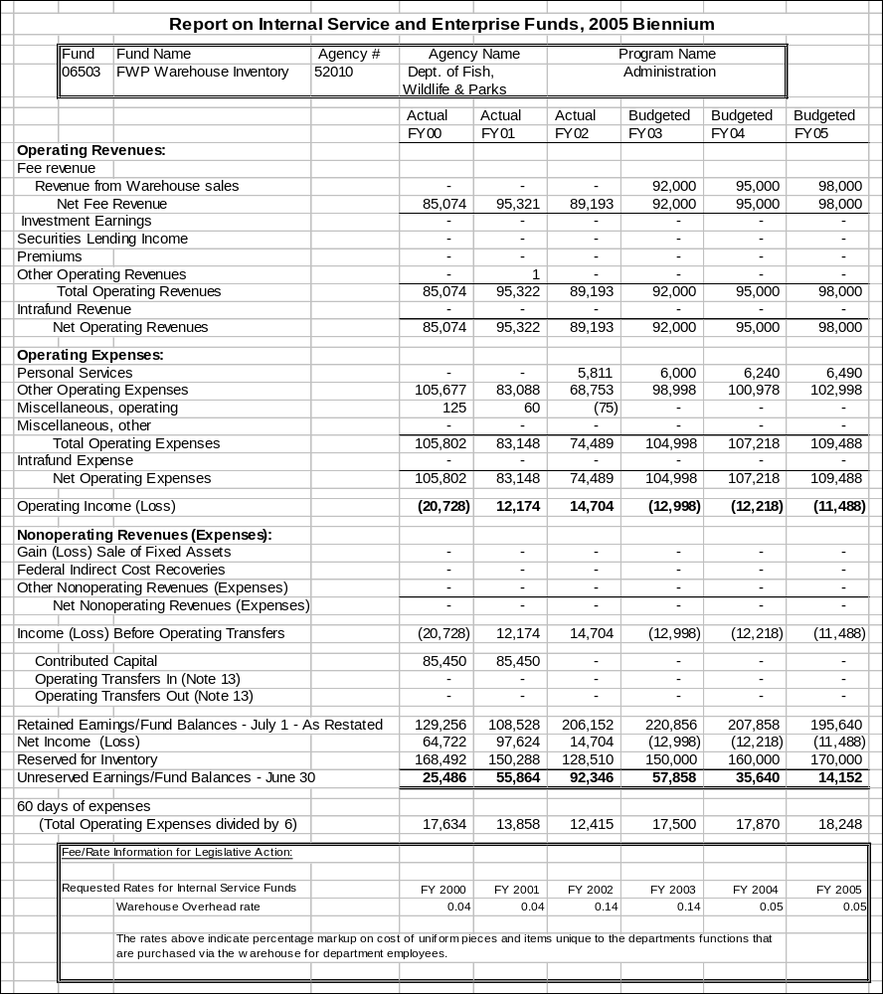

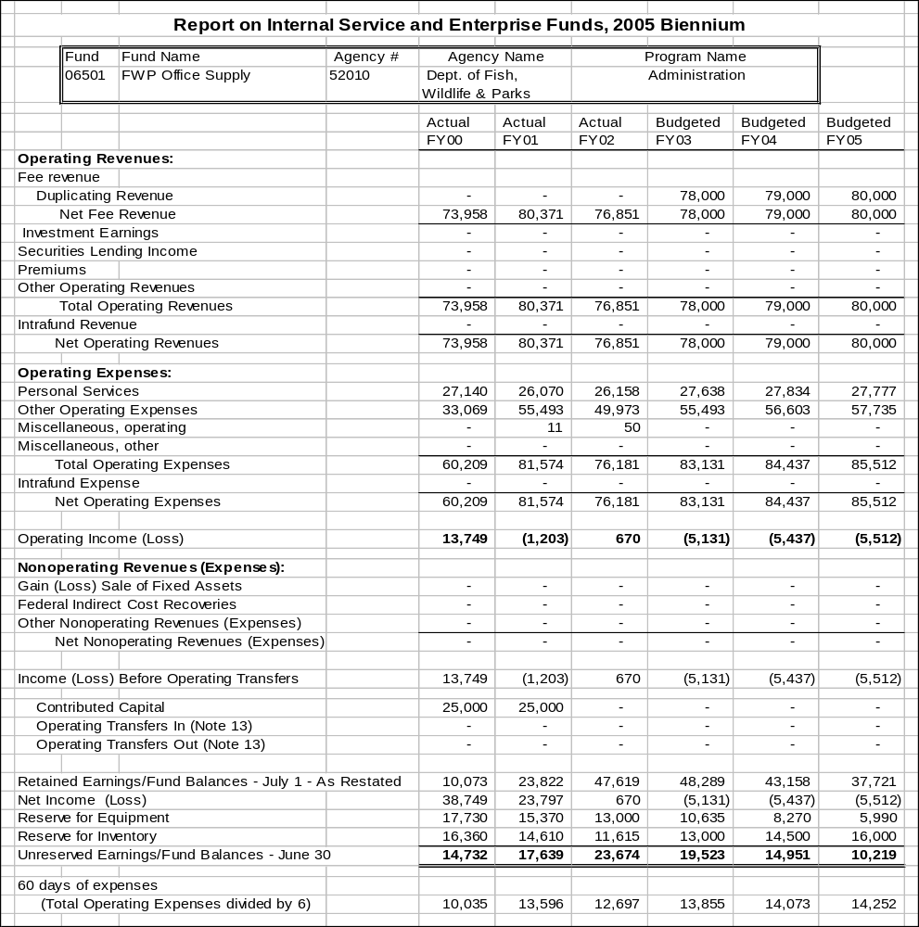

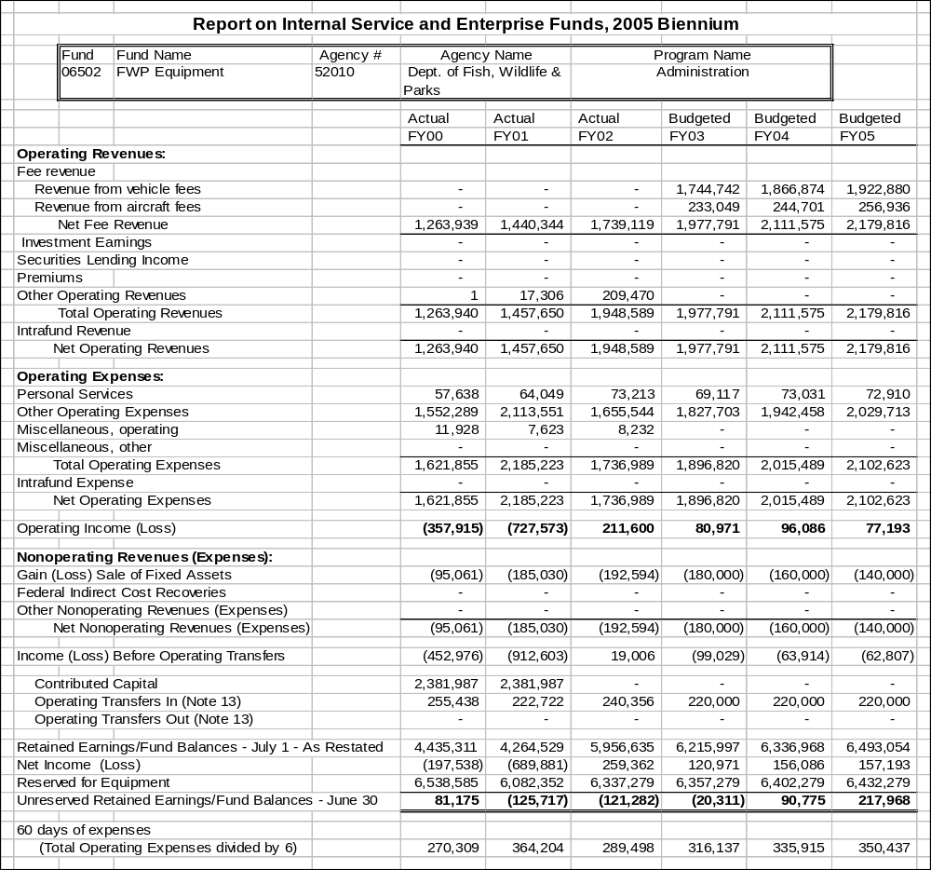
Proprietary Rates

Program Proposed Budget  Budget Item | Base  Budget  Fiscal 2002 | PL Base Adjustment  Fiscal 2004 | New  Proposals  Fiscal 2004 | Total  Exec. Budget  Fiscal 2004 | PL Base Adjustment  Fiscal 2005 | New  Proposals  Fiscal 2005 | Total  Exec. Budget  Fiscal 2005
FTE | 0.00 | 0.00 | 0.00 | 0.00 | 0.00 | 0.00 | 0.00
Operating Expenses | 211,121 | 20,939 | 0 | 232,060 | 22,754 | 0 | 233,875
Equipment | 16,076 | 43,715 | 0 | 59,791 | 43,715 | 0 | 59,791
Total Costs | $227,197 | $64,654 | $0 | $291,851 | $66,469 | $0 | $293,666
Proprietary | 227,197 | 64,654 | 0 | 291,851 | 66,469 | 0 | 293,666
Total Funds | $227,197 | $64,654 | $0 | $291,851 | $66,469 | $0 | $293,666

Please note that a HB 2 section exists for this program.

--------------------------------- Present Law Adjustments --------------------------------

Total Agency Impact | General Fund Total
FY04 $43,715 | FY04 $0
FY05 $43,715 | FY05 $0
PL- 215 - Aircraft Operations -
Restore operations budget for aircraft to previous level.

Proprietary Rates

Program Proposed Budget  Budget Item | Base  Budget  Fiscal 2002 | PL Base Adjustment  Fiscal 2004 | New  Proposals  Fiscal 2004 | Total  Exec. Budget  Fiscal 2004 | PL Base Adjustment  Fiscal 2005 | New  Proposals  Fiscal 2005 | Total  Exec. Budget  Fiscal 2005
FTE | 6.06 | 0.00 | 0.00 | 6.06 | 0.00 | 0.00 | 6.06
Personal Services | 156,750 | 22,462 | 0 | 179,212 | 22,614 | 0 | 179,364
Operating Expenses | 191,163 | 901 | 0 | 192,064 | 1,603 | 0 | 192,766
Equipment | 9,206 | 0 | 0 | 9,206 | 0 | 0 | 9,206
Total Costs | $357,119 | $23,363 | $0 | $380,482 | $24,217 | $0 | $381,336
State/Other Special | 0 | 0 | 0 | 0 | 0 | 0 | 0
Proprietary | 357,119 | 23,363 | 0 | 380,482 | 24,217 | 0 | 381,336
Total Funds | $357,119 | $23,363 | $0 | $380,482 | $24,217 | $0 | $381,336

Please note that a HB 2 section exists for this program.

Program Description - The Parks Division of Montana Fish, Wildlife and Parks is responsible for the state Capitol Complex Grounds Maintenance program. The department funds the program through the capitol grounds proprietary account (Fund 06541). Direct costs of the program are accounted for in SABHRS organizations 6391, 6392 and 6393. Indirect costs are charged to the grounds maintenance program and accounted for in SABHRS organization 6399. Indirect costs are recovered through assessment of an indirect cost rate on actual program expenditures of the previous period.

The total annual cost of the capitol grounds maintenance program is allocated to state agencies based on each agency's share of the total square footage of office space on the Capitol Complex, which is rented from Department of Administration, General Services Division.

Enterprise Fund
Section 23-1-105 (5), MCA, authorizes Parks Division of Montana Fish, Wildlife and Parks to establish an enterprise fund (fund 06068) for the purpose of managing state park visitor services revenue. The fund is used by the department to provide inventory through purchase, production, or donation and for the sale of educational, commemorative, and interpretive merchandise and other related goods and services at department sites and facilities.

The fund was established primarily to better manage parks visitor centers that sell books at parks like Ulm Pishkun, Makoshika and Chief Plenty Coups as well as parks that sell items like firewood. Monies generated go back into the purchase of inventory and also the improvement of visitor services in state parks and FWP overall.

In FY 2002 this fund accounted for the following monies: $15,000 of contributed capital, $66,008 of earned revenue, $51,813 of receipts and a balance of funds in the amount of $29,087.

Grounds Maintenance - Revenues and Expenses
There are no changes proposed in the provision of services. An increase of $0.01 cents per square foot is proposed for the 2003 biennium. On an annual basis, revenues and expenses are reviewed to ensure costs are commensurate with the fees charged agencies. Surplus cash may occur during years when the weather is favorable for maintenance and snow removal. Accumulated cash balances from previous periods are used to calculate rates for future periods. A total of 6.06 FTE are funded in this program.

Working Capital
The 60-day working capital requirement provides sufficient cash to fund on-going operations of the program.

On a biennial basis, program costs are reviewed to ensure fees charged to agencies are commensurate with program costs. Each biennium, the account is analyzed to determine if ending cash balances are long or short relative to program working capital requirements. Calculation of rates for future periods can be affected by ending cash balances.

Fund Equity
Fund balance is reserved for reverted appropriations from the previous period.

Cash Flow
Agencies are billed quarterly for grounds maintenance and snow removal. Cash balances fluctuate during the year relative to the season and weather conditions. Generally, cash balances are lowest in the first and last quarter of each fiscal year. This is during the busy summer months of lawn and landscape maintenance and during the start up season in the spring. During years of heavy and or frequent snowfall, cash balances can become low in the second and third quarters.

Enterprise Fund
Revenues and Expenses
Revenues are generated by the sales of merchandise at park visitor centers and regional offices.

The expenses associated with the enterprise fund include office supplies, merchandising materials and the purchase of inventory to replenish stock.

Working Capital
As the program develops, the 60-day working capital requirement will provide sufficient cash to fund on-going operations of the program.

Fund Equity
As the program continues to develop, a portion of the fund balance will be reserved for the inventory.

Cash Flow
In the first year of operation the fund cash balances were highest in the winter after the parks season ended and lowest in the spring when stock was replenished.

Rate Explanation -Grounds Maintenance
Capitol grounds unit of service is the grounds maintenance and snow removal on the Capitol Complex. The unit price is the total annual revenue of the program divided by the total square footage of rented office space on the Capitol Complex. Square footage of rented office space on the Capitol Complex for the 2005 biennium is provided by General Services Division and used in these calculations. The summary of costs billed to agencies and per unit costs for FY 1998 - FY 2005 are as follows:

 | FY 1998 | FY 1999 | FY2000 | FY 2001 | FY 2002 | FY 2003 | FY 2004 | FY 2005
Revenue | $297,349 | $298,562 | $296,112 | $296,000 | $319,189 | $319,189 | $326,374 | $326,374
Per Sq. Ft. | $0.3446 | $0.3446 | $0.3446 | $0.3446 | $0.3696 | $0.3696 | $0.3796 | $0.3796
An increase in the rate of $.01 cents for the 2005 biennium is proposed in order to maintain the current level of service. The program is absorbing the annualization of the 2001 session payplan, insurance increases and other costs.

Enterprise Fund - Rate Explanation
The enterprise fund applies a markup rate of no less that 40 percent on goods purchased for resale to ensure sufficient revenues to replenish stock.

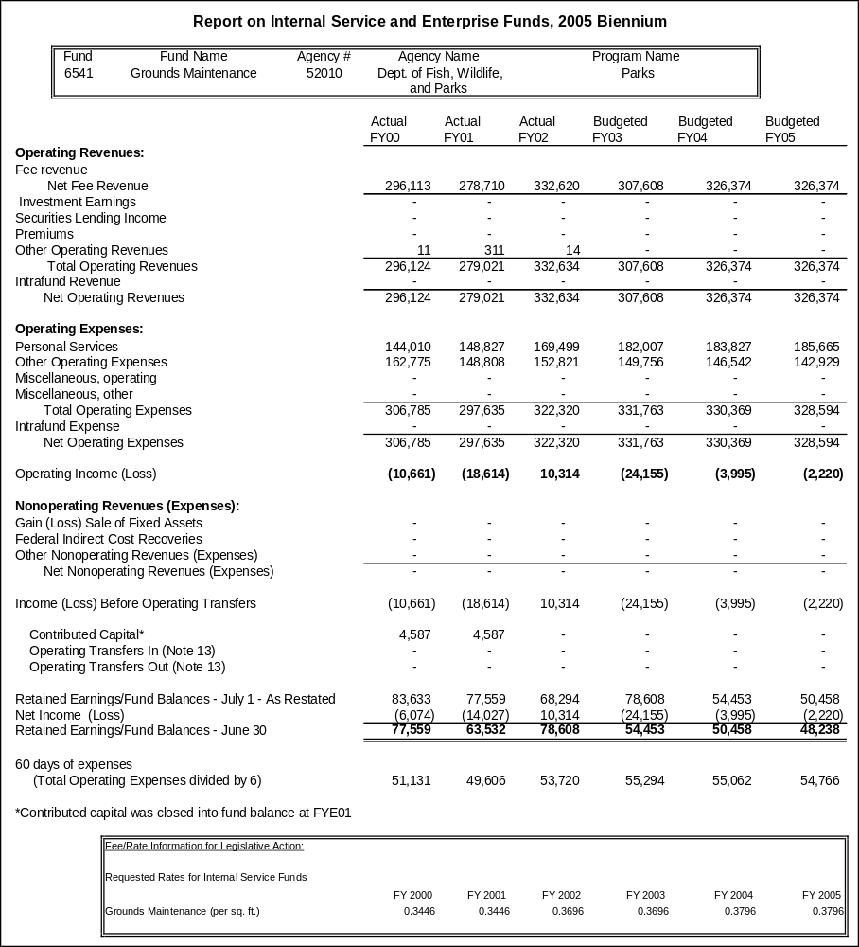

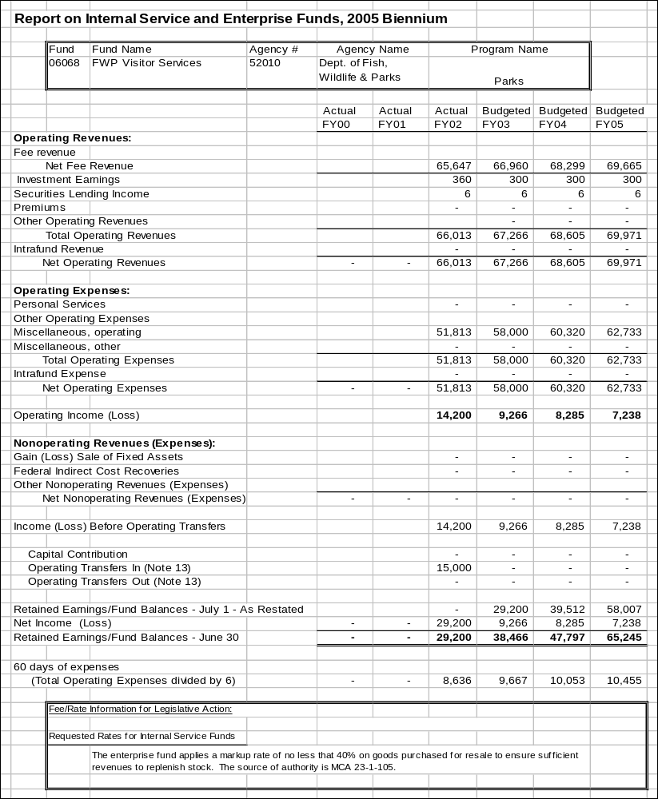

Proprietary Rates

Program Proposed Budget  Budget Item | Base  Budget  Fiscal 2002 | PL Base Adjustment  Fiscal 2004 | New  Proposals  Fiscal 2004 | Total  Exec. Budget  Fiscal 2004 | PL Base Adjustment  Fiscal 2005 | New  Proposals  Fiscal 2005 | Total  Exec. Budget  Fiscal 2005
FTE | 50.50 | 0.00 | 1.00 | 51.50 | 0.00 | 1.00 | 51.50
Personal Services | 2,012,983 | 424,134 | 40,633 | 2,477,750 | 422,630 | 40,513 | 2,476,126
Operating Expenses | 1,012,072 | 522,930 | 6,780 | 1,541,782 | 350,652 | 6,780 | 1,369,504
Equipment | 46,914 | 0 | 0 | 46,914 | 0 | 0 | 46,914
Total Costs | $3,071,969 | $947,064 | $47,413 | $4,066,446 | $773,282 | $47,293 | $3,892,544
Proprietary | 3,071,969 | 947,064 | 47,413 | 4,066,446 | 773,282 | 47,293 | 3,892,544
Total Funds | $3,071,969 | $947,064 | $47,413 | $4,066,446 | $773,282 | $47,293 | $3,892,544

Please note that a HB 2 section exists for this program.

Program Description - The Central Management Program consists of the Director's Office, a Financial Services Office, and an Information Technology Office. It is the organizational component of the agency that is responsible and accountable for the administration, management, planning, and evaluation of agency performance in carrying out department mission and statutory responsibilities. The Director's Office includes the director's staff, the deputy director, an administrative officer, public information officer, a centralized legal services unit, and a centralized personnel office. The Financial Services Office provides budgeting, accounting, payroll, procurement and contract management support to other divisions. The Information Technology Office provides information technology services support to other divisions.

The centralized Legal Services Unit has 3.00 FTE that are funded by the internal service fund, two attorneys and one paralegal. This staff provides the administration, management and planning for the Legal Services Unit, and specific duties for department programs, including legislation, rule making, enforcement actions and contract review. The remainder of this unit is funded by direct charges to the programs and projects requiring the legal work.

Customers are all divisions and employees of the Department of Environmental Quality. Use of these services is mandated by agency policies and procedures. There are no alternative sources for the Central Management Program as a whole. The department contracts for legal services whenever it is cost effective to do so; to obtain specific expertise for a case; or when legal jurisdiction of the case requires an attorney licensed in that state. The department contracts for information technology database development and for hosting of the department's enterprise database.

Revenues and Expenses -
Revenue Description: The department has one proprietary fund, which is an internal service fund used to account for the department's indirect cost activity. The department anticipates negotiating an indirect cost rate with the U.S. Environmental Protection Agency (EPA) of approximately 23 percent in FY 2004 and FY 2005. Revenues generated by the current indirect cost rate fund 50.50 FTE.

Central Management Program provides the services presented in the program description. The cost of providing support services is directly related to the number of staff served. The department negotiates an indirect rate with EPA based on that computation annually. Adjustments for over-recovery and under-recovery in the previous year are made to the calculations each year. EPA and DEQ agree to the services that are included in the indirect calculation. Funding is collected from all non-proprietary sources expended within the department. FY 2002 collections were: $462,818 in general fund, $1,396,273 in state special revenue and $1,255,469 in federal revenue. Expenditures are recorded in 62827. Revenues are recorded in 520501 and 584020.

Expense Description: The major cost drivers within this program are personal services costs and fixed costs. Additional costs for overtime are incurred when workload changes, such as the special legislative session, and increased monitoring and oversight of budgets due to revenue shortfalls. Fixed costs, especially tort liability coverage, continue to be a significant cost increase to the proprietary fund. The cost of providing support services is directly related to the number of staff served; therefore, future expenses are determined by projecting increases or decreases in program staff. Non-typical and one-time expenses are backed out of the cost of providing services before calculating the indirect rate. Salaries are constant throughout the fiscal year, except during fiscal year end, executive budget preparation and legislative session. Supplies are purchased on an as needed basis, except during peak times noted above. The indirect rate proposed to the Legislature will fund 51.50 FTE.

Working Capital
The objective of program management is to recover costs to fund necessary, ongoing operation of the Central Management Program. The program has no requirement to reserve an excess fund balance. The fund normally carries a 60-day working capital to meet its immediate cash needs for covering payroll and various operating costs

Fund Equity
The department does not reserve a fund balance on the accounting records nor does it try to maintain a fund balance. The revenues generated should be enough to cover the current year's operations. However, due to timing factors, the fund balance does not always equal zero.

Rate Explanation -
The department negotiates an annual indirect cost rate with EPA. The approved rate is a fixed rate. This rate is applied against personal services, temporary services and work-study contracts charged within each division of the department, other than the Central Management Program.

The department is requesting a decrease in its indirect cost rate from 24 percent approved in the last legislative session to 23 percent. The rate negotiated with EPA requires a carry-forward amount be built into the rate. This carry-forward amount represents the amount the department either under-recovered or over-recovered in a given year. This computation compares what was initially negotiated versus what actually occurred. The difference is then carried forward into the following year's rate.

The department's indirect cost rate is determined based on guidelines prescribed by the federal government. In addition, the department complies with 17-3-111, MCA, which requires agencies to negotiate a rate that would recover indirect costs to the fullest extent possible. In order to comply with this law, the department has requested a rate that may vary slightly from the rate the department actually negotiates with EPA. The rate approved by the Legislature is considered a cap; and therefore, the department cannot negotiate for a rate higher than what has been approved by the Legislature. However, the rate negotiated with EPA may be slightly lower.

--------------------------------- Present Law Adjustments --------------------------------

Total Agency Impact | General Fund Total
FY04 $243,441 | FY04 $0
FY05 $243,441 | FY05 $0
PL- 2 - CMP - Base Adjustments -
The executive is requesting $243,441 proprietary funds in the 2005 biennium. Due to staff vacancies, the program did not enter into information technology contracts in the base year.
________________________________________________________________________________________________

Total Agency Impact | General Fund Total
FY04 $100,000 | FY04 $0
FY05 $25,000 | FY05 $0
PL- 67 - CMP - Data Migration, Report Writing & Hosting -
The department is requesting $100,000 in FY 2004 to complete outstanding database development for the DEQ Enterprise Database. These funds will be used to move existing data into the new database and to write reports for staff and managers with information from the system. DEQ requests $25,000 each fiscal year for ITSD hosting the production Oracle database.
________________________________________________________________________________________________

Total Agency Impact | General Fund Total
FY04 $50,000 | FY04 $0
FY05 $10,000 | FY05 $0
PL- 72 - CMP - Database Development -
DEQ programs are funded with a variety of state special revenue accounts and numerous federal grants that require state funds for matching. Currently one IT staff member has spent 40 hours setting up Excel spreadsheets that are more suitable to an Access database. This will continue to require at least 10 hours of IT staff time to summarize budget projections. It will also take 30 to 40 hours to set up the reports at the beginning of each fiscal year. The database will allow the budget analysts to focus their time on reviewing and analyzing the budget projections for their division.
________________________________________________________________________________________________

Total Agency Impact | General Fund Total
FY04 ($52,500) | FY04 $0
FY05 ($52,500) | FY05 $0
PL- 89 - CMP - Alternative Payplan Adjustments -
This is a reduction to the proprietary account in operating costs to cover the personal services cost of the alternative payplan for the central management program.

---------------------------------------- New Proposals ----------------------------------------

Total Agency Impact | General Fund Total
FY04 $47,413 | FY04 $0
FY05 $47,293 | FY05 $0
NP- 56 - Personnel - New Safety FTE -
Request to add 1.00 FTE and operating costs to the personnel unit. The duties would be 50 percent as safety coordinator and 50 percent as training officer.

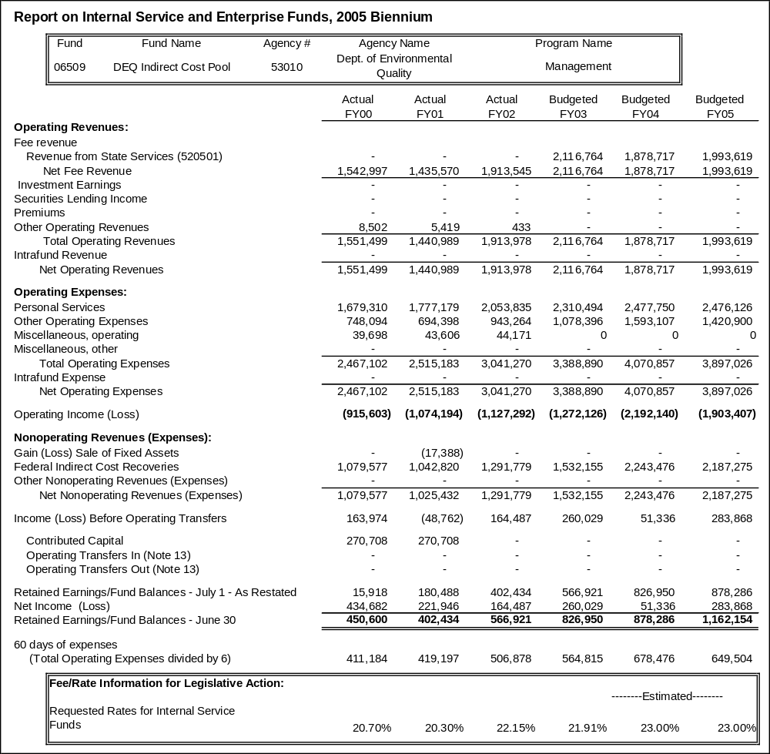

Proprietary Rates

Program Proposed Budget  Budget Item | Base  Budget  Fiscal 2002 | PL Base Adjustment  Fiscal 2004 | New  Proposals  Fiscal 2004 | Total  Exec. Budget  Fiscal 2004 | PL Base Adjustment  Fiscal 2005 | New  Proposals  Fiscal 2005 | Total  Exec. Budget  Fiscal 2005
FTE | 5.80 | 0.00 | 0.00 | 5.80 | 0.00 | 0.00 | 5.80
Personal Services | 318,078 | (13,788) | 0 | 304,290 | (11,909) | 0 | 306,169
Operating Expenses | 545,520 | 20,483 | 0 | 566,003 | 23,053 | 0 | 568,573
Total Costs | $863,598 | $6,695 | $0 | $870,293 | $11,144 | $0 | $874,742
Proprietary | 863,598 | 6,695 | 0 | 870,293 | 11,144 | 0 | 874,742
Total Funds | $863,598 | $6,695 | $0 | $870,293 | $11,144 | $0 | $874,742

Please note that a HB 2 section exists for this program.

Program Description -The air operations program in the Forestry Division is funded from the air operations proprietary account for those costs that can be supported by the aircraft rates charged to agencies that use the aircraft and general fund for fixed costs. The program operates three medium helicopters, two light helicopters, and three single engine fixed-wing airplanes. Aircraft are primarily used for fire detection, support and suppression of wildfires, and reclamation work in the Department of Environmental Quality. Fixed costs are paid by the general fund and fire protection tax revenue since they must be paid regardless of number of hours flown. These costs include hangar rent, insurance, and personnel costs. The general fund and fire protection taxes are appropriated by the Legislature and transferred to and spent from the proprietary account. Variable costs that are dependent on the hours flown, such as fuel and maintenance, are recovered through an hourly rate charged to all users of the aircraft. Users of the aircraft include DRNC, other state agencies, federal agencies, and the state's wildfire suppression efforts. This revenue is also deposited to the proprietary account.

Revenues and Expenses -
Base year funding: Customer payments are made up primarily of DNRC and the U.S. Forest service.
Expenses incurred by program: The cost drivers for the aircraft rates are to try and recover the actual expenses needed to maintain the aircraft in an air worthy condition and remain mission ready for the primary purpose of initial attacking wild fires on state and federal ground. This includes all costs associated in the operation and maintaining of that aircraft. There are some factors that contribute to the uncertainty in forecasting future expenses, including unforeseen events such as FAA and manufacturer directives, aircraft incidents resulting in unplanned maintenance and fluctuations in fuel and parts.

Rate Explanation -The reimbursement rates for the operation of the department aircraft are based on the time life of 5000 hours of aircraft usage. The rate has been determined to maintain the aircraft in its original condition. At the end of 5000 hours, all parts should have been replaced and a new maintenance / operation cycle started. The customer base is very specific and is made up of DNRC land managers and the U.S. Forest service. The aviation section provides aircraft for fire operations.

The aviation section uses this reimbursement rate strictly to maintain the aircraft in flyable condition. There is a need to maintain a fund balance due to the high price of aircraft parts. An engine for a Bell uh-1/h helicopter for example can cost upwards near $200,000. A rotor blade can cost $80,000. It is absolutely necessary to maintain a balance for unforeseen events such as a rotor blade strike or an engine failure. Also the FAA and the manufacturer can issue service and technical bulletins that mandate compliance to continue operation of that aircraft. These are all dynamics that require a balance be maintained to ensure continuity of the aviation program. The customer is billed at the fixed rate. This is based on the amount of hours and tenths of hours flown. All costs are direct and fixed. There are no indirect costs associated with the rates.
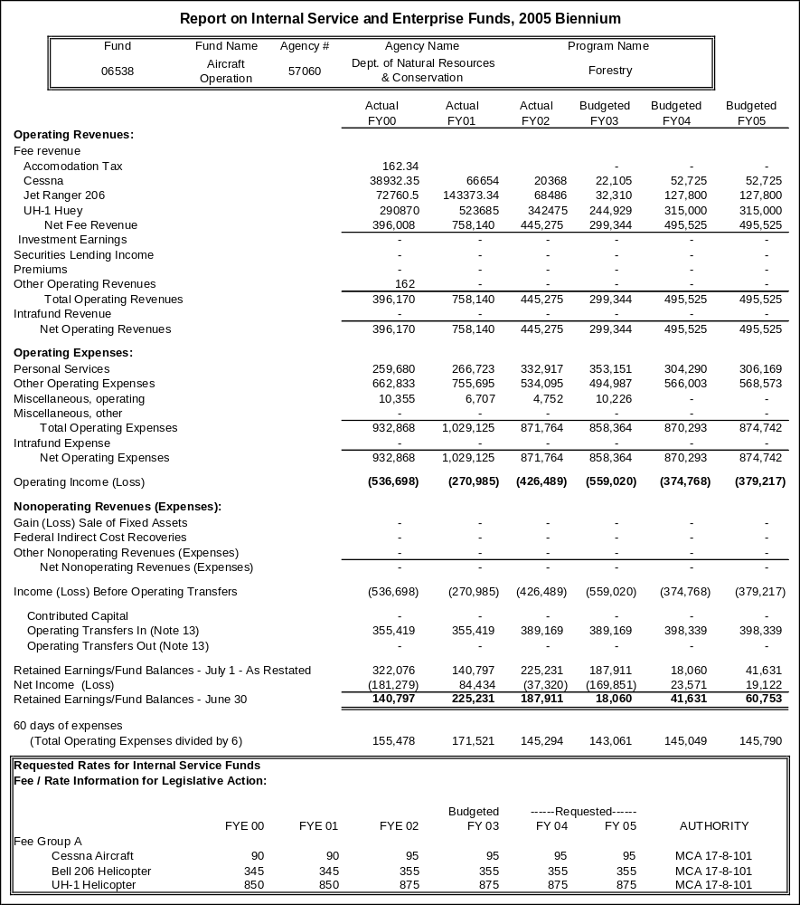

Proprietary Rates

Program Proposed Budget  Budget Item | Base  Budget  Fiscal 2002 | PL Base Adjustment  Fiscal 2004 | New  Proposals  Fiscal 2004 | Total  Exec. Budget  Fiscal 2004 | PL Base Adjustment  Fiscal 2005 | New  Proposals  Fiscal 2005 | Total  Exec. Budget  Fiscal 2005
FTE | 0.00 | 0.00 | 0.00 | 0.00 | 0.00 | 0.00 | 0.00
Personal Services | 3,317 | (106) | 0 | 3,211 | (106) | 0 | 3,211
Operating Expenses | 714 | 893 | 0 | 1,607 | 893 | 0 | 1,607
Total Costs | $4,031 | $787 | $0 | $4,818 | $787 | $0 | $4,818
Proprietary | 4,031 | 787 | 0 | 4,818 | 787 | 0 | 4,818
Total Funds | $4,031 | $787 | $0 | $4,818 | $787 | $0 | $4,818

Please note that a HB 2 section exists for this program.

Program Description - The Alfalfa Leaf-cutting Bee Program (fund 06011) was established in 1981 by Title 80, Chapter 6, part 11, MCA. The Alfalfa Seed Committee establishes standards for pathogens and parasites, certification of bees, and management of the program in cooperation with the department. Department personnel perform field and laboratory duties for the committee.

Revenues and Expenses - Alfalfa leaf-cutting bee account revenues are received from laboratory analyses for pathogens in larva and the determination of sex ratios. Expenditures include laboratory costs and committee members' per diem. There are no FTE funded in this program; however, there are usually overtime payments to the entomologist to pay for the laboratory analyses performed. There is a $15 registration fee for alfalfa leafcutting bee owners that is paid once. There is a $30 certification fee per sample for certifying samples. There is a $30 fee for sample analysis per sample and, if requested, an additional fee of $20 for sex ratio and percent emergence.

Rate Explanation - Fees are charged for certification and registration of Alfalfa Leafcutter bees in Montana and for laboratory expenses. The fees charged are set by rule. Rates are $30 for a minor A license and $15 for a minor B license.

--------------------------------- Present Law Adjustments --------------------------------

Total Agency Impact | General Fund Total
FY04 $4,102 | FY04 $0
FY05 $4,102 | FY05 $0
PL- 16 - Alfalfa Leafcutter Bee Service Fees -
Restore authority to pay the zero-based overtime and per diem expenses and to pay operational costs to analyze leafcutter bee samples for pathogens, parasites and larva count.
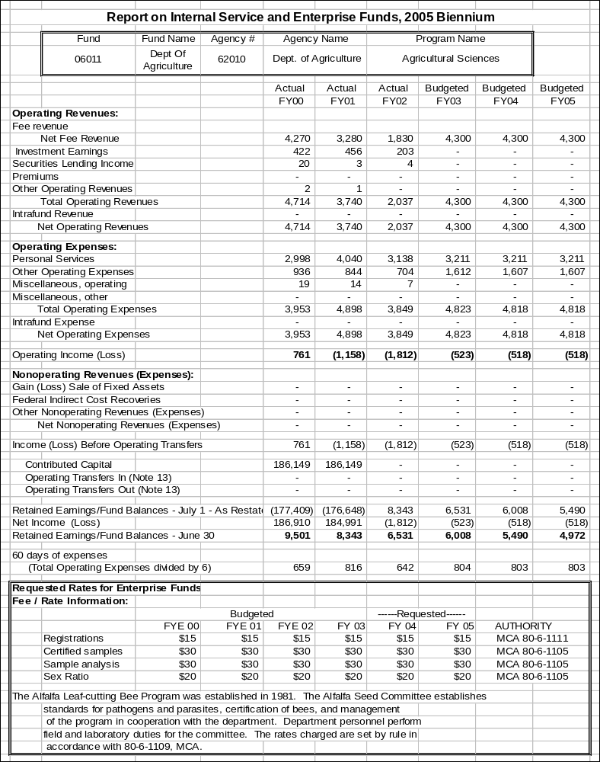

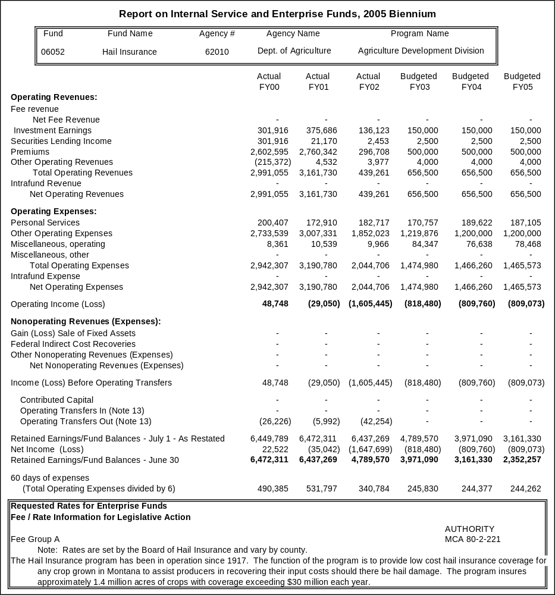
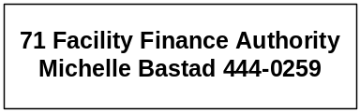

Proprietary Rates

Program Proposed Budget  Budget Item | Base  Budget  Fiscal 2002 | PL Base Adjustment  Fiscal 2004 | New  Proposals  Fiscal 2004 | Total  Exec. Budget  Fiscal 2004 | PL Base Adjustment  Fiscal 2005 | New  Proposals  Fiscal 2005 | Total  Exec. Budget  Fiscal 2005
FTE | 2.00 | 0.00 | 0.00 | 2.00 | 0.00 | 0.00 | 2.00
Personal Services | 135,409 | (15,241) | 0 | 120,168 | (15,522) | 0 | 119,887
Operating Expenses | 100,429 | 5,841 | 0 | 106,270 | (2,182) | 0 | 98,247
Grants | 33,880 | 1,120 | 0 | 35,000 | 1,120 | 0 | 35,000
Total Costs | $269,718 | ($8,280) | $0 | $261,438 | ($16,584) | $0 | $253,134
Proprietary | 269,718 | (8,280) | 0 | 261,438 | (16,584) | 0 | 253,134
Total Funds | $269,718 | ($8,280) | $0 | $261,438 | ($16,584) | $0 | $253,134

Please note that a HB 2 section exists for this program.

Program Description -The Facility Finance Authority was created by the 1983 Legislature and is governed by a seven-member quasi-judicial board. The Governor, with the advice and consent of the Senate, appoints the board members to four-year terms. The purpose of the authority is to assist health care and health care related facilities in containing future health care costs by offering debt financing or refinancing at low-cost, tax-exempt interest rates for buildings and capital equipment. These cost savings are shared with the health care consumer in the form of lower health facility fees. The Legislature extended eligible facilities to include community pre-release centers.

Revenues and Expenses -
(1) Change in Services or Fees: The authority has gradually reduced its application and annual administrative fee assessments contingent upon its business volume.

(2) Working Capital Discussion: The 60 day Working Capital Calculation is not reasonably applicable to the authority because the national bond rating agencies, national bond insurers and institutional investors expect the authority to reserve two years operating capital (approximately $485,000) to assure them that the authority can financially operate between legislative sessions.

(3) Fund Equity and Reserved Fund Balance: The Total Fund Equity requirement for FY 2004 ($4,885,000) is derived from the authority program reserve mandates as follows:
A. Biennium Working Capital Reserve=$485,000
B. Capital Reserve Account (Loan Loss Reserve)=$3,750,000
C. Facility Direct Loan Program Reserve=$650,000

(4) Cash Flow Discussion: The authority has gradually reduced its application and annual administrative fee assessments contingent upon its business volume. However, it continues to carry a two-year working capital reserve in order to respond to the forecasted extraordinary expenses and requirements.

--------------------------------- Present Law Adjustments --------------------------------

Total Agency Impact | General Fund Total
FY04 $2,939 | FY04 $0
FY05 $3,184 | FY05 $0
PL- 16 - Administrative Cost Adjustments HB 576 -
One-time moving costs are deleted from the base, offset by inclusion of zero-based board per diem and overtime, as well as the rent adjustment for the new location and the indirect charges required by state law adopted in the special session.

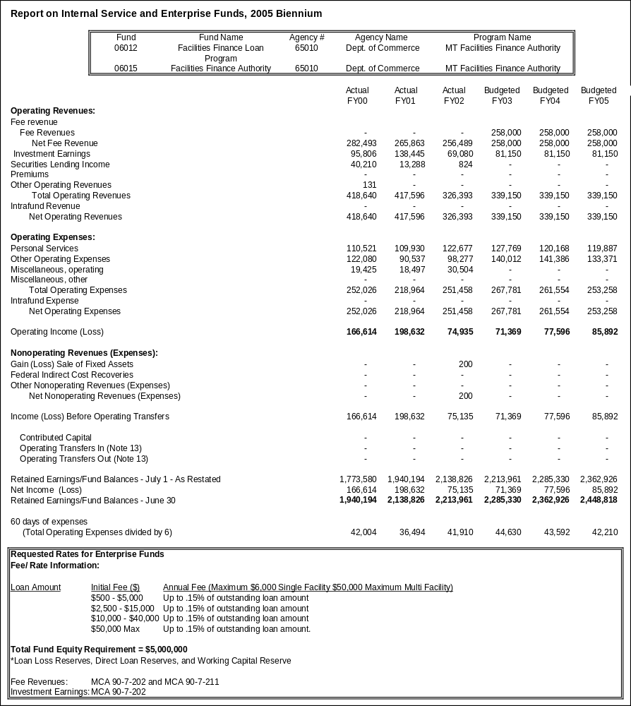
Proprietary Rates

Program Proposed Budget  Budget Item | Base  Budget  Fiscal 2002 | PL Base Adjustment  Fiscal 2004 | New  Proposals  Fiscal 2004 | Total  Exec. Budget  Fiscal 2004 | PL Base Adjustment  Fiscal 2005 | New  Proposals  Fiscal 2005 | Total  Exec. Budget  Fiscal 2005
FTE | 18.30 | 0.00 | 19.50 | 37.80 | 0.00 | 19.50 | 37.80
Personal Services | 668,373 | 145,876 | 789,084 | 1,603,333 | 147,221 | 789,428 | 1,605,022
Operating Expenses | 1,194,922 | 727,079 | 729,018 | 2,651,019 | 757,452 | 707,943 | 2,660,317
Equipment | 0 | 0 | 15,000 | 15,000 | 41,770 | 0 | 41,770
Grants | 0 | 0 | 38,234,502 | 38,234,502 | 0 | 40,248,513 | 40,248,513
Total Costs | $1,863,295 | $872,955 | $39,767,604 | $42,503,854 | $946,443 | $41,745,884 | $44,555,622
Proprietary | 1,863,295 | 872,955 | 39,767,604 | $42,503,854 | 946,443 | $41,745,884 | $44,555,622
Total Funds | $1,863,295 | $872,955 | $39,767,604 | $42,503,854 | $946,443 | $41,745,884 | $44,555,622
Please note that a HB 2 section exists for this program.

Program Description - The Montana Board of Housing was created by the Montana Housing Act of 1975. The board is an agency of the state and operates within the Department of Commerce for administrative purposes. Under the Housing Act, the board does not receive appropriations from the state's general fund and is completely self-supporting. Substantially all of the funds for the board's operations and programs are provided by the private sector through the sale of tax-exempt bonds. The powers of the board are vested in a seven-member board, appointed by the Governor, subject to the confirmation of the State Senate. The board provides policy direction to the agency staff, authorizes bond issues, approves development financing and evaluates board housing programs. These programs include the Single Family Program, Recycled Single Family Program, Multifamily Loan Programs, Low Income Housing Tax Credit Program, Housing Revolving Loan Fund and the Reverse Annuity Mortgage (RAM) Program. The Board of Housing portion of the Housing Division is funded by proprietary (enterprise type) funds derived from an administrative charge applied to projects and mortgages financed, there are no direct appropriations provided in HB 2.

Revenues and Expenses -
Single Family Charges: According to state statute and, in some cases, the Internal Revenue Code, the board is allowed to earn the amounts that are presented on the "Report on Internal Service and Enterprise Funds". The board earns the bulk of its income from the spread between the interest yield on the Single Family Mortgage loans and the yield on the bonds. The board is allowed to earn 1 ½ percent on Pre-1980 Single Family Programs and 1 1/8 percent on the Post-1980 Single Family Programs.

Financial institutions that originate Single Family loans for the board charge two points, which they keep. According to tax law, origination points must be included in the amount that the board can earn. Operating expenses and servicing fees must be paid from the 1 1/8 percent that board is allowed to earn. Servicing fees are .375 percent of the mortgage principal balance. The board does not always receive the full 1 1/8 percent or 1 ½ percent spread. The spreads for the last several bond issues were as follows:

- 1995B1 0.87990 percent
- 1995B2 0.81670 percent
- 1996A 1.12500 percent
- 1997A1 1.39063 percent
- 1997A2 1.08842 percent
- 1998A 1.10078 percent
- 1998B 1.04678 percent
- 1999A 1.11985 percent
- 2000A 1.10302 percent
- 2000B 1.11709 percent
- 2001A 1.11898 percent
- 2002A 1.12251 percent
- 2002B 1.09666 percent

Operating expenses and servicer fees further reduce the amount of these earnings. The earnings also include 2 points of origination fees that are not received by the board.

The board also charges a reservation fee of 1/2 of 1 percent of the loan amount reserved. This amount is included in the spread that the board can earn. These fees are capitalized and are amortized as income over the life of the loans, as required by generally accepted accounting principles. Extension fees and late fees are also, occasionally, charged. The majority of these fees are capitalized and amortized over the life of the loans. The extension fees are 1/4 of 1 percent of the loan amount and the late fees are 1/2 of 1 percent of the loan amount. The amortization of these fees results in an average of approximately $450,000 of income per year. These fees are deposited with the trustees and are used to originate new mortgages.

Multifamily Charges: Multifamily Programs can earn 1 1/2percent spread between the mortgage yield and the bond yield. On the last several issues, the Board did not receive the full 1 1/2percent spread. The spreads for the last four bond issues are as follows:

- 1992A 1.067700 percent
- 1996A 0.826000 percent
- 1998A 0.281566 percent
- 1999A 1.013963 percent
(Servicing fees and operating expenses further reduce the amount of this spread.)

We have currently had two loans payoff and one loan make a substantial prepayment but not completely payoff. It is always a possibility that loans will make prepayments but until that happens it is hard to predict this scenario. If these loans prepay, bonds will be redeemed with the prepayments, and the board will no longer earn any spread on these loans. In the 1992A bond issue, the board is currently using excess revenues to purchase loans at interest rates that are lower than the bond yield. This further reduces the amount of earnings in the Multifamily Program. Under the Multifamily Program, the board can charge a reservation fee, on new loans, of up to 1 percent of the principal balance. Normally, the board charges less than this amount.

Low Income Housing Tax Credit Charges: The board receives $2 million dollars of tax credit allocation, annually. The board charges 4 ½ percent of the amount of tax credit reserved. In the next biennium, reservation fee income is estimated to be approximately $90,000 per year. The board is also required to monitor the projects that receive tax credits to determine if the projects are in compliance with tax credit regulations. The board charges $20 per unit for compliance fees. The board has approximately 3,700 units. Approximately $74,000, annually, will be received during the biennium. Tax credit fees are charged to cover the operating expenses of the program.

Housing Revolving Loan Account Charges: The 1999 Legislature established this fund to provide loans to projects providing affordable housing in Montana. Although the fund was established in 1999 it was not funded. The 2001 Legislature added funding through a transfer of Section 8 reserve funds and an allocation of Temporary Assistance to Needy Families (TANF). The TANF funding is currently be used to finance down payment and closing cost loans for homebuyers. The other funding is available for other types of housing loans that will typically need that last small piece of financing to make them feasible. The interest that will be charged on HRLA loan will range from 2 percent – 6 percent.

Reverse Annuity Mortgage Loans (RAM) Charges: Under the RAM program, elderly homeowners can receive monthly payments, for 10 years, to assist them with their living expenses. The loans accrue interest at 5percent. The principal and interest is not due until the borrower dies or sells their home. It is difficult to determine how much of the interest and principal will actually be received on these loans or when it will be received. These loans are not guaranteed or insured.

Increase in Mortgage Income: The board's mortgage income during the last five years has continued to increase. Part of the reason is because there are three Single Family bond issues (1992RA, 1995B & 1997A) that were structured to use loan prepayments and excess revenues to originate loans rather than to call bonds or pay debt service. These bond series have 40 year bonds rather than the typical 30 year bonds. These series do not have principal payments on the bonds for 10 years, only interest is due. During first 10 years of each bond issues, mortgages will be originated with prepayments and the excess revenues. The 1992RA will begin paying principle in December, 2002 however the board is researching avenues to extend this requirement out another 5 years.
The board has continued to issue bonds each year to originate new mortgages. During fiscal years 2000, 2001 & 2002, the board issued bonds in the amounts of $87,695,000, $142,940,000 & $39,000,000, respectively. We anticipate mortgage revenue will continue to increase during the next biennium as the board continues to originate loans with prepayments, excess revenues and bond proceeds.

Note: The board established a $50 million draw down bond line of credit for the purpose of refunding bond principle payments in place of issuing new debt that requires state bond volume cap. The draw down bond line of credit is paid by a future issuance of bonds.

Investment Income: In fiscal year 2002, the board earned approximately $10,801,278 on its investments. During the latter part of fiscal year 2000, the board entered into a repurchase agreement on its Single Family II Indenture. The repurchase agreement is at 6.43 percent for 30 years and will help us predict investment income in the upcoming years.

NOTE: For Post 1980 Single Family issues and Post 1986 Multifamily issues, investment earnings cannot exceed the yield on the bonds.

Increase in Fair Market Value: The increase in fair value is a requirement of GASB 31. It requires that all investments be valued at fair value. During 1998, the first year that GASB 31 was implemented, the board recorded a gain of approximately $2.8 million. In the last four years, we have seen significant drops in the market value. The board does not intend to sell the long-term investments. If they are sold, we will receive the value of the investment on the day of the sale. This amount could be substantially different from the market value at June 30th. We did not estimate any increases or decreases in the fair value for fiscal years 2001, 2002 or 2003. The market fluctuations are significant and it is impossible to estimate the value of the investments at any given time.

Operations & personal services expense: Operations for the next biennium are anticipated to be approximately $5.2 million for FY 2004 and $5.6 million for FY 2005. The operating expenses include the following:

Servicer fees: $2.6 million (FY 2004) $2.8 million (FY 2005)
Operating expenses & personal services: $2.6 million (FY 2004) $2.8 million (FY 2005)

The operations of the board include purchasing mortgage loans, receiving repayments and prepayments, investing funds, issuing and redeeming bonds. During FY 2002, the board purchased $132,519,960 in mortgages and received $62,573,087 in mortgage repayments, prepayments and interest. The board paid interest and principal on bonds of $99,257,240 and issued new bond proceeds in the amount of $39,000,000. This was done with a staff of 19.00 FTE.

Miscellaneous Operating expense: Miscellaneous operating includes the interest expense on bonds. It also includes the periodic amortization of the cost of issuance expense. The costs associated with issuing the bonds are expensed over the life of the bonds, as required by generally accepted accounting principles.

During fiscal years 2000, 2001 & 2002, the board issued bonds in the amounts of $87,695,000, $142,940,000 & $39,000,000, respectively. The issuance of new debt has been greater than the maturities and redemptions of bonds. So, this has resulted in a higher debt service. The board anticipates that this increase in debt service will continue during the next biennium.

Rate Explanation - Fund Equity/Reservations of Fund Balance: As stated in the board's financial statements, Note 1, Fund Accounting: Reserved Retained Earnings (pledged to bondholders) represent bond program funds that are required to be used for program purposes as prescribed by individual bond indentures. The following are restrictions on the Reserved Retained Earnings: Special trust funds and accounts within the indenture are pledged as collateral for the bonds under the individual program indentures; Reserve requirements on cash and investments; Mortgage loans receivable are also pledged as security for holders of the bonds; Certain indentures require asset-liability coverage ratios be met as well as cash flow certificates be furnished for any significant change anticipated in the financial structure of an indenture.

The Trust Indentures entered into by the board requires all mortgages, and all moneys and investments within the indentures are legally restricted to uses provided for in the indentures and fund balance associated with the indentures is legally required to be reserved for those uses.

In addition to the legal requirements mentioned above, the board commits funds to various projects and programs throughout the year. The board has set aside over $200 million of first mortgage funds for special programs, and originates approximately $20 million per year of new loans under this program (targeting income levels of approximately $20,000). As of the end of FY 2002, the board had $14,967,801 in outstanding Recycled Mortgage Program commitments.

In the Multifamily area, the board commits funds to projects around the state, with the intent to pool mortgages and issue bonds to fund mortgages and reimburse the board where it has advanced funds on some of the projects. The board has 30 active first mortgages with initial principle balances of $25,914,653. There are also 8 second position loans funded from a AHP grant awarded to the board by the Federal Home Loan Bank of Seattle. The board has two loans prepay and two loans foreclosed on.

In order to operate a more efficient Multifamily program, the board was awarded a rating of A2 for its General Obligation on April 8, 1997. In order to obtain the A2 rating, the board pledged that it will use any and all of the moneys, assets or revenues of the board to back bonds issued using the General Obligation rating. All of the board's bond issues, with the exception of the Single Family III through X (issued from 1988-1992) hold the board's General Obligation pledge.

The fund balance within the Housing Trust fund is legally required to be reserved for security to the single family programs by Resolution 92-0821-S1, the Fifth Supplemental Trust Indenture for its Single Family II Indenture and by Resolution 93-0624-S2.

The board funds its RAM programs from the Housing Trust fund, because these are programs for which the board cannot issue bonds. As of the end of FY 2002, the board has RAM loans with an outstanding principal balance and interest of $550,143. Outstanding commitments from the Housing Trust Fund as of FY 2002 were $948,715 for RAM.

The board's budget monies (those projected to be needed for the fiscal year's operations) are drawn down from the indentures at the beginning of the fiscal year. These funds are legally pledged to the trust indentures from which they were drawn and any associated fund balance is reserved for the program from which the budgeted funds were withdrawn.

Management Objectives Regarding Fund Balance: The major component of the board's fund balance (retained earnings) is its single family program. The board has been recycling repayments and prepayments of mortgages for several years. The board has committed these funds to special programs, at rates which are in many cases below the average coupon on the bonds. The average income on the special programs is less than $20,000, whereas the average income on the board's regular bond programs is about $33,000. The board intends to continue these special programs as they serve Montana citizens the board would not otherwise be able to serve.

Net income over and above bond debt service, operating costs, and servicing fees, is used to write down the rates on special programs or to fund programs such as the RAM Program for elderly. These programs cannot be funded from direct bond proceeds as there is no repayment guarantee. In the Multifamily area, the board intends to continue to leverage its multifamily funds into new multifamily loans through the revolving pool so that loans can be completed in a timely and efficient manner.

The board is reviewed at the time of each bond issue by two rating agencies: Standard & Poor's, and Moody's Investor Services. In order to meet the cashflow tests, the board must have sufficient assets, earnings, and liquidity, to meet all bond interest and principal expenses, as well as pay operating expenses. The board just received an Aa2 from Moody's and a AA+ from Standard & Poor's on its largest indenture. The board's rating reflects the rates the board gets on its bonds, which is reflected in the mortgage rates passed on to first time home buyers in Montana. In 1990, the board purchased 1 in 10 of the mortgages. In 2002, the board purchased 1 in 4 of these mortgages. The board's continuous funding (which was a goal of current management set in 1994) and steady, low interest rates, as well as the board's special programs, have contributed to this increase. In addition the increase in housing costs in Montana has made the need for lower interest rate financing even more profound.

Cash Flow Discussion:
Collection of mortgage payments & purchase of loans: Each month the board receives funds from the financial institutions that service the board's Single Family and Multifamily loans. The funds include the amount of principal, interest, less servicing fees (.375percent, .125percent and .10percent of the principal balance) that are due on the board's loans. The money is collected by the board's trustees. Twice monthly, the board purchases loans from new bond proceeds, prepayments or other revenues.

The board receives tax credit reservations fees when the tax credits are approved. These fees are deposited with the state treasurer and are used to cover expenses of the program. Reservations fees on the Single Family and Multifamily Programs are deposited with the trustees when the approved loans are reserved. They are deposited in the program acquisition account and are used to originate new mortgages.

Payment of Bond P & I: Principal and interest, on the Multifamily and Single Family Bond issues, is due on each February 1, April 1, June 1, August 1, October 1 and December 1. During FY 1999, the board paid $99,257,240 in principal and interest on the bonds.

This number includes scheduled principal and interest payments as well as bond redemptions from prepayments and excess reserves and other revenues. The amount of debt service paid will vary depending on the amount of prepayments received. Under the Single Family I and II Indentures, except for those series that were structured for recycling, each semiannual debt service date, the board determines how many prepayments have been received. The board uses the loan prepayments to redeem bonds in an amount equal to the prepayments received. In eight of the Trust Indentures (Single Family III through X) all repayments, prepayments and investment income must, currently, be used to redeem the bonds each April 1 and October 1. The income cannot be used for any other purpose. Annually, the board reviews any other revenues and excess reserves in the Single Family programs and those amounts are also used to redeem bonds. The Multifamily Program has received prepayments on two loans and bonds will be redeemed. In the future, there may be prepayments, and bonds will also be redeemed.

Investment of funds: In the Single Family I and II Indentures, the board invests the majority of prepayments and repayments of loans in repurchase agreements. The interest coming due on the agreements also coincides with a debt service date. In two of the series under the Single Family II Indenture, prepayments and any other revenues are used to originate loans that could not otherwise be originated under the tax laws. These two series do not have principal due on the bonds for the first 10 years of the bond issue. These funds are normally invested based on the anticipated loan purchase dates. Under the Single Family I Indenture, a portion of prepayments and repayments are used to originate loans that do not meet the tax laws. These funds are currently invested in a repurchase agreement and withdrawn as the funds are needed for purchases.

The deposit of the initial bond proceeds, used for purchasing loans, is normally invested in a two year, fixed rate, repurchase agreement. As explained above, all funds received on Single Family III through X are used for bond calls and scheduled debt service. These funds are invested in 30 year Guaranteed Investment Contracts. All debt service reserve funds and mortgage reserve funds that must be held as security for the bondholders are invested in long-term securities, repurchase agreements or guaranteed investment contracts. Under the Multifamily Program, the funds are invested to the next debt service date or to a loan purchase date.

Other Mortgage Purchases: The board also purchases Reverse Annuity Mortgage (RAM). The RAM loans are not repaid until the borrower dies or sells their home. These amounts are assets of the board and the interest is accrued monthly, but we may not receive the principal and interest repayments for many years.

Operating Expenses: The board draws funds for its budget, annually, from the amounts available within the Indentures. The amount of the approved budget, less any cash on hand, is withdrawn from the Indenture and is allocated among the various Indentures. These funds are pledged to the bondholders.

--------------------------------- Present Law Adjustments --------------------------------

Total Agency Impact | General Fund Total
FY04 $713,337 | FY04 $0
FY05 $832,738 | FY05 $0

PL- 17 - Administrative Costs Adjustments HB 576 -
Adjustments include overtime, per-diem, trustee fees for bond issuance, legal counsel, foreclosure fees, and other items.

---------------------------------------- New Proposals ----------------------------------------

Total Agency Impact | General Fund Total
FY04 $39,767,653 | FY04 $0
FY05 $41,746,130 | FY05 $0
NP- 2 - Section 8 Housing Funding Shift -
The Section 8 Housing program works to provide rental assistance through Housing and Urban Development (HUD) Section 8 authority on behalf of low-income families and the elderly in Montana. Section 8 contracts with HUD to provide payments to landlords for the rental of private housing units to eligible program participants through an annual contribution's contract (ACC). For these services the Section 8 Housing program earns a fee for each unit it manages.

Since the Section 8 Housing program is financed and managed like a private business enterprise it should be accounted for in the enterprise fund type for the following reasons:

- Program customers are completely outside of state government
- GAAP requires it
- The program meets the National Council on Governmental Accounting Standards enterprise fund definition
- HUD requires the program to furnish it with annual financial reports using the enterprise method of accounting
- The HUD contracts are awarded on a competitive basis
- The CFDA categorizes the Section 8 Housing program as "Direct payments for Specified Use", not as grants or any other type of federal award and
- The program must maintain its lease rates, just like a private enterprise.

The recommendation to place the Section 8 Housing program in an enterprise fund will result in an overall reduction in HB 2 of approximately $39,752,850 in FY 2004 and $41,730,587 in FY 2005. There will be no requirement for legislative approval of rates because the program will be categorized as an enterprise fund. The program, like any other private business, will sink or swim on its own merits by securing contracts in a competitive environment, maintaining its lease rates, and controlling its expenditures.

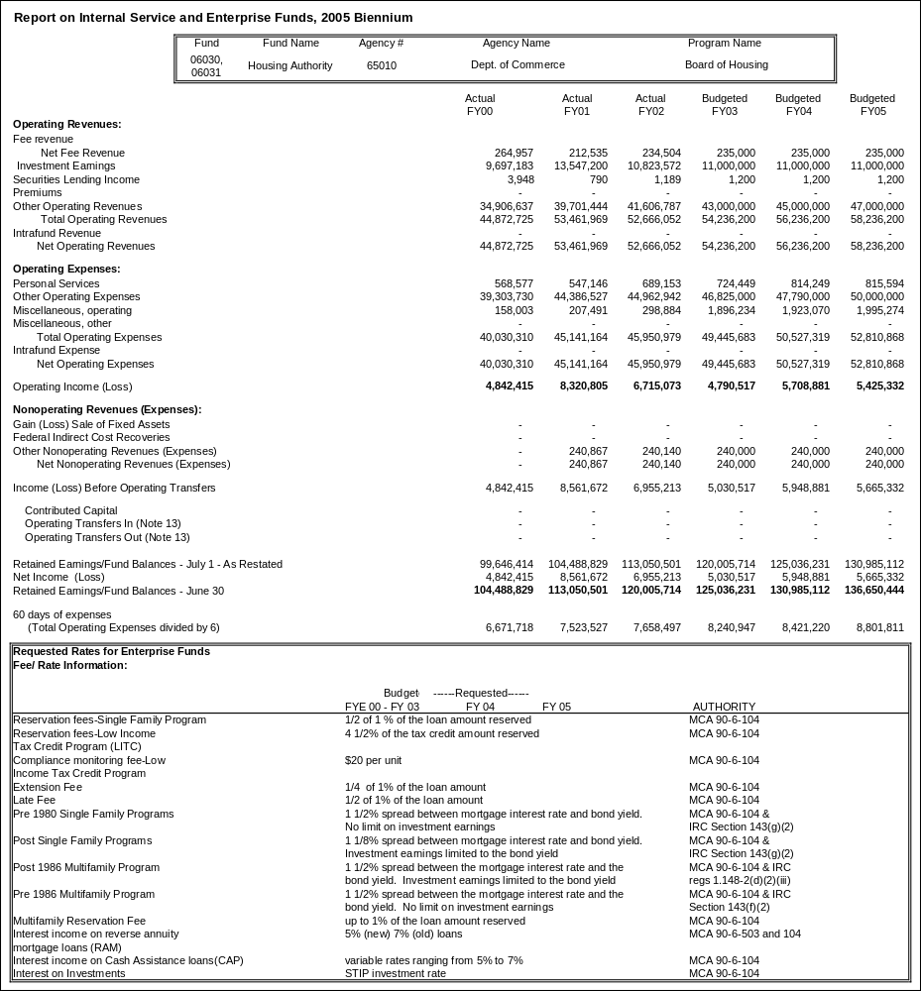
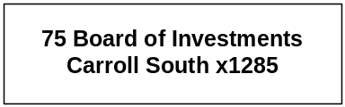
Proprietary Rates

Program Proposed Budget  Budget Item | Base  Budget  Fiscal 2002 | PL Base Adjustment  Fiscal 2004 | New  Proposals  Fiscal 2004 | Total  Exec. Budget  Fiscal 2004 | PL Base Adjustment  Fiscal 2005 | New  Proposals  Fiscal 2005 | Total  Exec. Budget  Fiscal 2005
FTE | 33.00 | 0.00 | 1.00 | 34.00 | 0.00 | 1.00 | 34.00
Personal Services | 1,926,214 | 193,109 | 49,496 | 2,168,819 | 201,368 | 49,376 | 2,176,958
Operating Expenses | 987,891 | 82,700 | 7,424 | 1,078,015 | 13,698 | 7,406 | 1,008,995
Total Costs | $2,914,105 | $275,809 | $56,920 | $3,246,834 | $215,066 | $56,782 | $3,185,953
Proprietary | 2,914,105 | 275,809 | 56,920 | 3,246,834 | 215,066 | 56,782 | 3,185,953
Total Funds | $2,914,105 | $275,809 | $56,920 | $3,246,834 | $215,066 | $56,782 | $3,185,953

Please note that a HB 2 section exists for this program.

Program Description –
Unified Investment Program:
The Board of Investments manages the Unified Investment Program mandated by Article VIII, Section 13 of the Montana Constitution. Section 17-6-201,MCA, created the Board of Investments, and gave the board sole authority to invest state funds. The board also invests local government funds at their discretion. The board currently manages an investment portfolio with a market value of approximately $8.6 billion. The board manages the portfolio under the "prudent expert principle."

To provide for diversification and reduced risk, the board manages several investment pools in which funds of similar types are invested. The Legislative Auditor audits the board annually. The board consists of nine members appointed by the Governor.

In-State Investments:
Section 17-6-305, MCA, authorizes the board to invest up to 25 percent of the permanent coal tax trust fund to assist Montana's economic development. This "In-State Investment Program" makes business loans from the trust in participation with financial institutions. The board also lends trust fund monies to local governments to fund infrastructure that will serve job-creating businesses locating in the government's jurisdiction. The Value-Added Loan Program provides low interest loans from the trust to value-added type businesses creating jobs. The board purchases Montana residential mortgages with pension funds as part of the In-State Investment program.

INTERCAP Program:
The board sells tax-exempt bonds and lends the proceeds to eligible governments for a variety of projects. Loan terms range from one to ten years, and short-term loans to finance cash flow deficits or bridge financing are also available. The INTERCAP and In-State Investment Programs were created in FY 1984 as part of the "Build Montana" program.

Revenues and Expenses -
(1) Change in Services or Fees: There has been no significant change in the services provided by the Board of Investments from those provided in the last biennium, although the investment portfolio continues to grow in size. The 2001 Legislature approved 33.00 FTE (30.00 funded from accounting entity 06527, and 3.00 funded from accounting entity 06014) in the last session.

(2) Working Capital Discussion: The Board of Investments charges its costs to the entities that use its services. Typically, this has been done by requesting a maximum level of expenditures similar to what occurs in HB 2 and set the fee at that level. This process has worked very well since the passage of HB 576 and this methodology is continued in the 2005 biennium because it provides an easy comparison with historical financial activity.
Rate Explanation -Investment Programs (accounting entity 06527): The revenue objective of the investment program is to fairly assess the costs of operations to each account the board invests while maintaining a reasonable and prudent 60 day working capital reserve.

Bond Programs (accounting entity 06014): Nearly all Bond Program revenues are generated by the difference between interest rates on bonds sold and the interest rate charged on loans to borrowers. Since these revenues are only received from the trustee on an annual basis, a 270 day fund balance is required to provide adequate funding for the Bond Program between draws. Remaining revenues are received monthly from the boards contract with the Montana Facility Finance Authority. Other revenues, if any, not received by billings to client agencies (e.g. direct appropriations):

The Board of Investments does not receive any direct appropriations. Funding for accounting entity 06527 is generated entirely from charges to each account that the board invests and is used to finance the investment program. Funding for accounting entity 06014 is the revenue generated from the difference between the interest earned from loans to borrowers and interest paid to bond holders; and monthly contract revenues received from the Montana Facility Finance Authority. Non-budgeted revenues are used to finance statutorily appropriated debt service expenditures.

(3) Fund Equity and Reserved Fund Balance: At the proposed level of expenditures, the board projects a FY 2005 ending unreserved fund balance and a working capital reserve for accounting entity 06527.

(4) Cash Flow Discussion: Costs to the entities using the board services are typically assessed on a monthly basis for accounting entity 06527. Since collections lag by at least one month, the board must maintain a nominal 60-day working capital reserve to meet ongoing operational expenses.

Revenues for accounting entity 06014 are typically received on an annual basis, so a 270 day fund balance is required to provide adequate funding for the bond program between draws.

Investment Programs (accounting entity 06527): The revenue objective of the investment program is to fairly assess the costs of operations to each account the board invests while maintaining a reasonable and prudent 60 day working capital reserve.

Bond Programs (accounting entity 06014): Nearly all bond program revenues are generated by the difference between interest rates on bonds sold and the interest rate charged on loans to borrowers. Since these revenues are only received from the trustee on an annual basis, a 270 day fund balance is required to provide adequate funding for the Bond Program between draws. Remaining revenues are received monthly from the Boards contract with the Montana Facility Finance Authority.

--------------------------------- Present Law Adjustments --------------------------------

Total Agency Impact | General Fund Total
FY04 $42,129 | FY04 $0
FY05 $43,434 | FY05 $0
PL- 18 - Administrative Cost Adjustments HB 576 -
Adjustments include restoration of zero-based board per diem and overtime, as well as the rent increase and the indirect charges required by state law adopted in the special session.

---------------------------------------- New Proposals ----------------------------------------

Total Agency Impact | General Fund Total
FY04 $56,920 | FY04 $0
FY05 $56,782 | FY05 $0
NP- 22 - Add 1.00 FTE -
In the 2003 biennium, the Board of Investments assumed the loan portfolio of the former Montana Science and Technology Alliance. At that time 1.00 FTE was to be moved from HB 2 into the HB 576 side of the Board of Investments. This transaction was inadvertently left out. In addition, the HB 2 portion of the former Montana Science and Technology Alliance portfolio will be assumed by the board and funding needs to be secured within the board internal service fund for the FTE manager of the outstanding portfolio.

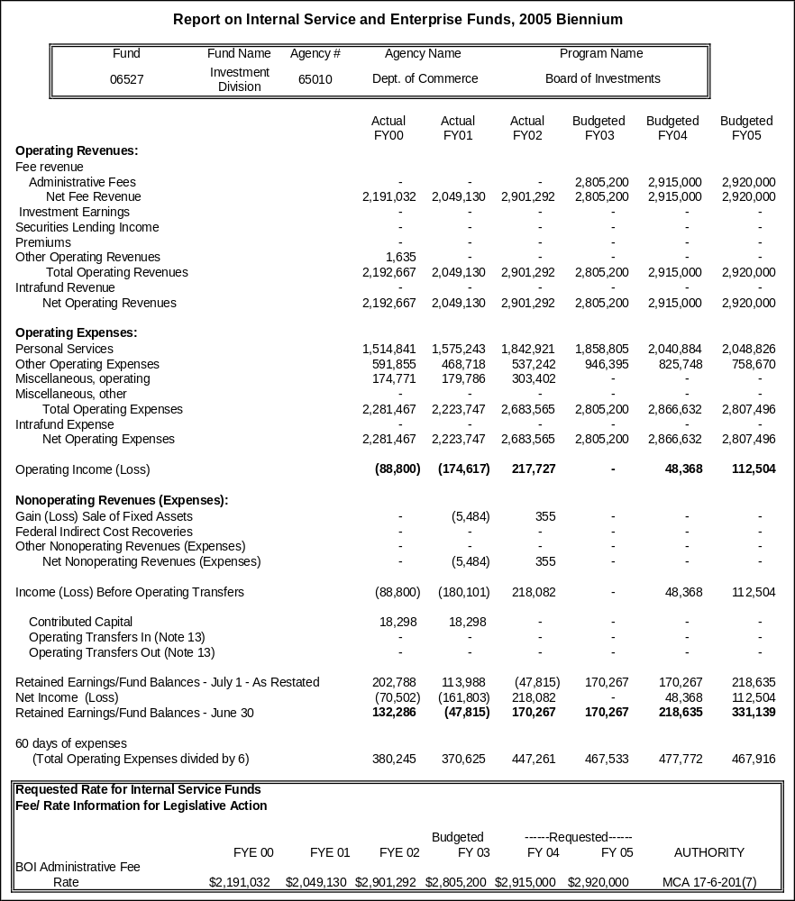
Revenue Objective: The revenue objective of the Board of Investments is to assess the costs of operations to each portfolio the Board invests while attempting to maintain a reasonable and prudent working capital reserve.
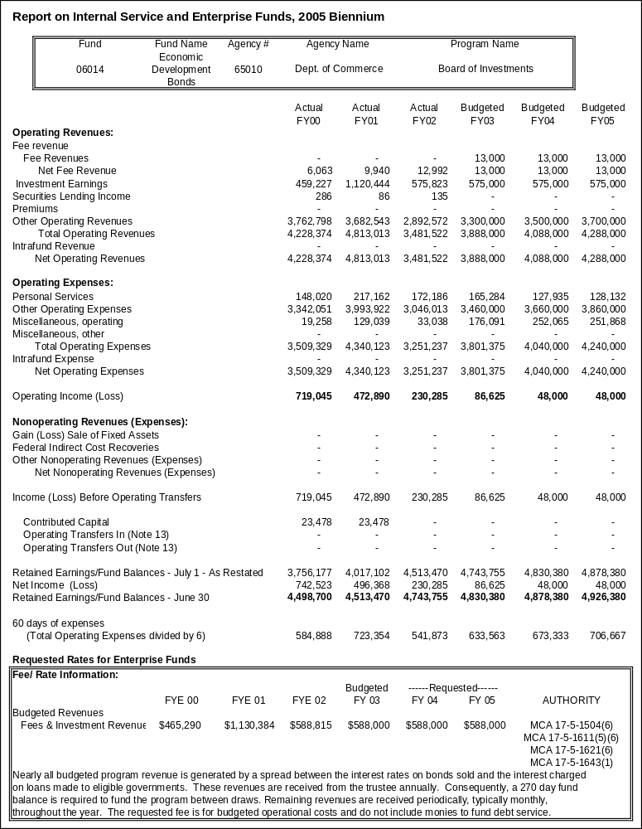

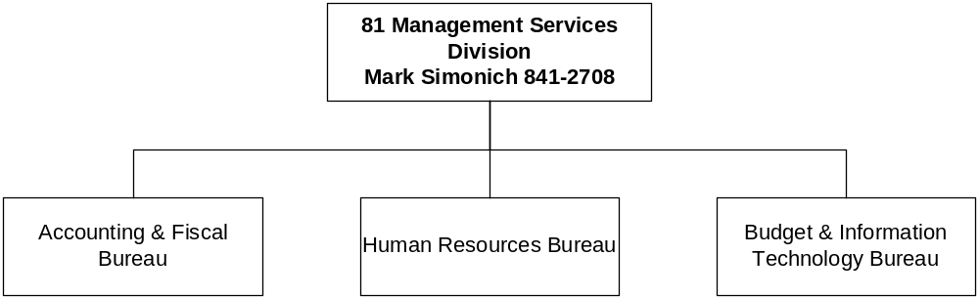

Proprietary Rates
Program Proposed Budget  Budget Item | Base  Budget  Fiscal 2002 | PL Base Adjustment  Fiscal 2004 | New  Proposals  Fiscal 2004 | Total  Exec. Budget  Fiscal 2004 | PL Base Adjustment  Fiscal 2005 | New  Proposals  Fiscal 2005 | Total  Exec. Budget  Fiscal 2005
FTE | 17.00 | 0.00 | 0.00 | 17.00 | 0.00 | 0.00 | 17.00
Personal Services | 843,578 | 67,813 | 0 | 911,391 | 67,669 | 0 | 911,247
Operating Expenses | 221,319 | (15,591) | 0 | 205,728 | (13,844) | 0 | 207,475
Total Costs | $1,064,897 | $52,222 | $0 | $1,117,119 | $53,825 | $0 | $1,118,722
Proprietary | 1,064,897 | 52,222 | 0 | 1,117,119 | 53,825 | 0 | 1,118,722
Total Funds | $1,064,897 | $52,222 | $0 | $1,117,119 | $53,825 | $0 | $1,118,722

Please note that a HB 2 section exists for this program.

Program Description - The Director's Office/Management Services Division consists of two programs - the Director's Office and the Management Services Division. The Director's Office assists the department with executive, administrative, legal, and policy guidance. This office acts as the liaison among private business, local governments, administratively attached boards, public and private interest groups, the legislature, Indian tribes, individuals, and the Governor's office. The Management Services Division provides internal support to all agency divisions, bureaus, and programs. Services provided by the Management Services Division include accounting and fiscal, budgeting and information systems, contracting and purchasing, human resources, payroll, and training.

Virtually every division, bureau, and program in the agency uses the division services. Division staff work closely with a host of other governmental agencies, both executive and legislative, in effect acting as the administrative contact points for the agency. The "central services" aspect of the Division greatly reduces the overlap and the redundancy found in decentralized business environments. These aspects enhance the overall effectiveness and efficiency of the agency by standardizing business processes and employing best business practices in as many areas of the agency as possible, while keeping the costs to supported programs as low as possible.

Revenues and Expenses -
(1) Change in Services or Fees: There has been no significant change in the services provided to supported divisions, bureaus, and programs. There are 17.00 FTE permanent funded through indirect charges to supported programs. There are no significant requests for funding increases in the 2005 biennium and the Department is proposing to reduce the 2005 biennium indirect cost rate to 15 percent from it' current 15.5 percent level.

(2) Working Capital Discussion: The indirect cost rate is calculated by dividing the projected annual expenditures of the Director's Office/Management Services Division, plus a nominal working capital reserve, by the projected actual personal services amounts estimated to be incurred by supported programs. Federally-funded programs are allocated indirect costs via a federally approved indirect cost rate, while state funded programs are allocated indirect costs via a legislatively approved indirect cost rate.

Indirect costs are charged to all supported programs on a monthly basis, and since indirect cost collections lag by at least one month the division must maintain a nominal working capital reserve to meet operating costs.

(3) Fund Equity and Reserved Fund Balance: At the proposed 15 percent rate, the department projects a fiscal 2005 ending unreserved fund balance of $175,525, or approximately a 57 day working capital reserve.

(4) Cash Flow Discussion: Indirect costs are charged to all supported programs on a monthly basis, since indirect cost collections lag by at least one month the division must maintain a nominal working capital reserve to meet on going operating costs.

Rate Explanation -The revenue objective of this unit is to maintain the lowest possible indirect cost charge to supported divisions, bureaus, and programs while attempting to maintain a nominal working capital reserve. Indirect costs are charged to divisions, bureaus, and programs on a monthly basis. For example, January's indirect costs would be charged to supported divisions, bureaus, and programs in February. Since indirect cost collections lag by at least one month it is necessary to maintain a reasonable and prudent working capital reserve to meet on going operational expenses. The department has historically used the same methodology in calculating indirect rates because the federal government requires it to be used to charge federally funded programs indirect costs. The rates proposed for the 2005 biennium are the most reasonable and appropriate available because they most closely match the fees commensurate with costs methodology, while maintaining a minimal working capital reserve, and meeting federal requirements.

Allocation Methodology: Indirect costs for the Director’s Office/Management Services Division are allocated to supported programs via a federally approved indirect cost plan for federally funded programs, and a legislatively approved rate for state funded programs. Indirect cost rates are charged to supported programs based upon actual personal services expenditures.

Authority: Federally negotiated indirect cost plan for federally funded programs, and legislatively approved rate for state funded programs. FY 2004 and FY 2005 federal rate is an estimated negotiated rate.

Significant Present Law -
The only present law adjustment is for administrative costs, primarily for the increased costs associated with moving from state owned space to privately owned space.

--------------------------------- Present Law Adjustments --------------------------------

Total Agency Impact | General Fund Total
FY04 $17,796 | FY04 $0
FY05 $19,440 | FY05 $0
PL- 19 - Administrative Cost Adjustments HB 576 -
One-time moving costs are deleted from the base, offset by inclusion of the rent adjustment for the new location.

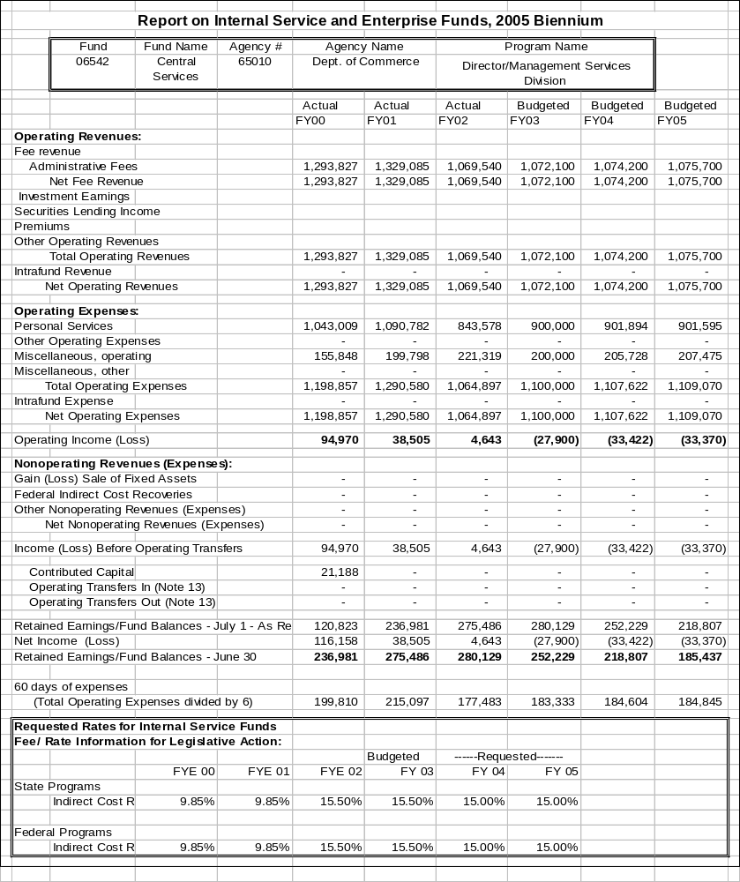
Proprietary Rates

Program Proposed Budget  Budget Item | Base  Budget  Fiscal 2002 | PL Base Adjustment  Fiscal 2004 | New  Proposals  Fiscal 2004 | Total  Exec. Budget  Fiscal 2004 | PL Base Adjustment  Fiscal 2005 | New  Proposals  Fiscal 2005 | Total  Exec. Budget  Fiscal 2005
FTE | 20.50 | (0.50) | 0.00 | 20.00 | (0.50) | 0.00 | 20.00
Personal Services | 933,169 | 97,117 | 0 | 1,030,286 | 99,220 | 0 | 1,032,389
Operating Expenses | 246,127 | 19,770 | 0 | 265,897 | 22,866 | 0 | 268,993
Total Costs | $1,179,296 | $116,887 | $0 | $1,296,183 | $122,086 | $0 | $1,301,382
Proprietary | 1,179,296 | 116,887 | 0 | 1,296,183 | 122,086 | 0 | 1,301,382
Total Funds | $1,179,296 | $116,887 | $0 | $1,296,183 | $122,086 | $0 | $1,301,382

Program Description - Agency Legal Services Bureau (ALSB) provides legal, hearings examiner, and investigative services to state agency clients on a contract basis. ALSB attorneys and investigators bill their time performing work for the clients, and case-related and incidental costs are also billed to the clients. ALSB also contains a bankruptcy unit that provides legal representation and advice to state agency clients regarding bankruptcy matters.

ALSB currently has 20 FTE funded from the revenues generated.

Statutory authority: The Attorney General is the legal officer for the state per Article VI, Section 4(4), Montana Constitution. Montana Code Annotated § 2-4-611(2) provides that state agencies may request from the Attorney General's Office a hearing examiner in a contested case.

Alternate Sources: State agencies have the option of using in-house or private counsel and investigators to perform the services provided by ALSB. Private law firms, however, typically charge considerably more per hour than ALSB. And, attorneys and investigators in ALSB have specific experience and knowledge related to litigation matters that client agencies find beneficial.

Customers Served: ALSB serves state of Montana agencies, boards, and commissions that have entered contracts with ALSB. According to Executive Order 5-93, the Legal Services Review Committee approves the use of private counsel by state agencies in lieu of ALSB counsel on a case-by-case basis.

Revenues and Expenses - Change in Services or Fees: There are no changes to service. The fees are requested to increase from $70 p/hr for attorneys and $38 p/hr for investigators to $71.80 and $39.80 respectively. The increase is due to the bureau moving from state-owned space to private space and the ability to recover a one percent cost projected for a pay plan increase.

Working Capital Discussion: The objective of program management is to recover costs only to fund necessary, ongoing operations.

Fund Equity and Reserved Fund Balance: While there is no requirement that an excess fund balance be maintained, the program seeks to build a limited capital reserve fund. The rates are influenced by the working capital necessary to maintain current operations.

Cash Flow Discussion: Cash flow into the program fluctuates depending on the volume of work in any given month, which can vary considerably.

Rate Explanation - Sufficient personnel are the drivers to achieve the requirements placed on ALSB. History has shown that the current staff has maintained the workload request from agencies. Staffing is monitored, for example, the FY 2004 and FY 2005 budget is deleting a 0.50 FTE.

The rate requested takes into account the volume expected, the known and expected expenditures. Various rates were analyzed to ensure the total fund equity did not increase. The minimum rate was requested, not addressing any requirement for a positive 60-day expense.

--------------------------------- Present Law Adjustments --------------------------------

Total Agency Impact | General Fund Total
FY04 $40,355 | FY04 $0
FY05 $41,333 | FY05 $0
PL- 601 - Agency Legal Services Base Adjustment -
Agency Legal Services is requesting a base adjustment to eliminate a 0.50 FTE and transfer rent costs from "DofA Rent" to "Non-Dof A Rent" to reflect the ALS move to a non-state building. The rent figures include base costs plus the increased rent costs for the new building. The FTE reduction and the rent increase were both included in the ALS rate charge, approved by the OBPP for all state agency budgets.

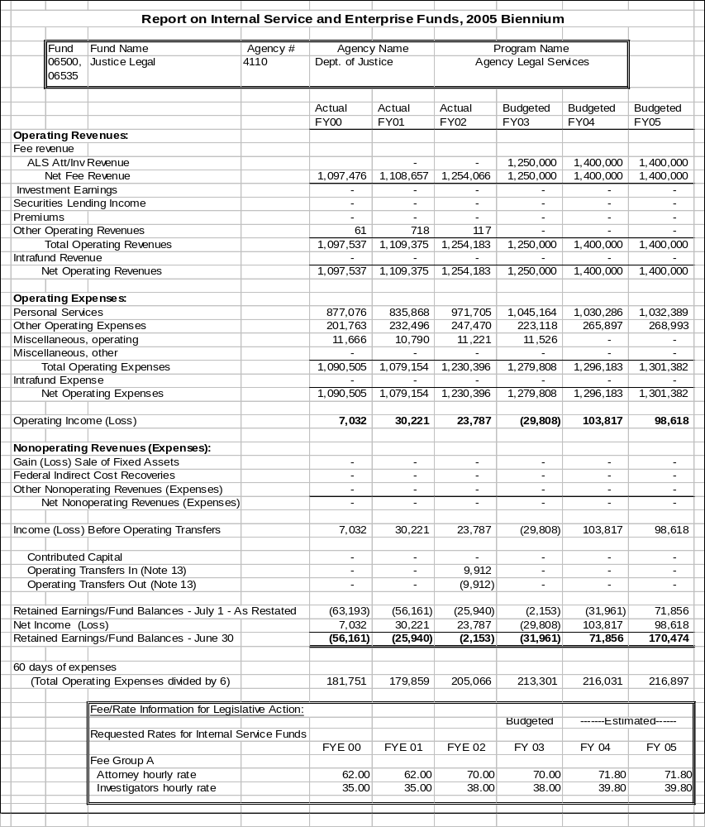

Proprietary Rates

Program Proposed Budget  Budget Item | Base  Budget  Fiscal 2002 | PL Base Adjustment  Fiscal 2004 | New  Proposals  Fiscal 2004 | Total  Exec. Budget  Fiscal 2004 | PL Base Adjustment  Fiscal 2005 | New  Proposals  Fiscal 2005 | Total  Exec. Budget  Fiscal 2005
FTE | 18.00 | 2.50 | 0.00 | 20.50 | 2.50 | 0.00 | 20.50
Personal Services | 673,144 | 2,656 | 0 | 675,800 | 2,850 | 0 | 675,994
Operating Expenses | 1,306,015 | 56,469 | 0 | 1,362,484 | 56,826 | 0 | 1,362,841
Equipment | 0 | 0 | 186,004 | 186,004 | 41,796 | 44,584 | 86,380
Total Costs | $1,979,159 | $59,125 | $186,004 | $2,224,288 | $101,472 | $44,584 | $2,125,215
Proprietary | 1,979,159 | 59,125 | 186,004 | 2,224,288 | 101,472 | 44,584 | 2,125,215
Total Funds | $1,979,159 | $59,125 | $186,004 | $2,224,288 | $101,472 | $44,584 | $2,125,215

Please note that a HB 2 section exists for this program.

Program Description - The Food Factory was established to provide cost effective nutritional meals to the Montana State Prison and other state and county agencies, using a cook-chill method of food preparation. The cook-chill method allows food to be prepared a week in advance and packaged in bulk or individual trays.

Revenues and Expenses - The Food Factory derives its revenue from the sale of bulk food and trayed meals to customers. Currently the customers who are served include: Montana State Prison, Montana State Hospital, Treasure State Correctional Training Center, Riverside Youth Correctional Facility, WATCH DUI Unit, and the Helena Prerelease Center. The anticipated revenues for FY 2004 and FY 2005 are $2,230,000 and $2,271,000 respectively. The largest expense the food factory incurs is the purchase of raw food items and personal services costs. The anticipated expenses for FY 2004 and FY 2005 are $2,179,470 and $2,221,266 respectively. Personal services in Fy 2004 and FY 2005 include the original budgeted authority in addition to the present law adjustments for inmate wages and additional 2.00 FTE supervisors at the warehouse whose work is associated with the Food Factory. The miscellaneous operating includes the original budgeted authority in addition to the present law adjustments for additional operating authority. FY 2005 includes the purchase of $41,796 of equipment.

Rates - Current Food Factory rates charged to the customers are lower than the rates established during the 2001 Legislative session. The rates as they were established assumed that all customers would be purchasing a trayed complete meal. In actuality, most customers receive a bulk product. The bulk customers are charged the food cost plus a monthly overhead charge. The per meal trayed customer rates for FY 2004 and FY 2005 are as follows: Montana State Prison: $1.37l, Riverside Youth Correctional Facility: $2.01, WATCH DUI Unit: $1.59 and Helena Prerelease: $2.01. All meal rates include delivery costs.

--------------------------------- Present Law Adjustments --------------------------------

Total Agency Impact | General Fund Total
FY04 $116,303 | FY04 $0
FY05 $116,132 | FY05 $0
PL- 21 - Food Factory Additional FTE -
The MSP Food Factory converted to a proprietary internal service fund July 1, 2001. Presently the Food Factory is operating with assistance from Montana State Prison in the warehouse, delivery and food service. At the time of start-up, it was not known what resources would be needed to run the operation for the benefit of the customers and the Food Factory proprietary budget. This request will enable operation with 2.50 FTE in the 2005 biennium.
________________________________________________________________________________________________

Total Agency Impact | General Fund Total
FY04 $75,724 | FY04 $0
FY05 $117,520 | FY05 $0
PL- 23 - Food Factory Adjustment -
The Food Factory was converted to a proprietary fund during the last Legislative session. The Food Factory operates a cook chill operation to produce meals for four facilities within the Department of Corrections, along with Montana State Hospital and Helena Prerelease. With the changeover to proprietary and the addition of customers from the previous year, this adjustment is needed to cover inmate payroll, food costs, etc.

---------------------------------------- New Proposals ----------------------------------------

Total Agency Impact | General Fund Total
FY04 $186,004 | FY04 $0
FY05 $44,584 | FY05 $0
NP- 22 - Food Factory New Equipment -
The MSP Food Factory will have new equipment needs due to the projected increase in meals to serve MSP and PHHS customers.

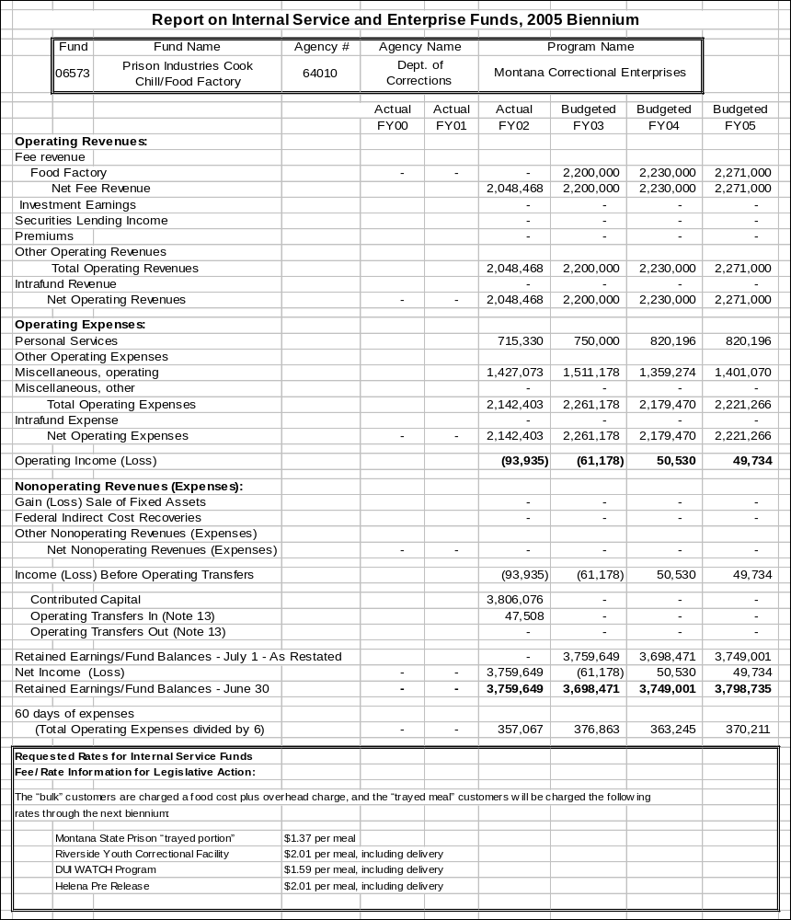

Proprietary Rates

Program Proposed Budget  Budget Item | Base  Budget  Fiscal 2002 | PL Base Adjustment  Fiscal 2004 | New  Proposals  Fiscal 2004 | Total  Exec. Budget  Fiscal 2004 | PL Base Adjustment  Fiscal 2005 | New  Proposals  Fiscal 2005 | Total  Exec. Budget  Fiscal 2005
FTE | 40.00 | (1.00) | 0.00 | 39.00 | (1.00) | 0.00 | 39.00
Personal Services | 2,438,657 | 362,162 | 0 | 2,800,819 | 362,816 | 0 | 2,801,473
Operating Expenses | 2,562,009 | (23,374) | 0 | 2,538,635 | (19,628) | 0 | 2,542,381
Equipment | 116,496 | 50,000 | 0 | 166,496 | 50,000 | 0 | 166,496
Capital Outlay | 151,421 | 300,000 | 0 | 451,421 | 0 | 0 | 151,421
Total Costs | $5,268,583 | $688,788 | $0 | $5,957,371 | $393,188 | $0 | $5,661,771
Proprietary | 5,268,583 | 688,788 | 0 | 5,957,371 | 393,188 | 0 | 5,661,771
Total Funds | $5,268,583 | $688,788 | $0 | $5,957,371 | $393,188 | $0 | $5,661,771

Please note that a HB 2 section exists for this program.

Program Description -The Montana Correctional Enterprise (MCE) Industry program includes furniture, upholstery, print, sign, and laundry operations at the Montana State Prison facility. In additional telemarketing programs are operated at the regional and private prison locations around Montana.

The MCE Ranch and Dairy operation includes range cattle, dairy, crops, feedlot and composting, which are all located at the Montana State Prison facility.

The MCE Vocational Education program operates a motor vehicle maintenance shop, Toyota cutaway operation, 2 x 4 lumber processing plant, and the Montana Food Bank cannery at the Montana State Prison Facility.

Revenues and Expenses -
Montana Correctional Enterprises (MCE) Industry revenues are derived from product sales to state and private customers. The expenses are determined by operational needs, cash flow, economic return, customer orders, and product inventory levels. Overall revenue levels are dependant on marketing efforts, legislative restrictions, state agency purchases, retail outlet dealer sales, expansion and adjustment of the product line, continuation of the Certified Industry Program, private sector complaints, private customer contracts, and the success of the programs at the Montana Women's Prison, regional and private prisons.

MCE Ranch and Dairy revenues are based on the market value of products sold. Expenditures are dependant on operational needs, cash flow, economic return, weather conditions, product market prices, and discussion with the Ranch Advisory Committee.

MCE Vocational Education Motor Vehicle Maintenance (MVM) revenues are based on customer vehicle and equipment repair and maintenance needs. Toyota revenues are based on contracts with the Toyota Company for producing motor vehicle cut-aways and trainers. The expenditure levels are determined by revenues and the need for parts and supplies for the repairs and contract projects. The MCE Vocational Education Food Bank revenues are derived from reimbursement of actual costs incurred.

Rate Explanation -The MCE Industries rates for furniture, upholstery, print and sign shops are based on competitive product pricing.

The MCE Industries laundry rates increased in FY 2002 for the first time since the inception of the laundry program in 1996. MCE is not projecting any rate increase for the 2005 biennium. The current laundry rates are as follows: Montana State Prison and Treasure State Correctional Training Center - $.39 per pound, Montana State Hospital - $.38 per pound and Montana Developmental Center Riverside Youth Correctional Facility - $.46 per pound. The break even cost for laundry operations is approximately $.35 per pound without delivery costs. Any profit is maintained within the Industries account to be used for future laundry equipment replacement, as well as the overall Industries enterprise operation.

The Industries telemarketing rates are based on contracts with private companies. MCE Ranch and Dairy rates are based on the current market prices of cattle, crops and dairy products.

MCE Vocational Education Motor Vehicle Maintenance (MVM) and Toyota pricing are based on the cost of parts and an hourly labor charged. The labor charge covers the cost of the four FTE associated with the MVM and Toyota operations.

--------------------------------- Present Law Adjustments --------------------------------

Total Agency Impact | General Fund Total
FY04 $50,000 | FY04 $0
FY05 $50,000 | FY05 $0
PL- 17 - MCE Industries Equipment -
This is a request for equipment authority for Montana Correctional Enterprises (MCE) for the 2005 biennium. MCE Industries is responsible for providing industry programs at the Montana Women's Prison, Great Falls Regional Jail, Cascade County Regional Detention Center and Crossroads Correctional Center in Shelby. To start new programs it is foreseeable that equipment purchases will be necessary. Purchase of the equipment will only be made if the programs are started and if the industries proprietary account has adequate cash flow.
________________________________________________________________________________________________

Total Agency Impact | General Fund Total
FY04 $66,843 | FY04 $0
FY05 $66,794 | FY05 $0
PL- 19 - MCE Ranch LP Program Authority Request -
This is a request for spending authority for the MCE Ranch. MCE Ranch and Louisiana Pacific (LP) lumber mill in Deer Lodge are working on a cooperative project where MCE processes non-stud (re-trim and economy) grade 2X4 and 2X6 lumber by cutting out the defects in the lumber and palletizing the remaining sections to be used as finger jointer blocks for processing at the LP mill. This request will continue this program, which was implemented in FY 2002.
________________________________________________________________________________________________

Total Agency Impact | General Fund Total
FY04 $300,000 | FY04 $0
FY05 $0 | FY05 $0
PL- 20 - MCE Ranch Dam Compliance Authority -
MCE is requesting spending authority for continuation of the rehabilitation work on the MCE Ranch high-hazard dams to comply with DNRC and the Montana Dam Safety Act requirements. MCE Ranch has eight irrigation dams as part of overall ranch operation. Five of these dams have been classified as high hazard by DNRC.
________________________________________________________________________________________________

Total Agency Impact | General Fund Total
FY04 $1,152,795 | FY04 $0
FY05 $1,152,795 | FY05 $0
PL- 24 - Ranch & Indus Inmate Payroll & Supervisor Overtime -
This is a request for ranch inmate payroll, which covers ranch workers associated with the dairy, range cattle, crops, granary, EMS, irrigation, business skills, Food Bank, and the feedlot. Projections for the ranch for the next biennium are based on 80 inmates @ $4.50 per day for 365 days, for a total of $131,400.
________________________________________________________________________________________________

Total Agency Impact | General Fund Total
FY04 ($142,497) | FY04 $0
FY05 ($145,476) | FY05 $0
PL- 28 - Termination of the Montana Food Bank Program -
This request will eliminate the Montana Food Bank Network Cannery. Montana Correctional Enterprises Ranch operates the Montana Food Bank Network Cannery. Funding for the Food Bank is shared among the Department of Corrections, Montana Correctional Enterprises Ranch proprietary fund and the Department of Public Health and Human Services general fund. During the past legislative sessions, in HB 2, the Legislature approved the funding for a 50-50 split between the two agencies. Per contract, any monies spent over the projected budget amounts of $136,844 in FY 2002 and $139,212 in FY 2003 will also be split evenly between the two agencies.

Based on the cannery production to date, the costing analysis shows that it is not cost effective. A similar type product could be purchased at a lower cost. This is due to various factors, e.g. lack of product (either no product or inadequate amounts of product) for all production days, lengthy preparation and processing times for certain types of products, and the length of time it takes to get new canning processes approved.

This proposal is to terminate the cannery project due to cost inefficiencies, which would free general and proprietary fund monies to be used for other areas. Based on current funding, termination of this program would result in yearly savings of approximately $70,000 in each of the general and proprietary fund annual budgets.

MCE does not have any means to recoup the financial loss incurred due to this program, as the only revenue generated is the payment from DPHHS for one-half of the funding. Closure of this program will result in loss of jobs for 2.00 FTE and approximately 12 inmates. It is the intent of MCE, should this program be terminated, that these positions would be moved to other MCE revenue producing programs, or to start new MCE revenue producing programs.

Note: The entire Food Bank Budget runs through MCE Ranch Proprietary account (06033), and MCE bills the Department of Health and Human Services for one half of the actual expenditures, per contract. Payment of the one-half of expenditures is recorded as revenue in the proprietary account.

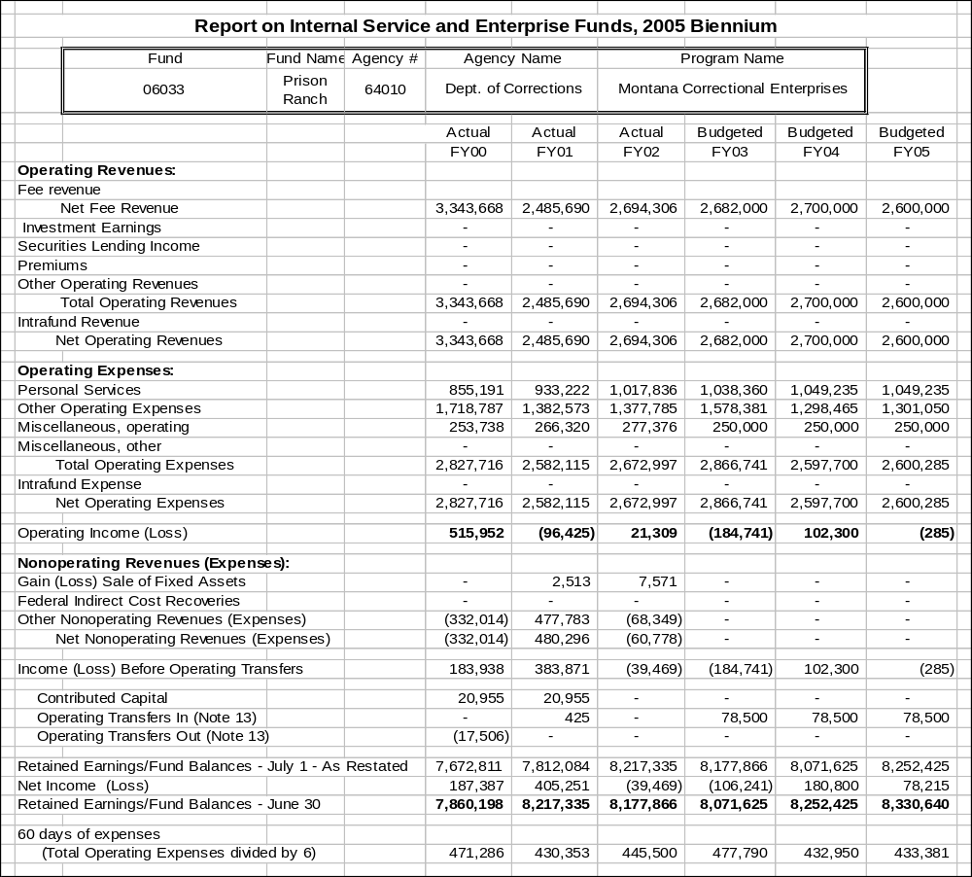
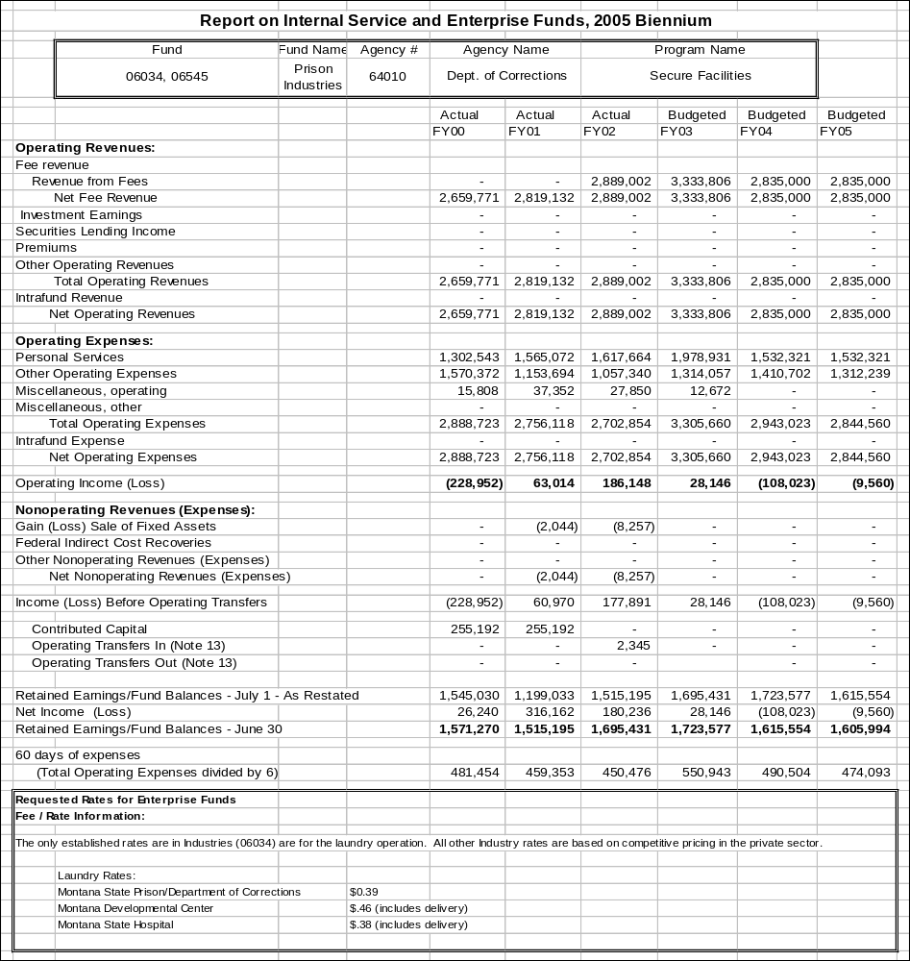

Proprietary Rates

Program Proposed Budget  Budget Item | Base  Budget  Fiscal 2002 | PL Base Adjustment  Fiscal 2004 | New  Proposals  Fiscal 2004 | Total  Exec. Budget  Fiscal 2004 | PL Base Adjustment  Fiscal 2005 | New  Proposals  Fiscal 2005 | Total  Exec. Budget  Fiscal 2005
FTE | 2.00 | 0.00 | 0.00 | 2.00 | 0.00 | 0.00 | 2.00
Personal Services | 79,672 | 8,200 | 0 | 87,872 | 7,956 | 0 | 87,628
Operating Expenses | 87,116 | 679 | 0 | 87,795 | 399 | 0 | 87,515
Total Costs | $166,788 | $8,879 | $0 | $175,667 | $8,355 | $0 | $175,143
Proprietary | 166,788 | 8,879 | 0 | 175,667 | 8,355 | 0 | 175,143
Total Funds | $166,788 | $8,879 | $0 | $175,667 | $8,355 | $0 | $175,143

Please note that a HB 2 section exists for this program.

Program Description - The Montana Career Information System (MCIS) has been active in Montana since 1980. The purpose of MCIS is to deliver current career and labor market information to Montanans in an easy-to-use, easy-to-understand format. This is the only career information delivery system in the country that has specific Montana labor market information included in each file. MCIS is currently being used at over 200 sites throughout the state by a wide variety of users: job service offices, vocational rehabilitation offices, high schools, community colleges, universities, tribal colleges, education and training agencies, and adult education programs.

Revenues and Expenses - Working Capital = $23,946 for 60 days.

Rate Explanation - The Montana Career Information System (MCIS) is funded by user fees not to exceed $1,500 per site. Discounted rates are available for small schools and groups.

The Montana Career Information System (MCIS) is funded by user fees for software and licensing. High schools with enrollments over 200, all postsecondary schools, and all agencies and businesses are charged $1150 per year. Smaller high schools are charged $575-$977 depending on enrollment, and school districts are charged $2000 per year.

The fluctuation that appears in the total expenditures in this fund is due primarily to a biennial conference hosted by MCIS. The conference was held in FY 1997, FY 1999, and FY 2001 and will be held annually from then on. The conference is related to the MCIS program, but expenditures and revenues might not be recorded in this enterprise fund in the future.

--------------------------------- Present Law Adjustments --------------------------------

Total Agency Impact | General Fund Total
FY04 $883 | FY04 $0
FY05 $890 | FY05 $0
PL- 12 - Operating Increase -
The executive recommends an increase in operating authority to cover increases in the agency's indirect cost allocation plan. This package also includes adjustments (reductions) to meet the general fund target for the agency. These reductions amount to $77,222 in FY 2004 and $77,223 in FY 2005 from the Apprenticeship Program.

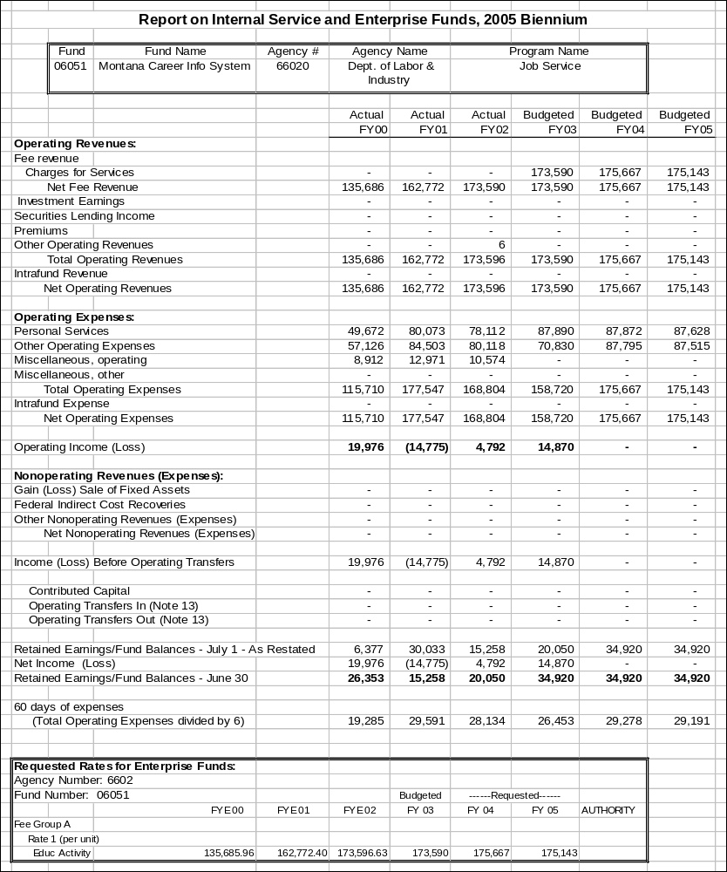

Proprietary Rates

Program Proposed Budget  Budget Item | Base  Budget  Fiscal 2002 | PL Base Adjustment  Fiscal 2004 | New  Proposals  Fiscal 2004 | Total  Exec. Budget  Fiscal 2004 | PL Base Adjustment  Fiscal 2005 | New  Proposals  Fiscal 2005 | Total  Exec. Budget  Fiscal 2005
FTE | 0.00 | 0.00 | 0.00 | 0.00 | 0.00 | 0.00 | 0.00
Benefits & Claims | 83,801,111 | 0 | 0 | 83,801,111 | 0 | 0 | 83,801,111
Total Costs | $83,801,111 | $0 | $0 | $83,801,111 | $0 | $0 | $83,801,111
Proprietary | 83,801,111 | 0 | 0 | 83,801,111 | 0 | 0 | 83,801,111
Total Funds | $83,801,111 | $0 | $0 | $83,801,111 | $0 | $0 | $83,801,111

Please note that a HB 2 section exists for this program.

Program Description - The Unemployment Insurance Program administers the state unemployment insurance law and issues payments to claimants for temporary, partial wage replacement due to involuntary unemployment. The Proprietary fund is used to record the collections of Unemployment Insurance Contributions and to issue payments of the Unemployment Insurance Benefits.

Revenues and Expenses - The revenues received in the proprietary fund are for the Unemployment Insurance Program tax collections, federal reimbursement for claims on federal employees, military personnel, and claimants in other states, and interest earnings to the unemployment insurance trust fund. The expenditures are Unemployment Insurance Benefits paid to claimants while unemployed, including federal withholding tax and child support payments the claimants have elected to have taken out of the benefit check.

Rate Explanation - The Unemployment Insurance Division administers the state unemployment insurance law. There is no proprietary rate but a collection of contributions from employers that are used to pay the Unemployment
Insurance Benefits to claimants who have involuntarily become unemployed.

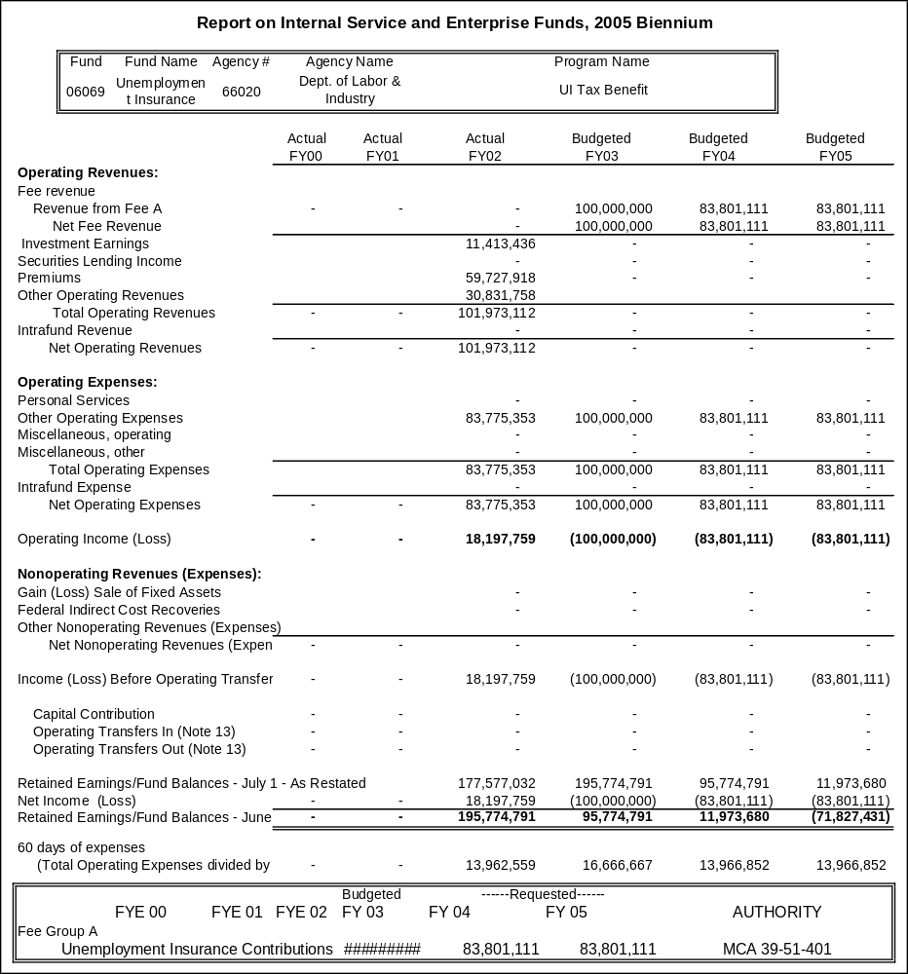This fund is shared by the Department of Revenue and Department of Labor & Industry. DOR collects the contributions paid by employers, based on their industry or individual experience rate, to pay for their Unemployment Insurance. DLI expends the funds by paying Unemployment Insurance benefit claims.
Proprietary Rates

Program Proposed Budget  Budget Item | Base  Budget  Fiscal 2002 | PL Base Adjustment  Fiscal 2004 | New  Proposals  Fiscal 2004 | Total  Exec. Budget  Fiscal 2004 | PL Base Adjustment  Fiscal 2005 | New  Proposals  Fiscal 2005 | Total  Exec. Budget  Fiscal 2005
FTE | 48.00 | 0.00 | 0.00 | 48.00 | 0.00 | 0.00 | 48.00
Personal Services | 1,877,951 | 202,699 | 0 | 2,080,650 | 200,116 | 0 | 2,078,067
Operating Expenses | 663,038 | 4,310 | 0 | 667,348 | 9,069 | 0 | 672,107
Equipment | 12,831 | 0 | 0 | 12,831 | 0 | 0 | 12,831
Total Costs | $2,553,820 | $207,009 | $0 | $2,760,829 | $209,185 | $0 | $2,763,005
Proprietary | 2,553,820 | 207,009 | 0 | 2,760,829 | 209,185 | 0 | 2,763,005
Total Funds | $2,553,820 | $207,009 | $0 | $2,760,829 | $209,185 | $0 | $2,763,005

Please note that a HB 2 section exists for this program.

Program Description - Cost Allocation Plan (CAP) -- The Commissioner's Office and the Legal/Centralized Services Division are funded through a cost allocation plan under which the various other divisions in the agency are assessed a percentage of their personal services cost to support centralized functions. The services provided through this accounting entity are administration, accounting, purchasing, budgeting, personnel, training, mail distribution, and information services.

Input/Output Control Operations Functions -- The Legal/Centralized Services Division recovers costs of a unit called the Input/Output control Operations Function, which provides traffic control of data input, jobs for the mainframe computer system, and report output.

Revenues and Expenses -
1) Change in Services or Fees - There will no change.
2) Working Capital Discussion – FY 2004 60-days of personal services, operations, and miscellaneous operating less non-cash expenses equals approximately $472,264. This figure is the minimum amount necessary to maintain on-going operations. Our Working Capital balance is used in calculating the final CAP rate.
3) Fund Equity and Reserved Fund Balance - The program has no requirement to reserve fund balance.
4) Cash Flow Discussion - There is no cash flow fluctuation.

Cost allocation plan (CAP) charges fund centralized functions such as CSD administration, accounting, budgeting, technical services, personnel and training, legal services, and commissioner's office.

The CAP rate is determined by dividing projected personal service expenditures on FTE not supported by CAP revenue by the projected revenue needed to perform centralized services required for the agency.

Direct charges are for services that are easily identifiable and charged directly to the beneficiary of the service. Direct charges are estimated during the budget submission process, and actual costs incurred are charges to the appropriate division/bureau.

One of the two direct charge items is the charge by Technical Services Bureau to capture and print data from databases housed at ITSD for Unemployment Insurance Division and Workforce Service Division. Costs are estimated during budget submission and based upon prior years' actual costs.

The other direct charge is charged by Legal Services Bureau to Workforce Service Division for services that are specific and agreed to in advance.

Rate Explanation - Cost Allocation Plan (CAP) - It is the intent of the Legislature that the rates charged for these functions be the rates agreed upon by the U.S. Department of Labor federal cost negotiator. It is anticipated that the assessment will be as much as 10 percent and 12 percent of a program's actual personal services costs incurred in FY 2004 and FY 2005.

Input/Output Control Operation Functions - Internal users are directly charged for the services received and are billed quarterly.

--------------------------------- Present Law Adjustments --------------------------------

General Fund Total
FY04 $0
FY05 $0
PL- 11 - Misc. Operating Increase -
This request includes an increase for the department's internal cost allocation plan that has been allocated among the different funds within this division responsible for paying into this pool.
________________________________________________________________________________________________

Total Agency Impact | General Fund Total
FY04 $13,250 | FY04 $0
FY05 $13,250 | FY05 $0
PL- 16 - BSD Hearings -
The executive recommends that the department be authorized sufficient authority to comply with the responsibilities created by SB 445 which transferred a portion of the Department of Commerce to the Department of Labor & Industry. Formerly, the Department of Justice Agency Legal Services performed all hearings for the boards and building codes through contracted services. DLI will be able to do the hearings at a cost-savings to the boards and Building Codes Bureau through the department's Hearings Bureau. The Hearings Bureau did not take over the hearings until three quarters of the way through the base year and this request is to bring the authority in line with the need.
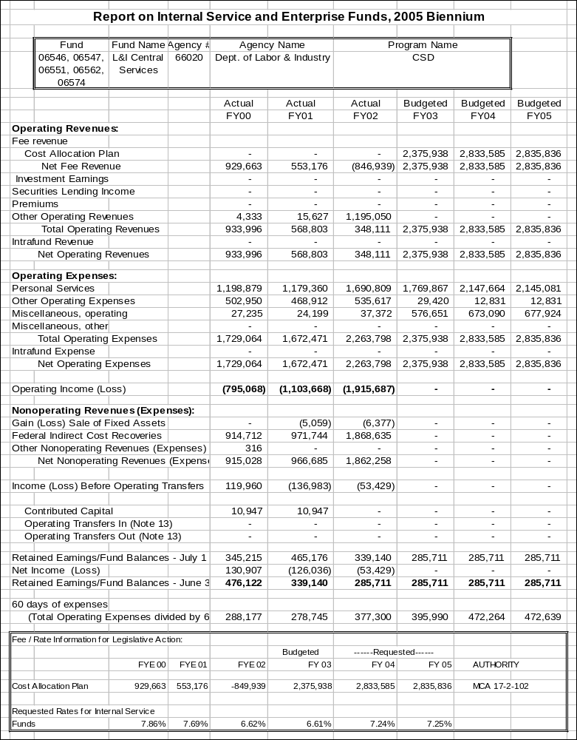
Proprietary Rates

Program Proposed Budget  Budget Item | Base  Budget  Fiscal 2002 | PL Base Adjustment  Fiscal 2004 | New  Proposals  Fiscal 2004 | Total  Exec. Budget  Fiscal 2004 | PL Base Adjustment  Fiscal 2005 | New  Proposals  Fiscal 2005 | Total  Exec. Budget  Fiscal 2005
FTE | 0.00 | 0.00 | 0.00 | 0.00 | 0.00 | 0.00 | 0.00
Benefits & Claims | 233,309 | 0 | 0 | 233,309 | 0 | 0 | 233,309
Transfers | 33,203 | 0 | 0 | 33,203 | 0 | 0 | 33,203
Total Costs | $266,512 | $0 | $0 | $266,512 | $0 | $0 | $266,512
Proprietary | 266,512 | 0 | 0 | 266,512 | 0 | 0 | 266,512
Total Funds | $266,512 | $0 | $0 | $266,512 | $0 | $0 | $266,512

Please note that a HB 2 section exists for this program.

Program Description - The subsequent injury fund was established in 1973 to assist persons with disabilities in becoming employed, by offering a financial incentive to the employers who hire them. The incentive has a limit of 104 weeks of benefits paid by their Workers' Compensation carrier in the event of an on-the-job injury to the certified employee, thus minimizing workers' compensation expenses. Beginning July 1, 1999, the fund is maintained by annual assessment of all Montana Workers' Compensation insurers, including self-insured employers, private insurers and the State Fund. The assessment is statutorily set (39-71-915, MCA) at the amount expended by the fund for the benefit payments plus the cost of administration in the previous calendar year, less other income. The assessment is allocated among insurers based on their compensation and medical payments for the previous calendar year. The fund balance is maintained at approximately $1 million to provide an operating balance for payment of benefits and administrative costs.

Revenues and Expenses - Beginning July 1, 1999, the fund is maintained by annual assessment of all Montana Workers' Compensation insurers, including self insured employers, private insurers and the State Fund. The assessment is allocated among insurers based on their compensation and medical payments for the previous calendar year.

Rate Explanation - The assessment is allocated among insurers based on their compensation and medical payments for the previous calendar year.

The SIF is authorized to assess insurers benefits paid losses reimbursed from the fund in the preceding calendar year and the expenses of administration less other income. For more detail see 39-71-915, MCA.

In FY 1998, the SIF ceased operating on a reserve basis and began to pay benefits on a "pay-as-you-go" basis. Subsequently, the retained earnings of the fund were distributed back to the insurance companies that had contributed to the fund. This was a one-time transfer to reduce the retained earnings balance to an operating level adequate to temporarily pay claims that are reimbursed by the insurance companies (See SB 375, L. 1997, for further explanation).

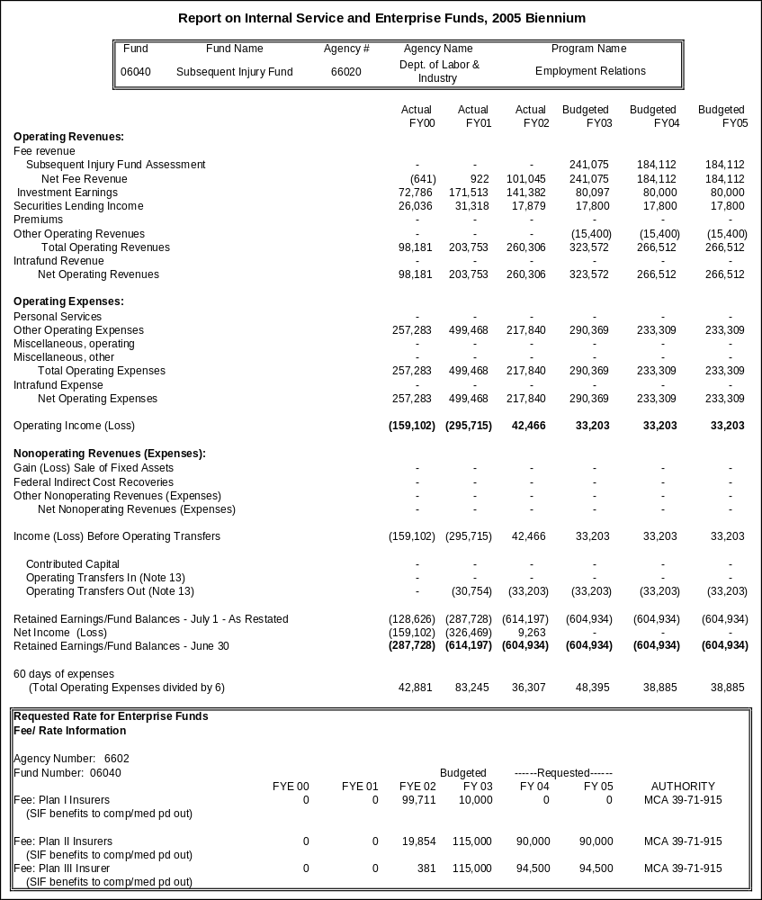

Proprietary Rates

Program Proposed Budget  Budget Item | Base  Budget  Fiscal 2002 | PL Base Adjustment  Fiscal 2004 | New  Proposals  Fiscal 2004 | Total  Exec. Budget  Fiscal 2004 | PL Base Adjustment  Fiscal 2005 | New  Proposals  Fiscal 2005 | Total  Exec. Budget  Fiscal 2005
FTE | 28.00 | 4.00 | 0.00 | 32.00 | 4.00 | 0.00 | 32.00
Personal Services | 1,041,338 | 262,620 | 0 | 1,303,958 | 264,123 | 0 | 1,305,461
Operating Expenses | 497,494 | (2,012) | 0 | 495,482 | (10,749) | 0 | 486,745
Equipment | 0 | 0 | 0 | 0 | 0 | 0 | 0
Total Costs | $1,538,832 | $260,608 | $0 | $1,799,440 | $253,374 | $0 | $1,792,206
State/Other Special | 0 | 0 | 0 | 0 | 0 | 0 | 0
Proprietary | 1,538,832 | 260,608 | 0 | 1,799,440 | 253,374 | 0 | 1,792,206
Total Funds | $1,538,832 | $260,608 | $0 | $1,799,440 | $253,374 | $0 | $1,792,206

Please note that a HB 2 section exists for this program.

Program Description - The Business Standards Division maintains an internal service fund to cover division and bureau level costs of operation that are common to the bureaus, boards and programs of the division. Common costs of operation are assessed through recharges to the various state special revenue accounts on an equitable basis, while attempting to reach a reasonable working capital reserve of approximately 60 days by the end of FY 2005.

Proprietary Revenues and Expenditures – Division level operating costs are assessed to the four bureaus on an FTE basis, with assessments as follows: BCB - 45.8 percent, WMB - 8.4 percent, HCLB - 20.8 percent and BOLB - 25.0 percent. BCB will pay 50 percent of its share of division level operating costs with HB 2 direct charges covering the personal services costs of the division administrator and division rent. The division level, bureau level and legal services operating costs assessments for HCLB and BOLB are passed through to the boards and programs located in each bureau on the basis of board/program-direct allocation of FTE. The allocation rate for the boards and programs in HCLB and BOLB are as follows:

HCLB | Percent |  |  |  | BOLB |  | Percent
Licensed Addiction Counselors | 4.64 |  |  |  | Bd. Of Architects |  | 1.01
Bd. Of Chiropractors | 2.09 |  |  |  | Bd. Of Athletics |  | 0.67
Bd. Of Dentistry | 6.97 |  |  |  | Bd. Of Barbers |  | 2.52
Bd. Of Hearing Aid Dispensers | 1.16 |  |  |  | Bd. Of Cosmetologists |  | 14.29
Bd. Of Respiratory Care Pract. | 0.92 |  |  |  | State Electrical Bd. |  | 7.39
Bd. Of Alternative Health Care | 1.16 |  |  |  | Bd. Of Outfitters |  | 20.17
Bd. Of Medical Examiners | 25.55 |  |  |  | Bd. Of Prof. Eng. & L.S. |  | 6.72
Bd. Of Funeral Services | 1.39 |  |  |  | Bd. Of Public Accountants |  | 6.72
Bd. Of Nursing | 28.01 |  |  |  | Bd. Of Realty Regulation |  | 17.65
Bd. Of Nursing Home Admin. | 1.86 |  |  |  | Bd. Of Real Estate Apprais. |  | 5.55
Bd. Of Optometry | 1.63 |  |  |  | Bd. Of Sanitarians |  | 0.16
Bd. Of Pharmacy | 11.61 |  |  |  | Bd. Of Priv. Sec. Pat. Off. |  | 1.68
Bd. Of Veterinary Medicine | 1.63 |  |  |  | Bd. Of Landscape Architects |  | 0.17
Bd. Of Psychologists | 1.86 |  |  |  | Bd. Of Plumbers |  | 6.05
Bd. Of Speech Path. & Aud. | 1.39 |  |  |  | Fire Prev. Installers Lic. |  | 1.18
Bd. Of Radiologic Technologists | 1.62 |  |  |  | Boiler, Blaster, Crane Lic. |  | 8.07
Bd. Of Social Workers & Prof. Coun. | 3.25 |  |  |  |  |  | 100.00
Bd. Of Physical Therapy Examiners | 1.39
Bd. Of Occupational Therapists | 0.71
Bd. Of Clinical Lab. Science Pract. |  | 1.16
 |  | 100.00

The total 06552 fund amount requested for Business Standards Division, to be collected by recharges as discussed above, is $2,500,000 per fiscal year.

--------------------------------- Present Law Adjustments --------------------------------

Total Agency Impact | General Fund Total
FY04 $177,279 | FY04 $0
FY05 $174,321 | FY05 $0
PL- 17 - BSD Administration/HB 576 -
The department has created the Business Standards Division (BSD) with four bureaus to manage the reorganization adopted last session in SB 445. The reorganization has resulted in more efficient and effective provision of business services in Montana. This request is for the new BCD internal service fund, and an adjustment for the alternative pay plan is also included in this request.

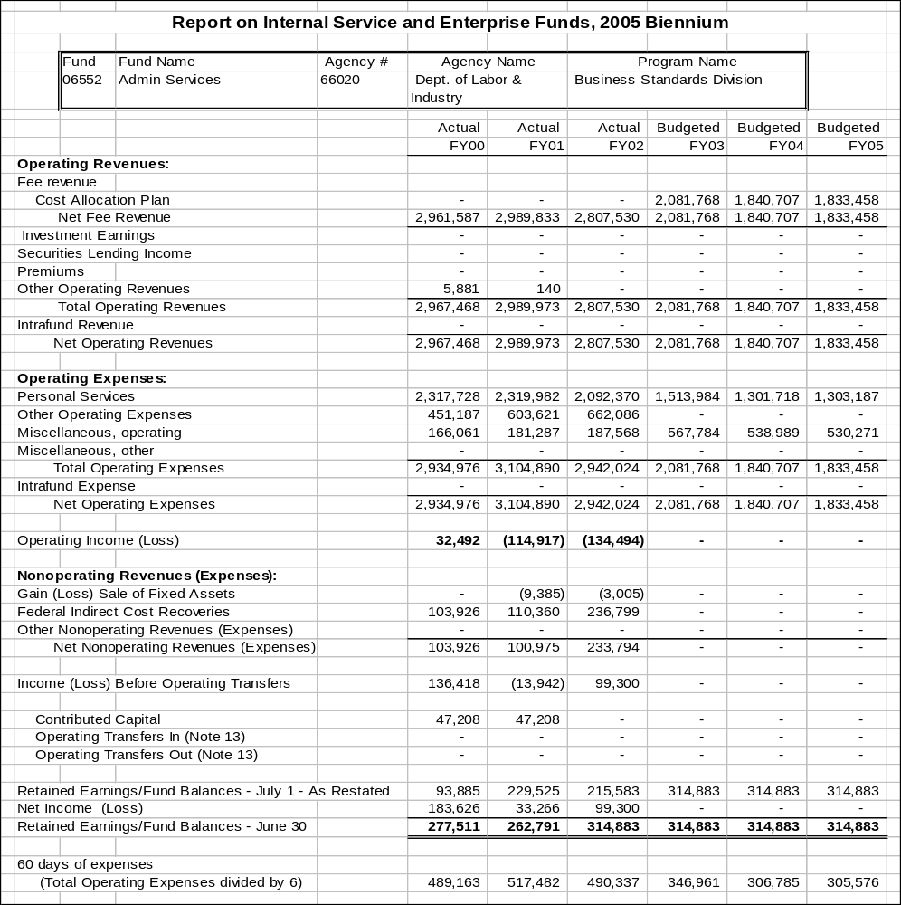

Proprietary Rates

Program Proposed Budget  Budget Item | Base  Budget  Fiscal 2002 | PL Base Adjustment  Fiscal 2004 | New  Proposals  Fiscal 2004 | Total  Exec. Budget  Fiscal 2004 | PL Base Adjustment  Fiscal 2005 | New  Proposals  Fiscal 2005 | Total  Exec. Budget  Fiscal 2005
FTE | 20.15 | 2.00 | 1.25 | 23.40 | 2.00 | 1.25 | 23.40
Personal Services | 936,814 | 105,990 | 67,266 | 1,110,070 | 106,072 | 67,121 | 1,110,007
Operating Expenses | 669,123 | 157,298 | 67,789 | 894,210 | 100,311 | 67,934 | 837,368
Total Costs | $1,605,937 | $263,288 | $135,055 | $2,004,280 | $206,383 | $135,055 | $1,947,375
Proprietary | 1,605,937 | 263,288 | 135,055 | 2,004,280 | 206,383 | 135,055 | 1,947,375
Total Funds | $1,605,937 | $263,288 | $135,055 | $2,004,280 | $206,383 | $135,055 | $1,947,375

Please note that a HB 2 section exists for this program.

Program Description - OPI Indirect Cost Pool - OPI's internal service fund (A/E 06512) is used to pool internal and statewide central service type costs that are charged back to all of OPI's state- and federally-funded programs using a pre-approved indirect cost rate.

Revenue Description - Indirect cost pool revenues are a function of the amount of expenditures recorded in the State Level Activities Program. Revenues are generated monthly by applying an approved indirect cost rate to the prior month's direct personal services and operating expenditures in both state and federally funded programs. Last fiscal year OPI federal programs contributed $819,356 (SABHRS revenue account 593400) towards the cost of "indirects"; general and other state-funded programs contributed $649,953 (SABHRS revenue account 520260). State and federal program payments to the indirect cost pool are recorded using SABHRS account 62827.

Expense Description - Costs of OPI operations that are paid from the indirect cost pool include:
- Termination payouts (vacation/comp time/sick leave) for all staff (except the State Superintendent and her personal staff).
- Services provided to OPI by other state agencies for a fee:
  - Depart. of Admin. (DofA) General Liability Insurance and Employee Bonds
  - DofA Warrant writing fees
  - DofA Payroll Service fees
  - DofA telephone equipment charges
  - DofA rent charge for common areas (bathrooms, halls, conference rooms)
  - Legislative Audit fees
  - DofA network service fees
  - Fish, Wildlife and Parks grounds maintenance fee\
  - SABHRS
- OPI's share of statewide indirect costs, allocated through a Statewide Cost Allocation Plan (SWCAP) prepared by the Department of Administration.
- Payroll, personnel, accounting, budgeting, data management, cash management, financial reporting, purchasing, word processing, mail delivery and resource center services to all OPI programs. Operating costs associated with 19.55 positions are paid from the pool, including the cost of rent for space they occupy, office supplies, postage, long distance phone charges, equipment, training, travel, photocopy charges, etc.
- General-use items such as paper, FAX lines and shared equipment, including maintenance contracts on that equipment.

Working Capital Discussion - Working Capital is not considered in the rate determination. Sufficient working capital is needed for cash flow during the first 30 - 45 days of the fiscal year.

Fund Equity and Reserved Fund Balance - There is no requirement to reserve fund balance. Management's objective is to maintain the minimum balance necessary for on-going operations. If a significant balance accumulates because direct expenses increase at a faster rate than indirect expenses, the approved rate will adjust downward to reduce the excess over time.
Rate Explanation - OPI negotiates a three-year "predetermined rate" with the U.S. Department of Education. The rate is calculated in accordance with federal regulations and section 17-3-111(1), MCA. The rate approved for fiscal years 2002 through 2004 is 17 percent. A new rate will be negotiated for the next three-year period based on actual costs incurred in fiscal year 2003. OPI's restricted indirect cost rate has been 17 percent since FY98 and is projected to remain the same through the next biennium.

Significant Present Law - No present law adjustments will have an affect on the requested rate. Additional authority is requested to pay for:
- Employee termination costs (removed from the base)
- Statewide indirect costs (not billed by Department of Administration in base year)
- 2.00 FTE in the Information Technology Services Division. Additional staff is needed to accommodate the workload increase that has resulted from an increase in OPI data management responsibilities under ESEA/NCLB. Revenue sufficient to pay for these additional services is included in OPI federal present law and new proposal decision packages.

--------------------------------- Present Law Adjustments --------------------------------

Total Agency Impact | General Fund Total
FY04 $219,432 | FY04 $0
FY05 $213,146 | FY05 $0
PL- 46 - General adjustments - Indirect cost pool -
Additional authority of $219,432 for FY 2004 and $213,146 for FY 2005 is requested to pay on-going indirect costs that were removed from or otherwise not included in the Indirect Cost Pool base budget, and to fund 2.00 FTE in the Information Technology Services Division.

In order to comply with federal regulations (OMB Circular A-87) and a Legislative audit recommendation, effective July 1, 2000, OPI began paying termination costs for all OPI employees, except personal staff to the State Superintendent, out of the indirect cost pool. The cost of termination payouts is zero-based. Termination costs of $72,355 were paid in FY 2002. A budget of $75,000 is requested for termination costs paid in both FY 2004 and FY 2005.

The Department of Administration has not provided agencies a Statewide Cost Allocation Plan (SWACP) for fiscal year ended June 30, 2001, so there was no payment in the base year to the general fund for OPI's share of statewide indirect costs. Based on the plan completed for fiscal year ended June 30, 2000 we estimate this cost will be $43,000 in FY 2004 and FY 2005.

The Office of Public Instruction is requesting 2.00 FTE in the Information Technology Services Division, a grade 15 Programmer and a grade 15 network support specialist. The Office of Public Instruction's responsibilities for data management and reporting have expanded considerably as a result of new federal requirements under ESEA/NCLB. Additional staff is needed to keep pace with the additional workload that results from the new requirements. Although OPI has significantly increased its use of technology in recent years, no staff increase has been requested to provide additional technology support services since at least 1995.

Indirect cost recoveries from base adjustments and from federal administration funds provided under NCLB and other new grants will be more than adequate to fund this proposal.

---------------------------------------- New Proposals ----------------------------------------

Total Agency Impact | General Fund Total
FY04 $135,055 | FY04 $0
FY05 $135,055 | FY05 $0
NP- 47 - Advanced Driver Education Program - HB 576 -
Establish the budget for the Advanced Drivers Education program, an enterprise fund, in non HB 2 proprietary account. NP-45 removes the budget from HB 2. This request also includes a rate increase. The current fee is $200 to attend a full-day workshop/person and $125 to attend a half-day refresher/person. The proposed fee effective October of FY 2003 is $225 for a full-day workshop/person and $150 for a half-day refresher/person. A new contract for a driving facility will be negotiated for the 2003 season and is expected to increase considerably.

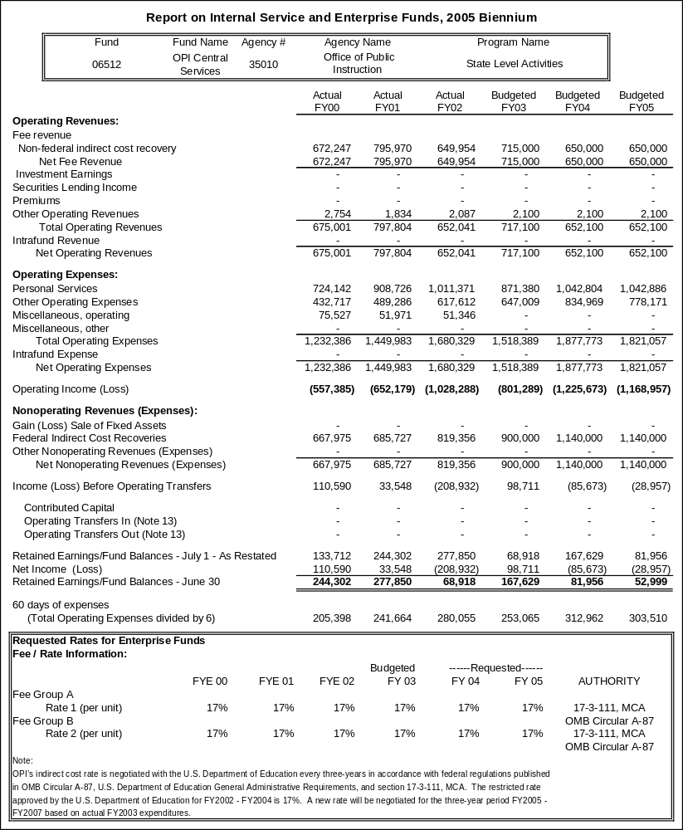

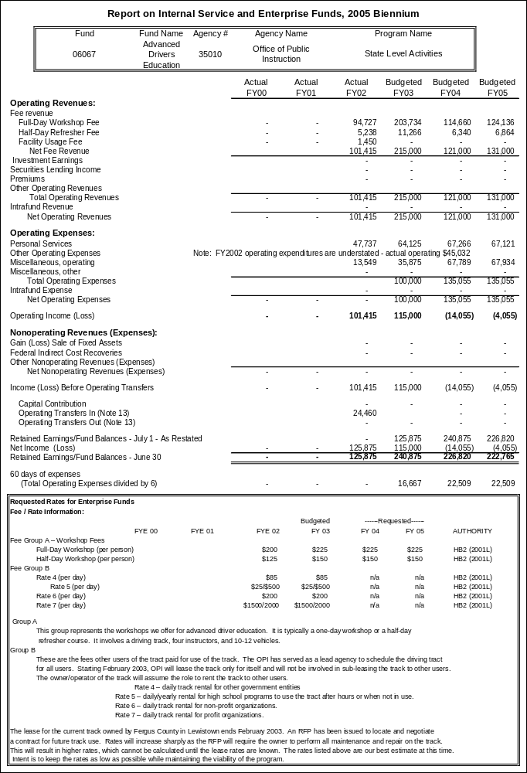

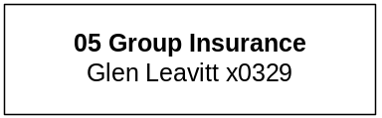

Proprietary Rates

Program Proposed Budget  Budget Item | Base  Budget  Fiscal 2002 | PL Base Adjustment  Fiscal 2004 | New  Proposals  Fiscal 2004 | Total  Exec. Budget  Fiscal 2004 | PL Base Adjustment  Fiscal 2005 | New  Proposals  Fiscal 2005 | Total  Exec. Budget  Fiscal 2005
FTE | 3.65 | 0.00 | 0.00 | 3.65 | 0.00 | 0.00 | 3.65
Personal Services | 150,525 | 22,901 | 0 | 173,426 | 22,773 | 0 | 173,298
Operating Expenses | 4,825,910 | 3,192 | 0 | 4,829,102 | 11,568 | 0 | 4,837,478
Benefits & Claims | 32,181,501 | 14,153,414 | 0 | 46,334,915 | 22,346,928 | 0 | 54,528,429
Total Costs | $37,157,936 | $14,179,507 | $0 | $51,337,443 | $22,381,269 | $0 | $59,539,205
Proprietary | 37,157,936 | 14,179,507 | 0 | 51,337,443 | 22,381,269 | 0 | 59,539,205
Total Funds | $37,157,936 | $14,179,507 | $0 | $51,337,443 | $22,381,269 | $0 | $59,539,205

Program Description - The Board of Regents provides faculty and staff with group benefits through the MUS Group Insurance Program. The commissioner is authorized by Board of Regents policy to administer the program as a self-insured, group insurance plan. All university system employees, retirees, and eligible dependents are offered medical, dental, vision, and group life insurance, as well as long-term disability benefits.

--------------------------------- Present Law Adjustments --------------------------------

Total Agency Impact | General Fund Total
FY04 $14,153,414 | FY04 $0
FY05 $22,346,928 | FY05 $0
PL- 51 - Increase in Estimated Claims -
The adjustment is based on projected claims increases by the MUS Group Insurance Program.

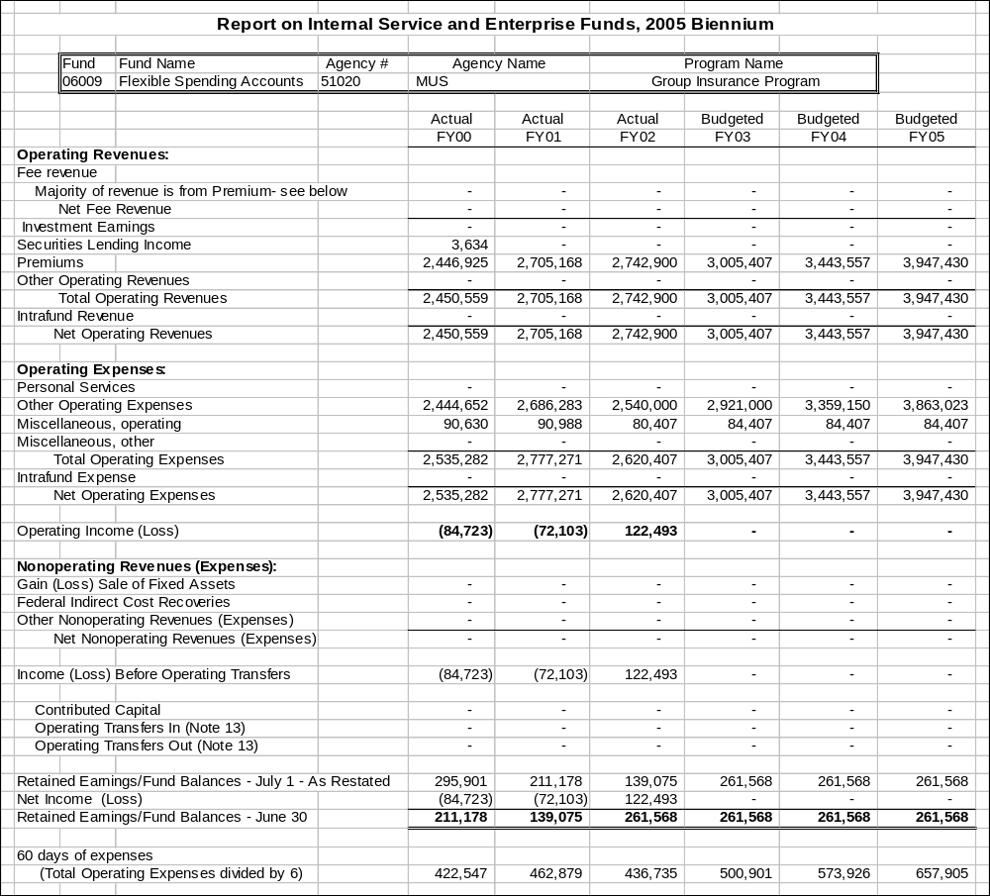

Rate tables continued from page 46 for fund 06530.



